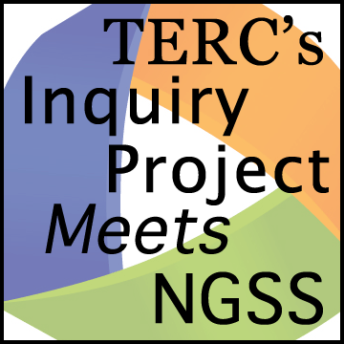Planning Tool

Survey the Curriculum

*Step back and look at the curriculum unit as a whole. Take stock of how the sequences of learning experiences and understandings build on each other to create a richer understanding of the disciplinary core idea (DCI).*

**Curriculum:**

**What DCI does this curriculum target?**

**What is the overarching learning goal (“big idea”) for the curriculum?**

**How does the big idea unfold over the entire curriculum?**

|  |  |
| --- | --- |
| **Curriculum Sequences** | **What are the learning experiences and understanding goals for each sequence?** |
|  |  |
|  |  |
|  |  |
|  |  |
|  |  |

**What component(s) of a DCI do these sequences of learning experiences target? (Refer to the NGSS.)**

**Are there sequences of learning experiences that you can omit because they don’t contribute to understanding the DCI?**