Planning Tool

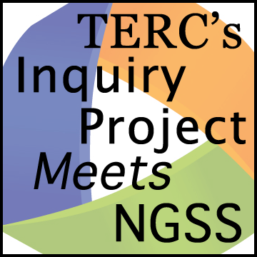Story Line

*Planning a sequence of learning experiences that allows students to figure out the answer to an overarching or driving question requires developing a story line. Students use their findings in each investigation to progressively create a richer explanation for their answer to the investigation question.*

**Curriculum:**

**Sequence of Learning Experiences:**

**What are the Learning Goals? (See PLC1):**

**What is the Driving Question? (What do students have to figure out?) If you cannot find one, can you craft one yourself? (See PLC2)**

**How does the answer to the investigation question develop over a sequence of learning experiences?**

|  |  |  |
| --- | --- | --- |
| **What is the Investigation Question?** | **Findings – What evidence will students find to help figure out the answer to the question?** | **What learning experience will help students find the evidence?** |
|  |  |  |
|  |  |  |
|  |  |  |
| **What claim can you make that answers the investigation question?** |  |  |

.