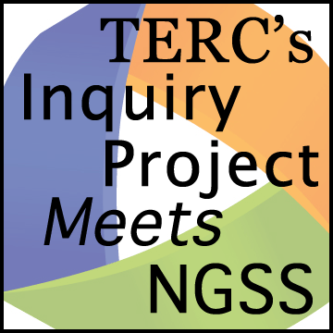Planning Tool

Lead with a Question

*One NGSS practice is* Asking questions and Defining Problems*. Designing a productive investigation question can be surprisingly challenging! Here’s a tool for designing a question to frame an investigation. The same question is revisited during the investigation and often is used to kick off a discussion to make meaning.*

**Curriculum:**

**Lesson(s):**

**What is the learning goal for the lesson?**  (DCI and practice)

**Draft your investigation question** (get out a pencil with an eraser – you’ll probably make revisions!)

**Review your question and revise as needed**

**Is the investigation question**

☐ content focused (does student activity relate to the learning goal)?

☐ worded simply?

☐ equitable (will every student have some relevant experience to draw from)?

☐ one you can ask again and again throughout the lesson?

**To find evidence to answer the investigation question, will students**

☐ explore and observe?

☐ measure or count?

☐ compare and contrast?

☐ find out what happens if?

☐ solve a problem?

☐ take a position and provide evidence?

☐ explain and provide evidence?

☐ use or construct a model?