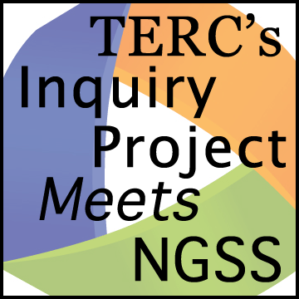Planning Tool

Make Meaning Discussion

*Planning productive talk requires a clear purpose, structure and outcome for the discussion. How important are discussions? Many NGSS Practices require social interaction and discourse as everyday classroom activities.*

**Curriculum:**

**Lesson:**

What NGSS Science and Engineering Practices Do the Students Engage in During Discussion?

☐ 1. Asking questions (for science) and defining problems (for engineering)

☐ 2. Developing and using models

☐ 3. Planning and carrying out investigations

☐ 4. Analyzing and interpreting data

☐ 5. Using mathematics and computational thinking

☐ 6. Constructing explanations (for science) and designing solutions (for engineering)

☐ 7. Engaging in argument from evidence

☐ 8. Obtaining, evaluating, and communicating information

**Investigation Question:**

**What is the purpose of the discussion?**

**What is the focus question that leads off the discussion?** ☐Open ☐Closed

**Discussion Type**

☐ Eliciting ideas☐ Constructing Explanations

☐ Analyzing and Interpreting Data ☐ Consolidating Learning

☐ Other: __________________________________________________

**What responses can I anticipate?**

**How will I bring the discussion to a close?**