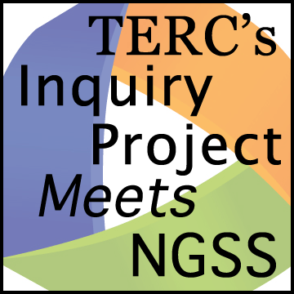Planning Tool

Target Core Ideas

*Planning a sequence of learning experiences that allows students to add to their understanding of a disciplinary core idea requires identifying a) the target components of a core idea and b) learning goals that help move students closer to the target.*

**Curriculum Unit:**

**What Disciplinary Core Idea(s) (DCI) and grade level does the unit as a whole address? (from the *NGSS*)**

**Zoom in. Identify a short sequence of learning experiences that address a DCI.**

**a) What component(s) of a DCI does this sequence of learning experiences target? (Refer to the NGSS.)**

**b) Look for the learning goal(s) for this sequence of learning experiences. List the ones that help students understand the target DCI?**

**Are there parts of the learning experiences that you can omit because they don’t contribute to understanding the target DCI?**