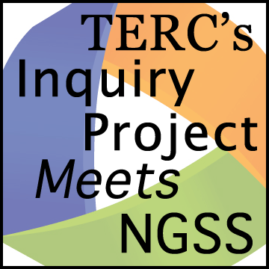Planning Tool

Highlight Evidence

*Planning activities where students build a scientific explanation requires a clear goal and opportunities for students to collect the evidence they need to support their claims.*

**Curriculum:**

**Lesson:**

**What is the learning goal? (See PLC 1)**

**What is the Investigation Question? (What do the students have to figure out?) (See PLC 2)**

**What evidence will students need to answer the investigation question?**

**What NGSS Practices will Students Use?**

☐ Carrying out investigation

☐ Analyzing and interpreting data

☐ Using Mathematics and computational thinking

☐ Creating or using representations

☐ Obtaining information

☐ Other:

______________________________

**What classroom activities will help students find the evidence?**

**Revise the Lesson.**

* **Are there parts of the lesson that you can omit because they don’t help students answer the question?**
* **Are there other experiences and/or sources of evidence that will help students answer the question?**