OVERALL GOAL:
Students will be able to make informed decisions and predictions using data, statistical reasoning, and resources.

Common Themes:
- Interpreting graphs and tables and understanding data are essential skills for making informed, day-to-day decisions beyond any standardized test.
- Students of all levels need to have opportunities to collect, organize, analyze, and evaluate data for understanding and application.
- Data evaluation and analysis skills lead to the ability to express ideas and create arguments informed by data and statistics.

Progression Summary:
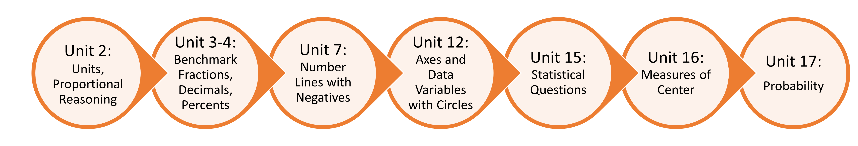
Unit / Lesson / Context | Notes
U2.L1 (measurement units; tables)
U2.L2 (thinking proportionally)
U3.L1 (exploring one-half)
U3.L2 (exploring fourths; intervals; bar models)
U3.L3 (applying and extending benchmarks; representing data with
benchmark fractions)
U3.L4 (exploring one-tenth)
U3.L5 (conducting a survey)
U4.L1 (displaying percents)
U4.L4 (a taxing time; estimating with benchmark percents and
fractions; visual models)
U4.L5 (calculating and comparing tax rates; application of data;
making informed decisions)
U7.L3 (expanding the number line to include negatives; includes
vertical number line)
U12.L1 (equal intervals in graphing; axis introduction with
independent and dependent variables from circle pattern
data)
U12.L2 (problem-solving; making decisions and predictions based
on area of circles and the benchmark ¾)
U15.L1 (describing the statistical process and formulating
questions; connects to survey and creating circle graphs in
U3.L5 and estimation in U4.L4)
U15.L2 (collecting and examining statistical data)
U15.L3 (using data for planning)
U16.L1 (measures of central tendency)
U16.L2 (box and whisker plots)
U16.L3 (influencing with data)
U16.L4 (comparing climate change data in box and whisker plots;
use data to make an argument)
U17.L1 (introduction to probability; connection to percents)
U17.L2 (determining probability for independent and dependent
events)
U17.L3 (introduction to permutations and combinations)
U17.L4 (using formulas for permutations and combinations)
U17.L5 (applying understanding of probability to games of chance)

Notes to Teachers:
- The entire curriculum is a complete progression. This two-page progression highlights selected lessons related to data and statistics.
- Each CALM lesson builds into the next. Keep this in mind as you seek to use this modified progression. Be sure to read (just below the title of each lesson plan) how this specific lesson connects to previous work in CALM. Recognize that some students may need some additional support to make those connections more concrete, i.e., you may find it useful to review what was previously taught before deciding on how to move forward. Additional practice from other resources in your classroom also may be used.
- You may need to provide your own transitions or segues between nonconsecutive lessons and units.
- Workforce Application Assessments and Unit Final Assessment Questions are excellent resources for evaluating if your students are ready to move on to the next unit. Even if these materials are not listed in the above progression, we encourage you to incorporate them into your class and/or homework time on a regular basis.
- Don’t forget CALM’s motto: Slow down to speed up. Recognize that teaching conceptually takes time to teach and learn but ultimately builds a solid foundation for advancing students through greater content than pure repetition and memorization techniques.

