

Multiplication Concepts
Beginning Curriculum for Adults Learning Math
Curriculum for GLE 2–4

TEACHER’S GUIDE



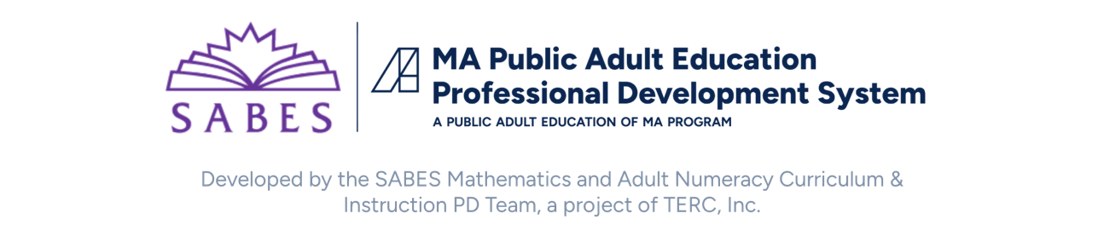
Created with funding from the Adult and Community Learning Services division of the Massachusetts Department of Elementary and Secondary Education by the SABES Mathematics and Adult Numeracy Curriculum & Instruction PD Center, which is managed by TERC, Inc.

Acknowledgements

The titles in the BeCALM series were developed and piloted in the classroom by Melissa Braaten for the SABES Mathematics and Adult Numeracy Curriculum & Instruction PD Team, with contributions from Yvonne Readdy, Emily Rudd, and Sherry Soares.

The BeCALM series includes four sequential packets:
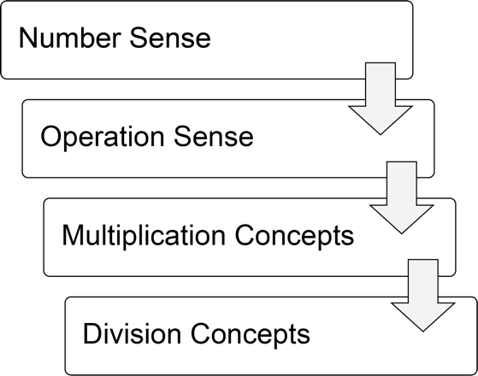
And three non-sequential packets:
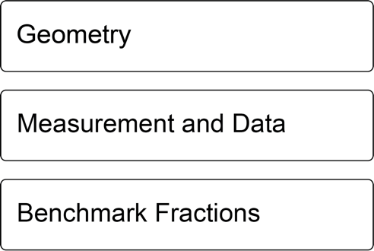
Activities from the EMPower™ and EMPower Plus™ series title Everyday Number Sense: Mental Math and Visual Models Student Book are used and/or adapted with permission from the author, TERC, Inc.

Learner Level
The math content is aimed at ABE level math students (approximately GLE 2–4). While adult students at this math level may have any level of reading, the student materials were designed to be used by adults with a reading level GLE 2 or above. To keep things accessible, the text in the Student Packet is kept to a minimum so that this can be used with students at an ABE reading level or students who are beginning to intermediate English Language Learners.

Use in Different Settings (In-Person, Remote, Corrections)
This curriculum was designed for use in-person, hybrid, or in a remote classroom. In some cases, the same activity could be used in either format. Other times, a virtual game or interactive is substituted for an in-person activity that can’t be facilitated in a remote classroom. Each activity is labeled based on its format.
Note: Virtual resources often work better on computers, laptops, tablets, or Chromebooks rather than on Smartphones, especially due to small screen size. There are notes on the specific websites used in each unit. These virtual activities could also be used in an in-person class or assigned for homework.
Throughout this guide you will see the following icons that denote the delivery format(s) of the activity or resource:
In-person |  | Remote |  | Not recommended for smartphones | 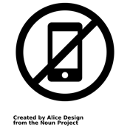
Suggestions for adapting in-person activities for use in correctional facilities are provided when necessary.
Students at the suggested level (GLE 2–4) are often building the skills covered in this unit, not simply reviewing them. The pilot-testing of these materials took 4-6 hours of synchronous class time for each unit. This time included all of the synchronous elements listed below.

Teaching Skills that Matter (TSTM)
Teaching Skills that Matter (TSTM) in Adult Education is a project of the Office of Career, Technical, and Adult Education (OCTAE). See https://lincs.ed.gov/state-resources/federal-initiatives/teaching-skills-matter-adult-education for more information about the program and toolkit.
Part of TSTM is integrating and contextualizing basic skill development in content areas relevant to adult learners. The five content areas highlighted by TSTM are Workforce Preparation, Financial Literacy, Health Literacy, Digital Literacy, and Civics Education. In this curriculum, each unit contains an activity in the context of financial literacy.

In addition, these activities are designed to build skills designated by TSTM as the “skills that matter,” which include:

- Adaptability and Willingness to Learn
- Communication
- Critical Thinking
- Interpersonal Skills
- Navigating Systems
- Problem-Solving
- Processing and Analyzing Information
- Respecting Differences and Diversity
- Self-Awareness

Financial Literacy activities are indicated with this icon:


Components of Synchronous Instruction

Routines
Classroom routines can be powerful tools in the math classroom. Routines provide a familiar structure to an activity that helps students feel safe because the directions and expectations are predictable. However, a good math routine still provides a cognitive challenge and requires some type of problem-solving every time. There are several routines included in this unit that reappear at the end of every unit. There are notes and descriptions of how to facilitate these routines in the unit details. Other common routines, such as Number of the Day or Math Talks, also work well in synchronous instruction with students at this level, even though they do not appear in the student materials.

Introduction of New Concepts
Each unit includes one or two activities to introduce the new concepts for that unit. Instructions for facilitating are included in the unit details. The goal is to lay the foundation for conceptual understanding of the concepts, rather than simply explaining procedures.

Vocabulary and Things to Watch For
Each unit includes some suggestions on valuable vocabulary words and common misconceptions or interesting student ideas that came up in the pilot class.

Student Interaction and Interpersonal Skills
When possible, it is helpful to allow students to interact and work together without the teacher constantly present. In a remote setting, this can often be done using breakout rooms in video conferencing software. As long as the students all have the student materials available to them, they can work together on some of the activities or routines, but remote group work usually requires more scaffolding than in a face-to-face class. It can help to explicitly discuss expectations, etiquette, and goals before breaking into groups, and to debrief afterwards to troubleshoot any problems with the process. Since remote interactions usually offer less in terms of non-verbal communication, students will need to learn ways to be more explicit and verbal in their communication with their classmates.

Tech Support
Synchronous technology instruction and support is often necessary for students to be successful in a remote environment. This includes instruction on how to navigate and use the features of video conferencing software (like Zoom or Google Meet), and how to use any features of any other apps or software used for school communication, assignments, or other asynchronous instruction. Most students will benefit from at least some synchronous instruction with demonstrations when they start a class, with frequent review and support as needed. Students who struggle with technology usually do better with synchronous help rather than videos or documents, so incorporate this into your class time if they are not getting this help somewhere else.

Materials Overview
- Unit 1: Visual Patterns in Multiplication
- Unit 2: Number Patterns in Multiplication
- Unit 3: Equivalent Expressions
- Unit 4: Breaking into Parts
- Unit 5: Application Project: Completing an Invoice
Each unit in the Student Packet includes materials for:
- Financial Literacy Instruction
- Activities and Practice
- Optional Language Support
- Self-Evaluation (reproducible from Teacher’s Guide pp. 53–57)
Additional PowerPoint documents referenced throughout the Teacher’s Guide are listed below and can be downloaded at:
https://www.dropbox.com/scl/fo/6os3wxr4wef5wv3jqxp84/AFaPTWGQ1TX_M758IkWb3kc?rlkey=sezsdo4et4icd28fn9rfzyp7j&st=e0ofl1dr&dl=0
- Quick Images
- Number of the Day Template
- Two Truths and a Lie
- Array of the Day
- Array Pictures

Math Background: Multiplication Concepts
Note: The Math Background content below reproduced and adapted from the EMPower Plus: Everyday Number Sense Teacher and Student books, with permission from the author (the Adult Numeracy Center at TERC).
BeCALM strives to make the most of strategies adults bring to the table and makes explicit the understandings adults hold about numbers so that new ideas can be built on this foundation. Highly numerate adults use flexible, accurate, and efficient strategies for manipulating numbers and quantities in real-world problem-solving.

The importance of students bringing their understanding into the classroom
Many students have invented or collected a set of strategies that circumvent the procedures (the methods or algorithms) historically taught in school yet may think those are not the school-approved or “real” ways. Observations of adults at work and in consumer situations uncover a surprising assortment of methods. It is important that students be encouraged to bring their own good math sense to bear in various situations for managing the mathematical demands of school and everyday life. Strategies and methods may include a mix of finger counting, mental math, estimation, calculator use, and paper-and-pencil methods. Such strategies can support insight into higher mathematics.
A Focus on Meaning Making and Conceptual Understanding
When meaning is lost, it is difficult for students to leverage their intuition or to apply common sense to problem solving, recognizing patterns, generalizing, and making connections.
The National Research Council summarizes the research on the development of children’s mathematical proficiency. Their conclusion about teaching rational numbers is that instructional programs that use “approaches that build on students’ intuitive understanding and use of objects or contexts that help students make sense of the operations offer more promise than rule-based approaches” (NRC, 2002).
Students’ work in math class should involve connecting “symbolic representations and operations with physical or pictorial representations, as well as translating between various symbolic representations” (NRC, 2002).
Operation Sense
Many people confront math problems and find themselves uncertain which operation to use: addition, subtraction, multiplication, or division. Operation sense includes understanding the relationships among the operations, and the effect an operation will have on a pair of numbers (Huinker, 2002).
Operation sense also includes understanding the meanings and models of operations, the real-world situations they connect with, and the symbols that represent them. Limited understanding of operations with whole numbers often leads to confusion about which operation to use.

Different Models for Operations
Different models cover different situations. Teachers and students become more conversant with different models and begin to anticipate how multiplication, addition, subtraction, and division affect whole numbers, fractions, and decimals.
Recognizing problem types and testing or matching them to different models ultimately gives a person a wider range of ways to approach any problem. It strengthens strategic competence. Consider, for example, this problem: “How much do 2½ pounds of meat cost at $3.00/lb.?” Some people see it in terms of addition ($3.00 + $3.00 + $1.50). Some see it in terms of multiplication (2.5 × $3.00). The relationship between multiplication and repeated addition is why both approaches work.
Researchers argue that a focus on the behavior of operations allows students to start in familiar territory of number and computation to progress to true engagement in the discipline of mathematics (Russell, Bastable, & Schifter, 2011).

Fluency with Multiplication Facts
In most classes, teachers will detect a wide range of fluency with one-digit addition, subtraction, and multiplication facts. Some students have never learned to recite their tables automatically. But adults who have never memorized 6 × 7 = 42, or even 6 + 7 = 13, buy things, earn money, and pay bills, and in doing so, do a lot of math. You do not have to know your multiplication tables to do some interesting math, although it certainly helps. Memorization (automatic retrieval of acts from memory) is one strategy; however, for learners who struggle with automatic retrieval, there are other strategies that can be effective to help them increase their fluency, such as noticing patterns and using known facts to find unknown facts.
This curriculum uses several methods to help students improve their fluency with multiplication facts:
- Embedded practice: problem-solving games and activities that involve a lot of calculation
- Visual models: fact practice that pairs with visual models, such as area models
- Patterns: observing patterns in multiplication facts makes them easier to retain
- Improving backup strategies: students learn ways they can find unknown facts from known facts, taking advantage of properties of operations
Note about mathematical learning disabilities: Some students in adult education classes may have specific mathematical learning disabilities which could interfere with their ability to benefit from the discovery of patterns or embedded practice to improve their fluency with single-digit multiplication facts. These students may also not have enough known facts to use as a basis for building to new facts. These students may require specific, tailored interventions that are outside the scope of this curriculum. If you think you have students who might need a more intensive intervention to improve their fluency with basic facts, reach out to the SABES Mathematics and Adult Numeracy Curriculum and Instruction Team director at heidi_schuler@terc.edu. We are currently investigating strategies that could be used with these adult learners and you may be able to help us in this effort.
Unit 1: Visual Patterns in Multiplication
Learning Objectives | CCRSAE
I can identify factors and products. | 3.OA.1, 4.OA.4
I can see and describe visual patterns in factors and products. | 3.OA.1, 3.OA.3, 3.OA.5, 3.OA.7, 3.OA.9, 4.OA.4, 3.MD.7, MP.7
I can break up a pattern into smaller parts.  (Quick Images) | MP.7
I can write expressions equal to a target number. (Two Truths and a Lie) | 5.OA.1–2, starting with simple expressions

Standards for Mathematical Practice
MP.7 Look for and make use of structure
Students will look for patterns in visual representations of numbers. The focus is on how numbers are built out of other numbers, and how some numbers are multiples of others. Students will also explore how rectangular arrays have equal rows (and equal columns) and can be interpreted as both repeated addition and multiplication. Rectangular arrays also provide the first informal exposure to the Commutative Property of Multiplication.

Extra Resources for this Unit
Downloadable file: Quick Images PowerPoint
Downloadable file: Two Truths and a Lie Template PowerPoint
- Reproducible: Evaluation Unit 1, Teacher’s Guide p. 53
Reproducible: Visual Numbers, Teacher’s Guide p. 58
Reproducible: Push/Support Cards for Visual Numbers, Teacher’s Guide p. 59
Reproducible: Array Cards, Teacher’s Guide pp. 60–65
Web link: Phet Area Builder
https://phet.colorado.edu/sims/html/area-builder/latest/area-builder_en.html
Web link: Factorize
https://www.nctm.org/Classroom-Resources/Illuminations/Interactives/Factorize/

Math Background
Numbers are built of other numbers. This first lesson introduces a number of important concepts through visual images. The specific names of the concepts, such as subitizing or Commutative Property of Multiplication, are not necessary for students at this level, but are just presented here as background for the teacher.

Subitizing
The first routine, Quick Images, pushes students to break an image into parts in order to be able to reproduce it. Within the pattern of the quick image, we want students to start to see smaller, component patterns. With small arrangements of objects, our brain is able to “subitize,” which means to see how many all at once, without having to count them one by one. Most people can subitize up to 4, or larger amounts if they are arranged in a familiar pattern, such as the 5 dots arranged in an x on a die. When we see arrangements of larger amounts, we can break the arrangement into smaller parts that can be subitized, such as the arrangement of 8, below, which could be seen as two 4’s, or the arrangement of 9, which could be seen as three 3’s.

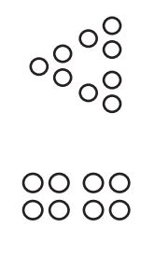

Structure of Numbers
In the Visual Numbers activity (see page 58 of Teacher’s Guide), students are given visual representations of the numbers 1–35, with each number drawn in such a way as to show it broken into equal groups. The small groups are represented in consistent ways, such as three dots arranged in a triangle or four dots in a square, as seen in the images below. Some numbers have complex structure, which can be seen in the arrangement of dots in a complex pattern. These are numbers with many factors. Others are simply a circle (prime numbers) because they have no factors other than one and the number itself. There are no other ways to arrange a prime number into equal groups.
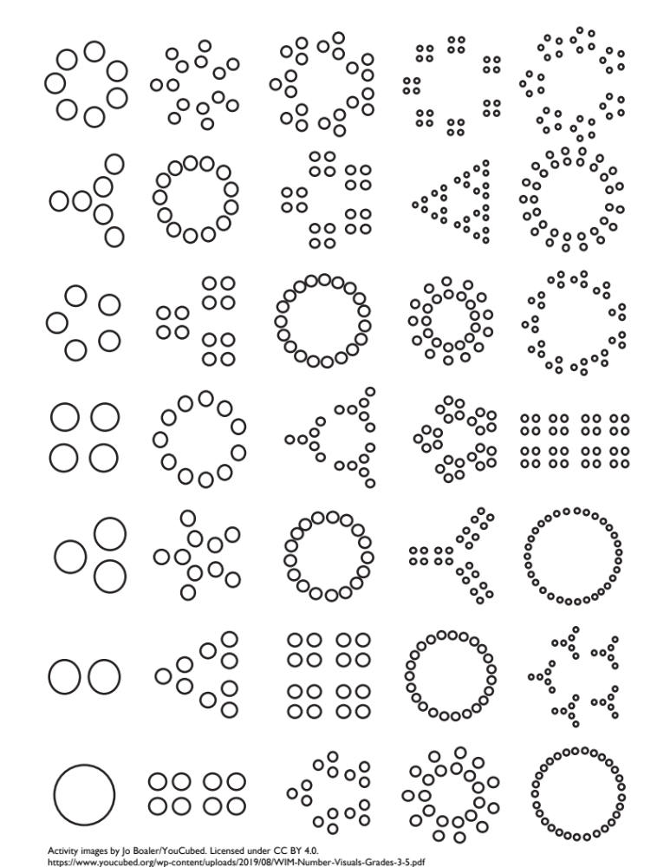

15 as 5 groups of 3, 16 as 4 groups of 4, and 17 is a prime number.

Arrays and Multiplication
This lesson also introduces the idea of using arrays (arrangements of rows and columns) to represent multiplication. Arrays are a powerful tool in math for exploring multiplication and division at all levels. The arrangement allows us to see the repeated equal groups. Also, an array can be used to demonstrate the Commutative Property of Multiplication. It may not be intuitively obvious that 3 groups of 5 is the same as 5 groups of 3 when seen as discreet groups,


but an array makes this clear in a single image.

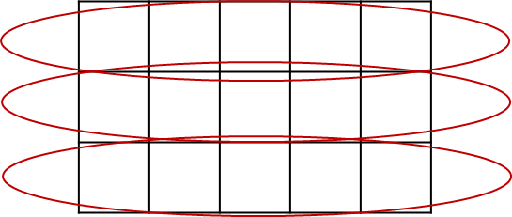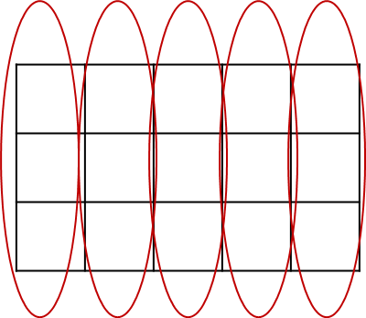

A note on multiplication facts
The array games especially can provide practice with multiplication facts to build fluency in a way that is also connected with visual and conceptual understanding of those facts. If students need more fluency practice, games or activities that connect facts with a visual representation of the factors and product or require strategic thinking can be helpful (more will appear in later units).
The array cards in this unit (see reproducible pages 60–65 at the end of the Teacher’s Guide) will be labelled with the factors on one side and the product on the other, functioning as a robust set of “flash cards” that also visually represent the meaning of the multiplication fact, and can be used in a variety of games and activities meant to improve both recall of facts and push for conceptual understanding of factors and products, without triggering the anxiety often associated with speed drills.

Activities and Practice



Financial Literacy: beliefs and attitudes about money
TSTM Skills: Self-Awareness, Respecting Differences and Diversity


In-Person/Remote Activity
Uses Student Packet p. 3
- Explain that many times, our decisions and behaviors around money are influenced by beliefs and attitudes that we have. Sometimes those beliefs and attitudes come from our culture or family. We may have adopted some of those into our personal belief system around money and finance, or we may have rejected them. Encourage students to brainstorm some of the “messages” about money that they heard from their culture and/or their family growing up. Then have them identify their own beliefs and attitudes about money. It might be helpful to prepare some of your own examples in advance to help people get started.
For example:
My family was very attentive to make sure they were never being charged incorrectly for anything. I grew up watching my dad spend a lot of time on the phone trying to get refunds for an incorrect charge or a product that didn’t work. I respect that, and I follow his example if there is a big financial problem, but if it is a small amount of money, I usually just let it go.
Offer time for them to share, if they want to, in a small group or as a whole class.
- Optional: Push the discussion further by looking at some examples of cultural or family beliefs about money. Ask: How has this belief helped you? Have you had any challenges because of your beliefs about money? If it comes up, this could be a good way to provide information about financial services and culture in the U.S., which can be very different from other countries and can clash with certain cultural beliefs. For example, some cultures are very wary of borrowing money and taking on debt. This can lead to good spending and saving habits, but it can also be tricky in the U.S. when borrowing is used to build credit and to make larger purchases or investments (such as a house). Certain cultural and religious groups object to the practice of charging interest on a loan, which is seen as taking advantage of the borrower, and yet paying interest on loans is a big part of the US financial system. Make sure the discussion is respectful of different attitudes and beliefs, which are often values based. The goal is just to explore the variety of approaches to money and to help students self-reflect on their own.

Things That Come in Groups
In-Person/Remote Activity
Uses Student Packet p. 4
This reading is adapted from Investigations Grade 3, Curriculum Unit: "THINGS THAT COME IN GROUPS" © 1998 by Savvas Learning Company LLC, or its affiliates. Used by permission. All Rights Reserved.
This short reading introduces the idea of working with equal sized groups in multiplication. Have students read and brainstorm ideas to create a class chart of common groups they encounter. This will also suggest some of the contexts in which multiplication can be used.
Some examples:
Groups of 5: fingers on hand, toes on foot, five-dollar bills, workdays
Groups of 10: fingers and toes, digits in phone number, ten-dollar bills, years in decade, millimeters in centimeter, crab legs, bowling pins
Groups of 100: years in a century, pennies in a dollar, paperclips in a box, sheets in a notebook (sometimes)
Groups of 12: eggs and other items sold in dozen, inches in foot
Groups of 16: ounces in a pound

Introducing Routine 1: Quick Images
In-Person/Remote Activity
Uses downloadable file Quick Images Dot Patterns PowerPoint
From Investigations Grade 3, Curriculum Unit: "FROM PACES TO FEET" © 1993 by Savvas Learning Company LLC, or its affiliates. Used by permission. All Rights Reserved.
In this activity, students are shown a picture of a dot pattern, then draw it by inspecting a mental image of it. In order to reproduce the pattern after seeing it only briefly, students must find meaningful ways to see and develop a mental image of the picture. This often involves decomposing (breaking) it into smaller, memorable parts (“groups of 3 arranged in a triangle”) or patterns (“four rows of five”).
- Show the image for 3 seconds. Try to keep it as close to 3 seconds as possible. (Too long, students will draw from the picture rather than constructing a mental image of it. Too short, they will not have time to construct a mental image.)
- Give students a minute to draw what they saw. They should use something that can be easily changed, like pencil and paper or a whiteboard.
- Show the image again for another 3 seconds and allow students to revise.
- When activity stops, put the picture back up and leave it up. Students can complete or revise their drawings.
- Have students share how they saw the drawing as they looked at it in successive “flashes.”
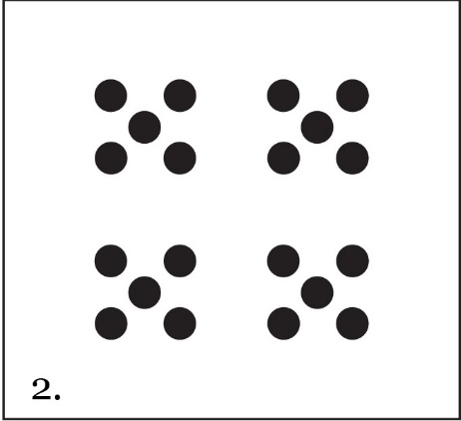
- Push for students to describe what groups or shapes they saw in the dots. For example, with this quick image, one student might report first seeing the four groups, and might have realized they are groups of five on a subsequent “flash”. Another student might recognize the x-shaped arrangement of the five dots and have been able to reproduce it in one try. Another student might see the four dots on the outside of each group and then realize that there is one in the middle.
Corrections alternative: If the classroom does not have technology to display the PowerPoint, the slides can be printed, one slide per page, and held up, or the patterns could be reproduced on a board and covered with paper.

Introducing Routine 2: Number of the Day
In-Person/Remote Activity
Uses downloadable file Number of the Day PowerPoint
This is a classic math routine that works great at all levels. Choose a number of the day (for this unit, consider numbers that have multiple sets of factors, such as 12 or 24.) Write the number on the board or screen (There is a template slide included in the routine materials). Offer three of your own examples. Students should create at least three of their own expressions equal to the number of the day.
When you first start this routine, allow students to use any operations and accept any expressions that are equal to the number, no matter how simple. As time goes on, start to push for expressions that use more than one operation, and encourage students to include multiplication. In a remote classroom, students can share responses in the chat box. In person, you can use small white boards or collect examples from students and put them on the board.
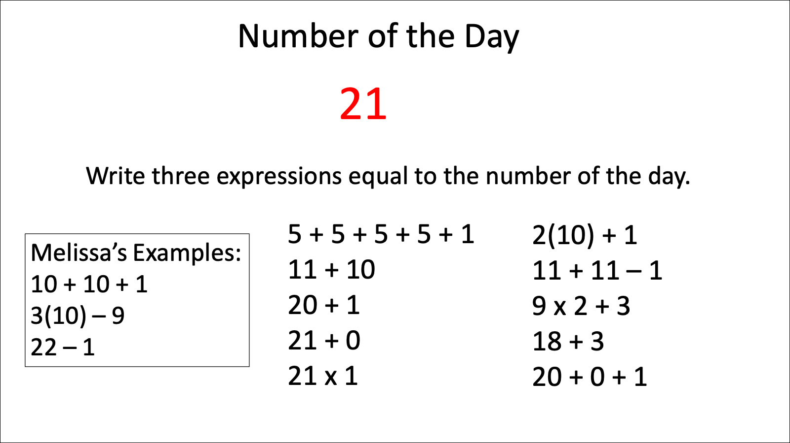
Make sure students have the opportunity to see and ask questions about expressions written by other students. (You could include a deliberate “wrong” expression that you wrote to make sure they are looking carefully.) In the debrief, discuss one or two student questions, or highlight one or two features, such as different ways of using notation, properties of operations that come up, or strategies for creating expressions. Keep it short. The power of this routine comes from revisiting it frequently. Once you have introduced both routines, alternate them as warmups for each class.

Visual Numbers 1–35
In-Person/Remote Activity
Uses Student Packet p. 7
Uses reproducible at end of Teacher’s Guide p. 58
From YouCubed https://www.youcubed.org/resources/number-visuals-k-12/_
Note: The page contains 35 pictures, each of which shows an arrangement of dots for the numbers 1–35. Prime numbers have dots arranged in a circle. Composite numbers have dots arranged in equal groups. Don’t tell students what they are supposed to see in the picture when you give it out: give them time to make their own observations. The goal of this notice/wonder activity is to have students notice that some numbers are made of equal groups, and that some numbers are made of the same equal groups (share the same factors).
Optional extra materials:
Colored pencils
Scissors or a few sets of the image already cut up
Push/Support Cards for Visual Numbers (in-person) Teacher’s Guide p. 59
- Distribute copies of Visual Numbers sheet. In pairs, give students 10–15 minutes to make observations and look for patterns. Ask: What do you notice? What do you wonder? Encourage students to color code any patterns they see.
- Use Push/Support Cards for Visual Numbers to help groups that seem stuck.
(A printable version that can be cut into cards can be found at the end of this Teacher Guide, or the questions below could be used in a remote class.) The Push/Support Cards for Visual Numbers provide prompts that can be given to individual students or student groups to provide a little more scaffolding if they are struggling (Support cards) or to push students to keep looking (Push cards).

Support Questions:
How many dots are in each picture? Is there a pattern?
Are there any patterns or shapes that you notice showing up over and over again?
Find two different pictures that look similar in some way. What is similar about them?

Push Questions:
- Why do some of the pictures have the dots arranged in a circle? What do those numbers have in common?
- Choose three of the pictures where you see multiplication and write the multiplication equation that you see.
- Draw a picture for 36. Compare what you drew with your partner. Is there more than one way that you could draw it?
- Allow groups to debrief. Add their observations and questions to a board (physical or virtual). If groups mention patterns related to multiplication, such as noticing some numbers made of equal sized groups, ask all groups to look back at the sheet and to see if there are any other numbers that look similar. What do these numbers have in common?
- Have one person in each pair cut their paper up to separate all the pictures. The pairs should then sort the pictures into groups. When they have done so, ask them to describe why they sorted them as they did. (Note: There isn’t a single correct way to sort the images. Sorting is a way for students to compare and contrast what they see and to look for patterns.) Students may group together pictures that contain the same factors, since these are arranged in consistent ways (for example, grouping together all the images with factors of three, where the three are arranged in little triangles.) Prime numbers appear as a circle, since there are no other ways (no factors other than 1) to arrange the dots.
Corrections alternative: Provide a few sets where the pictures have already been cut up for pairs to sort.

Introducing Arrays
In-Person/Remote Activity
- Teach the words factor and product. Define array as an arrangement of rows and columns and explain that we will be working with rectangular arrays in this activity, where all the rows are the same size and all the columns are the same size. Display a rectangular array (like 4 by 6) on the board or screen. Ask students to describe how they could find the total number of squares without counting every one. Illustrate different methods on the array as students share them and help them make connections to repeated addition and multiplication.
- Ask where they see the factors in the array (the length and width of the rectangle) and where they see the product (the total number of squares).
array: something arranged in rows and columns
row: arranged in a line, side to side (horizontal)
column: arranged in a line, up and down (vertical)
factor: a number that is being multiplied
product: the result of multiplying

Making Array Cards
In-Person Activity
Uses reproducibles at end of Teacher’s Guide, pp. 60–65
From Investigations Grade 3, Curriculum Unit: "THINGS THAT COME IN GROUPS" © 1998 by Savvas Learning Company LLC, or its affiliates. Used by permission. All Rights Reserved.
- Give each pair of students a set of array cards, printed on cardstock, if possible. Students should work together to cut out the arrays and to label each one on the front with the factors and on back with the product.
- Discuss why the same array can be used to represent 4 × 6 and 6 × 4, for example. (Same rectangle…we can see 6 groups of 4 or 4 groups of 6 depending on how we slice it.) Check that students are accurate with their labels.
Corrections alternative: Cut out sets of array cards ahead of time and have students label them. Cutting them out is time consuming, so you may want to have one set shared by three or four students.

Array Games
In-Person Activity
Uses Array Cards made in previous activity
From Investigations Grade 3, Curriculum Unit: "THINGS THAT COME IN GROUPS" © 1998 by Savvas Learning Company LLC, or its affiliates. Used by permission. All Rights Reserved.

Multiplication Pairs:
- Students can play with a partner or by themselves. Have them spread out the array cards on the table, some with the factors facing up, others with the total facing up.
- On their turn, each player chooses a card and puts their finger on it. If the dimensions (factors) are showing, they must give the total. If the total is showing, they must say the dimensions of the grid. They should pay attention to the shape of the array to help them find the dimensions.
- For example: Suppose they choose an array with a total of 36 showing. The dimensions (factors) could be 6 × 6, or 9 × 4, or 12 × 3. They must decide which matches the shape of the array.
- Then they should turn the card over to check if they are right. If so, they should pick up the card. Players can take turns until the cards are gone. Students can use this game to create a list of pairs that they know and pairs they don’t know yet.
- After students have played a round or two, debrief:
- What strategies did you use to find the total number of squares (product)?
- How can the shape of an array help you to find the factors?

- Choose an array. Ask students if they know of any division facts that they can see in the array. If not, draw the array on the board and explain how division asks for factors. (For example, if an array shows a total of 24 and its dimensions are 4 and 6, we can say that 24 divided by 4 is 6 and that 24 divided by 6 is 4.) After one or two examples together, give the pairs a chance to play again, although this time, they should try to mention two division facts associated with each array. (Students who are still struggling with the multiplication can stick with multiplication for now.)

Count and Compare:
- For this game, students will need to be in groups of 2 or 3. A set of array cards should be dealt out to each player so they all have the same number of cards. Extras can be set aside.
- Each player should put their cards in a stack in front of them, total side down (the total is on the blank side without the grid).
- Each player takes the top card off their deck and places these cards side by side (total sides still face down).
- Students should decide which array is the largest. They can do this by looking, by stacking to compare, or by skip counting by rows to find the total of each. Encourage students to avoid counting by 1’s.
- The player with the largest array takes the cards and places them total side down on the bottom of their own stack. The game continues until one player runs out of cards.
- After students have played, debrief about the strategies they used to determine which array was larger.
Note: These games can be repeated in later lessons throughout the unit, as appropriate. Some students may want to borrow a set of array cards to practice at home.

Array Games
Remote Activity
Online alternative to Array Cards, or supplemental activities

Phet Area Builder

https://phet.colorado.edu/sims/html/area-builder/latest/area-builder_en.html
Note: Not recommended on a phone due to small screen size.

Using the “Explore” mode, you can ask students to build a rectangular array using a certain number of tiles. Discuss how the factors and product relate to the properties of the rectangle (factors are length and width, product is area).
They can also toggle the lower right corner to allow them to create two different arrays side by side. This can be useful if you want them to create more than one way to make a certain product, for example.
Have students share (by sharing their screen or describing so you can recreate) how they made an array for a certain product. Choose numbers that have many factors, so students will come up with different examples.
Students can also try the “Game” mode, level 1, where they have to build shapes of a certain area. (Later levels introduce fractional squares, perimeter, and eventually shading fractions of the area different colors. You could use these as an extension for more advanced students.)

Factorize

https://www.nctm.org/Classroom-Resources/Illuminations/Interactives/Factorize/
Note: Not recommended on a phone due to small screen size.

This game asks students to create rectangles with certain areas, and they have to find all the rectangles that match the factors of the number. As they drag their finger or mouse over the grid, it will highlight and area and count it. When the area is correct, they can let go and the rectangle will stay highlighted (if the area is incorrect, it will disappear). They then must type the factors into the box on the right (such as 4 × 5). Different orientations (like 4 x 5 and 5 x 4) are treated as the same rectangle.
This is a nice game for exploring how some numbers have many pairs of factors, while some have only one (prime). It is faster than the Phet game since they do not have to move tiles one at a time.

Arrays That Total 36
In-Person/Remote Activity
Uses Student Packet p. 8
This can be used as a formative assessment to see where students are with their multiplication facts and understanding of factors and arrays. Students who struggle with this activity could use 36 tiles and try to rearrange them to make different rectangles.

Optional Language Support
In-Person/Remote Activity
Uses Student Packet pp. 9–10

Talking about groups
Explain that when we use the phrase ____ groups of ____, the first number tells us how many groups, and the second number tells us the size of the group (how many in one group?). See the example on page 9 in the Student Packet. Let students practice with the other examples on the page. If students need more support, have them mark this page in their packet (or post the example somewhere in the classroom), and refer to it to help them talk about the groups and arrangements they encounter in this unit.

Talking About Multiplication
The top part of the page provides a model for reading multiplication facts out loud. If students need practice with this, offer other facts and have them practice reading them out loud, using the page as a guide. Have them mark this page to refer to or post the example in the classroom. Use the array image as a guide to help students visualize what they are saying. It is also a good place to use the array to point out that “3 groups of 6” is equal to “6 groups of 3” (the first creates rows of 6, the other columns of 3).
The bottom part of the page provides models for talking about factors and products. Draw students’ attention to where the product and factor numbers appear in each sentence structure. Provide some more examples and have students practice using the example structures.

Exit Ticket/Homework (Formative Assessment)
In-Person/Remote Activity
Uses Student Packet p. 11
Students choose from the options below. Choice 2 is an extension.
Choice 1: Find a number for which you can draw at least three different arrays.
Choice 2: Find the number under 50 that has the most arrays.

Vocabulary
array: something arranged in rows and columns
row: arranged in a line, side to side (horizontal)
column: arranged in a line, up and down (vertical)
factor: a number that is being multiplied
product: the result of multiplying

Things to Watch For

Discomfort with open questions
Open questions in math are questions with more than one mathematically correct answer. There are many open question activities in this unit and curriculum, such as the routines (infinite number of ways to create the Number of the Day!) and activities where students are looking for patterns (like the notice/wonder with the Visual Numbers). Some students may not be used to open questions in the math classroom and may initially be uncomfortable, unsure how to know which answer is the right one. Be prepared to provide some scaffolding to help students get started (such as providing some examples for Number of the Day or using the Support Cards for the Visual Numbers activity). Most students will lose their discomfort once they get started and know what types of responses are expected.

More than one way to make some products
Although each number is represented one way in the Visual Numbers activity, it will soon become clear with the arrays (if students are not already aware) that some numbers have many factors, while others have few. Make sure students are noticing that many of the arrays have the same total number of squares (product), but look different (different factors, different length and width).

Long vs. square arrays
The array games should push students to pay attention to the shape of the array, along with the multiplication facts. Although 1 × 12 and 3 × 4 are both 12, the shapes look very different! Push students to try to articulate which pairs of factors make long skinny rectangles, and which make more “square” rectangles. And ask them if they notice what happens if the factors are the same (such as 5 × 5).

Unit 2: Number Patterns in Multiplication
Learning Objectives | CCRSAE
I can find number patterns in factors and products. | 3.OA.1, 3.OA.3, 3.OA.5, 3.OA.7, 3.OA.9, 4.OA.4, MP.7
I understand that the equal sign means that the right and left side have the same value. | 1.OA.7, extended to multiplication
I can break up a pattern into smaller parts.  (Quick Images) | MP.7
I can write expressions equal to a target number. (Number of the Day) | 5.OA.1–2, starting with simple expressions
I can decide if a math sentence is true or false.  (Two Truths and a Lie) | 1.OA.7, extended to multiplication

Standards for Mathematical Practice
MP.7 Look for and make use of structure
Students will look for patterns in the multiplication table, paying attention to odds and evens, repeating digits, and place value. They will start to connect these patterns (informally) to factors and properties of multiplication, especially the Commutative Property.

Extra Resources for this Unit
Downloadable file: Two Truths and a Lie PowerPoint
Reproducible: Evaluation, Unit 2, Teacher’s Guide p. 54
Reproducible: Close to 100 Game Board, Teacher’s Guide p. 66
Area Blocks from Math Playground
https://www.mathplayground.com/area_blocks/index.htm
Treasure Quest Multiplication
https://www.mathplayground.com/treasure_quest_multiplication_chart.html

Math Background

Patterns in the Multiplication Table
Multiplication is full of numerical patterns and noticing and describing patterns can help develop both fluency and a better understanding of our base-ten system.

Some patterns in the multiplication table explained:
Multiples of 0: Any number multiplied by 0 is 0.
Multiples of 1: Any number multiplied by 1 is equal to itself.
Multiples of 2: All multiples of 2 are even numbers, and the ones place repeats in the pattern 0, 2, 4, 6, 8, 0, etc. (This repetition occurs because 2 is a factor of 10, so repeatedly adding 2 eventually creates a ten and the pattern in the ones place starts over.)
Multiples of 3: All multiples of 3 have digits that add up to a multiple of 3. For example, the digits 2 and 7 in the number 27 add to 9, which is a multiple of 3. (Showing why this works involves decomposing the digits of the number and is probably not worth going in to with students at this level. Khan Academy has a nice video explanation here if you are curious: https://youtu.be/NehkLV77ITk)
Multiples of 3: Multiples of 3 alternate between even and odd. (Actually, all multiples of odd numbers do this. Even multiples of odd numbers are even, because the two “extra” ones go together make another pair. Odd multiples of odd numbers are odd because there will be an “extra” one left over.)
Multiples of 4: All multiples of 4 are even. (All multiples of even numbers are even.) Also, the ones place will follow a pattern: 0, 4, 8, 2, 6, 0, etc. (This is because 4 is a factor of 20, so eventually 4’s will make groups of 20, then the pattern will start over in the one’s place.)
Multiples of 5: The ones place alternates between 0 and 5. (This is because 5 is a factor of 10, so the fives make ten, then the ones place pattern starts over.)
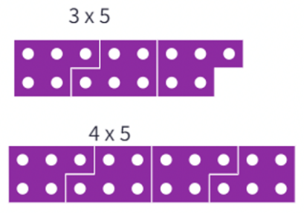
Multiples of 9: The digits of a multiple of 9 will add to 9, up to 9 × 10. for example, the digits 2 and 7 in the number 27 add to 9, as do the digits 5 and 4 in the number 5454. [This is interesting to explore. One way to understand why this is happening is to think of 9 as close to 10 but falling short by 1. Every time we add another 9, we fall short by one more in the ones place, so the ones place digit keeps decreasing by 1 (9, 18, 27, 36, etc.) At the same time, every time we add a 9 (up to 90), we move into the next “ten”, so the tens place goes up by one (9, 18, 27, 36, 45, etc.) Since the ones place is decreasing by one and the tens place is increasing by one, the sum stays the same.
Multiples of 10: The ones place is always 0.

Meaning of the equal sign
Understanding the meaning of the equal sign is the foundation of algebra. Often, students at beginning levels of math associate the equal sign with a command to calculate an answer. They are used to seeing equations like this:
2 + 3 = 5
They may be confused when they encounter equations like these:
5 = 2 + 3
1 + 4 = 2 + 3
The equal sign, instead of a command to perform an operation, is making a statement that the two expressions on either side of the equal sign have the same value. An equation is true if the two sides are, in fact, equal.

Expression and equations
A mathematical expression (like 2 + 3) does not have an equal sign and does not have a truth value. Like the phrase “red shoes”, it cannot be true or false because it is not making any claim.
However, when we include an equal sign and another expression to make an equation (2 + 3 = 1 + 4), we are now making a complete math sentence (like, “Jane is wearing the red shoes.”) Now that we are making a claim (that 2 + 3 and 1 + 4 have the same value), our statement can be true or false.

Activities and Practice

Financial Literacy: costs that repeat
TSTM Skill: Navigating Systems
In-Person/Remote Activity
Uses Student Packet pp. 13–15
- Start by explaining that there are some costs that repeat over time. Brainstorm a few examples, like rent or a streaming service fee, emphasizing costs that are the same over and over.
- Go over the vocabulary on the student sheet and have students brainstorm examples that fit in each category.

Subscriptions and membership fees: costs that are paid over and over, usually every month, to have access to certain products or services
Examples: gym membership, video streaming services (like Netflix), some software products (like Microsoft 365, Zoom, additional store space on Google or Dropbox)
Payment Plans: when borrowed money (debt) is paid back in small amounts that are the same every month
Examples: car or mortgage payments, credit card payment plan, student debt
Products that are consumed: Some of the products we buy are used up and need to be replaced after a certain period of time, over and over
Examples: paying for prescription medications, personal products, buying the same pet supplies over and over
- Choose an example that is relevant to the class or use the one below.
Fatima pays $12 per month for internet in her home. How much does she pay for 6 months of internet?
Give students some time to think and then share their ways of solving. Start by displaying examples that use repeated addition (adding 12 six times) and ask students what strategies they used to keep track of the addition.
For example,
- adding three twelves to get 36, then adding 36 + 36
- adding all of the ones to get 12, adding all of the 10’s to get 60, then adding 12 + 60
Then show examples that use multiplication or demonstrate if none do. Explain that multiplication is a way of showing that a certain amount is being added over and over. Show that the long addition expression has the same meaning as the multiplication expression. For example: 12 + 12 + 12 + 12 + 12 + 12 = 12 × 6
- Show the example of the Gym Membership. Have them write the addition and multiplication expressions for the other examples on the student sheet, then ask them to solve for the total. It is ok for them to use repeated addition strategies to solve. At this point, the goal is to make the connection between repeated addition and multiplication.

Warmup Routines
In-Person/Remote Activity
Uses downloadable files Quick Images Dot Patterns PowerPoint and Number of the Day Template PowerPoint
Continue alternating Routines 1 (Quick Images) and 2 (Number of the Day) as warmups.

Patterns in the Multiplication Table
In-Person/Remote Activity
Uses Student Packet pp. 18–20
- Direct students to the multiplication tables in the Student Packet, pages 18–19. Review the terms factor and product and connect with the table.
Note: You may also decide to introduce the word multiple here. The words multiple and product are used in very similar ways and are often interchangeable. However, when discussing a multiple you only have to name one of the factors (15 is a multiple of 3), whereas a product names both factors (15 is the product of 3 and 5). The word multiple might be useful for this activity, since the multiplication tables are arranged in such a way as to highlight multiples, such as looking at patterns in all the multiples of 5, for example.
- With a partner, ask them to find and describe as many patterns as they can. Give an example or two to start them off. For example, many students are familiar with the fact that the multiples of 5 alternate between 5 and 0 in the ones place.
- Debrief and have pairs describe the patterns they found in their own words. Provide vocabulary as needed, such as odd/even, ones place, and tens place. Add to class vocabulary chart and student notebooks. There is a page for students to record their observations on Student Packet p. 20.
- If it doesn’t come up, make sure to draw students’ attention to the way the table mirrors itself over the diagonal line of perfect squares. Ask if they can explain why this happens (they don’t need to know the term Commutative Property here, but you can introduce it if it seems appropriate.)
Questions for discussion:
- How can patterns help you remember multiplication facts?
- How can you use multiplication facts you know to help you figure out the ones you don’t know?
- How can you use the table to find division facts as well?

Review/Introduce Meaning of Equal Sign in an Equation
In-Person/Remote Activity
- Display a phrase related to something you are wearing (like, “white scarf”). Ask students if this is true or false. Since you are wearing it, some students might say true, but point out that you haven’t made any claims about the item of clothing. Since you haven’t claimed anything, it can’t be true or false.
- Then write, “I am wearing the white scarf” (or something similar). Ask, How is this different? Guide students to see that the second, complete sentence makes a claim (that can be true or false), while the first does not.
- Then write 2 × 5. Ask, Is this true or false? Explain that this is a mathematical phrase, like “white scarf” that makes no claim. These phrases are called expressions.
- Then write 2 × 5 = 10. Again, ask, Is this true or false? Explain that now we have a complete math sentence, which is making a claim that 2 groups of 5 is equal to 7. This complete math sentence is called an equation.
expression: a mathematical phrase. It can contain numbers, variables, and operations (addition, subtraction, multiplication, division), but there is no equal sign.
equation: a mathematical sentence. It contains an “=” symbol between two expressions that have the same value.

What Is an Equation?
In-Person/Remote Activity
Uses Student Packet, pp. 21–22
- Display the four equations below.
2 × 3 = 6 6 = 2 + 2 + 2
6 × 1 = 3 x 2 2 × 3 = 3 + 3
- Give students a chance to notice and wonder at the examples of equations. They should notice that while all of them have an equal sign, they do not all have a single ‘answer’ on the right side. Allow students to share what they think about this. Then read the page to clarify the meaning of the equal sign.
equal sign: the symbol "=", which means that the left side and the right side have the same value

Introducing Routine 3: Two Truths and a Lie
In-Person/Remote Activity
Uses downloadable file: Two Truths and a Lie PowerPoint
Uses Student Packet, p. 23
- For this routine, students are presented with three equations. Two of those equations are true (the expressions on both sides have equal value), and one is false. Give students a decent amount of wait time before any thoughts are shared (encourage them not to call out which one is the lie until the wait time is over).
- Then have volunteers explain how they know each equation is true or false. Emphasize the meaning of the equals sign (left and right side have equal value) by circling and evaluating the expressions on each side.
The first two Two Truths and a Lie are found in the Student Packet on p. 23. The remaining puzzles in the slideshow can be used as warmups throughout the curriculum, alternating with the other routines.
Note: The expressions start to include parentheses to signify multiplication and eventually grouping. Discuss and review this use of notation as needed.

How Close to 100?
In-Person Activity
Uses reproducible: How Close to 100?, Teacher’s Guide p. 66
Materials: Two dice
From Youcubed activity How Close to 100? https://www.youcubed.org/tasks/how-close-to-100/
This game is intended to reinforce the concepts from the array games, with a more strategic focus. This game can be repeated throughout unit, as appropriate.
- This game is played in partners. Two students share a blank 100 grid.
- The first player rolls two number dice. The numbers that come up are the numbers the student uses to make an array on the 100 grid.
- Player 1 can put the array anywhere on the grid, but the goal is to fill up the grid to get it as full as possible. After drawing the array on the grid, Player 1 writes in the number sentence that describes the array.
- Player 2 then rolls the dice, draws the number grid, and records their number sentence.
- The game ends when both players have rolled the dice and cannot put any more arrays on the grid.
- How close to 100 can you get?
Variation: Each student can have their own number grid. Play moves forward to see who can get closest to 100.
Extension: A more sophisticated version of this game involves rolling four dice and deciding how to combine pairs of dice to make the two dimensions. See a description here: http://www.collectedny.org/frameworkposts/cover-the-field/

Online Games
Remote Activity
Online alternative to How Close to 100?, or supplemental activities

Area Blocks from MathPlayground
https://www.mathplayground.com/area_blocks/index.htm
Notes:
• Not recommended on a phone due to small screen size.
• Teach perimeter if you are going to use this game.
This game is simple to play but sophisticated in strategy. Two players alternate (students can play against a computer as well). On their turn, they have to highlight a shape with the given area and perimeter (the game will display the area and perimeter of the shape as they highlight). When the shape fits the area and perimeter, they can submit. However, as the game progresses, each player is trying to cover as much of their grid as possible. If they don’t use the space wisely, they will run out of room to fit shapes for future turns.
This game reinforces the concept of area and perimeter, as well as the intuition around how to extend a perimeter (make the shape “skinnier”) or shorten a perimeter (make the shape more “square”).

Treasure Quest Multiplication
https://www.mathplayground.com/treasure_quest_multiplication_chart.html
This game give students a target product and asks them to find where that product appears in the multiplication table. Simple concept, but it highlights the fact that many products can be made in multiple ways. Works on any device.

Optional Language Support
In-Person/Remote Activity
Uses Student Packet pp. 24–25

The Language of Multiplication and the Language of Rectangles
- Rectangular arrays are used in this unit to help students visualize multiplication, and so far, students have been practicing the language associated with multiplication (factors and products). However, rectangles can also be described using the language of geometry. This activity starts with a reference sheet comparing the words used to describe multiplication and the words used to describe rectangles (length, width, area). The second page has a few practice exercises so students can use the language of geometry.
- If needed, post the resource page in the classroom, or have students mark this page for reference, and have them practice using this language frequently throughout the unit.
Note: The word length is commonly used for the longer dimension, and width for the shorter dimension. This is not hugely important, however, and the rectangle can be described in either order (6 by 4 or 4 by 6).

Exit Ticket/Homework (Formative Assessment)
In-Person/Remote Activity
Uses Student Packet p. 26
- Have students create their own “Two Truths and a Lie.” In-person, this could be done on index cards, and after using them as a formative assessment, they can be swapped around to other students as a practice exercise. In a remote classroom, student examples can be shared on slides as practice for the whole class.

Vocabulary
expression: a mathematical phrase. It can contain numbers, variables, and operations (addition, subtraction, multiplication, division), but there is no equal sign.
equation: a mathematical sentence. It contains an “=” symbol between two expressions that have the same value.
equal sign: the symbol "=", which means that the left side and the right side have the same value

Things to Watch For

Students thinking the equal sign means find an answer
The way that beginning computation is taught often conditions students to think of the equal sign as a command to find an answer:
10 + 5 = ?
In this case, students are usually expected to find the ‘answer’, meaning, the whole number sum of 10 + 5. Students learn to associate the equal sign with a command to come up with an answer. This is a very limiting view of the equal sign that can cause difficulties later when students encounter algebraic equations like x + 1 = 9 (If 9 is the answer, what do I do now?) or x + y = 3 (How am I supposed to add x and y?)
Even students working only with numerical equations (no variables) can become fluent in a much richer understanding of the equal sign. For example, the equation 10 + 5 = ? can just as correctly be completed this way 10 + 5 = 9 + 6. The task can be richer than simple computation, 10 + ? = 15. Equations with a single whole number on one side can start with that number (15 = 10 + 5) or even simply express identity (15 = 15). Exposure to different structures of equations can help students develop a more accurate understanding of the equal sign as a claim of equality, which will become a valuable foundation for later algebraic reasoning.

When students think that the first number after the equal sign is the answer
Seeing the equal sign as a command to calculate an answer can lead to confusion about how to interpret an expression on the right side of the equal sign. For example, when students see an equation like 9 + 7 = 10 + 6, they may interpret it as saying that the sum of 9 and 7 is 10, and then they should add 6 more (which leads to confusion, since 9 + 7 isn’t 10). This can often be seen as well in students’ own work. A student who has to add the numbers 1, 2, 3, and 4 may notate it as follows:
1 + 2 = 3 + 3 = 6 + 4 = 10
This is very common and shows that the students are using the equal sign to mean “the answer is” rather than expressing equality of expressions. While it is not advisable to overly-correct how students notate their own calculations while they are working them out, this is an important signal to the teacher that they need a better understanding of the equal sign.

Unit 3: Equivalent Expressions
Learning Objectives | CCRSAE
I can express repeated addition as multiplication. | 3.OA.1, 3.OA.3
I can use arrays to model multiplication expressions and scenarios. | 3.OA.1, 3.OA.3, 3.OA.5, 3.MD.7, MP.4
I can find equivalent expressions for an array.  (Array of the Day) | 3.OA.5
I can write expressions equal to a target number. (Number of the Day) | 5.OA.1–2, starting with simple expressions
I can decide if a math sentence is true or false.  (Two Truths and a Lie) | 1.OA.7, extended to multiplication
Note: EMPower Plus materials featured in Unit 3 can be found in Lesson 10 (Picture This) of the Everyday Number Sense: Mental Math and Visual Models books.

Standards for Mathematical Practice
MP.2 Reason abstractly and qualitatively
Students will write expressions for concrete arrangements of objects, and will explore how different expressions can represent the same arrangement. This involves going back and forth between the concrete arrangement and different symbolic representations.
MP.7 Look for and make use of structure
Students will look for patterns in equivalent expressions.

Extra Resources for this Unit
- Downloadable file: Array of the Day PowerPoint
- Downloadable file: Array Photographs Extension PowerPoint
- Reproducible: Evaluation, Unit 3, Teacher’s Guide p. 55

Math Background

Equivalent Expressions
The focus in this unit is on making connections between visual arrays and expressions. Because the same array can be seen in different ways, arrays provide a way for students to explore how different expressions can be equal, and the structure of the expression itself provides information about how the person sees the image.
For example, one student might see vertical groups of 3 in this array, with two extra tiles on the edges, and could write the expression 3 × 3 + 2.
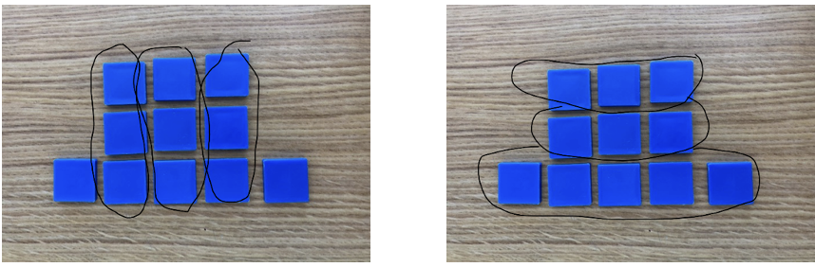
Another student might write 2 × 3 + 5 for the same array, because they saw two horizontal groups of 3 and a bottom group of 5.
In this way, students are showing that 3 × 3 + 2 = 2 × 3 + 5, and they are also learning how the expression itself carries information about the way the array is understood.

Activities and Practice

Financial Literacy: one time purchase or subscription?
TSTM Skill: Problem Solving
In-Person/Remote Activity
Uses Student Packet p. 27
- Explain that sometimes we have a choice whether to purchase something outright (one time purchase) or to pay a subscription fee over time (repeated cost). Have students read the situation and answer any questions they have about it.
Jean-Pierre just bought a new computer. He wants to be able to create documents on it using a word processing program.
He has two choices:
- He can buy the program and download it on his computer for $160. (one-time purchase)
- He can pay for a subscription that allows him to use the program. This costs $50 per year (a repeated cost).
- Give students a chance to discuss the pros and cons of each choice and fill out the chart, then debrief as a class. If they haven’t already, push students to consider how much the subscription would cost after 1, 2, 3, 4, or 5 years, and connect to multiplication as repeated addition.

Note: In addition to the financial considerations, see what other digital literacy background knowledge students have. Other pros or cons could include whether the program is available without internet connection (some subscriptions require a connection to use), the fact that subscriptions sometimes provide additional updates or tech support, and the expected longevity of the device and current version of the software (This may be something for students to research: how long could Jean-Pierre expect his new computer to last? How long do word processing programs generally last before the company comes out with a newer version? Before they are obsolete and no longer compatible with other software?)
- Based on the pros and cons, what would you do? Have students vote and share their reasoning. There is no right answer, the goal is to have students consider all the relevant factors and decide based on which choice would work best for them.

Warmup Routines
In-Person/Remote Activity
Uses downloadable files Number of the Day Template PowerPoint and Two Truths and a Lie PowerPoint
Continue alternating Routine 2 (Number of the Day) and 3 (Two Truths and a Lie) as warmups. In this unit, you will introduce a new routine, called Array of the Day.

Introduce Array of the Day
In-Person/Remote Activity
Uses downloadable file Array of the Day Template PowerPoint
To facilitate Array of the Day, download the slides and show one slide. Ask students to find a way to count the total number of tiles without counting one by one. Then ask them to write an expression for how they counted. Invite a student to annotate (in person or virtually) the slide to show how they grouped the tiles, and to write their expression. Encourage the student to make an explicit connection between the way they grouped the tiles and their expression (equal groups represented by multiplication, unequal groups, or extras with addition. Some students may also use subtraction to represent tiles “missing” from a larger array). After a volunteer has shared, ask: Did anyone see it differently? Try to get two or three examples of different ways to see the array and to write the expression. Show, by writing on the board, that the different expressions (if they are correct) are equivalent: they all have the same value, which we can see visually because they represent the same array, as well as symbolically, if we perform the calculations.
After students have done this routine for a few classes as warmups, you can have volunteers share their expression, and challenge other students to try to “see” the array the way they did.
Notes:
- This is another place to review different notation for multiplication, as well as the rules of order if they come up in a student’s expression.
- If you are teaching remotely and have students using Smartphones, you may want to skip the last couple of slides where the arrays are smaller.

Opening Discussion
In-Person/Remote Activity

Uses Student Packet, p. 30
- Say: I know someone who thinks in arrays! She washes windows for a living and charges for each window. She needs to make quick estimates for her customers, so she never counts one by one. When she looks at a building like this, how many windows does she see?
- Give students a moment to talk to a partner. As volunteers share approaches, record their ideas with equations. If someone says, “I counted by 3’s,” ask for details—what he or she said or thought when counting each group. Demonstrate on the board how the person saw the numbers in the array and record the numbers as well as any explanation of mental arithmetic.
3, 6, 9, 12, and 12 more is 24
2 times 4 is 8
3 × 4 is 12, 12 + 12 is 24
8 × 3 equals 24
Example: If someone explains, “I just knew that three 4’s equal 12, so I added 12 and 12,” post a copy of the picture and record:
3 × 4 = 12 (Box the first set of windows and label the sides with 3 and 4.)
12 + 12 = 24 (Box the second set of windows and label it “12.”)
- If the question “I saw 4 × 3…is that the same?” arises, take the opportunity to rotate the array pictured and ask, Has the total changed? You may wish to try a few more array examples to emphasize that 6 × 2 = 2 × 6, and these are equivalent because their total is equal. Encourage a variety of approaches by asking questions such as these:
- Did anyone count by 4’s?
- Did anyone use only addition? What did you do?
- Did anyone use only multiplication? What did you do?

Pictures and Numbers
In-Person/Remote Activity
Uses Student Packet pp. 31–33
- Students find totals without counting each individual item; instead, they focus on groups of things.
- They record at least two ways to find the total and mark the chosen pictures with different colored markers to show how they saw the numbers. Each student does this for two sets of objects.
- To review, summarize each problem separately and ask students to demonstrate how they saw the numbers.
- Different expressions will highlight different ways of seeing the image. For example, the stamps in #4 could be seen as 6 rows of 3, plus a row of 2 (6 × 3 + 2) or as two columns of 7 and a column of 6 ( 7 × 2 + 6), or as 7 groups of 3 with one missing (7 × 3 – 1).
- As connections are made between the expressions, take this opportunity to define equivalent expressions.
equivalent expressions: two expressions that look different but actually have the same value

Counting Smart
In-Person/Remote Activity
Uses Student Packet p. 34
- Refer students to Activity 2: Counting Smart and review the directions. Give each pair a small handful of small items, like paper clips, pennies, or chips (about 30 to 60).
- As students work, ask them how they are deciding on their arrangements and supporting the arrangements by recording the expressions. Ask students who are done quickly to create an arrangement that involves two operations.
- Student pairs that finish early look at another pair’s arrangement and explain with an equation how they found the total without counting each item. Pairs then compare their equations, noting how they are alike and different.
- Call the class together to share some of the ways they grouped the items. Find one pair who made arrays and ask them to make their sketch on the board. Ask:
- How many rows did you use? What did you do with the extra items that didn’t make up a full row?
- Who has another way to write an expression for this arrangement?
- Did anyone put the items in groups of the same size? What size groups did you use? Why?
- Which was easier for you to count? Why?
- In the sharing, highlight equivalent expressions and equivalent equations. If equations or expressions are incorrect, show how you see what the student’s equation represents pictorially.
In a remote classroom, have students use whatever small items they have available. Dried beans or cereal works well. Students can use their camera or take a photo to share their array.

Corrections adaptation: Use a collection of small, uniformly sized items that are permitted in the corrections classroom. If necessary, small squares of paper could be used.

Garden Pathway
In-Person/Remote Activity
Uses Student Packet p. 35
- When everyone is clear about the directions, allow time for individuals to create at least two ways to show the number of tiles mathematically. Then bring the class together to share expressions.
- There are several ways that students might write the expression for 68 tiles. Some might see the double rows of two 10’s on the sides and the corners with four tiles each. Possible answers include:
- A row of 14 on top, a row of 14 on bottom and 4 rows of 10 on the sides
- 14 + 14 + 10 +10 + 10 + 10 = 2(14) + 4 (10)
- Two rows of 12 on right and 2 rows of 12 on left and a row of 10 on top and a row of 10 on bottom
- 12 + 12 + 12 + 12 + 10 + 10 = 4(12) + (2 × 10).
Some students may figure out the number of tiles to cover the whole area, and subtract those that cover the garden:
14(12) – 10(10) or 14(12) – 10 2
If no one brings up the subtraction, say:
I saw this as 14(12) – 10(10). What did I see?
During the review, insist that students demonstrate to one another how they came to their expressions.
- Conclude by having them evaluate each expression, using the rules of order to verify that each expression equals 68.
- In a remote classroom, the image can be shared and students can be invited to annotate to show how they saw the tiles and how it connected with their expression. Expressions can be shared in the chat box.

Extension: Array Photographs
In-Person Activity
Uses downloadable file Array Photographs Extension PowerPoint
Note: In order to see the photos in enough detail to complete this activity, the photos will need to be printed out, one per page, in color if possible.
- In this activity, students should be trying to estimate the total number (of shoes, desserts, cars, or books), rather than trying to find an exact number (in these photographs, an exact count is difficult or impossible.) Have students work with a partner, and if possible, make sure at least two pairs of students are working on the same photo. (Alternately, you could have all the pairs work on the same photo).
- Explain that student should come up with a strategy for estimating the total, and to write an expression showing how they calculated their estimate. For example, students might count ten books in one pile and estimate that each pile contains about ten books, writing the expression 10 × 16.
Look to see if students are:
- Finding groups of equal or roughly equal size in the image
- Counting a portion of the photo and using it to estimate the rest
- Writing expressions that match their process.
- Have each pair share their estimate and process with the other pair that had the same photograph. They should compare and critique each other’s process and try to agree on a revised estimate between the four of them (or, have the whole class try to agree on a revised estimate after hearing strategies from different groups).

Array Scavenger Hunt
In-Person/Remote Activity

Give students a certain amount of time to gather photos of arrays they see in their school or home. This could be done during class time or for homework. The photos can be shared on a Padlet or simply sent to the teacher to compile.
Corrections adaptation: Have students make a list of places where they notice arrays in their environment and bring their list to class.

More Practice
In-Person/Remote Activity
Uses Student Packet pp. 36–39
There are two sheets that can be used as additional practice: Expressions, Arrays, and Stories, and How Do You See It?

Optional Language Support: Language for Sharing Your Thinking
In-Person/Remote Activity
Uses Student Packet, p. 40
This page contains some sentence stems that students could use to share their answers, strategies, or ideas in this unit. These could be posted in the classroom (and feel free to add or alter the stems to fit your needs) are marked in their packet so students can reference. If students need language practice, encourage them to use one of these stems in speech or writing during a specific activity in the unit. Also, emphasize that students can participate in a mathematical discussion even if they are not confident that they know the answer. They can share approaches that didn’t work, or just questions or observations. These can all be valuable contributions.

Exit Ticket/Homework (Formative Assessment)
In-Person/Remote Activity
Uses Student Packet, p. 41
Have students complete the worksheet Cartons of Eggs. Note if students are using multiplication to help count the eggs. A combination of addition and multiplication is fine but note if any students are using exclusively addition to see if they are struggling with how to represent equal groups as multiplication.

Test Practice
In-Person/Remote Activity
Uses Student Packet, pp. 42–43
Note: Some of the questions use parentheses in the answer choices to indicate multiplication, and others use parentheses to indicate grouping (“do this first”). Review these uses of parentheses if your students are not already comfortable with them.
There are also some common question types included in this set which might be helpful to review with students. Questions 1 and 2 involve a first set of answer choices in which all, some, or none of the choices might be true. This type of question is common on standardized tests, and it can be helpful to explicitly teach students how to approach them. Emphasize that students must test all of the choices A, B, and C, in order to know which combination if required in their final answer.
Question 4 asks which expression is NOT equivalent to the others. This is also a question type that requires students to evaluate all the answer choices and to compare them to one another, as well as to recognize the word “NOT” in the question and how it affects the task.

Answer Key:
- d
- d
- e
- 8 × 12 + 5 × 2 = 106 people

Vocabulary
equivalent expressions: two expressions that look different but actually have the same value

Things to Watch For

Borders and Corners
In the Garden Pathway activity (and similar activities that involve arrays with holes) it is common for students to count the corners twice. If anyone expression finds that there are 76 tiles, this is probably what happened. Give students time to see if they can figure out why they counted extra tiles and encourage them to “fix” their expression rather than rewriting it. For example, they can subtract the 8 tiles that were counted twice.

Arrays with Missing Parts
Arrays that have holes in the middle, or rows with missing elements, suggest a variety of different expressions. Some students will build them out of smaller pieces, while others may write an expression for the whole array and subtract out what is missing. Highlight examples of both approaches and make sure students understand why they both work.

Concrete to Representational to Symbolic
Initially, students have been working with physical objects (as in Counting Smart) or contexts in which the arrays represent physical objects (like tiles or chairs). On the practice sheet, Expressions, Arrays, and Stories, the context shifts to money, and the arrays become representational (money doesn’t have to look like an array or even be discrete objects). See if students are able to make this transition. The images are still concrete in the sense that every dot is represented, but the connection to the context is a little more abstract. In the final Application Project, students will be using what they know about multiplication to work with money, so this is a good point to assess if they are ready to make that jump.

Unit 4: Breaking into Parts
Learning Objectives | CCRSAE
I can break multiplication problems into smaller parts with an array. | 3.OA.5, 3.MD.7
I can break multiplication into smaller parts with numbers. | 3.OA.5
I can find equivalent expressions for an array.  (Array of the Day) | 3.OA.5
I can write expressions equal to a target number. (Number of the Day) | 5.OA.1–2, starting with simple expressions
I can decide if a math sentence is true or false.  (Two Truths and a Lie) | 1.OA.7, extended to multiplication
Note: EMPower Plus materials featured in Unit 4 can be found in Lesson 10 (Picture This) of the Everyday Number Sense: Mental Math and Visual Models books.

Standards for Mathematical Practice
MP.4 Model with mathematics
Students must create a seating plan that fulfills certain requirements and write equations to show both the structure of the arrangement and the number of chairs.
MP.7 Look for and make use of structure
Students explore how factors can be decomposed (Distributive Property) using arrays.

Extra Resources for this Unit
Partial Product Finder from the Math Learning Center https://apps.mathlearningcenter.org/partial-product-finder/
Reproducible: Evaluation, Unit 4, Teacher’s Guide p. 56

Math Background

Distributive Property
The distributive property is one of the core properties of operations that students should start to learn at an early level. It will reappear again and again (The distributive property even shows up when multiplying with variables in algebra too!)
The distributive property allows us to break up one (or both) of the factors in a multiplication problem. We may use this in our mental math without even realizing it. For example, if you need to multiply 12 × 8, you might break up the 12 into 10 and 2. You might not know twelve 8’s in your head, but you might know ten 8’s (10 × 8 = 80) and two 8’s (2 × 8 = 16). Combining those gives you 12 × 8. This mental process could be represented symbolically with: 12 × 8 = (10 + 2) × 8 = 10 × 8 + 2 × 8
This unit gives students a chance to explore the distributive property with the added visual of arrays. The process described above can be seen visually by slicing the array of 12 × 8:

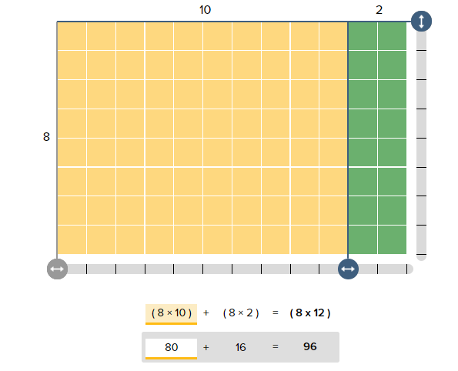
Breaking up factors, specifically by place value, is the basis of the traditional algorithm for multiplication. For example,
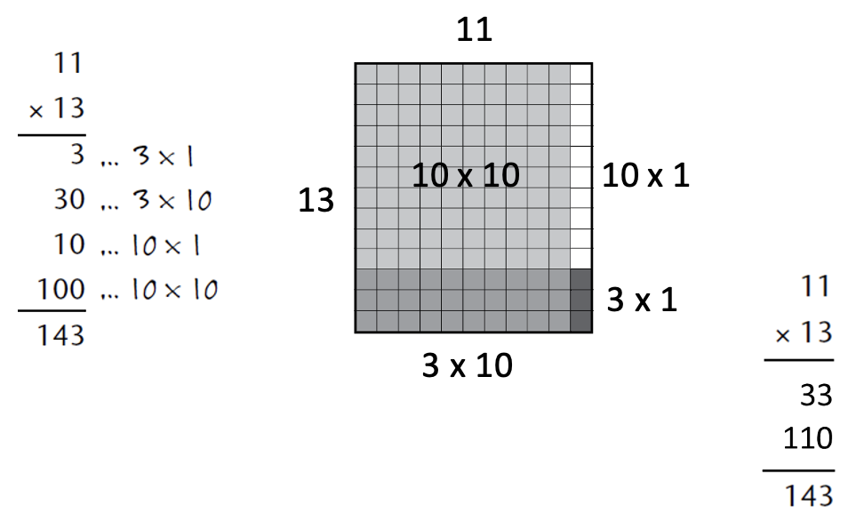
The traditional algorithm is a compressed version of what is shown above. The results of the first two multiplication steps are combined before they are written down, and the results of the third and fourth are also combined before they are written down, so that only two partial products are added in the final step.

Activities and Practice

Financial Literacy: small costs that add up
TSTM Skill: Critical Thinking
In-Person/Remote Activity
Uses Student Packet p. 45
- Explain that sometimes costs that seem small can add up to more than we expect when they are repeated a lot.
Note: Explain that the idiom “it adds up” means that the total is more than we might expect.
- Have students read the problem and answer any questions they have. Then give them time to work together to solve.
Jayla loves to get a coffee on her way to work. She pays about $3 for her favorite coffee drink. She does this 4 times a week.
How much does Jayla usually spend on coffee in a month?
- Debrief solutions, and highlight areas where multiplication was (or could be) used.
- Now explain that they found out that Jayla usually spends about $48 on coffee each month. How could multiplication be used to find out how much she spends on coffee in a year (12 months)? (48 $×$ 12 or 12 $×$ 48) Connect back to repeated addition.
- Give students time to solve for the total. Share different strategies. Highlight (or point out, if it doesn’t come up) that we don’t have to count all 12 months all at once. Sometimes we might want to break a multiplication problem into smaller parts, for example:
- finding the cost for 6 months and then doubling it
- finding the cost for 10 months, then adding two more
Demonstrate this by going back to the repeated addition expression and showing how the $48’s can be grouped to help find the total. They will be learning more about ways to break up a multiplication problem in this unit.
- Ask, Does the total amount for a year (~$576) surprise you? What other small costs that we pay frequently might “add up” over the course of a month or a year?

Warmup Routines
In-Person/Remote Activity
Uses downloadable files Number of the Day Template PowerPoint, Two Truths and a Lie PowerPoint, and Array of the Day PowerPoint
Continue alternating Routines 2 (Number of the Day) and 3 (Two Truths and a Lie) and 4 (Array of the Day) as warmups.

Opening Discussion
- Say, There are some multiplication facts that I find easier to remember than others. For example, I know 6 × 6 = 36, but I often forget 6 × 7. In my head, I think of six 6’s and add one more 6: 36 + 6 = 42. (Or give another example that is true for you).
- Ask, Does anyone else do this when you are multiplying? Have students offer examples.
- Explain that in this unit, students will be exploring the way that factors can be broken into smaller parts to make multiplication easier.

Breaking Up Arrays
In-Person/Remote Activity
Uses Student Packet, pp. 48–50
This activity illustrates the distributive property. For example, the first situation, (6 × 7), has been regrouped to show 6(5 + 2), or 6(5) + 6(2). Seven could have been regrouped as 6 + 1, 3 + 4, or some other combination totaling 7. Being able to break amounts apart makes it easier for problem solvers to use the math facts they know, which lessens the cognitive burden of mental math. If, for example, students don’t know the product of 6 × 7 but know their 5 facts, breaking the 7 into 5 + 2 allows them to do the multiplication mentally.
- In this inspection, ask students to work in pairs. Provide them with graph paper (included in Student Packet pp. 51–60 so that they can easily sketch the array.
- Encourage them to come up with different strategies for breaking apart numbers so that they can see that, no matter how the amount is separated, the total (product) is always the same.
- Be explicit in illustrating the distributive property; that is, no matter how 6 or 7 is divided, there is still distribution of amounts. For example, in 6 × (3 + 4) = 6(3) + 6(4), the operation of multiplication has to touch both parts of 7:3 and 4.
- This is a good place to define the words decompose and partial product.
decompose: to break down a number or shape into smaller parts
partial product: when we break the numbers into parts and multiply the parts separately

Math Inspection: Connecting Arrays to Multiplication
In-Person/Remote Activity
Uses Partial Products Finder (see link below)
- Use the Partial Products Finder (https://apps.mathlearningcenter.org/partial-product-finder/) to demonstrate different ways that an array can be broken up. Start with an array 5 × 9. Put the factors into the app and click “make”. Then ask for students to give examples of ways that the array could be “sliced”. You can drag the sliders on the bottom and right to break the array into parts. Show how the parts correspond to the expression below the array.
- Ask for other examples of ways they could break 5 × 9. Make sure to explore examples that work with groups of 5 and examples that work with groups of 9.
- Ask, Why might it be useful to break up a multiplication problem? (Sometimes you might know some but not all of your multiplication facts and can use what you know. For example, if someone doesn’t know 5 × 9, but does know 5 × 5 and 4 × 5, they can use what they know to solve for the larger product.)
- If you have devices that students can use in an in-person classroom, have students access the Partial Products Finder to explore multiplying larger numbers and breaking the array into parts. If devices are not available, students can use the grid paper provided in the Student Packet on p. 51–60.
- Provide options for numbers to multiply, so that students can self-differentiate:
12 × 8 17 × 9 12 × 18 24 × 13 45 × 32
- Discuss different ways of breaking up the different arrays and ask students which ways would make the multiplication easiest for them. For example, 17 × 9 could be broken up as (10 × 9) + (7 × 9), or as (17 × 5) + (17 × 4), but the first method of breaking might produce multiplication facts that are more easily known or calculated.
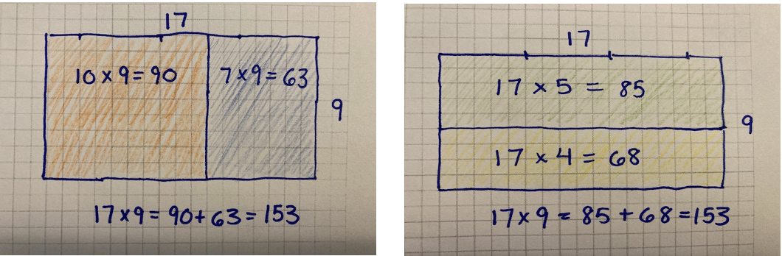
Students who choose to work with the examples of two-digit times two-digit numbers may explore breaking up both factors, or cutting the array into four partial products. For example, 24 × 13 could be broken into (20 × 10) + (20 × 3) + (4 × 10) + (4 × 3).

These correspond to the four partial products calculated in the traditional multiplication algorithm:
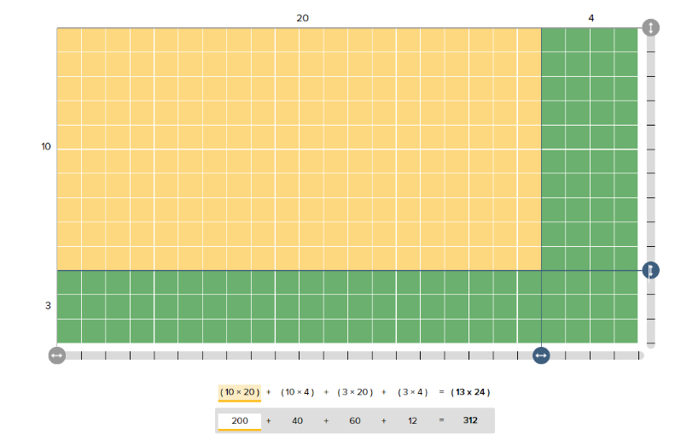
Note: The key idea in this activity is that the sub products calculated in the traditional multiplication algorithm are all visually represented as part of the total array. Make this connection visible. Check that students understand that the product of the two larger factors is equal to the number of squares in the array, and that the sum of the sub products or sub arrays is equal to the total product/array. The idea is not to change how students do multiplication, but to make sense of why it works the way it does.

Finding the Missing Factor
In-Person/Remote Activity
Uses Student Packet p. 61 or Partial Products Finder
Encourage students to use the Partial Products Finder or grid paper to find the missing factor, not simply to multiply. Highlight the patterns in the numbers and show how they relate to the arrays.

Performance Task: Graduation Seating
In-Person/Remote Activity
Uses Student Packet pp. 62–64
- Explain that they will be responsible for creating a seating arrangement for 60 people for an awards ceremony. Direct their attention to the room diagram. They should draw their arrangement on the diagram and write an expression that shows there are a total of 60 chairs. Remind students that they must think about spacing between rows, walkways, and exits. There are two versions of the room diagram, with and without gridlines. Students can choose which version to use.
- Based on the level of this class, having the chairs or diagram to scale is not critical. (For students who are ready for it, you can have them consider the size of the chairs and use the grid version to make the arrangement more realistic.) For all students, make sure students are paying attention to the arrangement and how they can reflect that in an expression (even if the scale is off).
- Read and discuss the rubric for the task before students get started.

Optional Language Support: Talking about Arrays
In-Person/Remote Activity
Uses Student Packet p. 65
This activity can provide a chance for students to practice using the language and vocabulary associated with arrays in writing (or speaking).

Vocabulary
decompose: to break down a number or shape into smaller parts
partial product: when we break the numbers into parts and multiply the parts separately

Things to Watch For

What size are my groups?
Rectangular arrays can be “sliced” in two ways. For example, the rectangle below has been broken into 3 groups of 5 and 4 groups of 5, which means the groups are all groups of 5. In this case, the factor of 7 has been broken into parts.
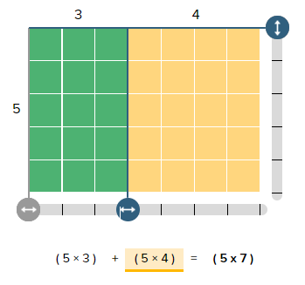
However, it could also be sliced horizontally, to make groups of 7. In that case, the factor of 5 has been broken into parts.
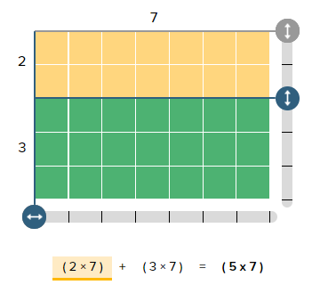
It can be easy for students to get lost in the symbols when they are only confronted with the symbolic representation of the Distributive Property. Keep drawing students’ attention to the connections between the arrays and the equations and pointing out which factor has been “broken” and which factor represents the size of the groups.

Unit 5: Application Project
Learning Objectives | CCRSAE
I can complete an invoice, using multiplication to find the total cost. | 3.OA.3
I can find equivalent expressions for an array.  (Array of the Day) | 3.OA.5
I can write expressions equal to a target number. (Number of the Day) | 5.OA.1–2, starting with simple expressions
I can decide if a math sentence is true or false.  (Two Truths and a Lie) | 1.OA.7, extended to multiplication

Standards for Mathematical Practice
MP.4 Model with mathematics
Students use simple formulas to calculate the total cost of items on an invoice in order to plan a party that fulfills certain requirements.
MP.5 Use appropriate tools strategically
Students must decide when it makes sense to use estimation, mental math, pencil and paper, calculators, or a spreadsheet to perform calculations.

Extra Resources for this Unit
- Downloadable file: BBQ Invoice Assignment Spreadsheet (optional)
- Downloadable file: Price Quantity PowerPoint
- Reproducible: Evaluation, Unit 5, Teacher’s Guide p. 57

Math Background
Shifting to representation
The use of multiplication in this context is less concrete than students saw in the previous units. When working with arrays, students could see every item represented, even though they were encouraged not to count the items one by one. When working with quantity and price, a visual representation will usually represent the quantity of discrete objects, with the price seen symbolically, like the image on the following page.
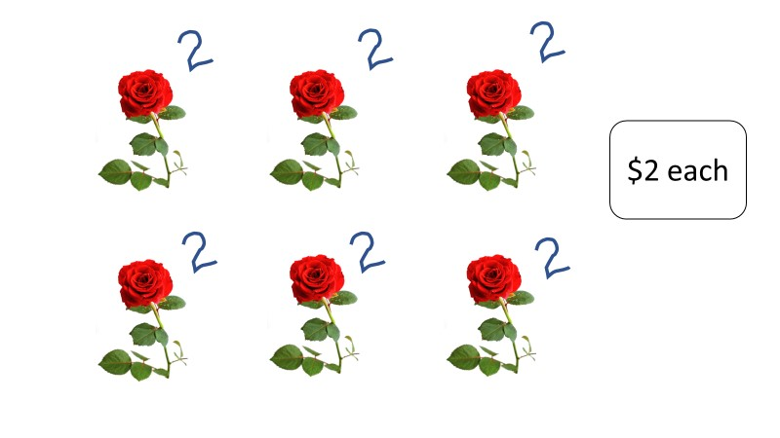
Draw students’ attention to the fact that they are adding equal groups (each item has the same price). The total could be calculated and represented by repeated addition, but multiplication gives us a more efficient way to perform and record these calculations.

Using appropriate tools strategically
Standard for Mathematical Practice 5 calls for students to be able to consider the tools they have available to solve a problem and to be strategic about choosing tools that make sense. In this application project, encourage students to consider what types of calculations they might make mentally, which would be best to do on paper, and for which calculations a calculator might be appropriate. Most adults would use a calculator or a spreadsheet to do at least some of the calculations involved in this type of task. Make sure students know how to use the calculator to perform multiplication and discuss how they could evaluate the reasonableness of their results.

Activities and Practice

Financial Literacy: Placing an Order

Teaching Skills That Matter (TSTM) Skill: Navigating Systems
In-Person/Remote Activity
Uses Student Packet p. 67
- Start the discussion by asking students if they ever have to place an order. In what situations: online, at a restaurant, etc.? Ask them how they place the order: over the phone, filling out a paper form, through an online process.
- Ask: If you were ordering office supplies for your workplace, what information would you need to know? What information would you need to provide to place the order?
- Define the words price, quantity, and total cost as they come up in the conversation.

Price/Quantity Slides
In-Person/Remote Activity
Uses Student Packet pp. 70–74 and downloadable file Price Quantity PowerPoint
- Demonstrate how the visual works by labelling each item with the price, then having students write an expression for the total cost.
- Draw connections (if students don’t already) between the repeated addition of the same price and multiplication. Have students complete the rest of the examples on their own or with a partner.
- Debrief, asking students to generalize: How can you use price and quantity to find the total cost? Push them to see that multiplying price times quantity (or quantity times price) will give the total cost.

Introduction to an Invoice
In-Person/Remote Activity
Uses Student Packet pp. 75–76
- Give students a minute look at the sample invoice. Ask: What do you notice? What do you wonder? Have them share their observations and questions.
- Write the three vocab words (price, quantity, total cost) on the board. Ask them where they think these labels should go and why. Make sure everyone has their invoice correctly labeled.
- On the next page, have students fill out the missing amounts in the invoice (they can choose the quantities, or you can provide them, if they need more structure). They will need to calculate the total cost for each type of item, as well as the grand total. Afterwards, discuss what tools they used to perform the calculations and why (mental math, paper and pencil, calculator)?
invoice: a list of everything that is being ordered. Includes the price, quantity, and total cost of all items.
price: the cost for one item
quantity: how many are being ordered
total cost: price times quantity equals the total cost

BBQ Invoice Project
In-Person/Remote Activity
Uses Student Packet pp. 77–78
Optional downloadable file: BBQ Invoice Assignment Spreadsheet (Some cells are locked so students don’t accidentally delete formulas. The password to unlock it is becalm)
- This project is best done in groups, if possible. Ask if any students have ever had to order catering for an event. How did they decide what to order?
- Discuss the scenario:
Your job is to plan a party for 10 people. Your total budget is $110. You don’t have to spend all of the money, but you can’t go over.
- Decide how many of each to order from the catering company and fill out the invoice.
- Encourage students to work in pencil and to use scrap paper, because they may have to try different amounts if their first order goes over budget.
Note: The budget is such that if they try to order 10 steaks, they will have no money left for drinks for the party. However, they also cannot afford to get beer/wine for everyone and still have enough money for ten dinners. It may not be a great idea to provide alcohol for only some of the guests!
- Before you turn students loose, explain that they can use a variety of tools to help them solve the task (mental math, pencil and paper, calculator). Have a short discussion about the advantages and disadvantages of each. Go over the rubric for evaluating their project.
Digital Literacy Option: If you have computers that can be used in the classroom, have pairs of students use the BBQ Invoice Assignment Spreadsheet to help them solve the problem. They can input quantities into the green cells, and the spreadsheet will perform calculations. There is still a good deal of reasoning to solve the problem, and it can be a good way to expose students to spreadsheets and the types of tasks they can be used for.

Optional Language Support: Talking about Price and Quantity
In-Person/Remote Activity
Uses Student Packet p. 79
This activity has a role play, which could be used in a variety of ways. Students could read the role play with a partner and could be encouraged to write their own with different prices and quantities. Emphasize the vocabulary and grammar in bold used to talk about unit prices:
10 notebooks at $3.99 each
3 boxes at $2.10 per box

Test Practice
In-Person/Remote Activity
Uses Student Packet, pp. 80–82
- b
- b
- c
- c

Vocabulary
invoice: a list of everything that is being ordered. Includes the price, quantity, and total cost of all items.
price: the cost for one item
quantity: how many are being ordered
total cost: price times quantity equals the total cost

Things to Watch For

Diagrams have changed
Some students may struggle with the change from the previous types of images in which the entire product was visible, as in an array. Encourage students to represent each item, and to label it with a price, so they can see that they are working with equal sized groups.

Choosing appropriate tools for multiplying
Generally, students who struggle with choosing appropriate tools lean too far in one of two directions: First you may have students who believe that they should rely exclusively on mental math, or on pencil and paper math, from some belief that the calculator is “cheating”. Emphasize that adults in mathematical careers and when performing mathematical calculations in their real lives often use calculators for calculations that may be tedious or time consuming, and this allows them to work more efficiently.
Other students may rely too exclusively on a calculator. Encourage them to think about ways that they can check the reasonableness of the results they get, such as estimation and mental math.

Name:___________________________ Date:__________________

Multiplication Concepts: Unit 1, Visual Patterns in Multiplication
Objective | Student Self-Evaluation  (Struggling, Learning, Mastery) | Teacher  Evaluation
I can identify factors and products.
I can see and describe visual patterns in factors and products.
I can break up a pattern into smaller parts. (Quick Images)
I can write expressions equal to a target number. (Number of the Day)
Name:___________________________ Date:__________________

Multiplication Concepts: Unit 2, Number Patterns in Multiplication
Objective | Student Self-Evaluation  (Struggling, Learning, Mastery) | Teacher  Evaluation
I can find number patterns in factors and products.
I understand that the equal sign means that the right and left side have the same value.
I can break up a pattern into smaller parts.(Quick Images)
I can write expressions equal to a target number.
(Number of the Day)
I can decide if a math sentence is true or false.
(Two Truths and a Lie)
Name:___________________________ Date:__________________

Multiplication Concepts: Unit 3, Equivalent Expressions
Objective | Student Self-Evaluation  (Struggling, Learning, Mastery) | Teacher  Evaluation
I can express repeated addition as multiplication.
I can use arrays to model multiplication expressions and scenarios.
I can find equivalent expressions for an array.
(Array of the Day)
I can write expressions equal to a target number.
(Number of the Day)
I can decide if a math sentence is true or false.
(Two Truths and a Lie)
Name:___________________________ Date:__________________

Multiplication Concepts: Unit 4, Breaking into Parts
Objective | Student Self-Evaluation  (Struggling, Learning, Mastery) | Teacher Evaluation
I can break multiplication problems into smaller parts with an array.
I can break multiplication into smaller parts with numbers.
I can find equivalent expressions for an array.
(Array of the Day)
I can write expressions equal to a target number.
(Number of the Day)
I can decide if a math sentence is true or false.
(Two Truths and a Lie)
Name:___________________________ Date:__________________

Multiplication Concepts: Unit 5, Application Project
Objective | Student Self-Evaluation  (Struggling, Learning, Mastery) | Teacher Evaluation
I can complete an invoice, using multiplication to find the total cost.
I can find equivalent expressions for an array.
(Array of the Day)
I can write expressions equal to a target number.
(Number of the Day)
I can decide if a math sentence is true or false.
(Two Truths and a Lie)

Visual Numbers

Push/Support Cards for Visual Numbers
How many dots are in each picture?  Is there a pattern? | How many dots are in each picture?  Is there a pattern?
Are there any patterns or shapes that you notice showing up over and over again? | Are there any patterns or shapes that you notice showing up over and over again?
Find two different pictures that look similar in some way.  What is similar  about them? | Find two different pictures that look similar in some way.  What is similar  about them?

Array Cards (1 of 6)

Array Cards (2 of 6)

Array Cards (3 of 6)

Array Cards (4 of 6)

Array Cards (5 of 6)

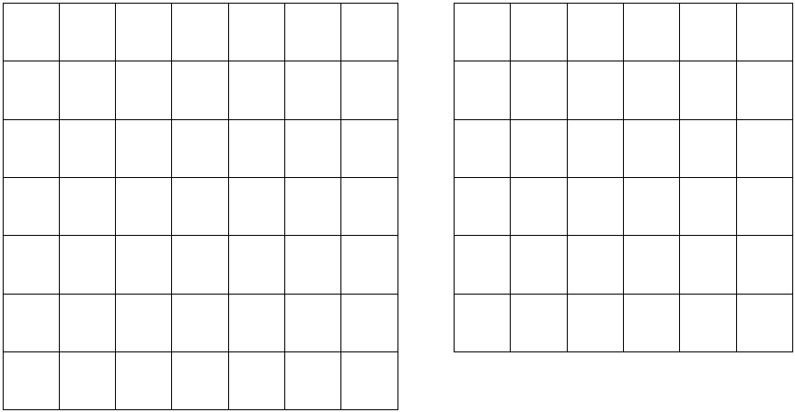
Array Cards (6 of 6)
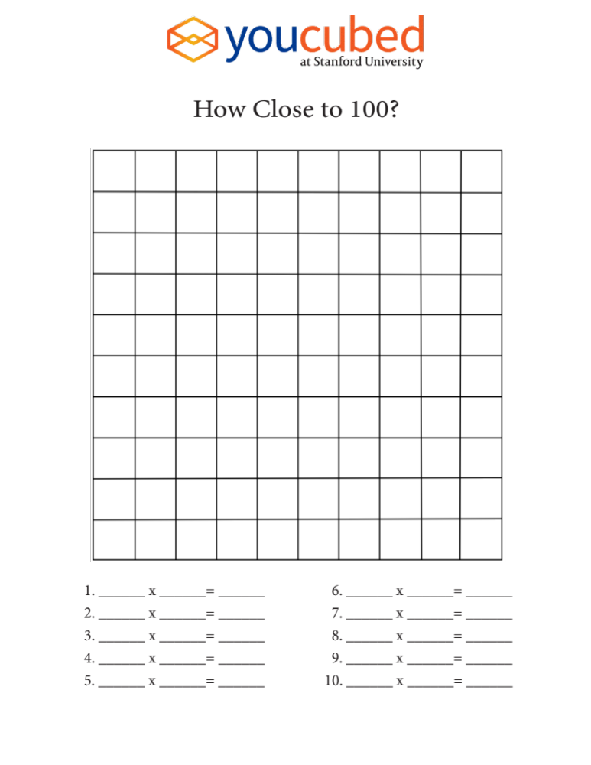
Activity images by Jo Boaler/YouCubed. Licensed under CC BY 4.0.
https://youcubed2.wpenginepowered.com/wp-content/uploads/2017/03/How-close-to-100-handout.pdf

Multiplication Table (grid)

x | 1 | 2 | 3 | 4 | 5 | 6 | 7 | 8 | 9 | 10
1 | 1 | 2 | 3 | 4 | 5 | 6 | 7 | 8 | 9 | 10
2 | 2 | 4 | 6 | 8 | 10 | 12 | 14 | 16 | 18 | 20
3 | 3 | 6 | 9 | 12 | 15 | 18 | 21 | 24 | 27 | 30
4 | 4 | 8 | 12 | 16 | 20 | 24 | 28 | 32 | 36 | 40
5 | 5 | 10 | 15 | 20 | 25 | 30 | 35 | 40 | 45 | 50
6 | 6 | 12 | 18 | 24 | 30 | 36 | 42 | 48 | 54 | 60
7 | 7 | 14 | 21 | 28 | 35 | 42 | 49 | 56 | 63 | 70
8 | 8 | 16 | 24 | 32 | 40 | 48 | 56 | 64 | 72 | 80
9 | 9 | 18 | 27 | 36 | 45 | 54 | 63 | 72 | 81 | 90
10 | 10 | 20 | 30 | 40 | 50 | 60 | 70 | 80 | 90 | 100

