
Multiplication Concepts
Beginning Curriculum for Adults Learning Math

STUDENT PACKET



Acknowledgements
The titles in the BeCALM series were developed and piloted in the classroom by Melissa Braaten for the SABES Mathematics and Adult Numeracy Curriculum & Instruction PD Team, with contributions from Yvonne Readdy, Emily Rudd, and Sherry Soares.
The BeCALM series includes four sequential packets:
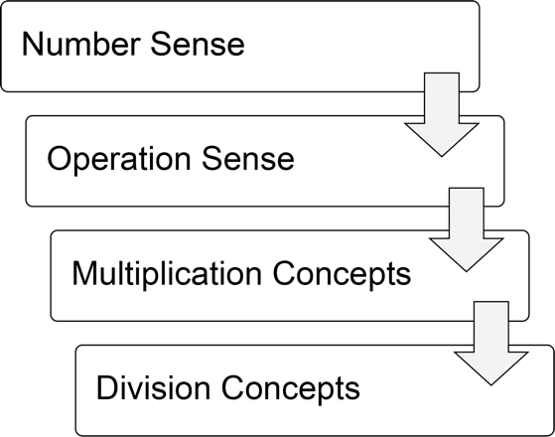
and three non-sequential packets:
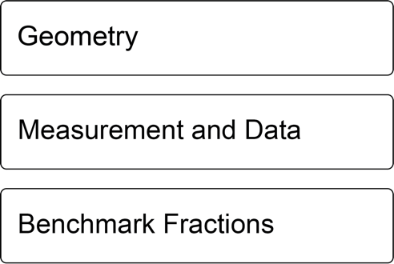
The following activities are adapted from Investigations Grade 3: Curriculum Unit: "THINGS THAT COME IN GROUPS" © 1998 by Savvas Learning Company LLC, or its affiliates. Used by permission. All Rights Reserved.
Page 4 “Things That Come in Groups”
Page 8 “Arrays That Total 36”

The “Visual Numbers” activity on page 7 is by Jo Boaler/YouCubed. Licensed under CC BY 4.0.

Activities from the EMPower™ and EMPower Plus™ series title Everyday Number Sense: Mental Math and Visual Models Student Book are used and/or adapted with permission from the author, TERC, Inc.

UNIT 1: Visual Patterns in Multiplication

Financial Literacy:

Beliefs and Attitudes about Money

From my culture

From my family

My personal beliefs and attitudes about money

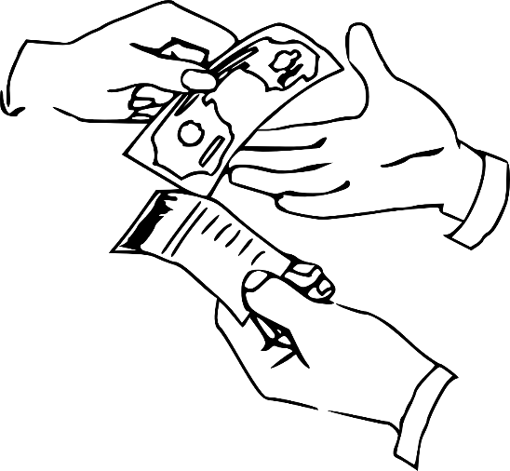

Things That Come in Groups
We often want to count items in groups, rather than one by one. Multiplication is a way to count things in equal sized groups.
Shoes and socks are sold in pairs (groups of 2), tires may be sold in groups of 4, and eggs are often sold in groups of 12 (a dozen). Do you buy drinks that come in six-packs? What can you think of that is usually sold in groups of a certain size?
There are also “groups” that are not physical objects. We create ten- and twenty-dollar bills so we can count money more easily. We make groups out of measurements, such as grouping 7 days into a week, 60 seconds into a minute, or 12 inches into a foot.
Brainstorm below some other groups you encounter in your daily life.
Groups of 5 | Groups of 10 | Groups of 100
Example: fingers on a hand | Example: years in a decade
Groups of ___ | Groups of ___ | Groups of ___

Vocabulary List for This Unit
Word | Definition | Example
array | something arranged in __________ and __________ | 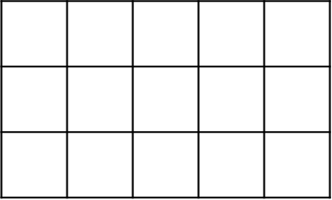
row | arranged in a line, ______________ (horizontal) | 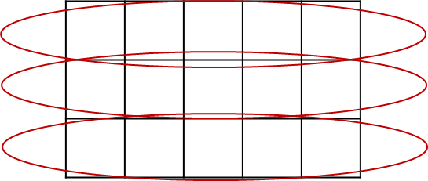
column | arranged in a line, ________________ (vertical) | 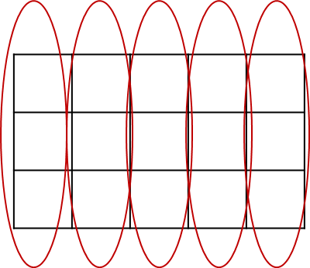
factor | a number that is being _______________ | 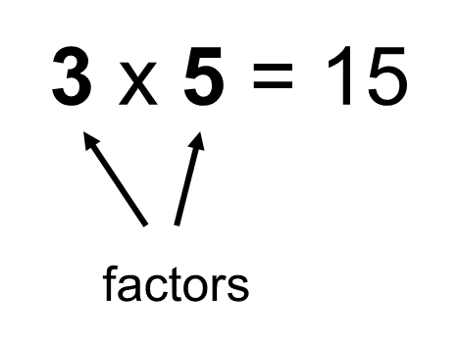

Word | Definition | Example
product | the ____________ of multiplying | 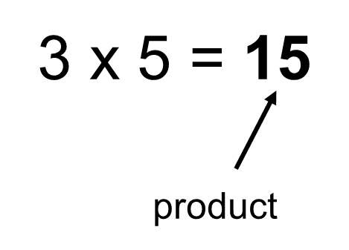

Visual Numbers
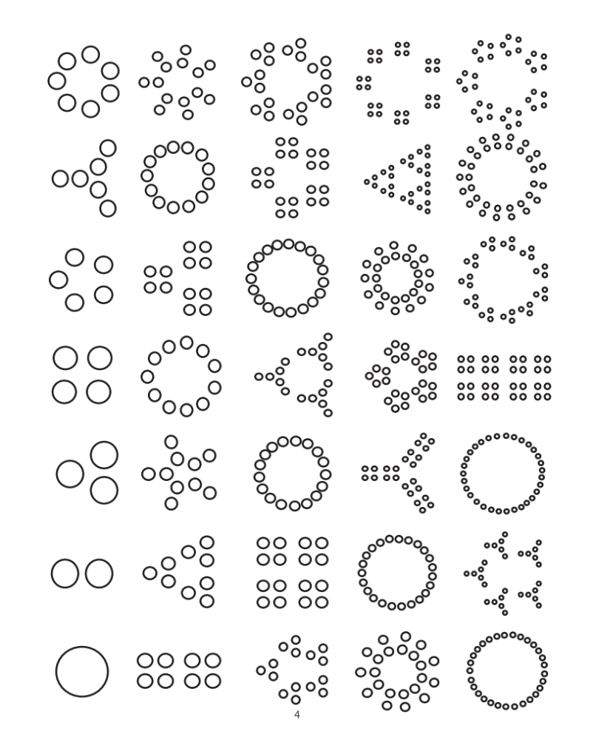

Arrays That Total 36
Here are five arrays for 36.
- Label the dimensions of each array.
- Write a multiplication sentence for each array.

- List all the factors of 36 here:

- Explain how you did one of these problems.


Talking About Groups
5 groups of 3

number of groups size of the group

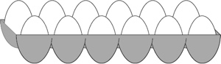
______ groups of ______
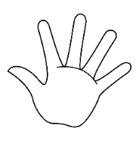
______groups of ______

Draw “3 groups of 2” | Draw “2 groups of 4”

Talking About Multiplication

3 x 6 = 18
“equals”
“is”
“is equal to”
“times”
“multiplied by”
“groups of”

Examples:

3 times 6 equals 18.
3 multiplied by 6 is 18.
3 groups of 6 is equal to 18.

3 x 6 = 18
product
factors

Examples:

18 is the product of 3 and 6.
3 and 6 are factors of 18.
Other factors of 18 are 1, 2, 9, and 18.

Exit Ticket/Homework
Choose one of the options below.

Choice 1: Find a number for which you can draw at least three different arrays. Sketch them below.

Choice 2: Find the number under 50 that has the most arrays. Explain how you know with words, pictures, or equations.

UNIT 2: Number Patterns in Multiplication

Financial Literacy: Costs That Repeat

Subscription and membership fees:

Examples:

Payment plans:

Examples:

Products that are consumed:

Examples:

Other costs that repeat:


Fatima pays $12 per month for internet in her home.

How much does she pay for 6 months of internet?
Show your thinking below.

For the examples below, write an addition expression and a multiplication expression that could be used to find the total cost.
Example: Gym Membership: $30 per month for 6 months

Using repeated addition
Using multiplication

30 + 30 + 30 + 30 + 30 + 30
30 x 6


- Video Streaming Service: $8 per month for 12 months (1 year)

Using repeated addition
Using multiplication


- Car Payments: $120 per month for 3 months

Using repeated addition
Using multiplication


- Prescription Medications: $15 per month for 4 months

Using repeated addition
Using multiplication

Vocabulary List for This Unit
Word | Definition | Example
expression | a mathematical ___________.  It can contain numbers, variables, and operations (addition, subtraction, multiplication, division), but there is no ____________. | 4 + 5  123  4 x 6 + 2 - 10
equation | a mathematical ____________. It contains an “=” symbol between two expressions that have the same ___________ | 4 + 5 = 9  1 + 2 = 5 – 2  10 = 5 + 5  2 x 3 = 3 + 3
equal sign | the symbol "=", which means that the left side and the right side have the same __________

Word | Definition | Example

Multiplication Table (grid)

x | 1 | 2 | 3 | 4 | 5 | 6 | 7 | 8 | 9 | 10
1 | 1 | 2 | 3 | 4 | 5 | 6 | 7 | 8 | 9 | 10
2 | 2 | 4 | 6 | 8 | 10 | 12 | 14 | 16 | 18 | 20
3 | 3 | 6 | 9 | 12 | 15 | 18 | 21 | 24 | 27 | 30
4 | 4 | 8 | 12 | 16 | 20 | 24 | 28 | 32 | 36 | 40
5 | 5 | 10 | 15 | 20 | 25 | 30 | 35 | 40 | 45 | 50
6 | 6 | 12 | 18 | 24 | 30 | 36 | 42 | 48 | 54 | 60
7 | 7 | 14 | 21 | 28 | 35 | 42 | 49 | 56 | 63 | 70
8 | 8 | 16 | 24 | 32 | 40 | 48 | 56 | 64 | 72 | 80
9 | 9 | 18 | 27 | 36 | 45 | 54 | 63 | 72 | 81 | 90
10 | 10 | 20 | 30 | 40 | 50 | 60 | 70 | 80 | 90 | 100

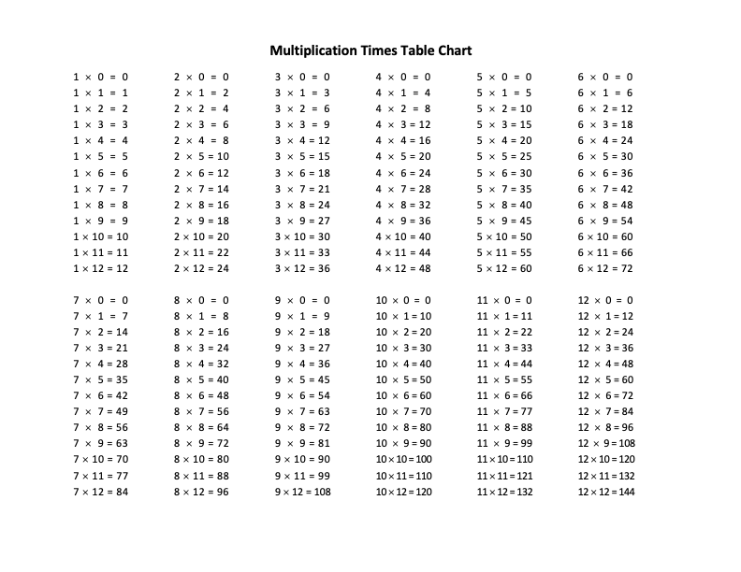

Patterns I See in the Multiplication Table

Describe a pattern that you see.
Useful words:
odd/even ones place tens place multiples of

____________________________________________________________________________________________________________________________________________________________________________________________________________________________________________________________________________________________________________

Describe another pattern that you see.
Useful words:
odd/even ones place tens place multiples of

____________________________________________________________________________________________________________________________________________________________________________________________________________________________________________________________________________________________________________

Equations
These are equations.

2 × 3 = 6 6 = 2 + 2 + 2
6 × 1 = 3 x 2 2 × 3 = 3 + 3

What do they have in common?

What is different? Do any of them surprise you?

What Is an Equation?
An equation is a math sentence. It says that both sides of the equal sign have the same value.

5 + 5 = 3 + 7

This has a value of 10. This has a value of 10.

Equations can look like this, with a single number on one side:

2 × 3 = 6 6 = 2 + 2 + 2

or like this, with operations on both sides:

6 × 1 = 3 × 2 2 × 3 = 3 + 3

All of these are true equations, since both sides of the equal sign have the same value.

Two Truths and a Lie
Two of these statements are true, and one is false.
Can you find the lie?

- 4 + 4 + 4 = 3 + 3 + 3 + 3
- 5 × 3 = 15 – 5
- 2 × 3 = 2 + 2 + 2

Two of these statements are true, and one is false.
Can you find the lie?

- 10 + 0 = 5 × 2
- 6 + 6 + 6 = 6 × 3
- 4 × 6 = 24 + 2

Talking About Multiplication

There are 4 groups of 6.
4 and 6 are factors.
24 is the product.

Length: 6

Width: 4

The length is 6. The width is 4.
This rectangle is 6 by 4.
The area of the rectangle is 24.

Practice describing each array using the language of rectangles.

A)

The length is _____. The width is ____.
This rectangle is ____ by ____.
The area of this rectangle is _____.

B)

The length is _____. The width is ____.
This rectangle is ____ by ____.
The area of this rectangle is _____.

Exit Ticket/Homework
Create your own two truths and a lie below.
Two of the equations must be true, one must be false.

UNIT 3: Equivalent Expressions


Financial Literacy: One-Time Purchase or Subscription?
Jean-Pierre just bought a new computer. He wants to be able to create documents on it using a word processing program.
He has two choices:
- He can buy the program and download it on his computer for $160. (One time purchase)
- He can pay for a subscription that allows him to use the program. This costs $50 per year. (Subscription)

One time Purchase ($160)

Pros
Cons

Subscription ($50 per year)

Pros
Cons

Vocabulary List for This Unit
Word | Definition | Example
equivalent expressions | two expressions that look __________ but actually have the same __________. |   2 x 4 + 1  4 + 5  8 + 1  1 + 4 + 4

Word | Definition | Example

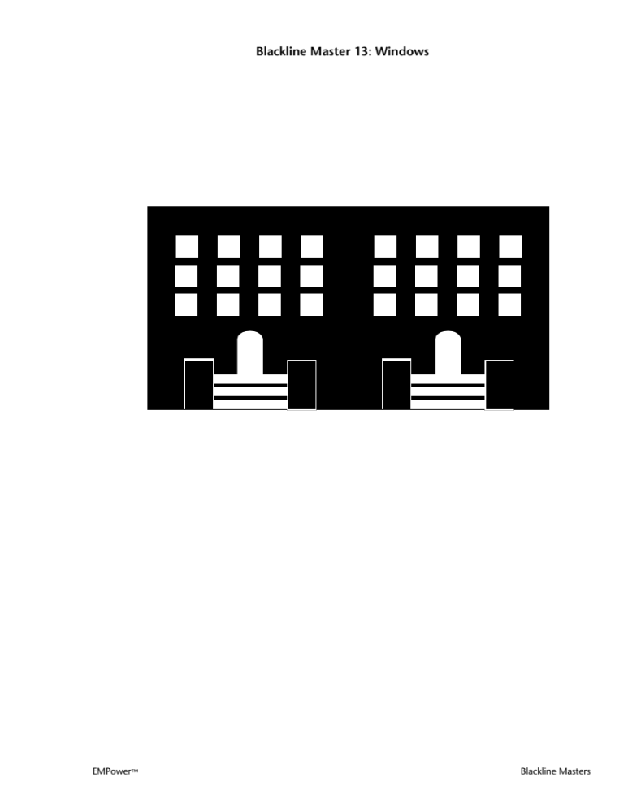
Windows

Source: EMPower™ book Everyday Number Sense: Mental Math and Visual Models

Pictures and Numbers
Choose one picture from this page and one from the next page. For each, find the total number of objects in the picture, but don’t count one by one. Write down two or more ways to find the total.

- Soda Cans

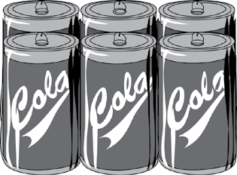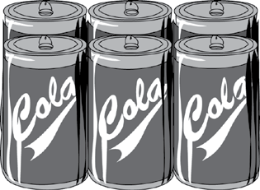

- Fingers



- Heads
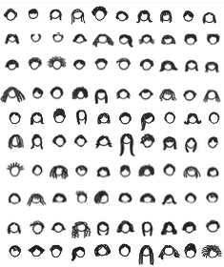

Reprinted with permission of World Education

- Stamps
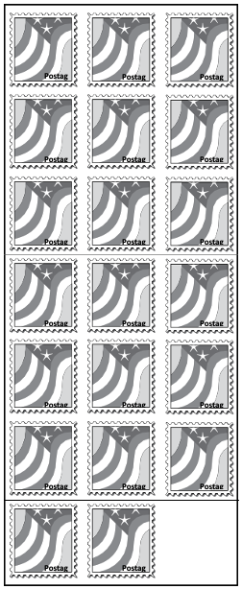
- Chocolates

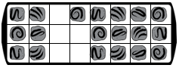

Source: EMPower™ book Everyday Number Sense: Mental Math and Visual Models

Counting Smart
Take a handful of paper clips, pennies, or tiles. Arrange them as arrays so you can see how many there are without counting each one.

- Sketch your arrangement using columns and rows.

- Write an equation that shows how you can find the total amount without counting each item.

- Sketch another arrangement. If you did not try arranging by 10’s, try that now.

- Write an expression that shows how you found the total amount without counting each item.

Source: EMPower™ book Everyday Number Sense: Mental Math and Visual Models

Garden Pathway
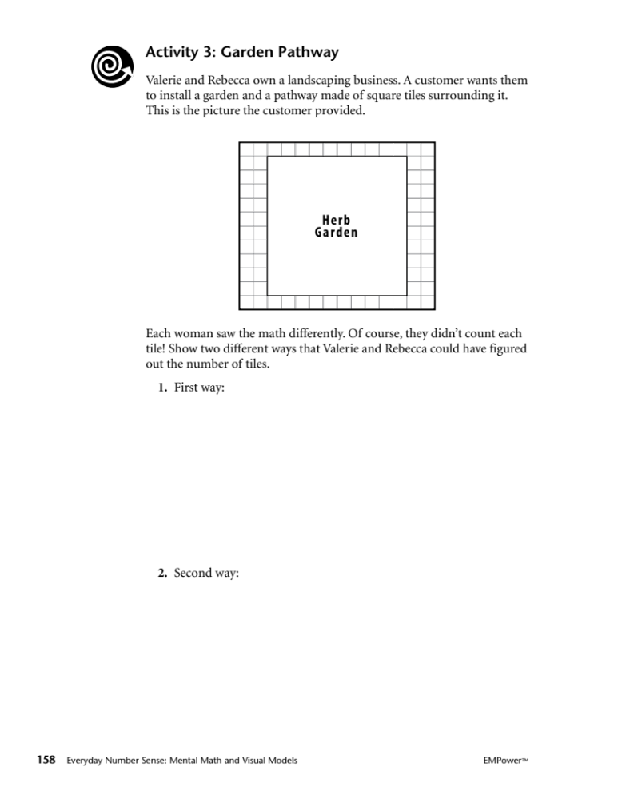
Valerie and Rebecca own a landscaping business. A customer wants them to install a garden and a pathway made of square tiles surrounding it. This is the picture the customer provided.

Each woman saw the math differently. Of course, they didn’t count each tile! Show two different ways that Valerie and Rebecca could have figured out the number of tiles.

- First way:

- Second way:

Source: EMPower™ book Everyday Number Sense: Mental Math and Visual Models

Expressions, Arrays, and Stories

Part 1

Circle the expressions that do not match the picture.
Reminder: Parentheses indicate multiplication or tell you to do the operation inside them first.

- 10 + 10 + 3 3 × 3 + 10 10 × 2 + 3 3 + 2(10)


- 3 × 10 + 7 10 + 10 + 10 + 7 3(10 + 3) 4 × 7 – 3
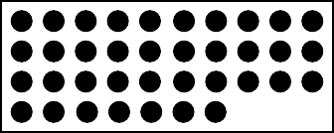

- 5 + 5 + 5 + 5 + 5 5(5) 5 × 5 + 5 + 5 + 5 5²


Part 2

Match each story to one of the pictures in Part 1.

- Zippy and four friends combine their money. Each person gives the same amount, $5.
Array

- Zippy and two friends want to buy a gift for their teacher. The two friends can spend $10 each. Zippy has $3.
Array

- Zippy and three friends order take-out. Everybody chips in $10 but Zippy. He is $3 short.
Array

Source: EMPower™ book Everyday Number Sense: Mental Math and Visual Models

How Do You See It?
For each picture below, give the total number of shapes or coins, without counting one by one.
- Circle the groups you see in each picture as you figure out the total. Write two expressions that describe what you see.
a.

Expression 1: _____________ Expression 2: _____________

b.


LIBERTY LIBERTY LIBERTY LIBERTY LIBERTY

2003 2003 2003 2003 2003
D D D D D

LIBERTY LIBERTY LIBERTY LIBERTY LIBERTY

2003 2003 2003 2003 2003
D D D D D

LIBERTY LIBERTY LIBERTY LIBERTY LIBERTY

2003 2003 2003 2003 2003
D D D D D

LIBERTY LIBERTY LIBERTY LIBERTY LIBERTY

2003 2003 2003 2003 2003
D D D D D

LIBERTY LIBERTY LIBERTY

2003 2003 2003
D D D

Expression 1: _____________ Expression 2: _____________

c.

Expression 1: _____________ Expression 2: _____________

- Show with words or an expression how you found the total number of tiles.
a.

Words/Expression:

b. Show with words or an expression how you could find the total another way.

Source: EMPower™ book Everyday Number Sense: Mental Math and Visual Models

Language for Sharing Your Thinking

The way I see it is…
I see ___ groups of ___ .
Another way to see it is…
My expression is…
My strategy was to…
I think they saw it this way…
One thing I tried that didn’t work…
I am wondering…
I noticed that…
I am confused about…

Exit Ticket/Homework: Cartons of Eggs


- Without counting each egg, how many do you see?

- How did you think of your answer?

- List with words and numbers each step you took mentally or on paper to find the total.

- Write another expression to show how you could count the eggs.

Source: EMPower™ book Everyday Number Sense: Mental Math and Visual Models

Test Practice Problems
- Which of the following expressions might be used to count the cookies on the tray?
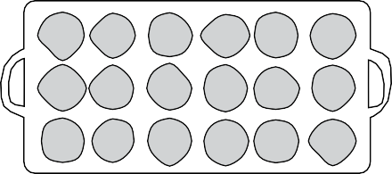
A. 6+ 6+ 6 B. 6 × 3 C. 6 × 6

  - A only
  - B only
  - C only
  - A and B
  - A and C

- Select the expression that is not equivalent to the rest of the expressions.
  - 36 + 4(5)
  - 4(9) + 20
  - 3(12) + 20
  - 4(9) + 4(6)
  - 2(18) + 2(10)

- The mayor wants all of the front windows on the city’s eight libraries to be cleaned. Charlie’s Windows charges $6 per window for cleaning. Which of the following expressions shows how much Charlie’s Windows will charge the city?



  - 6(3 × 4)
  - 6 + (3 × 4)8
  - 8(12 + 6)
  - 6(4 × 12)
  - 6(3 × 4 × 8)

- Lois enters a party room and sees people sitting at round tables. Eight people are seated at each of 12 tables and five people at each of two other tables. How many people does Lois see?

Source: EMPower™ book Everyday Number Sense: Mental Math and Visual Models

UNIT 4: Breaking into Parts


Financial Literacy: Small Costs That Add Up
- Jayla loves to get a coffee on her way to work. She pays about $3 for her favorite coffee drink. She does this 4 times per week.
How much does Jayla usually spend on coffee in a month?

- Jayla usually spends about ________ on coffee in a month.
Write an addition expression and a multiplication expression for how much she would spend on coffee in 12 months (1 year).

Addition Expression | Multiplication Expression

- Solve for the total, using a strategy that makes sense to you.

Vocabulary List for This Unit
Word | Definition | Example
decompose | to _______________ a number or shape into smaller parts | 7 = 5 + 2  7 = 6 + 1  7 = 3 + 4  7 can be decomposed different ways
partial product | when we break numbers into parts and multiply the parts __________________ | 7 = 5 + 2  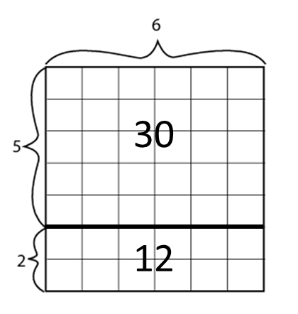  7 x 6  (5 + 2) x 6  5 x 6 + 2 x 6  30 and 12 are partial products

Word | Definition | Example

Breaking Up Arrays

One way to show multiplication is with a rectangular array.

- Look at this example:
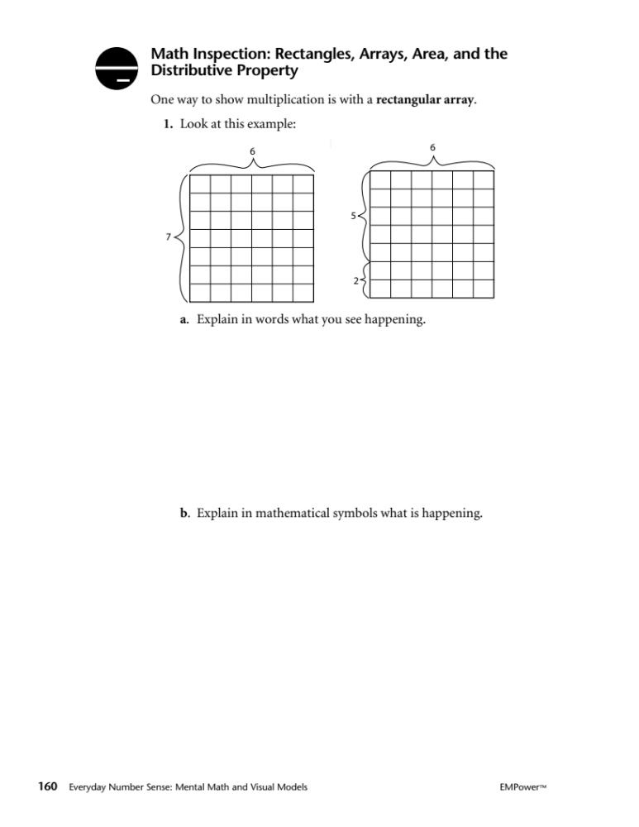

- Explain in words what you see happening.

- Explain in mathematical symbols what is happening.

- Below is an 8 × 9 array.
- Break it up into a new multiplication problem.

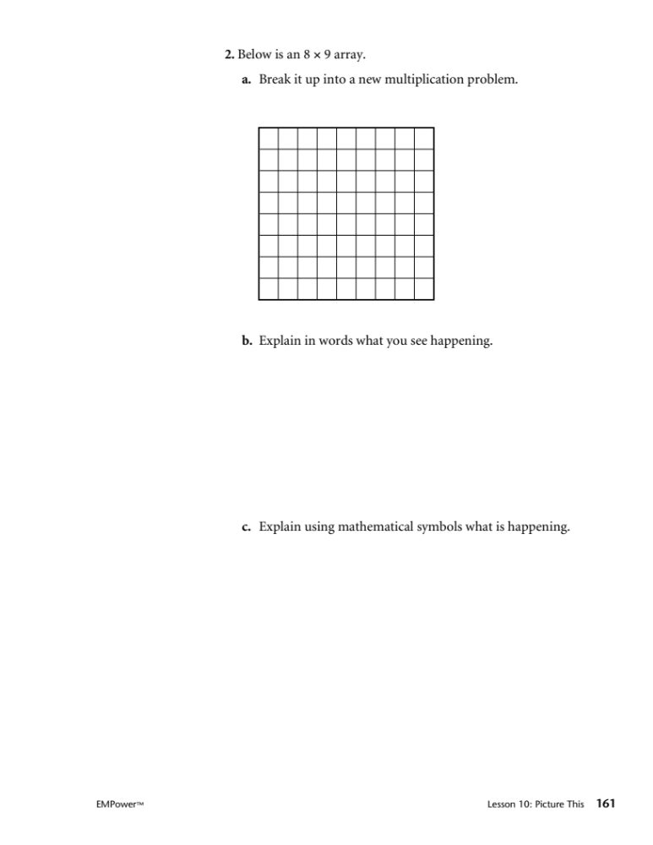

- Explain in words what you see happening.

- Explain using mathematical symbols what is happening.

- Below is a 5 × 12 array.
- Break it up into a new multiplication problem.

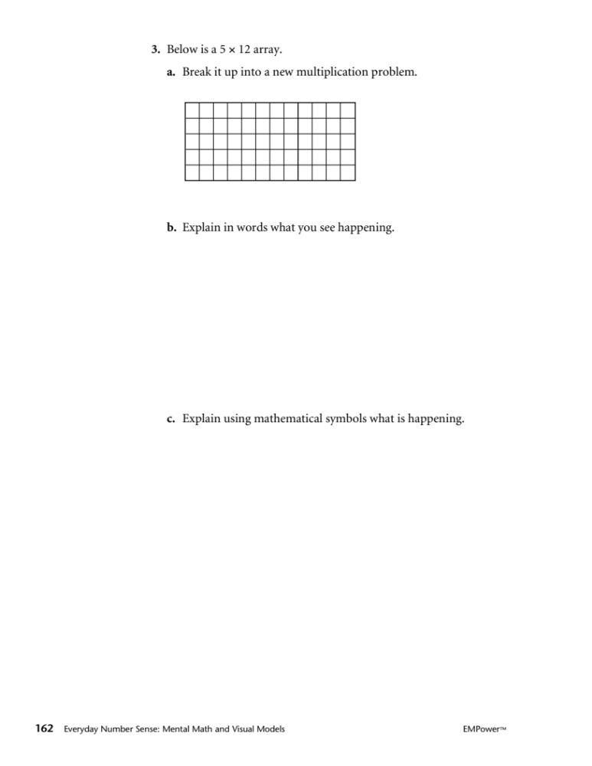

- Explain in words what you see happening.

- Explain using mathematical symbols what is happening.

Source: EMPower™ book Everyday Number Sense: Mental Math and Visual Models



Finding Missing Factors
Use the Partial Products Finder or grid paper to help you find the missing number.
- 6 × 7 = 6 × 4 + 6 × ___
- 9 × 8 = ___ × 8 + 4 × 8
- ___ × 7 = 2 × 7 + 5 × 7
- 6 × 7 = 5 × 7 + ___ × 7
- 7 × ___ = 5 × 6 + 2 × 6
- 9 × 9 = 5 × 9 + ___ × 9
- 8 × 7 = ___ × 7 + 5 × 7

Performance Task: Graduation Seating
- Design an arrangement for 60 chairs in the space available.
- Mark where you will put the chairs on the diagram provided (you can use the side with the grid or the blank side.)
- Write an expression that represents your array and show how it is equal to 60.

Things to consider:
- Everyone must be able to see the podium.
- Graduates need to be able to process in from the door to the podium.
- 15 chairs are for the graduates; think about where you want them to sit.

Rubric
Criteria | Outstanding | Good | Needs Support
Real world considerations | The plan takes all real world considerations into account: everyone can see the podium and graduates and others can easily get in and out. | The plan takes some of these considerations into account, but one or more issues may come up if this was really carried out. | The plan is not realistic and has multiple problems.
Math Expression | The math expression is accurate, uses algebraic notation (parentheses for multiplication), and clearly reflects the way that the chairs are arranged. | The math expression is accurate, but uses arithmetic notation and does not clearly reflect the arrangement. | The math expression is inaccurate or uses notation incorrectly.

Community Room
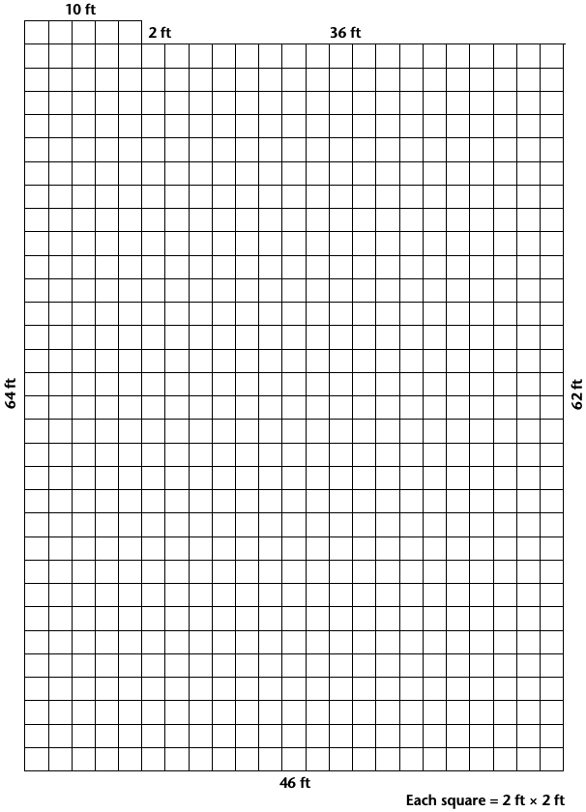

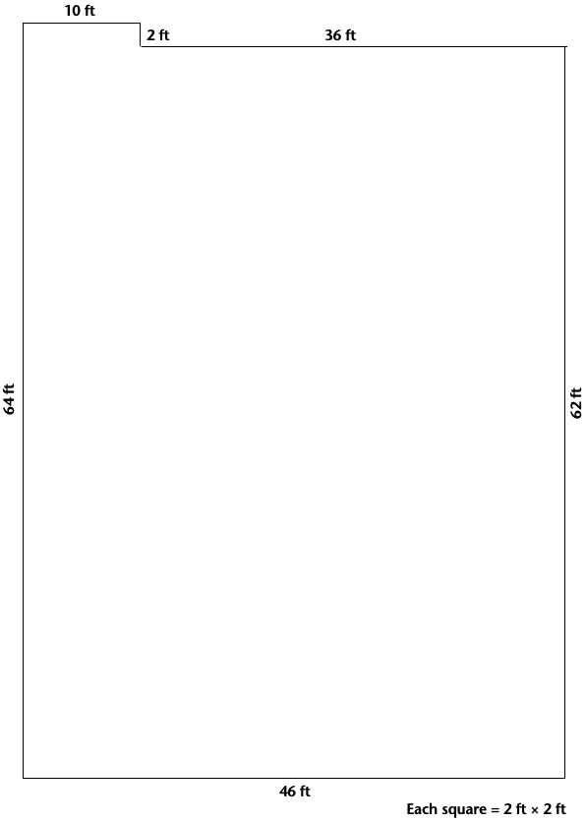

Talking about Arrays

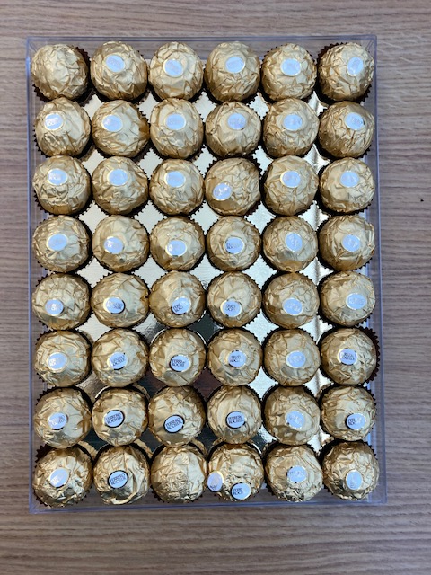

Write three sentences to describe the array of chocolates above.

Useful words:

rows columns ___ groups of ___

factors product equation

UNIT 5: Application Project


Financial Literacy: Placing an Order
Discussion questions:
When have you had to place an order?

How have you placed an order?
- On paper
- Over the phone
- Online

If you were ordering office supplies for your workplace, what information would you need to know?

Vocabulary List for This Unit
Word | Definition | Example
invoice | a _______ of everything that is being __________.  Includes the price, quantity, and total cost of all items.
price | the cost for ______ item | Staplers $7.00 each
quantity | ___________ are being ordered | 4 staplers ordered
total cost | price _________ quantity equals the total cost | $7.00 x 4 = $28.00

Word | Definition | Example

Price/Quantity Slides

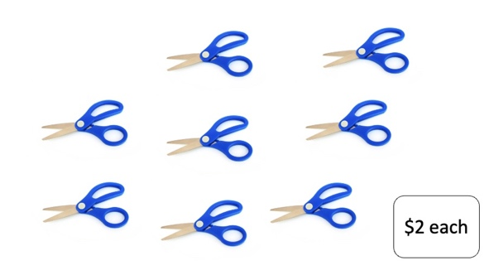
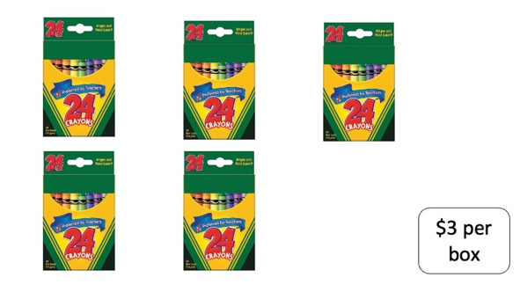

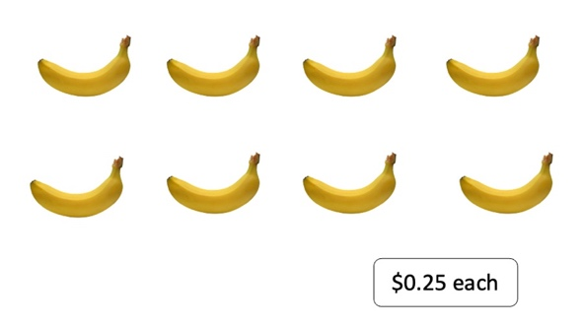

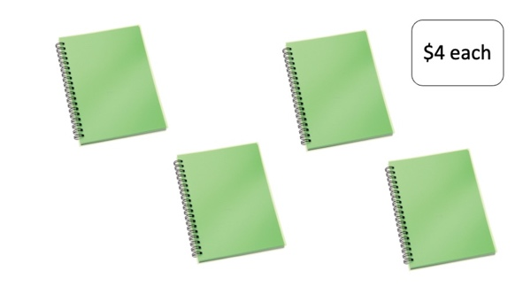

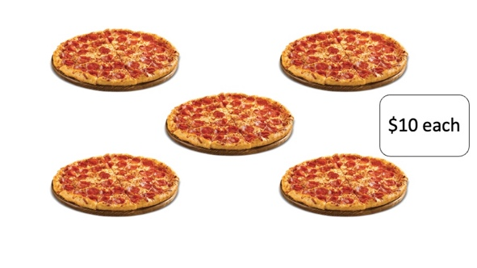

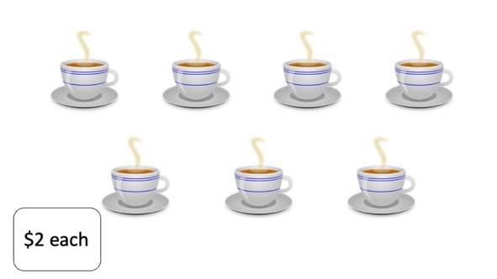

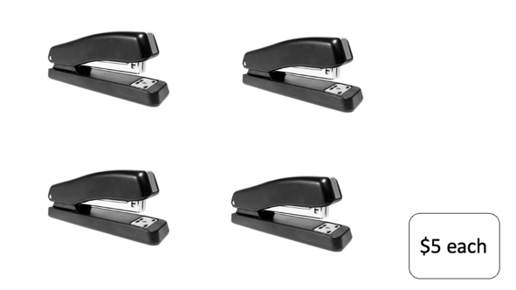

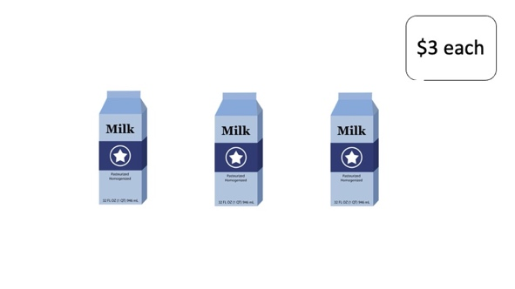

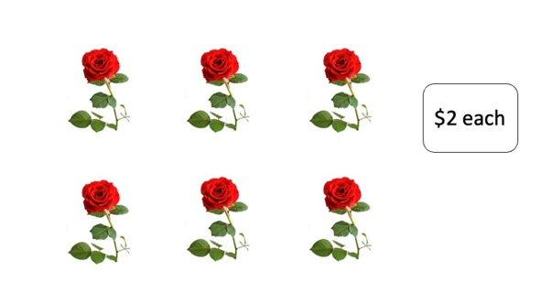

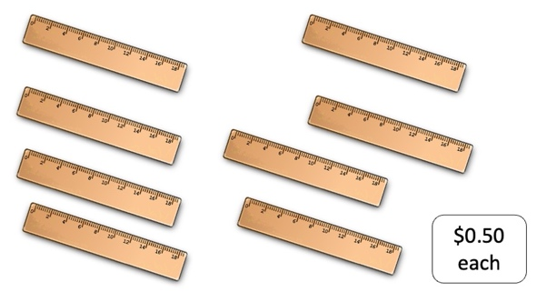

Introduction to an Invoice

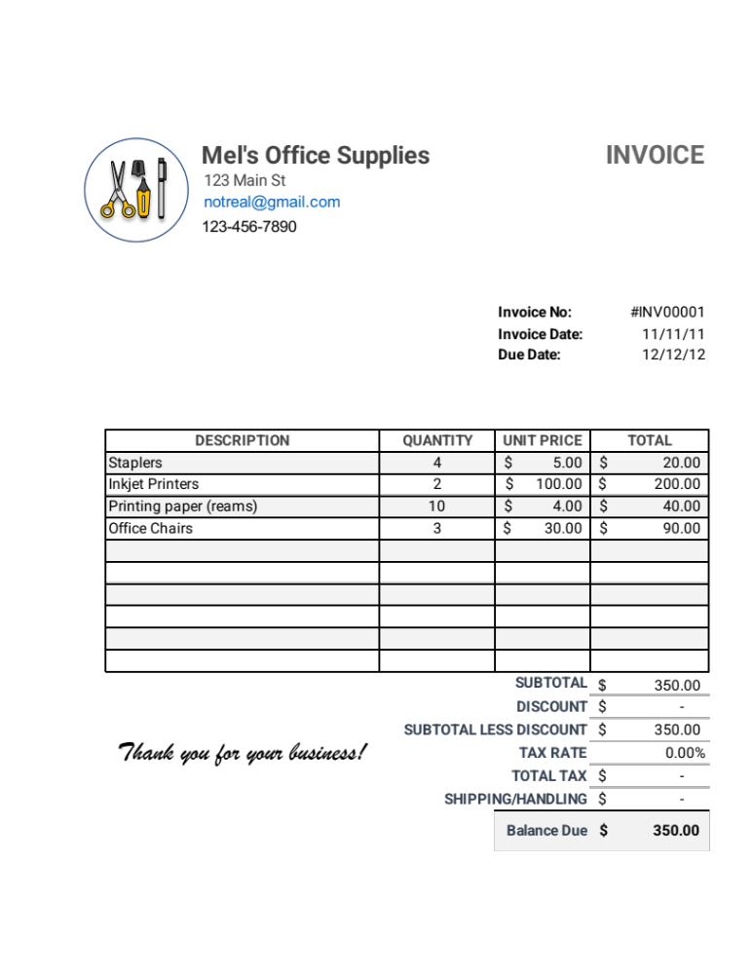
Introduction to an Invoice (practice)
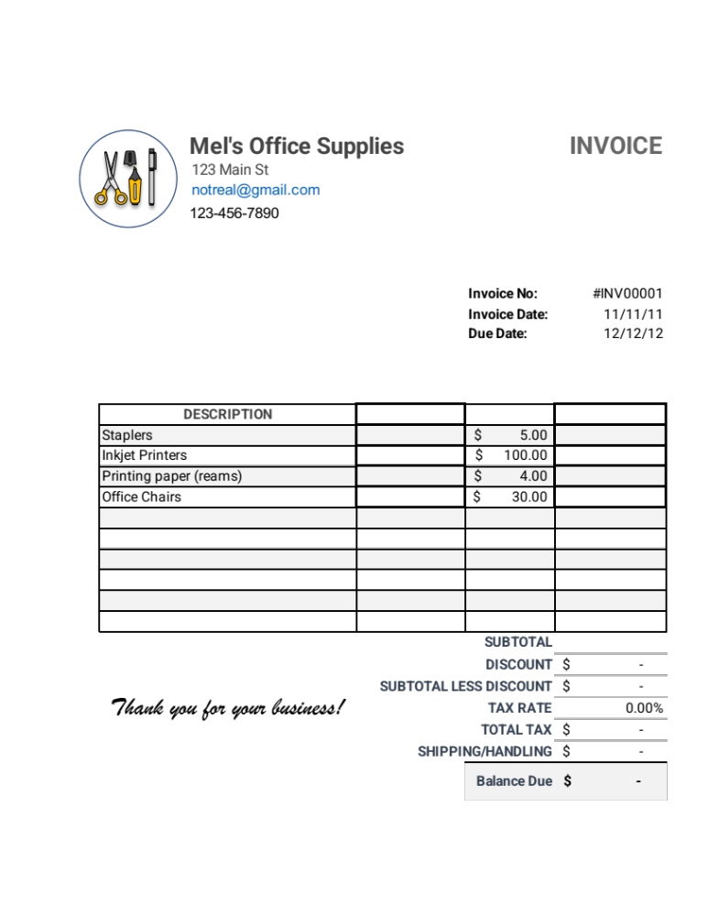
BBQ Invoice Project
Your job is to plan a party for 10 people. Your total budget is $110. You don’t have to spend all of the money, but you can’t go over.
Decide how many of each to order from the catering company and fill out the invoice.
Catering | Quantity | Price | Total Cost
Roast chicken  (per person) |  | $9.00
Veggie burger  (per person) |  | $7.00
Steak (per person) |  | $11.00
Unlimited soda  (per person) |  | $1.00
2 drinks, beer/wine  (per person) |  | $5.00
Grand total

Rubric for BBQ Project
Criteria | Outstanding | Good | Needs Support
Real world considerations | The invoice fits the budget and provides food and drink for all guests in a realistic way. | The invoice fits the budget and provides food for all guests. | The invoice is over budget and/or does not provide enough food for all guests.
Strategic Use of Tools | Mental math, paper and pencil, and calculators are all used strategically and efficiently to solve the problem. | Some thought given to using different tools. More than one tool used throughout the task. | No thought given to choosing tools strategically. Tools chosen are too laborious or reply exclusively on calculator without considering a way to check for reasonableness.

Talking About Price and Quantity

Customer: How much do the notebooks cost?
Salesperson: The notebooks are $3.99 each.
Customer: I would like to order 10 notebooks.
Salesperson: Ok, 10 notebooks at $3.99 each…
that is $39.90. Did you want to add anything else to your order?
Customer: Yes, I would like to order pens.
How much does a box of 20 pens cost?
Salesperson: Boxes of 20 pens are $2.10 per box.
Customer: I’ll take 3 boxes.
Salesperson: Ok, 3 boxes at $2.10 per box is $6.30
for the pens. Your total is $46.20.

Test Practice Problems

- Tom said he figured out the number of tiles needed for the floor of his kitchen with the equation 4 × 8 + 2. Which of the following arrangements shows a possible tile arrangement for Tom’s kitchen?






A.
B.
C.
D.
E.

  - A
  - B
  - C
  - D
  - E

- Every month, Marlene pays $16 for basic local phone service. Most months she has no extra charge. This past year, she did have an extra charge of $10 for one month. Which of the following expressions shows a way to find how much Marlene paid for her phone service this past year?

  - 12($10) + $16
  - 12($16) + $10
  - 12($16 + $10)
  - $16(12 + $10)
  - $16($10) + 12

- Eric charged 10 items last month on his credit card. Each item cost about $25. When he received his bill, he noticed that he had a $25 credit from a returned purchase made the previous month. What is the approximate amount of Eric’s current bill?

  - $60
  - $175
  - $225
  - $250
  - $275

- Laila works at a daycare center. Each day she takes out four six-packs of juice for the toddlers. Each toddler gets one serving of juice. Today, three toddlers are not in school. Which of the following expressions shows the number of juices Sara will use today?

  - 4 × 6
  - 4(6) + 3
  - 4(6) – 3
  - 24 ÷ 6
  - 24 ÷ 4

Source: EMPower™ book Everyday Number Sense: Mental Math and Visual Models

Multiplication Table (grid)

x | 1 | 2 | 3 | 4 | 5 | 6 | 7 | 8 | 9 | 10
1 | 1 | 2 | 3 | 4 | 5 | 6 | 7 | 8 | 9 | 10
2 | 2 | 4 | 6 | 8 | 10 | 12 | 14 | 16 | 18 | 20
3 | 3 | 6 | 9 | 12 | 15 | 18 | 21 | 24 | 27 | 30
4 | 4 | 8 | 12 | 16 | 20 | 24 | 28 | 32 | 36 | 40
5 | 5 | 10 | 15 | 20 | 25 | 30 | 35 | 40 | 45 | 50
6 | 6 | 12 | 18 | 24 | 30 | 36 | 42 | 48 | 54 | 60
7 | 7 | 14 | 21 | 28 | 35 | 42 | 49 | 56 | 63 | 70
8 | 8 | 16 | 24 | 32 | 40 | 48 | 56 | 64 | 72 | 80
9 | 9 | 18 | 27 | 36 | 45 | 54 | 63 | 72 | 81 | 90
10 | 10 | 20 | 30 | 40 | 50 | 60 | 70 | 80 | 90 | 100

