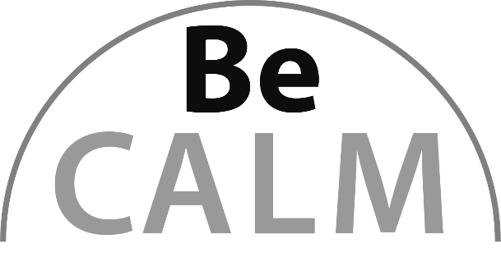

Operation Sense
Beginning Curriculum for Adults Learning Math
Curriculum for GLE 2–4

TEACHER’S GUIDE

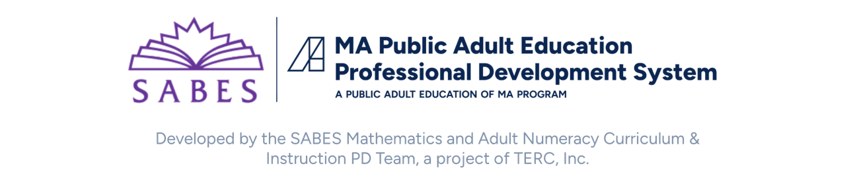

Acknowledgements

The titles in the BeCALM series were developed and piloted in the classroom by Melissa Braaten for the SABES Mathematics and Adult Numeracy Curriculum & Instruction PD Team, with contributions from Yvonne Readdy, Emily Rudd, and Sherry Soares.

The BeCALM series includes four sequential packets:
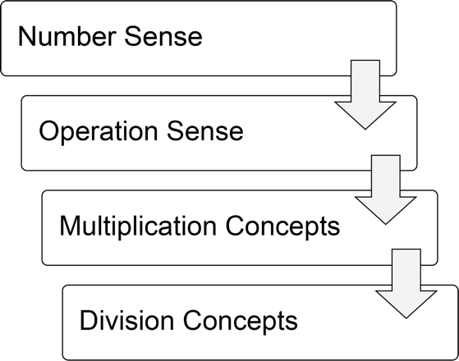
and three non-sequential packets:
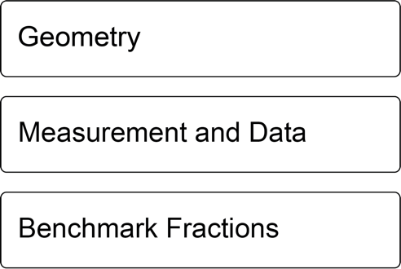

Activities from the EMPower™ and EMPower Plus™ series title Everyday Number Sense: Mental Math and Visual Models Student Book are used and/or adapted with permission from the author, TERC, Inc.

Learner Level
The math content is aimed at ABE level math students (approximately GLE 2–4). While adult students at this math level may have any level of reading, the student materials were designed to be used by adults with a reading level GLE 2 or above. To keep things accessible, the text in the Student Packet is kept to a minimum so that this can be used with students at an ABE reading level or students who are beginning to intermediate English Language Learners.

Use in Different Settings (In-Person, Remote)
This curriculum was designed for use in-person, hybrid, or in a remote classroom. In some cases, the same activity could be used in either format. Other times, suggestions are made for altering the activity in a remote classroom. Each activity is labeled based on its format.
Note: Virtual resources often work better on computers, laptops, tablets, or Chromebooks rather than on Smartphones, especially due to small screen size. There are notes on the specific websites used in each unit. These virtual activities could also be used in an in-person class or assigned for homework.
Throughout this guide you will see the following icons that denote the delivery format(s) of the activity or resource:

Students at the suggested level (GLE 2–4) are often building the skills covered in this unit, not simply reviewing them. The pilot-testing of these materials took about 12 hours of class time for each unit (not including the final survey project).

Components of Instruction

Routines
Classroom routines can be powerful tools in the math classroom. Routines provide a familiar structure to an activity that helps students feel safe because the directions and expectations are predictable. However, a good math routine still provides a cognitive challenge and requires some type of problem-solving every time. There are several routines included in this unit that reappear at the end of every unit. There are notes and descriptions of how to facilitate these routines in the unit details. Other common routines, such as Number of the Day or Math Talks, also work well in synchronous instruction with students at this level, even though they do not appear in the student materials.

Introduction of New Concepts
Each unit includes one or two activities to introduce the new concepts for that unit. Instructions for facilitating are included in the unit details. The goal is to lay the foundation for conceptual understanding of the concepts, rather than simply explaining procedures.

Vocabulary and Things to Watch For
Each unit includes some suggestions on valuable vocabulary words and common misconceptions or interesting student ideas that came up in the pilot class.

Materials Overview
- Unit 1: Hundreds and Thousands
- Unit 2: Subtraction and Number Lines
- Unit 3: Going Deeper with Subtraction
- Unit 4: Our Base Ten System
Each unit includes materials for:
- Activities and Practice
- Language Support
- Self-Evaluation (reproducible from Teacher’s Guide pp. 50–53)
Each part in the Student Packet includes materials for:
- Relevance
- Activities and Practice
- Routines

Math Background: Number and Operation Sense
Note: Much of the content contained in the Teacher’s Guides and Student Packets for the Number Sense Curriculum Parts 1 & 2 was reproduced and adapted from the EMPower Plus Everyday Number Sense: Mental Math and Visual Models Teacher and Student books, with permission from the author (the Adult Numeracy Center at TERC).
EMPower strives to make the most of strategies adults bring to the table and makes explicit the understandings adults hold about numbers so that new ideas can be built on this foundation. Highly numerate adults use flexible, accurate, and efficient strategies for manipulating numbers and quantities in real-world problem-solving.

The importance of students bringing their understanding into the classroom
Many students have invented or collected a set of strategies that circumvent the procedures (the methods or algorithms) historically taught in school yet may think those are not the school-approved or “real” ways. Observations of adults at work and in consumer situations uncover a surprising assortment of methods. It is important that students be encouraged to bring their own good math sense to bear in various situations for managing the mathematical demands of school and everyday life. Strategies and methods may include a mix of finger counting, mental math, estimation, calculator use, and paper-and-pencil methods. Such strategies can support insight into higher mathematics.

Developing number sense
To have sense about numbers means both to understand how numerical quantities are constructed and how they relate to one another.
Numerate adults can be flexible with numbers. They are able to break apart numbers in different ways. For example, they might see 36 as six more than 30, four less than 40, or more than half of 50. They use numbers such as 10, 100, and 1,000 as benchmarks with which to reason. Moreover, they can compare numbers to one another in an absolute way (how much more is 3,000 than 200?) as well as in a relative way (3,000 is how many times as great as 200?).
To support the development of this useable and supple appreciation of numbers, the lessons in the unit encourage students to look for patterns and generalizations.

Recognizing operation sense
Most of the materials in this unit are not about teaching or even reviewing the usual algorithms for addition and subtraction. Rather, learners share and strengthen their own trustworthy strategies, which may include sequential doubling, halving, multiplying by multiples of 10, and using the commutative, associative, and distributive properties.
A common question in any math class is, “What should I do: add, subtract, multiply or divide?” This puzzle may stem from several factors: difficulty moving between text and print; a fragile understanding of place value and weak mental math or estimating skills (so that they are not sure of the magnitude of the answer); or lack of a true understanding of addition, subtraction, multiplication, and division. Learners need to “understand meanings of operations and how they relate to one another” (National Council of Teachers of Mathematics (NCTM), 2000, p. 34).
Deep understanding comes when a person has a sense for the various models for an operation. It is not enough, for example, to conceive of subtraction as taking away one amount from another. The “take away” model works for having an amount of money, spending some, and figuring out what you have left. However, nothing is taken away when you compare the amount of money you have in the bank with the amount you wish you had. A concept of subtraction as difference or comparison is helpful in such a case. Knowing how operations relate to one another gives a person a wider range of ways to approach solving a problem.

The importance of visual models
To ably communicate mathematically and to flexibly approach problems, adults need visualization and expressive skills. They need to “see” the problem, and they need to know how to express the problem and their solution processes not only in words and with notation, but with visual representations as well.
A recurring question for students here is “How do you know?” To answer this question and to make the workings of mathematics visible, we count on visual representations, such as number lines, diagrams, words, and equations.

Unit 1: Hundreds and Thousands
Learning Objectives | CCRSAE
I can round numbers to the nearest ten and hundred. | 3.NBT.1
I can read and write large numbers in the hundreds and thousands. | 2.NBT.1–4
I can order and locate numbers in the hundreds and thousands on a number line. | 2.NBT.1–4
I can give a reason why one choice doesn’t belong with the group. | MP.3
I can keep working on a challenging problem even if I don’t understand it right away. | MP.1
I can fill in missing numbers on a number line. | 2.MD.6, also with intervals of lengths greater than 1*

Note: The last three learning objectives refer to the routines and are repeated in each part.
*The CCRSAE does not have many specific standards about learning to use a number line diagram, although they are mentioned throughout the levels as a visual aid to reasoning about other standards. Number lines also appear in different domains (for example, 3.NF.2–3 address number line use with fractions). Gaining fluency with their use at an early level will help students both to develop number sense and to be prepared when they encounter them in measurement, data, etc.
Note: EMPower materials featured in Unit 1 can be found in Lesson 3 (Traveling with Numbers) of the Everyday Number Sense: Mental Math and Visual Models books.

Standards for Mathematical Practice
In addition to the standards targeted by the routines in this packet (Open Middle, MP.1 and Which One Doesn’t Belong, MP.3), this unit also involves:
MP.4 Model with Mathematics
Students use a number line to model a trip across the US on I-90.

Extra Resources for this Unit
Reproducible: Evaluation Unit 1, Teacher’s Guide, p. 50
Reproducible: Blank Number Lines, Teacher’s Guide, pp. 58–59
Other materials
(optional) large map of US, world map

Math Background
The number line is a visual model that can be used as a thinking tool. Connecting numbers to points is a powerful idea and grounds understanding of graphs and like instruments (thermometers and rulers). A number line allows one to see the relative values of numbers and also illuminates operations on numbers. Adding and subtracting can be viewed as jumping up and down the number line. Differences between numbers connect to the distance between points. Multiplication is visually represented by jumps of equivalent size (repeated addition), and division can be seen as counting the number of times a particular distance can be found in another distance.
Rounding draws attention to the markings on a number line. For example, students are asked to consider the placement of 1,170 on a number line extending from 0–3,000, marked in increments of 100. The corresponding point should be closer to 1,200 than to 1,100.
As students start to focus on numbers in the hundreds and thousands in this unit, they are also extending the patterns they know with numbers 0-100 to apply to larger place values. For example, when we have 9 tens (90), and add one more ten, we move into the next place value (100). This pattern can be extended to increasing the value in the hundreds place (690 becomes 700). Then the pattern can be seen again when we have 9 hundreds (900). When we add one more hundred, we move again into a larger place value (1,000). Students should be exploring and making explicit how these patterns work so they can build their understanding and fluency with larger whole numbers.

Relevance

Transportation Equity and Inequity in the United States
The unit opens with a short article from The Change Agent* about how adult education students experience with transportation. The article could be read in or out of class. It is followed by a few discussion questions about how students are affected by access to transportation, to get them thinking about their own experience and to start the discussion of the role that transportation has played in historical inequities in the U.S.
*Massachusetts teachers are eligible for a free subscription to The Change Agent.
Email changeagent@worlded.org for details.
Later in this unit, students will learn about the Green Book and the difficulties African Americans and other minorities faced when travelling by car under Jim Crow segregation. This connects to an activity where students have to plan travel on I-90 by deciding where to stop each day. African American travelers during Jim Crow had to plan not only for distance but for safety. Using long distance travel allows students to work with numbers in the hundreds and thousands in a real-life context and to reflect on the role that transportation plays in the struggle for equity. They also read about how Civil Right leaders in the 1950s and 1960s targeted segregation in transportation and public accommodations for early protests.
Depending on your student body, you may have students with personal experiences of the historical situations and events covered in this unit. If you have access to the internet in your classroom, It can also be helpful to show a video to give more visuals and background information, such as The Negro Motorists Green Book and Route 66 by Candacy Taylor at https://www.youtube.com/watch?v=6V0Wxr37N70

Activities and Practice


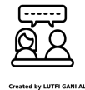
Introducing the Unit
In-Person/Remote Activity
Uses Student Packet p.3
- Have students read and, if desired, discuss.

Using Transportation in the U.S.
In-Person/Remote Activity
Uses Student Packet pp. 4–6
These two short articles could be assigned to different groups, or you could have students read both, then discuss the questions.

Vocabulary for this Unit
In-Person/Remote Activity
Uses Student Packet pp. 7–8
Fill-in-the-blank definitions and examples have been provided for the major terms in this unit. Teach/review words along with activities where they arise, rather than teaching them all at once.
- digit: a symbol used to write numbers. Digits: 0, 1, 2, 3, 4, 5, 6, 7, 8, and 9
- place value: each digit in a number has a place value, which tells how much that digit is worth
- rounding: estimating a number by choosing a benchmark close to the number. It is common to round to place values (the nearest 10 or 100, for example)
- four-digit number: a four-digit number will have digits in the thousands, hundreds, tens, and ones place.

How Many Miles to Boston?
In-Person/Remote Activity
Uses Student Packet pp. 9–10
This activity introduces students to a number line for three- and four-digit numbers and ties into the theme of U.S. transportation equity.
- The map that begins this activity can help begin a discussion about which of the states on the map students are familiar with, where they have travelled, and which highways they drive or ride on. If Interstate 90 is near where your program is located, talk about it! Ask if students have noticed mile markers on highways, or, if they are drivers, how they keep track of distances on the road.
Here are some other questions to ask while discussing the map:
- Which state do you think will take the longest time to cross?
- Which state do you think will take the shortest time to cross?
- Which state will you be in when you are halfway from Seattle to Boston?
- Explain that I-90 is about 3,000 miles long. Ask students to estimate how long it would take to drive the entire length.
- Then go on to the next page with the number line. Here, students will use the number line to figure out how many days it would take to drive the full length if they drive 300 miles per day. Make sure that students can identify that the increments in the number line are 100 miles.

Planning a Trip
In-Person/Remote Activity
Uses Student Packet pp. 11–12
Explain that students will be planning a trip from Seattle to Boston (return to the map on page 9 if helpful) by deciding which city they will stay in each night. Show them the chart on page 12. Seattle, WA is at mile 0. Explain that they should try to go about 300 miles each day. After they have planned their trip by circling the cities that they will stay in on page 12, they should return to page 11 to answer the questions.

Traveling and Civil Rights in the U.S.
In-Person/Remote Activity
Uses Student Packet pp. 13–18
This section includes four short readings and a vocabulary list. The first two readings relate to long distance car travel and the Green Book. The other two readings discuss actions (ultimately successful) taken by Civil Rights activists to resist injustice in transportation and public accommodations. It is telling that transportation and public accommodations were two of the early targets of the Civil Rights movement—these had very tangible effects on peoples’ lives. It is also important to acknowledge that the fight for transportation justice was not only about the indignity of “separate but equal” facilities, such as having to sit in the back of the bus, but the harassment, intimidation, and violence that African Americans and other targeted minorities faced. This violence and the constant threat of violence is sometimes downplayed in discussions of these events.
- Introduce a discussion of the Green Book by referring back to the trip planning students did in the previous activity and explain that long distance car travel has not been the same experience for everyone. Introduce some of the vocabulary, such as Jim Crow and Sundown Towns, and Green Book, and see what your students already know.
- Then show a short video to provide some historical background, such as the one mentioned in the Relevance section above.

Rounding to the Nearest Hundred
In-Person/Remote Activity
Uses Student Packet pp. 19–26
Reproducible Template in Teachers Guide, p. 57
This activity builds from what students learned in BeCALM Number Sense about rounding to the nearest dollar. Since dollars are based on 100 cents, the number lines and midpoints for rounding to the nearest 100 should look familiar.
Counting by hundreds: Provide an unmarked number line, and have students practice counting by hundreds. Give them different starting points. See if students can count by hundreds into a new thousand, for example from 1,900 to 2,000. This is a good quick warm up to repeat throughout the unit.
Between Which Hundreds?: When students can fluently count by hundreds, they can practice identifying the hundreds that each number is between. Students who are ready can work with larger numbers in the extension. (Student Packet pages 19–20)
Rounding to the Nearest Hundred Number Lines: Students will need to identify the hundreds benchmarks the number is between. Push them to generalize about 50 as the midpoint between each hundred. (Student Packet page 21)
Additional practice can be created from the template on page 57 in the Teacher’s Guide.
Rounding Distances to the Nearest 100 Miles: Students round numbers from the previous travelling activity to the nearest hundred and see how it changes the total estimate of the length of I-90. (Student Packet page 22)
This is a good place to go over the vocabulary words digit, place value, and rounding.

Rounding to the Nearest Ten
In-Person/Remote Activity
Uses Student Packet pp. 23–28
Reproducible Template in Teachers Guide, p. 57
Rounding by tens is generally more challenging for students in this unit because the numbers used are often three- and four-digit numbers. Identifying the benchmarks the number is between is often where students get stuck, especially when one of them is also a multiple of 100 (208 is between 200 and 210, for example.) Give a lot of practice counting up and down by tens to help students who struggle with this.
Counting Up and Down by 10s: Provide an unmarked number line. Explain that they will be counting by tens. Have students take turns. Give each student a starting number that is a multiple of ten in the hundreds or thousands, for example, 370. Students often struggle when the hundreds place is changing (390, 400, 410) and repeating this counting activity as a warmup can help students more confidently internalize that pattern.
As they get more comfortable, try counting by tens where the thousands place changes (1980, 1990, 2000, 2010). This practice can be valuable for familiarizing students with the sequence and patterns of larger numbers. During this activity, draw students’ attention to the numbers after you record them. Ask, What patterns do you see? What numbers (place values) are changing? Which place values stay the same?
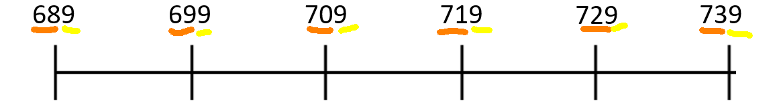
There is additional practice for counting up and down by tens in the Student Packet, pages 23–24.
Between Which Tens?: Students who are ready can work with larger numbers in the extension. (Student Packet pages 25–26)
Rounding to the Nearest Ten with Number Lines: Once students can identify “between which tens” a number can be found, they can then think about which of those tens the number is closer to. Number lines can be used to help visualize the midpoint. (Student Packet page 27)
Additional practice can be created from the template on page 57 in the Teacher’s Guide.
These activities work best when revisited frequently. The class can come back to this as a warmup, for example, while also working through other materials in the unit.
Rounding Distances to the Nearest 10 Miles: Students round numbers from the previous travelling activity to the nearest ten miles and see how it changes the total estimate of the length of I-90. Compare with the total they got from rounding to the nearest hundred miles. Which was closer to the actual length? (Student Packet page 28).

Place Value Practice
In-Person/Remote Activity
Uses Student Packet p. 29
- Introduce the place value chart and explain how we read numbers in the thousands (four-digit numbers).
- Also, have a conversation about how commas are used as place value separators in the US, and can help us to read large numbers more easily.
Cultural Note: Many countries around the world use commas as a decimal point and use periods or spaces as place value separators. For example, one thousand, three hundred fifty and twenty-five hundredths…
- Written in U.S. Notation: 1,350.25
- Written in Brazilian Notation (among others): 1.350,25
This is an important point to bring up, especially if you have students from other countries.

Reading and Writing Large Numbers
In-Person/Remote Activity
Uses Student Packet pp. 30–31
- Put students in pairs and assign one student to be A and the other B. (In a remote classroom, you will have to put the pairs in breakout rooms).
- Have Student A read the numbers on page 30, while Student B writes them down (in the chat box or on a whiteboard). Then Student B should share while Student A checks that it matches the number they read.
- When they have finished this page, they can go to the next page and switch roles.
More practice
There are several practice activities that follow that could be done individually, with a partner, or as a whole class:

Writing Large Numbers
In-Person/Remote Activity
Uses Student Packet p. 32
More practice writing four- and five-digit numbers in standard form

High and Not-So-High Peaks
In-Person/Remote Activity
Uses Student Packet p. 33
Practice ordering numbers in the thousands.

Writing Checks
In-Person/Remote Activity
Uses Student Packet pp. 34–36
Practice translating between standard and written form for numbers in the thousands

Filing
In-Person/Remote Activity
Uses Student Packet p. 37
Practice ordering numbers in the thousands (ask students which place values help them decide where to put the file).

More Filing
In-Person/Remote Activity
Uses Student Packet p. 38
More practice ordering numbers in the thousands

Which One Doesn’t Belong? 1
In-Person/Remote Activity
Uses Student Packet p. 39
This Which One Doesn’t Belong? uses whole numbers in the hundreds and thousands. The digits are limited to 1, 0 and 5 to encourage students to think about how the placement of digits (place value) affects a number.
There is no one correct answer to these activities. The point is to make an argument for the one you have chosen. In most cases, a valid argument could be made for any one of the four numbers. It can take some time for students to understand that there isn’t a right answer, but many different answers that could be correct, as long as they correctly identify an attribute that makes one different from the others.
When facilitating remotely, make sure students have time to think before sharing starts, and allow as many students to share as possible (the chat box works well for this).
Some possible responses:
- 500 doesn't belong because it is the only three-digit number.
- 1,501 doesn’t belong because it is the only number with only one zero digit.
- 1,005 doesn’t belong because it is the only number with a zero in the hundreds place.
- 1,500 doesn’t belong because it is the only multiple of another number in the square (500 x 3). It is also the only number over one thousand with zero in the ones place.

Close to 1,000
In-Person/Remote Activity
Uses Student Packet p. 40
If needed, remind students how Open Middle problems work (they are placing one digit in each box to create, in this case, three three-digit numbers). You can modify this activity by starting without the restriction on digits and just having them try to get close to 1,000, then have them solve it again with the restriction. (Or use the restriction on digits as an extension for students who need a challenge).
This problem forces students to pay attention to place value, since they will have to strategically place digits into certain place values to try to reach a desired total. Often, students will begin by paying attention only to the hundreds place and will end up with a sum that is over 1,000 (all the hundreds add up to 1,000, and the tens and ones put them over).
519 + 376 + 284 = 1,179
(The hundreds alone add up to 1,000, and the tens and ones create another 179)
Later they may realize that the tens and ones can easily make an extra hundred and may decide to adjust the hundreds place accordingly.
418 + 367 + 259 = 1,044 (Hundreds add up to 900, final total is closer to 1,000.)
Students may also discover that they can “swap” the tens and ones places without changing the total.
For example:
467 + 359 + 218 = 1,044
(The first two place values swapped from example above, same total)
Students may start by randomly trying different combinations but should become more strategic over time. If a student is stuck, you suggest they try swapping two digits within a number to see how they affects the total (Does it get larger or smaller? Why?)
519 + 376 + 284 = 1,179
591 + 376 + 284 = 1,251 (swapped the 1 and 9 digits and total got larger. Why?)
Note: There is also a great online tool that students can use to explore this problem:
Close to 1000 by John Ulbright: https://www.geogebra.org/m/mYTjP7Fc

Answer Key
Some solutions that are close to 1,000:
- There are many ways to make 999, including 247 + 563 + 189.
- Close answers above 1,000 include 195 + 327 + 486 = 1,008.

Number Line Puzzles 1a
In-Person/Remote Activity
Uses Student Packet p. 41
A: 900, intervals worth 300
B: 500, intervals worth 500
C: 500, 1,000, intervals worth 250

Number Line Puzzles 1b
In-Person/Remote Activity
Uses Student Packet p. 42
A: 420, intervals worth 210
B: 4,000, intervals worth 2,000
C: 3,500, 4,000, intervals worth 250

Vocabulary
digit: a symbol used to write numbers. Digits: 0, 1, 2, 3, 4, 5, 6, 7, 8, and 9
place value: each digit in a number has a place value, which tells how much that digit is worth
rounding: estimating a number by choosing a benchmark close to the number. It is common to round to place values (the nearest 10 or 100, for example)
four-digit number: a four-digit number will have digits in the thousands, hundreds, tens, and ones place.

Things to Watch For

Placement and sequencing of large numbers
Many beginner students are not completely fluent with how numbers in the hundreds and thousands are sequenced. Activities like “Counting by tens and hundreds” (described above) can be helpful. Continue to draw students’ attention to place values and patterns by asking What patterns do you see? What stays the same? What changes? The visual of the number line is a helpful support as well.

Discomfort with estimation/open questions
Some students are uncomfortable when working with real-life numbers. Students may struggle with the planning a trip activity because the numbers are not clean, and they are estimating and making judgement calls. Remind them that this is how numbers often work in the real world. There is more than one way to plan the trip. They should discuss with others why they might choose one town or another.

Unit 2: Subtraction and Number Lines
Learning Objectives | CCRSAE
I can use a number line to explain my addition and subtraction strategies. | 2.NBT.7
I can count up and down by 10s and 1s to solve addition and subtraction problems. | 2.NBT.7–8
I can write equations to match my strategies. | 2.OA.1
I can give a reason why one choice doesn’t belong with the group. | MP.3
I can keep working on a challenging problem even if I don’t understand it right away. | MP.1
I can fill in missing numbers on a number line. | 2.MD.6, also with intervals of lengths greater than 1

Note: EMPower materials featured in Unit 2 can be found in Lesson 4 (Traveling in Time) of the Everyday Number Sense: Mental Math and Visual Models books.

Standards for Mathematical Practice
In addition to the standards targeted by the routines in this packet (Open Middle, MP.1 and Which One Doesn’t Belong, MP.3), this unit also involves:
MP.4 Model with mathematics
Students use timelines as a way of understanding ordering and years between historical events.
MP.7 Look for and make use of structure
Students look for structure in different types of equations involving addition and subtraction. They also look for patterns in place values as they practice counting up and down by 10’s and 100’s.

Extra Resources for this Unit
Reproducible: Evaluation Unit 2, Teacher’s Guide, p. 51
Reproducible: Quiz, Unit 1 & 2, Teacher’s Guide, p. 54
Reproducible: Blank Number Lines, Teacher’s Guide, pp. 58–59

Other materials
(optional) painters tape (if you want to create a class timeline on the wall to display How Long Ago? activity)

Math Background
These number comparison problems call for either subtraction or addition to solve them:
- I’m 54, Rachel is 27, how much older am I?
- Sally lives on 53rd Street and I live on 120th Street; how far apart do we live?
- How long ago did the Wright Brothers fly their first plane?
The problems above represent two models for subtraction: (1) how much larger one number is than another (the age example) and (2) the distance between two numbers (the address and airplane examples). In each one, subtraction solves the problem. So does addition. Traditionally, schoolbooks teach these as 54 – 27 or 120 – 53. However, when people solve these mentally, they often use addition.
Using the age problem as an example, people may count on:
“27 to 30 is 3, to 54 is 24, and 3 and 24 is 27.”
Or, they count on and adjust:
“27 to 57 is 30, but I’ve gone too far, so it’s 3 less, or 27.”
And when subtracting, people sometimes explain the problem as follows:
“54 minus 4 is 50, minus 20 is 30, minus another 3 is 27, so that’s 4 and 20 and 3, or 27.”
Or, they may picture the traditional vertical algorithm and borrowing:
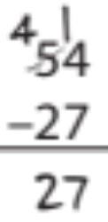
Here is another way to notate this:
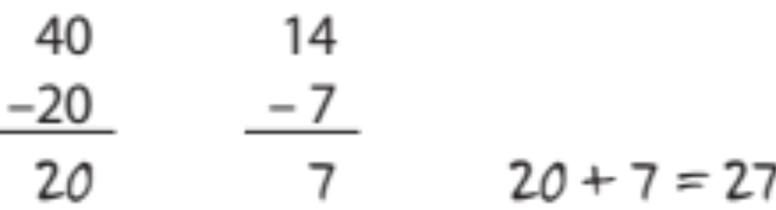
All of these strategies get to the solution, in this case 27. The focus in this lesson is on counting forward or back and using the number line to help show the moves. Using groups of 10s, 5s and 1s to count is one of the first efficient methods that students acquire for totaling or comparing numbers. In this lesson, you may notice that some students count only by 1s. The number line can encourage different strategies, such as counting on, adding on, and counting back.
The following is one way you might introduce those categories in class. First, say:
I drew a number line to show when the 18th amendment (Prohibition, which banned the manufacture and sale of alcohol) was approved in the U.S.:

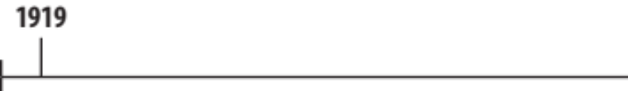

Then, say:
I went from 1919 to 1920, then ‘20 to ‘30, and then what?
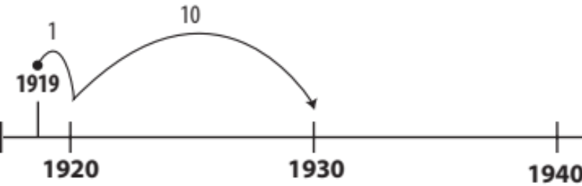
As students answer, for instance, ‘30 to ‘40, and ‘40 to ‘50, add these to your number line, and indicate the number above each jump, like this:
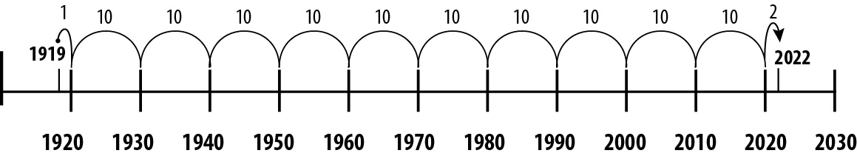
Next, say:
This way is called “count on or add up to a multiple of 10.”
What if you started with the larger number and counted back? I started at 2022, then went to ‘21, ‘20, then ’10, ‘00, ‘90 then ‘80... then what?

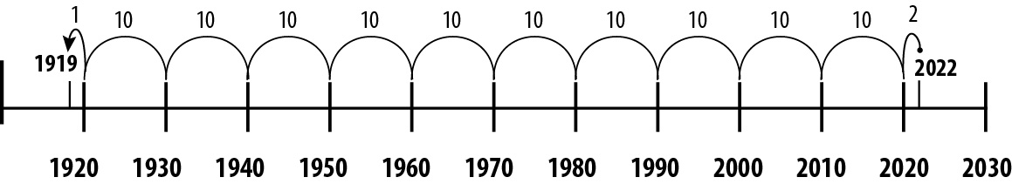

As students tell you the rest (for instance, ‘70, ‘60, ‘50, … ‘20, ‘19), ask them to help you label the numbers, and write
1 + 1 + 10 + 10 + 10 + 10 + 10 + 10 + 10 + 10 + 10 + 10 + 1 = 103 years
or
2 + 100 + 1 = 103 years
Finally, say:
This way is called “subtract/count down to a multiple of 10.”
Working with 10s and 1s reinforces the place value system we use for numbers. As students become more proficient, however, expect that they will count by multiples of 10—by 20s, 50s, or 100s.

Relevance
This unit opens with an explanation of how centuries are counted. (Why were the 1900s the 20th Century?) This is a very confusing idea and can lead to an aha moment!
Later, this unit uses number lines to look at some important events in American history. This can be a way to expose students to some historical events they may not be familiar with, as well as to discuss which historical events they think should be included. Who gets to decide which events are considered “important”? What makes an event “historical”?
If you have students from other countries, you could also open the discussion to include events (from the last 100 years or so) that occurred in their countries that they think are “historical.”
There are also a few notes added about groups of people who are often left out of stories about these particular events, such as the role that African-American activists played in the Suffragette Movement, or the role women played working in factories during WWII. A discussion of similarities and differences between the 1918 flu pandemic and the COVID-19 pandemic might be timely and interesting as well.

Activities and Practice

Counting Centuries
In-Person/Remote Activity
Uses Student Packet p. 43
- Many adults are confused by why, for example, the 1900s are the “twentieth century.” Have students fill out the chart, then ask them what they notice.
- Have them put into their own words why the pattern works the way it does. (If no one points it out, draw their attention to the fact that the first century starts with 0, not 100.)

Vocabulary for this Unit
In-Person/Remote Activity
Uses Student Packet pp. 44–45
Fill-in-the-blank definitions and examples have been provided for the major terms in this unit. Teach/review words along with activities where they arise, rather than teaching them all at once.
- decade: ten years
- century: one hundred years
- millennium: one thousand years
- difference: the result of subtraction. On a number line, it is the distance between two numbers

Birthday Numbers
In-Person/Remote Activity
Uses Student Packet pp. 46–47
- Start with the following scenario to introduce the first problem in Activity 1: Birthday Numbers. Say:
A friend of mine just celebrated her 48th birthday. I was trying to figure out in my head when she was born. In what year was my friend born? How do you know?
- Invite students to share their strategies for solving the problem. Someone may be 48 years old and know the answer immediately. However, try to bring out the mental calculations students used.
Note: The following examples are written for the year 2022. Adjust the lesson to the current year and follow the same method.
Starting with the first volunteer, write on the board the mental steps he or she used to determine the birth year for the 48-year old. Use the number line to demonstrate the steps, explaining the student’s process as you write. For instance:
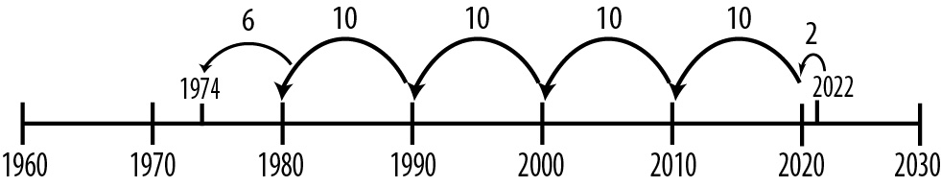

Say:
You started at this year (2022 or the current year, 20XX). You went back 2 years (or X years) to the year 2020, a round number. Then you went back 40 years to 1980, and then you went back 6 more years to 1974. Adding 2 and 40 and 6, you get 48 years. Did anyone solve the problem a different way?
- Listen to examples, tracking students’ reasoning on the number line. If student examples are not forthcoming, offer one of your own. Once you record the number line jumps and written steps for a few strategies on the timeline, begin to describe the steps, using mathematical notation. For instance, for the example above, you might write and talk through the problem as follows:
2022 – 2 = 2020
2020 – 40 = 1980
1980 – 6 = 1974
2022 – 2 – 40 – 6 = 1974
- Ask students to write both the number-line jumps and an equation in their books as they complete the problems on the page. Take time for students to share number-line strategies and equations for each problem.
- Name the methods you see students using—counting back by 10s, or multiples of 10; adding on by 1s and 10s; or finding a benchmark date, such as 2000, and working from there. Summarize briefly by saying:
All these strategies help us find the difference between two dates and how far apart different birth dates are from the current year, 2022 (or 20XX).
The equations show—in writing—how we add and subtract mentally. Though it might take more steps to calculate in our heads than with paper and pencil, what are some of the advantages of calculating mentally?
- Explain that the distance between two numbers on a number line can be called the difference. The difference is also the result of subtraction. We will explore the difference in several ways throughout this unit and the next.

Timeline of American History
In-Person/Remote Activity
Uses Student Packet p. 48
- Before launching into the How Long Ago? activity, give students a chance to brainstorm which events in American history they think are important and why. If you have students from other countries, you could invite them to share events from their countries history or from world history, although it is helpful to keep the examples in the last 200 years.
- Then ask:
How do we decide what makes an event “important” or “historical?”
Who gets to decide?

How Long Ago?
In-Person/Remote Activity
Uses Student Packet pp. 49–61
- Take a look at the first event together. Ask:
The American Civil War started in 1861. How long ago was that?
Encourage students to use whatever strategy makes sense to them and remind them that the number line can help them visualize the difference between the two dates (then and now).
- Clarify the term “difference,” then ask students to answer the questions, and as they work and share notice who is working with 10s and 1s comfortably. Always ask:
How would you find the answer in your head without using pencil and paper?
What is another way you could do the problem?
- Notice how students determine missing numbers. Do they count spaces accurately? Do they see the patterns of increments? Notice how they use the number line. Do they mark off 10s and 1s accurately? Do they use multiples of 10? The more fluent the students become, the more likely they will be able to work with larger increments of numbers, preferring to go down by 50 rather than 10, for instance. Encourage this efficiency and connect it with five 10s jumps on the number line when sharing strategies with the class. If no one chunks time into larger intervals, ask them how they could do that.
- Ask students to share their methods and help, if needed, to translate their methods into mathematical equations.
Note: This is a good place to introduce the use of multiplication for repeated addition (how many tens did you count?) and the use of parentheses as multiplication notation.
- Choose some examples and ask:
How did you know what the missing numbers were here?
What other numbers did you put on the number line?
How did you decide where to place them?
- Compare methods students used. Then focus on their solutions, asking:
Did you do the problem first in your head or on the number line?
Did counting with 10s (or multiples of 10) help you? How so?
- Then focus on their solutions, asking:
How did you know how many years ago this event happened?
How do you know that the event happened more or less than 100 years ago?
If students subtract in some other way (traditional algorithm, for example), make sure they also show what they did on the number line.
Because student pairs will only choose two or three events, you may want to assign them the rest for homework as extra practice.

Math Inspection: Make It True
In-Person/Remote Activity
Uses Student Packet p. 62
This math inspection extends the work with the equal sign by including the subtraction sign along with the equal sign and addition sign. As they explore the relationship between the numbers, students should begin to realize that addition and subtraction are related; in fact, they are inverses of one another. Two of the final equations will illustrate the idea of additive inverse (40 + 20 – 40 = 20 and 40 = 20 + 40 – 20). This inspection deals with the reflexive property of equality (anything is equal to itself):
a + b = a + b or a – b = a – b
This idea shows up in algebra: In the equation a + b – a = b, on the left side of the equal sign, adding a and then subtracting a results in 0, so b is left on both sides of the equation. The same is true if the action happens on the other side of the equal sign: a = b + a – b. On the right side of the equal sign, addition and then subtraction of b results in 0, so a is left on both sides of the equation.
- Ask students to work individually to determine the solution to each problem.
- Then have them share how they determined where to place addition and subtraction signs.
- Give students time to decide if this will work with another pair of numbers and ask for examples.

Math Inspection: Check Both Sides of the Equal Sign
In-Person/Remote Activity
Uses Student Packet p. 63
This inspection extends the work with the equal sign and asks students to notice patterns that occur with subtraction. This is a case in which noticing patterns and generalizing from them can lead to important insights about operations and the mathematical concept of equality.
In the equations for students to consider (for example, 9 – 6 =10 – 7), they are asked to look at the relationship between the numbers on the left and right of the equal sign. To maintain equality, each number increases by one. The relationship among the numbers remains stable and so the answer does not change. This is different from what we see with addition (for example, 5 + 2 = 6 + 1). With addition, if one number on one side of the equal sign increases, the other on that same side has to decrease for the sum to remain the same. Students may be confused or surprised by this contrast at first. Use number lines to illustrate what is happening in specific equations. Students may find it helpful if you and they mark off steps down a hall or across the classroom so they can act out sample equations with numbers less than 20. In this way they have a kinesthetic means to experience what changes and what stays the same.
As you prepare, you may notice that in the subtraction problem on the right (10 – 7), the numbers are each 1 more than the subtraction problem on the left (9 – 6), but the difference is the still the same (3). In the second equation, each number is three more. In the third, each number is 25 more. The difference remains the same as the difference between the original numbers. Another observation might be that in each case, the expression on the right side of the equation is easier to simplify since it is subtracting a multiple of 10, and that the right side can be created from the left by adding the same number to each value (for instance adding a 1 to the 9 and to the 6 results in 10 – 7). In other words, this is a good strategy for making numbers friendlier in order to do mental math calculations or to eliminate the need to borrow.
In mathematical terms, this is the zero identity property at work. For instance,
48 – 13 = (48 + 2) – (13 + 2)
which can be rewritten as
48 + 2 – 13 – 2, and + 2 and – 2 equal 0
- Begin by asking students to articulate again what the equal sign means (that the value on the left is equivalent to the value on the right).
- Ask them to verify that this is true for each of the three equations. First, draw their attention to 9 – 6. Then, draw their attention to 10 – 7. Ask:
Are these amounts equal? (Yes), then ask: How do you know?
People may have varied responses (for example, because I know my facts—they are both 3). Record responses on the board for all to see.
If no one says that each amount increases by 1, ask:
How do the amounts on the left change compared to the amounts on the right side?
Focus on the idea that “10 is 1 more than 9 and 7 is one more than 6, yet you still have the same difference.”
- Ask pairs to work together on the three equations, using this idea. As you circulate, you might ask students to think about how to show (with chips, pennies, on a number line) why this works with subtraction.
- Bring the class together to share what they have noticed. If you have access to the internet, a good way to provide a visual to support students understanding of these problems is to use an interactive number line, like the one at MathLearningCenter.org: https://apps.mathlearningcenter.org/number-line/
First, show the difference (distance) between the numbers on the left. Then show the difference (distance) between the numbers on the right. They should see how as the two endpoints shift together, the distance between them stays the same.

More practice

Count Up and Down by 10s
In-Person/Remote Activity
Uses Student Packet pp. 64–65
Practice with intervals of ten

By What Did I Count?
In-Person/Remote Activity
Uses Student Packet pp. 66–67
Uses sequences to practice equal intervals

Test Practice
In-Person/Remote Activity
Uses Student Packet p. 68

Answer Key
The students need to raise $325 more. (See if students can explain how they see this on the number line.)

Which One Doesn’t Belong? 2
In-Person/Remote Activity
Uses Student Packet p. 69
Some possible responses:
- 10 – 16 doesn’t belong because it is the only one with a negative answer (and the only one with a difference that is not positive 6)
- 15 – 9 doesn’t belong because it is the only one with two odd numbers.
- 16 – 10 doesn’t belong because it is the only one with two two-digit numbers.
Students might notice that three of the expressions have a value of 6, even though the numbers are different.

Subtraction to Get the Smallest Difference
In-Person/Remote Activity
Uses Student Packet p. 70
In this Open Middle activity, students explore how the size of the minuend and the subtrahend affect the difference. This setup in particular encourages students to see the difference as the distance between the two numbers, which could be visualized on a number line.
You could modify by starting without the restriction on digits. Students could also solve again for the largest difference.

Answer Key
Smallest difference: The smallest difference in this case is 2. Since digits cannot repeat, We can’t have the same number for subtrahend and minuend, so we can’t have a difference of 0 (45 – 45 = 0) We also have two numbers with the same tens place that are one apart (43 – 42 = 1). We also cannot use 0, so we can’t have a difference of 1 where one of the numbers is a multiple of ten (40 – 39 = 1). So the best we can do is a difference of 2 (e.g., 41 – 39 = 2). There are several answers that will give a difference of 2.
Largest difference: The largest difference will come from making the numbers as far apart as possible. We need the first number (the minuend) to be as large as possible, and the second number (the subtrahend) to be as small as possible). The largest difference comes from 98 – 12 = 86.

Number Line Puzzles 2
In-Person/Remote Activity
Uses Student Packet p. 71

Answer Key
A: $100.02, intervals of $0.02
B: $19.50, intervals of $0.50
C: 2,000, 2,200, 3,000 intervals of 200

Number Sense Quiz (Units 1&2)
In-Person/Remote Activity
Uses Teacher’s Guide p. 54

Answer Key
- 6,450. It would go into filing cabinet c.
- She was 36 years old. Methods and equations will vary.

Vocabulary
decade: ten years
century: one hundred years
millennium: one thousand years
difference: the result of subtraction. On a number line, it is the distance between two numbers

Things to Watch For

Talking about time
We talk about years differently than other numbers. Go over some of these conventions so make sure students are familiar with them (especially for English language learners).
- We read time by hundreds, rather than thousands (nineteen thirty-nine rather than one thousand nine hundred thirty-nine)
- Years in the thousands do not have commas for place value. (1939; not 1,939)
- We use an "s" to talk about a range of time (the 1900s, the 50s).

Counting Centuries
Many folks are confused by why the 1900s are considered the 20th century, the 2000s the 21st century, and so on. The reason is mathematical. The leading digits count the completed centuries, (1900s means 19 centuries have been completed, the 20th is ongoing). The chart at the beginning of the unit can help by helping students see the very first century did not have a 1 in the hundreds place.

Unit 3: Going Deeper with Subtraction
Learning Objectives | CCRSAE
I can recognize subtraction problems that involve a missing amount, comparison, or take away. | 2.OA.1
I can explain why the regrouping strategy works. | 2.NBT.9
I can give a reason why one choice doesn’t belong with the group. | MP.3
I can keep working on a challenging problem even if I don’t understand it right away. | MP.1
I can fill in missing numbers on a number line. | 2.MD.6, also with intervals of lengths greater than 1

Note: EMPower materials featured in Unit 8 can be found in Lesson 5 (Meanings and Methods for Subtraction) of the Everyday Number Sense: Mental Math and Visual Models books.

Standards for Mathematical Practice
In addition to the standards targeted by the routines in this packet (Open Middle, MP.1 and Which One Doesn’t Belong, MP.3), this unit also involves:
MP.2 Reason abstractly and quantitatively
Students will explore how the same subtraction equation can model different situations, and will have to attend carefully to what each number means in context.
MP.4 Model with mathematics
Students model different word problems with subtraction equations, including a formula to calculate simple profit.
MP.7 Look for and make use of structure
Students look closely into how value can be shifted between place values to make sense of the regrouping strategy for subtraction.

Extra Resources for this Unit
Reproducible: Evaluation Unit 3, Teacher’s Guide, p. 52
Reproducible: Blank Number Lines, Teacher’s Guide, pp. 58–59
Other materials
play money, base ten blocks, counters

Math Background
This unit expands the concept of subtraction to include “missing amount” situations, such as the scenario offered in Ways to Think About Subtraction:
Myrna had $80 when she went into the store. She came out with $30.
How much did she spend?
These types of problems tend to be a little more challenging for students because they have a different underlying structure. The problem above could be represented algebraically by $80 – a = $30.
To see how the problem above can be solved using $80 – $30 requires a deeper understanding of addition and subtraction. If we think in terms of a whole and its parts, $80 is the whole and it has been broken into two parts: $30 and the unknown quantity a ($80 = $30 + a). Subtracting either of the parts will give us the other. Students may need guidance to see this connection.
The expanded notation used in the exploration of the traditional addition and subtraction algorithms is based on an understanding of place value. In the explanation of “borrowing,” (in contemporary classrooms, often called “regrouping”) the associative property of addition is used. The associative property says that we can regroup addends (often notated with parentheses) without changing the sum.
For example,
(50 + 10) + 2 = 50 + (10 + 2)
In effect, this is changing the order in which we add the numbers, but without changing the order in which they appear (which would involve the commutative property of addition, explored in earlier units). While the final sum does not change, changing the order or grouping of addends does change the partial sums
(50 + 10) + 2 = 50 + (10 + 2)
60 + 2 = 50 + 12
which is what allows the borrowing/regrouping subtraction algorithm to work—we get the extra value “moved over” into the place value where we need it to subtract.
Borrowing methods of subtraction are not always the easiest to do mentally, since they often require holding a large number of digits and steps in working memory. This lesson also provides more practice with the strategy of adding the same amount to the subtrahend and minuend (See Check Both Sides of the Equal Sign—Subtraction). This concept was first explored in Unit 7, in Math Inspection Check Both Sides of the Equal Sign). In this way, the amounts being subtracted can actually be changed (usually, to friendlier numbers) while the difference between them stays the same.
This can be modeled on a number line: if the difference between numbers is the same as the distance between them on a number line, imagine that set distance sliding towards the right. Both numbers would be increasing, but the distance between them would stay constant. This could also demonstrate the reverse: sliding the distance left on the number line would decrease the subtrahend and the minuend while the difference remained constant.
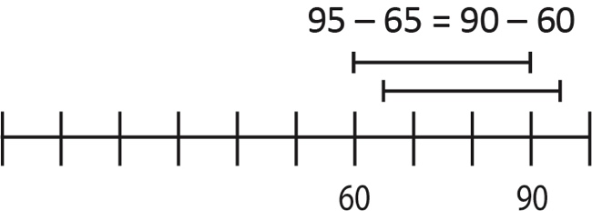
As in the previous unit, the virtual number lines from MathLearningcenter.org can be used to demonstrate this to the class: https://apps.mathlearningcenter.org/number-line/

Relevance
This unit introduces a very simple subtraction formula for calculating profit. Students learn the vocabulary and concepts of revenue, cost, and profit, practice with some examples, and read a short interview with two adult education students who started their own cleaning business.
The example page, How’s Business, gives different parts of the profit equation (in some they have to solve for the profit, some for the cost, some for the revenue). Have students share their methods for solving, and emphasize the relationships between the different amounts, as well as the relationship between addition and subtraction.

Activities and Practice

Revenue – Costs = Profit
In-Person/Remote Activity
Uses Student Packet p. 72
Introduce students to the vocabulary of revenue, costs, and profit, and see if they can give some examples of each. Make sure to explore several examples to illustrate the difference between revenue and profit. Also have students brainstorm what types of costs might be associated with different businesses or transactions.
revenue: the money a business takes in
cost: the money a business pays out for its expenses
profit: the money a business owner has left after costs are subtracted from revenue. the “extra benefit”

How’s Business?
In-Person/Remote Activity
Uses Student Packet pp. 73–74
- Remind students about the subtraction formula they learned to find the profit (or loss) of a business. Have them calculate the missing amount for each example. (Note: Mel’s Paint Shop is an example of a loss.)
- Have students explain how they found each amount. Underline the relationship between addition and subtraction and how they relate the three quantities. (For example, if they know the profit and the cost, they need to add to find the revenue.)
These types of problems can be a useful warmup for several classes.

Starting a Cleaning Business
In-Person/Remote Activity
Uses Student Packet pp. 75–77
Have students read the article and discuss the questions, in small groups if appropriate.

Vocabulary for this Unit
In-Person/Remote Activity
Uses Student Packet pp. 78–79
Fill-in-the-blank definitions and examples have been provided for the major terms in this unit. Teach/review words along with activities where they arise, rather than teaching them all at once.
- revenue: the money a business takes in
- cost: the money a business pays out for its expenses
- profit: the money a business owner has left after costs are subtracted from revenue. the “extra benefit”
- regrouping: a method of subtracting in which value can be regrouped from one place value into another. For example, one 10 can be regrouped into 10 ones.

Ways to Think about Subtraction / Subtraction Can Mean…
In-Person/Remote Activity
Uses Student Packet pp. 80–82
- Begin by explaining that subtraction can mean more than take away. Say:
If you understand the different meanings of subtraction, you may find it easier to figure out when a situation requires subtraction.
Pay attention to whether students are focusing on the subtraction aspect of each story. (Is it looking for a missing part, the difference between two things, or is it taking an amount away?)
- Bring everyone together and discuss each problem, asking the following questions to get at student definitions of types of subtraction situations:
Is this a situation that involves subtraction?
What is this problem asking you to look for? (missing part for the first problem, difference or comparison for the second, and how much is left (take away) for the third)
What strategies did you use to figure out the answer?

Visual Models of Subtraction
In-Person/Remote Activity
Uses Student Packet pp. 83–85
For each example, give students a chance to sketch how they would see the problem on a number line. Then share their drawings and discuss.
Since all three examples involve money, there is also a visual model using money for each of the problems. Ask students:
What is different about each problem? What is the same?

Write Your Own Problems
In-Person/Remote Activity
Uses Student Packet pp. 86–87
- Begin by having student write a subtraction problem, without specifying a specific type.
- Share problems with the class (if remote, you might type them into a document). Then, have students read and consider the problems and decide which type they are. After the class agrees that a problem is a certain type (assuming they are correct), the author of the problem should write their problem in their packet.
- Repeat this in a later class. Students should try to write of the types they don’t have yet. Many students struggle to create Missing Amount problems, even if they can identify them, so you may have to model these a number of times.

How Do You See It?
In-Person/Remote Activity
Uses Student Packet p. 88
- Begin by displaying 40 – 27 = ____ . Then ask:
If someone asked you what this subtraction problem could mean, how would you show it visually? Would you use something like a picture or diagram? And how would you connect that to a real-world situation?
- Give students a chance to work, then have them share their examples. Look to see if there are:
- Take-away interpretations, where someone begins with one amount, removes some part of it, and the answer is what remains, or is left. For example, “I had 40 tulip bulbs, then gave 27 to my friend. How many do I have now?”

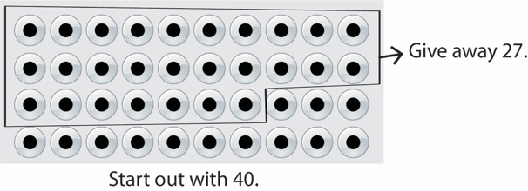

- Comparison interpretations, starting with two amounts, where the answer tells how much more (or less) one is than the other, or the difference between them. For example, “I have 40 tulip bulbs. My sister has 27. How many more do I have than she does?”
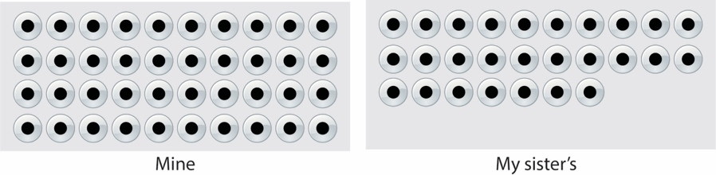
- Missing-part interpretations, where one starts with an amount (the total), is left with a known partial amount, and is trying to find the other part. For example, “This week I want to work a full 40 hours. I know that I still have 27 hours to go. How many hours have I already worked?” The back and forth of part-part-whole of addition and subtraction is the action. For example, 40 – ? = 27 can be thought of as 27 + ? = 40.
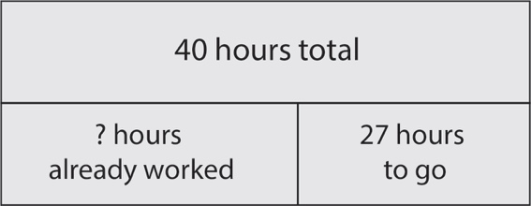
- Invite a volunteer to present an interpretation and explicitly label it as a take-away, missing-part, or comparison model. Ask:
Who also interpreted subtraction this way, as a take-away, missing-part or comparison model?
What was your story and picture?
Did anyone look at it a bit differently?
Ensure that all three models, with pictures and real-life situations, are addressed. Provide examples if all three types are not brought forth by the volunteers.
Note: As students work on Check Both Sides of the Equal Sign—Addition, and Check Both Sides of the Equal Sign—Subtraction, they are working with equivalent expressions. If those words don’t come up as they explain what they notice about the expressions given, bring them up yourself. You may define equivalent expressions as numbers and operations that describe the same value. For example, 5 + 3 = 6 + 2 are equivalent expressions; they are both equal to 8.

Check Both Sides of the Equal Sign—Addition
In-Person/Remote Activity
Uses Student Packet p. 89
This activity revisits the idea of moving value between addends. This forms of the basis of the explanation of the borrowing/regrouping strategy, when value is moved or regrouped from one place value to another.

The Regrouping Strategy (“BoRrowing”)
In-Person/Remote Activity
Uses Student Packet p. 90
Many students will have learned the regrouping, or “borrowing” strategy for subtraction when they were younger. Even if they can articulate the steps, many students do not have a solid understanding of why or how the strategy is working. This explanation builds on the concept of moving value between addends, which students played with in Number Sense, Part 1, and in the previous activity Check Both Sides of the Equal Sign—Addition. The steps show how the regrouping strategy involves moving value between different place values. This keeps the emphasis on the value of the place values and the value of the amount that has been regrouped.

Check Both Sides of the Equal Sign—Subtraction
In-Person/Remote Activity
Uses Student Packet p. 91
For reinforcement on the importance of paying attention to both sides of the equal sign, and exploring mathematical ideas, such as a – b = (a + c) – (b + c). Revisits concepts explored in Unit 7, Math Inspection: Check Both Sides of the Equation, and the strategy of adding the same amount to both minuend and subtrahend in order to find friendlier numbers to subtract.

Test Practice Problems
In-Person/Remote Activity
Uses Student Packet pp. 92–93

Answer Key
- b
- d
- d
- b
- c
- b (She can save about $2,500.)
Note: Students might need an explanation of how parentheses can be used for grouping, since this appears in the answers for #3 and #4.

Which One Doesn’t Belong? 3
In-Person/Remote Activity
Uses Student Packet p. 94
This Which One Doesn’t Belong? involves four addition expressions that all have the same sum. This gives them the opportunity to compare how the value is distributed among the different addends, often by place value. (Same concept explored in Check Both Sides: Addition and the Regrouping Strategy.) Students may not use all mathematical vocabulary correctly. Allow them to describe what they notice in their own words and provide vocabulary support as appropriate.
Some possible responses:
- 1,000 + 300 + 40 + 5 is the only expression where each addend is a different place value.
- 1,300 + 45 is the only one with two addends, broken by place value.
- 1,000 + 200 + 140 + 5 involves 100 shifted from the hundreds place to the tens place.
- 1,000 + 300 + 30 + 15 involves ten shifted from the tens place to the ones place.

Subtraction with Regrouping
In-Person/Remote Activity
Uses Student Packet p. 95
With the restriction on zero, the only way to get 9 in the ones place of the result is to create a subtraction problem that involves borrowing/regrouping. Since the difference is 9, the ones digit of the minuend will be one less than the ones digit of the subtrahend.
Encourage students to think about how addition can be used to help them generate or check their solutions.

Some possible answers:
52–13, 53–14, 56–17, 63–24, 64–25, 67–28, 68–29, 71–32, 74–35, 75–36, 78–39, 81–42, 82–43, 85–46, 86–47, 87–48, 91–52, 92–53, 93–54, 96–57, 97–58, 98–59

Number Line Puzzles 3
In-Person/Remote Activity
Uses Student Packet p. 96

Answer Key
A: 170, 180, 190, intervals of 10
B: 325, 475, intervals of 75
C: 1,200, 1240, 1,250, intervals of 10

Vocabulary
revenue: the money a business takes in
cost: the money a business pays out for its expenses
profit: the money a business owner has left after costs are subtracted from revenue. the “extra benefit”
regrouping: a method of subtracting in which value can be regrouped from one place value into another. For example, one 10 can be regrouped into 10 ones.

Things to Watch For

Take Away vs. Missing Amount
Take away and Missing Amount situations both involve a starting amount and a change. Since many students are most familiar with thinking of subtraction as "take away", it can be hard for them to recognize that the amount "taken away" is actually the difference in a missing amount situation. Many students also solve Missing Amount using addition (adding up) and may fail to see the connection to subtraction. Doing a deep dive into a few simple scenarios can help students understand the difference. Consider adding visuals as well, such as a number line.

Losing Track of Place Value
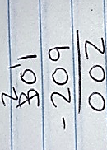
The traditional way that students were taught to perform the “borrowing” strategy encouraged them to narrate the digits (cross out the three and make it a two, put a 1 here and make it a twelve), rather than the place values (make three tens (thirty) two tens (twenty), and put the ten with the two to make twelve). It is easy for students to lose track of the value of the amounts they are shifting, which can lead to common errors, like the one below:

Unit 4: Our Base Ten System
Learning Objectives | CCRSAE
I can break a number down into 1’s, 10’s, 100’s, and 1,000’s in multiple ways. | 2.NBT.1–3, 4.NBT.1, 5.NBT.1–2
I can easily add or subtract 10’s, 100’s, or 1,000’s without a calculator. | 2.NBT.7–8
I can use parentheses to represent multiplication. | 5.OA.1 (parentheses as mult. only)
I can give a reason why one choice doesn’t belong with the group. | MP.3
I can keep working on a challenging problem even if I don’t understand it right away. | MP.1
I can fill in missing numbers on a number line. | 2.MD.6, also with intervals of lengths greater than 1

Note: EMPower materials featured in Unit 9 can be found in Lesson 8 (Take Your Winnings) of the Everyday Number Sense: Mental Math and Visual Models books.

Standards for Mathematical Practice
In addition to the standards targeted by the routines in this packet (Open Middle, MP.1 and Which One Doesn’t Belong, MP.3), this unit also involves:
MP.7 Look for and make use of structure
Students explore relationships between place values in the base ten system by looking for different ways that a check could be cashed.
MP.8 Look for and express regularity in repeated reasoning
Students are pushed to generalize about whether certain patterns will always be the same when doubling and whether certain place value relationships will hold true for larger place values.

Extra Resources for this Unit
Reproducible: Evaluation Unit 4, Teacher’s Guide, p. 53
Reproducible: Quiz, Units 3 & 4, Teacher’s Guide, pp. 55–56
Reproducible: Blank Number Lines, Teacher’s Guide, pp. 58–59

Other materials
play money, base ten blocks

Math Background
Students’ familiarity with denominations of money provides a basis for developing a deepened awareness of the composition of numbers in the base-10 system. This familiarity also is a foundation for an intuitive understanding of an expanded notation for a number, place value, and ease with mental calculations. This unit develops three important mathematical ideas.

Noticing patterns in the composition of base-10 numbers provides a basis for more powerful mental math calculations
The lottery activity requires students to go beyond identifying the place value of the digits in a four-digit number. Although it is important to be able to note the place value of each digit (the usual treatment of place value in basic math books), this exercise is designed to go a step further. By calculating how many $1,000, $100, and $10 bills they can derive from a certain amount of money, students not only attend to place value but at the same time develop connections between 10s, 100s, and 1,000s. Knowing that there are 10 hundreds in 1,000, 100 tens in 1,000, and 10 tens in 100 is important and provides a basis for later work, such as mentally multiplying and dividing by 10s, 100s, 1,000s, and their multiples.

A repertoire of notation conventions offers multiple ways to record and represent concrete experiences
Knowing equivalent expressions for a quantity and connecting those expressions to concrete representations is important. Play money or virtual manipulatives can be useful here. Parentheses are introduced in this lesson as a way to group and separate amounts.
The lesson also treats expanded notation more broadly than merely writing a number to show the value of each place, e.g., 679 = 6(100) + 7(10) + 9(1). Although students might be familiar with what is traditionally understood as expanded notation, they are asked to think about alternative and equivalent expansions of the number, such as 67(10) + 9(1).

The calculator can be used in tandem with mental calculations
This lesson focuses on the calculator as a way to check against reasonable mental calculations. Dissonance caused by answers that vary when both a calculator and mental math are used presents an opportunity to bring in concrete examples as the arbiter.

Relevance
This unit includes some information about the non-Western roots of the base ten number system, as well as some examples of number systems that do not use base ten. The discussion of the Maya base 20 system could be accompanied by other examples of their advanced achievements in mathematics and science.
Note: When discussing the Maya people and culture, it is important to convey that the people and culture very much still exist. Although the Maya political empire collapsed around 900 AD, the people, culture, and languages are still alive and influential in many parts of Central America. Also, although “Mayan” is often used as an adjective, Maya is the correct and preferred form for both noun and adjective.
This unit also uses the context of cashing checks to talk about how numbers are built with powers of ten. There is a financial literacy reading and a short activity about the fees associated with cashing checks at a check cashing service versus a traditional bank.

Activities and Practice

Our Base Ten System
In-Person/Remote Activity
Uses Student Packet pp. 97–98
Read the text. Make sure students understand the idea of “base ten” referring to our use of groups of tens to make new place values.

Other Number Systems
In-Person/Remote Activity
Uses Student Packet pp. 99–101
This introduces examples of a base twenty system (developed by the ancient Maya, among others) and a base two system (binary, used in computers). The point is not that students be able to use base twenty or base two, but just to introduce them to the fact that other systems exist. The examples at the end are to show how a number in base ten might look very different in another base system. The details are less important.

More Maya Mathematics
In-Person/Remote Activity
Uses Student Packet p. 94
Read the information at the top and ask students what they notice and wonder about the symbols for the numbers 0-20. A couple of interesting features:
- Maya “digits” use only three symbols, a dot, a line, and a shell. Numbers 0-20 are created by repeating groups of 5 and 1 (lines and dots), so the symbol for 16, for example is a visual representation of the structure of the number 16 (each line is worth 5, plus the dot, worth 1).
- The Maya had both a symbol and a clear understanding of zero as a number and a place value holder, centuries before this was adopted in Europe. Below, we can see the shell represents 0, but also becomes a place value holder in the number 20 (the dot representing one group of 20, the shell showing 0 additional ones).
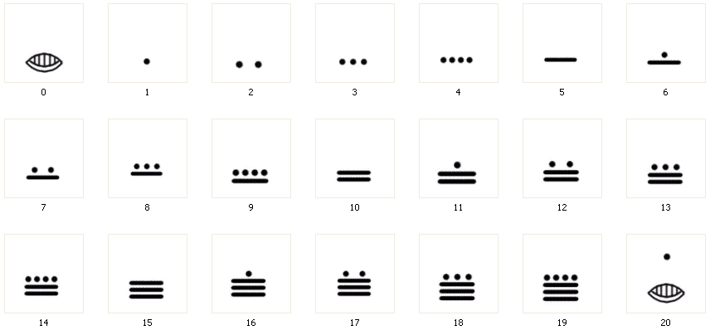

Vocabulary for this Unit
In-Person/Remote Activity
Uses Student Packet pp. 103–104
Fill-in-the-blank definitions and examples have been provided for the major terms in this unit. Teach/review words along with activities where they arise, rather than teaching them all at once.
- base ten: as place values move left, each gets ten times bigger
- parentheses: in math notation, parentheses can be used to show multiplication
- double: to multiply by two (or, to add a number to itself)

How do you want your money?
In-Person/Remote Activity
Uses Student Packet pp. 105–106
- Open the discussion by telling students that they will work more with tens, hundreds, and thousands today. They will need to think about the make-up of large amounts of money. As an introduction, pose the following questions:
If you had $1,000 in $100 bills, how many $100 bills would you have?
How do you know?
- Ask a volunteer to demonstrate the solution using play money or slips of paper (if in person) marked in appropriate denominations. In a remote class, the teacher could demonstrate with a virtual money manipulative, such as:
Play Money by Toy Theater:
https://toytheater.com/play-money-united-states/
Although this website only uses numbers on each “bill”, this also works well for demonstrating how place values can be grouped and ungrouped:
Make a Ten by Phet:
https://phet.colorado.edu/sims/html/make-a-ten/latest/make-a-ten_en.html
- Then ask someone to describe that solution process with numbers and math symbols. Students might write:
$100 + $100 + … + $100 = $1,000
or
10 × $100 = $1,000
or
$1,000 ÷ $100 = 10
- Make explicit the connection between the concrete task in the money demonstration and the symbolic math notation. Then ask:
If you had $1,000 in $10 bills, how many $10 bills would you have?
How do you know?
- Again, ask for a demonstration of the solution both in paper money and symbolically. Students might write:
100 × $10 = $1,000
or
$1,000 ÷ $10 = 100
- Ask:
If you worked at a bank as a teller, how could you count out $520?
What if you don’t have any $100 bills? Are there other ways you could count it out?
See if students understand how they could make $520 with 52 ten dollar bills. If needed, use one of the virtual or paper manipulatives to show how groups of ten $10 bills make each hundred.
Note: If students show signs of struggling with the connection between tens and hundreds in the last part of the opening discussion, work through more examples like the one where they count out $520, using numbers in the hundreds, before moving on to the numbers used in this activity.
- Ask a volunteer to read the story aloud at the beginning of How Do You Want Your Money? When everyone is clear about the directions, encourage student pairs to talk with one another to reach agreement on the ways each woman (Andrea, Bibi, and Carla) will receive her winnings.
- When everyone has finished the first problem, ask for volunteers to explain their solutions for the three different distributions of $2,643. Ask:
Who wants to share how they solved this problem?
Who solved it differently?
How can you be sure your answer is right?
- Write all offerings on the board. If there is disagreement, ask for verification with play money or a virtual manipulative.
Correct solutions for each woman’s payment preference are as follows:
Andrea receives two $1,000 bills and the rest ($643) in various denominations. Possibilities include:
- two $1,000 bills, six $100 bills, four $10 bills, and three $1 bills, or
- two $1,000 bills, sixty-four $10 bills, and three $1 bills, or
- two $1,000 bills, five $100 bills, 14 $10 bills and three $1 bills.
Bibi receives twenty-six $100 bills and the rest ($43) in various denominations.
Carla receives two hundred and sixty-four $10 bills with three $1 bills for the remainder.
Use this activity as an opportunity to reinforce the convention of parentheses in notation. Establish the practice that from now on the class will write two $1,000 bills and six $100 bills and four $10 bills and three $1 bills as
2($1,000) + 6($100) + 4($10) + 3($1)
- Have pairs continue with Problems 2 and 3, asking students now to use parentheses in the notation. In other words, “2($1,000)” will be a way to write “two $1,000 bills.”
- Share offerings for Problems 2 and 3 and reach agreement on possible ways each woman might receive her money. Say:
We have looked at various ways that an amount of money can be given; now we are going to think about a different situation.
- Post these questions or share them on a transparency one at a time:
Suppose Dora asked for her money in $10 bills. The clerk gave her 28($10) + 5($1). What was her total? ($285)
Suppose Emilia received 36($100) + 5($10). What was her total? ($3,650)
- Conclude this activity by pushing for some generalizations about the relationship between 1,000s, 100s, and 10s. Ask:
What patterns have you noticed about the make-up of a number?
Students might offers statements such as these:
“Three thousand, four hundred can be read as thirty-four hundred.”
“One thousand is the same as 10 hundreds.”
“One thousand is the same as 100 tens.”
If no one mentions that a number such as 3,000 is the same as 30 hundreds or 300 tens [3(1,000) = 30(100) = 300(10)], ask people to fill in the missing amounts in number sentences such as these: 3(1,000) = ?(100) = ?(10). Then ask students again what patterns they notice, especially with the zeroes.

Where Can I Cash My Check?
In-Person/Remote Activity
Uses Student Packet p. 107
- Ask students if they know any check cashing services in the local area. Invite them to share what they know about them and what their experience has been. Also ask them to brainstorm traditional banks that exist in the area and what their experience has been with those.
- Read the article that discusses the advantages and disadvantages of each.

Fees, Fees, Fees
In-Person/Remote Activity
Uses Student Packet p. 108
- Explain that check cashing services charge a fee to cash a check. Although the fee might seem small, it can add up over time.
- Ask students to continue to fill out the chart. Ask them to share strategies for finding the totals. Discuss the total of $364 in fees that Maria will have paid by the end of the year.
Possible discussion questions:
- Does this fee seem reasonable for the advantages of check cashing services?
- Some people argue that check cashers take advantage of low-income people, who are more likely to need to use their paycheck money right away. Other people argue that check cashers are providing an important service. What do you think?

Mystery Numbers
In-Person/Remote Activity
Uses Student Packet p. 109
This activity presents a game in which students figure out the amount that has been added or subtracted to change one number into another on the calculator screen. The goal is to investigate the effects of adding and subtracting multiples of 10, 100, and 1,000. The activity should go quickly, but it will afford another opportunity to concentrate on deconstructing numbers. Students will need to pay attention to place value.
Note: Make sure everyone has a calculator. In a remote classroom, have students use the calculator function on their phones.
- On the board, write a three- or four-digit number as the starting number. Ask students to clear their screens and enter that number in their calculators.
- Now secretly add 100 to the number and write the result as the end number. Set up the board like this:
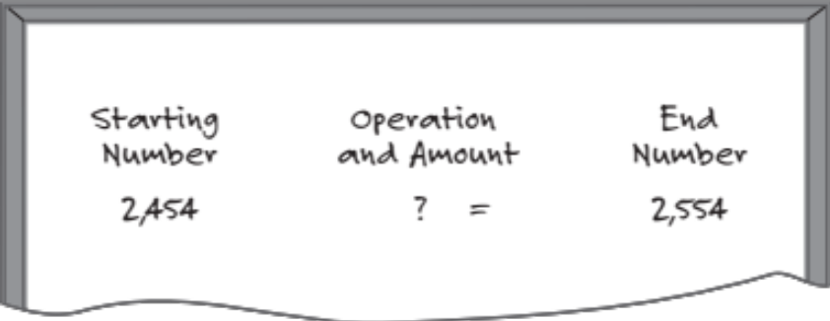

And then ask:
What could you do to the starting number to arrive at the end number? Do this in your head. How do you know?
- Take all suggestions and ask students to verify accuracy, using the calculator to check the operation with the number of the proposed answer and then pressing the “=” key to arrive at the result.
- Do another problem, this time secretly adding or subtracting a multiple of 10, 100, or 1,000 to a starting number to get the end number. Students first arrive at the operation and amount using mental math and then verify their answers with calculators.
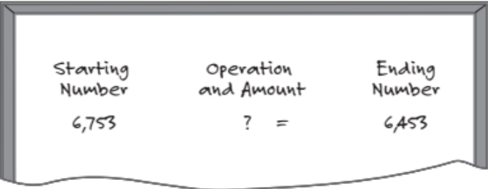
For example: You write “6,753” and students enter in their calculators “6,753.” You secretly subtract 300 and write down “6,453”for the end number. Students again use mental math to find the answer and calculators to check its accuracy.
- Next, ask students to suggest some starting numbers. Proceed with each number as you did with the previous problems and give students the end number. For example:
7,541 – 40 = 7,501
Note: Be prepared for issues about calculator use to arise. For example, students who are accustomed to seeing a comma divide decimal and whole numbers may be thrown off. Some students may need to be reminded to press the equal key.
- Direct individuals to complete Mystery Numbers. When everyone is done, compare and verify solutions and summarize by asking:
What did you look at to make your decisions about the operation and amount?
What makes it so easy to do these problems in your head?
Students should notice which digit changed, the value of the digit in that place, and whether there was an increase or decrease. In each case, they should see that adding or subtracting a multiple of 10, 100, or 1,000 made the math easy to do mentally.
When you review this activity, call attention to “wrap-around” numbers, those that change in more than one column as you add or subtract. Ask students to share their strategies for solving these and illustrate their comments with a number line. Provide a few more examples if these problems interest students (for example, 526 – 80; 739 + 70).

True or False?
In-Person/Remote Activity
Uses Student Packet p. 110
Practice deciding whether equations are true or false. Equations based on place value decompositions.

More Mystery Numbers
In-Person/Remote Activity
Uses Student Packet p. 111
Similar to previous activity.

Mental Math Practice: Double Trouble
In-Person/Remote Activity
Uses Student Packet pp. 112–113
Practice looking for patterns in the ones place when numbers are doubled.

Test Practice
In-Person/Remote Activity
Uses Student Packet pp. 114–115

Answer Key
- a
- b
- c
- e
- c
- 300

Which One Doesn’t Belong? 4
In-Person/Remote Activity
Uses Student Packet p. 116
Push students to name place values in their responses. Some possible responses:
- Upper left doesn’t belong because it is the only set to increase by a factor of ten each time (or to add a zero, or to multiply by ten).
- Upper right is the only set with no zeros. It increases by one place value each time, but not by multiplying by ten.
- Lower left doesn’t belong because it is the only set to increase by a factor of 100 each time (or to add two zeros, or to multiply by 100)
- Lower right doesn’t belong because the one digit increases in place value, but the two remains in the ones place. This pattern does not appear in the other sets.

Greatest Difference of Two Rounded Numbers
In-Person/Remote Activity
Uses Student Packet p. 117
This Open Middle problem pushes students to explore the extremes of rounding. It is not explicit about whether the numbers are rounded to the nearest ten or nearest 100: both interpretations could be valid. Students will have to think about the largest and smallest numbers they can round to 500.
Reasonable answers could include 549 – 450 = 99, or 495 – 504 = 9.
Students may also question whether decimals could be used, i.e., 549.5 – 450.5 = 99
Allow differences in responses to create discussion. Remind students that we round for different reasons, depending on how precise we need our rounded number to be and what numbers will be easy to work with.

Create an Equation
In-Person/Remote Activity
Uses Student Packet p. 118
This Open Middle problem can be done a few times with different variations. First, have students create an equation that works. Later you can have them find the smallest or largest sum. Discuss the limitations posed by the place values available. For an extra challenge, have students only use each digit once, 1–9 only. Solutions are as follows:
- Largest sum without digit restriction: Any combination that adds to 99.
- Largest sum with digit restriction: There are several ways to make 98, including 98 = 57 + 41
- Smallest sum without digit restriction: Any combination that adds to 10, or to 01 if you want to allow zero in the tens place.
- Smallest sum with digit restriction: 39 = 14 + 25, 39 = 15 + 24

Number Line Puzzles 4
In-Person/Remote Activity
Uses Student Packet p. 119

Answer Key
A: 1,200, 1,210, 1,220, intervals of 10
B: 1,850, 1,950, intervals of 100
C: 5,300, 6,300, 7,300, intervals of 1,000

NUMBER Sense Quiz (Units 3&4)
In-Person/Remote Activity
Uses Teacher’s Guide pp. 55–56

Answer Key
- a) Missing Amount
b) Take Away
c) Comparison
- Student work will be the most useful in determining understanding. The answers are:
122 – 119 = 3 (Did students recognize the small difference or just plug away at a regrouping algorithm?)
450 – 280 = 170
670 – 498 = 172
- Nina won $4,180. Describe two different ways that she could take her winnings using $1,000, $100, or $10 bills. Write an equation for each.
Some possibilities (not exhaustive):
4(1,000) + 1(100) + 8(10) = 4,180
41(100) + 8(10) = 4,180
418(10) = 4,180
3(1,000) + 11(100) + 8(10) = 4,180
- Decide if each equation is true or false. How do you know?
a) 5(1,000) + 6(100) + 3(1) = 56(100) + 3(10) FALSE 5,603 $≠$ 5,630
b) 5(1,000) + 6(100) + 30(1) = 56(100) + 3(10) TRUE 5,630 = 5,630
c) 56(100) + 30(10) = 59(100) TRUE 5,900 = 5,900

Vocabulary
base ten: as place values move left, each gets ten times bigger
parentheses: in math notation, parentheses can be used to show multiplication
double: to multiply by two (or, to add a number to itself)

Things to Watch For

Difficulty with non-standard forms of expanded notation
As students begin working with different ways of “counting out” money, they will often naturally break up numbers by place value (standard expanded notation). For example,
$3,843 = 3($1000) + 8($100) + 4($10) + 3($1)
This shows an understanding of place value. We can then help students deepen their understanding by finding other ways to count out the total, which forces them to think about the relationships between different place values, such as understanding that $3,800 could be made with 38($100) or 380($10).
It is also possible for students to mix and match, with solutions like
2($1000) + 18($100) + 4($10) + 3($1)
In this case, some of the value in the thousands place is made by hundreds.
If students struggle with these, start with three-digit numbers. Use visuals like the virtual manipulatives or paper play money to help them see how groups of ten create a new place value.

“Wrap-Around” Numbers
“Wrap Around” numbers occur when more than one place value changes at once. For example, when students are trying to solve the mystery number
9,705 + ? = 10,005
Adding 300 causes both the hundreds, thousands, and ten-thousands places to change.
Understanding wrap around numbers involves understanding the sequence and patterns of numbers in larger place values. If you find students struggling with this, reviewing the counting by tens and hundreds activities can help. Do these counting activities on a number line to help students visually see the sequence of numbers.

Name:___________________________ Date:__________________
Operation Sense: Unit 1, Hundreds and Thousands
Objective | Student Self-Evaluation  (Struggling, Learning, Mastery) | Teacher  Evaluation
- I can round numbers to the nearest ten and hundred.
- I can read and write large numbers in the hundreds and thousands.
- I can order and locate numbers in the hundreds and thousands on a number line.
- I can give a reason why one choice doesn’t belong with the group.
I can keep working on a challenging problem even if I don’t understand it right away.
I can fill in missing numbers on a number line.
Name:___________________________ Date:__________________
Operation Sense: Unit 2, Subtraction and Number Lines
Objective | Student Self-Evaluation  (Struggling, Learning, Mastery) | Teacher  Evaluation
- I can use a number line to explain my addition and subtraction strategies.
- I can count up and down by 10s and 1s to solve addition and subtraction problems.
- I can write equations to match my strategies.
- I can give a reason why one choice doesn’t belong with the group.
- I can keep working on a challenging problem even if I don’t understand it right away.
Name:___________________________ Date:__________________
Operation Sense: Unit 3, Going Deeper with Subtraction
Objective | Student Self-Evaluation  (Struggling, Learning, Mastery) | Teacher  Evaluation
- I can recognize subtraction problems that involve a missing amount, comparison, or take away.
- I can explain why the regrouping strategy works.
- I can give a reason why one choice doesn’t belong with the group.
- I can keep working on a challenging problem even if I don’t understand it right away.
- I can fill in missing numbers on a number line.
Name:___________________________ Date:__________________
Operation Sense: Unit 4, Our Base Ten System
Objective | Student Self-Evaluation  (Struggling, Learning, Mastery) | Teacher  Evaluation
- I can break a number down into 1’s, 10’s, 100’s, and 1,000’s in multiple ways.
- I can easily add or subtract 10’s, 100’s, or 1,000’s without a calculator.
- I can use parentheses to represent multiplication.
- I can keep working on a challenging problem even if I don’t understand it right away.
- I can fill in missing numbers on a number line.
Name:___________________________ Date:__________________

Number Sense Quiz (Units 1 & 2)
- Write the number below in standard form.
Six thousand, four hundred fifty:__________________

Which filing cabinet would this go in?
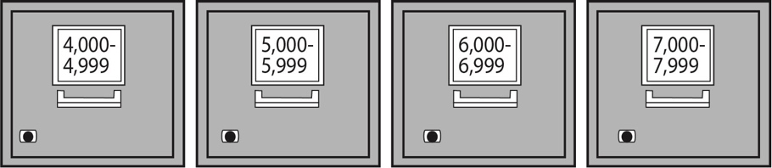

- 4,000 – 4,999
- 5,000 – 5,999
- 6,000 – 6,999
- 7,000 – 7,999
- Doretha was born in 1985. How old was she in 2021? Show your work on the number line below.

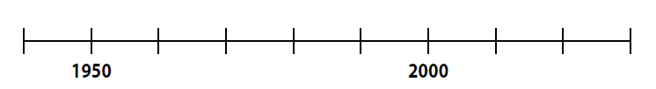
Write an equation that matches how you solved the problem.

Name:___________________________ Date:__________________

Number Sense Quiz (Units 3 & 4)
- Label each word problem below with the model of subtraction it demonstrates (missing amount, comparison, or take away).

- Last week I had $430 in my bank account. Today I have $350. How much did I spend since last week?

- I have $450 in my budget for food this month. So far I have spent $290. How much do I have left?

- Last week I spent $120 on groceries. This week I spent $150. How much more did I spend this week?

- Subtract. Draw or explain your strategy.

122 – 119 =

450 – 280 =

670 – 498 =

- Nina won $4,180. Describe two different ways that she could take her winnings using $1,000, $100, or $10 bills.

Write an equation for each.

- Decide if each equation is true or false. How do you know?

- 5(1,000) + 6(100) + 3(1) = 56(100) + 3(10)

- 5(1,000) + 6(100) + 30(1) = 56(100) + 3(10)

- 56(100) + 30(10) = 59(100)

Rounding Number Line Template
- Put the benchmarks in the boxes. Label the midpoint.
- Which side of the midpoint is the exact amount?
- Circle the benchmark nearest to the exact amount.

Exact amount:

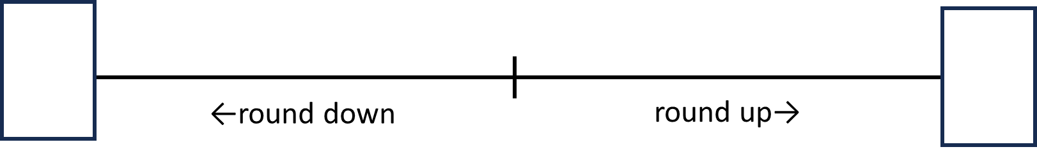

Exact amount:

Exact amount:

Exact amount:

Blank Number Lines

