
Operation Sense
Beginning Curriculum for Adults Learning Math

STUDENT PACKET



Acknowledgements

The titles in the BeCALM series were developed and piloted in the classroom by Melissa Braaten for the SABES Mathematics and Adult Numeracy Curriculum & Instruction PD Team, with contributions from Yvonne Readdy, Emily Rudd, and Sherry Soares.

The BeCALM series includes four sequential packets:
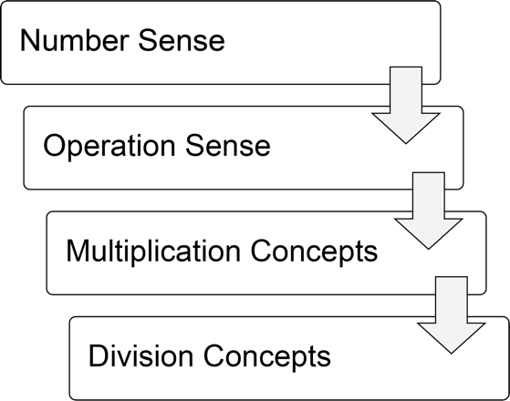
and three non-sequential packets:
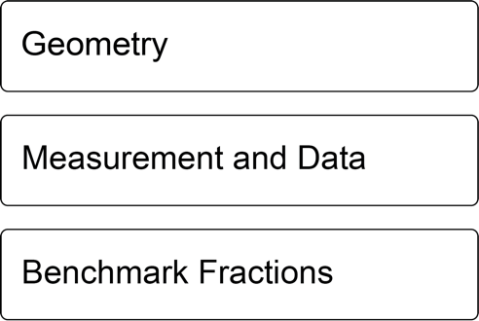

Activities from the EMPower™ and EMPower Plus™ series title Everyday Number Sense: Mental Math and Visual Models Student Book are used and/or adapted with permission from the author, TERC, Inc.

Operation sense is the understanding of how the basic operations (addition, subtraction, multiplication, and division) are related to each other, and how they are used to solve real world problems.

Operation sense also involves having multiple strategies for performing different operations. The next couple of units will focus on operation sense with addition and subtraction.

Hmm, I had $40, but now I
only have $28 dollars left. I can add up to
figure out how much I spent. 28 plus 2 is 30,
then I add 10 more. So I added 12.
That means I spent $12.

Hmm, I know I had 50 flyers when I started, but now there are only 21 left. How many did I give out? I can subtract 50—21 to find out what is missing.

UNIT 1: Hundreds and Thousands

Using Transportation in the U.S.
This article and the one on the following page were published on page 10 of The Change Agent, Issue 43 “Transportation”, September 2016.

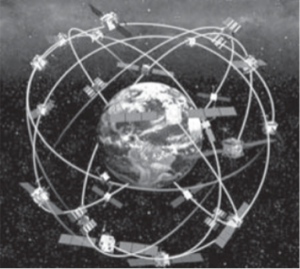
Not Finding My Way with GPS
By Adnan Mesrabi

I had been in this country for only two weeks. It was my first day at the University of New Haven. It was very cold. I did not have a car.
GPS uses satellites to calculate your position on Earth.
I did not want to miss my first day at the university. I had only one choice: the train. Inside the train, I was comfortable and warm, but outside the train, I was freezing. I used my GPS to get directions to the university, but I forgot to put my GPS on "walk" mode. I left it in "drive" mode.
It took me to Interstate 95. I was very confused, and I was going the wrong way. I did not know what I could do. I decided to return to the train station and wait for my friends to give me a ride.

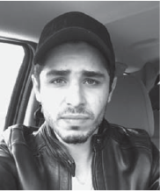

Adnan Mesrabi is originally from Syria. He left his country in 2012 because of the war. He was a good student. In his last year in high school, he was ranked second in his city. Now he is at student at East Shore Region Adult & Continuing Education in Branford, CT, where he is studying for the TOEFL so that he can go to college.

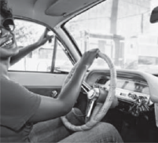
Sometimes You Just Have to Do It!
By Rose Carmelle Sandy Valcin

When I came to the U.S., my husband said to me, "My love, in America you must be independent. You have to be able to go anywhere, sometimes alone." In my native country, when I wanted to go out, I always found someone to go with me. But in the U.S., people go out alone.
My husband taught me how to drive. I thought it was going to be difficult for me because in America you have to move fast. The day arrived that I had to drive by myself. I had no choice because I had to get the children to school, and my husband had gone to work early. I took the wheel and I drove! I was really excited (because I was going to drive alone) and angry (because I wasn't ready). Obviously, my husband thought differently. Thank God, everything went well. Since that day, I learned how to go everywhere I want without the help of my husband. The ease of private transportation is so good, it makes you independent and always ready to go!

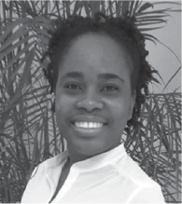
Rose C. Sandy Valcin is 28 years old. She is from Haiti, and she has two handsome boys. She earned a bachelor’s degree in business administration in the Dominican Republic. She is fluent in Spanish, French, and Creole. Now, she is learning English at Atlantic Technical College in Fort Lauderdale, FL, so that she can get a better job.

Questions for Discussion

How do you prefer to get to school or work?

How do you prefer to travel?

How has access to transportation affected your life?

Vocabulary List for This Unit
Word | Definition | Example
digit | a ___________ used to write numbers. | 0, 1, 2, 3, 4, 5, 6, 7, 8, and 9
place value | each digit in a number has a place value, which tells how much that digit is __________ | 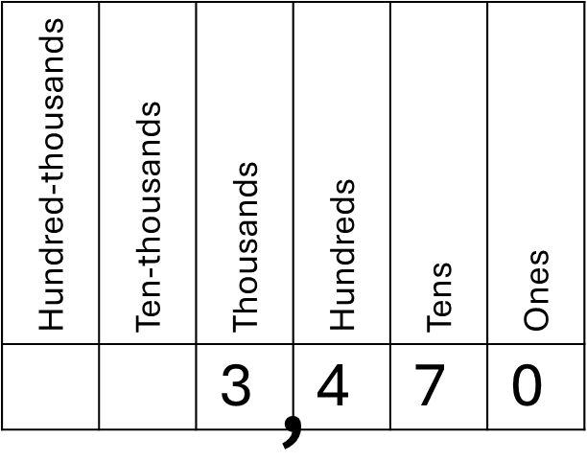  In this number, the 4 is worth 400.
rounding | __________ a number by choosing a benchmark close to the number. It is common to round to place values (the nearest 10 or 100, for example) | 3,470 rounded to the nearest 100 is 3,500.
four-digit number | a four-digit number will have digits in the __________, hundreds, tens, and ones place. | 3,470 is a four-digit number  Three thousand, four hundred seventy

Word | Definition | Example

How Many Miles to Boston?
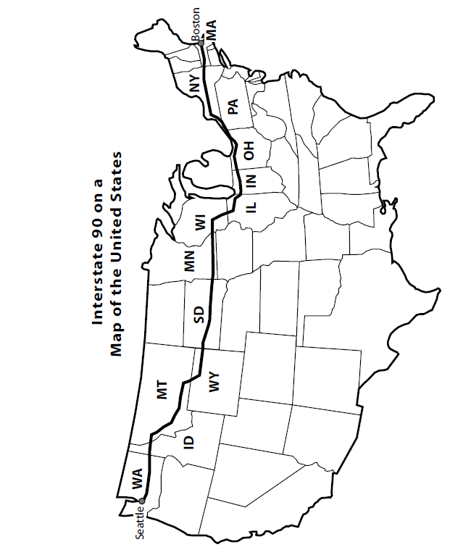
Interstate 90 (I-90) is the longest highway in the United States. It extends across the country from Seattle, Washington, to Boston, Massachusetts, crossing many states for a total of about 3,000 miles.

Source: EMPower™ book Everyday Number Sense: Mental Math and Visual Models

Use the number line below to think about a cross-country trip from Seattle to Boston. You should plan to travel 300 miles a day.

How many days will your trip take?

Planning a Trip
Starting in Seattle, WA (mile 0), plan a trip across the country to Boston on I-90. You want to travel about 300 miles per day. Circle each city that you will stay in (see page 12). Then, answer the questions below.

- Will you spend more than one night in any state? Which one(s)?

- Which town is closest to the halfway mark?

- How many days will you spend traveling across the country?

- Did you use rounding and mental calculations to arrive at your answers? How?

Travel Data for I-90
Seattle, WA (Jct I-5)—0 | Sundance, WY—1,111 | Rockford, IL—2,020
Mercer Island, WA—5 | Spearfish, SD—1,143 | Belvidere, IL—2,029
Bellevue, WA—8 | Sturgis, SD—1,161 | Elgin, WI—2,059
Issaquah, WA—15 | Rapid City, SD—1,189 | O’Hare Airport, IL—2,082
Easton, WA—69 | Box Elder, SD—1,196 | Junction I-94, IL—2,089
Cle Elum, WA—82 | Wall, SD—1,242 | Chicago, IL—2,097
Ellensburg, WA—108 | Kadoka, SD—1,282 | Junction I-94, IL—2,104
Kittitas, WA—114 | Murdo, SD—1,323 | Hammond, IN—2,119
Moses Lake, WA—174 | Jct I-83, SD—1,340 | Gary, IN—2,126
Sprague, WA—243 | Presho, SD—1,357 | Portage, IN—2,136
Spokane, WA—280 | Kennebec, SD—1,367 | South Bend, IN—2,179
Greenacres, WA—293 | Chamberlain, SD—1,395 | Elkhart, IN (I-80)—2,189
Post Falls, ID—302 | Plankinton, SD—1,440 | Junction I-69, IN—2,231
Coeur d’Alene, ID—310 | Mitchell, SD—1,462 | Toledo, OH— 2,309
Kellogg, ID—348 | Hartford, SD—1,519 | Lorain, OH—2,387
Wallace, ID—359 | Sioux Falls, SD—1,530 | Cleveland, OH—2,415
Superior, MT—418 | Luverne, MN—1,556 | Euclid, OH—2,430
Alberton, MT—446 | Worthington, MN—1,588 | Madison, OH—2,458
Missoula, MT—475 | Jackson, MN—1,618 | Conneaut, OH—2,486
Drummond, MT—525 | Fairmont, MN—1,646 | Erie, PA—2,513
Deer Lodge, MT—555 | Albert Lea, MN—1,702 | Junction I-86, PA—2,525
Butte, MT—593 | Austin, MN—1,722 | Buffalo, NY—2,605
Whitehall, MT—626 | Rochester, MN—1,753 | Rochester, NY—2,669
Bozeman, MT—678 | St. Charles, MN—1,776 | Syracuse, NY—2,748
Columbus, MT—778 | La Crosse, WI—1,823 | Utica, NY—2,826
Billings, MT—821 | Sparta, WI—1,845 | Amsterdam, NY—2,890
Junction I-94, MT—826 | Junction I-94, WI—1,864 | Schenectady, NY—2,918
Hardin, MT—865 | Mauston, WI—1,889 | Albany, NY—2,938
Crow Agency, MT—879 | Wisconsin Dells, WI—1,904 | W. Springfield, MA— 3,019
Sheridan, WY—947 | Junction I-39, WI—1,925 | Worcester, MA—3,069
Buffalo, WY—981 | Madison, WI—1,955 | Junction I-95, MA—3,098
Gillette, WY—1,050 | Janesville, WI—1,988 | Boston, MA—3,112
Moorcroft, WY—1,078 | Beloit, WI—2,002

Traveling and Civil Rights in the U.S.

A Short History
1. The Negro Motorist Green-Book (1940 edition)
This guidebook was written by Victor H. Green, an African American mailman from New York City. It appeared yearly between 1936 and 1966. It helped Black travelers navigate "sundown towns" which Black people had to leave by sunset. Sometimes it was called "Negro Traveller's Green-Book.
History Note: The word “Negro” was commonly used by African Americans to refer to themselves during earlier periods in American history.

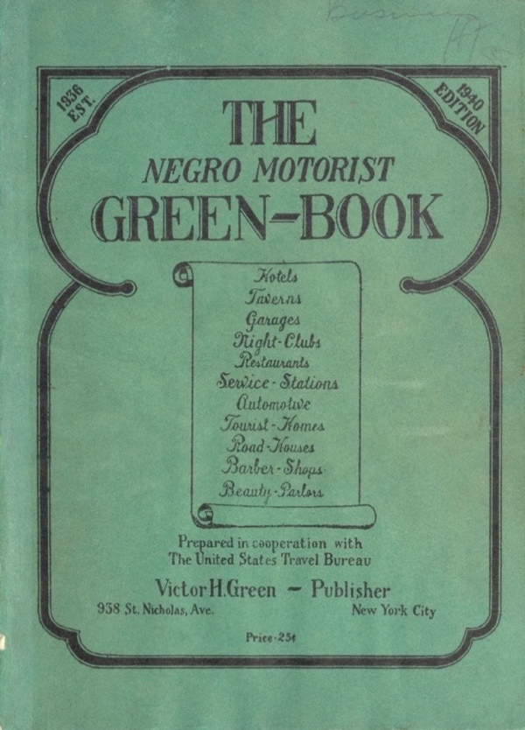
The guide for travel and vacations as shown in the Hollywood movie Green Book (2018).
Source: https://en.wikipedia.org/wiki/The_Negro_Motorist_Green_Book#/media/File:The_Negro_Motorist_Green_Book.jpg
2. Travelling While Black
The Green Book was created and published during a period of Jim Crow segregation in the United States. Car travel had become popular, but Black Americans (as well as other ethnic and religious minorities, such as Mexicans and Jews) faced harassment, discrimination, or violence when they tried to use certain public accommodations like restaurants, hotels, and gas stations. The Green Book listed business in each city that were safe and friendly to African Americans so they could travel safely.

There will be a day sometime in the near future when this guide will not have to be published. That is when we as a race will have equal opportunities and privileges in the United States. It will be a great day for us to suspend this publication for then we can go wherever we please, and without embarrassment.

Source: Introduction, Negro Motorist Green Book, 1948 edition. https://www.history.com/news/the-green-book-the-black-travelers-guide-to-jim-crow-america

3. Montgomery Bus Boycott: Resisting Discrimination in Transportation
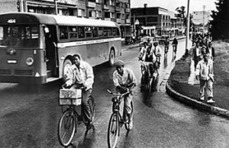
African Americans faced discrimination not only in long distance car travel, but in local transportation as well. Under Jim Crow, buses, especially in the South, were segregated. Black riders had to sit in the back of the bus and were regularly harassed by drivers. In 1955, African Americans in Montgomery, AL, successfully boycotted (refused to ride) the buses for 381 days. They set up systems of carpooling and ride sharing to make this possible.

This eventually brought an end to the segregation of buses when the U.S. Supreme Court ruled that segregated buses were illegal because they did not provide “equal protection under the law,” as guaranteed by the 14th Amendment. This was an early victory against Jim Crow segregation.
4. Resisting Discrimination in Public Accommodations
One form of protest used successfully during the Civil Rights movement of the 1960s were lunch counter sit-ins. Under Jim Crow, African Americans were not allowed to sit and eat at certain lunch counters.
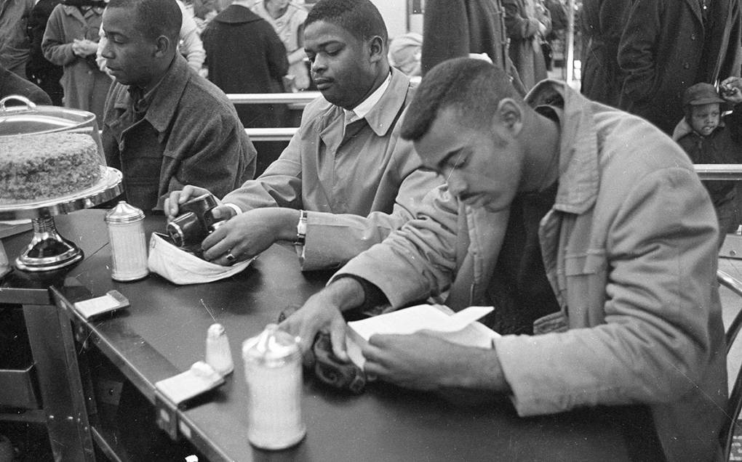
Three Civil Rights protesters at Woolworth's Sit-In, Durham, NC, 10 February 1960, as part of a series of protests that led to the end of legal segregation. Source: State Archives of North Carolina under Public Domain
Restaurants could discriminate and only serve white customers. During the sit-ins, black college students would sit quietly at the whites-only lunch counters. They were harassed and sometimes beaten. They refused to fight back, other than to sit peacefully until they were forcibly removed or arrested.
This helped the movement gain support, as more people saw how violent Jim Crow segregation was. Segregation in public accommodations like restaurants and hotels was outlawed under the Civil Rights Act of 1964, one of the great accomplishments of the Civil Rights Movement of the 1950s and 1960s.

Traveling and Civil Rights in the U.S. – Vocabulary List for This Unit
Sundown towns
towns where African Americans (and sometimes other minorities, such as Jews) were harassed and mistreated. They were called sundown towns because black people were told to get out of town before sundown (or else they would be threatened with violence).
Jim Crow
a term for the system of harsh laws and practices that forced African Americans to use separate and inferior institutions, such as schools, public transportation, and public accommodations. This was enforced both legally with harsh punishments and through intimidation and violence.
Segregation
requiring different races to use different facilities. While many claimed that segregation involved “separate but equal” facilities, this was not the reality. African Americans almost always encountered inferior treatment and access under segregation.

Boycott
to refuse to use a certain service or to buy a certain product. Boycotts are used as a form of protest by withholding money from certain companies until they make changes.
Sit-in
a form of non-violent protest in which people would peacefully sit in places they were not permitted to by law. This was used as a way to protest segregation, because the violent way that protesters were treated helped the movement gain sympathy and support.
Civil Rights Act of 1964
made segregation in public accommodations illegal, and outlawed discrimination in employment.

Between Which Hundreds?
We can count by 100. Many numbers will fall between the hundreds.
623
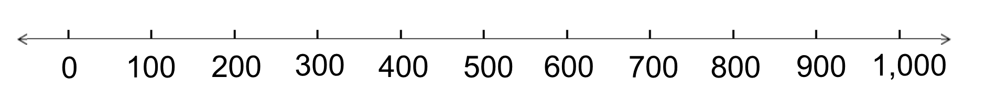

This is more than 600, but less than 700.
We can say that it is between 600 and 700.

Use the number line below to help you decide between which hundreds each amount will be.

- 345 is between _____ and _____.
- 123 is between _____ and _____.
- 670 is between _____ and _____.
- 50 is between _____ and _____.
- 991 is between _____ and _____.

Between Which Hundreds Extension:

Larger Amounts

- 1,345 is between ______ and _______.
- 2,123 is between ______ and _______.
- 5,670 is between ______ and _______.
- 1,050 is between ______ and _______.
- 2,391 is between ______ and _______.

In your own words:
How do you decide which hundreds the amount is between?

These will be our benchmarks for rounding to the nearest hundred.

Rounding to the Nearest Hundred Number Lines
- Put the hundred benchmarks in the boxes. Label the midpoint.
- Which side of the midpoint is the exact amount?
- Circle the hundred nearest to the exact amount.

Example: 239
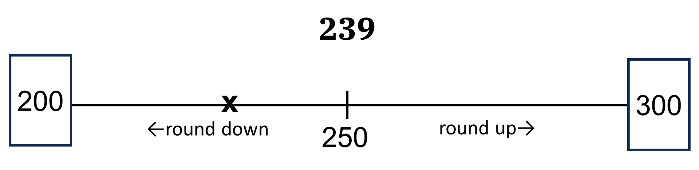
Exact amount: 803
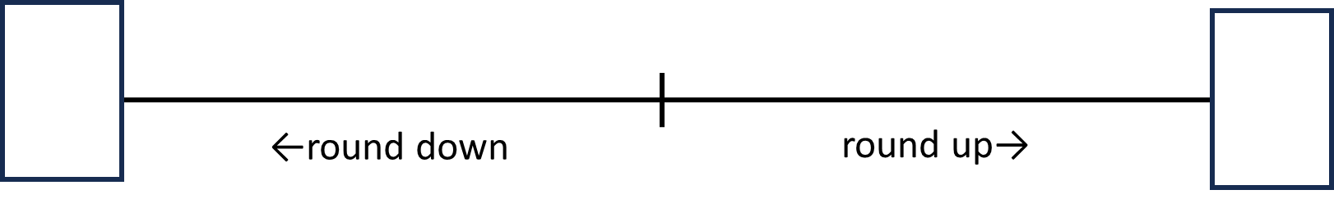
Exact amount: 632
Exact amount: 374

Rounding Distances: Nearest 100 Miles
The number 3,000 is a “friendlier” number than 3,112; the number 400 is easier to think about than 392; and 50 is easier to work with than 47. We often round numbers to friendlier benchmarks so we can work with them more easily.
Round each of distances of I-90 to the nearest hundred miles.
Example using Washington: Is 298 closer to 200 or 300?
State | I-90 Distance  (in miles) | Rounded to the Nearest 100 Miles
Washington | 298
Idaho | 73
Montana | 558
Wyoming | 207
South Dakota | 412
Minnesota | 275
Wisconsin | 188
Illinois | 103
Indiana | 157
Ohio | 244
Pennsylvania | 47
New York | 391
Massachusetts | 159
Total | 3,112
Source: EMPower™ book Everyday Number Sense: Mental Math and Visual Models

Counting Up and Down by 10s

Count Up by 10, Starting at…
20 | 360 | 610
30 | 370 | 620

Count Down by 10, Starting at…
310 | 200
300 | 190

Between Which Tens?
When we count by tens, many numbers fall in between.

62
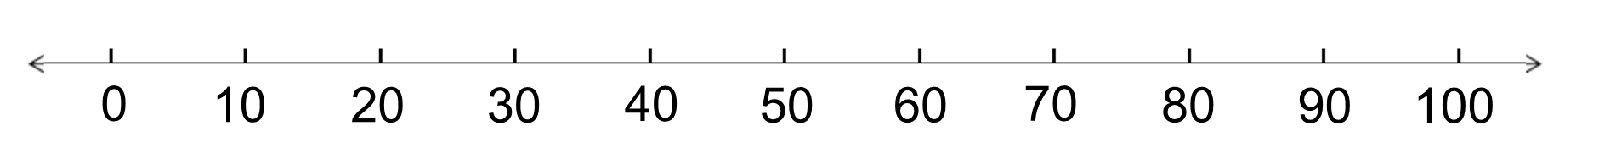

This is more than 60, but less than 70.
We can say that it is between 60 and 70.

Use the number line below to help you decide between which tens each amount will be.

- 34 is between _____ and _____.
- 15 is between _____ and _____.
- 67 is between _____ and _____.
- 59 is between _____ and _____.
- 91 is between _____ and _____.

Between Which Tens Extension:

Larger Amounts
When you count by tens into larger amounts, pay attention to the tens place.
Example: 273 273
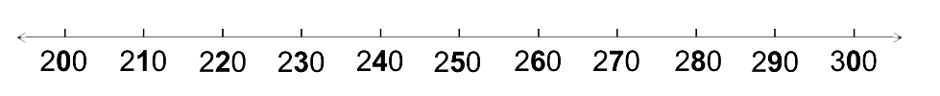
273 is between 270 and 280.
- 345 is between ______ and _______.
- 123 is between ______ and _______.
- 670 is between ______ and _______.
- 234 is between ______ and _______.
- 391 is between ______ and _______.

In your own words:
How do you decide which tens the amount is between?

These will be our benchmarks for rounding to the nearest ten.

Rounding to the Nearest Ten Number Lines
- Put the tens benchmarks in the boxes. Label the midpoint.
- Which side of the midpoint is the exact amount?
- Circle the ten nearest to the exact amount.

Example: 239
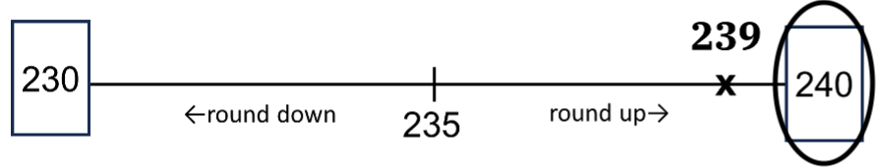
Exact amount: 823
Exact amount: 632
Exact amount: 374

Rounding Distances: Nearest 10 Miles

This time, round each of the distances to the nearest ten miles. Pay close attention to which tens the number is between.
Example using Montana: Is 558 closer to 550 or 560?
State | I-90 Distance  (in miles) | Rounded to the Nearest 10 Miles
Washington | 298
Idaho | 73
Montana | 558
Wyoming | 207
South Dakota | 412
Minnesota | 275
Wisconsin | 188
Illinois | 103
Indiana | 157
Ohio | 244
Pennsylvania | 47
New York | 391
Massachusetts | 159
Total | 3,112
Source: EMPower™ book Everyday Number Sense: Mental Math and Visual Models

Place Value Practice
Use the place value chart to help you read the numbers below.
Hundred-thousands | Ten-thousands | Thousands | Hundreds | Tens | Ones

768
2,560
27,000

450,400

Reading and Writing Large Numbers
Have one partner be Student A and the other Student B. Student A reads the first set of numbers, while Student B writes them down. Then partners switch and Student B reads the second set of numbers.

Student A:

Boston to New York City 190 miles

Boston to Orlando, FL 1,286 miles

Boston to Santo Domingo, 1,650 miles
Dominican Republic

Boston to Los Angeles, CA 2,982 miles

Boston to Mogadishu, Somalia 7,437 miles

Student B:

Boston to Chicago 982 miles

Boston to Port-au-Prince, Haiti 1,643 miles

Boston to Guatemala City, Guatemala 3,496 miles

Boston to Conakry, Guinea 4,123 miles

Boston to Christchurch, New Zealand 9,290 miles

Writing Large Numbers
Write the standard form for each number written in words.

- Twenty-five thousand, four hundred
- Four thousand, eight hundred fifty
- One hundred twenty thousand, one hundred fifty
- Two hundred eighty thousand
- Two hundred thousand, eighty
- Thirteen thousand, sixty-five
- Two thousand, seven hundred
- One thousand, eight
- Thirty thousand, eight hundred thirty-five
- One hundred twenty-nine thousand, one hundred twenty-nine

High and Not-So-High Peaks
The mountains listed here are in alphabetical order.

Bradbury Mountain in the United States 485 feet
Cadillac Mountain in the United States 1,532 feet
Kilimanjaro in Tanzania 19,340 feet
Mt. Apo in the Philippines 9,692 feet
Mt. Cook in New Zealand 12,349 feet
Mt. David in the United States 48 feet
Mt. Etna in Italy 10,902 feet
Pico Duarte in the Dominican Republic 10,417 feet

List the mountains and their heights from lowest to highest.
Mountain Name | Height (in feet)
a.
b.
c.
d.
e.
f.
g.
h.

Source: EMPower™ book Everyday Number Sense: Mental Math and Visual Models

Writing Checks
Write the amount of the check in words.
Example:
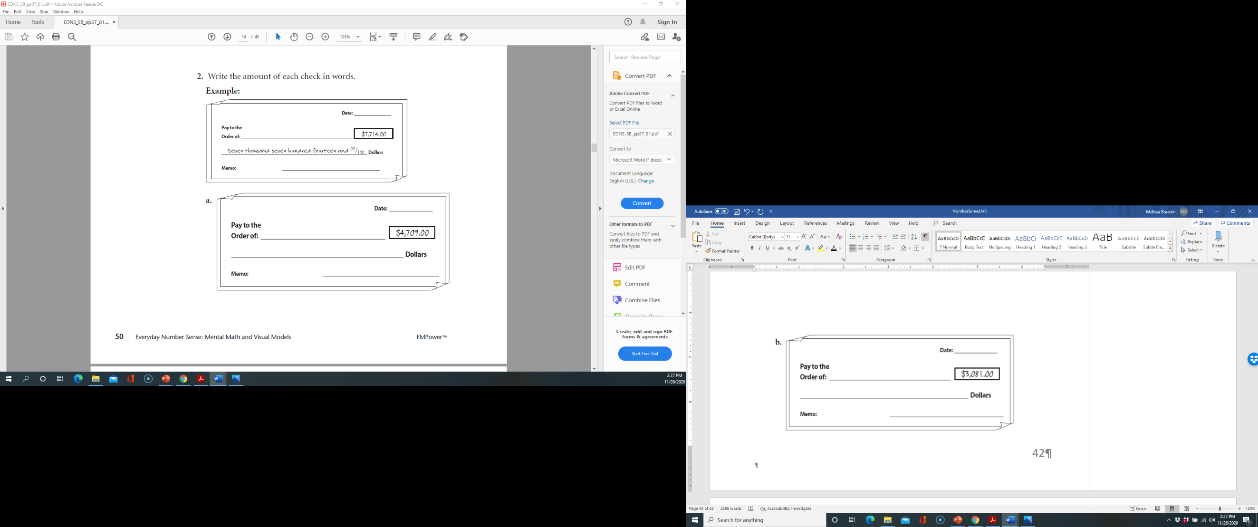

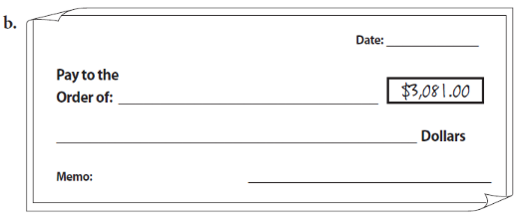
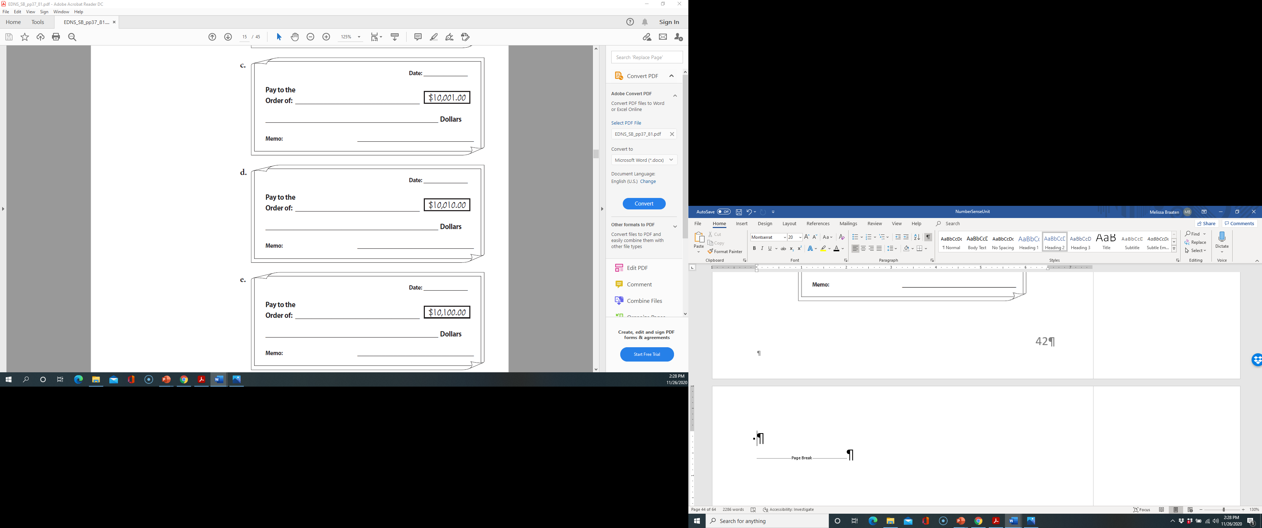

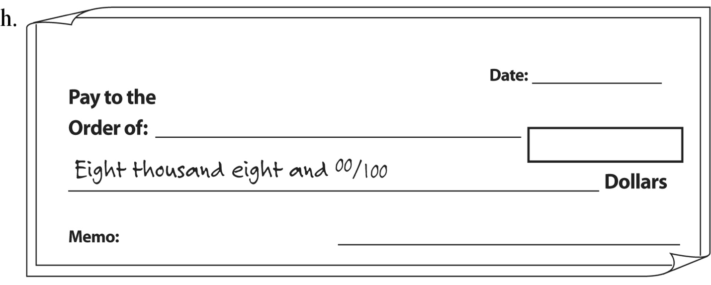

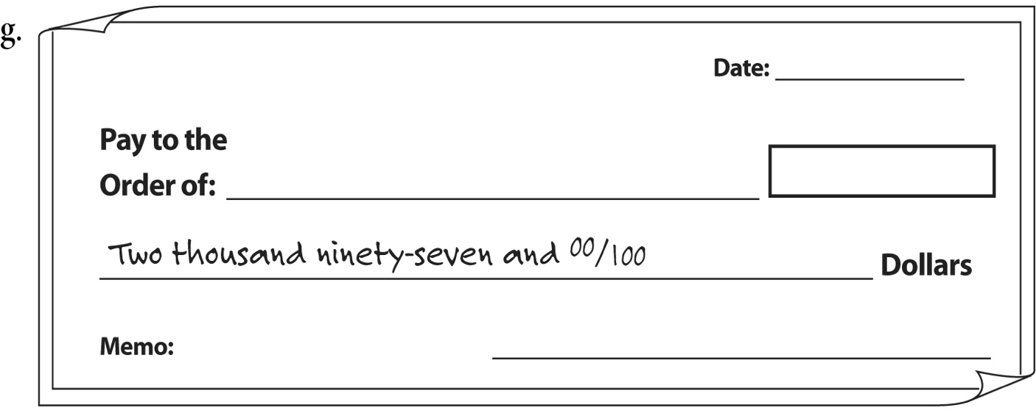

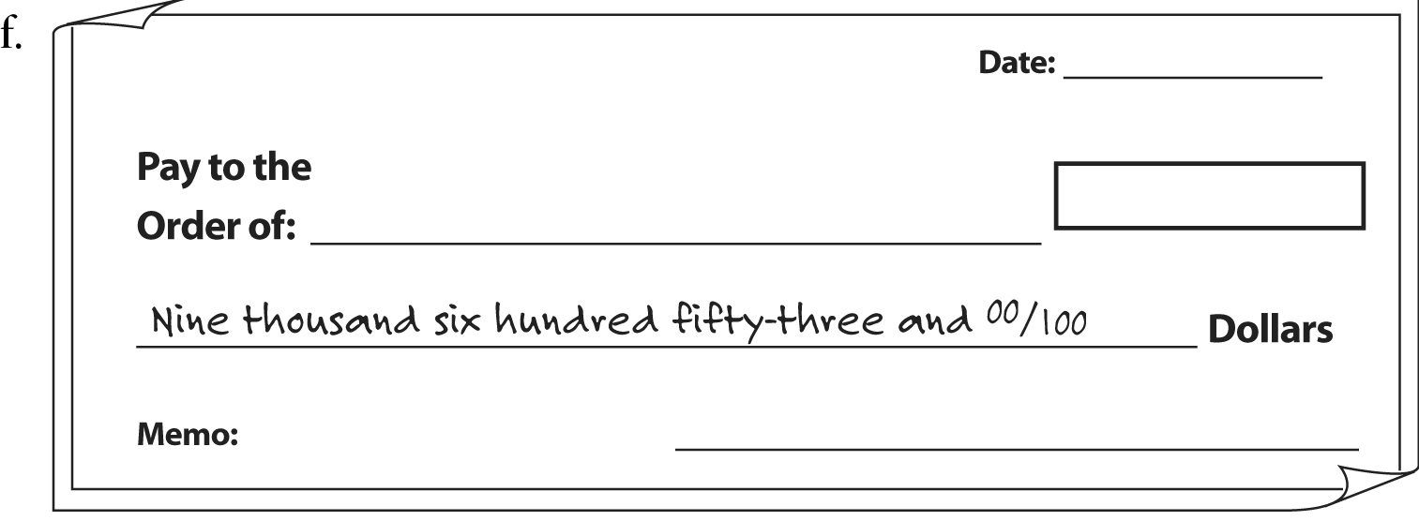
Source: EMPower™ book Everyday Number Sense: Mental Math and Visual Models

Filing
Shown here are pictures of some file cabinet drawers and files to go in them. Look at the account numbers on each file, find the drawer where it belongs, and write the account number below that drawer. The first file has been done for you.

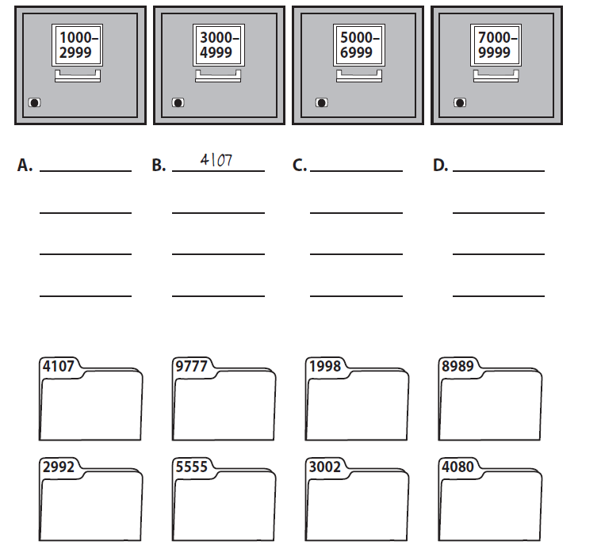

Source: EMPower™ book Everyday Number Sense: Mental Math and Visual Models

More Filing
This time, the drawers are set up differently. Write the account number of the file below the drawer where it belongs. The first file has been done for you.

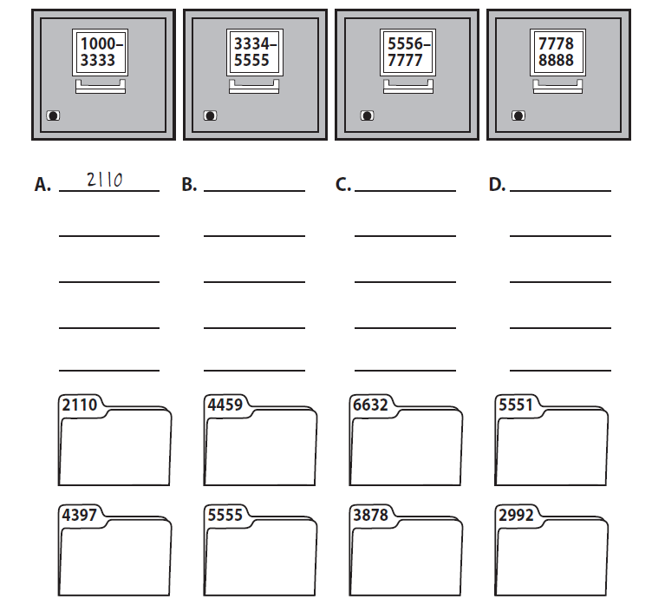

Source: EMPower™ book Everyday Number Sense: Mental Math and Visual Models

Which One Doesn’t Belong? 1
Choose one number that you don’t think belongs with the rest. Explain why.

500 | 1,500
1,501 | 1,005

Now pick another number and explain why it doesn’t belong.

Close to 1,000
Directions: Using the digits 1 to 9, place a digit in each box to make the sum as close to 1,000 as possible.




Source: https://www.openmiddle.com/ - John Ulbright & Robert Kaplinsky. Open Middle© problems are licensed under a Creative Commons Attribution-NonCommerical-ShareAlike 4.0 International License

Number Line Puzzles 1a
Fill in the missing numbers.

300
1,200
600
1,500
A

0
1,500
1,000

B

0
750
1,250
250

C

Create your own number line puzzle below.

Number Line Puzzles 1b
Fill in the missing numbers.

0
630
210
840
A

2,000
8,000
6,000

B

3,000
3,750
4,250
3,250

C

Create your own number line puzzle below.

UNIT 2: Subtraction and Number Lines

Counting Centuries
century: 100 years
The way we count centuries can be confusing. Many of us were born in a year that starts with 19__. So why do those people say that they were born in the Twentieth Century?

Years CE | Century | Years CE | Century
0-99 | 1st | 1000-1099
100-199 | 2nd | 1100-1199
200-299 | 3rd | 1200-1299
300-399 | 4th | 1300-1399
400-499 | 5th | 1400-1499
500-599 |  | 1500-1599
600-699 |  | 1600-1699
700-799 |  | 1700-1799
800-800 |  | 1800-1899
900-999 |  | 1900-1999

Right now, we are in the century, which goes from 2000-2099.
Vocabulary List for This Unit
Word | Definition | Example
decade | ___________ years
century | ___________ years | The Twentieth Century lasted from 1900 to 1999.
millennium | ___________ years | In the year 2000, we started a new millennium.
difference | the ___________ of subtraction. On a number line, it is the ___________ between two numbers. | 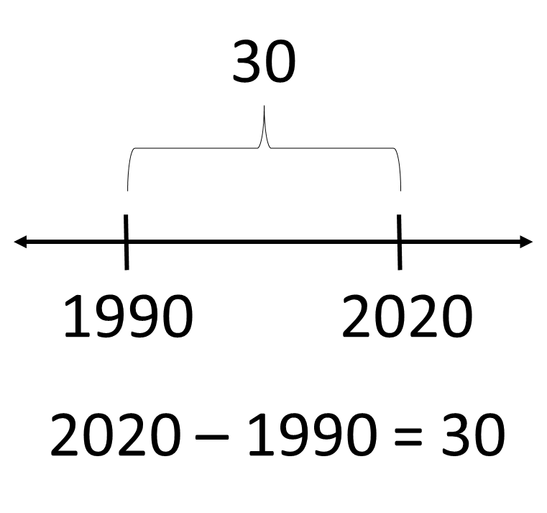

Word | Definition | Example

Birthday Numbers

- Use the following number line to find the birth year of someone 48 years old today. Then write down, step by step, what you did in your head.

- Use the number line to find the birth year of someone 36 years old today. Then, write down your steps.

- Use the number line to determine the age of a person born in 1949. Write down your steps.

- Use the number line to show your age. Write down your steps.

Source: EMPower™ book Everyday Number Sense: Mental Math and Visual Models

Timeline of American History
A timeline can be used to show when important events happened. It can help us to see visually the order in which things happened and how much time was between them.
If you were making a timeline of American History, what are some events that you would include? Choose 3–5 events that you think should be included. Explain why you chose them.

2.

3.

4.

5.

How Long Ago?
For each event, use the number line to help you figure out how many years ago the event happened. Each interval on the number line is one decade (ten years).
Then write an equation for your method of solving.
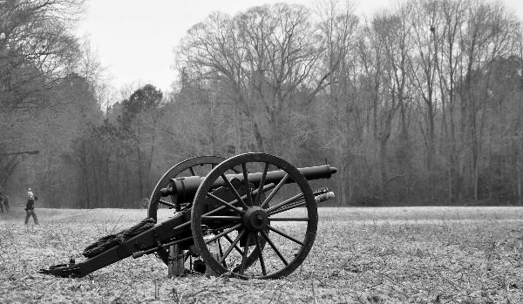
1. 1861 — United States Civil War Starts

The North (the Union) fought the South (the Confederacy) over the continuation of slavery and states’ rights.

- The U.S. Civil War started _______ years ago.

- Equation(s) for my method of solving the problem:
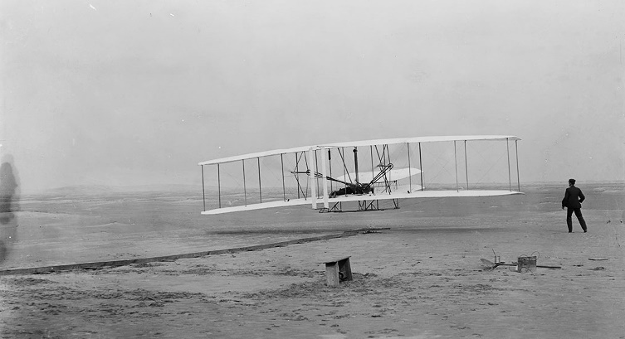
2. 1903 — Wright Brothers First Flight

The Wright Brothers flew their first plane in Kitty Hawk, North Carolina. They built their plane and its engine in their bicycle shop. They flew three times that first day. On the first day, their third and final flight went a distance of 852 feet and lasted 59 seconds.

- This flight was _________ years ago.

- Equation(s) for my method of solving the problem:

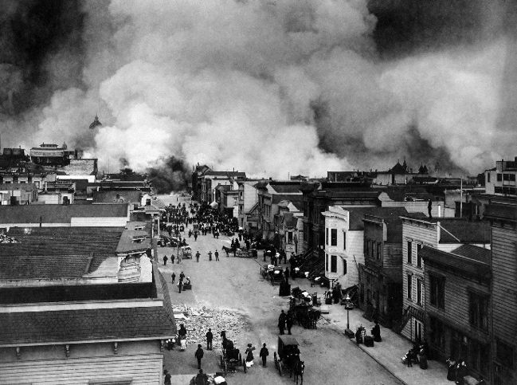
3. 1906 — San Francisco Earthquake

In San Francisco, California, an earthquake killed more than 500 people. It caused a huge fire which destroyed homes and stores across the entire city.

- The San Francisco Earthquake occurred _______ years ago.

- Equation(s) for my method of solving the problem:

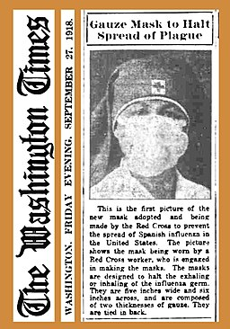

4. 1918 — The Great Flu Pandemic
Look familiar? Masks were used during the 1918 flu pandemic to try to help slow the spread of the virus. Large gatherings were limited, and other business was done outside when possible. There was no way to quickly make a vaccine at the time, and this deadly virus infected about one-third of the world’s population (~33%).

A deadly flu pandemic swept across the world. Around 500,000 Americans died, young and old, as well as millions around the world.

- The Great Flu Epidemic took place _______ years ago.

- Equation(s) for my method of solving the problem:

5. 1920 — Women Granted the Right to Vote

The 19th Amendment to the Constitution passed, giving women over the age of 21 the right to vote. Many black women were involved in working for women’s right to vote but were often excluded from events led by white women. These black suffragettes (women who worked for the right to vote) faced racism and sexism as they worked towards civil rights for all.

“If white American women, … need the ballot, that right protective of all other rights... how much more do black Americans, male and female need the strong defense of a vote to help secure them their right to life, liberty and the pursuit of happiness?” —Adella Hunt Logan, Colored American Magazine, 1905

- Women were granted the right to vote ______ years ago.

- Equation(s) for my method of solving the problem:
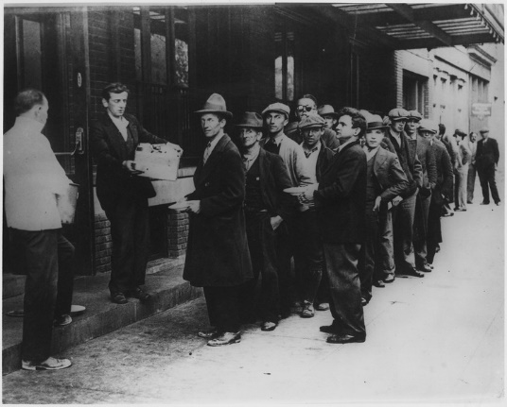
6. 1929 — The Stock Market Crash

The United States stock market crashed on October 29, 1929. People were making deals with no money to back them up. The crash caused banks and businesses to fail. Millions of people were put out of work. It was the beginning of the Great Depression.

People wait in line for food during the Great Depression.

- The stock market crash occurred _______ years ago.

- Equation(s) for my method of solving the problem:
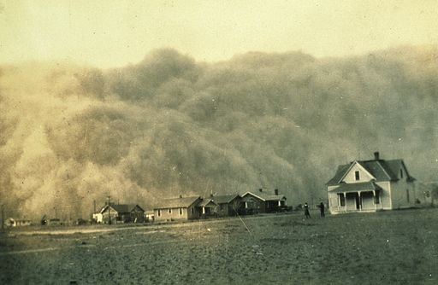
7. 1935 — The “Dust Bowl”

In 1935, after years of little or no rain, the farmland in the central part of the United States turned to dust. On a day called Black Sunday, a strong wind blew the dust into gigantic black clouds of dirt that covered everything, turning day into night.
With their farms ruined, many farmers and their families took what little they had and left their land. Many ended up in California, where millions of people with no jobs lined up every day in soup lines for something to eat.

- Black Sunday happened ______ years ago.

- Equation(s) for my method of solving the problem:
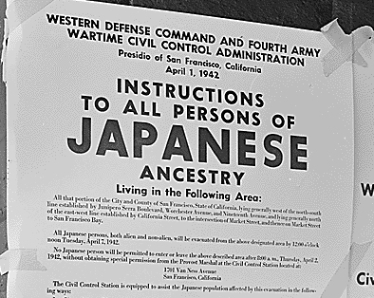
8. 1941 — Attack on Pearl Harbor and Aftermath

On December 7, 1941, the Japanese Air Force bombed the American Naval Base at Pearl Harbor in Hawaii. This unexpected attack pushed the US to get involved in World War II. A few months later, the US government started forcing Japanese American citizens and residents in concentration camps. This imprisonment continued for almost four years. It was not until 1988 that the US government officially apologized for this action and paid reparations to remaining survivors, admitting that the actions were based on “race prejudice, war hysteria, and a failure of political leadership.”

- The attack on Pearl harbor happened ______ years ago.

- Equation(s) for my method of solving the problem:
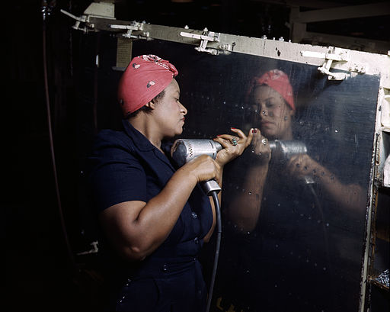
9. 1945 — World War II Ends
Did you know? So many men were drafted to fight in the war that the US government started recruiting millions of women (black and white) to work in the factories to make items needed for the war. Before then, not many women worked in factories. The nickname for these women was “Rosie the Riveter.”

World War II began in 1939, when Germany, led by Hitler, invaded other countries in Europe. The dictators in Italy and Japan joined forces with Hitler; Britain and France declared war on Germany. Before the war was over, 25 countries across the world, including the United States, were involved. More than 52 million people died in fighting, in concentration camps, and from atomic bombs that the US dropped on Japan. The war ended in 1945, when Germany and Japan surrendered.

- World War II ended ______ years ago.

- Equation(s) for my method of solving the problem:
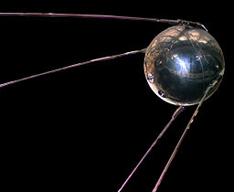
10. 1957 — Soviets Launch Sputnik

The Soviet Union sent the first satellite, named Sputnik, into space. Sputnik was the size of a basketball and circled Earth every 98 minutes. From Earth, you could see it crossing the sky. Sputnik collected information about space and sent it back to Earth.

- Sputnik was launched _______ years ago.

- Equation(s) for my method of solving the problem:

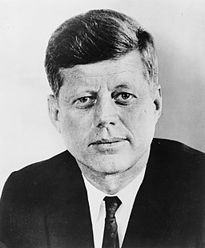
11. 1963 — President John F. Kennedy Assassinated

John F. Kennedy, the 34th President of the United States, was shot and killed in Dallas, Texas. (The next day, his supposed assassin, Lee Harvey Oswald, was shot and killed by a visitor to the jail where Oswald was being held.)

- President Kennedy was shot and killed ______ years ago.

- Equation(s) for my method of solving the problem:

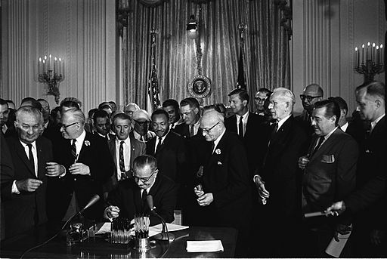
12. 1964 — Civil Rights Act Passed

After decades of activism, the Civil Rights Act of 1964 was signed into law. This outlawed discrimination on the basis of race, creed (religion or beliefs), or country of origin.

President Lyndon B Johnson signs the Civil Rights Act on July 2, 1964, into law. Dr. Martin Luther King, Jr. can be seen standing behind him.

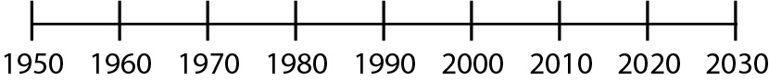

- The Civil Rights Act became law ______ years ago.

- Equation(s) for my method of solving the problem:
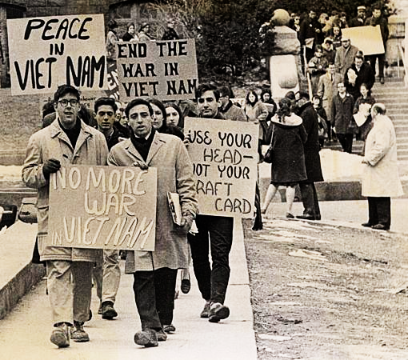
13. 1975 — The Vietnam War Ends

The United States got involved in a war in Vietnam to stop the spread of Communism. The war became very unpopular; thousands of people thought the United States should not have interfered. For the first time in history, public opinion caused the United States to withdraw from a war.
Credit: uwdigitalcollections License: CC BY 2.0

- The Vietnam War ended ______ years ago.

- Equation(s) for my method of solving the problem:

Source: EMPower™ book Everyday Number Sense: Mental Math and Visual Models

Math Inspection: Make It True
Place an equal sign and addition or subtraction signs to make a new equation that is true for each problem below.

- 40 20 40 20
- 40 20 40 20
- 40 20 40 20
- 40 20 40 20

Source: EMPower™ book Everyday Number Sense: Mental Math and Visual Models

Math Inspection:

Check Both Sides of the Equal Sign
Look at the equations below. How do the numbers change from the left to the right side of the equal sign? Why does this keep the value equal?

9 – 6 = 10 – 7

19 – 13 = 20 – 14

25 – 9 = 26 – 10

Source: EMPower™ book Everyday Number Sense: Mental Math and Visual Models

Count Up and Down by 10s

Count Up by 10, Starting at…
27 | 365 | 619
37 | 375 | 629

Count Down by 10, Starting at…
315 | 203
305 | 193

Source: EMPower™ book Everyday Number Sense: Mental Math and Visual Models

By What Did I Count?

Look at the pattern. Find the missing number.

- 63, 73, ______, 93, 103

By what did I count?

- 40, 70, _____ , 130, 160

By what did I count?

- 114, 214, 314, _____

By what did I count?

- 250, 240, ______ , 220

By what did I count?

- 377, 337, ______ , 257

By what did I count?

- 1,006, ______ , 986, 976

By what did I count?

- 1,006, _____ , 806, 706

By what did I count?

Test Practice
The Sunshine Library is trying to raise $750 for a new computer. According to the sign, how much more do they need to raise?
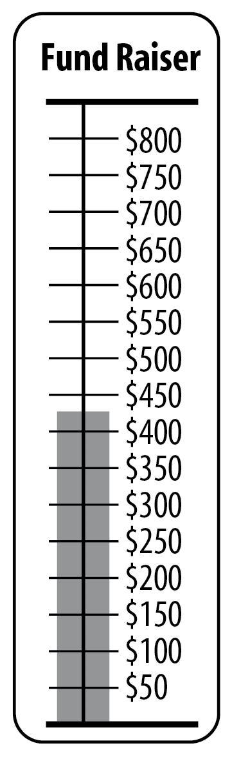

Which One Doesn’t Belong? 2

Choose one expression in this picture that you don’t think belongs with the rest. Explain why.

15 – 9 | 16 – 10
14 – 8 | 10 – 16

Now pick another expression and explain why it doesn’t belong.

Subtraction to Get the Smallest Difference

Directions: Using the digits 1 to 9, at most one time each, fill the boxes below to create the smallest possible difference.

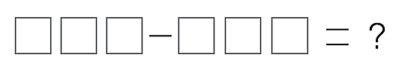

Source: https://www.openmiddle.com/ - Graham Fletcher
Open Middle© problems are licensed under a Creative Commons Attribution-NonCommerical-ShareAlike 4.0 International License

Number Line Puzzles 2
Fill in the missing numbers.
$100.02
$100.06
$100.04
A

$100.08
$100.10

$21.00
$20.50
$20.00

B

2,600
2,800
2,400
C

Create your own number line puzzle below.

Source: https://www.openmiddle.com/ - Marilyn Burns and Graham Fletcher
Open Middle© problems are licensed under a Creative Commons Attribution-NonCommerical-ShareAlike 4.0 International License

UNIT 3: Going Deeper with Subtraction

Revenue – Costs = Profit
Have you ever wanted to own your own business?
Business owners have to keep track of whether they are making a profit.

Revenue – Costs = Profit

Revenue
the money a business takes in

Costs
the money a business pays out

Profit
the extra money the business owner earns by running the business

Let’s say in May, your business took in $1,200 in revenue. You had to pay $800 in costs for materials and fees.
$1,200 – $800 = ________ profit

If the costs are greater than the revenue, then instead of a profit, the business owner has a loss.

How’s Business?

Revenue – Costs = Profit

Business Reports for May

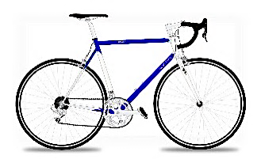
Phill’s Bike Shop
Revenue: $1,500
Costs: $400
Profit:


Maria’s Catering
Revenue: $1,200
Costs: $600
Profit:


Saul’s Computer Repair
Revenue: $2,000
Costs:
Profit: $1,600

Juana’s Accounting Services

Revenue: $2,300
Costs:
Profit: $1,800

Mel’s Paint Shop
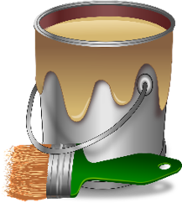
Revenue: $1,200
Costs: $1,500
Profit:

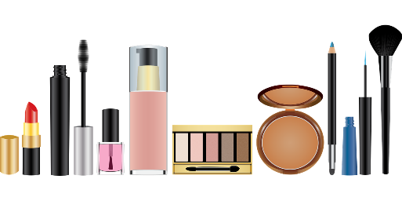
Destiny’s Beauty Supply
Revenue:
Costs: $500
Profit: $50

Which companies did well in May?

Which companies struggled?

How do you know?

Starting a Cleaning Business
The name of our business is Edwin and Zulma LLC Cleaning Service. We recently opened a cleaning service for commercial and residential cleaning.

Zulma and Edwin are originally from El Salvador. They are both enrolled in an adult education program in Maine. This reading contains excerpts from an interview with them. The content was edited for length and clarity.
What expenses do you have?
Right now we just started, we have a lot expenses. We got new vacuums, we got new machines for cleaning the floors, the chemicals. We also had to purchase QuickBooks (accounting software). So right now it seems like a lot. But once we set up it will just be supplies, and that’s it.
We were able to get a credit card for the business from the bank with no interest for 18 months. As soon as we get more business, we going to pay the credit card off.
Right now I am starting with my accounting and I keep all of my receipts and try to keep organized.

How do you decide how much to charge a customer?
We look into how much time it will take and how big the house or apartment is. Then we take all that into consideration. We ask the customer if they want windows cleaned, if they say yes, we add extra time for that. We ask if they want cabinets cleaned inside and out, and if they say yes, we add time for that and then, we put that all together and come up with the price.
We also see about how much supplies we will need, how much gas, and if we have to pay for parking.
How did you decide on your hourly rate?
I have other friends that have cleaning services, and I charge a little bit less, to get customers, and it’s been working. And it’s still better than working for other people.

expenses
costs
accounting
keeping track of all the money going in and out of a business
interest
the fee a person pays when he or she borrows money from a bank or company
hourly rate
the amount of money charged for each hour

Questions for Discussion
- Zulma and Edwin named some different expenses for their business. Which of those expenses do they need to pay once? Which expenses will they need to pay again and again?

- Name some of the things that Edwin and Zulma consider when they are deciding how much to charge for a cleaning job.

Vocabulary List for This Unit
Word | Definition | Example
revenue | the money a business _____________
cost | the money a business ____________ for its expenses
profit | the money a business owner has left after costs are subtracted from revenue. “_____________”
regrouping | a method of subtracting in which value can be regrouped from one ____________ into another. For example, one 10 can be regrouped into 10 ones. | 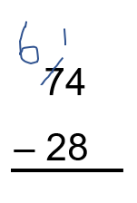

Word | Definition | Example

Ways to Think about Subtraction
Read carefully and solve each problem. Show your work and your thinking with pictures or equations.

- Myrna had $80 when she went into the store. She came out with $30. How much did she spend?

- Myrna has $30. Jodi has $80. How much more money does Jodi have?

- Myrna had $80. She spent $30 on groceries. How much does she have now?

Source: EMPower™ book Everyday Number Sense: Mental Math and Visual Models
- What is the same about each of the three problems?

- How are they different?

Subtraction Can Mean…

Missing Amount
You know the starting amount and the ending amount. You subtract to find out what is missing.

- Myrna had $80 when she went into the store. She came out with $30. How much did she spend?

Comparison
You have two amounts. You want to know how much more one amount is than the other. You subtract to find the difference.

- Myrna has $30. Jodi has $80. How much more money does Jodi have?

Take Away
You have a starting amount. You take some away. You subtract to find what is left.

- Myrna had $80. She spent $30 on groceries. How much does she have now?

Visual Models of Subtraction
Missing Amount
- Myrna had $80 when she went into the store. She came out with $30. How much did she spend?

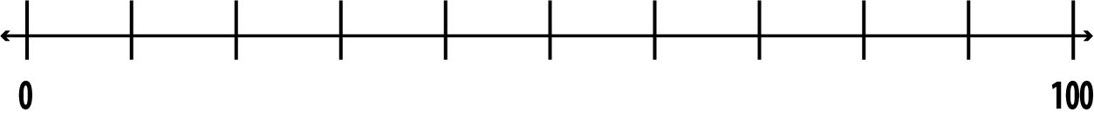

Before After
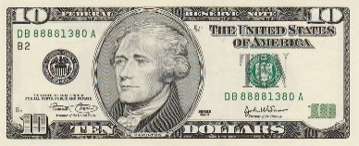
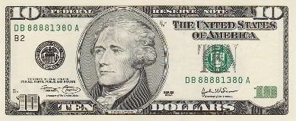

What happened to get from here to here?

Comparison
- Myrna has $30. Jodi has $80. How much more money does Jodi have?

Jodi Myrna

What’s the difference between them?

Take Away
- Myrna had $80. She spent $30 on groceries. How much does she have now?

Before Now?

Write Your Own Problems

Missing Amount
You know the starting amount and the ending amount.
You subtract to find out what is missing.
Write your own missing amount problem here:
__________________________________________________________
__________________________________________________________
__________________________________________________________
__________________________________________________________
__________________________________________________________

Comparison
You have two amounts. You want to know how much more one amount is than the other. You subtract to find the difference.
Write your own comparison problem here:
__________________________________________________________
__________________________________________________________
__________________________________________________________
__________________________________________________________
__________________________________________________________

Take Away
You have a starting amount. You take some away. You subtract to find what is left.
Write your own take away problem here:
__________________________________________________________
__________________________________________________________
__________________________________________________________
__________________________________________________________
__________________________________________________________

How Do You See It?

40 – 27 =

Draw a picture or a diagram to show how you understand this problem.

Write a word problem that involves 40 – 27.

Source: EMPower™ book Everyday Number Sense: Mental Math and Visual Models

Check Both Sides of the Equal Sign —Addition

40 + 5 = 30 + 15
600 + 80 + 4 = 500 + 180 + 4
4,000 + 200 + 70 + 5 = 3,000 + 1,200 + 70 + 5

- What changes from the left side to the right side of the equation?

- Write your own equation like this.

- Use that idea to complete these equations.

- 90 + 4 = 80 + ____
- 70 + 6 = 60 + ____

- 400 + 80 = 300 + ____

Source: EMPower™ book Everyday Number Sense: Mental Math and Visual Models

The Regrouping Strategy (“Borrowing”)
74 – 28

74  – 28 | Tens Ones  70 + 4  - 20 + 8
74  – 28 | Tens Ones  60 + 14  – 20 + 8

Check Both Sides of the Equal Sign—Subtraction

30 – 17 = 33 – 20
42 – 28 = 44 – 30
70 – 38 = 72 – 40

- What changes from the left side to the right side of the equation?

- Write your own equation like this.

- Use that idea to complete these equations.

- 71 – 26 = ____ – 30
- 94 – 39 = 95 – ____

- 47 – 18 = ____ – 20

Source: EMPower™ book Everyday Number Sense: Mental Math and Visual Models

Test Practice Problems
- The temperature at mid-day was 98 degrees. The weather forecaster said that there would be a 30 degree drop by 6:00 pm. Which expression below represents the expected temperature in the evening?

- 98 + 30
- 98 – 30
- 30 – 98
- 98 – 30 – 6
- 98 – 6

- Rosa budgeted $300 for food this month. On her first two trips to the grocery store, she spent $35.23 and $67.34. Which of the estimates is closest to the amount of money she has left to spend on food for the month?
- About $50
- About $100
- About $150
- About $200
- About $250

- Todd is traveling from Denver to Little Rock, for a total of 966 miles. If he travels 259 on the first day and 329 on the second day, which expression represents the number of miles he has left to travel?

- 259 + 329
- 259 + 329 + 966
- (259 + 329) - 966
- 966 – (259 + 329)
- 966 – 259 + 329
- Jo had a twenty-dollar bill in their wallet. After buying a few things at the store, they noticed that they had a five-dollar bill and three one-dollar bills. Which expression would represent the amount of money spent at the store?

- 3 – 5 – 20
- 20 – (5 + 3)
- 20 – 5 + 3
- (3 + 5) – 20
- 8 – 20

- Main Street Grocery Store received a shipment of 1,200 oranges. They sold 263 on the first day. How many remained for them to sell?

- About 50
- About 150
- About 950
- About 1,250
- About 1,400

- Makayla loves to look at car deals online. What is the largest amount she can save?
- $23,999 Now $22,998
- $28,995 Now $26,495
- $21,000 Now $19,999
- $37,998 Now $37,500

Source: EMPower™ book Everyday Number Sense: Mental Math and Visual Models

Which One Doesn’t Belong? 3
Choose one expression that you don’t think belongs with the rest. Explain why.

1,000 + 300 + 40 + 5 | 1,300 + 45
1,000 + 200 + 140 + 5 | 1,000 + 300 + 30 + 15

Now pick another expression and explain why it doesn’t belong.

Subtraction with Regrouping

Put digits in the boxes so that the difference is 39.
You cannot use 0.

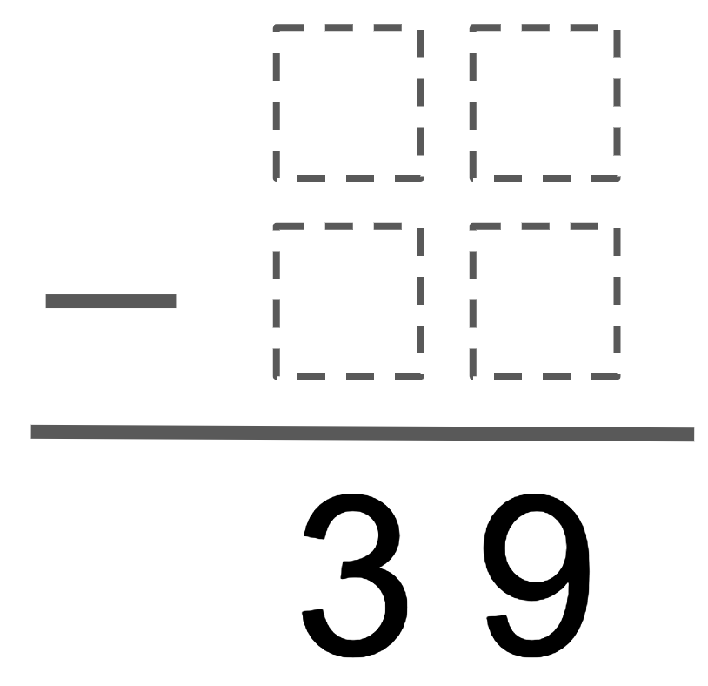

Source: Chris Ignaciuk on Openmiddle.com

Number Line Puzzles 3
Fill in the missing numbers.
160
200
A

250
400

B

1,220
1,230
1,210

C

Create your own number line puzzle below.

UNIT 4: Our Base Ten System
Our number system is called “base ten.” That is because we make groups of ten when we write and describe numbers. Notice that the numbers 0 – 9 each have their own symbol.
0 1 2 3 4 5 6 7 8 9

When we get to ten, we don’t have a new symbol. Instead, we count it as one group of ten. We use the symbols 1 and 0 to represent ten.
1 0
1 ten 0 ones

After that, we count groups of tens and ones. When we have ten groups of ten, we use another place value and say we have one group of a hundred.
1 0 0
1 hundred 0 tens 0 ones

When we get ten hundreds, we call it a thousand.

1 0 0 0
1 thousand 0 hundreds 0 tens 0 ones

Every time we have ten of one group, we create a new group with a new place value.
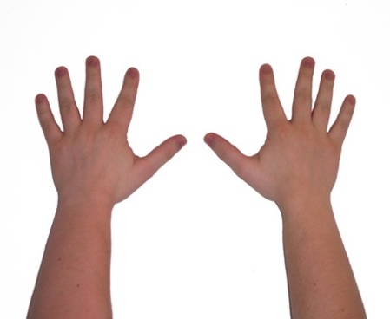
Why ten? Math historians believe this system came from the fact that we have ten fingers, and humans have always used fingers to visualize numbers.

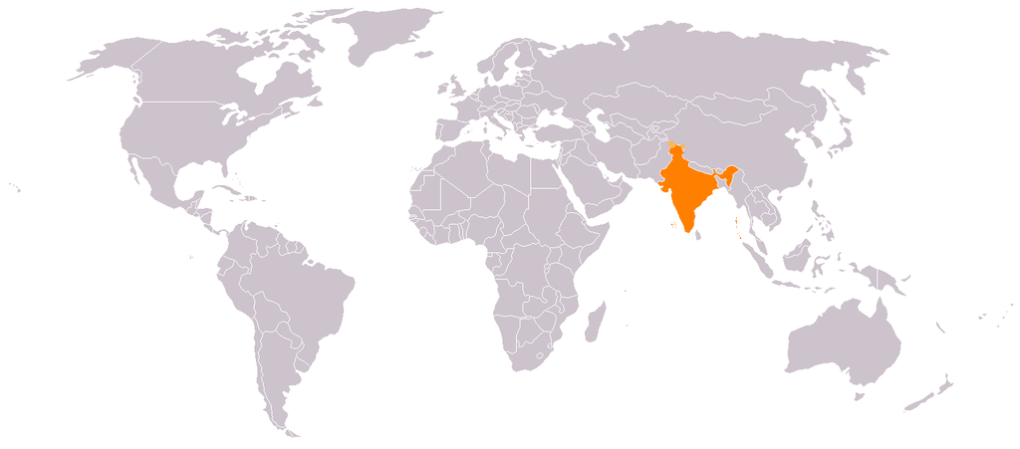
The base ten system we use today, along with the symbols we use for the digits 0 – 9, originally comes from India almost two thousand years ago. The system was adjusted over time and eventually spread around the world.
India

Other Number Systems
Base ten is not the only type of number system! Older civilizations had other types of number systems, based on 60 or 20 or 5. Even today, other base systems are used for specific purposes.

Maya: Base 20
The Maya civilization was in Central America, centered around modern-day Guatemala. While the Maya political empire collapsed over a thousand years ago, the Maya people, culture, and languages still live in that part of the world.
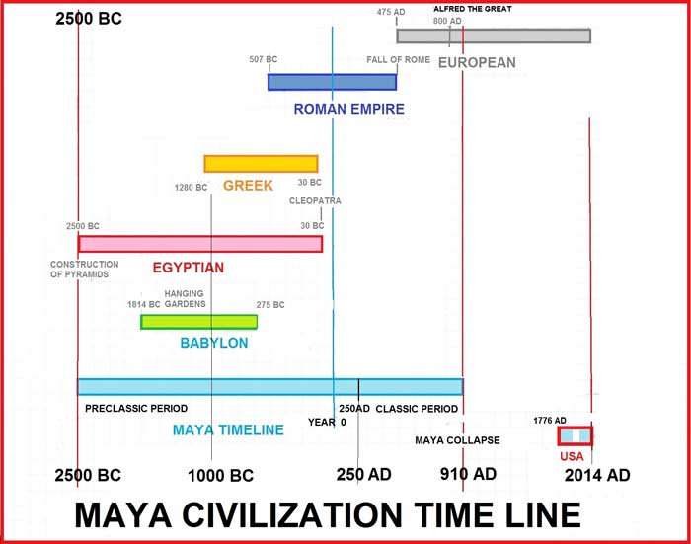
The ancient Maya had very advanced mathematics. They used a base 20 system. That means they had different symbols for numbers 0 – 19, then grouped them into groups of 20. When they had 20 groups of 20, they would group that into one group of 400.

Binary: Base 2
Computers use a system called binary, which is base 2. That means it only has two symbols, 0 and 1. When you have two of something, you use a new place value. When you have two groups of two, you use another place value, and so on.

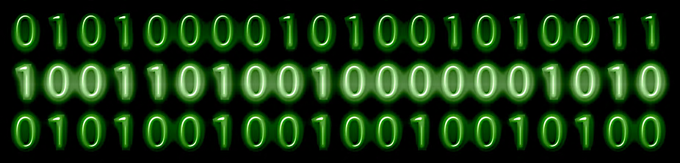

As an example, let’s use the year two thousand twenty-one. Here’s what the year 2021 would look like in different number systems:

Base 10: 2,021
2 x 1,000 + 0 x 100 + 2 x 10 + 1
(Each place value is 10 times bigger.)

Base 20: 511
5 x 400 + 1 x 20 + 1
(Each place value is 20 times bigger.)

Base 2: 11111100101
1 x 1,024 + 1 x 512 + 1 x 256 + 1 x 128 + 1 x 64 + 1 x 32 + 0 x 16 + 0 x 8 + 1 x 4 + 0 x 2 + 1
(Each place value is 2 times bigger.)

More Maya Mathematics
Not only did the ancient Maya people have a different base system (base 20), but they had their own symbols as well.
Take a look at the symbols below for the numbers 0 – 20.

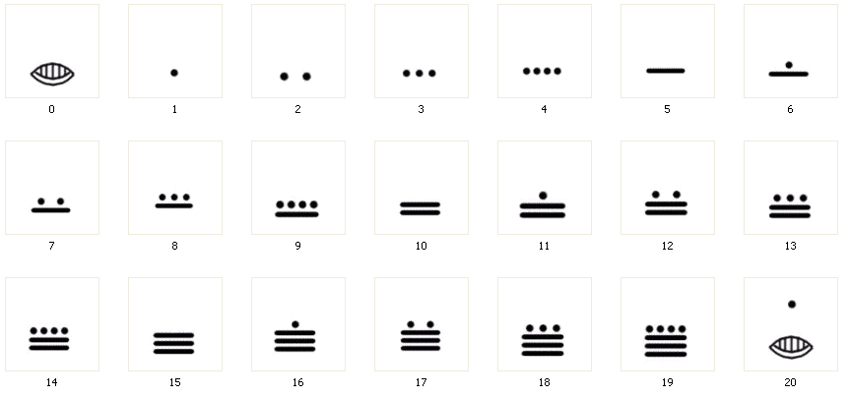

What do you notice?
What do you wonder?

What do you think the symbol — represents? Why does it appear several times in some numbers?

Vocabulary List for This Unit
Word | Definition | Example
base ten | as place values move left, each gets ____________ bigger | 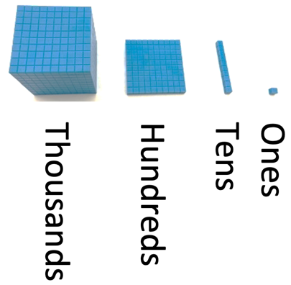
parentheses | in math notation, parentheses can be used to show ____________ | 4 x 5 can be written as 4(5) or (4)(5)
double | to ____________ by two (or, to add a number to ____________) | double 25 is 50  25 x 2 = 50  25 + 25 = 50

Word | Definition | Example

How Do You Want Your Money?
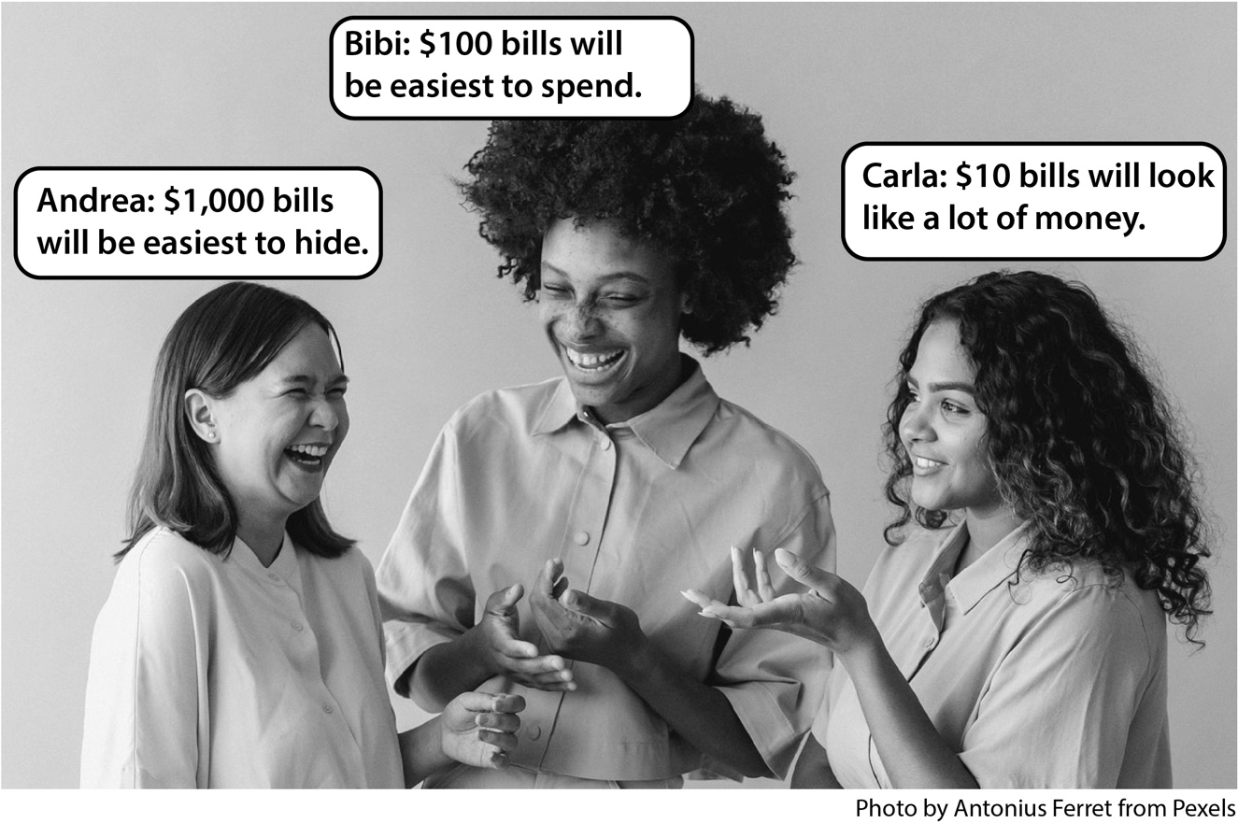
Three friends went to cash paychecks. Each paycheck was for $2,643. Each person wanted their cash in a different way using only $1,000, $100, $10, and $1 bills.
- How did each person receive her money?
Andrea:
Bibi:
Carla:
- Suppose the checks were for $1,305 each. How would each receive her money?

Andrea:
Bibi:
Carla:
- Suppose the checks were for $3,045 each. How would each receive her money?

Andrea:

Bibi:

Carla:

Adapted from EMPower™ book Everyday Number Sense: Mental Math and Visual Models

Where Can I Cash My Check?
Check Cashing Services
Advantages:
- Allow you to cash a check without a bank account
- Make money available almost immediately
Disadvantages:
- Charge high fees, so the take home money is less
- Having a lot of money in cash can be risky

Traditional Banks
Advantages:
- Safe place to store your money
- No fee to cash a check if you have an account
- You can write checks or use a debit card to pay with money from your account
Disadvantages:
- It takes time and usually a photo ID to open an account.
- People with a bad banking history report may have a hard time opening an account.
- You may have to wait a day or two for a check to clear before you can withdraw the money.

Fees, Fees, Fees
Maria is paid $600 a week. Every week, she cashes her paycheck at the local check cashing service. Each time, she pays a $7 fee.
How much will she pay in fees? Continue the pattern.
Weeks | Total Paid in Fees
1 | $7
2 | $14
3
4
5
6
7
8
9
10

After one year, Maria will have paid the $7 fee 52 times! She will have paid a total of $364 in fees.

Mystery Numbers
Use a calculator to help you. Decide what needs to be done to get from the starting number to the end number.
The first problem has been done for you.

Starting Number | Operation and Amount | End Number
- 1,543 | + 30 = | 1,573
- 826 | = | 526
- 1,988 | = | 3,988
- 1,988 | = | 2,088
- 7,070 | = | 7,670
- 2,006 | = | 2,506
- 4,260 | = | 4,240
- 10,765 | = | 8,765
- 9,999 | = | 9,599
- 1,750 | = | 2,350

Source: EMPower™ book Everyday Number Sense: Mental Math and Visual Models

True or False?
Mark each equation T (true) or F (false). Change all the false equations to make them true.

Statement | True or  False? | False Statement  Changed to Be True
- 4 thousands = 40 hundreds
- 100(10) = 10(100)
- 6,503 = 6(1,000) + 53(10)
- 666 + 40 = 1,066
- 5,958 – 300 = 2,958
- 92(10) = 9(100) + 2(1)
- 57(100) + 4 = 5,704
- 2(1,000) + 5(100) =
20(100) + 50(10)

Source: EMPower™ book Everyday Number Sense: Mental Math and Visual Models

More Mystery Numbers
Use a calculator to help you. Decide what needs to be done to get from the starting number to the end number.
Starting Number | Operation and Amount | End Number
- 543 | + 1,000 = | 1,543
- 876 | = | 526
- 1,088 | = | 3,088
- 1,077 | = | 707
- 21,156 | = | 21,156
- 2,006 | = | 1,706
- 4,640 | = | 4,590
- 10,065 | = | 10,060
- 9,009 | = | 9
- 1,750 | = | 2,350

Source: EMPower™ book Everyday Number Sense: Mental Math and Visual Models

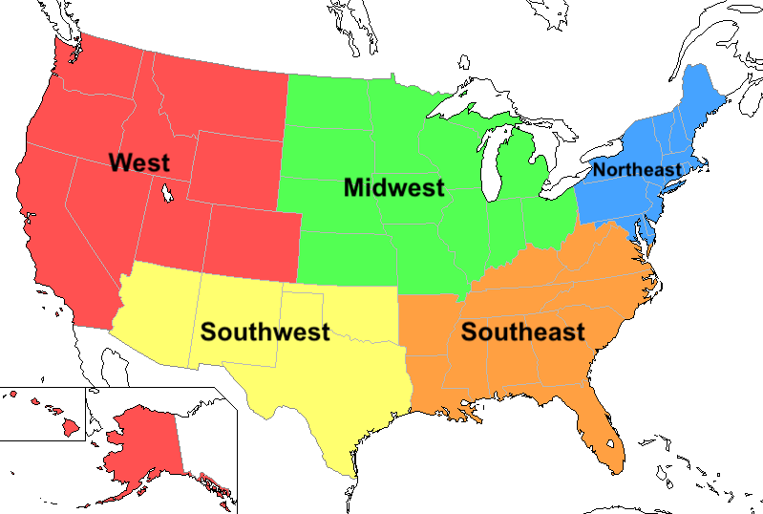
Mental Math Practice: Double Trouble
Try to do as many of these doubling and halving problems as you can in your head. Use a calculator to check your answers.
1. It was a wet year all over the United States. Average rainfall doubled in each region this year. What are the missing numbers?
Region Average This Year’s Total
Rainfall (in) Rainfall (in)

a. Midwest _______ 48
b. Southeast _______ 38
c. Northeast 44 ______
d. West _______ 118
e. Southwest 9 ______
What is true about the 1s digit in numbers that, when doubled, end in “8”? Will this always be true?

2. Xiomara delivers groceries. She has to return to the store after each delivery. She looked up the distance to each delivery site that she visited today so she could calculate how far she drove.
Store to Site Round Trip
a. Delivery 1 7 miles ______
b. Delivery 2 17 miles ______
c. Delivery 3 27 miles ______
d. Delivery 4 37 miles ______

What is true about the 1s digit in all the answers?

Source: EMPower™ book Everyday Number Sense: Mental Math and Visual Models

Test Practice
- John earned $5,906 last month. Which one of the following is not a way he could take his earnings?
- 5($1,000) + 9($100) + 6($10)
- 5($1,000) + 9($100) + 6($1)
- 59($100) + 6($1)
- 590($10) + 6($1)
- 5($1,000) + 90($10) + 6($1)

- 3($1,000) + 5($10) + 2($1) + 1($100) =

- $1,135
- $3,152
- $3,521
- $5,213
- $5,352

- Kay wants her group to raise more money this year than they ever have before. Last year’s sales were $350; this year Kay wants to raise $900. How does this year’s goal compare with last year’s sales?
- Ten times more than last year
- About double last year’s sales
- About $600 more than last year
- About ten times less than last year
- About $6,000 more than last year
- Vera’s company has given her a sales goal of $5,000. She has sold $495 worth of merchandise. How do her actual sales compare with her goal?
Her goal is ...
- Double what she has sold
- About $500 less than what she has sold
- About $5,000 more than what she has sold
- About $500 more than what she has sold
- About 10 times more than what she has sold

- N stands for an unknown number. N + 10 = 260.
What does N equal?
- 26
- 160
- 250
- 260
- 270

- How much more than 39,705 is 40,005?

Source: EMPower™ book Everyday Number Sense: Mental Math and Visual Models

Which One Doesn’t Belong? 4
Choose one group of numbers that you don’t think belongs with the rest. Explain why.

8  80  800  8,000 | 5  55  555  5,555
9  900  90,000  9,000,000 | 12  102  1,002  10,002

Now pick another group and explain why it doesn’t belong.

Greatest Difference of Two Rounded Numbers
Directions: Find two numbers that round to 500. What is the difference between them? Try to find two numbers that both round to 500 with the greatest possible difference.

Source: https://www.openmiddle.com/ Michael Wiernicki, Graham Fletcher, and Rachel Nelli

Create an Equation

Directions: Fill in the boxes to create a true equation.
What is the largest sum you can make?
What is the smallest sum you can make?


Adapted from source: https://www.openmiddle.com/ Eric Appleton

Number Line Puzzles 4
Fill in the missing numbers.

1,180
1,190
42
A

1,650
1,750

B

4,300
2,300
3,300

C

Create your own number line puzzle below.

Blank Number Lines

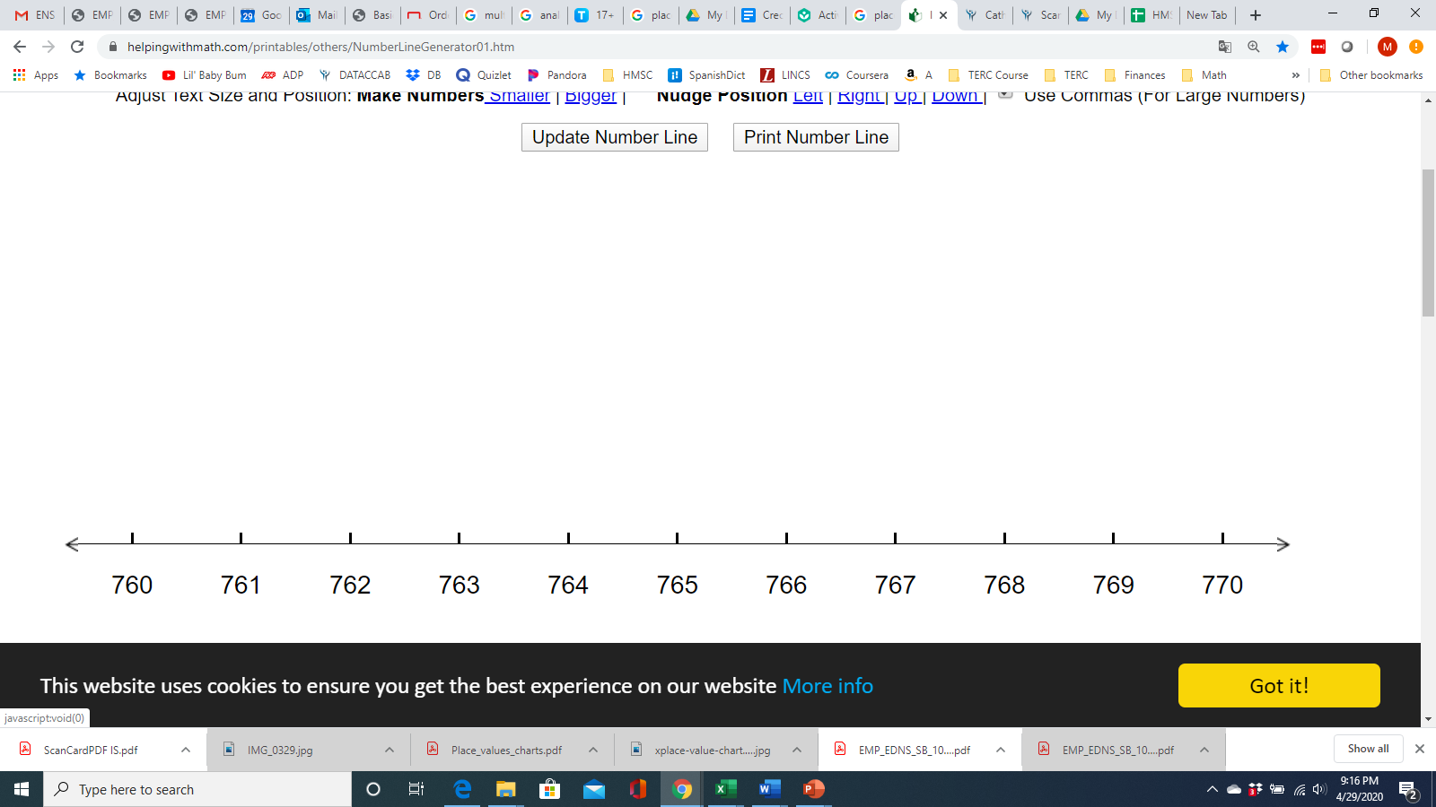

Blank Number Lines

