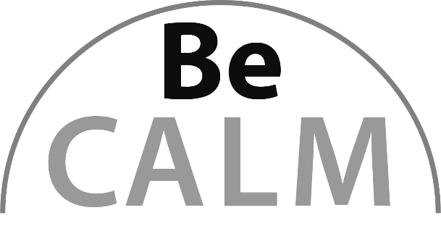

Geometry
Beginning Curriculum for Adults Learning Math
Curriculum for GLE 2–4

TEACHER’S GUIDE

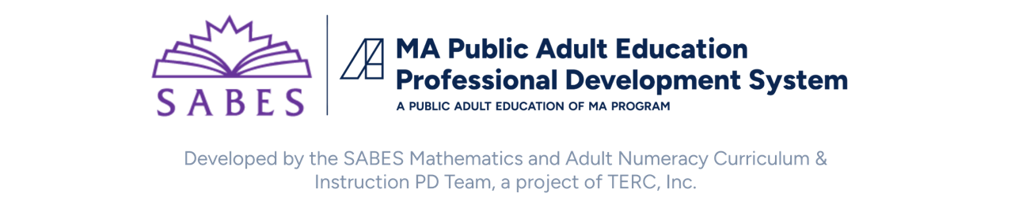

Acknowledgements

The titles in the BeCALM series were developed and piloted in the classroom by Melissa Braaten for the SABES Mathematics and Adult Numeracy Curriculum & Instruction PD Team, with contributions from Yvonne Readdy, Emily Rudd, and Sherry Soares.

The BeCALM series includes four sequential packets:
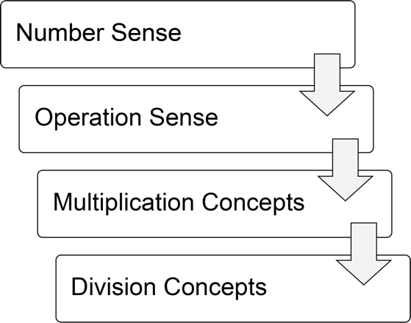
and three non-sequential packets:
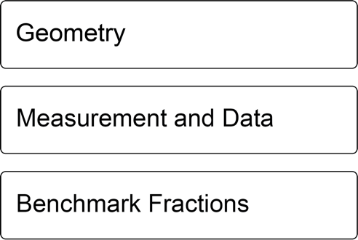

Activities from the EMPower™ series title Over, Around, and Within: Geometry and Measurement are used and/or adapted with permission from the author, TERC, Inc.

Learner Level and Rationale
The math content is aimed at ABE level math students (approximately GLE 2–4). While adult students at this math level may have any level of reading, the student materials were designed to be used by adults with a reading level GLE 2 or above. To keep things accessible, the text in the Student Packet is kept to a minimum so that this can be used with students at an ABE reading level or students who are beginning to intermediate English Language Learners.
These materials could be used with students in-person or remotely.
Many of the concepts may be new to students at this level, so they may need repetition (with variation) of some activities. The activities are arranged in a suggested order in the Student Packet and Teacher’s Guide, but teachers can choose to skip activities or reorder them as needed.

Preparation Suggestions
- There are some shape puzzles that use the Shape Set, so it is important that both the Shape Set and the Student Packet be printed true to size, so that the shapes will fit the puzzles. If printing the Shape Set PDF document in Adobe, be sure to choose “Actual Size” in the Page Sizing & Handling print menu.
- The packets can be printed on ordinary paper. It is recommended that you use a brightly colored sheet of paper as a cover sheet. This makes it easier for students to keep track of the packet and makes it easy to refer to (“You will need your green packet.”).
- Most of the activities work fine when printed in black and white. If possible, print out the Flag activity (page 54 in Student Packet) in color if you can, so that you can refer to the shape in the flags by color.
- Start collecting pictures on your phone of where you see shapes in your home and around your neighborhood. These will be useful examples when you are talking about different shapes.

Vocabulary and Things to Watch For
Each unit includes some suggestions on valuable vocabulary words and common misconceptions or interesting student ideas that came up in the pilot class.

Materials Overview
- Unit 1: Putting Together and Taking Apart Shapes
- Unit 2: Finding Half and Understanding Symmetry
- Unit 3: Right Angles and Parallel Lines
- Unit 4: Review and Extension

Each unit includes materials for:
- Activities and Practice
- Language Support
- Self-Evaluation (reproducible from Teacher’s Guide pp. 35–38)
Each part in the student packet includes materials for:
- Relevance
- Activities and Practice
- Routines

Math Background: The Development of Geometric Reasoning
Just like other domains of mathematics, the study of geometry is about more than just acquiring knowledge. When we teach geometry, we are looking to provide students with the opportunity to develop geometric reasoning.
A pair of influential Dutch educators named Pierre van Hiele and Dina van Hiele-Geldof developed a model of the way in which students develop geometric thinking. Here are a few important things to know about their theory of the development of geometric reasoning:
- There are five levels of understanding spatial concepts.
- The levels are sequential; must pass through all prior levels to arrive at any specific level.
- The levels are not age-dependent. It is possible for adult students to be at any of the five levels, including the earliest (level 0).
- Geometric experiences have the greatest influence on advancement through the levels.
- Instruction and language at a level higher than the level of the student may inhibit learning.
This curriculum is meant to provide geometric experiences for students in the first two levels of geometric reasoning.

Level 0: Visualization
At this level, students are developing an intuitive and sensory understanding of what different shapes “look like”. It is important for students at this level to have many concrete experiences with different ways that shapes can look. For example, they may not realize that the two shapes below are the same:
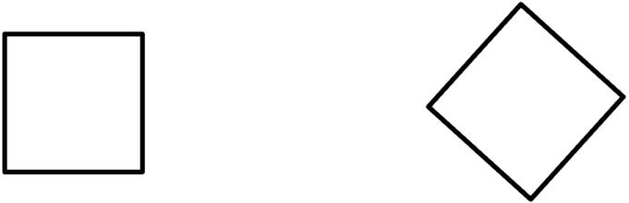
Or that some shapes can be flipped and be “different” (in this case, a reflection).
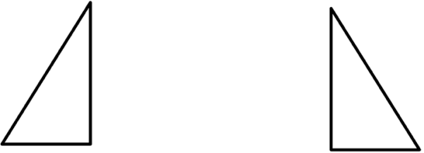
Students need the concrete experience of manipulating shapes to develop this intuitive understanding. That is why the Shape Set is such a critical part of the curriculum—don’t be tempted to skip it!
Many of the activities in the packet work on giving students at this level lot of experiences with the different ways that shapes can look, including the introductions to different shapes where they look for similarities and differences, shape puzzles, creating designs, and trying to identify shapes in real life objects.

Level 1: Analysis
At this level, students are paying more attention to the specific attributes of shapes and how these attributes define categories of shapes. For example, a student at this level will decide whether something is a rectangle based on whether it has right angles, and not just whether it “looks like” a rectangle.
This curriculum has students explore a few common attributes of shapes: angles (especially right angles), parallel lines, and symmetry. For students at Level 0, this will provide them with more concrete vocabulary to describe what they see in the shapes. For students at Level 1, this will help them begin to think about more formal definitions of shapes and how shapes can be categorized, based on these attributes.
Higher levels of geometric reasoning start using both informal and formal methods of deduction and proof. Since this curriculum is intended for students at early levels of geometric reasoning, these types of tasks are not included.
This section is based on a summary of van Hiele and van Hiele-Geldof’s work found in Chapter 21 “Geometric Thinking and Geometric Concepts” in Elementary and Middle School Mathematics: Teaching Developmentally, 4th ed. (J.A. Van de Walle, Ed., 2001).

Teacher Cheat Sheet: Shapes and Their Attributes
On the next page, we’ve provided a “teacher cheat sheet” of shapes, their attributes, and examples of places where those shapes can be observed in everyday life.
Note: The shapes in this unit are all convex forms of the shape, meaning none of the internal angles are more than 180°

convex hexagon concave hexagon

Most of the definitions of these shapes do not require that the sides be of equal length. When the sides (and angles) are equal, the shapes are called “regular”. For example, the convex hexagon above is a regular hexagon.

Shapes and Their Attributes
Shape Name | Definition  (Essential Attributes) | Familiar Examples | Notes
Rectangle | Four sides  Two pairs of opposite sides of equal length  Opposite sides parallel  Four right angles | Cell phone  Computer screen  Door  Window  Table  Paper | Rectangles are an important foundational shape for students to understand. Make sure they can see examples of “fat” and “skinny” rectangles, as well as rectangles in different orientations.
Square | Four equal sides  Four right angles  A square is both a rectangle and a rhombus (a special case of each). | Floor tiles  Napkins  Coasters  Holes in a chain link fence | Students often do not recognize a square turned on its side (“diamond”).
Triangle | Three sides  (Because that is the only requirement, triangles can vary widely in other attributes) | Often seen on bridges  Clothes hangers  Objects leaning against a wall | Triangles are an important shape because all other polygons can be broken (decomposed) into triangles.
Trapezoid | Four sides  Exactly one pair of parallel sides | Lamp shade  Glass lamp  Window  Pedestal | Trapezoids can have right angles (or not) and can be symmetrical (or not).
Pentagon | Five sides | House  Home plate  Crossing sign
Hexagon | Six sides | Cereal  Tea bag  Bolt and nut | Regular hexagons (equal sides and angles) can tile, that is, cover a surface without leaving gaps.
Octagon | Eight sides | Stop sign
Rhombus | Four equal sides (a square is a special rhombus with right angles) | Diamond shape

Unit 1: Putting Together and Taking Apart Shapes
Learning Objectives | CCRSAE
I can break a shape into simpler shapes. | Analyze, compare, create, compose shapes. (K.G.4)
I can put simple shapes together to make a new shape. | K.G.4
I can identify a rectangle. | K.G.4

Standards for Mathematical Practice
MP.1 Make sense of problems and persevere in solving them
Students will engage in a number of spatial reasoning activities and puzzles. These typically take some time and perseverance for students who are not used to this type of task.
MP.7 Look for and make use of structure
Shapes have structure: for example, every rectangle can be decomposed into two triangles. As students compose and decompose shapes, they will explore some of these relationships.
Extra Resources for this Unit
- Reproducible: Shape Set, Teacher’s Guide p. 39–40
- Reproducible: Evaluation Unit 1, Teacher’s Guide, p. 35
Other materials
scissors, Tangrams and Tangram puzzles, pattern blocks and pattern block puzzles (these are standardized sets of shape blocks with standardized colors)

Math Background

Composing and decomposing basic shapes
Composing and decomposing refers to putting shapes together to make new shapes, or breaking shapes apart into component shapes. Students explore composition and decomposition of shapes as they use their shape set to solve shape puzzles (similar to the popular game Tangrams) and create their own shapes. They also explore how everyday objects can be decomposed into basic shapes.
Tangrams and pattern blocks are both useful manipulatives to have on hand for this unit. They can be purchased inexpensively or printed out and cut out from online. Both sets are standardized (tangram sets always include the same 7 “tans”) and pattern blocks have standard shapes and colors. You can also find many puzzles for both sets online. These puzzles are great practice for students who need to build spatial reasoning. The puzzle gives the outline of a complex shape, and students must compose the smaller shapes to build the outline.
Students also need practice decomposing complex shapes into simpler ones. For example, the outline of this carton is a pentagon, but it can be decomposed into a triangle and rectangle.
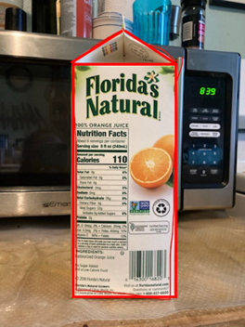
Puzzles and games can help with the affective barriers that can come up for adult students. Often, they think shape tasks should be “easy,” because they know that children learn about shapes at a young age. Nevertheless, spatial reasoning activities can still be very challenging for many adults, and keeping the tone fun can help students let down their guard and allow themselves to learn and explore.
Visualization and recognition of basic shapes
Many adult education students who lack concrete experiences with geometry and spatial reasoning still need to work visualizing shapes. This means recognizing what basic shapes can “look” like; for example, that a rectangle can be skinny or fat, or that a triangle can have equal sides, or be long and skinny, or irregular, and can point in any direction. Having the cut-out shapes in the Shape Set is an important part of this because they can be rotated, flipped, and manipulated.
Part of this visualization is also to get students looking for and recognizing shapes in their environment. The first time you ask, a student might say, “But there are no triangles in my home!” It is important to provide students with plenty of examples.
It is often easier for students to identify shapes when they are presented in a graphic, abstract form (see example on the left, below). It can be more challenging for students to identify shapes that are created by objects in the environment.
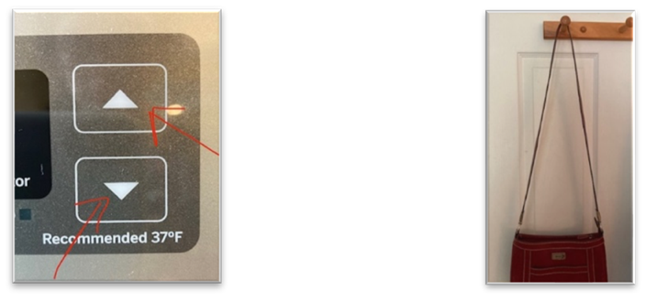
Note: Keep looking for shapes in your own environment so that you have plenty of examples!

INTRODUCING THE UNIT
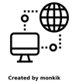
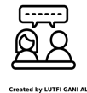
In-Person/Remote Activity
Uses Student Packet p. 3
- Explain to students that they will be studying geometry. Have them read the definition on page 3. Explain that while there are numbers and measurements in geometry, some of the work they will be doing will involve analyzing pictures, shapes, and space, and that this is an important part of mathematics. Give some examples of how geometry is used in the real world: art, design, building, engineering, home improvement, event planning, etc.
- Go over the two words “side” and “angle” on the first page. Make sure students understand what these words refer to on a shape. Ask them to tell you how many sides and angles there are in the shapes A–C on the page. It is ok to use the word “corner” as well, to help students understand that in a shape, angles make corners.

Pre-Assessment
In-Person/Remote Activity
Uses Shape Set
Ask students if they have studied geometry before. Have them take out their Shape Set and make sure that they have twelve shapes. Ask them to tell you what they know about any of the shapes. You can ask probing questions, such as:
- Do any of these shapes look familiar?
- Do you know the names of any of these shapes?
- Can you think of anything in the real world that looks like one of these shapes?
If students identify any of the shapes by name (correctly or incorrectly), you can ask: How do you know that is a [rectangle]? Take notes on what students tell you.

Which One Doesn’t Belong?
In-Person/Remote Activity
Uses Student Packet p. 4
- Like the Same or Different activity, this is an example of an open question. The goal is to have students provide a mathematical reason for their choice. There are many different arguments that could be made. For example:
- A doesn’t belong because it’s the only shape where the sides are not all the same length.
- B doesn’t belong because it’s the only shape that is shaded in (color is an attribute too!)
- C doesn’t belong because it’s the only shape that points straight down.
- D doesn’t belong because it’s the only shape with 5 sides (or with no right angles, or with no parallel lines).
- Anything a student says is valid as long as it is true. Listen for gaps in understanding, such as if a student says that B is the only square (C is also a square). This type of activity can be good for a quick assessment to see what types of concepts your student is noticing and what type of math vocabulary they use.

Vocabulary for this Unit
- In-Person/Remote Activity
Uses Student Packet pp. 5–6
Fill-in-the-blank definitions and examples have been provided for the major terms in this unit. Teach/review words along with activities where they arise, rather than teaching them all at once.
- geometry: the study of shapes, sizes, and positions
- sides: the straight lines that make a shape
- angles: the corners of a shape
- compose: to put together. We can compose shapes to make new shapes.
- decompose: to break apart. We can decompose shapes into smaller shapes.
- rectangle: a shape with four sides and four right angles.

Shape Puzzles
In-Person/Remote Activity
Uses Student Packet pp. 7–12
- Explain that the shape puzzles can be built with shapes from the Shape Set (like the example). Not all the shapes will be used. Shapes can be turned or flipped over.

Shape Puzzles Answer Key
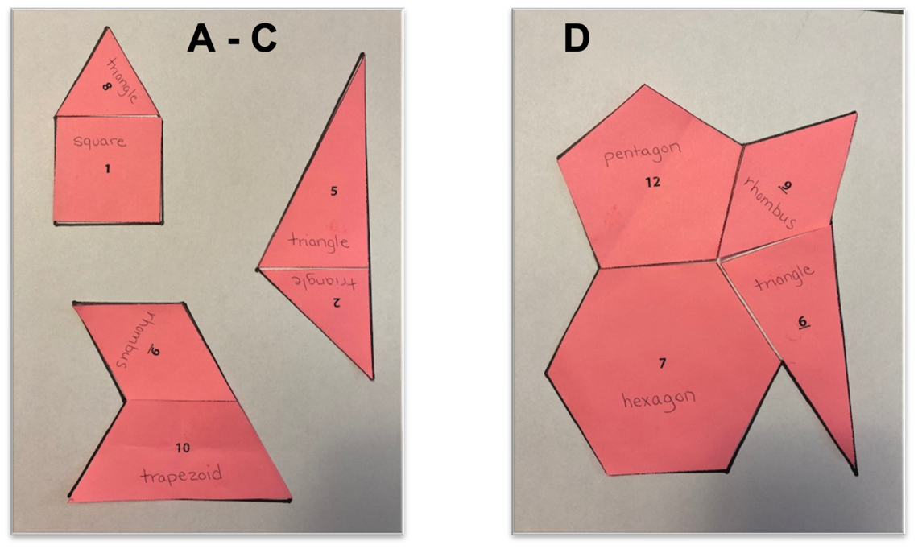
Continue to the next page for the rest of the Shape Puzzles Answer Key.
Note for Puzzle F: Right triangle #5 must be flipped.
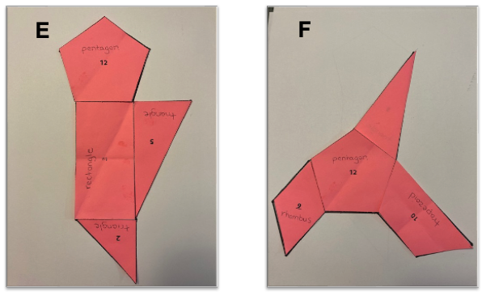

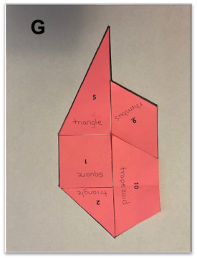

Squares from investigations
In-Person/Remote Activity
Uses Student Packet p. 13
- Have students cut out each square. Then, for each, they cut the square into two triangles and make a new shape out of the two triangles. (If needed, provide the words “square” and “triangles” for the shapes.) The triangles must touch on one side and should not overlap. Have students tape them together in the new shape.
- Students should see how many new shapes they can make out of two triangles.

Create a Shape Puzzle
In-Person/Remote Activity
Uses Shape Set
- Students create their own shape puzzles by putting together shapes in their Shape Set and tracing the outside carefully onto paper.
- Encourage students to challenge other students or family members to solve their puzzle!

Creating Shapes
In-Person/Remote Activity
Uses Student Packet p. 15
Uses Pattern Blocks (in-person)
- The hexagons are the same size as the yellow hexagons in a set of pattern blocks. Ask students to use pattern blocks to create hexagons. Each one should be different.
- Students may notice that the square (orange) and the narrow rhombus (tan) do not work. Let them explore this for a bit until they are convinced there is no way to make the hexagon with these shapes.
Remote Alternative: Have students use a ruler or straight edge. Explain that they should draw one or more straight lines through the hexagon. Then, they should identify the new shapes that have been created. Students should break up each hexagon differently.

Create a Design
In-Person/Remote Activity
Uses Student Packet p.16 and Shape Set
- In this activity, students will trace shapes from the Shape Set to create a design that covers as much of a piece of paper as they can. Send them a photo of an example. The idea is to get the shapes to fit together so they cover the paper without leaving gaps. Shapes can be traced more than once.
- Have students text you a photo of the design they have created. Discuss with them: Which shapes fit together well? Which ones were hard to fit?
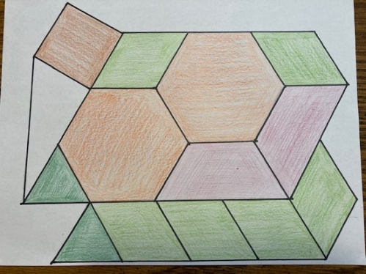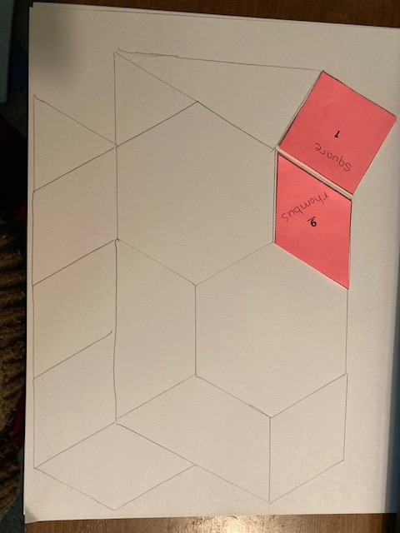

Rectangle Activity from Investigations
In-Person/Remote Activity
Uses Student Packet pp. 17–20
- This works well if students work with a partner. Ask students to order the rectangles from largest to smallest. When all groups have decided on an order, debrief by having different groups explain their order and how they came up with it.
- Some students may order the rectangles “standing up”. Ask students to consider that rectangles could be turned another way. Others may use area or some combination of dimensions and area. Discuss ideas of what could be meant by “biggest” and different ways we could compare. Provide words like “length,” “width,” or “area” as appropriate.

Rectangles and Find the Rectangles
In-Person/Remote Activity
Uses Student Packet pp. 21–22 and Shape Set
- Explain that the shapes on this page are all rectangles. Ask students what they notice about the shapes and what they have in common. They can write this in the first box. Make sure they notice the number of sides and angles, and something about opposite sides being equal, however they choose to describe that. You don’t have to go into right angles yet if they don’t have that concept.
- Also ask students what they see that is different between the shapes. They don’t have to write this down, but point out that although some of the rectangles are skinny, other are fat, some are oriented vertically and others across, they are all rectangles.
- Ask students to brainstorm, “What has this shape in real life?” If they have a hard time, give them some examples that you see in the room around you.
- Students may point out that C is a square. Affirm that yes, C is a square, and ask them how they know, or what makes it look like a square. Explain that a square is a special type of rectangle where all the sides are the same length. They will look at squares in more detail later.
- Ask students to find the rectangles in the Shape Set (#1 and #3). They can label these shapes with the word “rectangle”.
- On the next page, Find the Rectangles, ask students to identify objects that they see in each picture that are rectangles.

Vocabulary
geometry: the study of shapes, sizes, and positions
sides: the straight lines that make a shape
angles: the corners of a shape
compose: to put together. We can compose shapes to make new shapes.
decompose: to break apart. We can decompose shapes into smaller shapes.
rectangle: a shape with four sides and four right angles.

Things to Watch For
Difficulties with Manual Dexterity or Visual Alignment
Some adults may struggle with the shape puzzles (or tangrams and pattern blocks) because they have difficulty manipulating the shapes with their fingers, or because they have difficulty aligning them visually with the shape outlines on the page. You may notice shapes sticking out or covering parts of the outline, or large gaps between shapes.
Adding friction to the pieces can help (dots of hot glue on plastic pieces can keep them from sliding around). You can also highlight the outlines of the shapes on the puzzles and tell students that they must be able to see all of the (yellow) outline when their shapes are inside. Coloring in the puzzle shape or the background can also make the contrast more visible.
Students who are not able to manipulate physical shapes could use a virtual form of the activity: https://polypad.amplify.com/p#polygons

Frustration Tolerance
Spatial reasoning puzzles like the ones in this unit are challenging for many learners. You will notice quickly if students have a hard time tolerating the frustration of puzzles that require some perseverance. The shape puzzles in the book start simple and become more complex. If you are also using tangram or pattern block puzzles, start frustrated students on simpler problems to ensure that they will experience some success, then bring the level of challenge up gradually. If you find these puzzles online, they usually come with an answer key, which shows the tan or pattern block outlines that make up the larger shape. A student who is really struggling could start by building the shapes onto the answer key directly, before moving on to simple puzzles. Most students improve both their skill and frustration tolerance with these puzzles over time, if they can tolerate the challenge of the unknown at first!

Unit 2: Finding Half and Understanding Symmetry
Learning Objectives | CCRSAE
I can find half of different types of shapes. | Reason with shapes and their attributes. (2.G.3, 3.G.2, halves only)
I can find a line of symmetry in a shape. | Reason with shapes and their attributes. (2.G.1)

Standards for Mathematical Practice
MP.1 Make sense of problems and persevere in solving them
Creating symmetrical shapes also requires spatial reasoning, and for students without experience in this type of task it can require trial, error, adjustment, and perseverance.
Extra Resources for this Unit
- Reproducible: Shape Set, Teacher’s Guide pp. 39–40
- Reproducible: Evaluation Unit 2, Teacher’s Guide, p. 36
- Web link: Reflection Painter
https://www.mathplayground.com/reflection_painter.html

Other materials
scissors, colored pencils

Math Background

Finding Half and Line Symmetry
This unit starts with the concept of half, which is likely to be familiar to many students. Often finding half of the area of a shape is done naturally in a symmetrical way, by cutting it down the middle (or along a line of symmetry).
Although half is a nice jumping off point for talking about symmetry, the two concepts are not identical. One half of a shape just means that the two portions have the same area. They don’t necessarily have to have a line of symmetry, as in the image below.
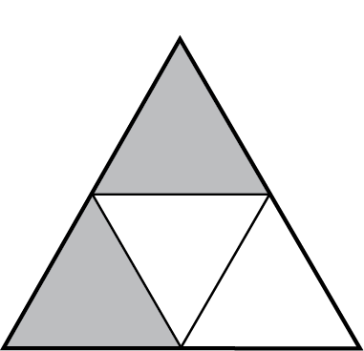
Many everyday objects are symmetrical, so the concept is fairly intuitive for many adults. Shapes made out of folded paper, or allowing students to fold shapes in their shape set, can help make this concrete.
What is not intuitive for many students is reproducing or reflecting a shape over a line of symmetry, such as when students are given half of a symmetrical shape and asked to draw the other half. This requires being able to reverse the image in one’s mind and to look back and forth at corresponding points on both sides. Many beginning adult math learners need quite a bit of exposure to this type of task to develop the spatial reasoning to accurately reverse the image. There are a number of different activities in this unit to provide some of that exposure, including the symmetry challenge and the digital Reflection Painter interactive.

Activities and Practice

Halves and Not Halves
In-Person/Remote Activity
Uses Student Packet p. 23
- Start by introducing a rectangular array that is 3 × 4. Ask: What are some ways that I could color this array half blue and half red (or any two colors)? Give students square inch tiles or grid paper and color pencils to demonstrate. Share different solutions, and have students explain how they know it is “half and half.” Come up with a class understanding of halves as two equal parts. In this case, any pattern of six red and six blue will be halves.
- Do more examples with grid paper or tiles, as needed. Then have students complete “Halves and Not Halves” to show examples and counter examples on rectangles.

Shape Halves
In-Person/Remote Activity
Uses Student Packet pp. 26–27
- Remind students of halves as two equal parts and ask them to find a way to divide each of the shapes into halves. Some shapes will have more than one way to cut them. Look at examples of shapes with one way and examples with more than one way.

Making Symmetrical Shapes and Symmetry
In-Person/Remote Activity
Uses Student Packet pp. 28–29
- If possible, have students cut out their own symmetrical shapes following the example. Any shape they cut will be symmetrical with the fold as the line of symmetry.
- Go over the definition of symmetry and the examples on page 29. Discuss the letter examples on the bottom to check for understanding.
- Have students experiment with cutting folded paper to create symmetrical shapes. Can they create a shape that unfolds to make a heart? A star? A triangle? A rectangle? A donut?

Lines of Symmetry
In-Person/Remote Activity
Uses Student Packet p. 30
- Before working on this page, have students practice folding shapes in their Shape Set to check for symmetry. Discuss a couple of these examples. Are there shapes that have more than one line of symmetry?
- Encourage students to physically fold the page if they need to in order to visualize whether the shape is symmetrical. Make sure students are checking the line that is marked, as many shapes may be symmetrical across other lines.

Symmetrical or Not?
In-Person/Remote Activity
Uses Student Packet p. 31
These are more examples of human-made objects. Discuss with students whether each example is symmetrical (with a vertical line of symmetry). If it is not symmetrical, have them explain what details don’t match.

Symmetry in Nature
In-Person/Remote Activity
Uses Student Packet p. 32
Explain that symmetry is very common in nature and natural objects. Ask them to think of other examples of symmetry in nature. (Another challenging question would be if they can think of animals that are NOT symmetrical in some way.)

Front and Side Views
In-Person/Remote Activity
Uses Student Packet p. 33
- Explain that it is common for some objects to be symmetrical from one direction, and not symmetrical in the other. Discuss the examples on the page and whether each view is symmetrical or not.
- Can students think of another object that is symmetrical from one direction, and not another? Can they think of an object (like the bird feeder) that is symmetrical from more than one view?

Symmetry Challenge
In-Person/Remote Activity
Web link: Reflection Painter
https://www.mathplayground.com/reflection_painter.html
Note: This program works best if students have a computer with a mouse. It does not work well with touch screens.
After students have had a chance to play around with the reflection painter, encourage them to create some of the following shapes:
- A heart
- A rectangle
- A triangle
- A star
- A smiley face
They want to draw half of the shape, and have the program draw the other half, so that the line in the center is the line of symmetry. This is a challenging task that requires students to think about the whole shape and what only half of the shape would look like. Many students will begin, for example, drawing a heart on one side of the line and will end up with two hearts!

Finish the Shape
In-Person/Remote Activity
Uses Student Packet p. 34
- Students finish the shape by reflecting over the line of symmetry. Encourage students to look at their finished shape and to see if it would “fold” over the line.

Adinkra Symbols/adrinka stamped cloth
In-Person/Remote Activity
Uses Student Packet pp. 35–36
This includes a short reading about the use of Adinkra symbols and Adinkra stamped cloth in Asante culture. On the second page, ask students what they notice and wonder about the image. Accept any noticing and wonderings, and gently prompt students to pay attention to the way the symbols are arranged (generally in square or rectangular arrays, the same symbol repeated many times).
A short video of Ghanian artisans creating Adinkra stamped cloth using traditional techniques can be found here: https://traveling.black/adinkra-symbols-kente-cloth/

Symmetry in Adinkra Symbols
In-Person/Remote Activity
Uses Student Packet pp. 37–38
Encourage students to pay close attention to the shapes of these symbols. Where can they draw lines of symmetry? Are there any shapes with no lines of symmetry? Any with more than one?
Note: Page 38 of the Student Packet contains descriptions of the symbols on the previous page and their meanings. One of the symbols is identified as a variation of a swastika. The swastika symbol has a long history in religions and cultures all over the world as a symbol of well-being and good luck. It became a symbol of hate in Western cultures after it was adopted by the Nazi party in the 1930s but does not have the same meaning in other parts of the world. There is a note about this on page 38 in the Student Packet. It might be good to point out this information explicitly, since the connotations of the swastika symbol and even just the word can have such strong connections with hate and bigotry for many people. The symbol does not have this meaning as used in Asante culture and Adinkra.

Vocabulary
half / halves: one of two equal parts or portions
(line) symmetry / symmetrical: when a shape or image is the same when folded or reflected over a line
line of symmetry: the line in a symmetrical shape where the shape can be “folded”

Things to Watch For
Things that Fold/ Things that Don't Fold
Cutting shapes out of folded paper and folding paper to see symmetry in shapes is a great way to make the concept of symmetry concrete. When students understand symmetry on this level, push to make sure they still apply the concept to things that don’t “fold” in physical reality, such as a symmetrical piece of furniture.
Symmetry in Complex Images
Some of the more complex images in the packet do not have symmetry as a whole but may have symmetry in some of their parts. For example, the desk below is not symmetrical as a whole, but the drawers on the left side are symmetrical, if the desk is decomposed into parts.
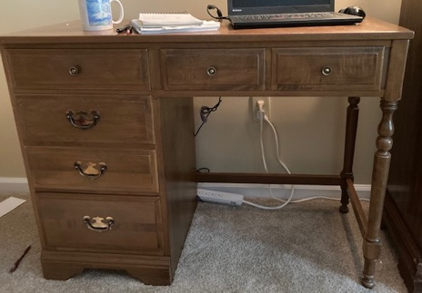
Unable to Reflect an Image
Some students may be able to recognize symmetry, but unable to produce it, such as in the “Finish the Shape” exercises in the Student Packet on page 34. If they are struggling unproductively to do this by hand, have them try creating the shapes with the help of the Reflection Painter at https://www.mathplayground.com/reflection_painter.html

Unit 3: Right Angles and Parallel Lines
Learning Objectives | CCRSAE
I can identify a right angle in a shape. | Draw and identify lines and angles, and classify shapes by properties of their lines and angles. (4.G.1)
I can identify parallel lines in a shape. | Draw and identify lines and angles, and classify shapes by properties of their lines and angles. (4.G.1)
I can identify triangles and trapezoids. | Reason with shapes and their attributes. (2.G.1, 3.G.1)

Standards for Mathematical Practice
MP.6 Attend to precision
Students will learn to identify and describe certain characteristics of shapes (right angles and parallel lines) and will start to form more precise definitions for shapes based on these characteristics.
Extra Resources for this Unit
- Reproducible: Shape Set, Teacher’s Guide p. 39–40
- Reproducible: Evaluation Unit 3, Teacher’s Guide, p. 37
Other materials
uncooked spaghetti

Math Background
Identifying basic attributes of shapes
This unit presents students with a few important geometric concepts that are also attributes of shapes: angles (especially right angles) and parallel lines. Just like the shapes, these concepts need to be experienced as concretely as possible, so that students develop an intuition for what they look and act like. Angles are introduced using joints in the body, so that students can understand both visually and kinesthetically that an angle is an amount of opening or closing, like the way we can open or close our arm. Parallel lines are explored using long straight objects to extend sides into space. Along with the line symmetry that students explored in Unit 2, these attributes allow students to start creating more precise definitions of shapes, laying the foundation for later thinking about relationships between types and categories of shapes.

Activities and Practice

Angles in the Body
In-Person/Remote Activity
Uses Student Packet p. 39
- Explain that one way to think about angles is that our body makes angles when we bend our joints. For example, our arm makes angles when we bend our elbow. The angle is the corner, like the corner in a shape. We measure how small or large an angle is by how open it is. When our arm is bent sharply, so that our elbow sticks out, the angle is small because the arm is only open a little bit. When we stretch out our arm so the elbow is only bent slightly, the angle is larger.
- Explain that there is a special type of angle called a right angle. Make sure to point out that while we call this angle “right”, it doesn’t have to do with right or left, and it doesn’t mean that other angles are wrong. The word “right” has a special meaning in math when we talk about angles.
- To make this special angle with your arm, make your upper arm flat, and let your hand and fingers point straight up to the sky. This is a right angle. A right angle looks like the corner of a rectangle.
- Draw their attention to the two pictures at the bottom. Which joints are making right angles? Point out that the right angle can point in any direction, as long as it is open the same amount as the angle we made with our hand pointing up.
- Revisit the rectangles on page 21. Ask: Are all the angles right angles? How do you know?

Right Angles: Paper Test
In-Person/Remote Activity
Uses Student Packet p. 42 and Shape Set
- Another way of testing for right angles is to use the paper test. Explain that regular paper is cut so that all the corners are right angles. We can use a piece of paper to test whether something has a right angle or not. We put the corner of the paper into the corner of the angle. If it fits perfectly, then the angle is a right angle.
- Have students use the corner test on the angles A–D to decide if they are right angles.
- Have students use the paper test to find right angles in the Shape Set.

Trapezoids
In-Person/Remote Activity
Uses Student Packet pp. 43–44
- Follow the procedure used in Unit 1’s activity, Rectangles. If students don’t point it out, ask them if they see any right angles (B has two right angles. Some of the others are close, but they should check with the paper test.)
- Students may not have the vocabulary to talk about parallel lines yet. That will be addressed in the next activity.
- Ask students to look for trapezoids in the Shape Set (#10). They should label this shape.
- On page 44, have students match which of the trapezoids at the bottom can be seen in each photo.

Parallel or Not?
In-Person/Remote Activity
Uses Student Packet p. 45
Explain that parallel lines are lines that will never meet. Make sure students understand that it is not about whether we see them meet or cross on the page or in the shape, but about whether that would ever cross if they were extended.

Checking for Parallel Lines and Parallel Lines
In-Person/Remote Activity
Uses Student Packet p. 46–47
- This page shows an example of using spaghetti to check whether lines in a shape are parallel. If students don’t have spaghetti, they can use pens or coffee stirrers or anything long and skinny and straight.
- After students understand how to check for parallel lines, have them practice by looking for parallel lines in the shapes of the Shape Set.
- The following page, Parallel Lines, also has examples of what parallel lines might look like in the real world.
- Lastly, return to the Rectangles and Trapezoids pages. Ask: Where do parallel lines appear in these shapes?

Triangles
In-Person/Remote Activity
Uses Student Packet p. 48
- Follow the procedure used in the Rectangles activity.
- If students don’t point it out, ask them if they see any right angles (D has a right angle. They should check with the paper test.)
- Extension question (students can explore this question with spaghetti or pens, or by drawing):
Do you see parallel lines in any of the triangles? Is it possible to have parallel lines in a triangle? Why or why not?
- Ask students to look for triangles in the Shape Set (#2, 5, 6, 8). They should label these shapes.

Triangles: Same and Different
In-Person/Remote Activity
Uses Student Packet p. 49
Have students fill in the two columns with what is the same about the two triangles, and what is different. Push them to use the vocabulary and concepts that they have been learning when appropriate, such as side, angle, right angle.

How Do You Make Sure the Corners are Square?
In-Person/Remote Activity
Uses Student Packet pp. 50–51
If possible, provide students with something they can use to create the 3-4-5 triangle. You can use small strips of paper, wooden sticks, inch tiles, or Cuisenaire rods. Make sure the lengths of the three parts are in the ratio 3-4-5. Have students arrange these into a triangle. Ask them to compare their triangle with another student’s triangle. Do they look the same? Do all the triangles have a right angle (yes)? Is it possible to arrange the sides to make a different triangle? (no) Let students play around until they are convinced that there is only one triangle that can be made with the sides (other than different positions).
Read the article on pages 50–51. Ask students if they have ever encountered this or other strategies for making sure that corners are “square.”
Note: Although in Western texts Pythagoras is often credited with “discovering” right triangles and their properties, other cultures were using right triangle triples and other right triangle properties long before Pythagoras. See https://www.livescience.com/earliest-form-of-pythagorean-triplet for an interesting article about a Babylonian tablet showing right triangle properties from a millennium before Pythagoras.

Vocabulary
right angle: a “square corner.” The corner of a piece of paper will fit into it perfectly.
parallel: Parallel lines go in the same direction, stay the same distance apart, and never meet
trapezoid: a four-sided shape with exactly one pair of parallel sides
triangle: any three-sided shape

Things to Watch For
Right Angles in Different Positions
Make sure students can identify right angles in many different positions, such as the one in the point of this arrow shape. Students often look for right angles where the lines are horizontal and vertical, and do not recognize them in other orientations as easily.
Parallel vs. Equal Length
Many students confuse the concept of parallel sides with sides that have equal length. This may be because they are usually most familiar with rectangles, where opposite sides are both parallel and equal. However, when they encounter a shape like this trapezoid, they may confuse the top and bottom sides, which are parallel, with the left and right sides, which have equal length.
Pairs of Parallel Sides
In order for sides to be parallel they must be parallel to each other, so there must be at least two parallel sides. A single side cannot be parallel. Students sometimes say this if they mistake parallel for an orientation, such as horizontal.

Unit 4: Review and Extension
Learning Objectives | CCRSAE
I can identify some common shapes by their characteristics. | Reason with shapes and their attributes. (2.G.1, 3.G.1)
I can reason about how shapes are similar and different. | Classify two-dimensional figures into categories based on their properties. (5.G.3)

Standards for Mathematical Practice
MP.6 Attend to precision
Students continue to identify and define shapes by their characteristics, and to use precise language to identify, compare, and contrast shapes.
MP.7 Look for and make use of structure
Open ended tasks that ask students to draw different shapes on dot paper force them to (informally) pay attention to the relationships of sides and angles in different shapes.
Extra Resources for this Unit
- Downloadable file: Who Am I? PowerPoint
- Reproducible: Shape Set, Teacher’s Guide pp. 39–40
- Reproducible: Dot paper (several types), Teacher’s Guide pp. 41–48
- Reproducible: Evaluation Unit 4, Teacher’s Guide, p. 38
Other materials
rulers, colored pencils

Math Background
Pushing forward
In addition to a robust review of all concepts in the first three units, a few of the activities push students to start to analyze shapes at a more abstract level, using precise characteristics and definitions to identify or sort shapes (Square and Rhombus, Is It a Rectangle?, Compare Shapes, Sort Shapes). These come later in the packet after students have had a chance to explore visualizations of shapes in the earlier activities.

Activities and Practice

Flags: Did You Know?
In-Person/Remote Activity
Uses Student Packet pp. 53–54
This short reading talks about the evolution of flags from battlefield banners to national symbols and gives some examples of how the colors or symbols used on flags can represent the history, identity or ideals of a people or nation. Students can be pushed to think further about ways in which the symbolism of flags can be liberating or oppressive. The case of New Zealand is interesting because it involves a debate over the legacy of colonialism on the country’s flag, a multi-year campaign to change it, and a popular vote that led to keeping the status quo.
The next couple of activities show examples of flags and ask students to identify the geometric shapes and properties used to create the design.

Flags
In-Person/Remote Activity
Uses Student Packet p. 55
- Ask, What shapes to do you see in these flags? As students identify shapes, ask them how they know that it is a [triangle]. (You can also do this activity with a flag that is meaningful to the student.)
Extension: Have students design their own flag. Their flag should include at least three different types of shapes.

U.S. Flag Review
In-Person/Remote Activity
Uses Student Packet p. 56
- This is a quick review of concepts that have been studied so far. Ask:
- What shapes do you see in this flag?
- What types of angles do you see?
- Do you see any parallel lines?
- Are there any lines of symmetry?
- Discussion: Ask students if they know the symbolism of the colors and shapes on the American flag. See https://www.pbs.org/a-capitol-fourth/history/old-glory/
- Based on what they learned, ask, Is this a good flag to represent the U.S.? Why or why not?

Who Am I? (Shape Set)
In-Person/Remote Activity
Uses Downloadable File: Who Am I? PowerPoint
https://www.dropbox.com/scl/fi/es9mkkj80hqtzwq6q0j6x/BeCALM-Geo_Who-am-I.pptx?rlkey=2jdx2bs20oh8cmgnjrttvl8yt&st=l9ojhq0q&dl=0
Uses Reproducible: Shape Set, Teacher’s Guide, pp. 39–40
- You can play this game repeatedly throughout the unit. Model being the clue giver first, then take turns being the one giving clues.
- One person chooses a shape from the Shape Set. They then give a clue about the shape. The other person than makes a pile of all the possible shapes that fit that clue. Then the clue giver gives another clue. Repeat until there is only one shape left and the person is ready to guess.
- Another variation is to have one person pick a shape, and to have the other person ask yes or no questions about the shape.
- As the teacher, model giving clues or asking questions about numbers of sides or angles, the existence of right angles, equal sides, or parallel lines. You can also give clues about objects in the real world that have this shape.

Dot Paper Activities Part 1
In-Person/Remote Activity
Uses Reproducible: Dot paper, Teacher’s Guide, pp. 41–48
Below are two ideas for investigations you can have students do with the dot paper, included at the end of the Student Packet. This will work best if your student can send you photos of what they have done, so that you can see their work and discuss it with them.
To use the dot paper, students can draw lines connecting any dots on the page. They cannot draw curved lines. They cannot draw lines that do not connect dots.
More accessible:
- Create three different rectangles (on square or triangle dot paper). Explain how they are different.
- Create three different triangles (on square or triangle dot paper). Explain how they are different.
More Challenging:
- Create four different four-sided shapes. At least three cannot be a rectangle. Describe how they are different.
- Create a triangle with a right angle. Try to do this on the square dot paper and the triangle dot paper. Does it work on both?
- Create a triangle with three sides of equal length. Try to do this on the square dot paper and the triangle dot paper. Does it work on both?

Shapes with More Sides: Examples
In-Person/Remote Activity
Uses Student Packet p. 59
- Give students the names and definitions of pentagons, hexagons, and octagons. Explain that these shapes are defined by the number of sides and angles, but the sides do not all have to be the same length. Have them write the letters of each shape in the appropriate box.
- Where have they seen these shapes? Brainstorm, then have them look at the photos on the next page (Shapes with More Sides: Examples, page 60) for more ideas.
Find and label the pentagon (#12), hexagon (#7) and octagon (#11) in the Shape Set. Have the students turn the shapes around. Ask: Do they look different when you turn them? Do they look different when you flip them over?

Road Signs
In-Person/Remote Activity
Uses Student Packet p. 61
This is a nice way to review the shapes that have been learned so far. Students write the letter of the road signs that match each shape in the box. This activity could be assigned for homework.

Square and Rhombus
In-Person/Remote Activity
Uses Student Packet p. 62
Note to teachers: A rhombus is a shape with four equal sides. Technically, a square is a special type of rhombus with right angles. Very beginning students may not be ready to grasp this relationship (all squares are rhombuses but not all rhombuses are squares). Instead, focus on getting students to notice that all the images on the page have equal sides, and that both squares and rhombuses can look like a “diamond” when angles point up and down. Have students pay attention to the way the angles change in the video.
- Share the following link with students to give them a visual of how a square and a rhombus are related: Square Box https://youtu.be/DY9ApTGiSsE
- Ask students to look at the images on the page. What do they notice? Ask them to check for equal sides, right angles, parallel lines, and lines of symmetry. You can also have them pull out the square and rhombus from their Shape Set (#1 and #9) to help with this exploration.

Compare Shapes
In-Person/Remote Activity
Uses Student Packet p. 63
This activity is similar to Triangles: Same or Different?
Dot Paper Activities Part 2
In-Person/Remote Activity
Uses Reproducible: Dot paper, Teacher’s Guide, pp. 41–48
More accessible:
- Try to create as many of the following shapes as you can on the triangle dot paper: rectangle, triangle, square, trapezoid, pentagon, hexagon, octagon.
Ask: Which shapes were easy to make? Which were hard to make? Are there any shapes you can’t make?
- Connect dots on the dot paper to make a block letter of your first initial.
- Connect the dots to make a large, irregular shape, like the one in the shape puzzles. Now break the shape into smaller shapes. What types of shapes did you break it into?
More challenging:
- Connect dots on the dot paper to make a block letter of your first initial. Can you break this shape up into rectangles? Triangles? A combination of both?
- Connect the dots to make a large, irregular shape, like the shapes in the shape puzzles. Now break your shape up into smaller shapes. Can you break up your shape into all four-sided shapes?

Shape Scavenger Hunt
In-Person/Remote Activity
Uses Student Packet p. 64
- This can be done in-person or remotely. If possible, have students text you photos and display them to the class.

Sort Shapes
In-Person/Remote Activity
Uses Student Packet p. 65 and Shape Set
This is an open-ended task. Ask the student (or pairs of students) to sort the shapes in the Shape Set into four piles, based on things that the shapes have in common. The piles do not have to be the same size. Have students tell you which shapes they placed in each pile. Then have the student give each pile a name.
Extension: You can do this activity again and ask them to sort into two or three piles.

Study Strategy
In-Person/Remote Activity
Uses Student Packet p. 66
It can be helpful to explicitly teach students ways that they can study on their own to build independence.

Common Shapes Review
In-Person/Remote Activity
Uses Student Packet pp. 67–68
Have students fill this out with you and check for accuracy and completeness. Review the relevant concepts they have learned so they can give an accurate description of each shape.

Is It a Rectangle?
In-Person/Remote Activity
Uses Student Packet p. 69
This activity pushes students to start to use a more formal definition to identify rectangles. In addition to deciding which shapes are rectangles, make sure they can identify which parts of the definition are violated in the shapes that are NOT rectangles.

Design Challenge
In-Person/Remote Activity
Uses Student Packet p. 70
While students are looking at the design on the page, ask them the following questions:
- What is the name of the largest shape in the design? (hexagon)
- What is the most frequent shape in the design? (rhombus)
- How many shapes share a side with the hexagon? (6)
- How many triangles are in this design? (3)
- How can you tell which shape is the square? (four equal sides, four right angles, two sets of opposite parallel sides)
- Of the 13 shapes in this design, how many are four-sided shapes? (9)

Geometry Quiz
In-Person/Remote Activity
Uses Student Packet p. 71
The purpose of this quiz is to give students a reason to study and review what they have learned and to allow you a final opportunity to assess student mastery of the concepts.
- Name these shapes.
- Which of the shapes have right angles? How can you tell?
- Which of the shapes have parallel lines? How can you tell?
- Name one of the shapes that is symmetrical if the lines go across the shape (horizontal).
- Give an example of somewhere you might see each of these shapes in real life

Vocabulary
pentagon: a five-sided shape
hexagon: a six-sided shape
octagon: an eight-sided shape
square: a shape with four equal sides and four right angles. A special rectangle and a special rhombus.
rhombus: a shape with four equal sides

Things to Watch For
Spatial Reasoning on the Dot Paper
The dot paper activities are great for spatial reasoning and perseverance, but they can be very challenging for some students. For example, when asked to draw a block letter of their initial, some students may draw line letters and have difficulty understanding how to add “thickness” to the letters. Curved letters can also be challenging. Encourage them to use a ruler to connect dots and to approximate curves this way. With all straight lines, the polygons they create can be decomposed into rectangles and triangles.
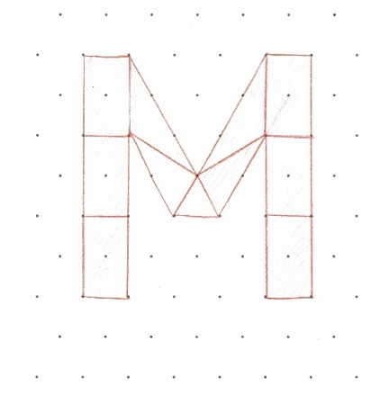
When drawing different types of shapes, students may need a lot of trial and error. Some shapes with a lot of sides, like an octagon, can be difficult to fit on the dot paper because it requires a lot of wide angles (it is possible though!) The square is not possible on the triangle dot paper because the regular distances between dots horizontally and vertically are not the same.

Here are some examples of dot paper shapes on the triangle dot paper:
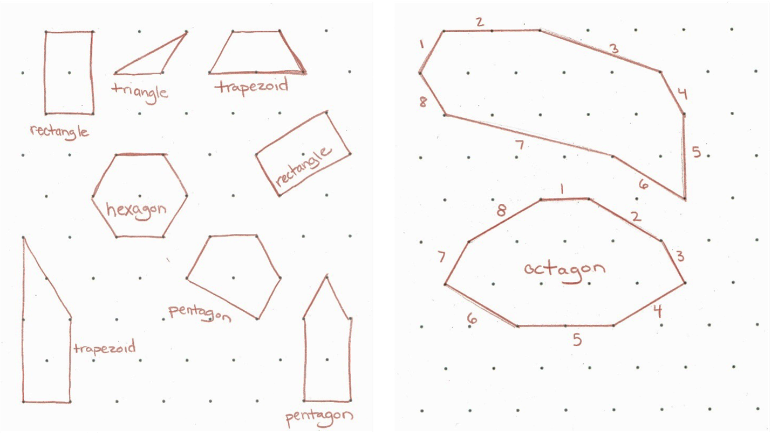

Students may need to see examples from the teacher or other students if they are not sure how to get started.

Special Cases
As students develop towards higher levels of geometric reasoning, they can use definitions to understand how a shape can fit into more than one category. For example, a square is special case of rectangle (with 4 equal sides) and a special case of rhombus (with right angles). Basically, a square is where the definitions of rectangle and rhombus overlap. This is the next step in geometric reasoning (van Heile Level 2: Informal Deduction), and some students may be ready to start discussing these categories by the end of this packet.
Name:___________________________ Date:__________________

Geometry: Unit 1, Putting Together and Taking Apart Shapes
Objective | Student Self-Evaluation  (Struggling, Learning, Mastery) | Teacher Evaluation
- I can break a shape into simpler shapes.
- I can put simple shapes together to make a new shape.
- I can identify a rectangle.

Name:___________________________ Date:__________________

Geometry: Unit 2, Finding Half and Understanding Symmetry
Objective | Student Self-Evaluation  (Struggling, Learning, Mastery) | Teacher Evaluation
- I can find half of different types of shapes.
- I can find a line of symmetry in a shape.

Name:___________________________ Date:__________________

Geometry: Unit 3, Right Angles and Parallel Lines
Objective | Student Self-Evaluation  (Struggling, Learning, Mastery) | Teacher Evaluation
- I can identify a right angle in a shape.
- I can identify parallel lines in a shape.
- I can identify triangles and trapezoids.

Name:___________________________ Date:__________________

Geometry: Unit 4, Review and Extension
Objective | Student Self-Evaluation  (Struggling, Learning, Mastery) | Teacher Evaluation
- I can identify some common shapes by their characteristics.
- I can reason about how shapes are similar and different.

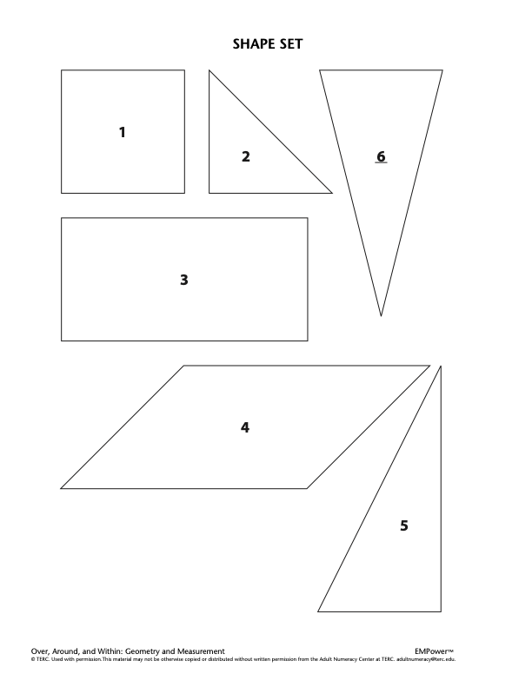
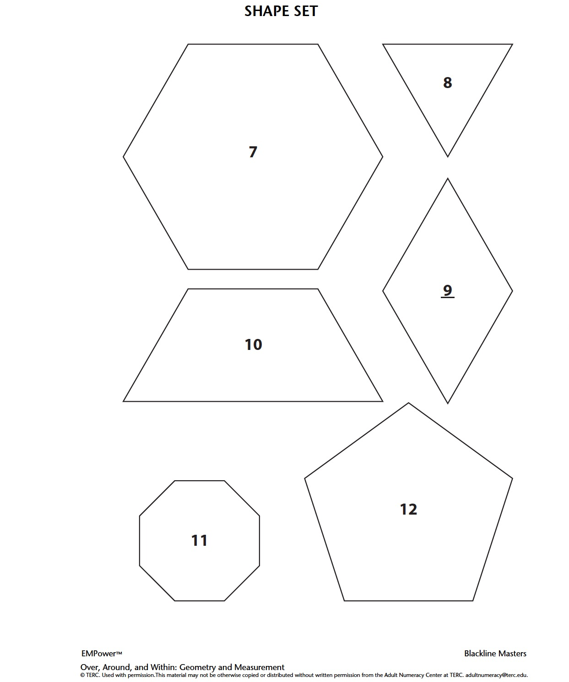

Square Dot Paper – Large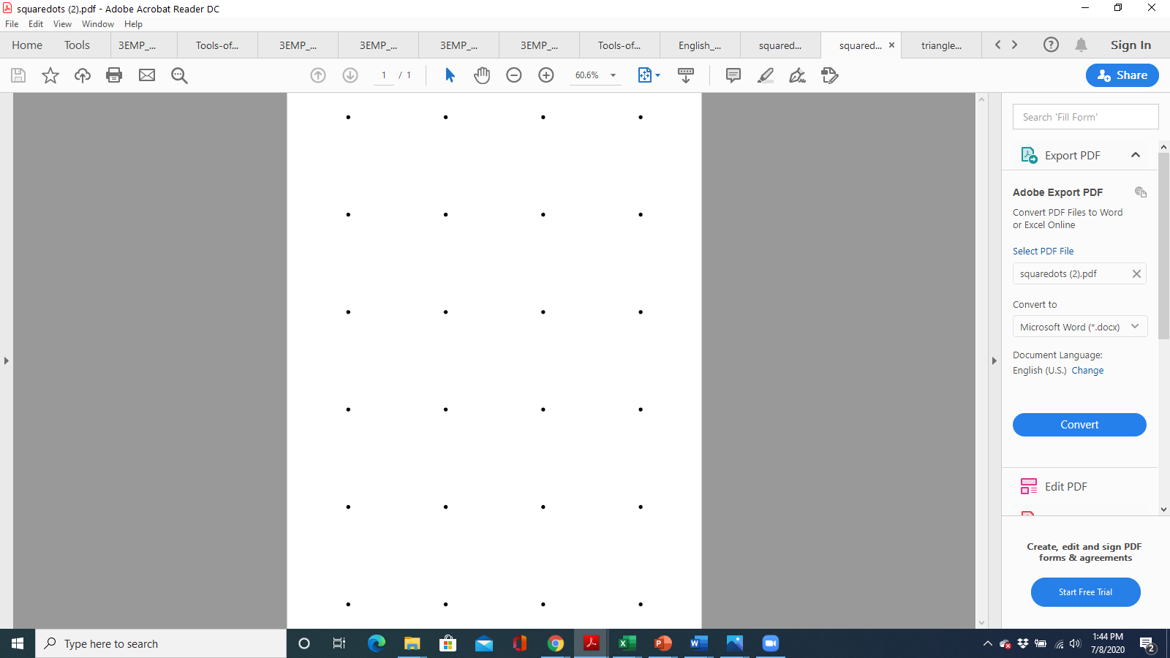
Square Dot Paper – Large
Square Dot Paper – Small

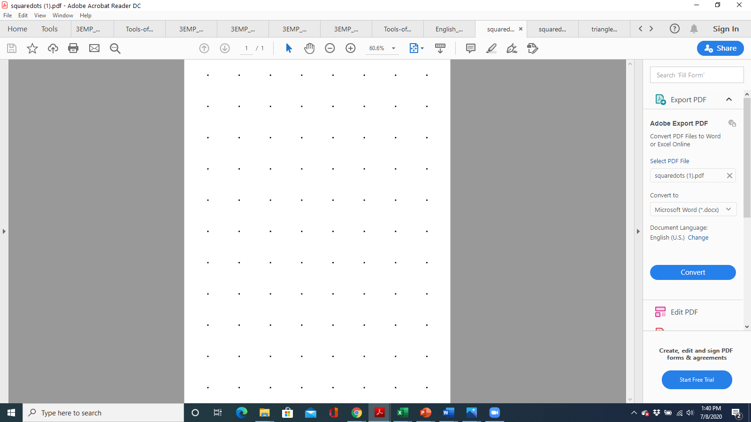
Square Dot Paper – Small
Triangle Dot Paper – Large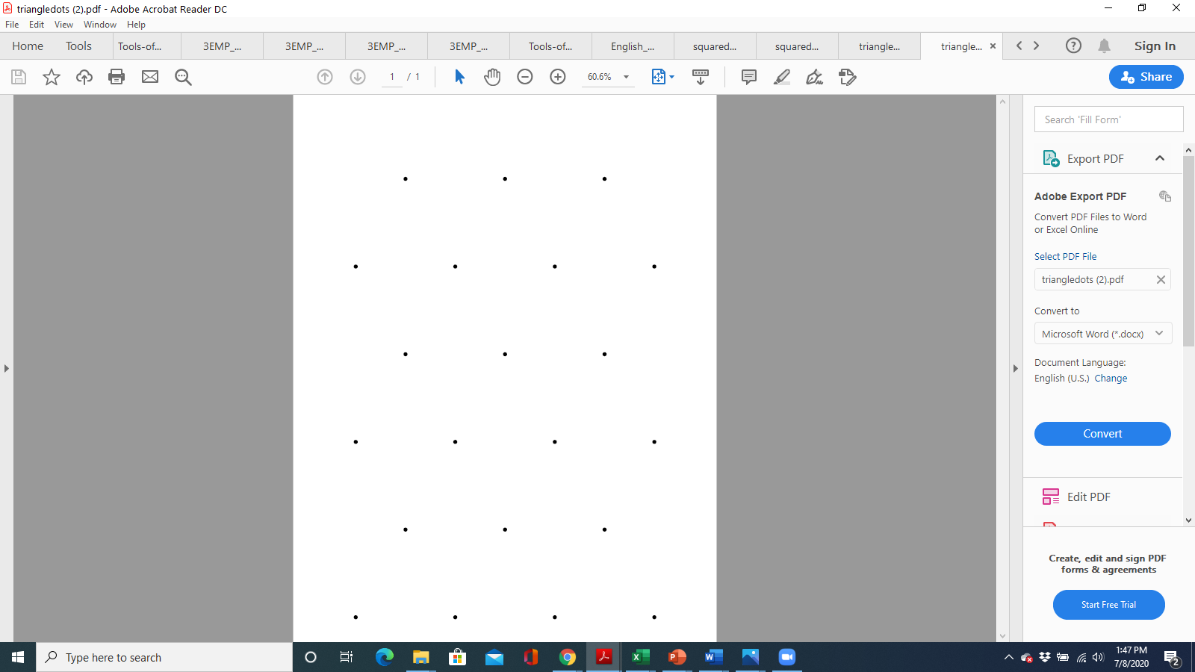
Triangle Dot Paper – Large
Triangle Dot Paper – Small

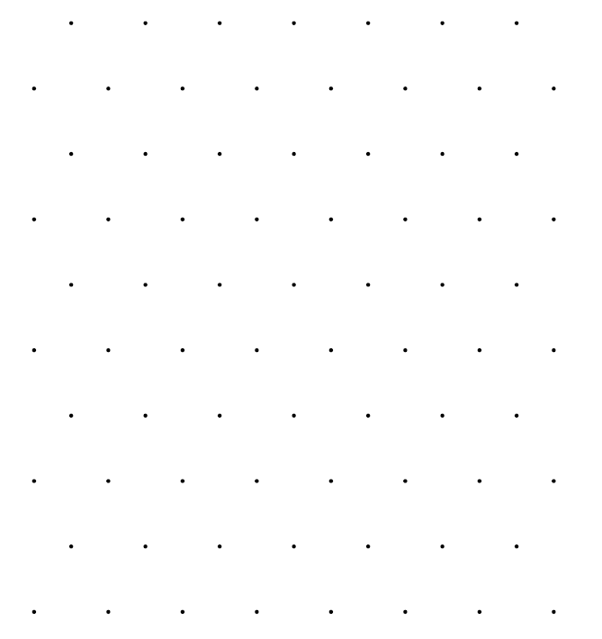

Triangle Dot Paper – Small

