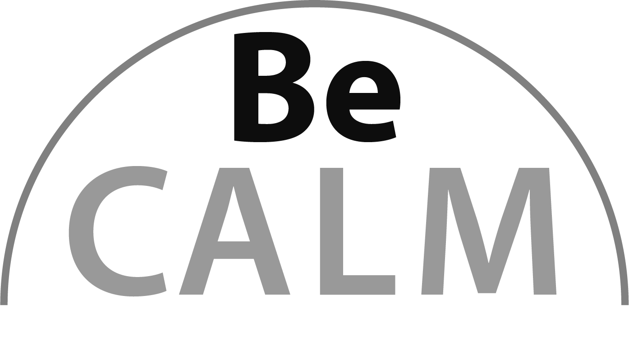
Geometry
Beginning Curriculum for Adults Learning Math

STUDENT PACKET

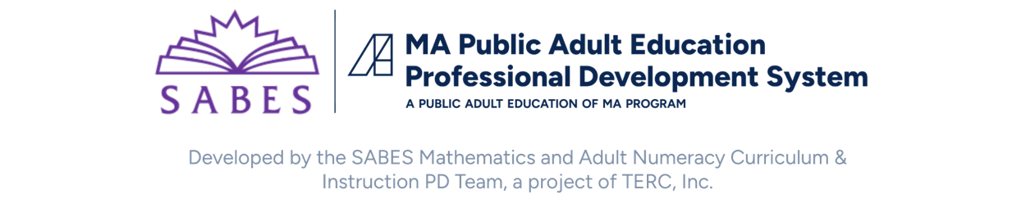

Acknowledgements

The titles in the BeCALM series were developed and piloted in the classroom by Melissa Braaten for the SABES Mathematics and Adult Numeracy Curriculum & Instruction PD Team, with contributions from Yvonne Readdy, Emily Rudd, and Sherry Soares.

The BeCALM series includes four sequential packets:
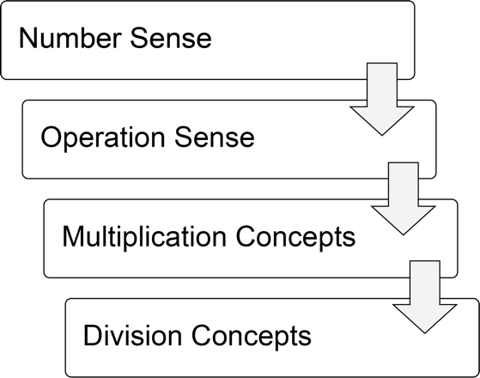
and three non-sequential packets:
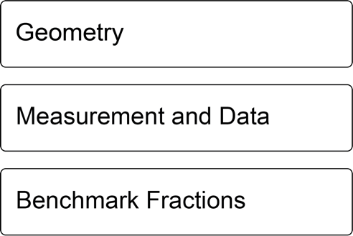

Activities from the EMPower™ series title Over, Around, and Within: Geometry and Measurement are used and/or adapted with permission from the author, TERC, Inc.
The activities on pages 13, 17, 19, 23, 26, and 27 are from Investigations: Shapes, Blocks and Symmetry © 2012 by Savvas Learning Company LLC, or its affiliates. Used by permission. All Rights Reserved.

UNIT 1: Putting Together and Taking Apart Shapes

Geometry is the part of math where we study shapes, sizes, and positions.

Shapes

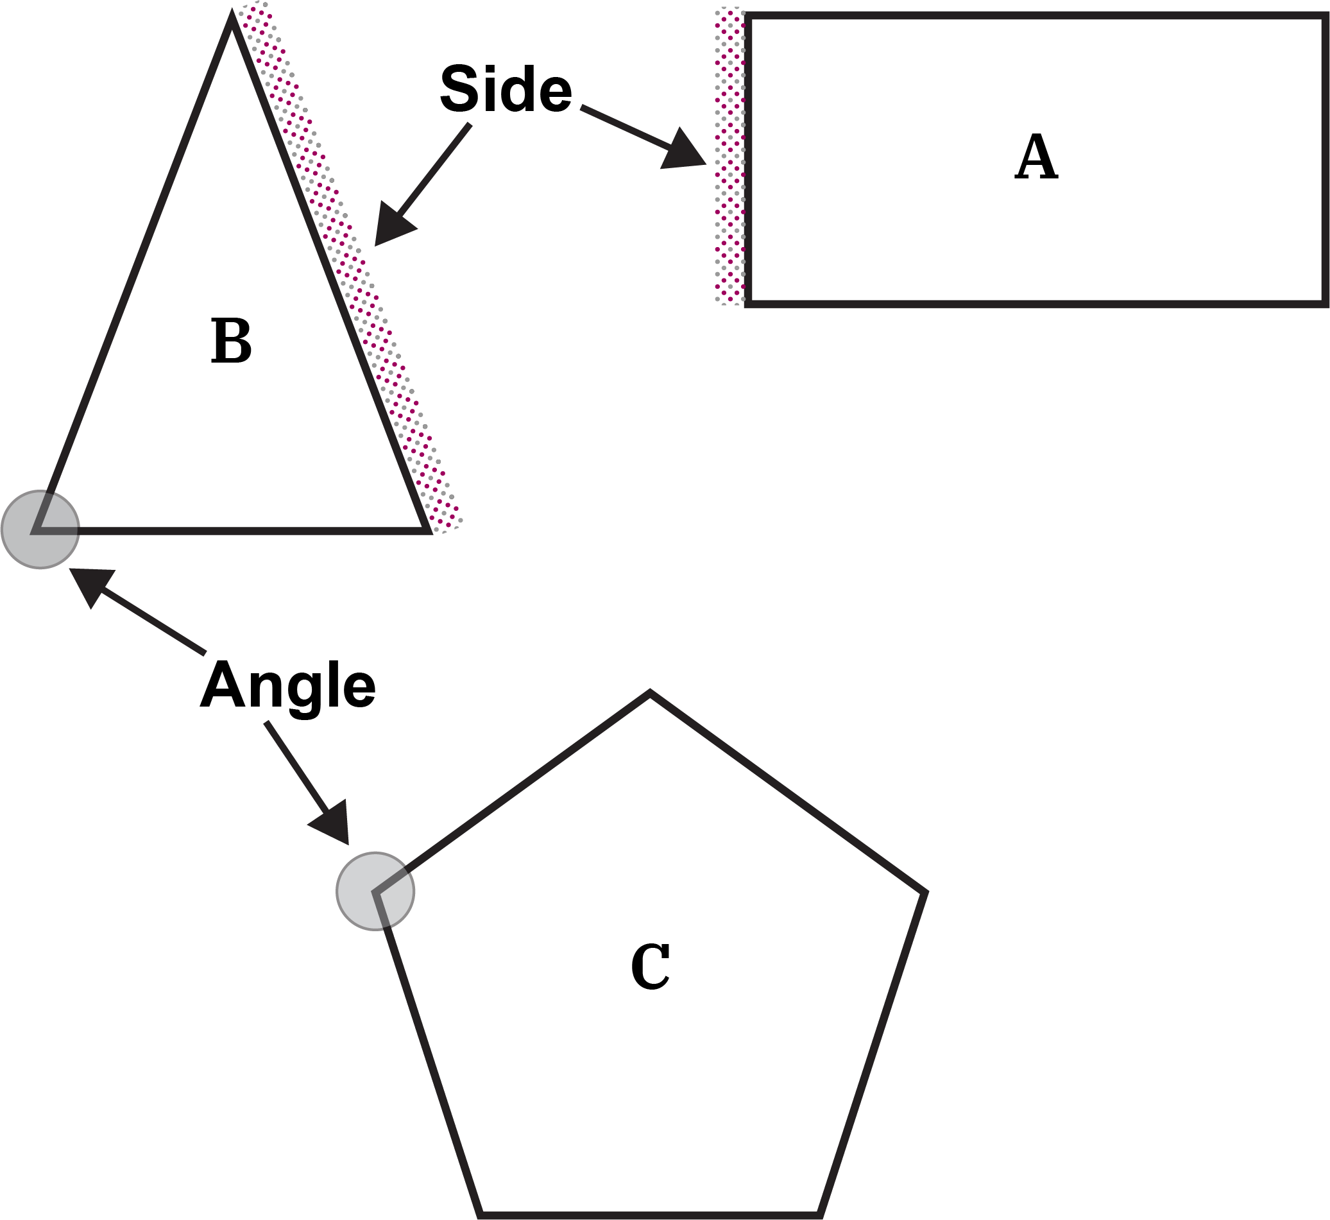

Which One Doesn’t Belong?
Choose one shape in this picture that you don’t think belongs with the others. Explain why.
Can you pick another shape and give a different reason?

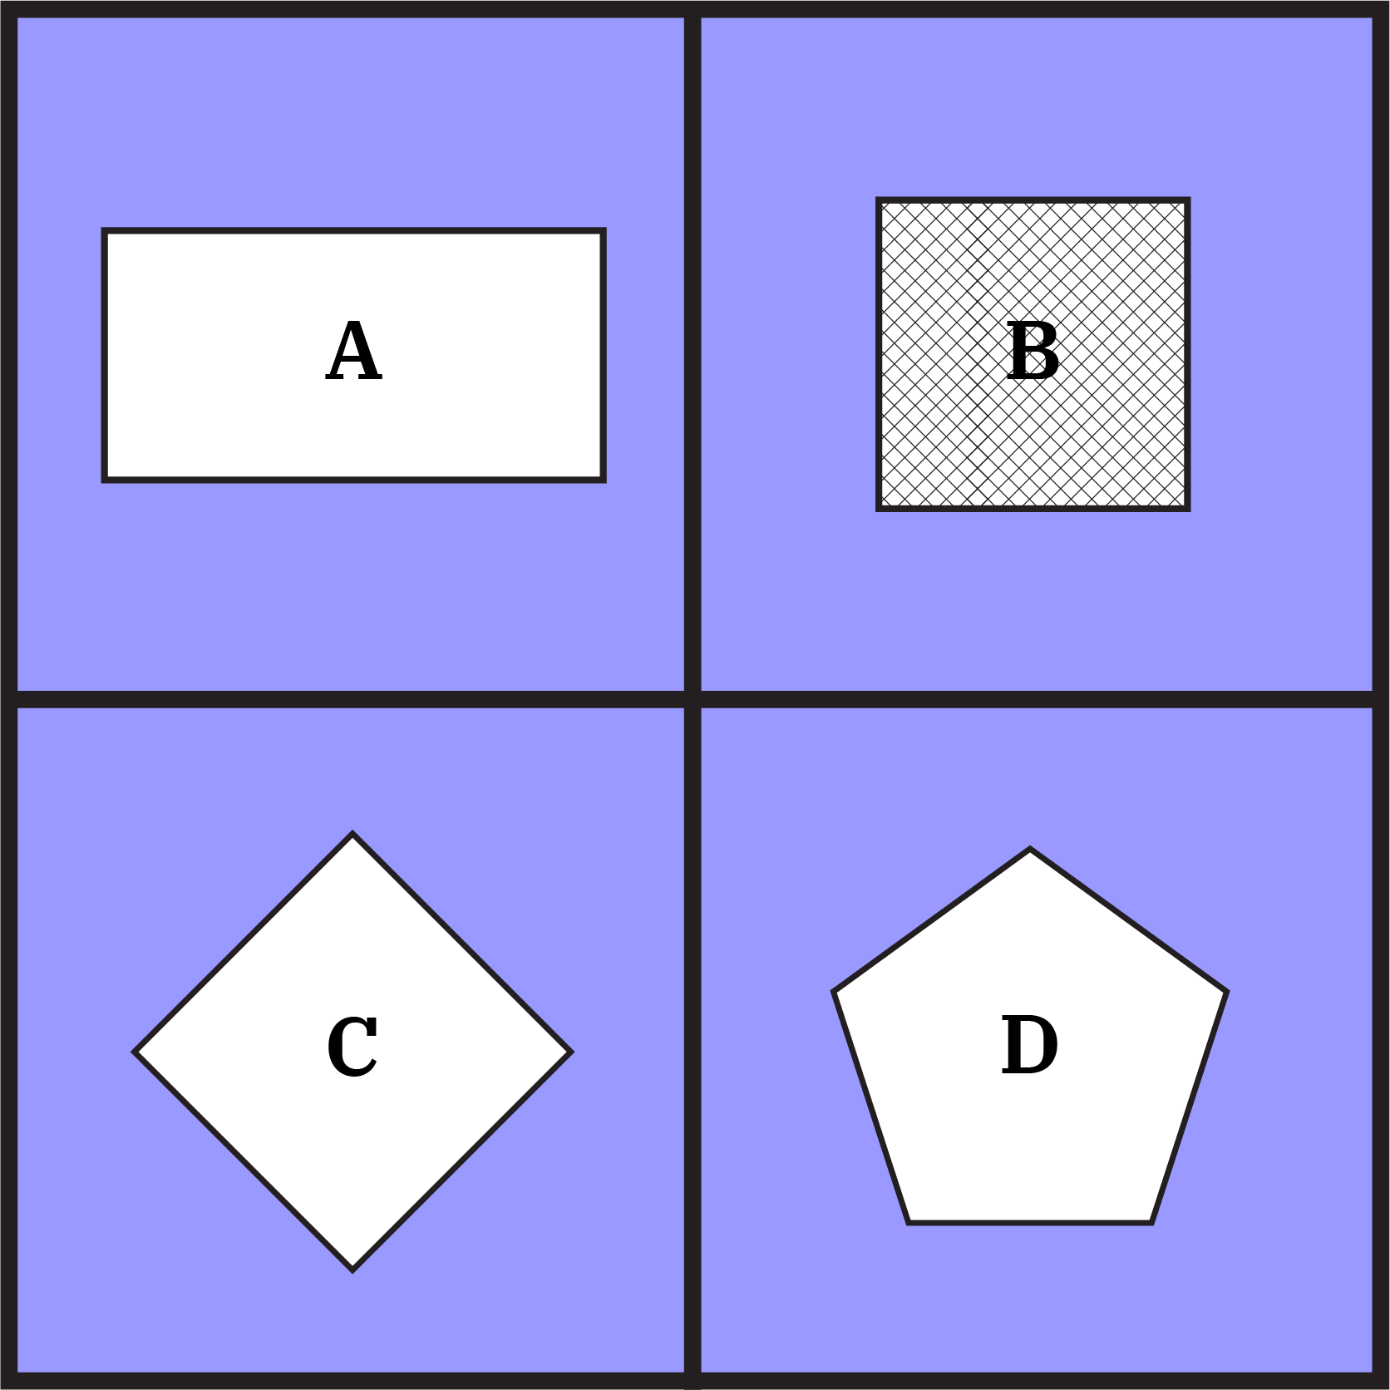
Source: https://talkingmathwithkids.com/wodb/

Vocabulary List for This Unit
Word | Definition | Example
geometry | the study of _________, sizes, and positions
sides | the straight _________ that make a shape | Side
angles | the __________ of a shape
compose | to put __________. We can compose shapes to make new shapes. | 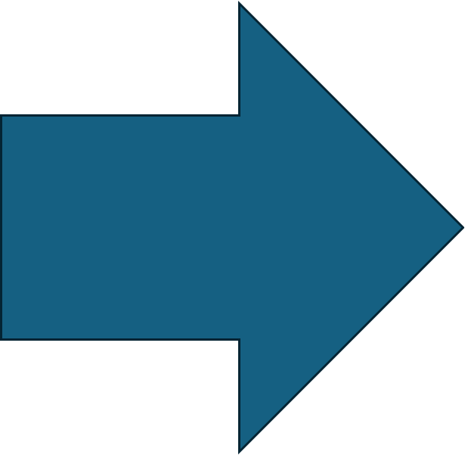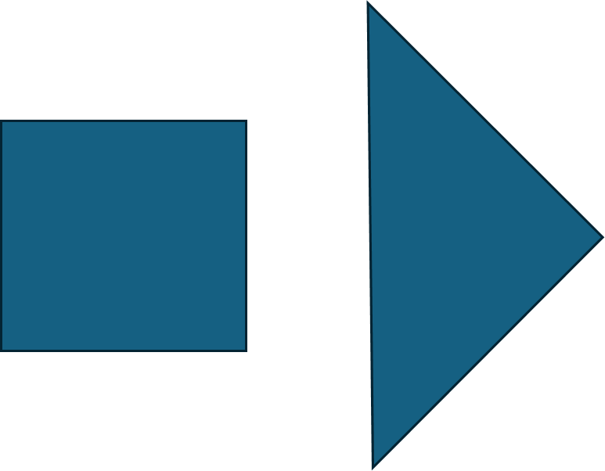
Word | Definition | Example
decompose | to break _________. We can decompose shapes into smaller shapes.
rectangle | a shape with four _________ and four _________ angles.

Shape Puzzles
Build the outlined shape using the shapes in your Shape Set. You can turn and flip over the shapes if you need to.

Here is an example:
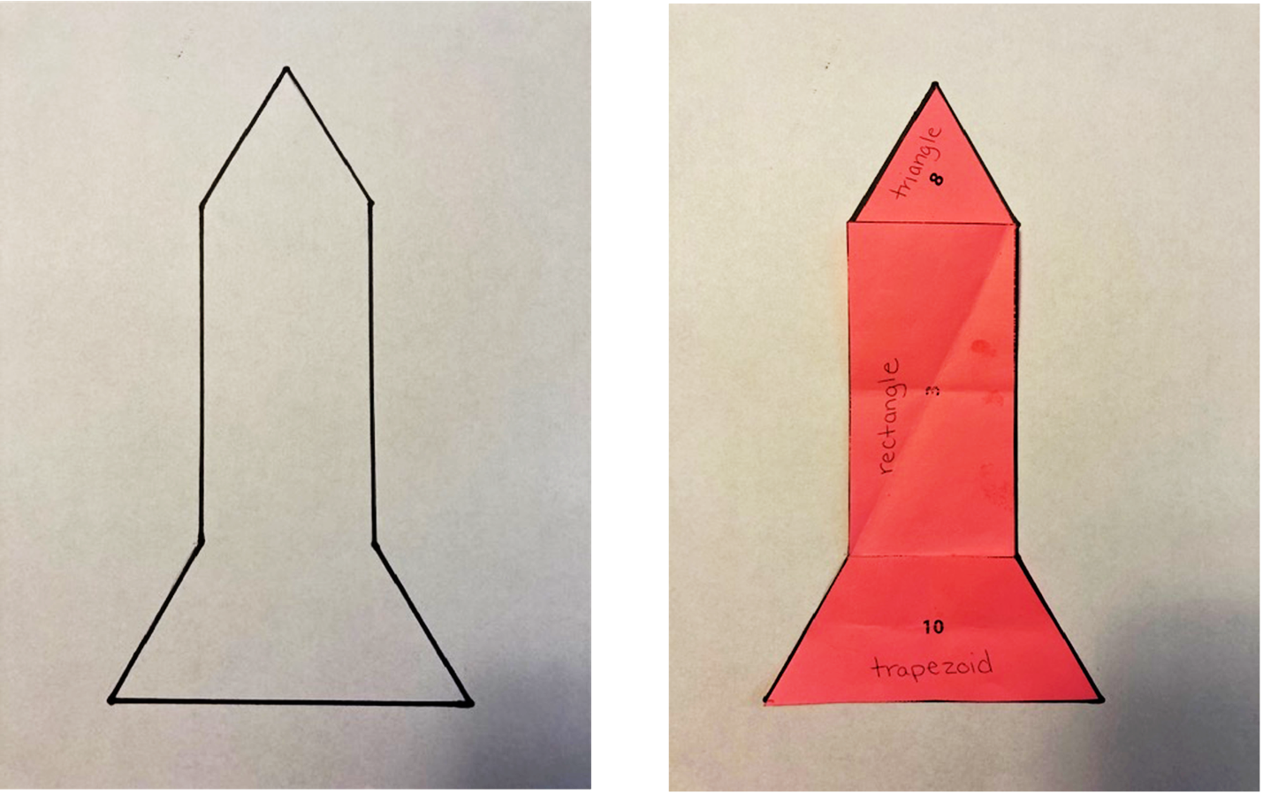

Shape Puzzle Possible Solution

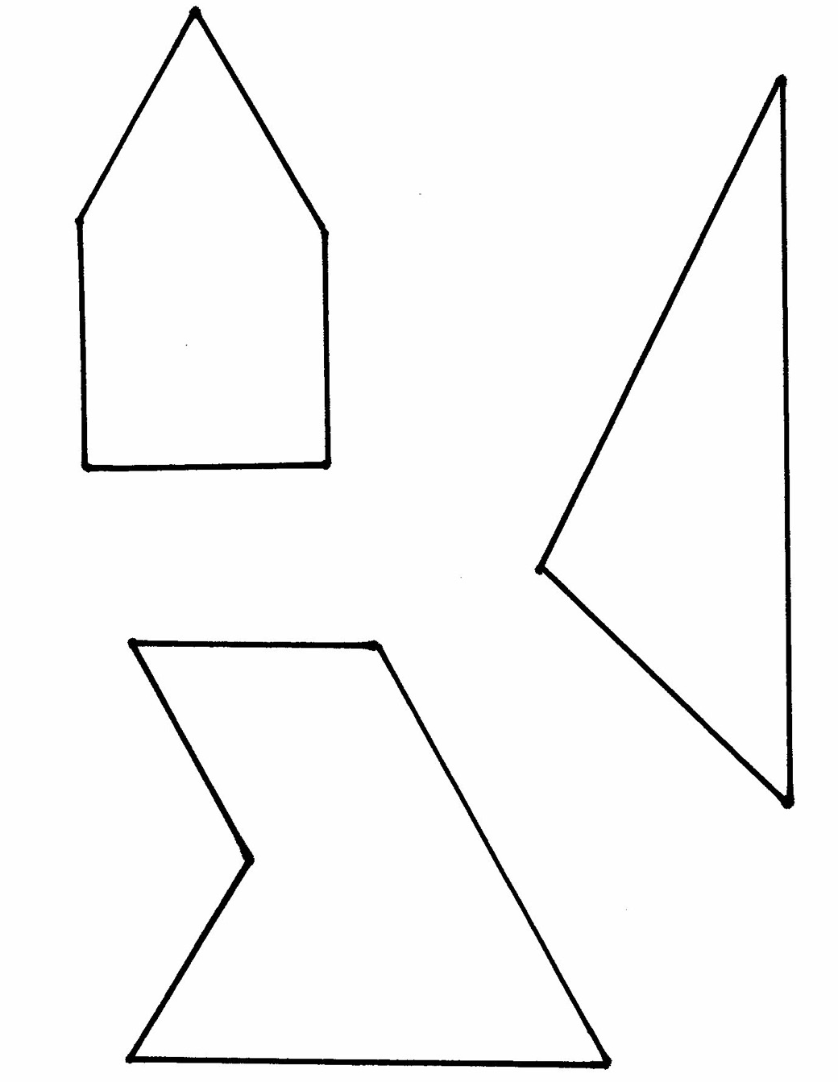
Shape Puzzles
B
A
C

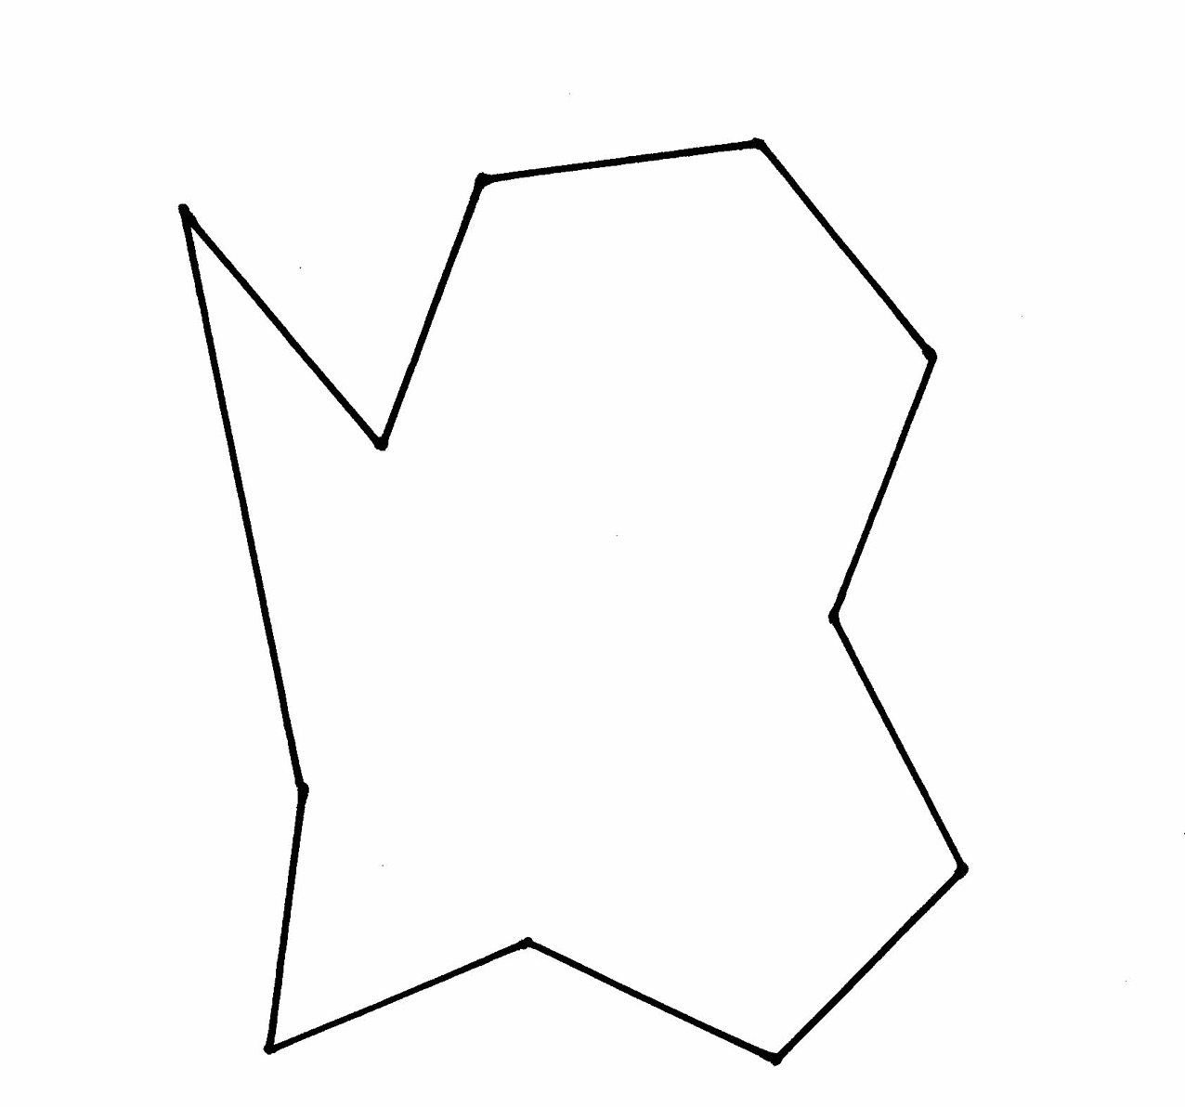
Shape Puzzles
D

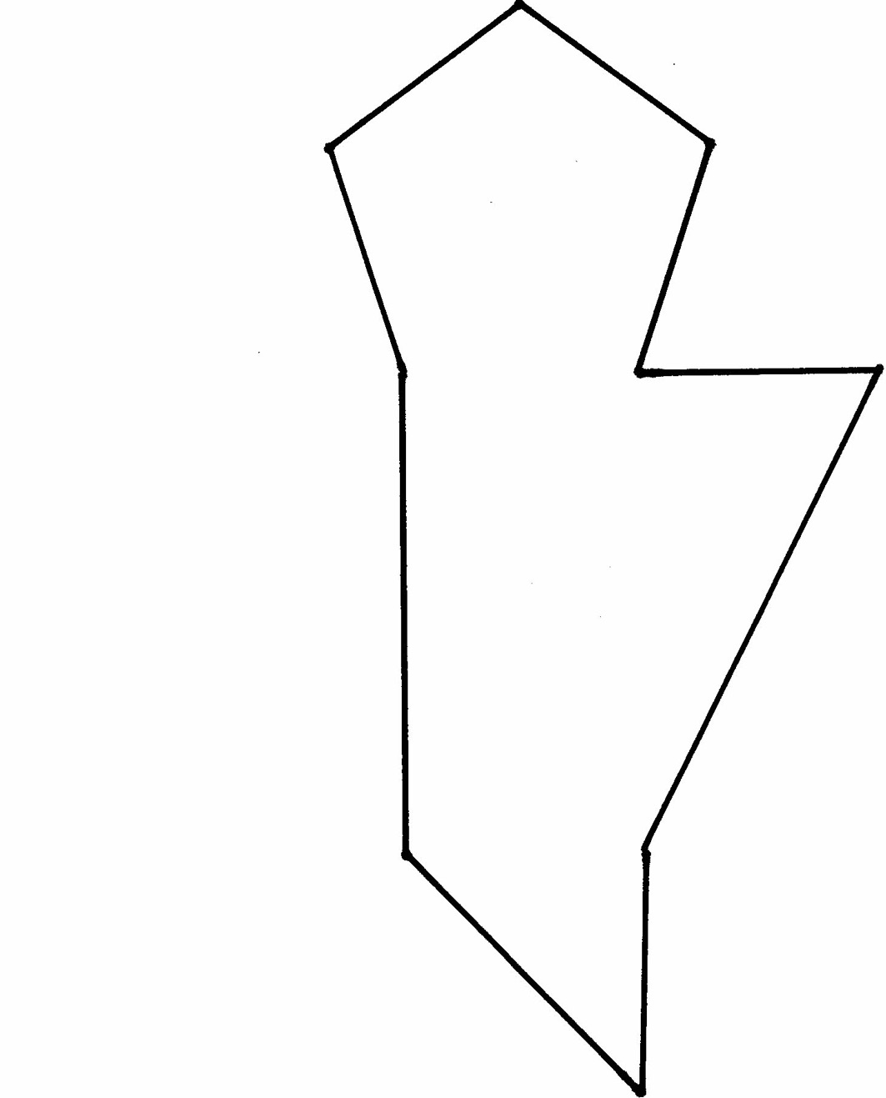
Shape Puzzles
E

Shape Puzzles
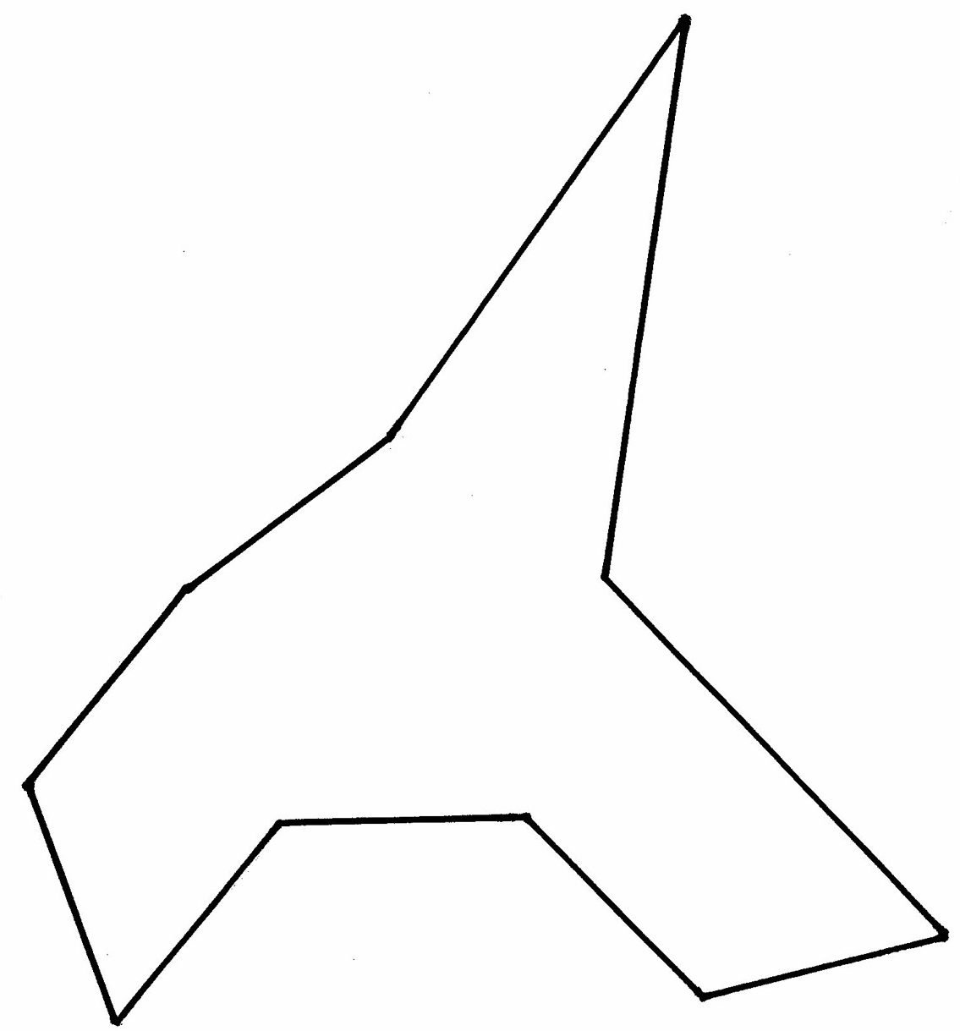
F

Shape Puzzles
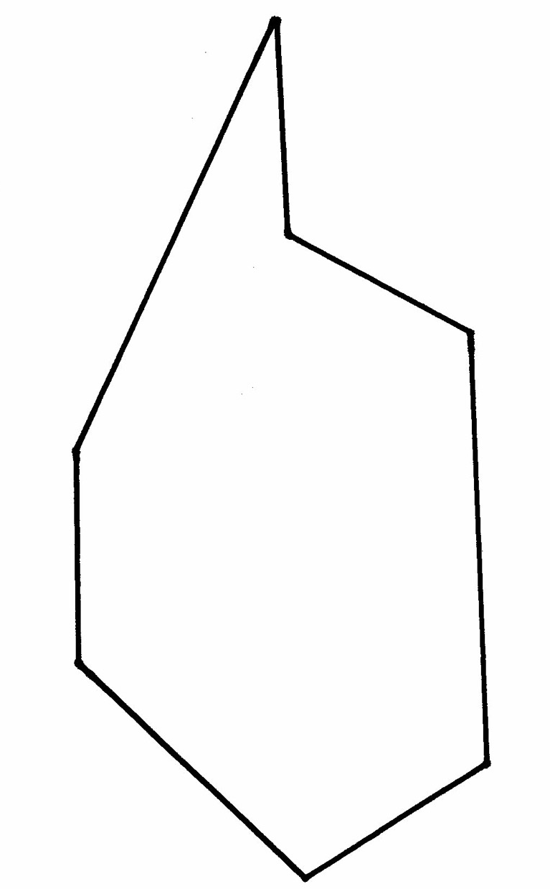
G

Squares from Investigations
Cut out the squares. Cut each square in half along the dotted line.

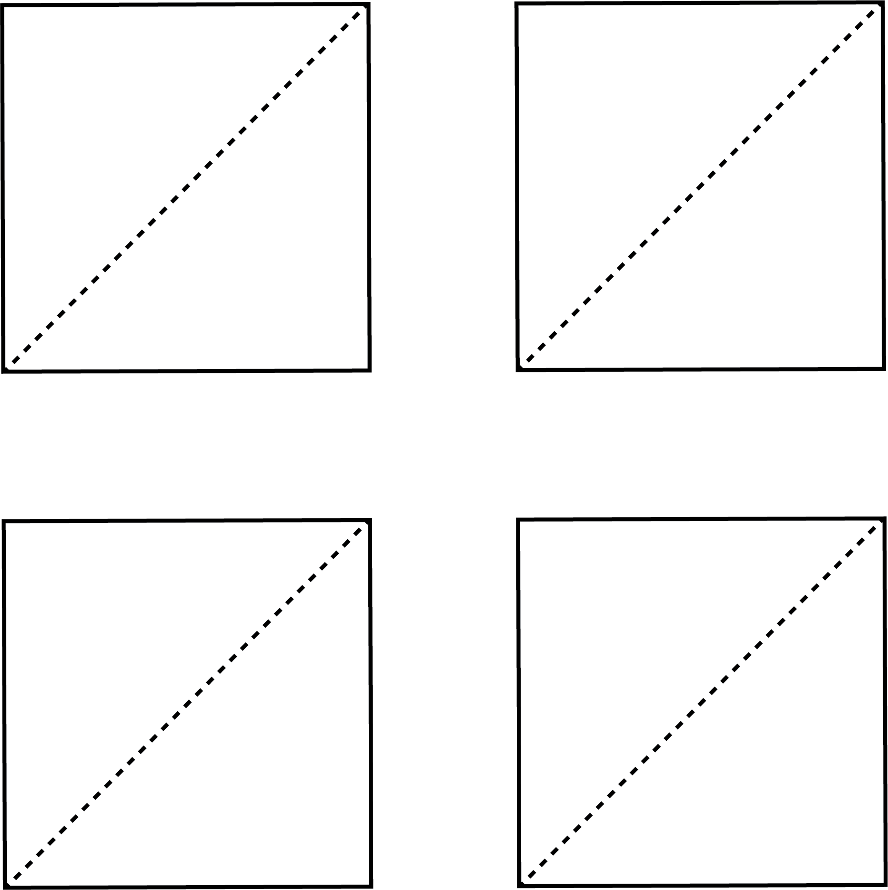

From Investigations: Shapes, Blocks and Symmetry © 2012 by Savvas Learning Company LLC, or its affiliates. Used by permission. All Rights Reserved.

Creating Shapes
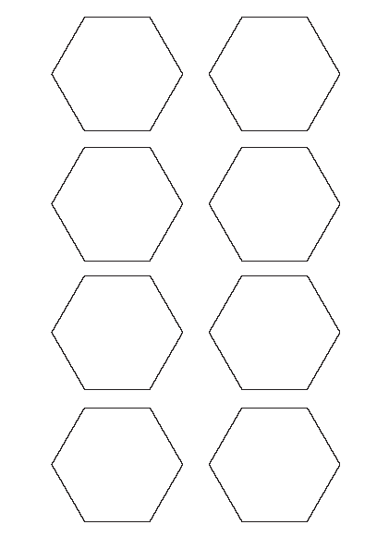

Create a Design
Use the shapes in your Shape Set. Trace the shapes on a blank piece of paper to create a design. Try to cover as much of the paper as possible.

Here is an example:
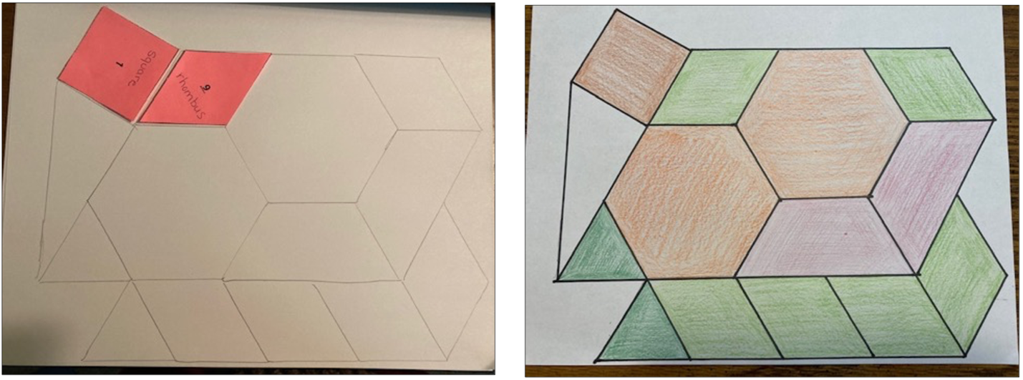

Which shapes were the easiest to fit together?

Which shapes were the hardest to fit? Why?

Rectangle Activity from Investigations 1
Cut out the rectangles. Which is the smallest? Which is the biggest? Put them in order.

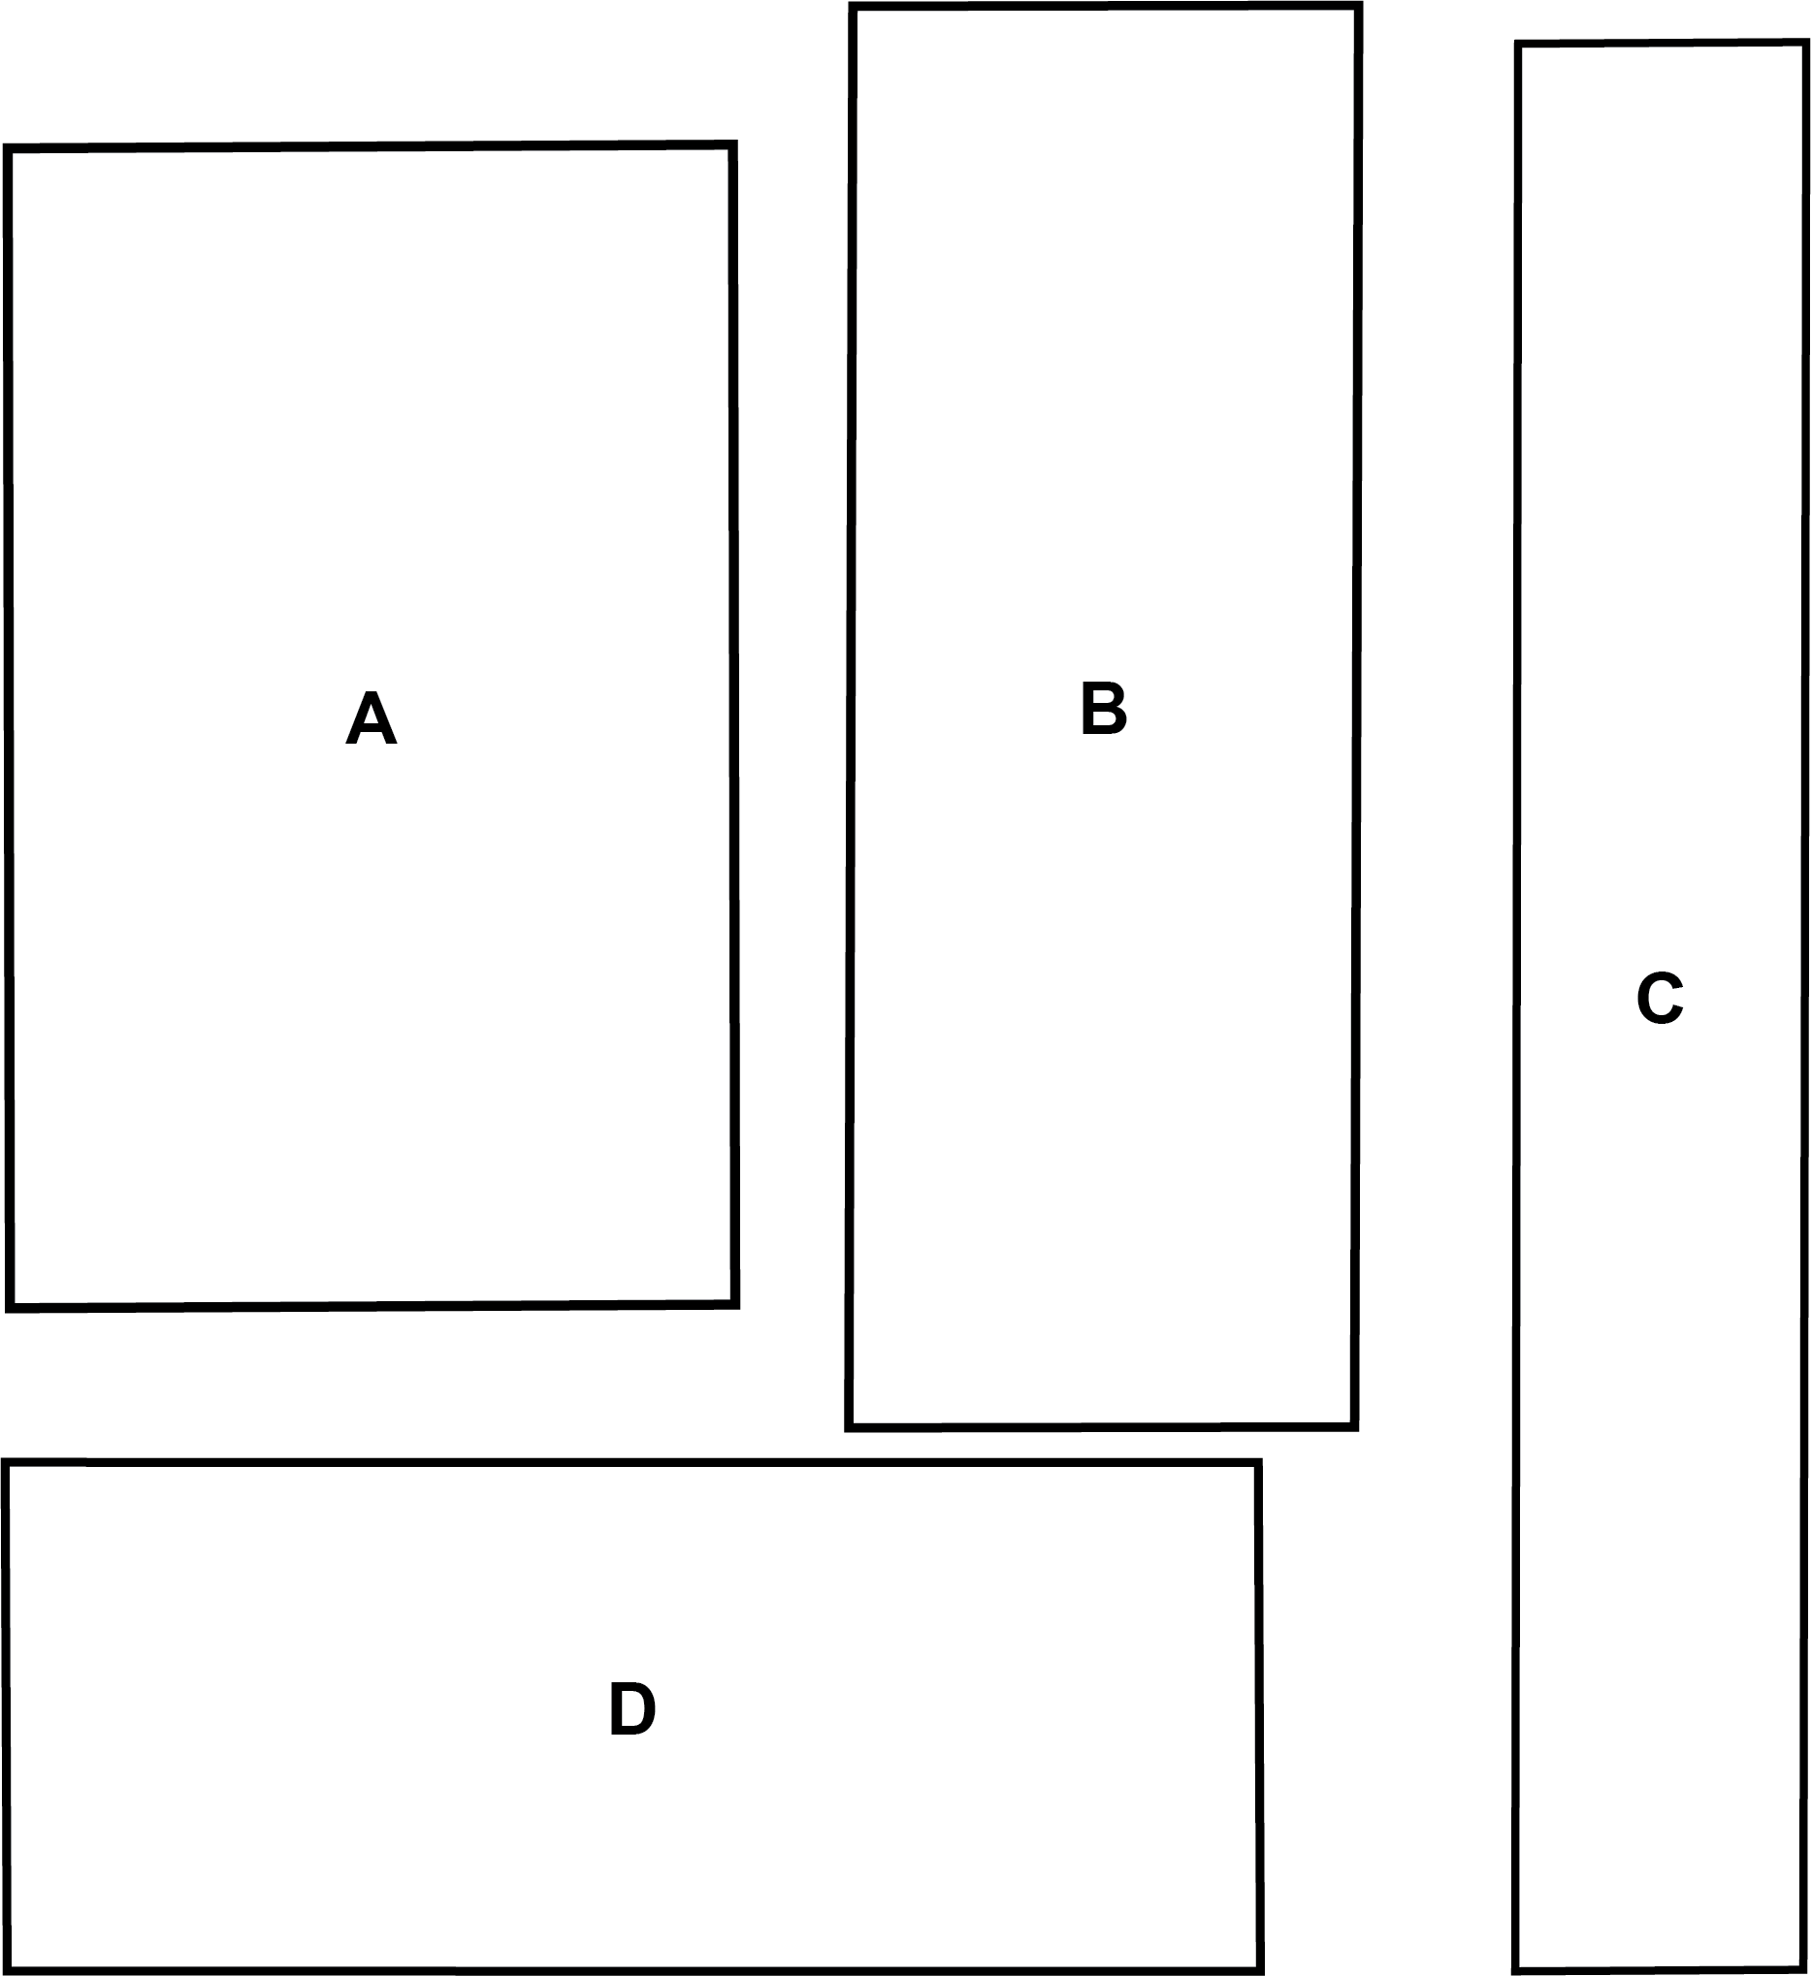

From Investigations: Shapes, Blocks and Symmetry © 2012 by Savvas Learning Company LLC, or its affiliates. Used by permission. All Rights Reserved.

Rectangle Activity from Investigations 2
Cut out the rectangles. Which is the smallest? Which is the biggest? Put them in order.

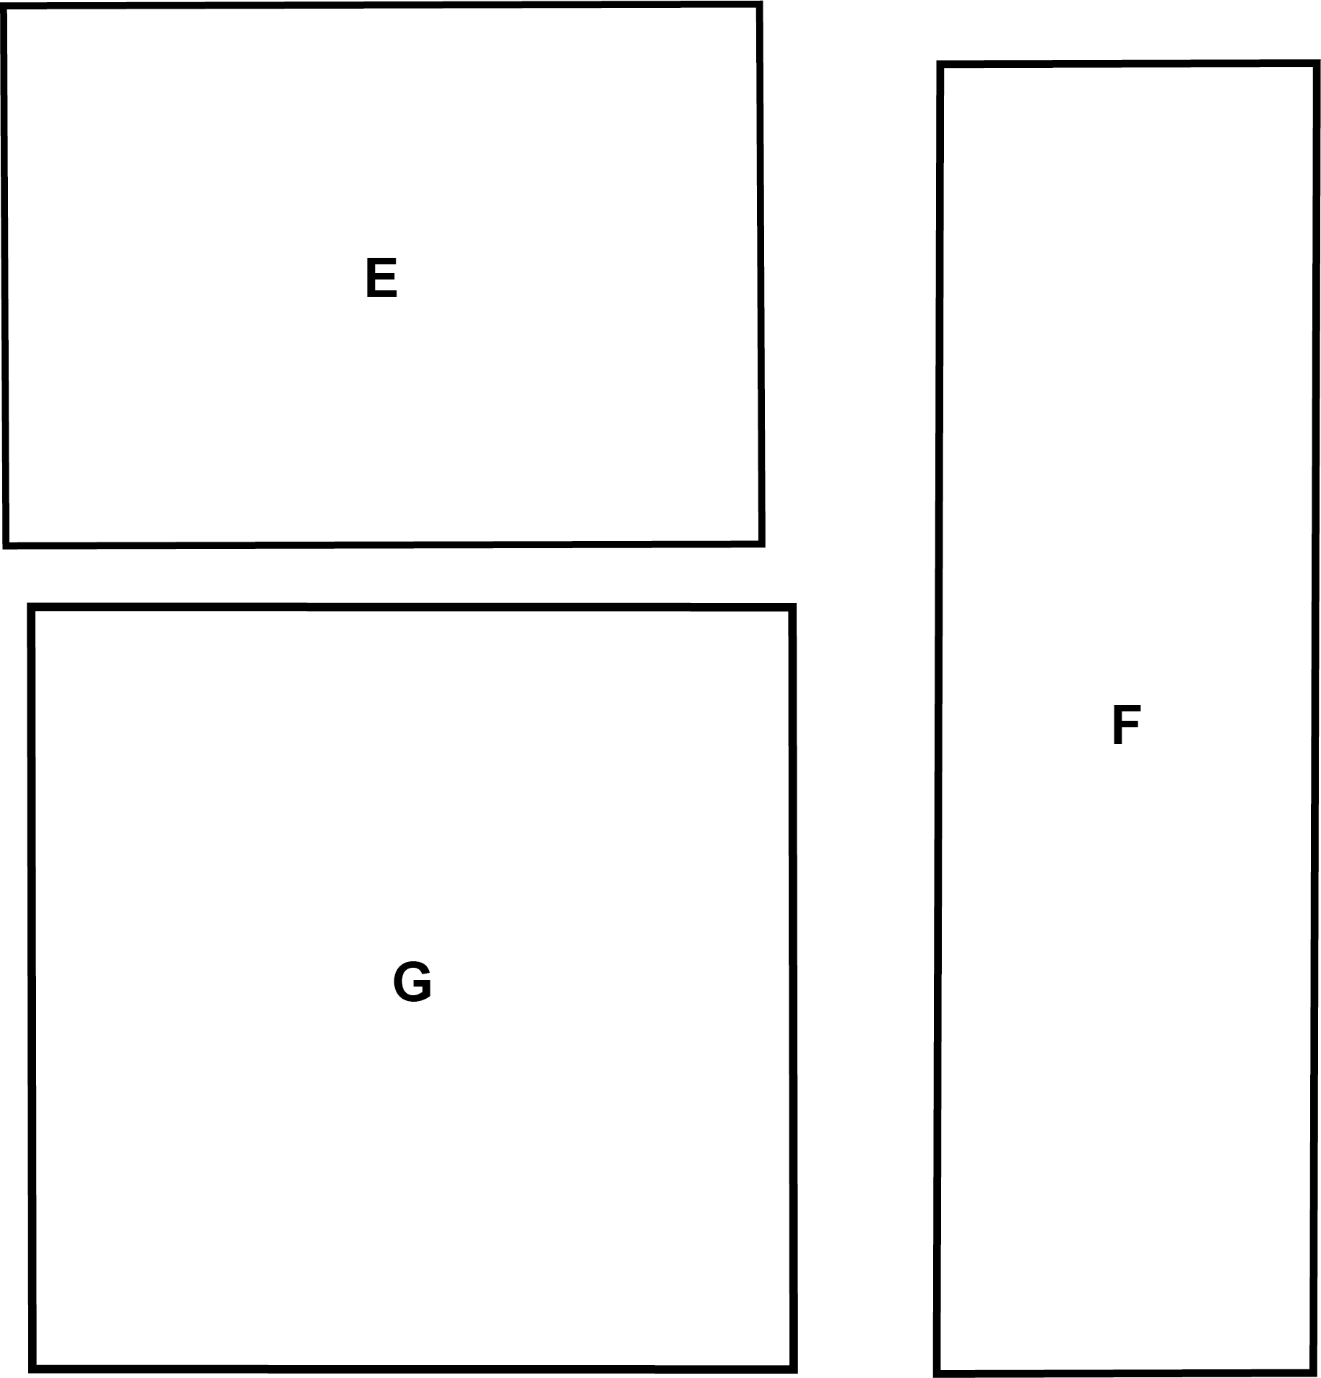

From Investigations: Shapes, Blocks and Symmetry © 2012 by Savvas Learning Company LLC, or its affiliates. Used by permission. All Rights Reserved.

Rectangles
A
C
B

D

E

What do these shapes have in common? | What has this shape in real life?
Draw two more rectangles. | Draw two shapes that are NOT rectangles.

Find the Rectangles


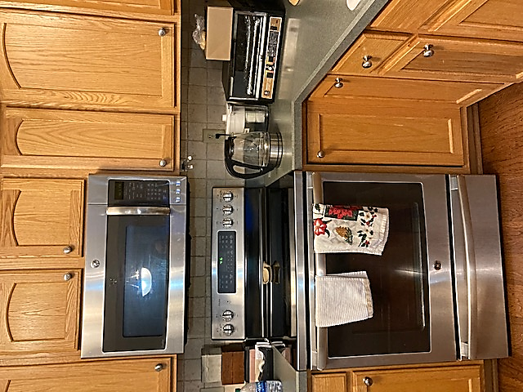

UNIT 2: Finding Half and Understanding Symmetry

Halves and Not Halves

Use 2 colors. Color each rectangle to show halves and not halves.
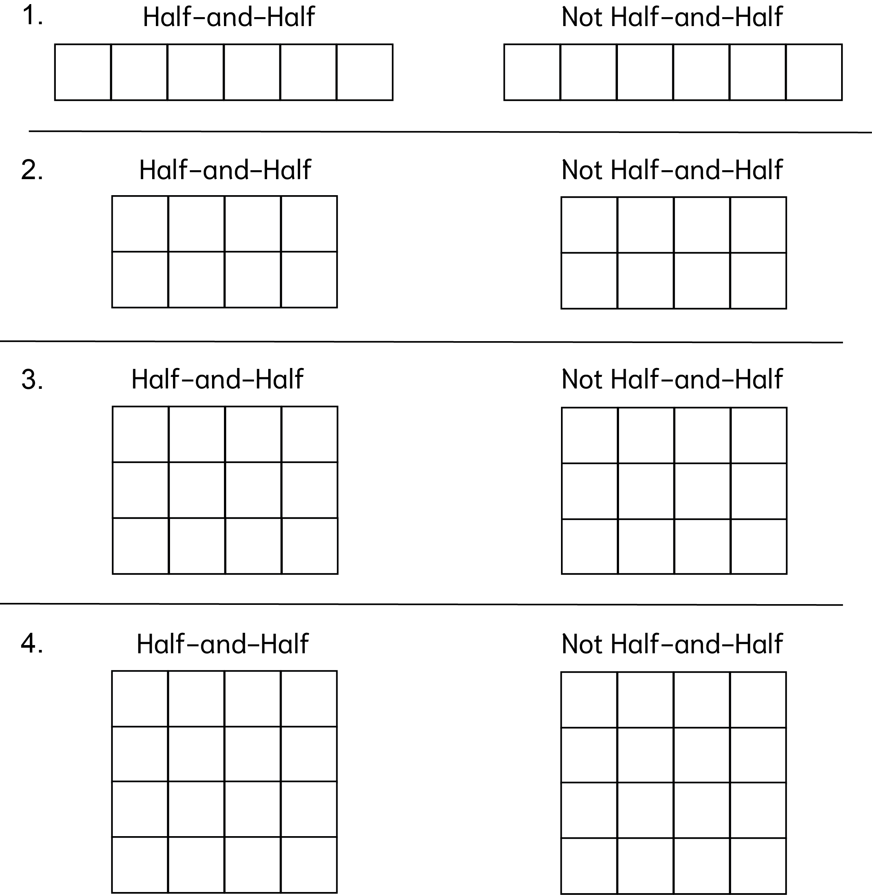

From Investigations: Shapes, Blocks and Symmetry © 2012 by Savvas Learning Company LLC, or its affiliates. Used by permission. All Rights Reserved.

Vocabulary List for This Unit
Word | Definition | Example
half  halves | one of two __________ parts or portions | 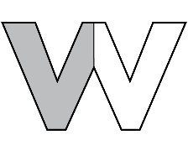  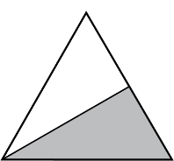
(line) symmetry  symmetrical | when a shape or image is the __________ when folded or reflected over a line
line of symmetry | the line in a symmetrical shape where the shape can be “folded” | 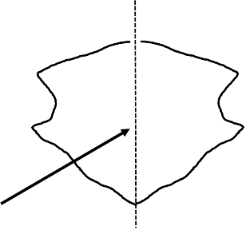
Word | Definition | Example

Shape Halves
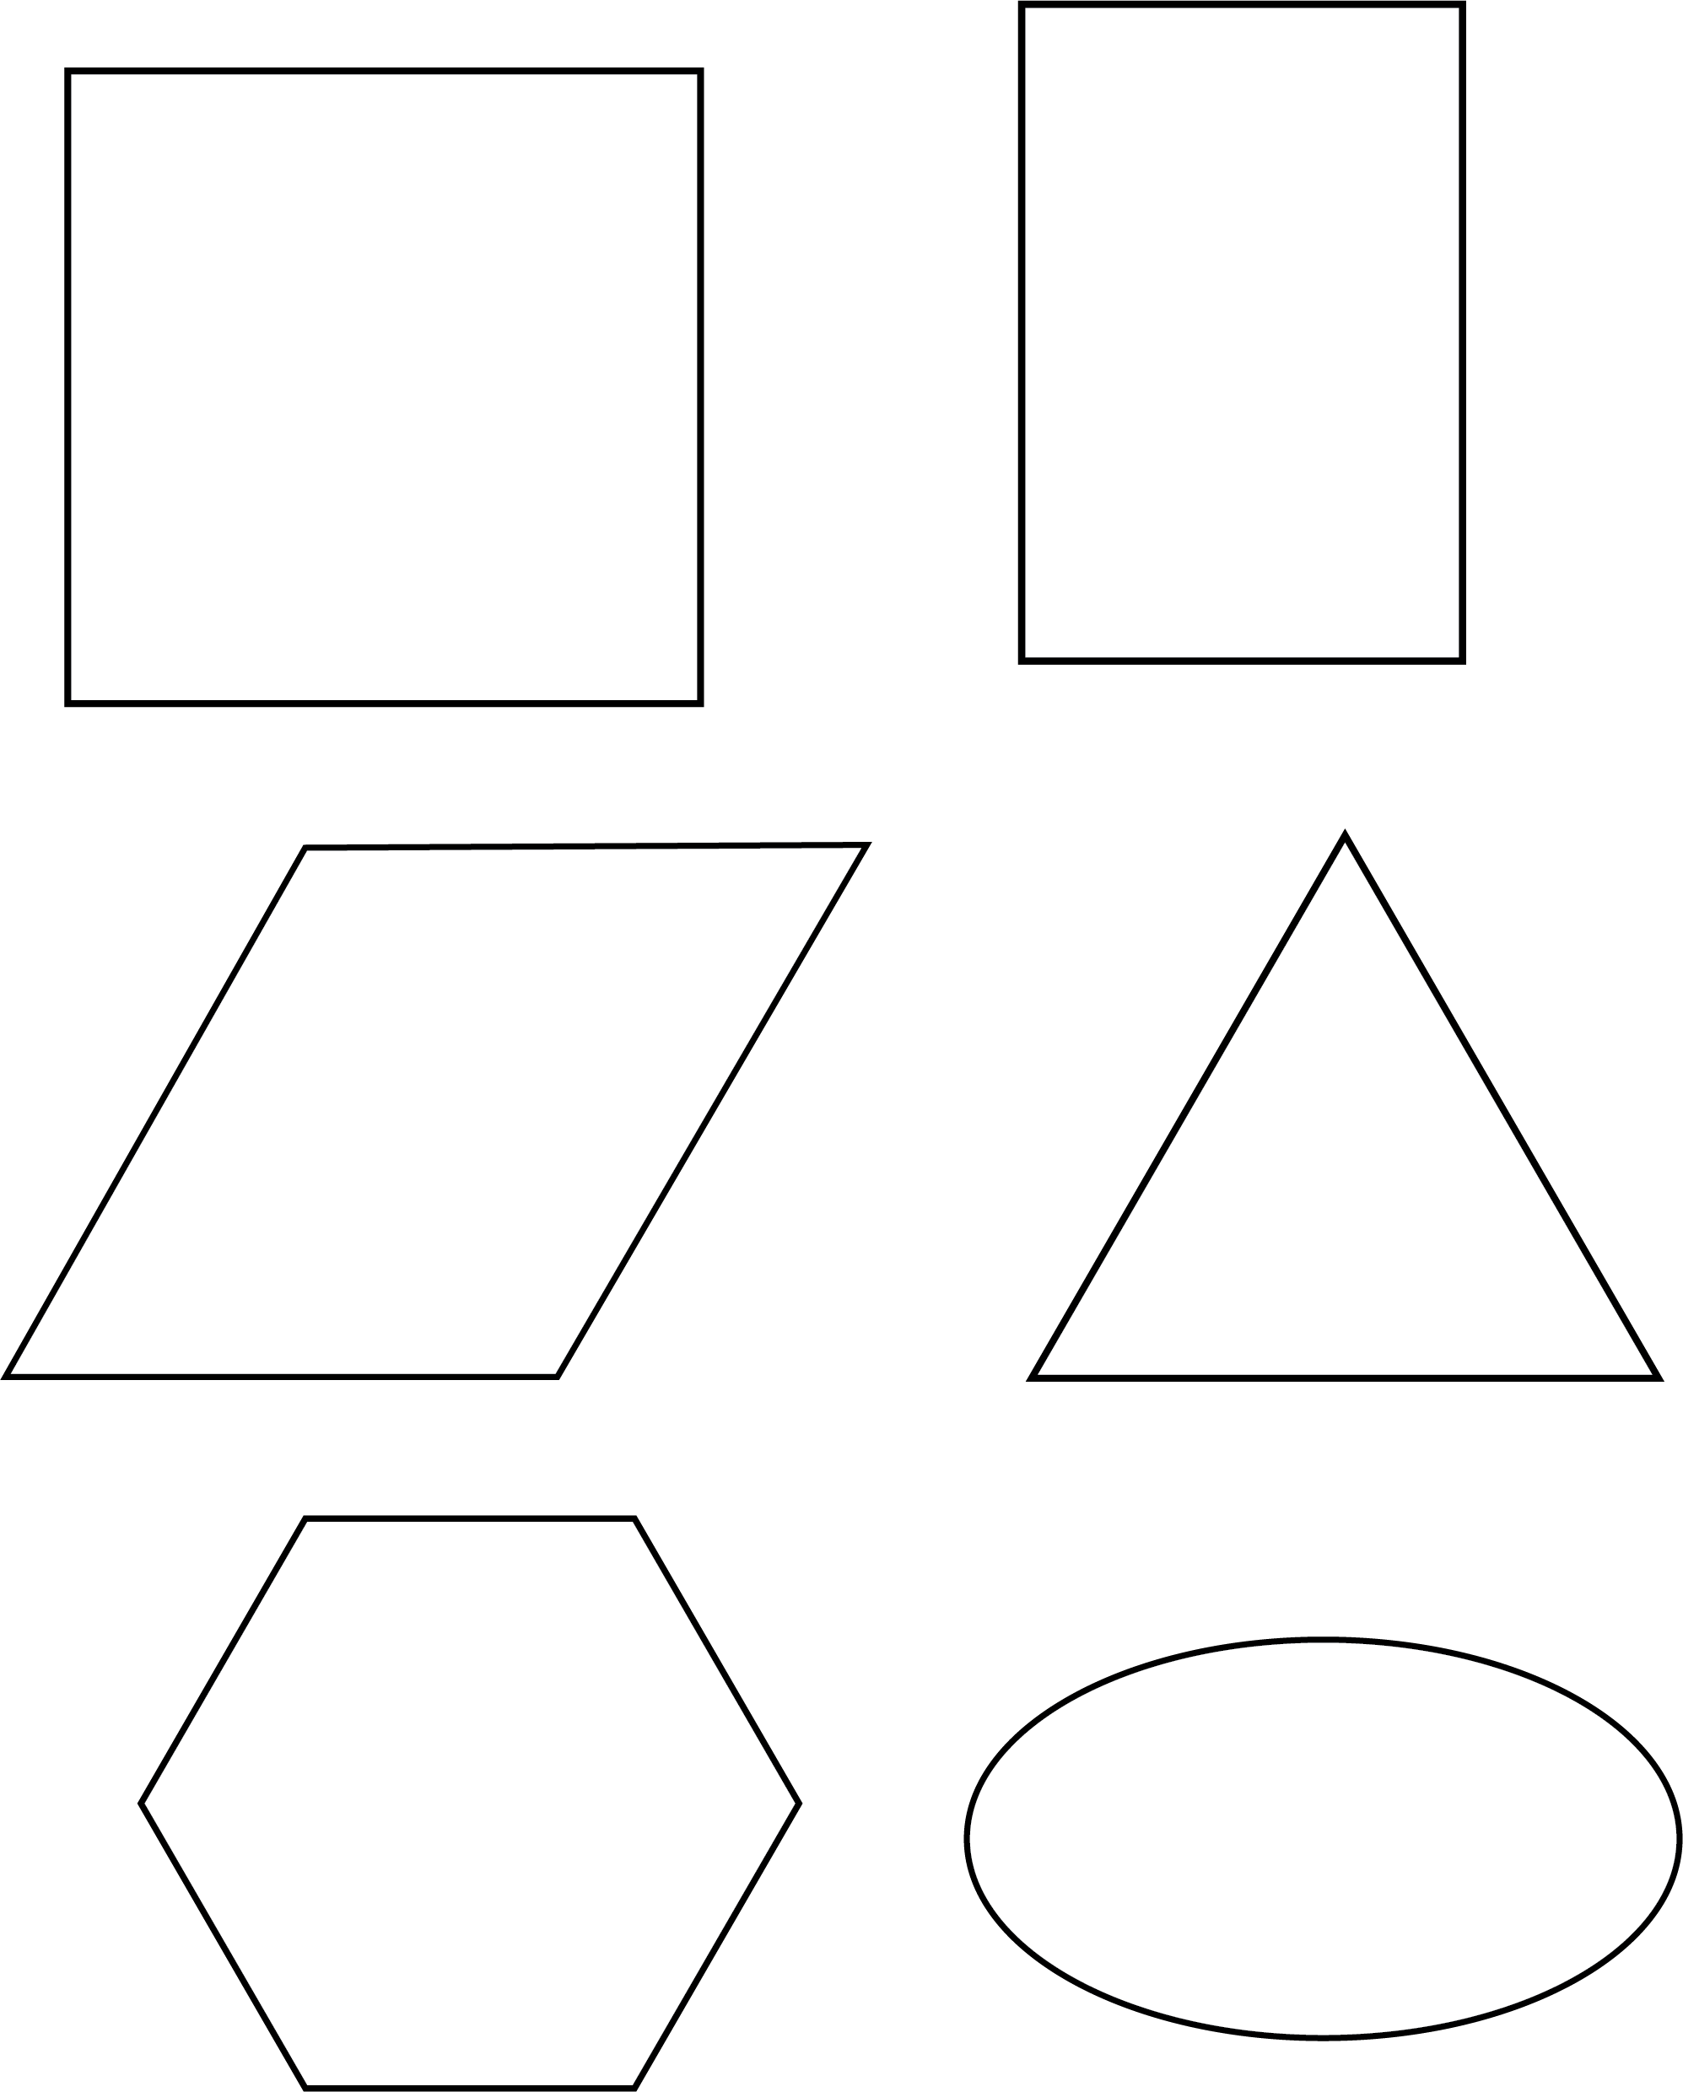

From Investigations: Shapes, Blocks and Symmetry © 2012 by Savvas Learning Company LLC, or its affiliates. Used by permission. All Rights Reserved.
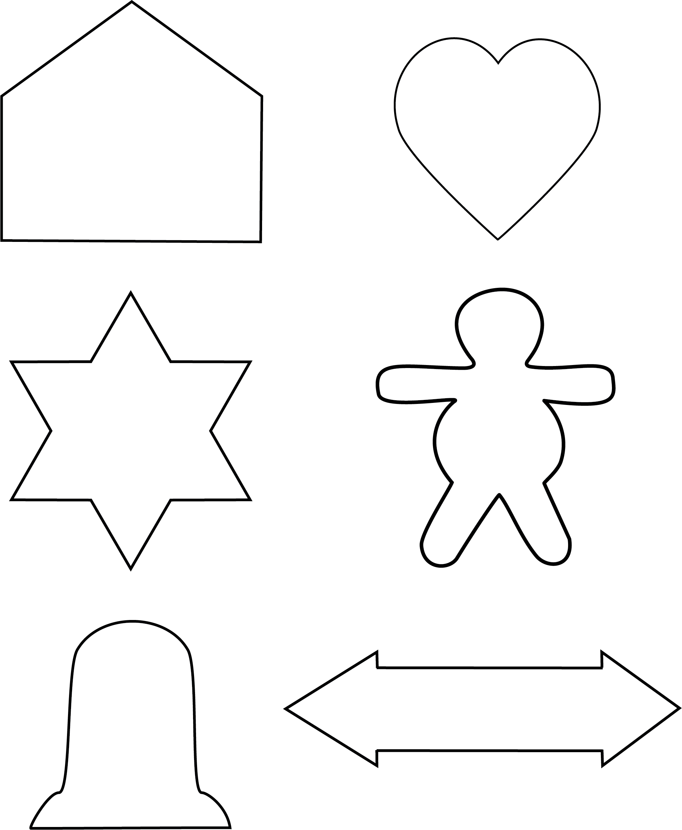

From Investigations: Shapes, Blocks and Symmetry © 2012 by Savvas Learning Company LLC, or its affiliates. Used by permission. All Rights Reserved.

Making Symmetrical Shapes
Fold a piece of paper. Hold the paper on the folded side.
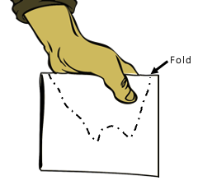

Use scissors to cut the paper around your hand.
Unfold the shape that you cut out.
You have a symmetrical shape.
The fold is the line of symmetry.

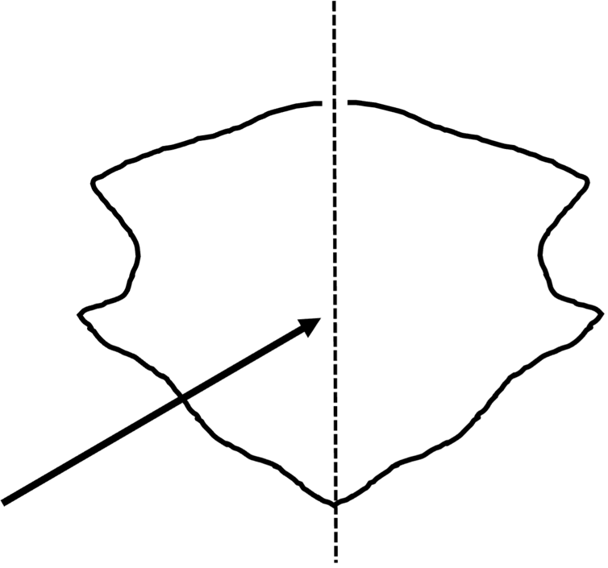

Symmetry
Symmetry is when a shape or image is the same when folded over a line. The line is called a line of symmetry. The shape is said to be symmetrical.

Are the dashed lines below lines of symmetry?
U Y P A

Lines of Symmetry
Is the dashed line a line of symmetry?
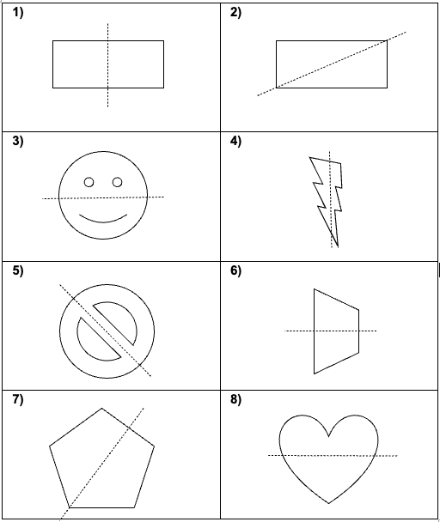

Symmetrical or Not?
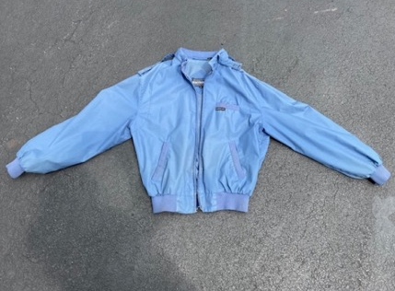
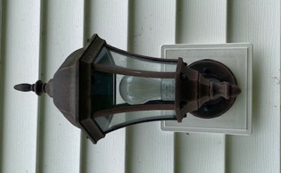

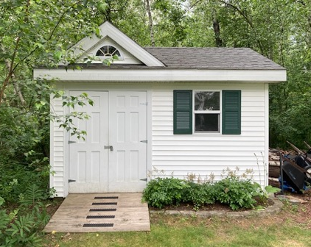
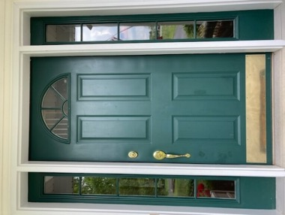

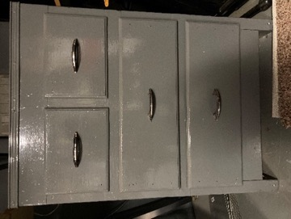
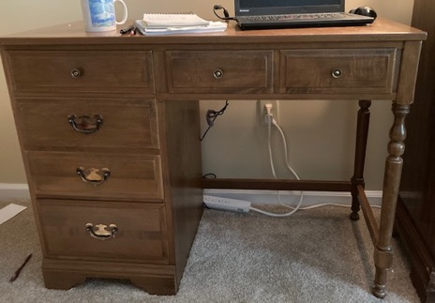

Symmetry in Nature
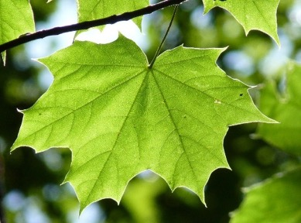


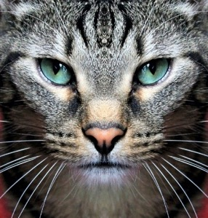
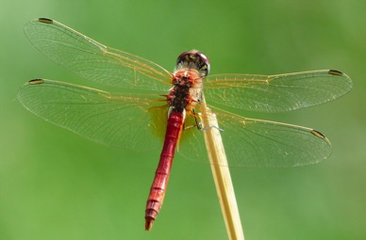

Where else do you see symmetry in nature?
Explain and draw a picture.

Front and Side Views
Is it a line of symmetry? Write yes or no.
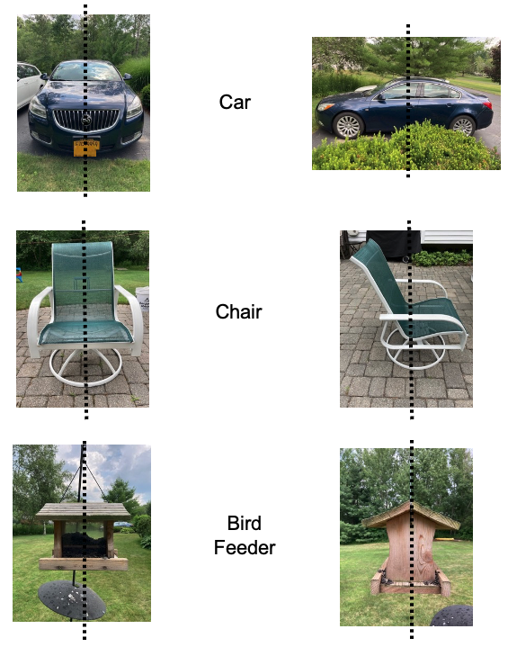

Finish the Shape
Draw the other side of each symmetrical shape.

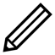
Example:
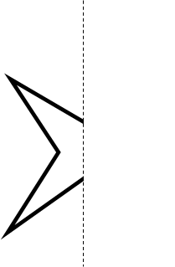

Draw two of your own symmetrical shapes below.

Adinkra Symbols
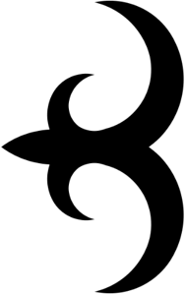
Adinkra symbols are common in Ghana. They are traditional symbols of the Asante culture. Each symbol represents an ideal or belief. There is often a proverb that goes with the symbol. For example, Akokonan (“the leg of the hen”) represents mercy and nurturing. This comes from the proverb, “The hen steps on her chicks but does not hurt them.”

Adinkra symbols are most commonly used in textiles (cloth). The cloth is worn to ceremonies and special events, like funerals. Today, Adinkra symbols are also used in architecture, sculptures, pottery, and even in company logos.

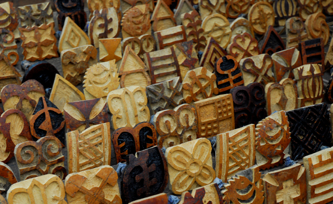
Calabash Adinkra stamps. Photo by Dr. Carol Ventura

To stamp the cloth, artists carve the symbols into a calabash (a type of gourd that can become very hard). They attach bamboo sticks for grip. The ink is made from the bark of a Badie tree. The cloth is laid out on a table, the stamps are pressed in ink and stamped on the cloth equal distances apart.
The above text is adapted from Barta, J., Eglash, R., & Barkley, C. (2014).Adinkra Symbols. In Math is a Verb: Activities and Lessons from Cultures Around the World (pp. 61-62). Reston, VA: National Council of Teachers of Mathematics.

Adinkra Stamped Cloth
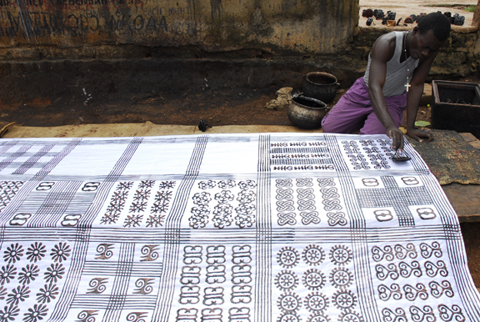
Anthony Boakye prints an adinkra cloth with a calabash stamp in Ntonso, Ghana. Photo by Dr. Carol Ventura.

What do you notice? What do you wonder?

Symmetry in Adinkra Symbols
These are some Adinkra symbols. Which symbols have a line of symmetry? Which do not?
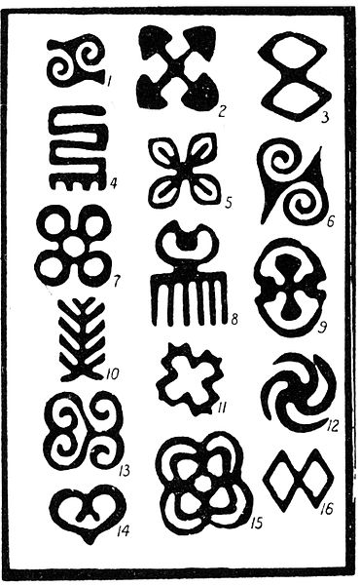
Image by Robert Sutherland Rattray

If you are curious, the next page lists the names and meanings of the symbols above.
1. Gyawu Atiko, lit. the back of Gyawu's head. Gyawu was a sub-chief of Bantama who at the annual Odwira ceremony is said to have had his hair shaved in this fashion.
2. Akoma ntoaso, “the joined hearts.”
3. Epa, handcuffs. See also No. 16.
4. Nkyimkyim, the twisted pattern.
5. Nsirewa, cowries (a type of shell)
6. Nsa, from a design of this name found on nsa cloths.
7. Mpuannum, “five tufts (of hair)”
8. Duafe. the wooden comb.
9. Nkuruma kese, lit. dried okros.
10. Aya, the fern; the word also means ' I am not afraid of you ', ' I am independent of you' and the wearer may imply this by wearing it.
11. Aban, a two-storied house, a castle; this design was formerly worn by the King of Asante alone.
12. Nkotimsefuopua, certain attendants on the Queen Mother who dressed their hair in this fashion. It is really a variation of the swastika. (Note: The swastika symbol has been used for thousands of years as a spiritual or religious symbol in cultures all over the world, usually meaning good luck or well-being. In Western cultures, it became a symbol of hate after the Nazis used it in the 1930’s. It does not have this connection in other parts of the world.)
13 and 14 Both called Sankofa, lit. turn back and fetch it.
15. Kuntinkantan, lit. bent and spread out ; nkuntinkantan is used in the sense of ' do not boast, do not be arrogant '.
16. Epa, handcuffs, same as No. 3.

The above text is from R.S. Rattray. (1927). Religion and Art in Ashanti. Oxford: Clarendon Press.

UNIT 3: Right Angles and Parallel Lines

Angles in the Body
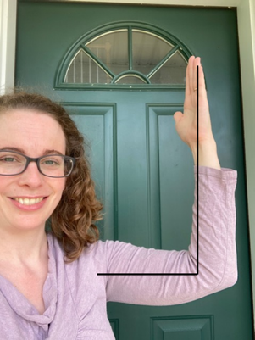
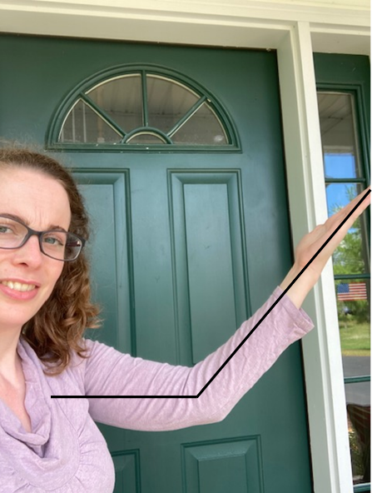
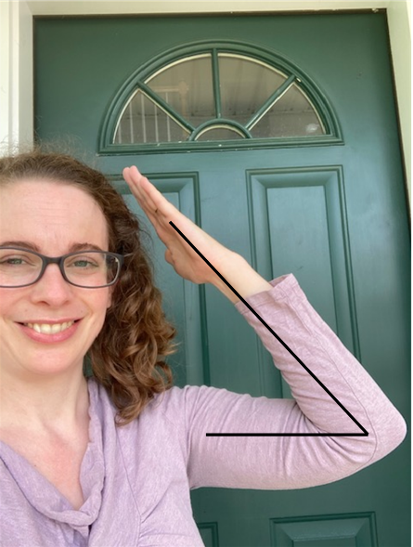
Small Right Large

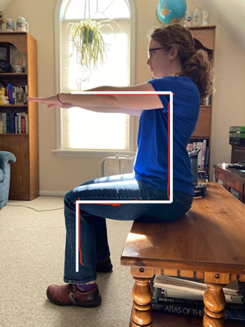
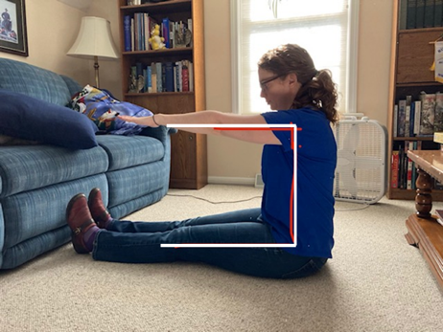

Which joints are making right angles?

Vocabulary List for This Unit
Word | Definition | Example
right angle | a “_______________.” The corner of a piece of paper will fit into it perfectly. | 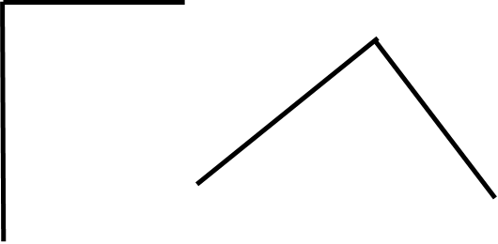
parallel | Parallel lines go in the same ____________, stay the same ____________ apart, and never __________.
trapezoid | a four-sided shape with exactly one pair of ____________ sides | 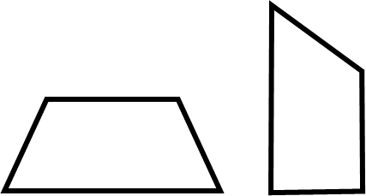
triangle | any __________-sided shape | 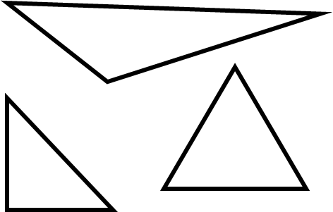
Word | Definition | Example

Right Angles: Paper Test

A right angle looks like the corner of a square.
You can check for a right angle because the corner of a piece of paper will fit into it perfectly.

Paper test:
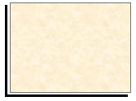
Does the corner of a paper fit?
Yes? It’s a right angle!

Use the paper test to see if the angles below are right angles.
A
B
C
D

Trapezoids
C
A

B

E
D

What do these shapes have in common? | What has this shape in real life?
Draw two more trapezoids. | Draw two shapes that are NOT trapezoids.

Trapezoids
Match each photo to the trapezoid shape seen in the photo.
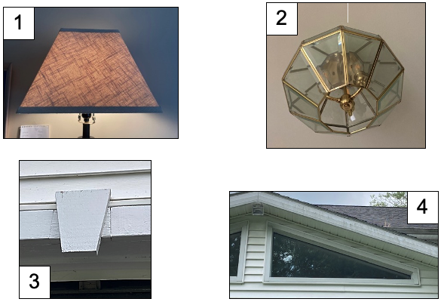
A
B
C
D

Parallel or Not?
Parallel lines go the same direction. They are always the same distance apart. They will never meet.

These are examples of parallel lines.

These are examples of lines that are not parallel. If you continued the lines, they would cross.

Checking for Parallel Lines
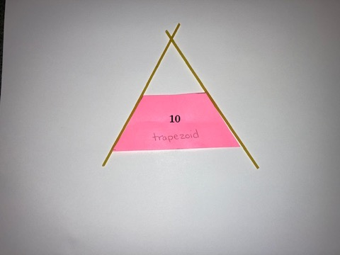
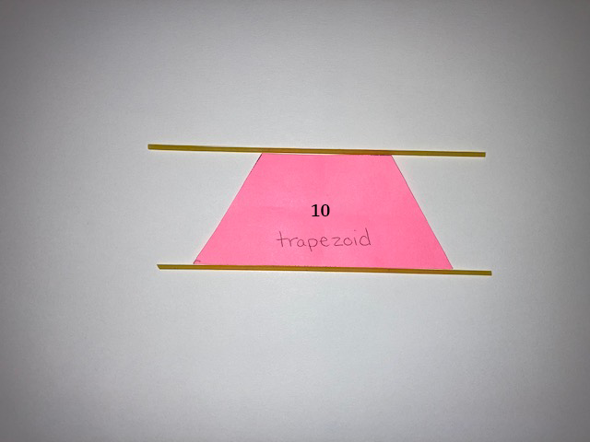
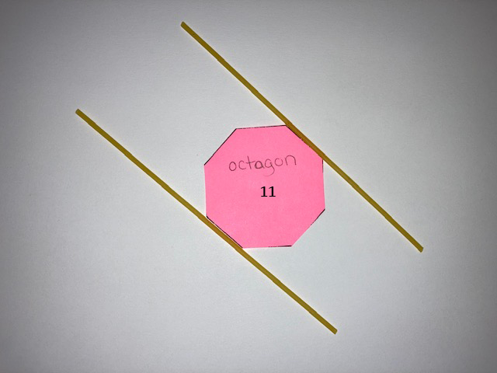
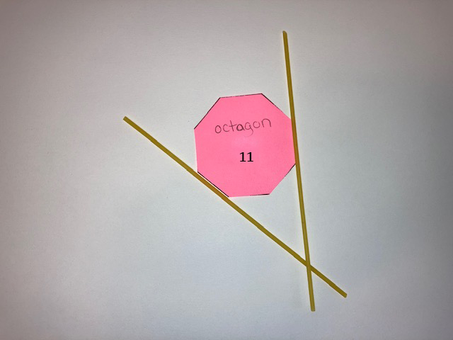
You can use spaghetti, or something else long and skinny, to check if two sides of a shape are parallel.
Not Parallel
These are pairs of sides that are not parallel.
The spaghetti shows that the lines, if they continue, will cross.
Parallel
These are pairs of sides that are parallel.
The lines will never cross.

not parallel
parallel
not parallel
parallel

Parallel Lines

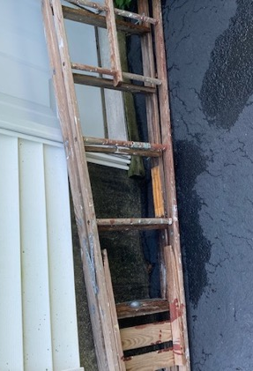
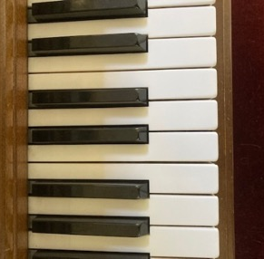
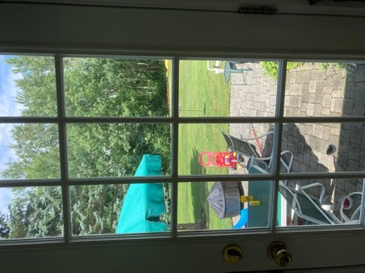
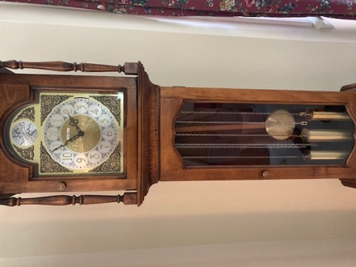
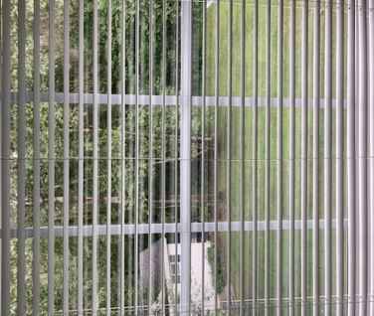
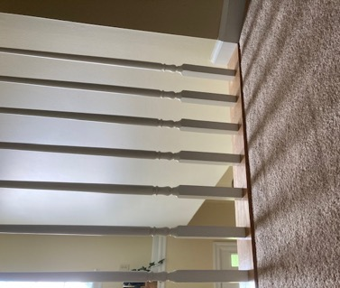

Triangles
C
A

B

D
E

What do these shapes have in common? | What has this shape in real life?
Draw two more triangles. | Draw two shapes that are NOT triangles.

Triangles: Same and Different
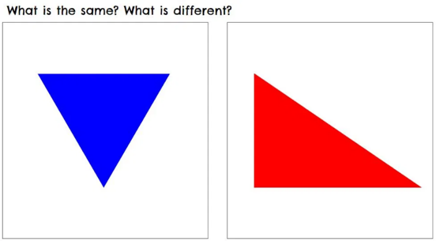
On a piece of paper, make two columns. In one column, list the things that are the same in this picture. In the other column, list the things that are different.

Things that are the same | Things that are different
Credit: Brian Bushart, https://samedifferentimages.wordpress.com

How Do You Make Sure

the Corners Are Square?

You will need three lengths: one 3 inches long, one 4 inches long, and one 5 inches long (you can also use lengths of 3, 4, and 5 centimeters).
Put them together to make a triangle.

3
4
5

Did you notice something about your triangle? It has a right angle! The lengths 3, 4, and 5 will always create a triangle with a right angle (also called a right triangle).

3
4
5

Making a 3-4-5 triangle is a method for making a right angle that has been used for thousands of years. We know it was used by the Babylonians, an ancient civilization in the Middle East, and by the Egyptians in Northern Africa, before it was brought to Greece (and Europe) by Pythagoras around 500 BCE.
Source: https://www.livescience.com/earliest-form-of-pythagorean-triplet

This method is still commonly used by carpenters and construction workers today to check that the angles on a building are right angles.

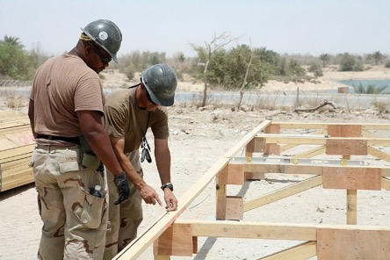
U.S. Navy photo by Mass Communication Specialist 2nd Class Kenneth W. Robinson

UNIT 4: Review and Extension

Flags: Did You Know?
Flags were originally used on the battlefield. They could be used to identify an army and to signal across a distance. Later, flags became common on ships. A ship’s flag would show which country the ship was from. Like on the battlefield, flags were also used to signal and communicate between ships.
Now flags have become national symbols. Cloth flags like we have today were first used in India and China more than 2000 years ago. A country’s flag often uses colors or designs to show its cultural, religious, or political connections to other countries. For example, the flag of Ethiopia uses green, yellow, and red. Since Ethiopia was one of the oldest independent states in Africa, these colors were adopted by many other African countries and became associated with Pan-Africanism.
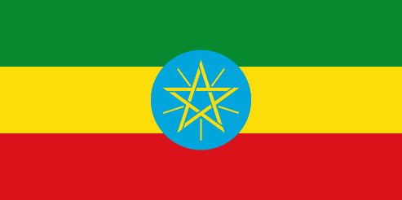
Some flags of former British colonies still have the British “Union Jack” as part of their flag. Not everyone likes having the Union Jack on their flag because of its connections to colonialism. New Zealand actually had a national vote in 2016 to decide if they should keep their current flag or switch to a new flag. Just over half of the voters chose to keep the current flag.
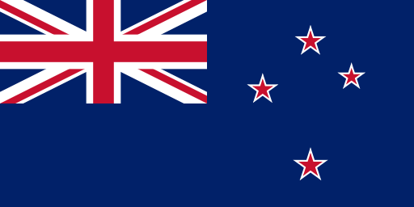

Sources: New World Encyclopedia https://www.newworldencyclopedia.org/entry/flag, Wikipedia https://en.wikipedia.org/wiki/Flag, and New Zealand History https://nzhistory.govt.nz/politics/flags-of-new-zealand)

Choose one of the following questions to discuss with your group:

- Do you think countries should change their flags if the design has connections to colonialism or other historical oppression? Why or why not?

- Do you think a vote is a good way to decide on a flag? Why or why not?

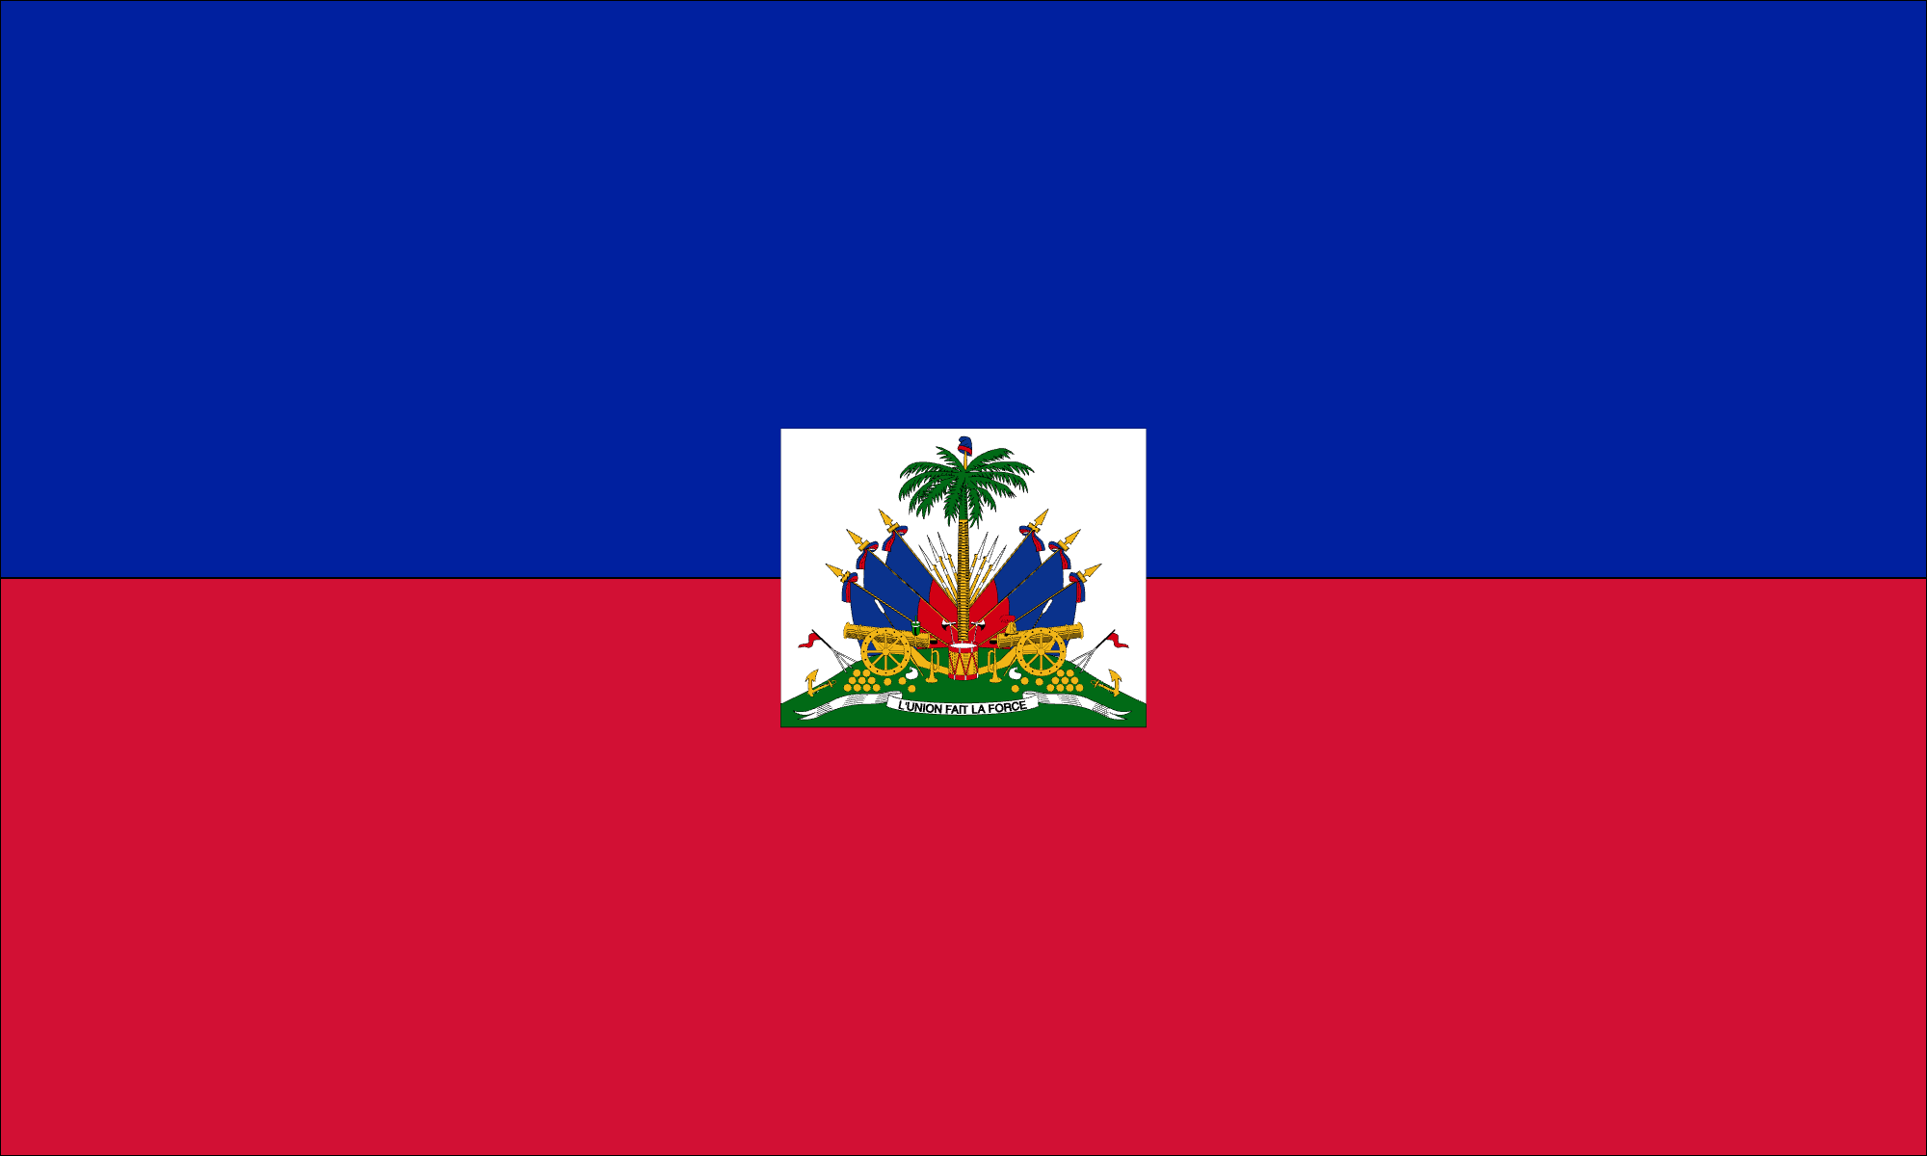
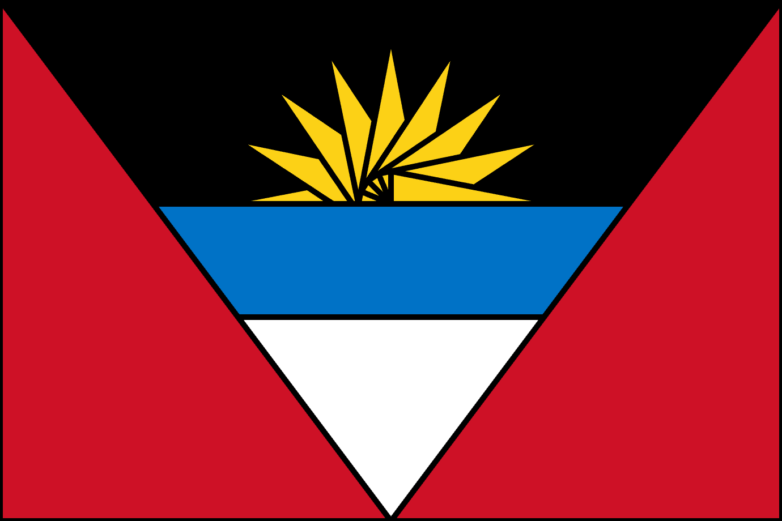
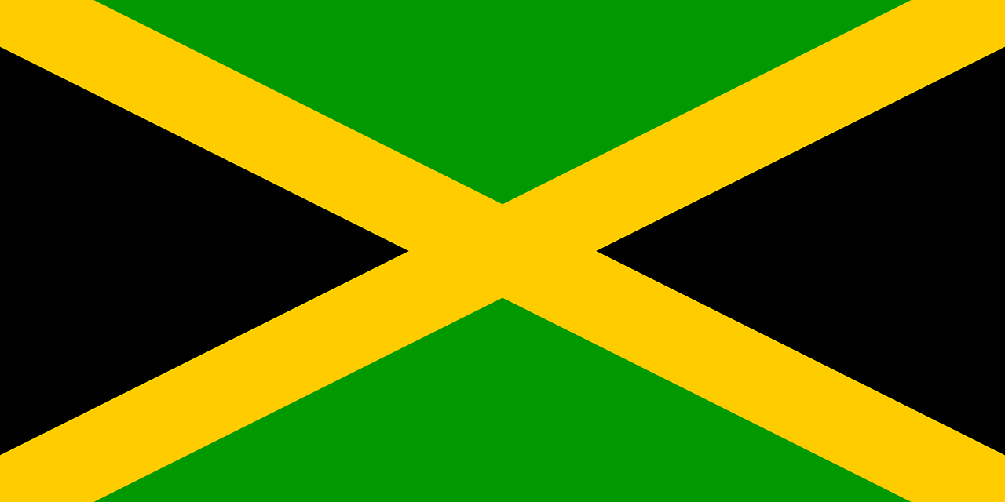
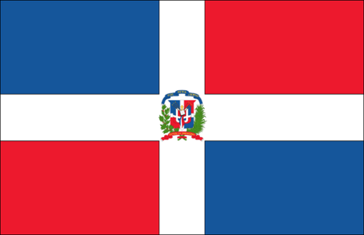
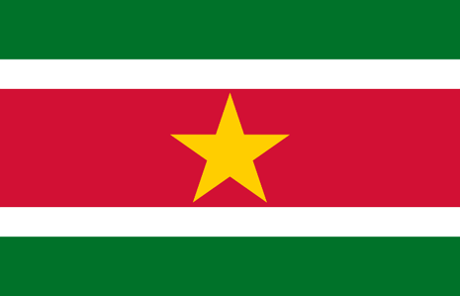
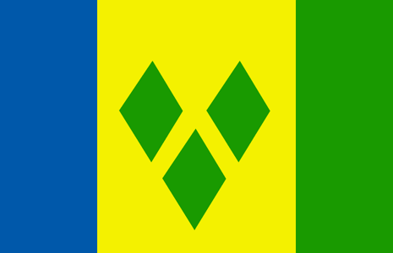
Flags
Suriname
St. Vincent
Antigua
Dominican Republic
Jamaica
Haiti

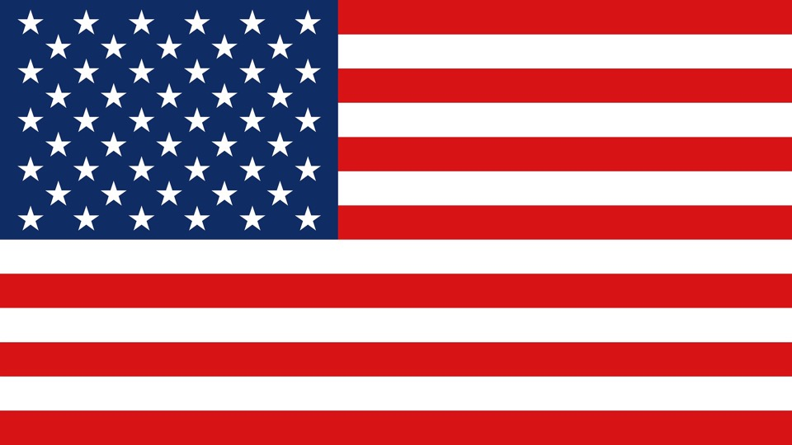
U.S. Flag Review

What shapes do you see in this flag?

What types of angles do you see?

Do you see any parallel lines?

Are there any lines of symmetry?

Vocabulary List for This Unit
Word | Definition | Example
pentagon | a _______-sided shape | 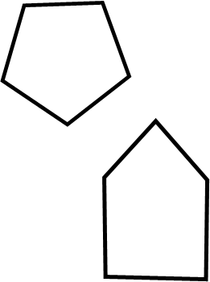
hexagon | a _______-sided shape | 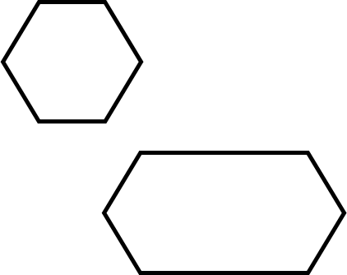
octagon | an ______-sided shape
square | a shape with four _______ sides and four _______ angles. A special rectangle and a special rhombus.
Word | Definition | Example
rhombus | a shape with four ________ sides

Shapes with More Sides
B
C
A

F
E
D

A pentagon has 5 sides and 5 angles. Which of the shapes above are pentagons? | A hexagon has 6 sides and 6 angles. Which of the shapes above are hexagons? | An octagon has 8 sides and 8 angles. Which of the shapes above are octagons?
Where have you seen a pentagon in real life? | Where have you seen a hexagon in real life? | Where have you seen an octagon in real life?

Shapes with More Sides: Examples
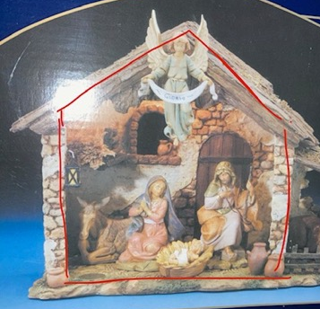
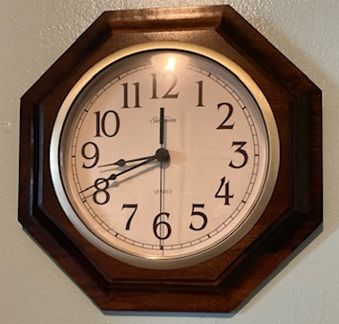

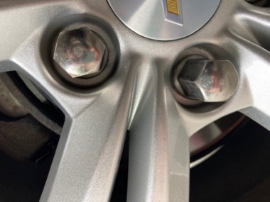
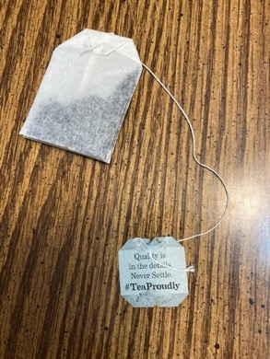
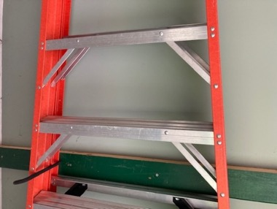

Road Signs
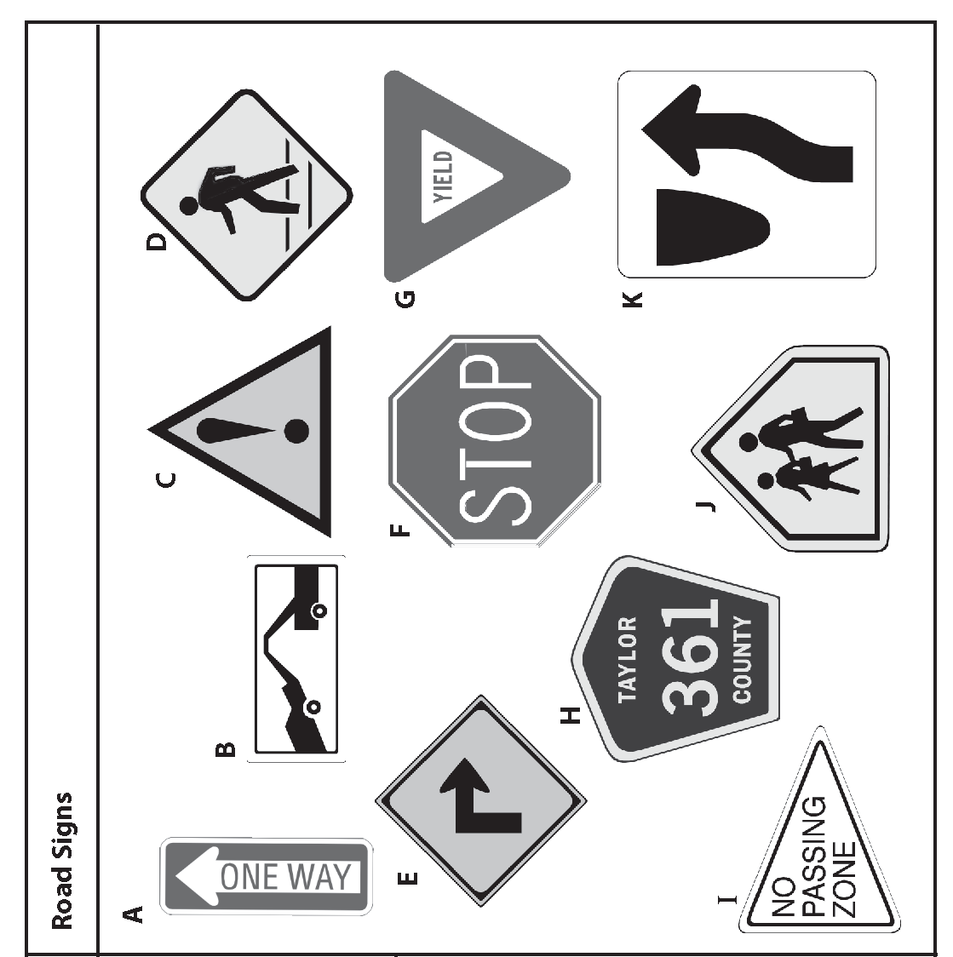
Next to each shape below, write the letters of the road signs that have the same shape.

Square Rectangle Triangle

Octagon Pentagon

Source: EMPower™ book Over, Around, and Within: Geometry and Measurement

Square

Rhombus

Compare Shapes

A
B

How are these two shapes alike?

How are they different?

How would you describe the angles in each shape?

Source: EMPower™ book Over, Around, and Within: Geometry and Measurement

Shape Scavenger Hunt
Look around your home. Where do you see…
Squares | Rectangles
Triangles | Right angles
Parallel Lines | Symmetry

Sort Shapes

Study Strategy
- Label the shapes in your Shape Set with the name of each shape.
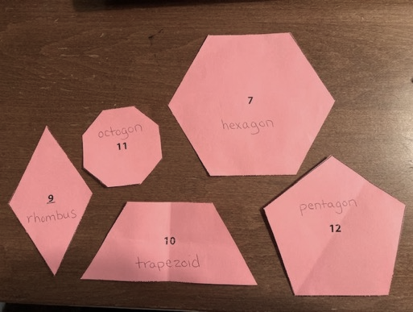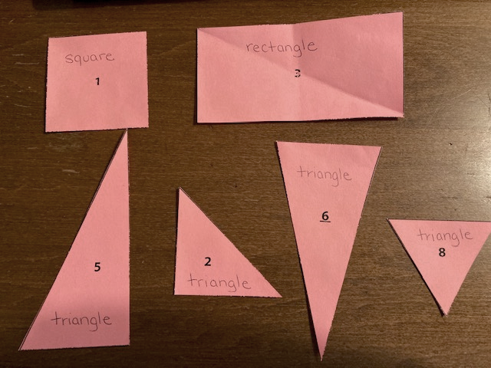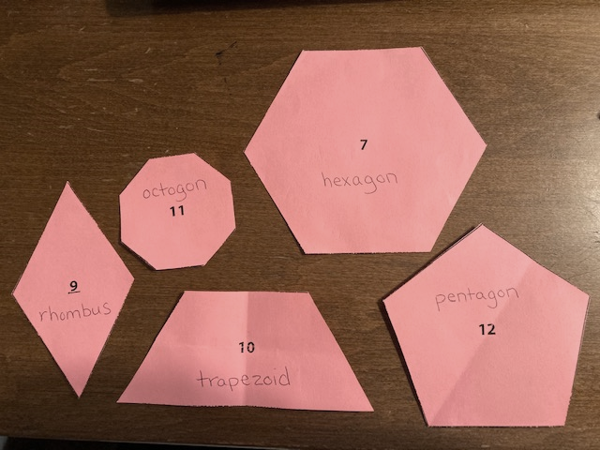
square
rectangle
triangle
triangle
triangle
trapezoid
octagon
hexagon
triangle
rhombus
pentagon

- Turn the shapes over so that the names are facing down. Can you find the
- triangles?
- square?
- rectangles?
- trapezoid?
- rhombus?

- Check each one by flipping it over to see if you are correct.
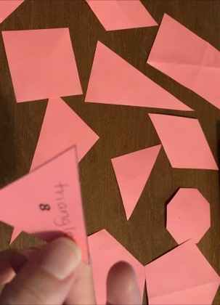

Common Shapes Review
 | Name of shape | Describe it | Where do you see this shape?
A | Square
B | Rectangle
C | Triangle
D | Trapezoid

 | Name of Shape | Describe it | Where do you see this shape?
E | Pentagon
F | Rhombus
G | Hexagon
H | Octagon

Is It a Rectangle?
A rectangle is a shape with four sides and four right angles.
The opposite sides are equal length.

For each shape, decide if it is a rectangle. Check three things:
- Does it have four sides?
- Does it have four right angles?
- Are the opposite sides equal length?

C
B
I
G
D
A
H
E
F

Design Challenge

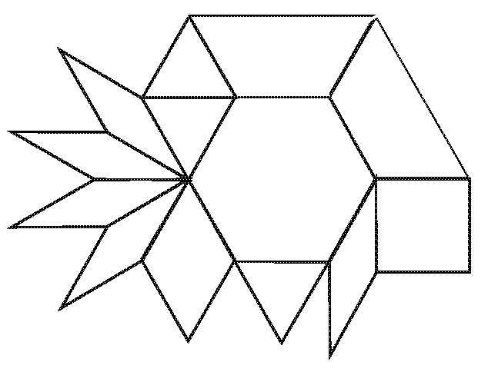

Source: EMPower™ book Over, Around, and Within: Geometry and Measurement

Geometry Quiz
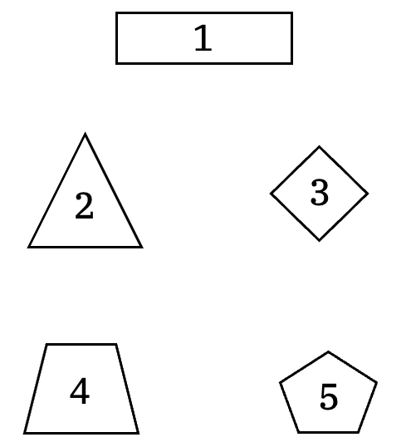

Square Dot Paper – Large

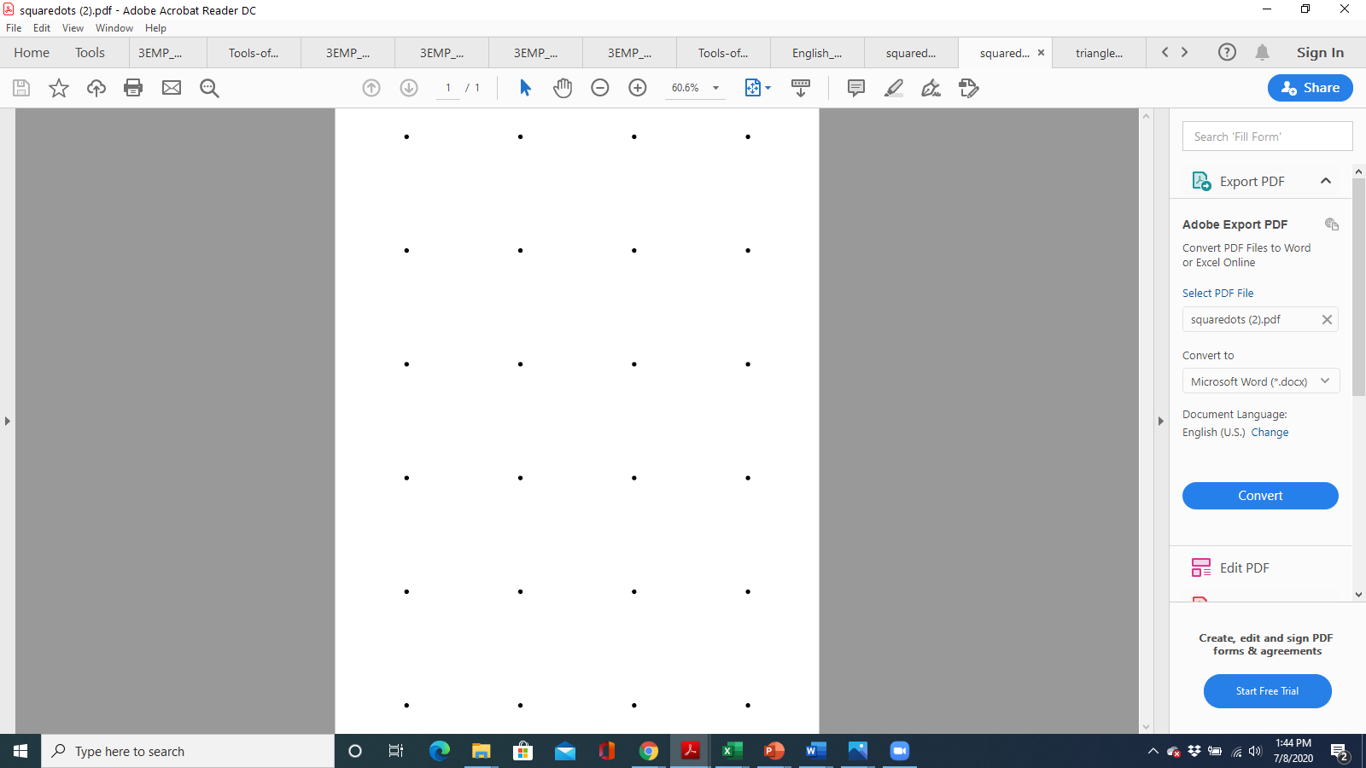

Square Dot Paper – Large

Square Dot Paper – Small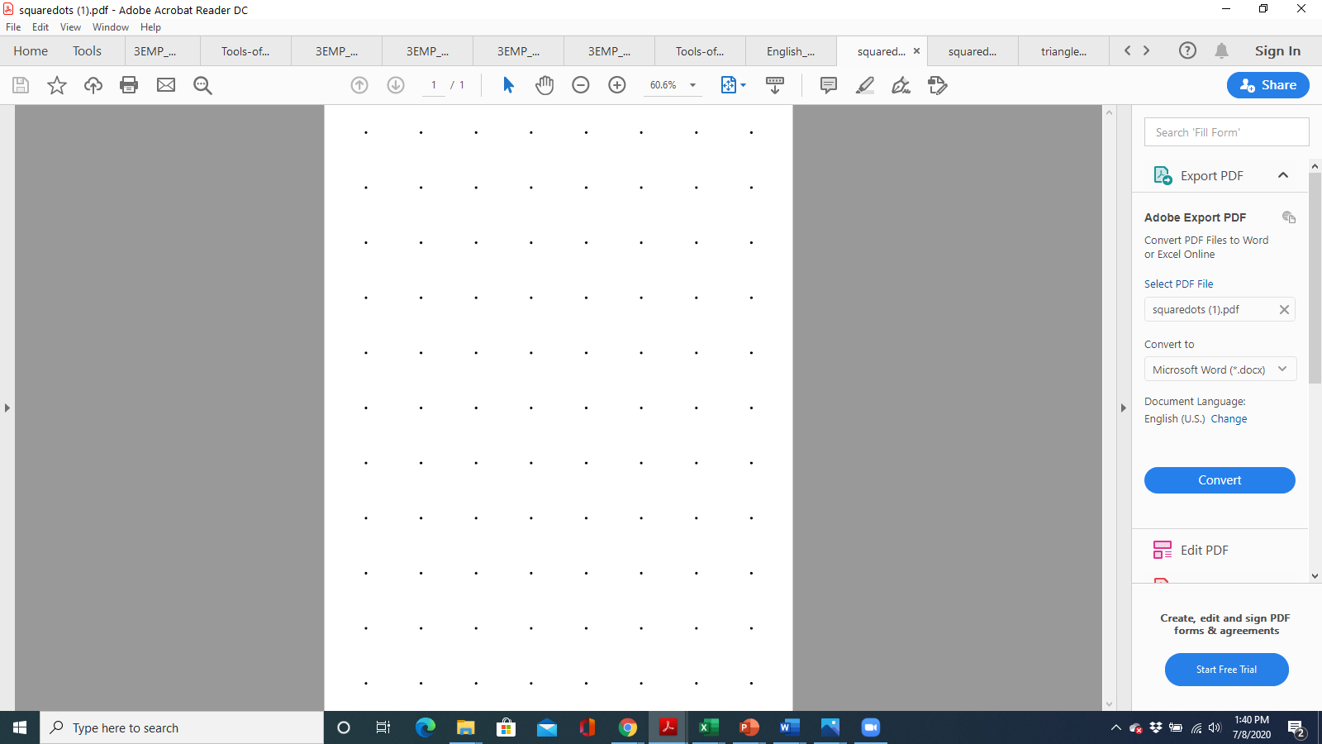

Square Dot Paper – Small

Triangle Dot Paper – Large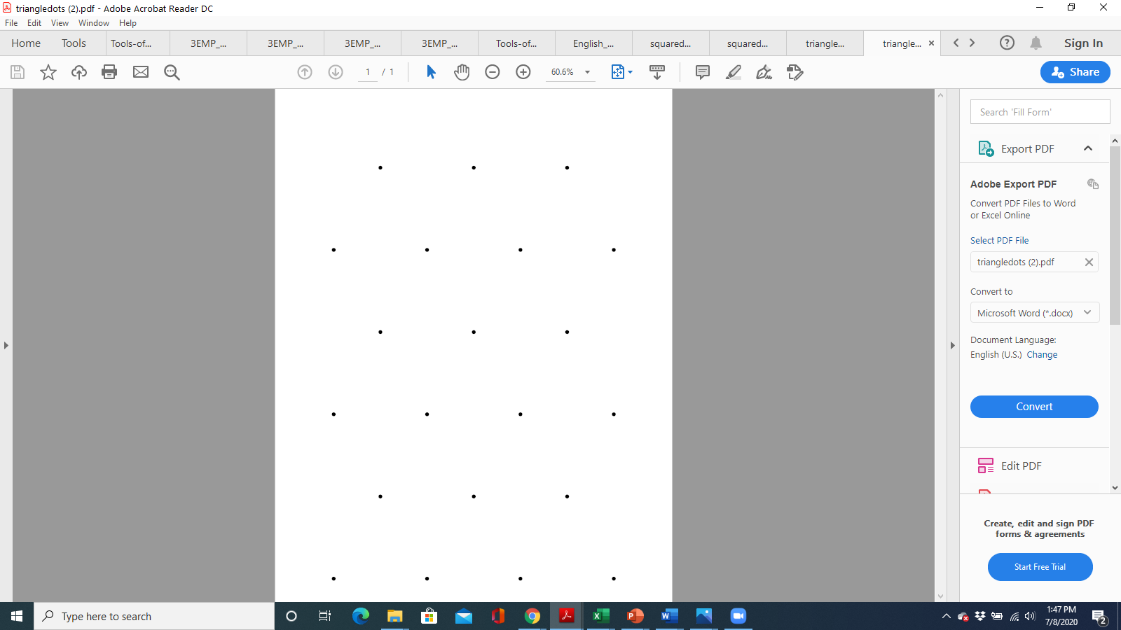

Triangle Dot Paper – Large

Triangle Dot Paper – Small
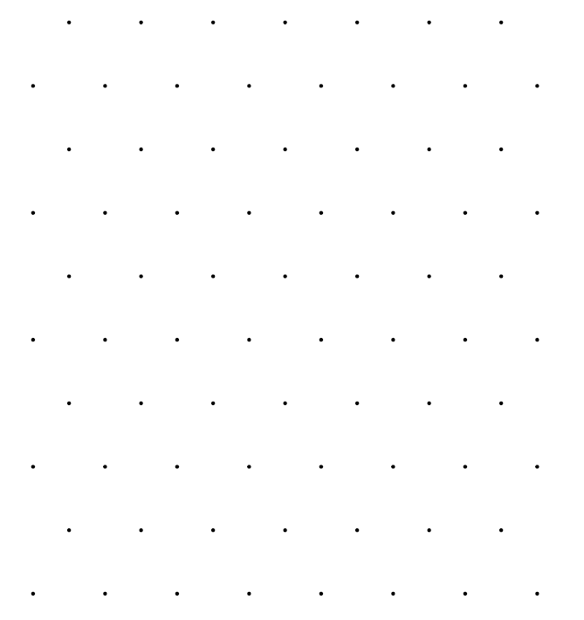

Triangle Dot Paper – Small

