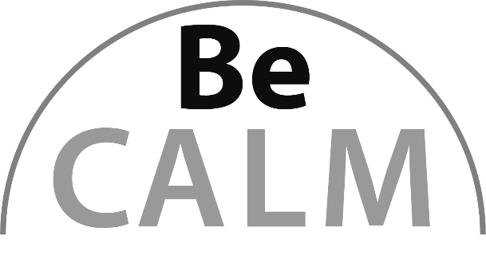
Benchmark Fractions
Beginning Curriculum for Adults Learning Math

STUDENT PACKET



Created with funding from the Adult and Community Learning Services division of the Massachusetts Department of Elementary and Secondary Education by the SABES Mathematics and Adult Numeracy Curriculum & Instruction PD Center, which is managed by TERC, Inc.


Acknowledgements

The titles in the BeCALM series were developed and piloted in the classroom by Melissa Braaten for the SABES Mathematics and Adult Numeracy Curriculum & Instruction PD Team, with contributions from Yvonne Readdy, Emily Rudd, and Sherry Soares.

The BeCALM series includes four sequential packets:
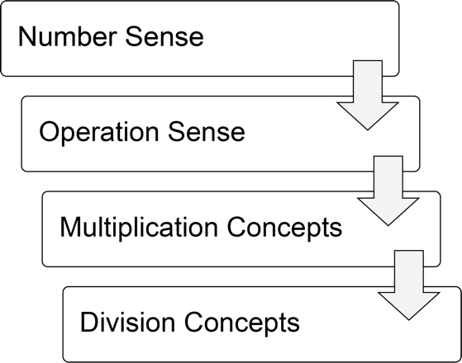
and three non-sequential packets:
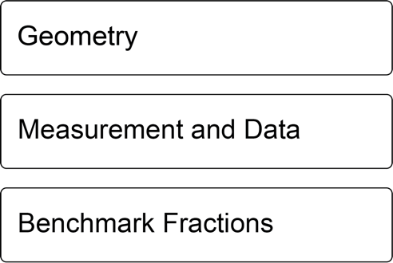

Activities from the EMPower™ series title Using Benchmarks: Fractions and Operations are used and/or adapted with permission from the author, TERC, Inc.

UNIT 1: One-Half

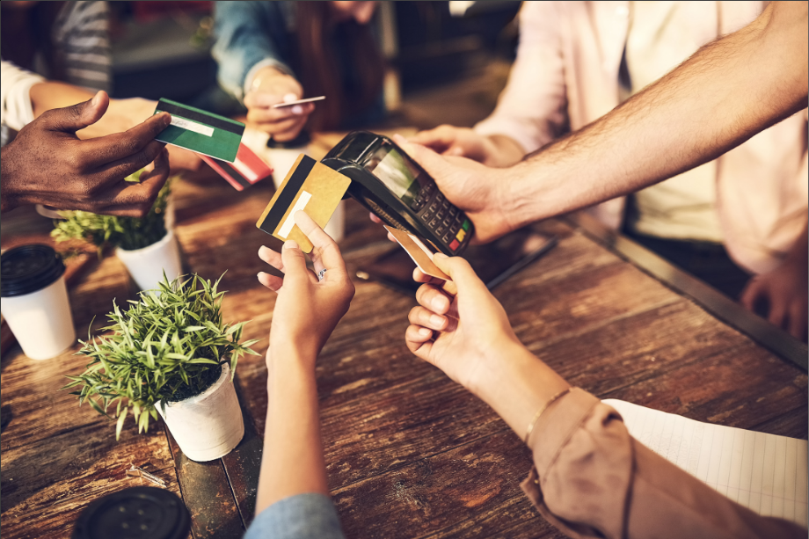
In this unit, you will learn about a useful benchmark fraction, one-half.

Think and share:
A time when you had to split something with someone else. Did you split it equally? How did you decide?

Vocabulary List for This Unit

Word | Definition | Example
part-whole | a _____ of something  The part is ________ in the whole. |   4 is the part,  6 is the whole  “4 of 6” or “4 out of 6”
one-half  $$\frac{1}{2}$$ | one of two_________ parts or groups | 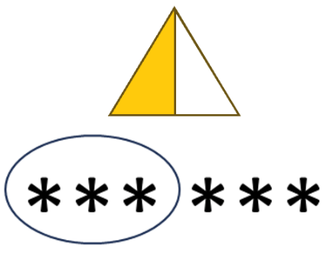
numerator | the ________ number in a fraction, representing the __________ | 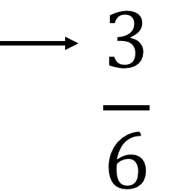
denominator | the ________ number in a fraction, representing the __________ | 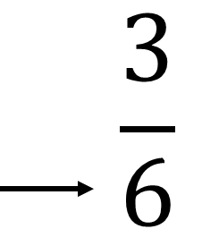

Word | Definition | Example

One-Half of a Shape
Shade half of each shape in three different ways.

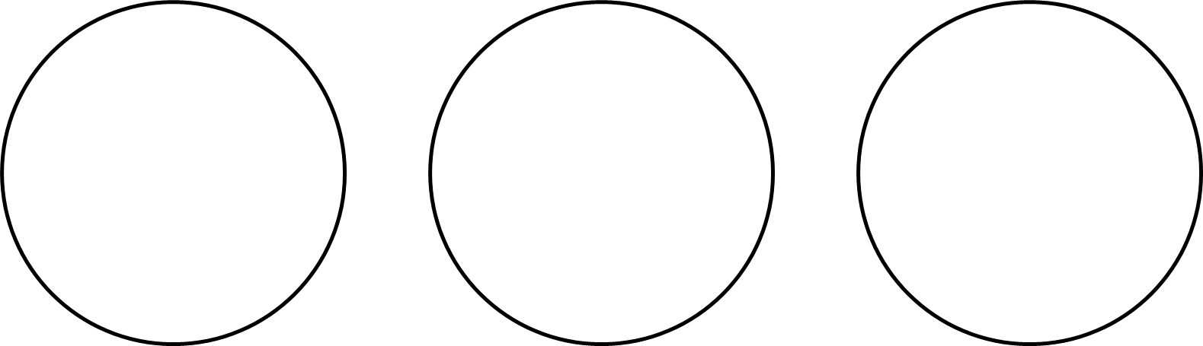



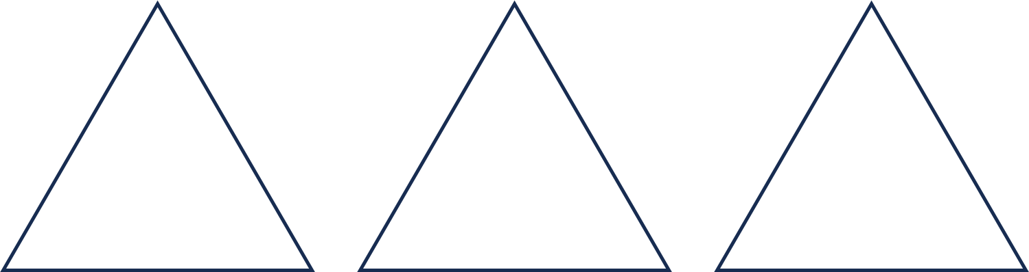

More Shapes
Shade one-half of each shape. How do you know that you shaded one-half?
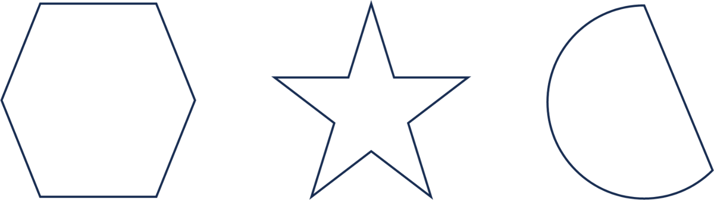

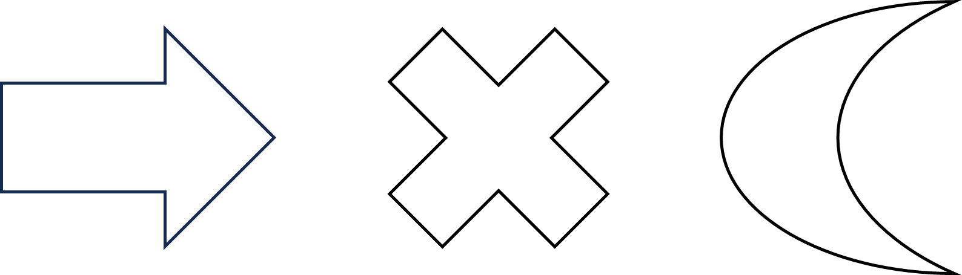



Show Me One-Half
- Shade half of the candles in two different ways.

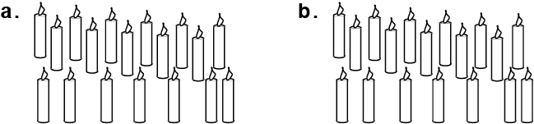

- This measuring cup can hold 8 fluid ounces. Shade $\frac{1}{2}$ of 8 ounces (oz).
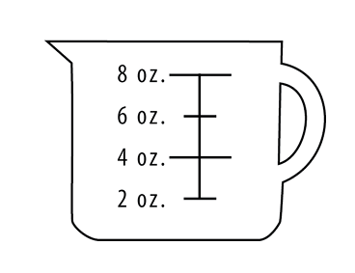

- Show one way to paint the wall below so that it is $\frac{1}{2}$ green and $\frac{1}{2}$ yellow. Don’t paint the window!
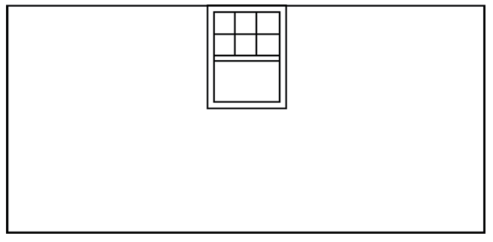
- Now show another way to paint the wall half green and half yellow.

Source: EMPower™ Using Benchmarks: Fractions and Operations. © TERC. Adapted with permission.

Find Half of It
Find half of each amount. Then write the fraction.
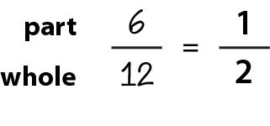

Example: 12 hours

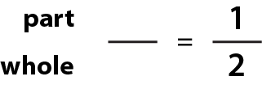
- 88 years

- 16 ounces of chocolate

- 30 days

- $25

- 750 people

- 90 feet

- 400 years

- 72 miles

- 54 minutes

Source: EMPower™ Using Benchmarks: Fractions and Operations. © TERC. Adapted with permission.

Doubling
How do you double a number?

Double each of the numbers. Write the double below the number.

1 2 3 4 5

6 7 8 9 10

How are doubles related to one-half?
Now double each of these numbers. Write the double below the number.
- 10 20 30 40 50

- 60 70 80 90 100

- 12 21 33 44 52

- 15 25 35 45 55

- 26 37 48 56 69

What is the Whole?
What if you know what one-half of a number is? How do you find the whole?
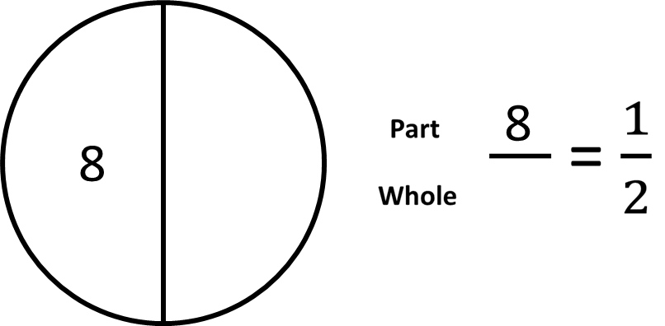

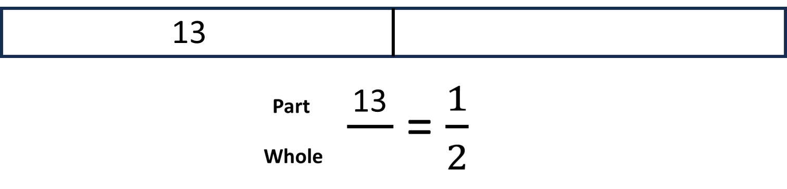

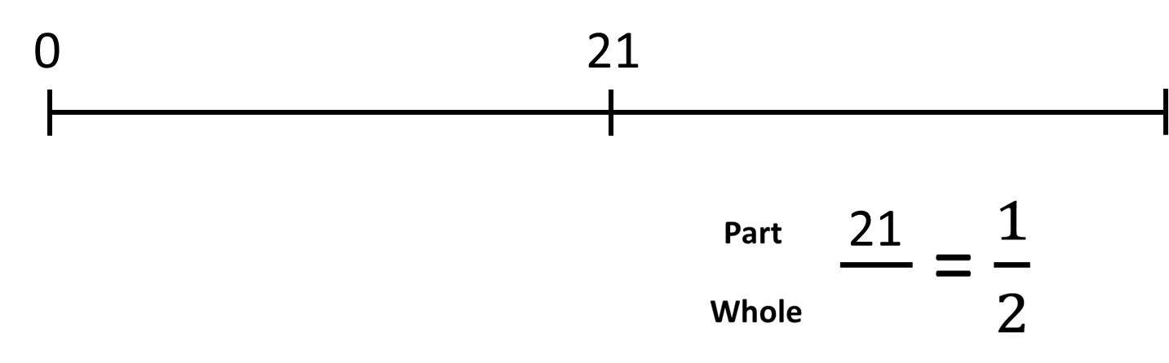

Practice: What is the Whole?
In the table below, you are given half of a number. Find the whole and write a fraction for the whole.

$\frac{1}{2}$ of the number | The whole number | Fraction for the whole
6 | 12 | $$\frac{12}{12}$$
15
23
75
36
335
2.50

Talking About Parts and Wholes

Which of the following is true?
A) 10 is $\frac{1}{2}$ of 20.
B) 20 is $\frac{1}{2}$ of 10.

Talking About Parts and Wholes
Which of the following is true?

A) 10 is $\frac{1}{2}$ of 20. TRUE

B) 20 is $\frac{1}{2}$ of 10. FALSE

One-half is a portion that involves a part and a whole. We use the word “of” before the whole.

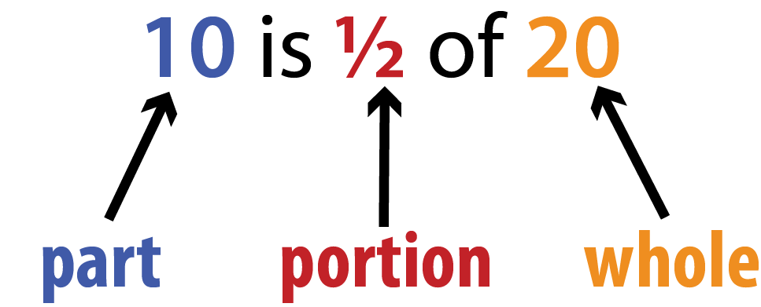

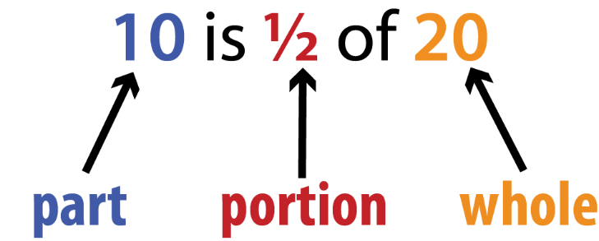

Fill in the blanks below so that the sentences are true.

___ is $\frac{1}{2}$ of 18.
part whole

___ is $\frac{1}{2}$ of 26.
part whole

___ is $\frac{1}{2}$ of 84.
part whole

8 is $\frac{1}{2}$ of ___.
part whole
14 is $\frac{1}{2}$ of ___.
part whole
32 is $\frac{1}{2}$ of ___.
part whole

Fill in the blanks below so that the sentences are true, then turn each into a fraction.
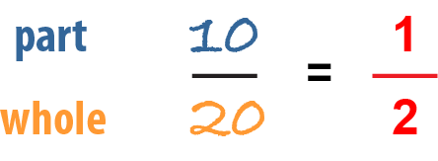
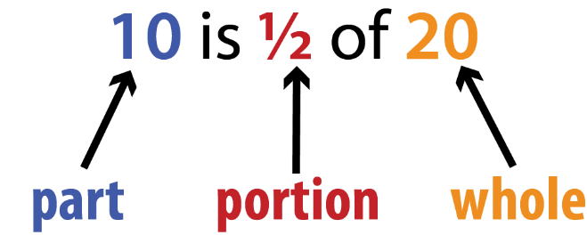

____ is $\frac{1}{2}$ of ____.
part whole

____ is $\frac{1}{2}$ of ____.
part whole

____ is $\frac{1}{2}$ of ____.
part whole

____ is $\frac{1}{2}$ of ____.
part whole
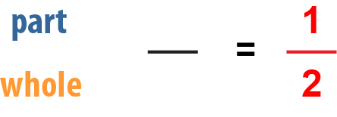

Portion of Whole

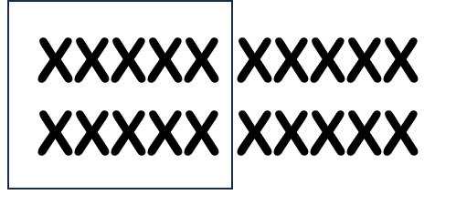

Even if the word order changes, the phrase is still “portion of whole.”

10 is ½ of 20.

½ of 20 is 10.

What is ½ of 20?

10 is ½ of what?

Practice: Portion of Whole
Fill in the blanks for the image below.

___ is $\frac{1}{2}$ of ____ . $\frac{1}{2}$ of ____ is ____ .
whole whole

What is $\frac{1}{2}$ of ____? ____ is $\frac{1}{2}$ of what?
whole whole

Practice: Portion of Whole
Fill in the blanks for the image below.

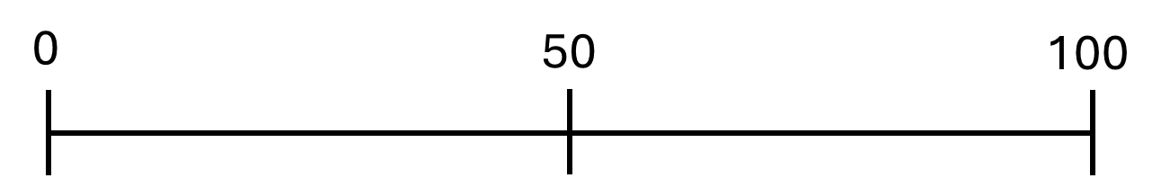

___ is $\frac{1}{2}$ of ____ . $\frac{1}{2}$ of ____ is ____ .
whole whole

What is $\frac{1}{2}$ of ____? ____ is $\frac{1}{2}$ of what?
whole whole

Practice: Portion of Whole
Fill in the blanks for the image below.

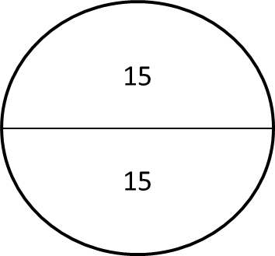

___ is $\frac{1}{2}$ of ____ . $\frac{1}{2}$ of ____ is ____ .
whole whole

What is $\frac{1}{2}$ of ____? ____ is $\frac{1}{2}$ of what?
whole whole

Practice: Portion of Whole
Fill in the blanks for the image below.
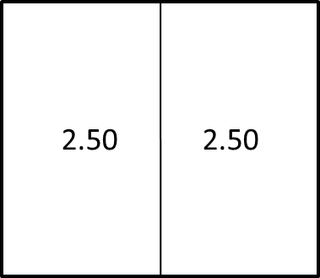

___ is $\frac{1}{2}$ of ____ . $\frac{1}{2}$ of ____ is ____ .
whole whole

What is $\frac{1}{2}$ of ____? ____ is $\frac{1}{2}$ of what?
whole whole

Word Problem Practice
Ask yourself: What is the part (half)? What is the whole?

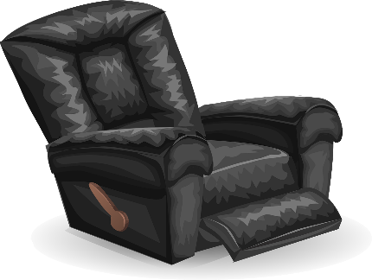
- Daria is buying a new chair.
She has to pay half of the price now and half later.
The price of the chair is $146.
How much did she pay now?

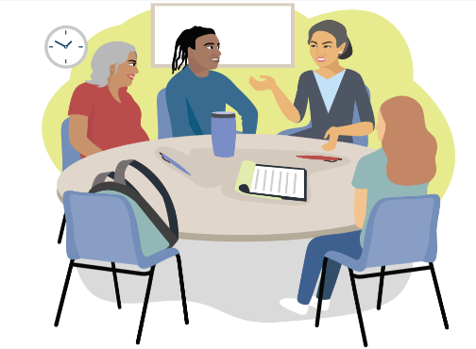
- One half of the students enrolled in the class are absent today.
9 students are absent.
How many students are enrolled in the class?

- Pierre’s paycheck will pay for half of his rent.
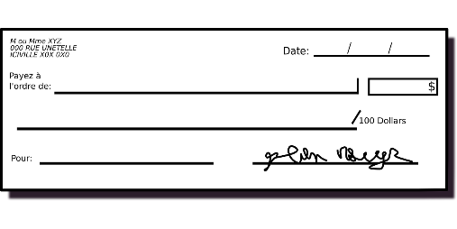
His rent is $1,200.
How much was his paycheck?


- Marlo finished grading half of the student papers.
They graded 23 papers.
How many student papers are there in total?

Exit Ticket / Homework
You went out to dinner with a friend. You need to pay one-half of the bill. Find the amount you need to pay. Show how you know it is one-half of the bill.
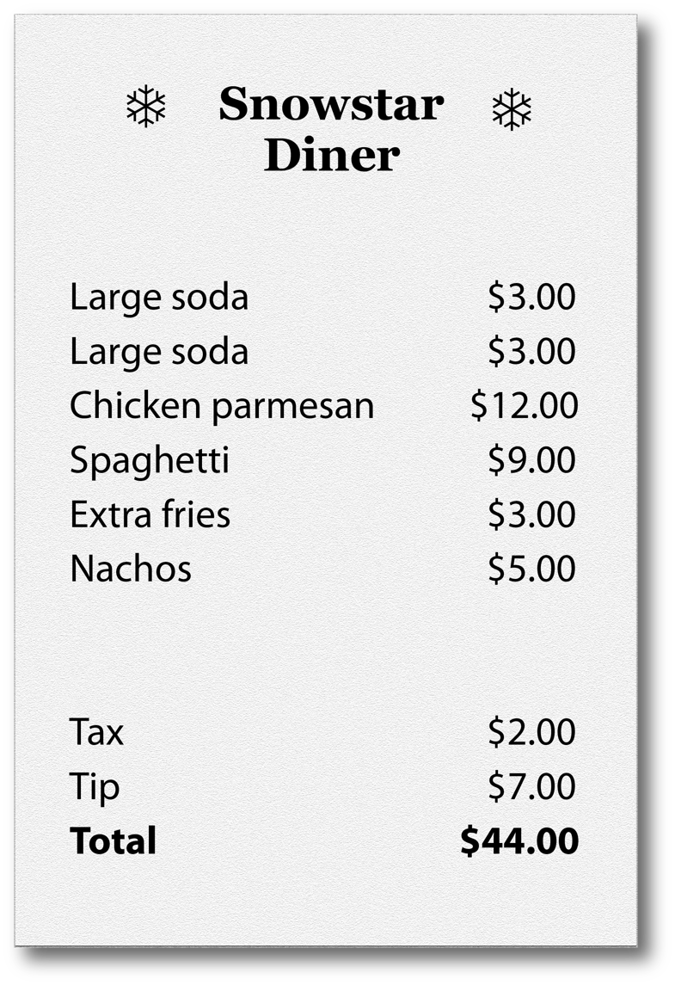

____ is $\frac{1}{2}$ of ____ .

UNIT 2: More or Less than One-Half?
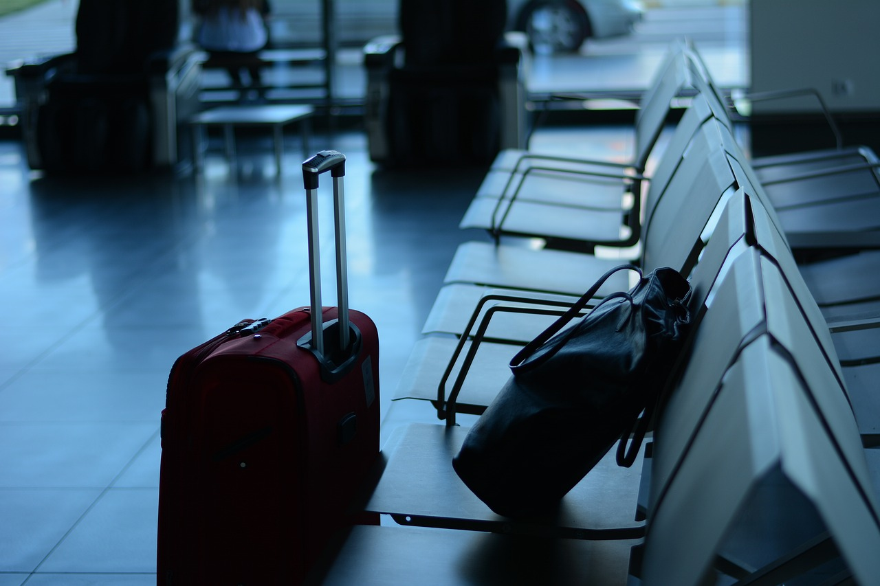

In this unit, you will learn how to use the benchmark fraction one-half to decide if other fractions are more or less than one-half. You will also learn about other ways to say one-half, using decimals and percentages.

Think and share:
A time when you had to travel far. How long did it take? How did you keep track of how far you had gone?

Vocabulary List for This Unit
Word | Definition | Example
benchmark fractions | A fraction that is ______ to understand and calculate. We can __________ other fractions to the benchmark. | more than $\frac{1}{2}$  less than $\frac{1}{2}$  almost all
percent  (percentage) | A percentage is a part of _____________ (the whole is 100). | 50% is equal to one half.
decimal | The place values that come after the decimal _________.  These represent ___________ or parts of a whole. | .5 or .50 are decimals equal to one half.
circle graph/ pie chart | A graph that shows _____________ by breaking up a circle into parts.  The whole circle represents _______ . | 

Word | Definition | Example
data | _______________ or _________ of things in the real world. | I am 5’2” tall.  The US population is about 336 million people.
to the nearest $\frac{1}{2}$ inch | When measuring, this means you choose the closest _______ or _______ inch on the ruler | 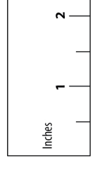

Why is 50% a Half?

- How many small squares are in the grid below? How do you know?

- Use pictures, words, or the grid to show why 50% is $\frac{1}{2}$ .

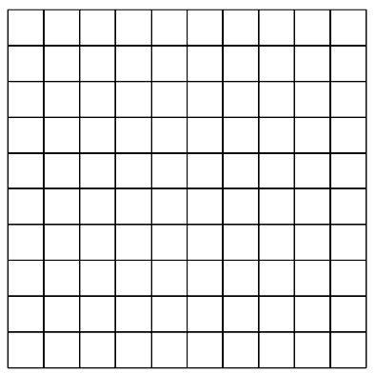

Source: EMPower™ Using Benchmarks: Fractions and Operations . © TERC. Adapted with permission.

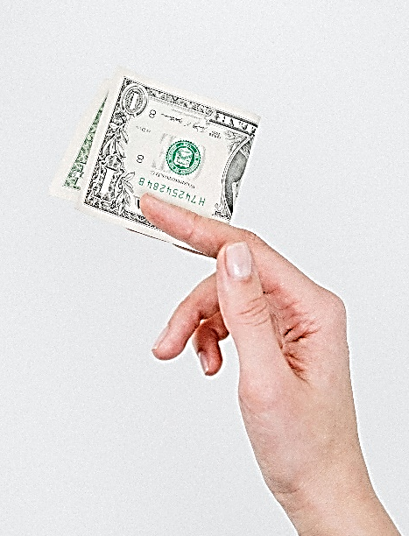
Half of a Dollar

How much is $\frac{1}{2}$ of a dollar?
How do you know?

We write dollars and cents using decimal places.

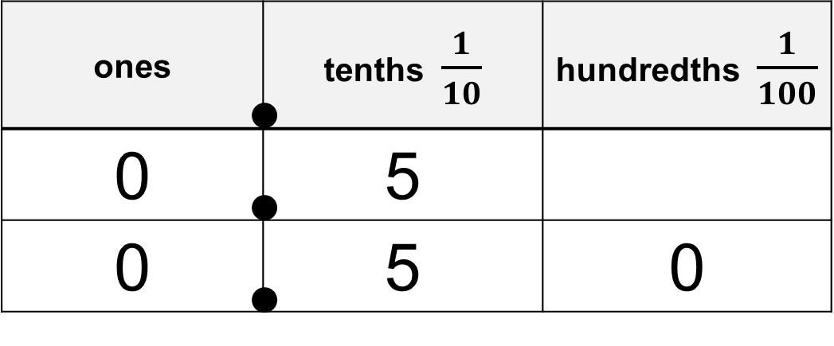
0.5 means $\frac{5}{10}$ 0.50 means $\frac{50}{100}$

Like 5 out of 10 dimes Like 50 out of 100 pennies

Women in the Workforce
This data is about working women in the United States.
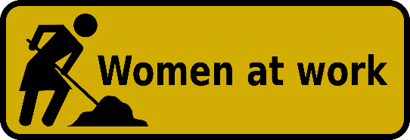

For each percentage, decide if it is more or less than half (50%).
Data | More or less than half?
Women who work: 58%
Women with children under 18 years old who work: 73%
Women make up 35% of workers in STEM (science, technology, engineering, and math) occupations.
36% of lawyers are women.
92% of childcare workers are women.
9% of firefighters are women (although most are volunteers).
Data from US Department of Labor, DataUSA, National Science Foundation, and Women in Fire. All statistics are from 2020-2024.

Are We There Yet?
Label each number line below with the number of miles for 0%, 50% and 100% of the trip.

Boston to Worcester: 50 miles

Boston to New York City: 240 miles

Boston to Philadelphia: 300 miles

Boston to Chicago: 980 miles

Stations: Comparing Fractions to One-Half
At each station, find the part and the whole.
Write the fraction.
Is the fraction you wrote more or less than one-half?
Item at each station | Part | Whole | Fraction | More than $\frac{1}{2}$  Less than $\frac{1}{2}$  Equal to $\frac{1}{2}$
Station 1:  one month | 16 days
Station 2:
Station 3:
Station 4:
Station 5:

Source: EMPower™ Using Benchmarks: Fractions and Operations . © TERC. Adapted with permission.

Choose an Amount
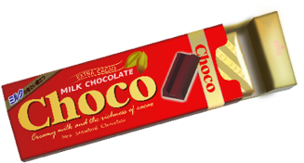
There are many correct answers for each question.

- More than $\frac{1}{2}$ of the chocolate bar (16 oz.)

- Less than half of her age (42 years old)

- More than $\frac{1}{2}$ of the class (26 students)

- More than half of a million dollars ($1,000,000)

- Less than 50% correct on the test (45 questions)

- Less than $\frac{1}{2}$ the time (6 hours 20 minutes)

Source: EMPower™ Using Benchmarks: Fractions and Operations . © TERC. Adapted with permission.

Is It Half?
- Sherry dropped a box of crackers. There were 80 crackers in the box. 60 crackers broke.
Fraction for the whole (total) | Fraction for half of the whole | Fraction of crackers that broke
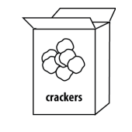
The number of broken crackers was
more than $\frac{1}{2}$ of the box
less than $\frac{1}{2}$ of the box
exactly half of the box

- Vernon had $15. He gave $7 to his sister.
Fraction for the whole (total) | Fraction for half of the whole | Fraction of money he gave to sister
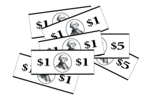
Vernon gave his sister
more than 50% of his money
less than 50% of his money
exactly 50% of his money

Source: EMPower™ Using Benchmarks: Fractions and Operations. © TERC. Adapted with permission.
- A ream (package) of paper has 500 sheets. Allie used 228 sheets.
Fraction for the whole (total) | Fraction for half of the whole | Fraction of sheets Allie used

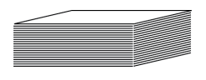
Allie used
more than 50% of the ream
less than 50% of the ream
exactly 50% of the ream

- Kari bikes 7 miles to work. Today she biked 3.5 miles, then stopped for coffee.
Fraction for the whole (total) | Fraction for half of the whole | Fraction of the trip that Kari biked

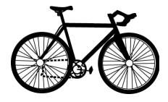
Kari was
more than halfway to work
less than halfway to work
exactly halfway to work

From EMPower™ Using Benchmarks: Fractions and Operations. © TERC. Adapted with permission.

More “Is it Half?” Problems
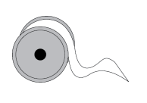
- Irina had a 21-inch ribbon. She cut off 10 inches for her daughter. She then had
more than $\frac{1}{2}$ of the ribbon left.
less than $\frac{1}{2}$ of the ribbon left.
exactly half of the ribbon left.
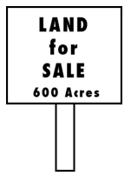
- The Marquez-Brown family owns a ranch with 1,300 acres of land. They plan to sell 600 acres.
They will sell
more than $\frac{1}{2}$ of their land.
less than $\frac{1}{2}$ of their land.
exactly half of their land.
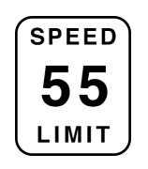
- Luz was driving at 55 mph (miles per hour) when traffic suddenly slowed to 25 mph.
Luz’ speed became
more than half of what it had been.
less than half of what it had been.
half of what it had been.

From EMPower™ Using Benchmarks: Fractions and Operations. © TERC. Adapted with permission.

Notes on Using a Ruler
- Point the ruler in the same direction as the length that you want to measure.
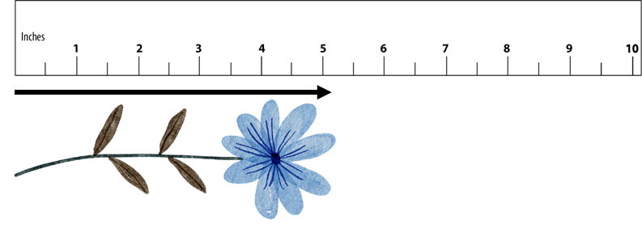
- Start measuring at the 0 on the ruler. It might not be labeled.
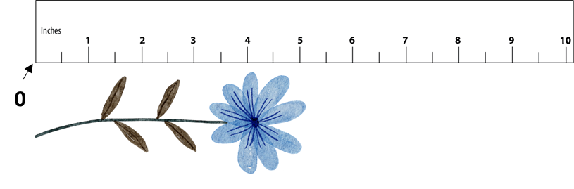
- Choose the inch (the labeled number) or the half inch closest to the end of the length.
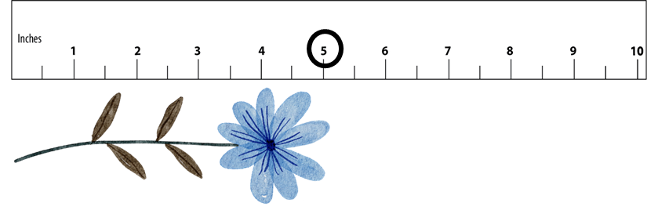

Measuring to the Nearest Half Inch
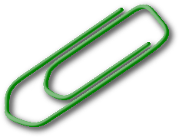
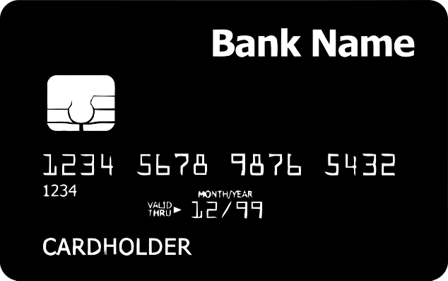

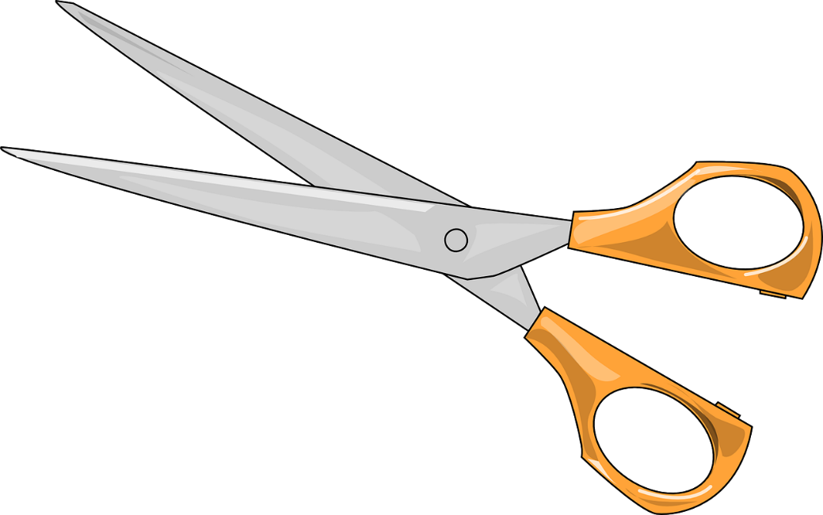
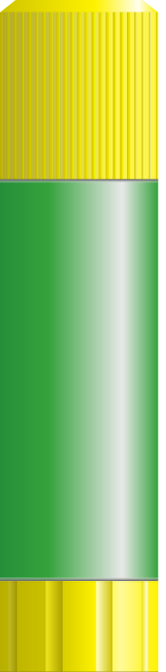
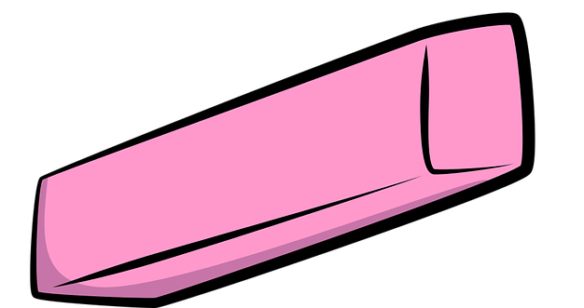
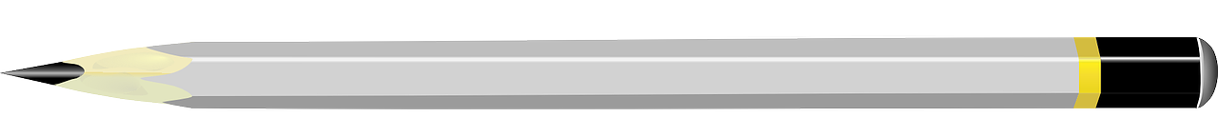

Financial Literacy: Comparing Sales
With a partner, discuss which sale you think is the best deal and why.
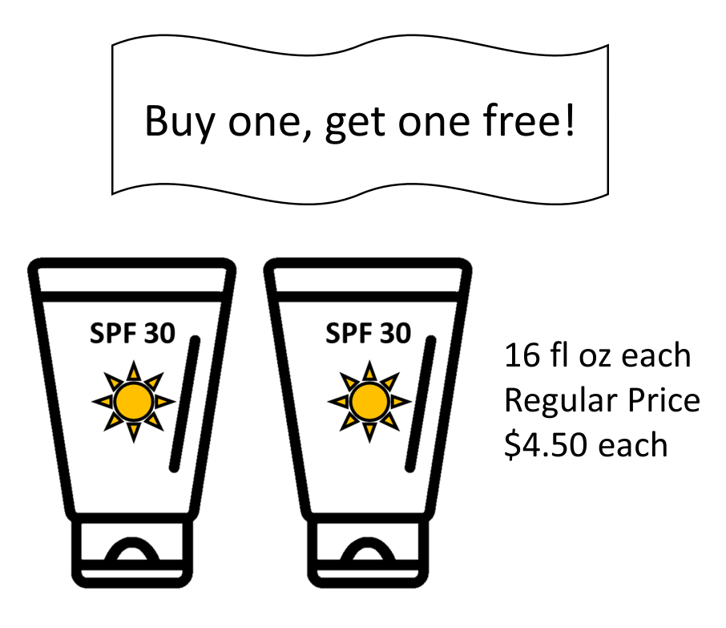
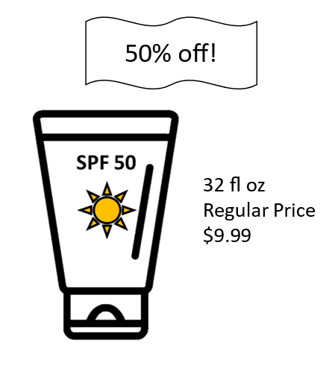
Sale A Sale B

Sale C
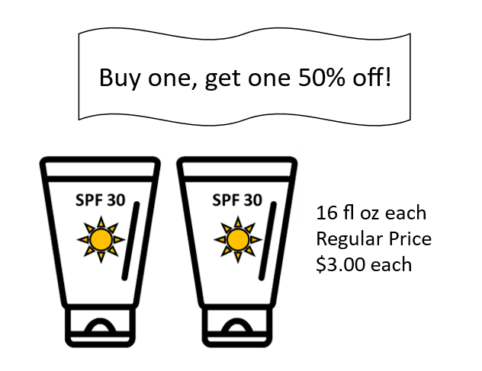

Exit Ticket

“The original price was $120, but it was on sale! I bought it for only $70!”
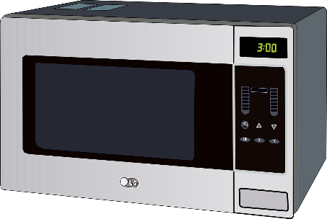

The discount was
50%
more than 50%
less than 50%

Show how you know.

UNIT 3: One-Fourth
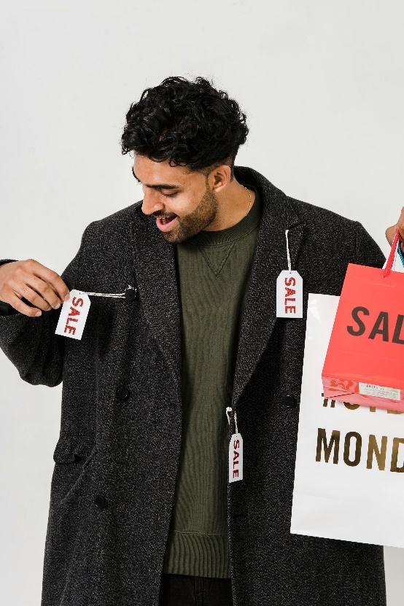
In this unit, you will learn a new benchmark, one-fourth. You will also practice applying your knowledge of benchmark percents to find discounts.

Think and share:
A time when you got a really good deal on something you bought.

Word | Definition | Example
one-fourth  one quarter  $$\frac{1}{4}$$ | One out of _____ equal parts or portions  “______ of a half”  As a decimal: _____  As a percent:_____ | 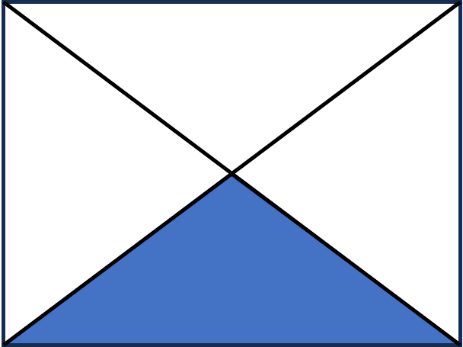  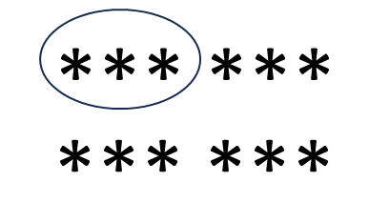
discount | When a price has been lowered

Vocabulary List for This Unit

Word | Definition | Example

What a Bargain!

What are some words that mean that a price has been lowered?

 Watch out for:
for sale | on sale
the item can be bought | the price has been lowered (a discount)

25% of | 25% off
A portion of an amount, such as 25% of the class was absent | A discount. 25% of the price is removed. 25% off of $20 means a sale price of $15.

Thinking About Discounts
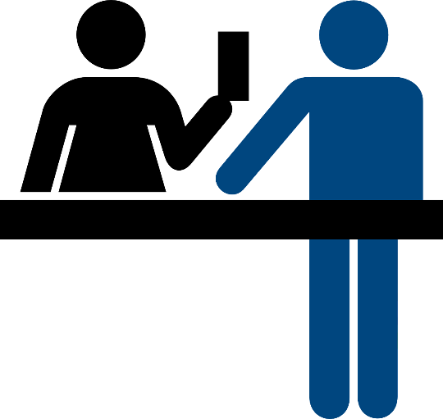
- Moira has a coupon for 50% off of each item she buys. The cashier says that he is going to find the total and then take 50% off of the total. Is that the same? Why or why not?

- Josef wants to buy a table. The table is on sale for 50% off. He also has a coupon for 50% off the purchase price. Does that mean he gets the table for free? Why or why not?

One Fourth of a Shape
Shade one-fourth of each shape. How do you know that you shaded one-fourth? Are there any shapes that will not work?
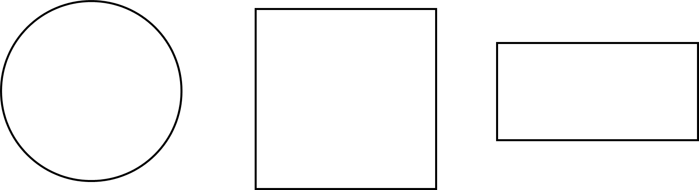

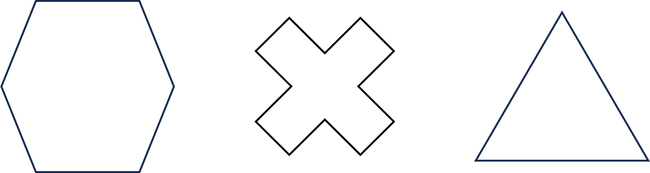

One-Fourth Spent

If you spend, waste, or lose $\frac{1}{4}$ of something, you have $\frac{3}{4}$ left.
$\frac{1}{4}$ spent + $\frac{3}{4}$ left = $\frac{4}{4}$ (the whole) 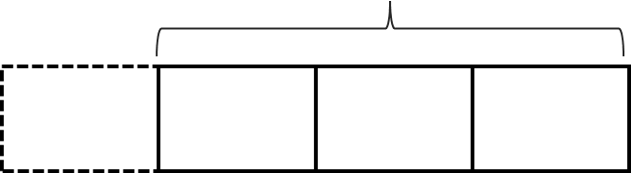

Find how much is spent and how much is left in each situation.
- Whole: $10 in all
$\frac{1}{4}$ spent $\frac{3}{4}$ left

- Whole: $5 in all
$\frac{1}{4}$ spent $\frac{3}{4}$ left

- Whole: $90 paycheck
$\frac{1}{4}$ spent $\frac{3}{4}$ left

- Whole: $220 paycheck
$\frac{1}{4}$ spent $\frac{3}{4}$ left

- Whole: $300 electric bill
$\frac{1}{4}$ paid $\frac{3}{4}$ owed

Source: EMPower™ Using Benchmarks: Fractions and Operations. © TERC. Adapted with permission.

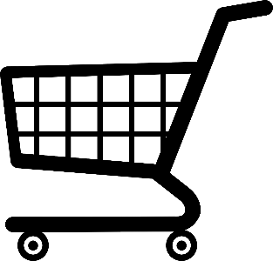
Supermarket Power Lost

After the supermarket lost power, some of the food went bad. Find the missing amounts in each situation.

- 82 lbs. of meat in total
$\frac{1}{4}$ bad $\frac{3}{4}$ still good

- 200 containers of yogurt in total
$\frac{1}{4}$ bad $\frac{3}{4}$ still good

- How much cheese in total?
$\frac{1}{4}$ bad $\frac{3}{4}$ still good
5 lbs.

- How much chicken in total?
$\frac{1}{4}$ bad $\frac{3}{4}$ still good
15 lbs.

- How much ice cream in total?
$\frac{1}{4}$ bad $\frac{3}{4}$ still good = 18 cartons

Source: EMPower™ Using Benchmarks: Fractions and Operations. © TERC. Adapted with permission.

What Makes It a Quarter?
Look at the grid below. Explain how you know that the shaded portion is $\frac{1}{4}$, .25, or 25%.

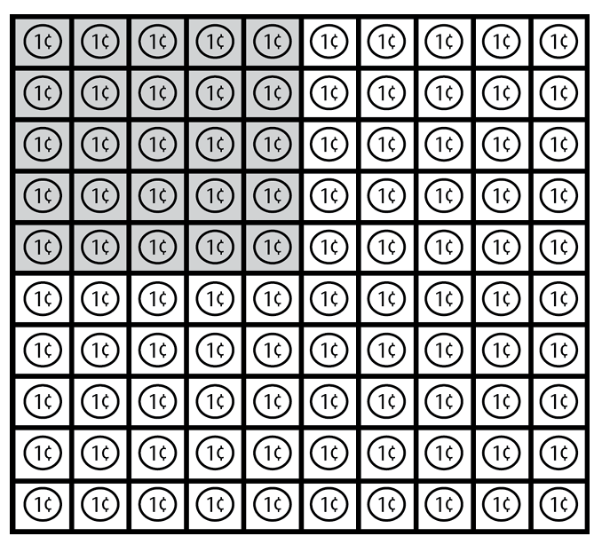

Source: EMPower™ Using Benchmarks: Fractions and Operations. © TERC. Adapted with permission.

Show Me $\frac{1}{4}$
Shade one-fourth of each of the following shapes or sets of objects, then write a fraction.
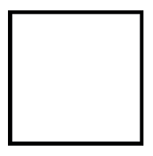
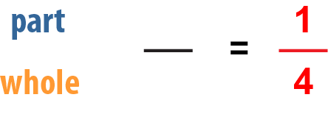

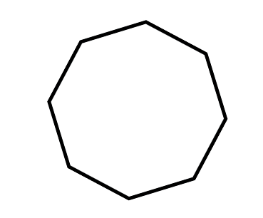

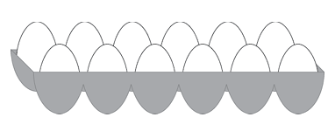

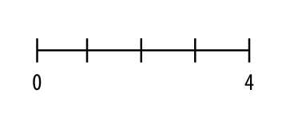
For problems 4–6, shade one-fourth of the number line and write a fraction.

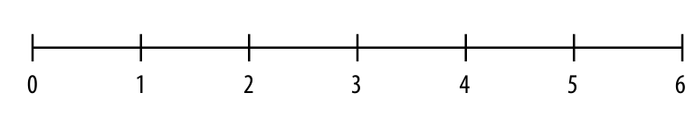

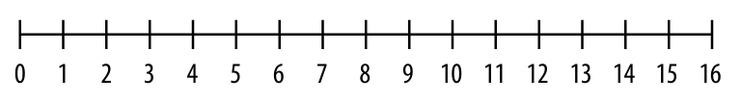

Source: EMPower™ Using Benchmarks: Fractions and Operations. © TERC. Adapted with permission.

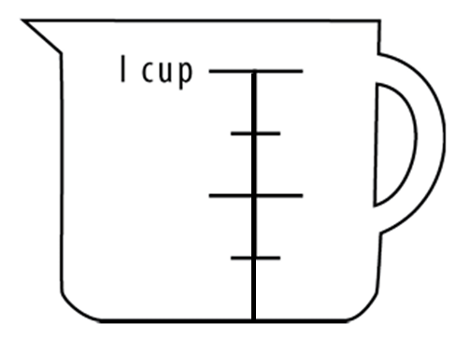
One-Fourth Measurements

- Shade one-fourth of 1 cup.
How much did you shade?

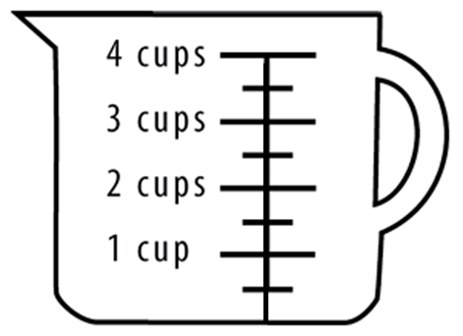

- Shade one-fourth of 4 cups.
How much did you shade?

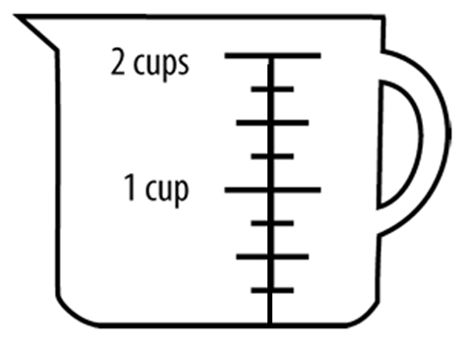

- Shade one-fourth of 2 cups.
How much did you shade?

- Shade one-fourth of 12 inches.
How much did you shade?

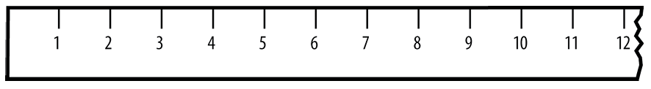

- $\frac{1}{4}$ of 5 pounds = ______ pounds

- $\frac{1}{4}$ of a day (24 hours) = ______ hours

- Shade $\frac{1}{4}$ of an hour on the clock below.
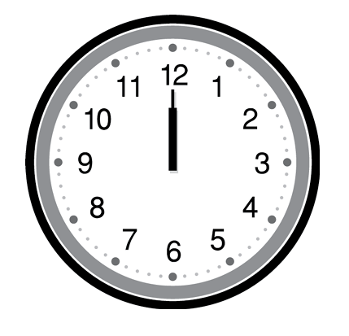

- $\frac{1}{4}$ of an hour (60 minutes) = ______ minutes

Source: EMPower™ Using Benchmarks: Fractions and Operations. © TERC. Adapted with permission.

How Many, How Far
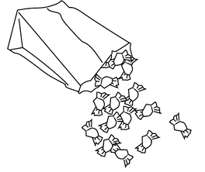
- DaQuan and Lulu agreed to share a bag of candies. DaQuan took 45 candies and Lulu took 15.
Kurt was watching and said, “This sharing is not fair! That is not a 50-50 split!”

- How many candies were in the bag? How do you know?

- What fraction of the candies did Lulu get? (Label the part and the whole.)

- Is Kurt right? Explain.

- Suggest a different way of sharing the candy.

- Would Kurt say that this way of sharing is fair? Why?

- Enrique walks 18 blocks to the Farmers’ Market. He takes his granddaughters with him.
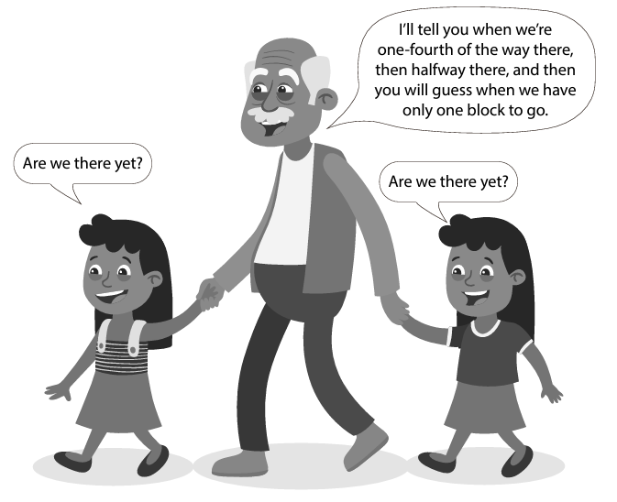

- At what block will Enrique tell the girls that they are one-fourth of the way there?

- At what block will Enrique tell them that they are halfway there?

- How do you know? Use a number line to show your reasoning.

- One-fourth of Shana’s hourly wages go to cover healthcare benefits. Shana makes $16 an hour.

- How many dollars an hour does Shana contribute to healthcare benefits? Show how you know.

- If she gets a raise and the cost of health insurance stays the same, will Shana pay more or less than one-fourth of her new wage? Show how you know.

- The education budget is fully funded at $200 million. If lawmakers decide to cut 25% of that budget, how much will they cut? Show how you know.

Source: EMPower™ Using Benchmarks: Fractions and Operations. © TERC. Adapted with permission.

Discounts
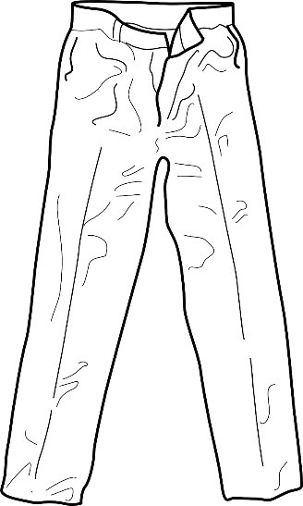
When a sale advertises 25% off, it means that one-quarter is removed from the price.

25% off!
Original Price: $24

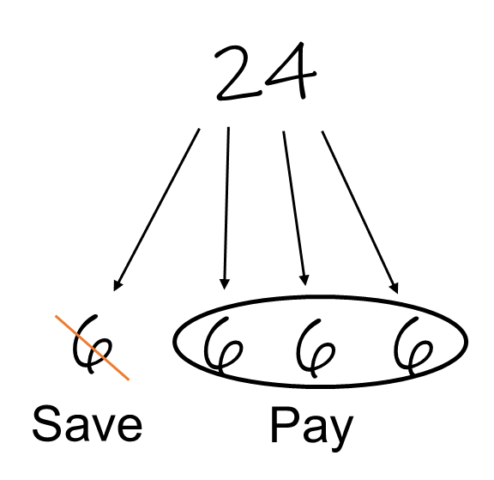
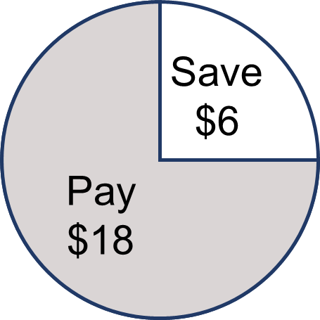

In this case, you save $6.
You pay $18 for the pants.

Discounts: Practice
50% off!  Original Price: $48  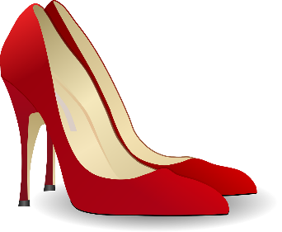  You save: _____  You pay: _____ | 25% off!  Original Price: $32  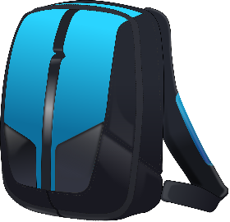  You save: _____  You pay: _____
25% off!  Original Price: $52  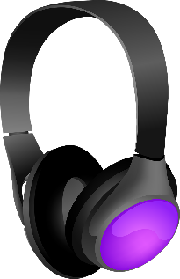  You save: _____  You pay: _____ | Clearance: 75% off!  Original Price: $60  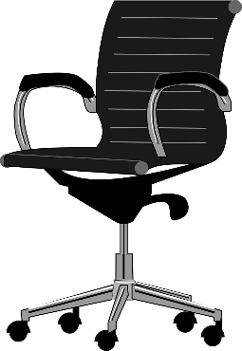  You save: _____  You pay: _____

Comparing Fractions to One-Fourth
For each example, find the part and the whole.
Write the fraction.
Is the fraction you wrote more, less, or equal to one-fourth?
Example | Part | Whole | Fraction | More than $\frac{1}{4}$  Less than $\frac{1}{4}$  Equal to $\frac{1}{4}$
- 8 days of rain out of 30 | 8 days | 30 days | $$\frac{8}{30}$$
- 125 yards run in a 440 yard race
- 20 minutes out of an hour
- 1,320 feet out of a mile (5,280 feet)

Source: EMPower™ Using Benchmarks: Fractions and Operations. © TERC. Adapted with permission.

Extension: Missing Quantities—Parts and Wholes
Find the missing amounts and explain how you found the answer.
$$\frac{1}{4}$$ | $$\frac{3}{4}$$ | $$\frac{4}{4}$$
12 | 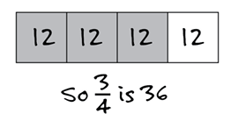 | 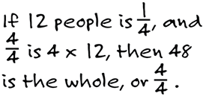
 | 12
 |  | 12
10
 | 18

Open Sentences with $\frac{1}{4}$
Fill in the blanks so the sentences are true. Circle or highlight the whole in each sentence.

- _________ is $\frac{1}{2}$ of _________.

- _________ is 50% of _________.

- _________ is $\frac{1}{4}$ of _________.

- _________ is one quarter of _________.

- _________is 25% of _________.

- $\frac{1}{2}$ of _________ is _________.

- 25% of _________ is _________.

- What is one-fourth of _________? _________

- _________ is 25% of what? _________

Test Practice Problems
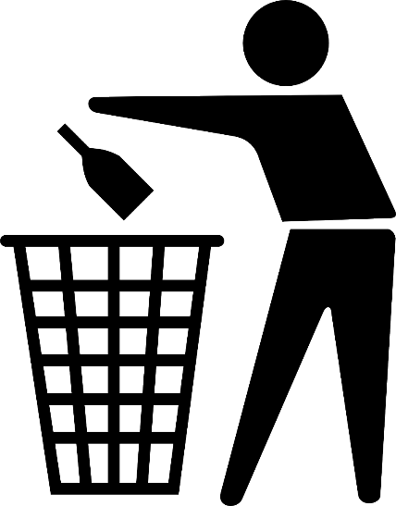
- There are 150 clear glass bottles in a recycling bin. These are $\frac{1}{4}$ of the total bottles in the bin. How many bottles are in the bin?
- 150
- 154
- 300
- 450
- 600

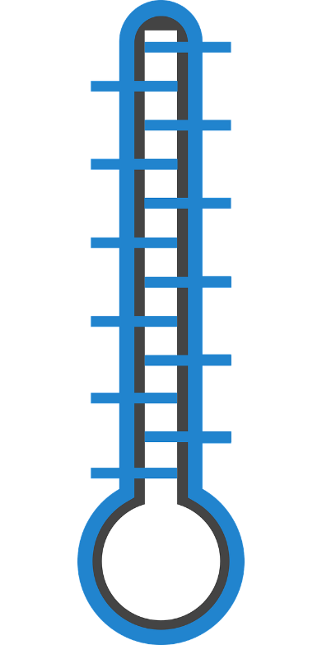
- Guy plans to raise $1,000 for the asthma fund. To figure out the amount that represents one-fourth of his goal, Guy can
- divide $1,000 by 4.
- find $\frac{1}{2}$ of $1,000 and multiply by 2.
- multiply $1,000 by 4.
- divide $1,000 by 2.
- divide $250 by 2.

- In the graph below, which age group made up about $\frac{1}{4}$ of the total voters?
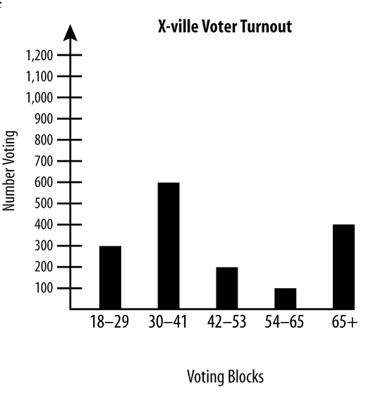
- 18 to 29
- 30 to 41
- 42 to 53
- 54 to 65
- 65+

Source: EMPower™ Using Benchmarks: Fractions and Operations. © TERC. Adapted with permission.

Financial Literacy: Getting Paid

Have you ever had money taken out of your paycheck? Why? What are some reasons that you might not “take-home” all of the money you earn?

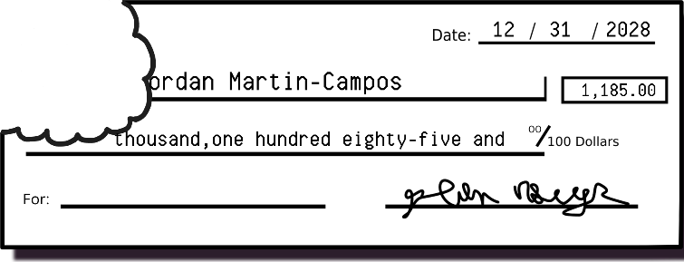

Gross pay | the _____________ of money a person earns in each paycheck
Net pay /  Take-home pay | the amount of money the person is paid, after ______________
Deductions | to deduct means to ____________. Deductions are amounts _________ from the gross pay (money that you don’t get to take home!).

Common Deductions

Income Tax:
Most people who are working pay some tax on their income. Usually this tax is deducted (or subtracted) from the gross pay in each paycheck. Income taxes are based on a percentage of your income.
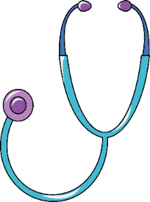
Health Insurance:
If a job offers health insurance that means the cost of the insurance plan is shared: the employer pays part of the cost, and the employee pays part of the cost. This is usually deducted from the gross pay in each paycheck.

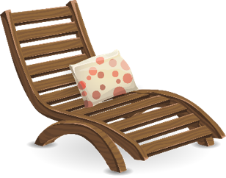
Retirement:
Some jobs offer a retirement plan (401K or 403B). Employees can choose to put part of each paycheck into their retirement account. This money is invested so it can increase in value and can be used when the person retires (or reaches a certain age).

What are some other possible deductions?

Practice: Marie’s Pay

- Marie earns $1,800 of gross pay each month. Her deductions for income tax and health insurance are about 25% of her gross pay.
What is her take-home pay each month?

- Marie is looking for a new job. She guesses that her deductions for income tax and health insurance will still be about 25% of her gross pay. She wants at least $1,500 of take-home pay per month to pay her rent and other expenses.
How much gross pay does Marie need to earn each month? Show how you know.

Ming’s Paystub
- Ming is looking at his paystub. His gross pay was $1,200. His take-home pay is $940. Ming’s deductions are
- less than 25% of his gross pay
- exactly 25% of his gross pay
- more than 25% of his gross pay
Show how you know.

- Use benchmarks to sketch a circle graph of Ming’s gross pay. Label one section “Deductions” and the other section “Take-home Pay.”

Exit Ticket
Janine’s math class met twice a week for 14 weeks. She missed 7 classes. Janine’s attendance percentage was:
- 25%
- 50%
- 75%
- 100%
Show how you know.

UNIT 4: Survey Project

In this unit, you will complete a project where write your own survey question, collect data, and graph and describe your results.


Think and share:
A time when you filled out a survey. What was the survey about? Why do you think someone wanted to collect that information?

Vocabulary List for This Unit

Word | Definition | Example
survey | A tool used to collect _______. A survey asks people to __________________. Can be done face-to-face, on paper, or electronically.

Word | Definition | Example

Writing Yes or No Survey Questions

You are going to write survey questions that can be answered yes or no. Here are examples of good yes or no questions:

- Do you have a pet?
- Do you live on the first floor?
- Did you drink coffee this morning?

Some questions do not always give a yes or no answer.

Weak: Do you eat rice? (could be “sometimes”)
Better: Did you eat rice yesterday?

Weak: Do you walk to school? (could be “sometimes”)
Better: Did you walk to school today?

Weak: Can you speak English? (could be “a little”)
Better: Is English your native language?

Name(s)_____________________________________________
Survey Question Report
Question
________________________________________________________________________________________________________
Data Circle Graph (Label!)
Yes
No
Total Responses

Conclusion (Use benchmarks to describe your results.)
____________________________________________________
____________________________________________________
____________________________________________________
____________________________________________________

