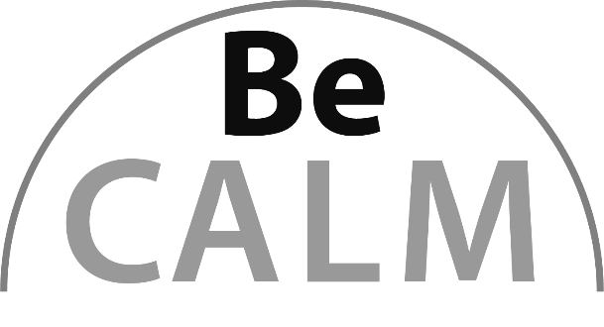

Number Sense
Beginning Curriculum for Adults Learning Math
Curriculum for GLE 2–4

TEACHER’S GUIDE



Created with funding from the Adult and Community Learning Services division of the Massachusetts Department of Elementary and Secondary Education by the SABES Mathematics and Adult Numeracy Curriculum & Instruction PD Center, which is managed by TERC, Inc.
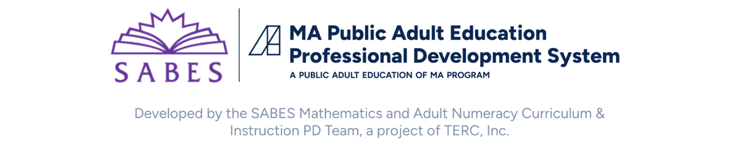
Acknowledgements

The titles in the BeCALM series were developed and piloted in the classroom by Melissa Braaten for the SABES Mathematics and Adult Numeracy Curriculum & Instruction PD Team, with contributions from Yvonne Readdy, Emily Rudd, and Sherry Soares.

The BeCALM series includes four sequential packets:

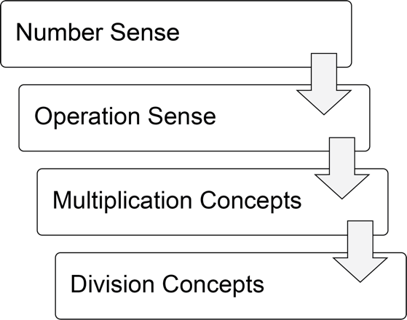

and three non-sequential packets:

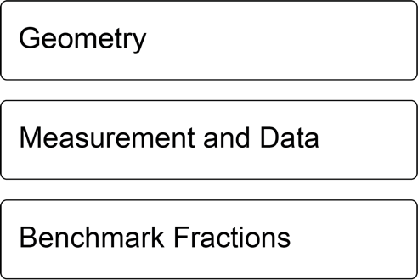

Activities from the EMPower™ and EMPower Plus™ series title Everyday Number Sense: Mental Math and Visual Models Student Book are used and/or adapted with permission from the author, TERC, Inc.

Learner Level
The math content is aimed at ABE level math students (approximately GLE 2–4). While adult students at this math level may have any level of reading, the student materials were designed to be used by adults with a reading level GLE 2 or above. To keep things accessible, the text in the Student Packet is kept to a minimum so that this can be used with students at an ABE reading level or students who are beginning to intermediate English Language Learners.

Suggestions for Use
The Student Packet was designed to be used by students while they attend remote, synchronous classes but could also be used for face-to-face or hybrid instruction. Most of the activities in each unit work best when done synchronously but the routines, once established, could be assigned for homework.
Students at the suggested level (GLE 2–4) are often building the skills covered in this unit, not simply reviewing them. The pilot-testing of these materials took 8–10 hours of synchronous class time for each unit. This time included all of the synchronous elements listed below.

Components of Synchronous Instruction

Routines
Classroom routines can be powerful tools in the math classroom. Routines provide a familiar structure to an activity that helps students feel safe because the directions and expectations are predictable. However, a good math routine still provides a cognitive challenge and requires some type of problem-solving every time. There are several routines included in this unit that reappear at the end of every unit. There are notes and descriptions of how to facilitate these routines in the unit details. Other common routines, such as Number of the Day or Math Talks, also work well in synchronous instruction with students at this level, even though they do not appear in the student materials.

Introduction of New Concepts
Each unit includes one or two activities to introduce the new concepts for that unit. Instructions for facilitating are included in the unit details. The goal is to lay the foundation for conceptual understanding of the concepts, rather than simply explaining procedures.

Vocabulary and Things to Watch For
Each unit includes some suggestions on valuable vocabulary words and common misconceptions or interesting student ideas that came up in the pilot class.

Relevance
Relevance is a major part of adult educational principles and beginning math learners are no exception. There are different ways that we can make good, conceptual math content relevant to adult learners:
- We can help them learn new strategies for mathematical tasks they already perform, such as estimation.
- We can affirm mathematical ideas that they have to help them revise beliefs about themselves as math learners.
- We can teach them skills that will increase their independence and their ability to navigate real-life and academic situations involving math, both immediately and in the future.
- We can make connections to historically and culturally relevant topics.
- We can give them space to reflect on their identity as a mathematical learner.
- We can help them reflect on the role that mathematical thinking and learning plays in our society, especially when it comes to matters of justice and equity.
Each unit of this packet provides a reading or discussion prompt aimed at one or more of the goals above.

Student Interaction and Interpersonal Skills
When possible, it is helpful to allow students to interact and work together without the teacher constantly present. In a remote setting, this can often be done using breakout rooms in video conferencing software. As long as the students all have the student materials available to them, they can work together on some of the activities or routines, but remote group work usually requires more scaffolding than in a face-to-face class. It can help to explicitly discuss expectations, etiquette and goals before breaking into groups, and to debrief afterwards to troubleshoot any problems with the process. Since remote interactions usually offer less in terms of non-verbal communication, students will need to learn ways to be more explicit and verbal in their communication with their classmates.

Tech Support
Synchronous technology instruction and support is often necessary for students to be successful in a remote environment. This includes instruction on how to navigate and use the features of video conferencing software (like Zoom or Google Meet), and how to use any features of any other apps or software used for school communication, assignments, or other asynchronous instruction. Most students will benefit from at least some synchronous instruction with demonstrations when they start a class, with frequent review and support as needed. Students who struggle with technology usually do better with synchronous help rather than videos or documents, so incorporate this into your class time if they are not getting this help somewhere else.

Materials Overview
- Unit 1: Estimation and Adding
- Unit 2: Rounding
- Unit 3: Combining
- Unit 4: Gauges
- Unit 5: Equations
Each unit includes materials for:
- Activities and Practice
- Language Support
- Self-Evaluation (reproducible from Teacher’s Guide pp. 41–45)
Each unit in the student packet includes materials for:
- Relevance
- Activities and Practice
- Routines

Math Background: Number Sense
Note: Much of the content contained in the Teacher’s Guides and Student Packets for the Number Sense Curriculum Parts 1&2 was reproduced and adapted from the EMPower Plus: Everyday Number Sense Teacher and Student books, with permission from the author (the Adult Numeracy Center at TERC).
EMPower strives to make the most of strategies adults bring to the table and makes explicit the understandings adults hold about numbers so that new ideas can be built on this foundation. Highly numerate adults use flexible, accurate, and efficient strategies for manipulating numbers and quantities in real-world problem-solving.

The importance of students bringing their understanding into the classroom
Many students have invented or collected a set of strategies that circumvent the procedures (the methods or algorithms) historically taught in school, yet may think those are not the school-approved or “real” ways. Observations of adults at work and in consumer situations uncover a surprising assortment of methods. It is important that students be encouraged to bring their own good math sense to bear in various situations for managing the mathematical demands of school and everyday life. Strategies and methods may include a mix of finger counting, mental math, estimation, calculator use, and paper-and-pencil methods. Such strategies can support insight into higher mathematics.

The importance of estimation
When a group of adults was asked to keep track of how they used math in a 24-hour period, most of the math (85%) they did was in their heads or by arriving at good estimations (Ginsburg, Manly, & Schmitt, 2006; Northcote & McIntosh, 1999). The researchers also found that estimates were sufficient for approximately 60% of all calculations, and exact answers necessary only 40% of the time.
In this unit, estimation is treated as a first step in problem-solving. Precision or accuracy can be as easily achieved by rounding and adjusting as it can by calculations on paper. Furthermore, students recognize that estimating or rounding (and adjusting) can help them determine a solution that is accurate enough for many circumstances. Estimations are particularly useful for gauging the accuracy of calculator-generated solutions, and it is vital for students to know how and when to use a calculator. A numerate person has all of these strategies at their disposal.

The importance of visual models
To ably communicate mathematically and to flexibly approach problems, adults need visualization and expressive skills. They need to “see” the problem, and they need to know how to express the problem and their solution processes not only in words and with notation, but with visual representations as well.
A recurring question for students here is “How do you know?” To answer this question and to make the workings of mathematics visible, we count on visual representations, such as number lines, diagrams, words, and equations.

Opening Activities


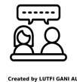
Estimation and Number Sense
In-Person/Remote Activity
Uses Student Packet pp. 3–4
Have students read and brainstorm some examples of their own.

“Street Math” and “School Math”
In-Person/Remote Activity
Uses Student Packet pp. 5–6
This short article shares some research affirming the value of “street math,” the type of flexible thinking exhibited when people use math in their real life. Estimation and number sense, the focus of this curriculum, are an important part of this “useful” math. This article and the discussion questions are meant to both affirm the math that students are already using in their lives and to set up the expectation that this type of flexible math is what they will be developing in this curriculum: not necessarily the type of rule driven math they may have previously encountered in school.

Unit 1: Estimation and Adding
Learning Objectives | CCRSAE
I can estimate the total when adding several amounts. | 2.NBT.6-9, 3.OA.8, MP.5
I can explain my strategy for estimating to others. | MP.3
I can give a reason why one choice doesn’t belong with the group. | MP.3
I can keep working on a challenging problem even if I don’t understand it right away. | MP.1
I can fill in missing numbers on a number line. | 2.MD.6, also with intervals of lengths greater than 1*
Note: The last three learning objectives refer to the routines and are repeated in each part.
*The CCRSAE does not have many specific standards about learning to use a number line diagram, although they are mentioned throughout the levels as a visual aid to reasoning about other standards. Number lines also appear in different domains (for example, 3.NF.2-3 address number line use with fractions). Gaining fluency with their use at an early level will help students both to develop number sense and to be prepared when they encounter them in measurement, data, etc.
Note: EMPower materials featured in Unit 1 can be found in Lesson 1 (Close Enough with Mental Math) of the Everyday Number Sense: Mental Math and Visual Models books.

Standards for Mathematical Practice
In addition to the standards targeted by the routines in this packet (Open Middle, MP.1 and Which One Doesn’t Belong, MP.3), this unit also involves:
MP.3 Construct viable arguments and critique the reasoning of others
Students must explain the strategies they used to estimate a total and listen to other students’ strategies.
MP.5 Use appropriate tools strategically
Students are asked to consider when it makes sense to use estimation strategies and when they should use pencil and paper or a calculator to get an exact total.
MP.7 Look for and make use of structure
Students do a math investigation to explore whether order and grouping affect the total when adding.

Extra Resources for this Unit
Reproducible: Evaluation, Unit 1, Teacher’s Guide, p. 41
Reproducible: Blank Number Lines, Teacher’s Guide, pp. 50–51

Math Background
Estimation skills are among the most important skills in arithmetic. The commutative and associative properties support mental math and estimation as they allow problem-solvers to change the order for addition and multiplication problems and to re-group quantities, for example, grouping numbers that add to 10 or other friendly numbers. Knowing when an answer is in the ballpark involves having a good idea of what the numbers are individually, combined, separated, or grouped. So, for example, seeing 29 as 1 less than 30 or 4 more than 25 is important for different reasons and different problems (e.g., 29 + 17 ≈ 30 + 20; 29 + 74 ≈ 25 + 75).
Note: The symbol ≈ means about or approximately equal to.
By practicing estimation, students will gain flexibility in their thinking and problem solving, both of which are aspects critical to attaining fluency with computation.

Relevance
The unit opens with a short article from The Change Agent* about how a student uses estimation in her life. The article could be read in or out of class, but it is a good opportunity for students to share their own ideas about how they use estimation in their lives.
*Massachusetts teachers are eligible for a free subscription to The Change Agent. Email changeagent@worlded.org for details.

Activities and Practice
Note: The following activities “About How Much?” and “Agree or Disagree?” were excerpted from Lesson 1: Close Enough with Mental Math in the EMPower Plus: Everyday Number Sense Teacher Book.

Saving Money on Coffee
In-Person/Remote Activity
Uses Student Packet p. 7
Have students read and discuss the questions as a class or in groups.

About How Much?
In-Person/Remote Activity
Uses Student Packet p. 10
- Explain that for each of the problems you will show, students will select the closest answer from among three choices. You may choose to share only one of the problems at a time on a slide, or you can have them look at all three at once. Emphasize that students need not find the exact answer, but only to see which one is closest, using mental math if possible.
- Allow students to post responses in the chat box, then ask for volunteers to explain how they found the closest answer. Record students’ strategies.
Examples of possible strategies:
- Round up each number: $1.95 is close to $2, and $3.95 is close to $4, so $2 + $4 is $6.
- Add the dollars ($1 + $3 is $4), then round the cents each up to $1, and add another $2.
- Repeat the process for the rest of the problems. End the activity by saying: How do the estimates you made in these problems relate to estimates you make in your daily life? Ask for specific examples.
This activity can be repeated in future classes with similar teacher-generated problems.

Agree or Disagree?
In-Person/Remote Activity
Uses Student Packet pp. 11–12
This is the first of many opportunities for students to begin to think critically about algorithms, or procedures. Students have a chance to think about their own procedures and then judge the reasoning of others.
One way to facilitate this is to put each of the friend’s explanations on a separate slide, and have students share in the chat, with a few volunteers out loud. Students could also work on this in small groups in breakout rooms, if that has been established. In the examples, Lianne, Peter, and Ana are demonstrating the commutative property of addition, which states that the sum is always the same regardless of the order of the addends. Chen’s method relies on the associative property of addition, since he is grouping the addends while adding—a method that will also result in the same sum. Students explore the commutative and associative properties of addition. They see that order doesn’t matter in addition and that numbers can be grouped in various ways.
- As a class, have them share their responses to the question, “What is the best advice about the order in which numbers can be added?”
- Listen to and record several suggestions in students’ exact words on the board, then seek a class consensus on the clearest way to say that the order in addition does not matter. You might hear and record ideas such as:
It is OK to order the numbers from smallest to largest, but this isn’t a procedure that must be followed.
When you have a list of numbers to add, you can take them two at a time.
When you add, the order doesn’t matter. You get the same answer either way.
a + b = b + a

Which One Doesn’t Belong? 1
In-Person/Remote Activity
Uses Student Packet p. 13
This first Which One Doesn’t Belong? uses objects rather than numbers to help students understand how the activity works. In subsequent units, this routine becomes more numerical.
Students are asked to choose one item that they think doesn’t belong with the rest. In order to do this, they have to think about various types of attributes that the objects may have in common (or not). Ideally, they find an attribute shared by three of the objects, but not by the fourth. When students are new to this activity, they may instead only be able to break the four objects into two groups.
There is no one correct answer to these activities. The point is to make an argument for the one you have chosen. In most cases, a valid argument could be made for any one of the four objects (or numbers). It can take some time for students to understand that there isn’t a right answer, but many different answers that could be correct, as long as they correctly identify an attribute that makes one different from the others.
When facilitating remotely, make sure students have time to think before sharing starts, and allow as many students to share as possible (the chat box works well for this).
Some possible responses (not exhaustive!)
The raisins don’t belong because they are the only fruit that is dried (or in a box, or that doesn’t grow on a tree, or that isn’t yellow).
The apple doesn’t belong because it is the only fruit with a core (or with red on it).
The lemon doesn’t belong because it is the only fruit you don’t usually eat on its own (or the only citrus fruit).
The banana doesn’t belong because it is the only fruit that doesn’t roll (a grape would roll before it was dried).

Adding Two-Digit Numbers
In-Person/Remote Activity
Uses Student Packet p. 14
Students often need guidance when first introduced to this type of problem. First of all, the vocabulary digits and sum might not be familiar. It may also be helpful to do this first problem several times, starting without the restriction on digits. Have students offer examples that you post to the class, then challenge them to see if they can find a sum higher (or lower) than the best so far. The first few times you do this type of activity, it is helpful to do it once in class (for example, to find the largest sum), then it can be assigned again for homework (but this time, they find the smallest sum).
These problems require perseverance, problem solving, an understanding of base ten, and operation sense. They also provide calculation practice at the same time.
The largest sum that can be made with the digit restrictions is 97 + 86 =183 (or 96 + 87 = 183). The smallest sum that can be made is 13 + 24 = 37 (or 14 + 23 = 37). For all possible addends, the ones places can be swapped to create an equal sum.
Example: 13 + 24 = 10 + 3 + 20 + 4 = 10 + 4 + 20 + 3 = 14 + 23

Introduction to Number Lines
In-Person/Remote Activity
Uses Student Packet p. 15
The packet has a page to introduce the vocabulary tick mark and interval. In this unit, students will be working only with proportional number lines, which means that intervals of the same size have the same value. There are number line puzzles included at the end of each unit, since number lines play a large role in this unit and repeated exposure can help students gain familiarity with how they work. In the puzzles, students must figure out what number goes in the blank to make sure that all of the intervals have equal value. At the end of each number line puzzle page, students create their own number line. This is a valuable form of informal assessment. The number line puzzles increase in complexity with each and use numbers related to the content of the unit, if appropriate.

Number Line Puzzles 1a
In-Person/Remote Activity
Uses Student Packet p. 16

Answer Key
A: 9, intervals worth 3
B: 5, intervals worth 5
C: 50, 100, intervals worth 25

Number Line Puzzles 1b
In-Person/Remote Activity
Uses Student Packet p. 17

Answer Key
A: 8, intervals worth 4
B: 40, intervals worth 20
C: 350, 400, intervals worth 25

Vocabulary
estimate (verb, action): to find an answer that is close but not exact
estimate (noun, thing): an answer that is close but not exact
tick mark: the vertical marks on a number line. These are often labeled, but not always.
interval: the space between two tick marks on a number line.

Things to Watch For

Finding exact answer first
Many students feel they must find an exact answer first, then they “round off” that answer to get an estimate. They don’t feel comfortable using rounded or estimated numbers in their calculations. They should be gently encouraged to do so, using modified numbers at first if that makes it more accessible.

Mixing up tick marks and intervals
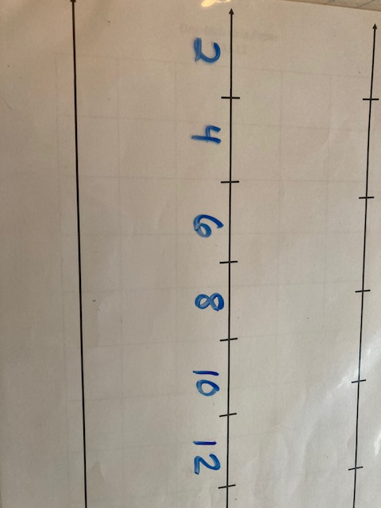
The Number Line Puzzle routine introduces students to number lines. Students are often more comfortable with discrete (countable) quantities, rather than the way quantity is represented with distance, as on a number line. Seeing the tick marks as representing number locations, and the intervals as difference between those locations can be confusing. Teaching them the vocabulary for tick mark and interval can help. Student errors (real or teacher generated) where the intervals are labeled rather than the tick marks can be used to generate discussion about the difference.

Unit 2: Rounding
Learning Objectives | CCRSAE
I can round to the nearest dollar. | 3.NBT.1
I can give a reason why one choice doesn’t belong with the group. | MP.3
I can keep working on a challenging problem even if I don’t understand it right away. | MP.1
I can fill in missing numbers on a number line. | 2.MD.6, also with intervals of lengths greater than 1
Note: EMPower materials featured in Unit 2 can be found in Lesson 1 (Close Enough with Mental Math) of the Everyday Number Sense: Mental Math and Visual Models books.

Standards for Mathematical Practice
In addition to the standards targeted by the routines in this packet (Open Middle, MP.1 and Which One Doesn’t Belong, MP.3), this unit also involves:
MP.8 Look for and express regularity in repeated reasoning
Students look for patterns in how numbers round to the nearest dollar and start to generalize this to other place values.

Extra Resources for this Unit
Reproducible: Evaluation, Unit 2, Teacher’s Guide, p. 42
Reproducible: Blank Number Lines for Rounding, Teacher’s Guide, pp. 50–51
Other materials
(in-person) large, classroom number line from 0–100
Smaller, personal number lines from 0–100 (for students needing extra support)
(remote) virtual number lines, such as Math Learning Center Number Line App https://apps.mathlearningcenter.org/number-line/

Math Background

Rounding
The typical rule for rounding taught in school (look at place value to the right, and if the number is five or higher, round up) is often considered an elementary math skill, but it requires an understanding of place value and how different numbers are related to one another. As we will see below, in real life there are many acceptable ways to ‘round’ depending on the purpose and the estimate needed. We will start with a look at the traditional way of rounding since it involves an understanding of place value, which is an important concept for students to understand. We also start with a context that is familiar to most students: rounding to the nearest dollar amount.
This unit starts with a discussion of a rounded number to draw out student thinking about how an exact amount relates to a rounded number. Students discuss what the possible exact amounts could be. Although many students have intuitions about this, some may not realize that the exact number could be larger or smaller than the rounded number, for example.
In addition, some students struggle to identify dollar benchmarks, so the unit uses a simple number line with units of $1 to ask students to place the exact amount in the correct interval:
13.65 is between which two numbers?
After students are able to identify appropriate benchmarks, we want them to start thinking about the nearest or closest benchmark. Number lines are used for this as well. For example, if we are told: Round $13.65 to the nearest dollar, we can imagine a number line with each interval of $1 acting as a benchmark (nearest dollar). Then we look at which benchmark is closest to our number.

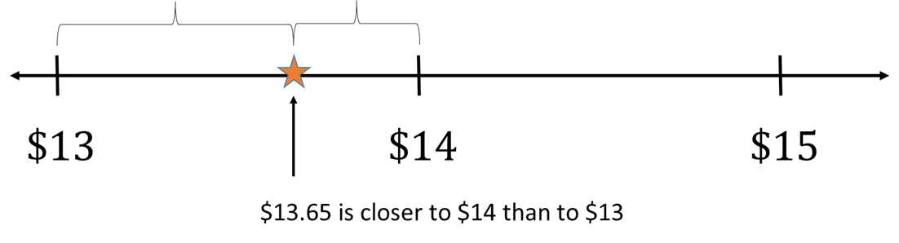
To help students visualize which benchmark is closer, the unit uses a variety of number lines to help students locate the exact amount in between the benchmarks. A large number line from 0-100 can help students identify 50 cents as the midpoint between two dollars, and the point at which the nearest benchmark changes. There are also number lines with intervals of 10 cents, and number lines with only a midpoint labeled. Each of these tools provides different levels of scaffolding, as needed.
While this is explicitly teaching rounding to the nearest dollar and nearest $10, many adults have a variety of sound ways of rounding in their everyday lives that do not always rely on place values as the ‘benchmarks’. For example, let's say a person is buying three grocery items that cost $2.23, $6.65, and $10.99. They might round each to the nearest dollar in their head. Or they might decide to round the first two amounts ($2.23 and $6.65) to $2.25 and $6.75, which will simplify addition by making a dollar out of the change. They may also simply decide to round every amount up, no matter what, to make sure they doesn’t go over budget. A final activity involves students comparing the effects of different rounding strategies on their final estimate.

Relevance
This unit opens with a short anecdote about how an adult student uses rounding to manage her money at the grocery store.

Activities and Practice

Rounding at the Grocery Store
In-Person/Remote Activity
Uses Student Packet p. 18
- Have students read and discuss the article as a class or in groups.
This is a good example of how we don’t have to follow the “rules” for rounding when we are using it as a tool for estimation in the real world. The author explains how she always chooses to round up, so as to avoid going over her budget.

Opening Discussion
In-Person/Remote Activity

- Provide students with a rounded number. For example,
My dog weighs about 30 pounds.
My coffee cost about $4.
There are about 60 students in the school.
- Ask, What might be the exact amount? [exact weight for the dog, exact cost of the coffee, exact number of students in the school, etc.] Write down all of the numbers that students offer.
- If students only offer numbers above [or below] the rounded number, ask, could the weight be less than 30 pounds [or higher than 30 pounds]?
- Ask, what is the highest number that seems reasonable? [Or offer numbers: If the dog actually weighs 45 pounds, is it reasonable to say it weighs about 30? What about 37?]
- Ask, Have you heard people give estimates like this before? Can you give an example?
- The goal of this opening discussion is to get students to consider
- That an estimate can be slightly higher or lower than the exact amount
- An estimate should still be fairly close to the exact amount. How close might vary depending on the number or context.
- Explain that in this unit, they will be studying a process called rounding that helps us to choose good estimates for messier exact numbers.
- Introduce the vocabulary for this unit:
benchmarks: Number used to compare and understand less-familiar numbers. We choose benchmarks that are easy to understand and work with. “friendly numbers”
round: to estimate a number by choosing a benchmark that is close. Place values (ones, tens, hundreds) are often used as benchmarks for rounding.
round to the nearest …: “nearest” means closest. This phrase explains which benchmarks were used for rounding.

Between which Dollars?
In-Person/Remote Activity
Uses Student Packet pp. 21–22
Large number line 0–10 (or virtual number line https://apps.mathlearningcenter.org/number-line/)
- Display a large number line with intervals of $1. It should start at $0 and go to about $10. (Note: if it is practical to do so, it can be helpful to display the number line vertically, with the amounts increasing as the line goes up. This can help students understand the phrases “rounding up” and “rounding down.”)
- Provide a dollar amount in this range. For example, $4.78. Ask, Where does this amount go on the number line? Between which dollars? Teach students the phrase “between ___ and ___” as a way to explain the dollars on either side. For example, “$4.78 is between $4 and $5.”
- Explain that for $4.78, $4 and $5 are benchmarks: close numbers that are easier to understand and work with.
- Do more examples as a class. If you have an in-person classroom with a large number line, you could put the exact dollar amounts on sticky notes and have them place the sticky notes in the appropriate interval. If you are teaching remotely, you could have students answer in the chat. Encourage them to use correct grammar: “between ___ and ___.”
- At this point, we are not asking which dollar is closer [nearer]. The goal is to get each number in the correct interval. Students must first be able to identify possible benchmarks for rounding before they consider which is a better choice.
- There is additional practice in the Student Packet on page 22. If students are comfortable identifying the interval for numbers up to 10, have them complete the extension.

Rounding to the Nearest Dollar
In-Person/Remote Activity
Uses Student Packet pp. 23
Reproducible: Rounding Number Line Templates, Teacher’s Guide pp. 48–49
Large number line 0–100 (or virtual number line https://apps.mathlearningcenter.org/number-line/)

- Review that “nearest” in the phrase “rounding to the nearest dollar” means “closest.” They have been locating the two dollars that a certain amount is in between. Now they will be asked to decide which of those two benchmarks is closer to the amount.
- Display a large number line that goes from 0–100. (These can be found online and printed out in an in-person classroom, or you could make use of a virtual number line, such as source)
- Connect the 0–00 with 100 cents in a dollar. Explain that in order to decide which dollar is closer, we will have to consider the cents.
- Start with some examples that are very close to one end or the other. For example, if the amount is $4.03, is it closer to go back to 0 cents or closer to go up to 100 cents, which means adding another dollar? Ask them to figure out how much the amount has to be changed to go each direction. We can lose 3 cents by going back to $4 or add 97 cents to go up to the next dollar ($5). Introduce the phrases round up and round down.
- Do an example at the other end. Is $4.98 closer to $4 or $5? Compare adding 2 cents to round up to $5 or removing 98 cents to round down to $4.
- Show the “distances” visually on the number line. Which dollar is “closer” (shorter distance?) A shorter distance means we are not changing the amount as much when we estimate.
- Start to ask about some more examples that are closer to the middle. Eventually, ask, When is it closer to round down? When is it closer to round up? When does it change? Students should identify 50 cents as the exact middle between the two benchmarks. Explain that this is called the midpoint. It may be helpful to color code the two halves of the number line.
- The goal is that students will be able to explain that numbers before/less than the midpoint are closer to round down, and numbers that are after/greater than the midpoint are closer to round up. Probe to make sure they can connect this generalization to the “distances” between the amounts on the number line.
- Explain that the midpoint is a special point. Because it is exactly halfway between the dollars, it is not actually closer/nearer to either end. However, there is a convention to round up when we are at the midpoint. In real life, we may have a good reason to go in either direction.
- Have students complete the practice on Student Packet pages 23–24. They should label each end of the number line with the whole dollars, then mark with an X where the amount would fall. Lastly, have them circle the closer dollar benchmark.
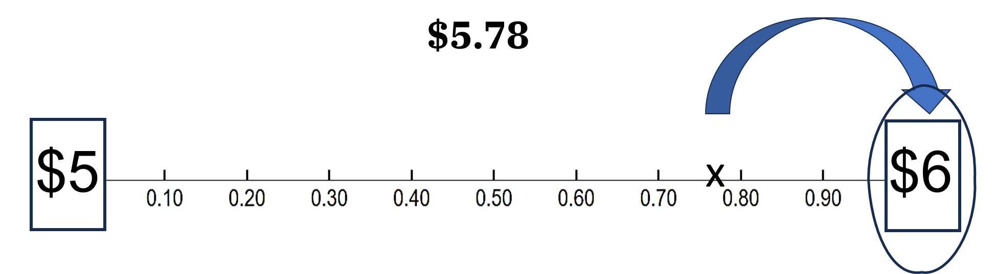
- The second page provides a different type of scaffolding. Students must label the midpoint and compare the exact amount to the midpoint to see which benchmark is closer.
- There are additional templates at the end of the Teacher’s Guide on pages 48–49 to create more practice. Page 48 has intervals of 10 cents and page 49 has only the midpoint labeled.

round up: to make the amount larger/greater when rounding by choosing the larger benchmark.
round down: to make the amount smaller/less when rounding by choosing the smaller benchmark
midpoint: the exact middle between two benchmarks
Note: In this activity, students will have to consider whether a number of cents is more or less than the midpoint of $0.50. This presumes that students can fluently compare two-digit numbers to know which is larger. Students with more significant mathematical learning disabilities may not be fluent with this (but realistically, may still be in a BeCALM class). For these students, they should first work on mastering the interval for each dollar amount (which dollars is the amount between)? If they can consistently answer this question, they can be provided with a small personal number line to use to locate and compare two-digit numbers to $0.50. These students could use intervention to improve their number sense with two-digit numbers, but that is outside the scope of these materials.

Rounding to the Nearest Dollar Practice
In-Person/Remote Activity
Uses Student Packet pp. 25–27
This provides various levels of scaffolding for students to practice rounding to the nearest dollar. The extension involves larger dollar amounts.

Roll and Round
In-Person/Remote Activity
Uses Student Packet p. 28
10-sided dice (0–9), three for each pair of students
This activity works well in pairs. The students roll three ten-sided dice and then fill the digits into the blanks on the page to create dollars and cents. Then they round each number to the nearest dollar.
In a remote classroom, the teacher could roll three dice and the students could put the digits into the blanks in any order.

Shopping Trip
In-Person/Remote Activity
Uses Student Packet pp. 29–31
- This activity asks students to consider different ways of rounding and how each will affect the final estimate. Students are asked to round four numbers and find a total. First, they are asked to round all amounts up and total them. Then they are asked to round all amounts down and total them. Finally, they round each to the nearest dollar and total them. Students could be put in groups or pairs and each group could find one of the totals, then share out.
- For each estimate, students are asked whether their estimate will be higher or lower than the exact amount. Push students to think about how the numbers are changing when they round. Finally, students find the exact amount, with a calculator if needed.
- Discuss as a class: Which method gave the best estimate? There might be more than one possibility. For example, rounding to the nearest dollar will give the closest estimate, but rounding everything up could be used to make sure the shopper doesn’t go over.

Which One Doesn’t Belong? 2
In-Person/Remote Activity
Uses Student Packet p. 32
Note: Students may not have the precise geometry vocabulary to explain their reasoning. Describing the attributes in their own words is fine and you can provide the term that matches their description if it seems beneficial. The focus here is on noticing and categorizing attributes, not on teaching the geometry concepts/vocabulary.
Some possible responses:
- The square doesn’t belong because it is the only shape with four sides (or with four right angles, or that has four lines of symmetry).
- The oval doesn’t belong because it is the only shape with no straight sides (or with no angles, or with exactly two lines of symmetry)
- The equilateral triangle doesn’t belong because it is the only shape with all acute angles (or with exactly three lines of symmetry).
- The right triangle doesn’t belong because it is the only shape that is blue (or that has exactly one right angle, or that is not symmetrical (mirror or rotational).

Missing Digits
In-Person/Remote Activity
Uses Student Packet p. 33
In this Open Middle activity, students explore how the size of the minuend and the subtrahend affect the difference. This setup in particular encourages students to see the difference as the distance between the two numbers, which could be visualized on a number line.
- Smallest difference: The smallest difference between the two numbers will be when the first is as low as possible and the second is as high as possible (in this case, 40 – 19 = 21).
- Largest difference: The largest difference will be when the first is as high as possible and the second is as low as possible (in this case, 49 – 10 = 39).

Number Line Puzzles 2
In-Person/Remote Activity
Uses Student Packet p. 34

Answer Key
A: $1.08, intervals of $0.02
B: $2.30, intervals of $0.10
C: $1.50, $2.50, $4.00, intervals of $0.50

Vocabulary
benchmarks: Number used to compare and understand less-familiar numbers. We choose benchmarks that are easy to understand and work with. “friendly numbers”
round: to estimate a number by choosing a benchmark that is close. Place values (ones, tens, hundreds) are often used as benchmarks for rounding.
round to the nearest …: “nearest” means closest. This phrase explains which benchmarks were used for rounding.
round up: to make the amount larger when rounding by choosing the larger benchmark.
round down: to make the amount smaller when rounding by choosing the smaller benchmark
midpoint: the exact middle between two benchmarks

Things to Watch For

Finding the benchmarks
As this scaffolding is removed (either by having students create their own number lines, or when they move on to rounding without number lines), some students will struggle with identifying the appropriate rounding benchmarks. For example, when rounding the number $13.67 to the nearest dollar, some students may struggle with identifying that $13.67 is in between $13 and $14. If students need more practice with this, it may be helpful to practice with a zoomed-out number line with whole number intervals, and have students identify in which interval the number would fall.

Nearest dollar versus nearest ten
Some students may be confused when asked to round a larger number, such as $89.04, to the nearest dollar, instead automatically switching to the nearest ten (rounding to $90). This is a reasonable instinct, as we tend to round larger numbers off to larger place values in everyday life. It is important to validate the instinct and reasonableness of rounding in this way, since there are no rules beyond reasonableness in everyday life. To then refocus on the idea that we can round larger numbers to the nearest dollar, you can rephrase the question: Is $89.04 closer to $89 or $90? Draw their attention to the fact that the choices you gave them are one dollar apart. Other times we might be looking at choices that are ten dollars apart.
The introductory rounding pages are structured to start by asking “Is it closer?” questions and later labeling this activity as “Rounding to the Nearest Dollar” or “Rounding to the Nearest Ten.”

Rounding to other benchmarks, like $0.50
Imagine a student says, “I wouldn’t round $6.55 to $7. I would round it to $6.50.” This is not actually a misconception but a great use of number sense! Validate the usefulness of other benchmarks for rounding. You can distinguish between the ways a person could choose to round (whatever way makes sense) versus a specific request to round to the nearest dollar. For example, you could first say that you agree the strategy that the student chose would be a useful way to round the number. Then, ask the student how she would answer the question, Is it closer to $6 or $7? Try to draw a distinction between estimating and rounding. Estimating does not have rules beyond reasonableness and usefulness. Rounding involves specific mathematical questions.

Unit 3: Combining
Learning Objectives | CCRSAE
I can find pairs of numbers that add together easily. | 1.OA.6, 2.NBT.6-9, 3.OA.8
I can estimate the total when adding several amounts. | 2.NBT.6-9
I can explain my strategy for estimating to others. | MP.3
I can give a reason why one choice doesn’t belong with the group. | MP.3
I can keep working on a challenging problem even if I don’t understand it right away. | MP.1
I can fill in missing numbers on a number line. | 2.MD.6, also with intervals of lengths greater than 1
Note: EMPower materials featured in Unit 3 can be found in Lesson 1 (Close Enough with Mental Math) of the Everyday Number Sense: Mental Math and Visual Models books.

Standards for Mathematical Practice
In addition to the standards targeted by the routines in this packet (Pyramid Puzzle, MP.1 and Which One Doesn’t Belong, MP.3), this unit also involves:
MP.3 Construct viable arguments and critique the reasoning of others
Students must explain the strategies they used to estimate a total and listen to other students’ strategies.

Extra Resources for this Unit
Reproducible: Evaluation, Unit 3, Teacher’s Guide, p. 43
Reproducible: Quiz, Units 1-3, Teacher’s Guide, p. 46
Reproducible: Blank Number Lines, Teacher’s Guide, pp. 50–51

Math Background
Another common strategy for estimation or mental math with addition is to find combinations of ‘friendly’ numbers. In these examples, students look for combinations that make $1 or $10. This relies on students understanding that they can rearrange and group addends in any order (Commutative and Associative Properties of Addition). Finding friendly combinations can make calculations more efficient and more accurate.

Relevance
This unit starts with a short article from The Change Agent where an adult education student talks about both her experience with her own mother when she was trying to learn math and her experience trying to help her children with math. The reflection questions ask students to think about this part of their own math story. The questions may be very personal for some students. In the pilot of this unit, students were very receptive to the article and willingly shared stories about how they felt as parents trying to help their kids with math, and reflected on the role that their current studies played in how they saw themselves as a math learner and a parent.

Activities and Practice

Help Me, Mom!
In-Person/Remote Activity
Uses Student Packet p. 35
Have students read the article and discuss, either as a class or in groups.

Closest Answer
In-Person/Remote Activity
Uses Student Packet p. 38
This is a review activity, similar to About How Much? in Unit 1.
- Explain that for each of the problems you will show, students will select the closest answer from among three choices. You may choose to share only one of the problems at a time on a slide, or you can have them look at all three at once. Emphasize that students need not find the exact answer, but only to see which one is closest, using mental math if possible.
- Allow students to offer responses (or if online, put them in the chat box), then ask for volunteers to explain how they found the closest answer. Record students’ strategies.

How Much Money Is in the Jar? and how much money is in the jar—larger amounts
In-Person/Remote Activity
Uses Student Packet pp. 39–40
Encourage students to look for amounts that would be easy to add. Starting with the picture of the jar seems to help students who want to automatically plunge into addition from left to right. This is a good exercise to let students help each other with, since some will probably find combinations of $1 on their own, and other students are often impressed with how much easier the addition becomes with this method. Other jars have amounts that lend to combinations of $10 or $100.
Encourage students to cross out or color code amounts to make sure that they are adding all the amounts once.

Which One Doesn’t Belong? 3
In-Person/Remote Activity
Uses Student Packet p. 41
Note: The sides of a solid are called faces. The white and red dice are cubes, the bronze die is an octahedron, and the gray die is a dodecahedron. This vocabulary is not necessary for students at this level (except for cube). They can describe the attributes in their own words.
Some possible responses:
- The upper left is the only die that represents numbers with dots.
- The upper right is the only die with sides/faces that are triangles (or the only die that has 8 sides/faces, or the only die that appears to be made of metal, or the only die with sharp points/vertices).
- The lower left is the only die that is red (or the only die on which a 1 is visible).
- The lower right is the only die that is gray (or the only die to use roman numerals, or the only die to have pentagonal sides/faces, or the only die to have the same number visible more than once).

Pyramid Puzzle 3
In-Person/Remote Activity
Uses Student Packet p. 42
This puzzle is a not an Open Middle problem, and there is one correct way for the pyramid to be filled out. Make sure that students understand the word sum and how the pyramid works. You can create more pyramid puzzles, then leave the same boxes blank. Do one or two together with the class until everyone understands how the puzzle works before letting them work in groups or independently.

Answer Key
- Top Row: 20
- Second row: 8, 12
- Third row: 3, 5, 7
- Bottom row: 1, 2, 3, 4

Number Line Puzzles 3
In-Person/Remote Activity
Uses Student Packet p. 43

Answer Key
A: $70, $74, intervals of $4
B: $210, intervals of $5
C: $2.45, intervals of $0.15

Number Sense Quiz (Units 1–3)
In-Person/Remote Activity
Uses Teacher’s Guide p. 46

Answer Key
Students’ explanations of their thinking will be the most valuable for assessing their progress, but answers are listed below.
1a) Around $30. Take note of student strategies.
1b) Around $19. Take note of student strategies.
2a) $4
2b) $56
3) Yes. Total is around $19. Take note of student strategies.
4a) 40. See if students make use of friendly combinations to add.
4b) 300. See if students make use of friendly combinations to add.

Vocabulary
friendly numbers: numbers that are easy to understand and work with. Often used as benchmarks.
sum: the result of adding

Things to Watch For

Numbers without a partner
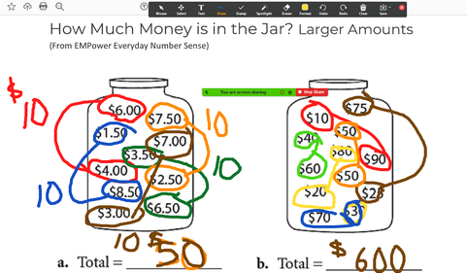
Some students lost track of numbers that did not ‘match’ with another number or were unsure what to do with them. Simple visual strategies such as crossing out the numbers on their own page or color-coding annotations on the screen can help with this.

Losing track of the size
Since all of the amounts combine to either $1, $10, or $100, many students treated them like they were all $1 or otherwise lost track of the actual size of the groups they were combining. When going over their results, make this explicit: What size groups were you making here?

Unit 4: Gauges
Learning Objectives | CCRSAE
I can read a gauge. | 3.MD.1-2, 4.MD.2
I can give a reason why one choice doesn’t belong with the group. | MP.3
I can keep working on a challenging problem even if I don’t understand it right away. | MP.1
I can fill in missing numbers on a number line. | 2.MD.6, also with intervals of lengths greater than 1
Note: EMPower materials featured in Unit 4 can be found in Lesson 1 (Close Enough with Mental Math) and Lesson 2 (Mental Math in the Checkout Line) of the Everyday Number Sense: Mental Math and Visual Models books.

Standards for Mathematical Practice
In addition to the standards targeted by the routines in this packet (Pyramid Puzzle, MP.1 and Which One Doesn’t Belong, MP.3), this unit also involves:
MP.2 Reason abstractly and quantitatively
Students will have to read gauges abstractly, as number lines, but also refer back to context of what is measured (i.e., why doesn’t the stove gauge go down to 0 degrees?).

Extra Resources for this Unit
Reproducible: Evaluation, Unit 4, Teacher’s Guide, p. 44
Reproducible: Blank Number Lines, Teacher’s Guide, pp. 50–51
Other materials
(optional) a collection of gauges for students to investigate, i.e., cooking thermometers, tire gauges, outdoor thermometers, sphygmomanometers, etc.

Math Background
Gauges use number lines to show a measurement of something. They rely on basic number line concepts of proportional intervals, and the idea that tick marks indicate precise locations, which in this case stand for real world measurements. Many gauges do not label all of the tick marks, and measurements may fall in between marks, so there is often some proportional reasoning and estimation that has to occur to get a reading.
Because gauges are measurement tools, they also have ranges that correspond to their use. The gauge on a kitchen stove doesn’t show cold temperatures. The air pressure gauge for tires doesn’t show 0 psi (if that were the case, we wouldn’t need a gauge to tell us!)
Make use of the content to allow students to share and build their background knowledge of gauges and their uses and measurement units.

Relevance
All adults have encountered gauges: on stoves, in cars, on medical equipment, even clocks and rulers are gauges of a sort. Adult students who struggle to read gauges may avoid using them or rely on someone else to read it for them. As they gain proficiency with reading gauges for themselves, they often feel a new sense of efficacy and independence.

Activities and Practice

Opening Discussion
In-Person/Remote Activity
Uses Student Packet p. 44
The opening activity of this unit involves doing a notice/wonder activity with students about a gauge.
- Project a clear image of the gauge from page 44 of the Student Packet.
- First, ask students to share two things they notice about the image (if teaching remotely, possibly in a chat box, to make sure you get maximum participation). Read through student observations (when everyone has had a chance to share). See if students are paying attention to which intervals are labeled, the size of the intervals, and the maximum and minimum numbers.
- Then, ask them to share one thing they wonder about the picture.
- Ask them to share (again, possibly starting in the chat) what number the pointer is pointing to and how they know.
- Brainstorm where they have seen gauges like this and what they think this one might measure.

Examples of Gauges
In-Person/Remote Activity
Uses Student Packet p. 47
You could facilitate this as a class, looking closely at each gauge individually, or have students look at different gauges in groups and report back. For each gauge, they are trying to answer the four questions:
- What is the smallest interval worth?
- Which numbers are labelled?
- What is are the smallest and largest amounts that this gauge can measure?
- What do you think this gauge would be used for?
If they don’t come up, or even if they do, reinforce these takeaways from the conversation:
- Gauges use number lines to show measurements.
- Like other number lines, intervals of equal size have equal value.
- Not all tick marks are labeled on a gauge.
- The minimum and maximum values on a gauge are determined by its use.
- The difference between the minimum and maximum values is called the range. (For example, the thermometer has a range of 42 – 34 = 8 degrees Celsius.)
- Units matter, since we are measuring things in the real world.
You can also ask students to take pictures of examples of gauges they find in their home and share the images in class for further discussion.

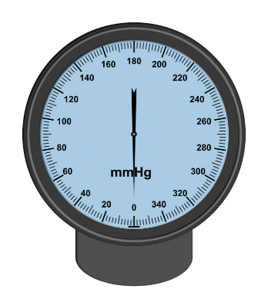
Notes about the examples on page 47
Gauge 1
- This is a blood pressure gauge or sphygmomanometer. It measures pressure in mmHg (millimeters of mercury).
- The smallest intervals are worth 2 mmHg.
- The tick marks are labelled every 20 mmHg.
- The smallest amount that can be measured is 0 mmHg, the largest is 350 mmHg (at the same spot as 0). This is a range of 350.

Gauge 2
- This is an analog thermometer, measured in degrees Celsius.
- The smallest intervals are .1 °C (one tenth of a Celsius degree).
- The tick marks are labeled every 1 °C.
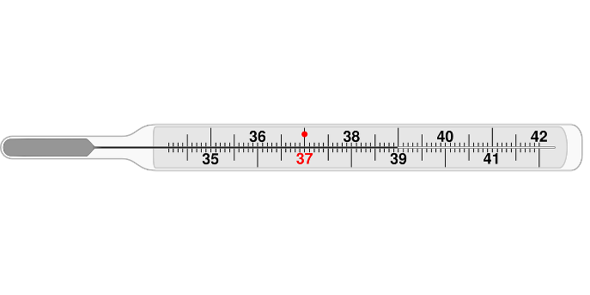
- The lowest amount that can be measured is 34 °C, the highest is 42 °C. This is a range of 8 °C. Since this is a tool to measure human body temperature, it only measures the spread of temperatures likely to be found. 37 °C is a normal body temperature (98.6°F), which is why it is red on the gauge.

Gauge 3
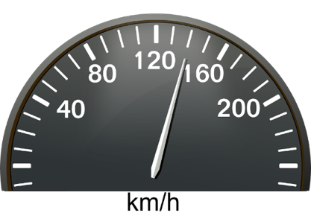
- This is a speedometer. It measures the speed of a vehicle in kilometers per hour (km/h).
- The smallest intervals are 10 km/h.
- The tick marks are labeled every 40 km/h.
- The lowest speed that can be measured is 0 km/h, the highest is 240 km/h. This is a range of 240 km/h. (The maximum and minimum tick marks are not labeled. They are the bolder, horizontal tick marks. There is also a tick mark before and after the bold ones. It is not clear what this would mean on the 0 end. It is possible that the gauge can measure up to 250 km/h on the high end.) Since this is a tool to measure speed, the spread of speeds of which the vehicle is (possibly) capable.

Practice: Reading Gauges
In-Person/Remote Activity
Uses Student Packet pp. 48–49

Digital Read-out
In-Person/Remote Activity
Uses Student Packet pp. 50–51

Which One Doesn’t Belong? 4
In-Person/Remote Activity
Uses Student Packet p. 52
This is the first Which One Doesn’t Belong? routine that uses just numbers. Help students brainstorm characteristics of numbers that could be used to put them in categories.
Note: Most of the vocabulary that might come up is relevant for students at this level, such as digit, even/odd, and multiple. Provide this vocabulary if it is relevant.
In the process of working through this problem, students may also notice attributes that two of the numbers have in common, such as the fact that 45 and 150 are both multiples of 3 and 15. While this doesn’t quite answer the task, it is still a valuable and mathematically relevant observation.
Some possible responses:
- 1 doesn’t belong because it is the only number that is not a multiple of 5 (or the only number that doesn’t include the digit 5).
- 5 doesn’t belong because it is the only single digit divisible by 5. (or the only prime number.)
- 45 doesn’t belong because it is the only number that is a multiple of 9 (or the only two-digit number).
- 150 doesn’t belong because it is the only even number (or the only multiple of 10, the only three-digit number).

Pyramid Puzzle 4
In-Person/Remote Activity
Uses Student Packet p. 53

Answer Key
- Top row: 50
- Second row: 27, 23
- Third row: 17, 10, 13
- Bottom row: 15, 2, 8, 5

Gauge Puzzles
In-Person/Remote Activity
Uses Student Packet p. 54

Answer Key
- Air pressure gauge: 1000, 3000, intervals of 500 between labels, intervals of 100 between tick marks. Values on outer ring measured in psi (pounds per square inch).
- Thermometer: 30, 0, intervals of 10 between labels, intervals of 1 between tick marks. Values measured in degrees Celsius.
- Other Gauge: 20, 30, intervals of 10 between labels, intervals of 2 between tick marks. No units given.

Vocabulary
gauge: a measuring tool that uses a number line
analog: using a number line to show a number or measurement
digital: displaying digits to show a number or measurement
maximum: the largest value
minimum: the smallest value
range: the difference between the maximum and minimum value
units: what is counted by the gauge

Things to Watch For

Assuming the smallest interval is 1
For example, let’s say students were presented with the following thermometer.
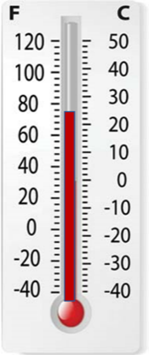
It is common for students to read this as 64 (°F) or 22 (°C). They look for the tick mark below the reading and round up by 1. One way to help students see their error is to zoom in on the image and ask them to keep counting until they reach the next labeled tick mark. They will see that the value they count to does not match the label.

Confusing the interval between labels and the interval between tick marks
Usually gauges do not have all of the intervals labeled. For example, on the gauge below, the intervals are worth 2, but only every fifth interval is labeled (worth 10 total). This requires students to figure out the value of the smallest interval.
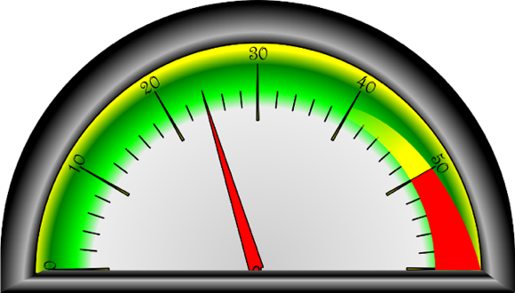
They can do this by dividing the value of the interval between labels by the number of small intervals in that space (10/5 = 2) or using trial and error, counting up (common method for students at this level), or by using proportional reasoning, finding a halfway point, then dividing those in half, etc.

Confusion when the maximum and minimum values are not clearly labeled
The minimum and maximum values are sometimes not labeled because there is no space, or for aesthetic reasons. For example, this thermometer actually measures down to 34 °C. Students may have to count backwards to find the lowest value.
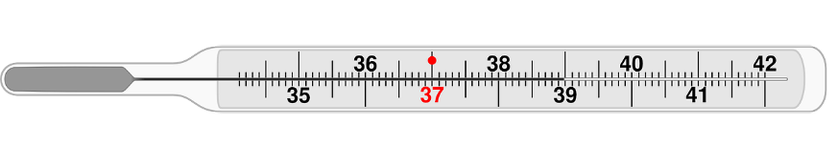

Difficulty reasoning about the value when the gauge is not on a tick mark
The example below is from page 51. Sometimes, students have to estimate the reading by comparing where the dial is relative to the nearest tick marks. Simple proportional reasoning, such as noticing that the dial is halfway between 30 and 40, can help students get a good estimate.
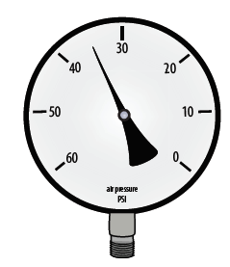

Forgetting about the context
Gauges are number lines with a purpose. As you work through this unit, bring students back to their application and use by asking them to notice units, ranges, and to connect these to what the gauge is meant to measure. Ask them to reflect on the gauges they encounter in their home and life.

Unit 5: Equations
Learning Objectives | CCRSAE
I can write a true equation. | 1.OA.7
I can give a reason why one choice doesn’t belong with the group. | MP.3
I can keep working on a challenging problem even if I don’t understand it right away. | MP.1
I can fill in missing numbers on a number line. | 2.MD.6, also with intervals of lengths greater than 1
Note: EMPower materials featured in Unit 5 can be found in Lesson 2 (Mental Math in the Checkout Line) of the Everyday Number Sense: Mental Math and Visual Models books.

Standards for Mathematical Practice
In addition to the standards targeted by the routines in this packet (Pyramid Puzzle, MP.1 and Which One Doesn’t Belong, MP.3), this unit also involves:
MP.6 Attend to precision
Students learn to use and interpret the equal sign precisely.
MP.7 Look for and make use of structure
Students explore the structure of different types of equations

Extra Resources for this Unit
Reproducible: Quiz, Units 4 & 5, Teacher’s Guide, p. 47
Reproducible: Evaluation, Unit 5, Teacher’s Guide, p. 45
Reproducible: Blank Number Lines, Teacher’s Guide, pp. 50–51

Math Background

Meaning of the equal sign
Understanding the meaning of the equal sign is the foundation of algebra. Often, students at beginning levels of math associate the equal sign with a command to calculate an answer. They are used to seeing equations like this:
2 + 3 = 5

They may be confused when they encounter equations like these:
5 = 2 + 3
1 + 4 = 2 + 3
The equal sign, instead of a command to perform an operation, is making a statement that the two expressions on either side of the equal sign have the same value. An equation is true if the two sides are, in fact, equal.

Expression and equations
A mathematical expression (like 2 + 3) does not have an equal sign and does not have a truth value. Like the phrase “red shoes”, it cannot be true or false because it is not making any claim.
However, when we include an equal sign and another expression to make an equation (2 + 3 = 1 + 4), we are now making a complete math sentence (like, “Jane is wearing the red shoes.”) Now that we are making a claim (that 2 + 3 and 1 + 4 have the same value), our statement can be true or false.

Relevance
Mathematical notation is a symbolic language for communication. It has structure, punctuation, and grammar of a sort. If students do not know this language, it will be harder for them to access mathematical ideas and to communicate their own mathematical ideas to others (it acts like a gatekeeper). Becoming fluent in this language is a skill that will increase their access to further knowledge and ideas and often has the effect of reducing math anxiety. (Nothing makes students anxious like symbols they don’t understand!) In this unit, we start with the fundamentals (expressions, equations, and the equal sign) and pay close attention to ironing out the misconceptions that can occur.

Activities and Practice

Opening discussion
In-Person/Remote Activity
Uses Student Packet p. 55
- Display a phrase related to something you are wearing (like, “white scarf”). Ask students if this is true or false. Since you are wearing it, some students might say true but point out that you haven’t made any claims about the item of clothing. Since you haven’t claimed anything, it can’t be true or false.
- Then write, “I am wearing the white scarf” (or something similar). Ask, How is this different? Guide students to see that the second, complete sentence makes a claim (that can be true or false), while the first does not.
- Next, write 2 + 5. Ask, Is this true or false? Explain that this is a mathematical phrase, like “white scarf” that makes no claim. These phrases are called expressions.
- Then write 2 + 5 = 7. Again, ask, Is this true or false? Explain that now we have a complete math sentence, which is making a claim that 2 plus 5 is equal to 7. This complete math sentence is called an equation.

What Is an Equation?
In-Person/Remote Activity
Uses Student Packet p. 58
- Display the four equations below.
10 + 5 = 15 15 = 8 + 7
5 + 10 = 8 + 7 2 + 5 = 9 – 2
- Give students a chance to notice and wonder at the examples of equations. They should notice that while all of them have an equal sign, they do not all have a single ‘answer’ on the right side. Allow students to share what they think about this.
- Then read the page to clarify the meaning of the equal sign.
Note: The activities “Make It True” and “Check Both Sides of the Equal Sign” were excerpted from Lesson 2: Mental Math in the Checkout Line in the EMPower Plus: Everyday Number Sense Teacher Book.

Make It True
In-Person/Remote Activity
Uses Student Packet p. 59
This is an opportunity for students to think about the equal sign and its role in showing that two sides of an equation are equal. The activity positions the equal sign in places other than at the end of a series of operations. Typically the equal sign indicates: “Here comes the answer,” such as in the problem:
2 + 3 – 4 + 5 =____
In the problems in this activity, the unfamiliar set-up is meant to trigger critical thinking about the value of the numbers. Students need to think critically about the value of the numbers in order to create a balanced equation.
- Give students time to notice patterns and justify their reasoning.
- Ask students to work individually or in pairs to determine the solution to each problem.
- Then, as a class, have volunteers share their reasoning about how they determined where to place addition signs and the equal sign. Be sure that students can articulate that the equal sign is not a signal to ‘do’ something, but rather to show that the values on each side of the equal sign are equivalent. This will build understanding of the mathematically important concept of equality.

Check Both Sides of the Equal Sign
In-Person/Remote Activity
Uses Student Packet p. 60
This inspection is designed to encourage students to understand why a simple mental math trick works when adding numbers. Addends can be adjusted to make it easier to add numbers in your head. For example, 79 + 7 is easier to compute if you think of it as (79 + 1) + (7 – 1), or 80 + 6. This works because by adding and subtracting the same amount you are only adding 0. This activity can highlight the additive inverse (a + -a = 0) and additive identity (a + 0 = a) principles.
- Begin by asking students to articulate what the equal sign means (that the value on the left is equivalent to the value on the right).
- Ask them to verify that this is true for each of the three equations.
First, show 9 + 7. Then, show 10 + 6. Ask: Are these amounts equal? (Yes) Then ask: How do you know?
- People may have varied responses (i.e., because I know my facts—they are both 16; because 10 is 1 more than 9 and 6 is one less than 7). Record responses for all to see.
For students who struggle to see the pattern, offer additional examples using small numbers and allow them to use manipulatives (dried beans or cereal work well) to see how the numbers change from one side of the equation to the other. For example, the first equation could be modeled using a pile of nine beans and another pile of seven beans. By shifting one bean from the second pile to the first, students can see why adding one to the first pile necessitates subtracting one from the second. Give struggling students more problems with small numbers to work out with chips until they are clear why the amount added and subtracted must be the same.
Focus on the idea that we haven’t taken anything away nor added anything, just rearranged the numbers: 10 is one more than 9 and 6 is one less than 7, so we still have the same amount.

Fast Actions with 10 or 100
In-Person/Remote Activity
Uses Student Packet p. 61
For practice seeing the patterns when adding 10 or 100 to a number. Draw attention to how the place values do or do not change.

Fast Actions with 9 or 90
In-Person/Remote Activity
Uses Student Packet p. 62
This builds on the previous practice activity, nudging students to use what they know about adding 10 or 100 to find a strategy of adding 10 and subtracting 1 to add 9 (or adding 100 and subtracting 10 to add 90).

Which One Doesn’t Belong? 5
In-Person/Remote Activity
Uses Student Packet p. 63
Some possible responses:
- 7 + 8 = 10 + 5 doesn’t belong because it is the only equation with an operation on both sides (also the only one containing numbers other than 5, 10, and 15).
- 15 = 15 doesn’t belong because it is the only equation with the same number/expression on both sides (also the only one that doesn’t add 10 and 5).
- 5 + 10 = 15 doesn’t belong because it is the only equation where the numbers are in “order” (from smallest to largest).
Students may also offer answers like, 5 + 10 = 15 is the only one that has an ‘answer’. If so, you can probe for clarification by saying, Do you mean it is the only one with an addition on the left and a single number on the right? You can also ask students to compare and contrast any of the equations, especially the top two.

Make It Equal
In-Person/Remote Activity
Uses Student Packet p. 64
To scaffold this Open Middle problem, you may want to start without the restriction on digits. This is a great problem to see if students are understanding the equal sign correctly. Are all three expressions equal, or do they use the equal sign to mean ‘the answer is’ as they add from left to right?
There are four solutions that work with the restriction to use digits 1–9 only one time each (the numbers in each sum can be rearranged as well):
8 = 2 + 6 = 1 + 3 + 4
9 = 1 + 8 = 2 + 3 + 4
9 = 2 + 7 = 1 + 3 + 5
9 = 4 + 5 = 1 + 2 + 6

Adding Two-Digit Numbers Given One
In-Person/Remote Activity
Uses Student Packet p. 65
Again, it may be helpful to scaffold by starting without the restrictions on digits.
There are many correct solutions to this problem. It is helpful to notice that both the missing numbers are two digits, and that the difference between them is 53. That can help to establish a maximum and minimum for the missing addend and the missing sum.

Number Line Puzzles 5
In-Person/Remote Activity
Uses Student Packet p. 66

Answer Key
A: 28, 35, intervals of 7
B: 250, 550, intervals of 150
C: 12, 60, 72, intervals of 12

Test Practice
In-Person/Remote Activity
Uses Student Packet p. 67–68

Answer Key
- b
- e
- b
- a

Number Sense Quiz (Units 4 & 5)
In-Person/Remote Activity
Uses Teacher’s Guide p. 47

Answer Key
Students’ explanations of their thinking will be the most valuable for assessing their progress, but answers are listed below.
- 130 km/h. See if students are able to identify the intervals of 10 and why 130 would fall at the designated tick mark. Also see if they pay attention to the units (km/h)
- (a) is true because both sides have a value of 5.
(b) is not true because the left has a value of 12 and the right has a value of 13
(c) is not true because the left has a value of 11 and the right has a value of 12
(d) is not true because the first expression has a value of 5, the second has a value of 6, and the third has a value of 6. This is how many students (incorrectly) use the equal sign in their own calculations.

Vocabulary
expression: a mathematical phrase. It can contain numbers, variables, and operations (addition, subtraction, multiplication, division), but there is no equal sign.
equation: a mathematical sentence. It contains an “=” symbol between two expressions that have the same value
operation: something you can do to a number or numbers.

Things to Watch For

The equal sign means find an answer
This is often conditioned by the way beginning computation is taught:
10 + 5 = ?
In this case, students are usually expected to find the ‘answer’, meaning, the whole number sum of 10 + 5. Students learn to associate the equal sign with a command to come up with an answer. This is a very limiting view of the equal sign that can cause difficulties later when students encounter algebraic equations like x + 1 = 9 (If 9 is the answer, what do I do now?) or x + y = 3 (How am I supposed to add x and y?)
Even students working only with numerical equations (no variables) can become fluent in a much richer understanding of the equal sign. For example, the equation 10 + 5 = ? can just as correctly be completed this way: 10 + 5 = 9 + 6. The task can be richer than simple computation, 10 + ? = 15. Equations with a single whole number on one side can start with that number (15 = 10 + 5) or even simply express identity (15 = 15). Exposure to different structures of equations can help students develop a more accurate understanding of the equal sign as a claim of equality, which will become a valuable foundation for later algebraic reasoning.

The first number after the equal sign is the answer
Seeing the equal sign as a command to calculate an answer is a common mistake. For example, when students see an equation like this:
9 + 7 = 10 + 6
they may interpret it as saying that the sum of 9 and 7 is 10, and then they should add 6 more (which leads to confusion, since 9 + 7 isn’t 10). This can often be seen as well in student’s own work. A student who has to add the numbers 1, 2, 3, and 4 may notate it as follows:
1 + 2 = 3 + 3 = 6 + 4 = 10
This is very common and shows that the students are using the equal sign to mean ‘the answer is’ rather than expressing equality of expressions. While it is not advisable to overly-correct how students notate their own calculations while they are working them out, this is an important signal to the teacher that they need a better understating of the equal sign.
Name:___________________________ Date:__________________
Number Sense: Unit 1, Estimation and Adding
Objective | Student Self-Evaluation  (Struggling, Learning, Mastery) | Teacher  Evaluation
I can estimate the total when adding several amounts.
I can explain my strategy for estimating to others.
I can give a reason why one choice doesn’t belong with the group.
I can keep working on a challenging problem even if I don’t understand it right away.
I can fill in missing numbers on a number line.

Name:___________________________ Date:__________________
Number Sense: Unit 2, Rounding
Objective | Student Self-Evaluation  (Struggling, Learning, Mastery) | Teacher  Evaluation
I can round to the nearest dollar or the nearest ten dollars.
I can give a reason why one choice doesn’t belong with the group.
I can keep working on a challenging problem even if I don’t understand it right away.
I can fill in missing numbers on a number line.
Name:___________________________ Date:__________________
Number Sense: Unit 3, Combining
Objective | Student Self-Evaluation  (Struggling, Learning, Mastery) | Teacher  Evaluation
I can find pairs of numbers that add together easily.
I can estimate the total when adding several amounts.
I can explain my strategy for estimating to others.
I can give a reason why one choice doesn’t belong with the group.
I can keep working on a challenging problem even if I don’t understand it right away.
I can fill in missing numbers on a number line.
Name:___________________________ Date:__________________
Number Sense: Unit 4, Gauges
Objective | Student Self-Evaluation  (Struggling, Learning, Mastery) | Teacher  Evaluation
I can read a gauge.
I can give a reason why one choice doesn’t belong with the group.
I can keep working on a challenging problem even if I don’t understand it right away.
I can fill in missing numbers on a number line.
Name:___________________________ Date:__________________
Number Sense: Unit 5, Equations
Objective | Student Self-Evaluation  (Struggling, Learning, Mastery) | Teacher  Evaluation
I can write a true equation.
I can give a reason why one choice doesn’t belong with the group.
I can keep working on a challenging problem even if I don’t understand it right away.
I can fill in missing numbers on a number line.

Name:___________________________ Date:__________________

Number Sense Quiz (Units 1–3)

- Estimate a total.
- $11.88 + $18.00
- $4.00 + $8.95 + $5.75

- Round to the nearest dollar.
- $3.68
- $56.13

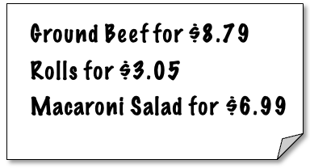
- You have $20. Do you have enough to buy these items? Show how you know.

- Add these numbers. Explain or show your strategy.
- 3 + 5 + 5 + 7 + 2 + 4 + 6 + 8
- 25 + 10 + 60 + 40 + 75 + 90

Name:___________________________ Date:__________________

Number Sense Quiz (Units 4 & 5)
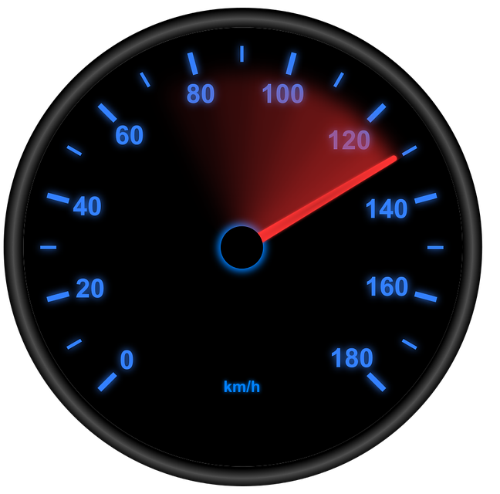
- This is a speedometer. How fast is the car going?

How do you know?

- Are the following equations true or false? For each one, explain why.

- 5 = 3 + 2
- 5 + 7 = 12 + 1
- 5 + 6 = 12
- 3 + 2 = 5 + 1 = 6

Round to the Nearest Dollar Template 1
- Put the dollar benchmarks in the boxes.
- Put an x on the number line where the exact amount of money would go.
- Circle the dollar benchmark nearest to the exact amount.

Exact amount:
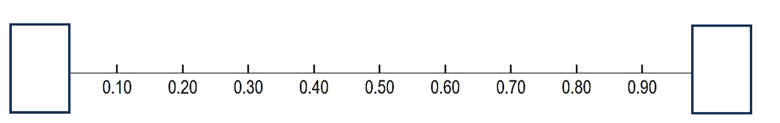

Exact amount:

Exact amount:

Exact amount:

Round to the Nearest Dollar Template 2
- Put the dollar benchmarks in the boxes. Label the midpoint.
- Which side of the midpoint is the exact amount?
- Circle the dollar benchmark nearest to the exact amount.

Exact amount:



Exact amount:

Exact amount:

Exact amount:

Blank Number Lines
