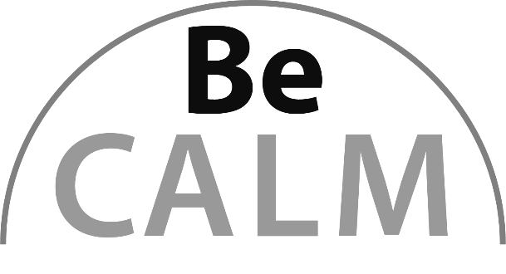
Measurement and Data
Beginning Curriculum for Adults Learning Math
Curriculum for GLE 2–4

TEACHER’S GUIDE

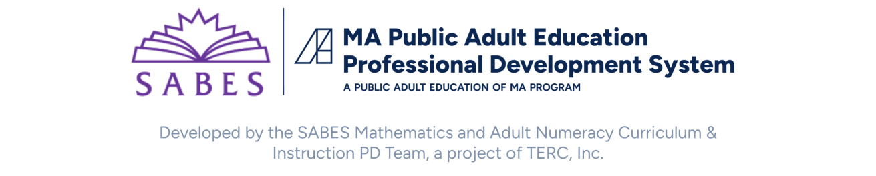
Acknowledgements

The titles in the BeCALM series were developed and piloted in the classroom by Melissa Braaten for the SABES Mathematics and Adult Numeracy Curriculum & Instruction PD Team, with contributions from Yvonne Readdy, Emily Rudd, and Sherry Soares.

The BeCALM series includes four sequential packets:
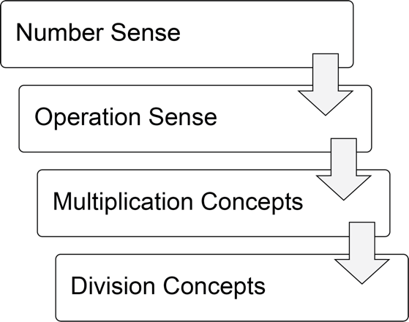
and three non-sequential packets:
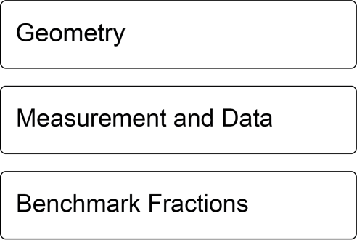

Learner Level
The math content is aimed at ABE level math students (approximately GLE 2–4). While adult students at this math level may have any level of reading, the student materials were designed to be used by adults with a reading level GLE 2 or above. To keep things accessible, the text in the Student Packet is kept to a minimum so that this can be used with students at an ABE reading level or students who are beginning to intermediate English Language Learners.

Use in Different Settings (In-Person, Hybrid, Corrections)
This curriculum was designed for use in-person (or possibly hybrid) classrooms. While there are some practice activities that could be done remotely using video conferencing software, the core activities require an in-person format.
Throughout this guide you will see the following icons that denote the delivery format(s) of the activity or resource:
In-person |  | Remote |  | Not Recommended for Smartphones | 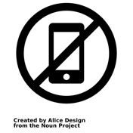
Suggestions for adapting in-person activities for use in correctional facilities are provided when necessary.
Note: Virtual resources often work better on computers, laptops, tablets, or Chromebooks rather than on Smartphones, especially due to small screen size. There are notes on the specific websites used in each unit. These virtual activities can be used in an in-person class or assigned for homework.
Students at the suggested level (GLE 2–4) are building the skills covered in this unit, not simply reviewing them. The pilot-testing of these materials took 6-8 hours of class time for each unit.

Teaching Skills that Matter (TSTM)
Teaching Skills that Matter (TSTM) in Adult Education is a project of the Office of Career, Technical, and Adult Education (OCTAE). See https://lincs.ed.gov/state-resources/federal-initiatives/teaching-skills-matter-adult-education for more information about the program and toolkit.
Information on the Massachusetts Teaching Skills That Matter Academies can be found at https://www.doe.mass.edu/acls/frameworks/tstm.html?section=fy2025.
Part of TSTM is integrating and contextualizing basic skill development in content areas relevant to adult learners. The five content areas highlighted by TSTM are Workforce Preparation, Financial Literacy, Health Literacy, Digital Literacy, and Civics Education. In this curriculum, each unit contains an activity in the context of health literacy or financial literacy.
In addition, these activities are designed to build skills designated by TSTM as the “skills that matter,” which include:
- Adaptability and Willingness to Learn
- Communication
- Critical Thinking
- Interpersonal Skills
- Navigating Systems
- Problem-Solving
- Processing and Analyzing Information
- Respecting Differences and Diversity
- Self-Awareness



These activities are indicated with one of these icons:
Financial Literacy Health Literacy

Components of Instruction

Routines
Classroom routines can be powerful tools in the math classroom. Routines provide a familiar structure to an activity that helps students feel safe because the directions and expectations are predictable. However, a good math routine still provides a cognitive challenge and requires some type of problem-solving every time. There are several routines included in this unit, with notes and descriptions of how to facilitate these routines in the unit details.

Introduction of New Concepts
Each unit includes one or two activities to introduce the new concepts for that unit. Instructions for facilitating are included in the unit details. The goal is to lay the foundation for conceptual understanding of the concepts, rather than simply explaining procedures.

Vocabulary and Things to Watch For
Each unit includes some suggestions on valuable vocabulary words and common misconceptions or interesting student ideas that came up in the pilot class.

Student Interaction and Interpersonal Skills
When possible, it is helpful to allow students to interact and work together without the teacher constantly present.

Materials Overview
- Unit 1: Steps and Directions
- Unit 2: Measuring Length
- Unit 3: Using Dimensions
Each unit includes materials for:
- Health Literacy or Application Project
- Activities and Practice
- Language Support
- Self-Evaluation (reproducible from Teacher’s Guide pp. 39–41)
Additional PowerPoint documents referenced throughout the Teacher’s Guide are listed below and can be downloaded at:
https://www.dropbox.com/scl/fo/gn9ah3vsray0ktr0jn4le/h?rlkey=yfey4ff2msfhjvuw5blypjb4e&dl=0
- Find something the same length…
- Estimate the length
- What Am I?
Each part in the Student Packet includes materials for:
- Relevance
- Activities and Practice
- Routines

Math Background: Measurement and Data
Text below adapted from Investigations Grade 3, Curriculum Unit: "FROM PACES TO FEET" © 1993 by Savvas Learning Company LLC, or its affiliates. Used by permission. All Rights Reserved.
Scope of this Curriculum
This unit explores both measurement and simple statistics, as students develop ideas about why we need to measure, learn to use different measuring tools and systems, and interpret data they collect by measuring. Through some initial work with informal, nonstandard units of measure (small steps, large steps, paces), students see that defining a standard or middle-sized pace provides more accurate and more consistent measures. Students then learn to use standard measuring tools—inch rulers and yardsticks, centimeter rulers and metersticks – as they collect measurement data about themselves and their classroom; they then learn ways to organize, represent, and analyze this data, discovering the power of measurement in communicating about the world.
Measurement connects mathematics to real life in powerful ways: It is a tool that we use to collect data and communicate about the world. This unit involves students in thinking about why people need to measure, the different tools and systems we use for measuring, and how we use and interpret data that are based on measurements.
Data collection and data analysis are important parts of this unit. Students collect real data through measuring, using both informal and standard measurement systems. They then represent the data in a variety of ways, describe landmarks and features of the data, and finally formulate hypotheses and build theories about the reality represented by the data. Through the activities in this unit, students learn to use simple statistical tools and concepts, gaining a good foundation for their later work in statistics and data analysis.
Building a Conceptual Foundation
Student’s ideas about measurement grow out of a great deal of experience with informal measurement: Constructing how long something is in small steps or in unit cubes is not just playing at measurement – it is an important mathematical construction. Seeing the need to describe length in a reliable and accurate way, so that you'll get the same results if you measure a second time or if someone else does it, is a skill that students develop through repeated experiences with describing and comparing the sizes of things.
Students need many opportunities to use informal as well as more standard measuring tools. As they use different units of measure, they begin to learn about the relationship between sizes of measuring units and the results of measuring (that is, for any given measure, the smaller the measuring unit, the greater the total amount of units needed). Through discussing the methods and units they use, they learn that defining procedures, recording information, and agreeing upon a standard are critical parts of communicating measurement information to others.
Relevance for Adult Learners
Adults who lack a conceptual foundation in linear measurement may avoid or delegate tasks that require measurement, or simply guess without an accurate toolkit of internal benchmarks to make good estimates. Building their skills with linear measurement, and the language skills needs to accurately communicate these measurements, can increase their confidence and independence. Measurements appear in adult life in many different contexts. Some applications to consumer literacy and health literacy are included in the curriculum.
Note about Metric Measurements
Adult students from other countries will probably have some exposure and experience with metric measurements. Draw on this experience throughout the unit and help them make connections to the US Standard/Imperial measurements, so that they can develop internal benchmarks in both systems.

Unit 1: Steps and Directions
Learning Objectives | CCRSAE
I can measure the same distance using large and small steps. | 1.MD.2
I can make a dot plot of measurement data. | 1.MD.4, 2.MD.10, 3.MD.4
I can write directions to get from one place to another. | 1.MD.2
I can find the median and range of a group of measurements. | 1.MD.4, 2.MD.10, 3.MD.4

Standards for Mathematical Practice
MP.3 Construct viable arguments and critique the arguments of others
Students will have to interpret the results of their data and defend their conclusions.
MP.6 Attend to precision
Students will have to agree on procedures for collecting data.

Extra Resources for this Unit
- Downloadable file: Find Three Things PowerPoint
- Web link: Robot Islands
https://www.mathplayground.com/logic_robot_islands.html
- Reproducible: Evaluation Unit 1, Teacher’s Guide, p. 39
- Reproducible: Unit 1 Vocabulary Quiz, Teacher’s Guide, pp. 42–43
Other materials
painters tape, roll of receipt paper, scissors, markers, easel paper or whiteboard
Math Background

Informal Units
In this first unit, students are working with informal units (their own large, small, and regular step length). The goal of this work is to help students gain an intuitive understanding of the relationship between the size of a unit and the number of units needed to measure a certain length. As students compare the number of steps it takes each person in the class to cross the same distance, we want them to understand that the person who took the most steps also had the shortest steps. This inverse relationship between the size of the unit and the number of units is important when students are later using standardized units and doing unit conversions (Why is the number of centimeters more than the number of inches, for example?)

Collecting Data
This unit is an early introduction to data collection and analysis. Students collect data right in the classroom by counting and comparing their classmates’ steps. Although students are not explicitly taught a statistical process, they go through the various stages in their investigation:
- Formulate a statistical question (one that anticipates variability): For example, How many steps does it take to cross the classroom?
- Collect data: Students have to carry out the data collection, dealing with issues as they arise (i.e., What if there is not a full step at the end? Where should people’s feet start? What if the person doesn’t walk in a straight line?)
- Analyze the data: In this case, the teacher models how to create a dot plot of the data, and how to find the range. There is also an activity in which students find the median sized step.
- Interpret the results: Students must describe the data in the graph, and also draw conclusions about the relationship between the size of the step and the number of steps.

Analyzing Data: Shape, Center, Spread
Analysis of numerical data (counts or measurements) usually involves paying attention to the shape, center, and spread of the data. In this example, the shape can most easily be seen in the dot plot. Do most of the dots cluster together? Are there clusters in the middle of the range or at both ends? Are they evenly distributed?
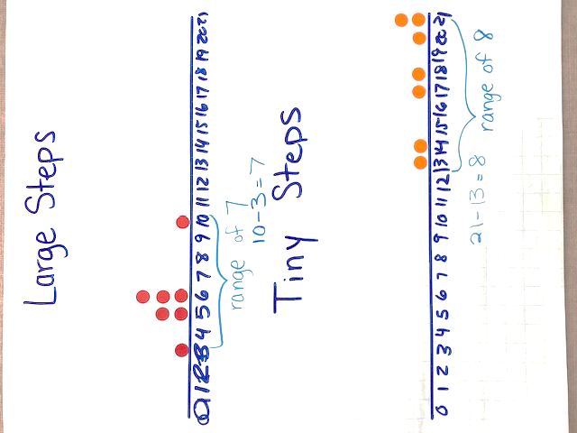
Center is addressed when students explore the median sized step. The median is a way of talking about the center of a group of data by identifying the middle value if all of the data points are arranged from smallest to largest. This median value is larger than half of the data and smaller than the other half.
Spread is addressed by teaching students to identify the range of the data. The range is the difference between the highest and lowest data point. This tells us how spread apart the data are. A large range means the highest and lowest are far apart. A small range means all the data are clustered together.

Activities and Practice


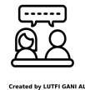
Introducing the Unit
In-Person/Remote Activity
Uses Student Packet p. 3
Have students read the text on p. 3. The prompt (A time when you got lost trying to get somewhere) can be used for a Think, Pair, Share—students get a minute to think, then to share with a partner, then a few groups share with the whole class.
Point out any details of the shared stories that are relevant to the idea of directions and measurement. Did anyone get lost because they missed a step (missed a turn)? Did they get a distance wrong (turned too soon or too late)? Did they not have directions at all? Did they rely on a GPS that interpreted their location incorrectly? All of these real-life experiences are relevant to the math students will be learning in this unit.

Introducing Routine 1: Find three things…
In-Person/Remote Activity
Uses downloadable file Find Three Things PowerPoint
This is a simple warm up to get students to visually compare lengths and to start to build a set of personal benchmarks. Each slide asks students to find something the same length as something else. Explain that they are not looking for an exact match, but something reasonably close. Give them a few minutes to find objects around the classroom that match the prompt and debrief.
The benchmarks are chosen because they are similar to common length units:
- Last joint of your thumb: about 1 inch
- Forearm: about 1 foot
- Pen: about 6 inches
- Length of notebook: about 1 foot
- Height of chair: about 1 yard / 1 meter
- Your height: varies, but each person will know their own height!

Language Support: Talking About Quantity / Talking About Length
In-Person/Remote Activity
Uses Student Packet pp. 6–7
Some students may need language support around words that compare quantities (more, fewer, least, most) and lengths (longer, shorter, longest, shortest). These pages can be used to review and highlight the difference before the data collection activities.
If these words are new to students, they will need more practice than is provided here.

Large Steps and Small Steps
In-Person Activity
Uses Student Packet pp. 8–9
Materials: painters tape, easel paper or whiteboard

From Investigations Grade 3, Curriculum Unit: "FROM PACES TO FEET" © 1993 by Savvas Learning Company LLC, or its affiliates. Used by permission. All Rights Reserved.

Collecting the Data—Large Steps
- Mark off a straight path across the classroom (or part of it, or a section of hallway, etc.) with painters’ tape. Make sure the beginning and end of the distance are clear.
- Have a volunteer start at the beginning and take two large steps (as large as they can comfortably do), then stop. Ask students to estimate how many large steps they think it would take that person to do the full distance. Write their estimates on the board.
- Have the person take two more steps and allow students to revise their estimates. Then have the volunteer finish walking the distance in large steps.
- Explain that they will each measure the same distance in their own large steps (for all students who are physically comfortable doing so). Ask: Will you all have the same number of steps? Why or why not?
Most adult students will anticipate that they will have different numbers of steps, since some students will have longer steps than others.
- Set up a simple two-column chart on the board to record the names of students and their number of steps. Most adults will be familiar with this type of table or chart, but some may not, so demonstrate how each row matches a name to their number of steps, as needed. (Note: Due to various types of disabilities, some students may struggle to create their own tables and to align the names and data properly. If you notice this happening, consider providing blank tables for students to fill in, or have them create the tables on wide-ruled lined paper.)
- As students measure out the distance in their large steps, some questions about measuring procedure may come up. For example, what if a student needs only a partial step to complete the distance? What if someone takes a misstep—should they start over? Allow the class to discuss and come to a decision about these things and point out that these types of “guidelines” have to be created whenever we are collecting data. Note: in a large class, you may want to create two lines of the same distance so more than one student can be walking and collecting data at one time.
- Once the data has been collected, ask student to look at the numbers. Ask: Did everyone get the same results? Is that surprising? Why or why not? Listen for students to mention that some people had larger steps than others, and if they can identify who had the largest and smallest steps. Some students will have an easy time seeing that the size of a student’s step makes a difference in numerical results; others won’t. Inverse relationships—the smaller the step, the more steps are needed—are sometimes hard to grasp, hold on to, and use.

Making a Dot Plot
- Make a dot plot to show the results. (You may want to put this on chart paper so you can save it for future classes.) Draw a number line, label the points to include the smallest and largest numbers of steps, and show students how to make dots, x’s, or other symbols to record their data on the line. Emphasize that each symbol represents one data point, in this case, one person. Explain that if more than one person had the same number of steps, the symbols are placed above each other. Ask what they notice about the dots (Are they clustered anywhere? Are they spread out?) At this point, accept whatever informal language students use.

Measuring in Small Steps
- Explain that now they are going to measure the same distance using small steps (heel to toe). Ask: Do you think we will get different results? Why or why not?
- Repeat the steps 1–8 above from the activity with large steps.
- Put the two dot plots one above the other, lining up the numbers on the number lines. Ask: What do you notice? What do you wonder? Asks student to pay attention to differences between the two plots and see if they can explain those differences.
Corrections alternative: If painters’ tape is not available, the distance could be marked off with landmarks, like door to window.
This is a good place to teach the following vocabulary words and have students enter them on their vocabulary list (Student Packet pp. 4–5):
unit: What you count when you are measuring. Units must be the same size to be useful.
length: How long something is in one direction
dot plot: A dot plot has numbers along the bottom, and one dot for each time that number appears in the data
data: measurements or counts of things in the real world

Vocabulary Review 1
In-Person/Remote Activity
Uses Student Packet p.10
Fill in the blank review for unit, length, dot plot, and data.

Answer Key:
- unit
- length
- data
- dot plot

Siblings Dot Plot
In-Person/Remote Activity
Uses Student Packet p. 12
- Make sure students understand the word siblings and have them count how many siblings they have (not including themselves).
- Collect the data on the board. Also have students enter the data into their own tables on p. 12.
- Demonstrate how to create the dot plot, and have students create on their own sheets.
- Ask: Who has the most siblings? Who has the least siblings?
- Which number of siblings is the most common in this class? Point out that this will appear as the highest column of dots in the plot.

Estimating in Paces
In-Person Activity

From Investigations Grade 3, Curriculum Unit: "FROM PACES TO FEET" © 1993 by Savvas Learning Company LLC, or its affiliates. Used by permission. All Rights Reserved.
- Explain the word pace, which means a normal size walking step. Have a volunteer stand in a fairly open part of the room and select a target that is a moderate distance away in a straight line. Have the student take three or four paces to help the others visualize the length of a pace.
- You may want to dramatize the visualization process by “thinking aloud” your own way of making an estimate:
Let’s see…I can see how long Chantelle’s pace is, so I’ll try to imagine: 2…3…4...5…6. About 6 paces to the desk, I think. Let’s have her try it! Now how many paces do you think Chantelle is from the globe? Students estimate, the pacer paces the distance, and everyone counts.
- Repeat this two or three times, selecting different objects. You may want to use more than one student as a pacer.

Robot Directions
In-Person Activity
Uses Student Packet p. 13

From Investigations Grade 3, Curriculum Unit: "FROM PACES TO FEET" © 1993 by Savvas Learning Company LLC, or its affiliates. Used by permission. All Rights Reserved.

Forward and Backwards only
- Explain that if you are giving or receiving directions to get somewhere, you want the directions to be accurate! Today they are going to be practicing giving direction to a “robot”, another student who will follow their directions exactly to try to reach a target.
- Ask for a volunteer to be a “robot”. Put a paper plate some distance away from the robot, directly in their path: this is the target. Give directions that will move the robot to the target paper plate. Use only “forward” or “backward” commands: you will add turns in the next activity. For example,
Robot, go 5 paces forward.
- Assess the effect of this movement with the class.
- Ask: Does the robot need to be given new directions? Did my estimate work for this robot?
- Have student work in pairs, taking turns as the robot. Give each team a paper plate. The direction-giver positions the plate, tells the robot how many paces to take toward the target and assesses the success of the directions. Then students swap roles.
- After students have had a few turns in each role, debrief: Was this difficult? Were you estimates of distance fairly accurate?

Pacing and Turning
- Explain that now they ae going to be giving more realistic directions that involve pacing and turning. Have a student volunteer as a robot. Give them simple directions on the board that involve making turns:
Turn left. Go 4 paces forward. Turn right.
- Help students establish a working definition of a turn. Most classes decide that a turn is a 90-degree turn, or a square corner. Point out a target in the classroom and give directions to the robot as a demonstration. The robot is to move as directed after each command.
- Explain that this time when they give directions to their robot, they’ll be writing them down so that they have a record of them.
Have students work in pairs, taking turns being the robot. They place their target, then write down a few simple directions to reach the target, such as “Forward 3 paces, Turn left. Forward 2 paces.” The robot should follow the directions as exactly as they can, so the direction-giver can assess if their directions were accurate.
This may not be easy for students! Estimating how many paces and what kind of turns are needed is a complex task. Students may need to practice this in more than one class.

The Middle-Sized Step
In-Person Activity
Materials: receipt paper, scissors, tape, marker
From Investigations Grade 3, Curriculum Unit: "FROM PACES TO FEET" © 1993 by Savvas Learning Company LLC, or its affiliates. Used by permission. All Rights Reserved.
- Say: When you were giving directions to robots, we noticed that everyone’s pace is a little different. Today we are going to find the middle-sized pace, so we will have a standard that we can use to give directions. How could we go about finding the middle-sized pace?
- Let students brainstorm and note their ideas on the board. Some students might suggest using standardized units, such as inches or centimeters. Acknowledge that this is a good idea, but we are going to hold off on those for now. This is just an introductory brainstorm to get them thinking about how they might go about measuring and comparing paces.
- Ask: We need to find the length of everyone’s pace. Let’s start by finding out how long my pace it. How could we use the paper tape?
Solicit ideas for measuring your pace directly. Take two or three paces and freeze. Have student volunteers mark your pace on the tape and use scissors to cut it to size, following directions from the class.
There is lots of opportunity for discussion here, and students will need to agree on a single method before the volunteers cut the tape. Will they measure toe to toe or heel to heel? (Some may want to measure toe to heel. Why is this an issue?)
- Once the class has settles on a method, give groups a pair of scissors, a pencil, and a length of receipt tape. Students in the group should work to cut the paper tape to the length of each person’s pace. Write the names of each person on the paper strip that corresponds to their pace. (Be sensitive to students who may not be comfortable bending down to do the measuring and marking and cutting – other students can assist.)
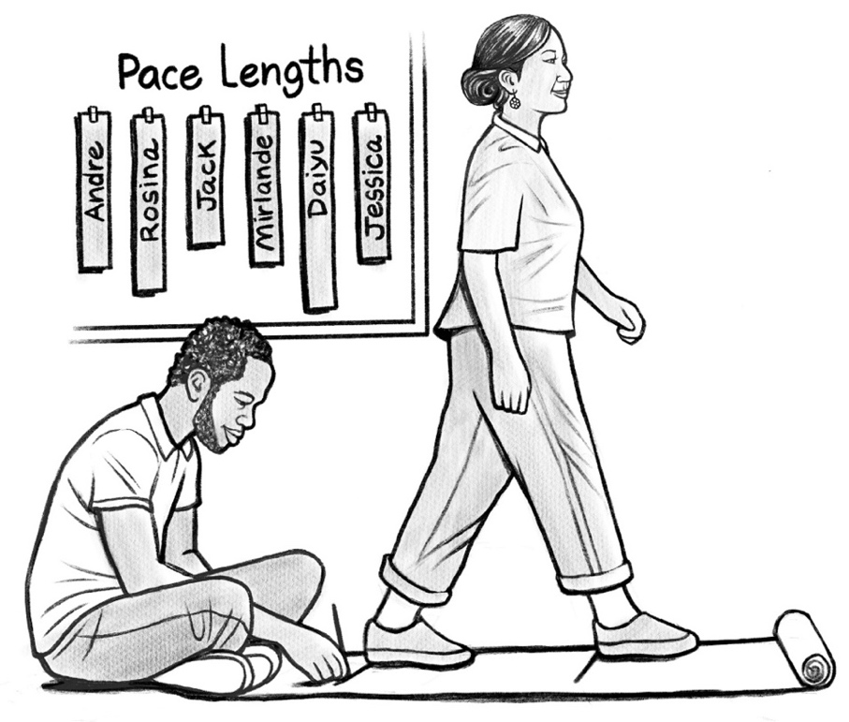
- As the groups finish, tape the paper strips to the board. Ask students how they propose to find the middle-sized pace. Some may suggest ordering the tapes by size; try not to accept this suggestion too quickly. Wait to hear many ideas, then ask students to explain or demonstrate their methods. Then have a volunteer help you order the tapes by size on the board. Ask: Now that we have all of our paces, how could we find the middle-sized pace?
- Probe student ideas. If they mention looking for the one in the “middle.” Ask: How could we do that? Which one is in the middle? How can you tell?
- After you have identified the middle-sized pace, define the term “median” as the middle in an ordered set of data. Explain that the median pace is the one in the middle, and that it breaks the data (the paces) into two groups: half of the class has paces longer than the median pace, and half of the class has paces shorter than the median pace.
- Ask each student to consider: Is your pace longer or shorter than the median pace? Would it take you more or fewer steps to cross the room, compared to the median pace?
Corrections alternative: Students can rip paper tape if scissors are not available.
This is a good place to teach the following vocabulary words and have students enter them on their vocabulary list (Student Packet pp. 4–5):
median: When you put all of the data in order, the median is the number in the middle.
range: The difference between the largest data point and the smallest data point.
Note: the idea of a difference will come back in Unit 2. See if any students already connect the idea of a difference to the idea of subtraction.

Vocabulary Review 2
In-Person/Remote Activity
Uses Student Packet pp. 14–15
Fill in the blank review for dot plot, data, median, range.

Answer Key:
- median
- dot plot
- range
- data

Health Literacy: Children's Growth Charts
TSTM Skills: Processing and Analyzing Information
In-Person Activity
Uses Student Packet p. 16
Most parents will have encountered growth charts for their children when meeting with a pediatrician, especially when children are young. This activity and reading are to help students understand the meaning of growth charts and percentiles, using what they have learned about the idea of data and medians.
- Before reading the article, it may be helpful to start with a demonstration. Have all students line up from shortest to tallest. Once they are in line, have them find the person in the middle of the line. This person has the median height, which is also known as the 50th percentile. This means that half (50%) of the class is taller, and half (50%) of the class is shorter than this person.
Note: If there are an even number of data points, the median is the number in between the two middle numbers (or two middle heights). This technicality is not super important at this beginning level. You can avoid an even number of data points by including or excluding yourself in the lineup, as needed, so that there are an odd number of people.
- Have students read the article and ask them if they have had experiences talking to doctors about children’s growth percentiles.
Note: Growth percentiles compare a person’s size (in this case, a child’s height) against their same-age peers. Percentiles are not a value judgment (a higher percentile is not better than a low one), simply a descriptive one. Unless a doctor specifically mentions concern about a child’s growth percentile, they are not a health issue, just a reflection of variation in human heights and growth.

Computer Game
In Person/Remote Activity
Supplemental activity

Robot Island
https://www.mathplayground.com/logic_robot_islands.html
Works on computers, tablets, and phones.
This simple game actually builds skills used in computer coding! Players add arrows to cause the robot to turn in a certain direction to help him out of an island maze. As the levels progress, not only the direction of the turn but the sequencing of the turns becomes important.
Similar to what students did in the classroom with their own bodies, but here, they must translate the turns from their own frame of reference to figure out which way the robot needs to turn based on the robot’s frame of reference.
Corrections alternative: This game is not downloadable and needs to be streamed over the internet. In some settings, it may be possible to have the instructor at the controls while students give input.

Unit 1 Vocabulary Quiz (Summative Assessment)
In Person/Remote Activity
Reproducible in Teachers Guide pp. 42–43

Answer Key:
Part 1
- data
- units
- length
- dot plot
Part 2
Median: 2, 3, 5, 6, 8
The median is 5 (Peter’s age).
Range: 8 – 2 = 6
The range is 6 years.

Exit Ticket/Homework (Summative Assessment)
In Person/Remote Activity
Uses Student Packet p. 17
This question is meant to assess understanding of the relationship between the number of units and the size of a unit. Students should understand that the person who took the least steps to walk the same distance (Jamal) must have taken longer steps.
This understanding of the inverse relationship between the number of units and unit size is important when making sense of standardized units (why does it take more centimeters than inches to measure the same length) and when students at an intermediate level start applying proportional reasoning to perform unit conversions.

Vocabulary
unit: What you count when you are measuring. Units must be the same size to be useful.
length: How long something is in one direction
dot plot: A dot plot has numbers along the bottom, and one dot for each time that number appears in the data
data: measurements or counts of things in the real world
median: When you put all of the data in order, the median is the number in the middle.
range: The difference between the largest data point and the smallest data point.
Note: the idea of a difference will come back in Unit 2. See if any students already connect the idea of a difference to the idea of subtraction.

Things to Watch For

The relationship between quantity and size of a unit
Inverse relationships (one amount goes up while the other goes down) are challenging. Many students struggle to understand the inverse relationship between the size and quantity of a unit. If students just look at a table of data like the one here, they often think that the smallest number (19) means the smallest steps. Having the concrete experience of collecting this data in class gives them a visual and kinesthetic memory to refer back to help explain why this is not the case, but you may have to “reenact” the steps multiple times.
Name | Number of steps
Maria | 25
Jose | 21
Fatima | 29
Jamal | 19

Procedures for collecting data
In order to make meaningful comparisons between data points, data needs to be collected using an agreed upon procedure. What distance are students walking? How do you define a “tiny step”? How do they position their feet at the start? Let students discuss and decide on a procedure as these questions arise: there is no one right answer. The important take away is that these sorts of decisions have to be made whenever we collect data.

Interpreting a Dot Plot:

Quantity of data points vs. value of a data point
Students can sometimes confuse the number of dots with the value of a data point. For example, in the dot plot below each dot represents one person, and the dot is positioned above the number of siblings that person has. So, the dot plot could be turned back into a data set by listing the value of each dot: 0, 1, 1, 1, 1, 2, 2, 2, 3, 3, 3, 4, 6.

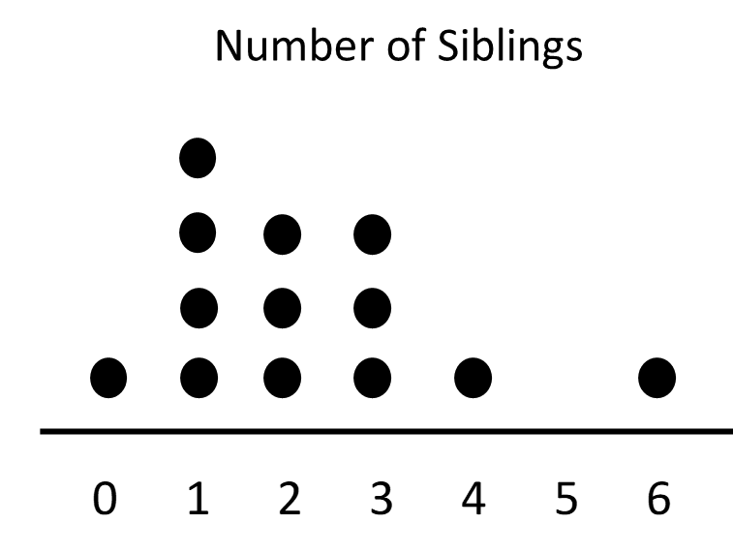

However, some students may misread this, and instead interpret each column as one data point, and the number of dots as the value. For example, they are thinking of the data set as follows:
1, 4, 3, 3, 1, 0, 1 (The number of dots in each column.)
One way to help students with this is to create a dot plot in class, like the one above, created in Student Packet p. 12, then have them go backwards from the dot plot to recreate the data set. Since they have a recent memory of creating the dot plot, it is easier to point out if they interpret it the wrong way (Remember that Alma has 6 siblings? That dot represents Alma. Which dot is you?)

Giving Directions Inside and Outside of Ones frame of reference
Our physical body is our “frame of reference” when we think about directions and location. When I am told to turn left, the direction I turn is based on how my body is positioned. If someone is facing me, their left will be opposite mine.
It is generally easier for people to understand directions from their own frame of reference. Imagine following directions on a GPS that shows the turns from the car’s point of view (the drivers frame of reference) versus a static bird’s eye view (may not match drivers frame of reference).

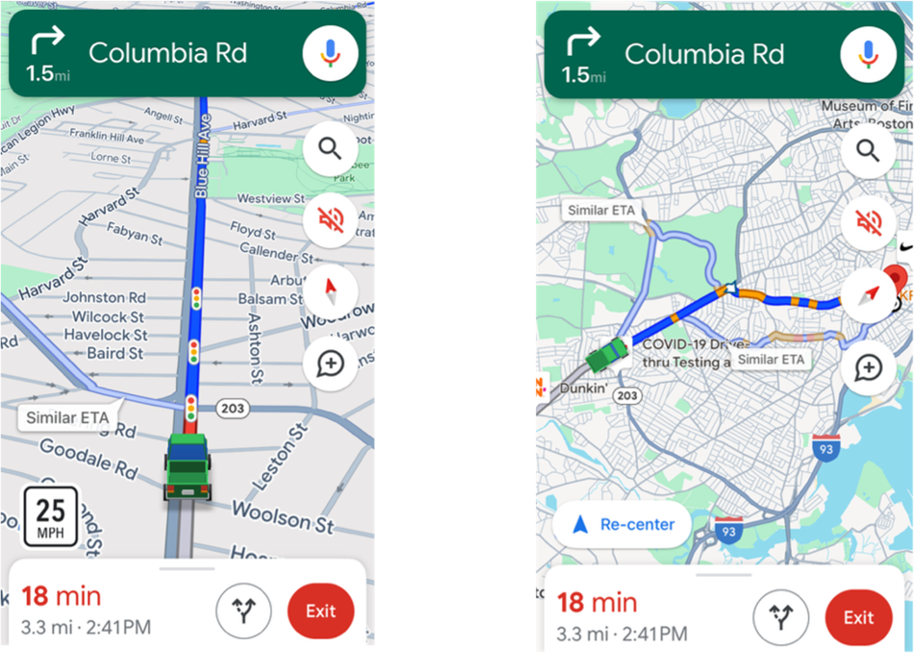

Students with more sophisticated spatial reasoning may be able to correctly shift their frame of reference without turning their body, but if students struggle, encourage the direction giver to face the same way as the robot, so they are walking through the turns in their own frame of reference.

Unit 2: Measuring Length
Learning Objectives | CCRSAE
I can use a ruler, yardstick, or measuring tape to measure length. | 2.MD.2, MP.5
I can measure length to the nearest foot, inch, or centimeter. | 2.MD.2
I can use correct grammar to compare the lengths of two objects. | 2.MD.4
I can use familiar benchmarks to estimate length in different units. | 2.MD.3, MP.6

Standards for Mathematical Practice
MP.5 Use appropriate tools strategically
Students will consider the best measuring tool to use in different measurement situations to increase accuracy and efficiency.
MP.6 Attend to precision
Students will learn to estimate common measurement units with body benchmarks and will consider when an estimate is appropriate. They will also practice using measurement tools carefully and make decisions about how to round partial units. Students will also learn to interpret and express measurement comparisons using precise grammar.

Extra Resources for this Unit
- Downloadable file: Find Three Things PowerPoint
- Downloadable file: Estimate the Length PowerPoint
- Reproducible: Evaluation Unit 2, Teacher’s Guide, p. 40
- Reproducible: Unit 2 Vocabulary Quiz, Teacher’s Guide, pp. 44–45
- Reproducible: Inchstick, Teacher’s Guide, p. 48
- Reproducible: Inch Rulers, Teacher’s Guide, p. 49
- Reproducible: Centimeter Rulers, Teacher’s Guide, p. 50
- Reproducible: Centimeter Grid Paper, Teacher’s Guide p. 51

Other Materials:
Rulers (inches and centimeters), yardsticks, tape measures

Corrections alternative: Printable paper rulers and inchsticks are available on pp. 48–50 of this Teacher’s Guide. Paper measuring tapes can sometimes be obtained from furniture stores (like Ikea) or ordered online (they are commonly used in medical settings).

Math Background

Using Measurement Tools
Length measuring tools are not always intuitive for students who don’t have much experience with them. First of all, they have to identify the direction of the length they want to measure and line the tool up so that the number line goes in the same direction.
They have to understand why the length measurement starts from 0 and not 1, which is not intuitive for students who are used to counting discrete objects. We start counting with 1, but in the case of a ruler, we are counting intervals or distances, so we need the first interval to run from 0 to 1.
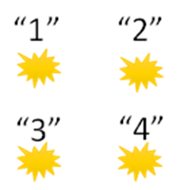

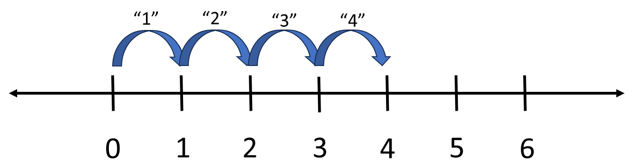

Counting discrete objects vs counting intervals
There are also practical considerations. If someone is using a yardstick to measure the height of the chair, they will want the zero to start at the floor, since the yardstick is not bendable, and the extra length can stick into the air, but not into this floor.
Tape measures are wobbly, can sag due to gravity, and usually need an extra person to hold the beginning.
This unit provides students with opportunities to practice with all of these tools, make mistakes, and get feedback so they can develop comfort and accuracy with these tools.

Choosing Tools Strategically
Part of attaining “fluency” in measurement is choosing the tool that makes the measurement as easy as possible. When it comes to length measurements, this involves recognizing the ideal size that each tool can best measure. For small objects, a ruler may be the easiest to read and manipulate. For longer length measurements (over 3 feet), it is usually much easier to use a tape measure. Students occasionally use some good problem solving to measure a long table with rulers or yardsticks, but we also want them to see that using the tape measure is probably faster and more accurate in that situation. Yardsticks can be useful for medium sized objects, although these are less common for people to have lying around (since they are long and usually don’t fold.) Many of these activities explicitly ask students to be strategic in their choice of measuring tool: ask students to reflect on the advantages and disadvantages of each one, especially if they stick to one tool for everything.

Estimating Length
Students may have few internal benchmarks for estimating the length of objects they encounter. For example, ask students how high they think the classroom ceiling is, and see what kind of numbers you get. Without internal benchmarks, guesses can range all over. However, if you have a student share their height, then stand against the wall, and ask them to estimate again, you may get some better estimates. (Most ceilings are 9–11 feet high. If an average student is about 5.5 feet, most ceilings will be roughly twice their height. This simple benchmark suddenly makes the ceiling height suddenly much easier to understand).
In this unit, students will learn body benchmarks for common units and measurements. Since they are part of their own body, they will always be available for use!

Making Length Comparisons
Many beginning students need help with the language and grammar of comparisons, in which we discuss the difference between lengths, not the lengths themselves.
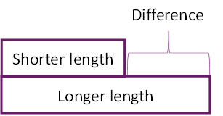
This unit uses a simple diagram and grammar structure and lots of scaffolded practice to help students master this concept and grammar, which will help them in both real-life situations and word problems.

Activities and Practice

Introducing the Unit
In-Person/Remote Activity
Uses Student Packet p. 18
Have students read the text on p. 18. The prompt (A time when you had to measure or estimate the length of something) can be used for a Think, Pair, Share—students get a minute to think, then to share with a partner, then a few groups share with the whole class.
Point out any details of the shared stories that are relevant to the idea of measuring and estimating. What tools (formal or informal) did they use? What units? Why? See if any students mention their thinking about why they chose a certain unit or tool (was it based on the size of the thing to be measured? Did they have to think about how accurate the measurement needed to be? All of these real-life experiences are relevant to the math students will be learning in this unit.

Who Is Right? and Notes on Using a Ruler
In-Person/Remote Activity
Uses Student Packet pp. 21–22
Introduce the Who Is Right? scenario and give students some time to think. Then they should discuss, giving reasons. If students don’t see the problem with starting at 1 on the ruler, make the intervals more visible and explain that when we measure inches we are counting distances, not just the tick marks on the ruler. If we want to use the numbers on the ruler, we have to make sure we start at 0 (or the end of the ruler) so the count is correct.
Two images from Who Is Right? The first shows a measured object starting at 1 (ruler count doesn’t correctly give length). The second shows the measurement starting at 0 (ruler count gives length correctly).
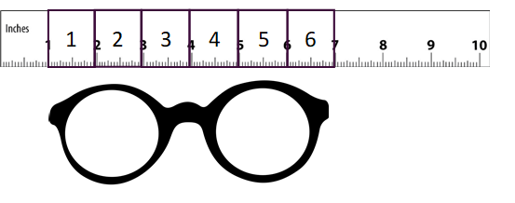
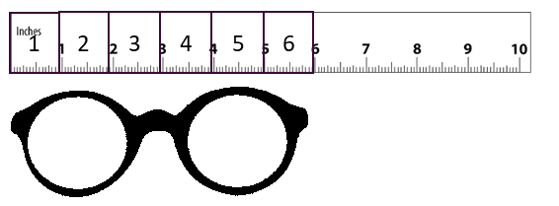
After this discussion, go over “Notes on Using a Ruler” on Student Packet p. 22 and practice by having all students measure a standard object (such as a marker).

Classroom Measurements – Small Objects
In-Person/Remote Activity
Uses Student Packet pp. 23–24
Setup: Place around 5 small objects on each table for students to measure. If possible, provide identical objects to each group (like glue sticks, pencils, etc.). Have different rulers available on each table.
Note: In a remote classroom, have students measure the images on p. 24 in the Student Packet, so that they are all measuring the same thing.
- Have students measure the objects to the nearest inch and record their measurements in the table on p. 23. As you walk around, see if students are using the rulers correctly and recording data in the tables correctly.
- Debrief as a class. If groups disagree on any of the measurements, have them investigate and see if they can come to an agreement.

Classroom Measurements – Large Objects
In-Person/Remote Activity
Uses Student Packet, p. 25
Setup: Mark around 5 large objects in the classroom for students to measure (tables, chairs, whiteboards, windows, etc.) Indicate whether they should measure the length, width or height of the object with arrows. Have different measuring tools (rulers, yardsticks, tape measures, paper tape measures) available.
- Teach the names of the measuring tools and units as vocabulary words and show students how inches and feet are measured with each tool.
- Have students measure the objects to the nearest inch and record their measurements in the table on p. 25. As you walk around, see if students are using the rulers correctly and recording data in the tables correctly.
- Debrief as a class. If groups disagree on any of the measurements, have them investigate and see if they can come to an agreement.
- Ask: Which tool did you use to measure each object? Why did you choose that tool?

Introducing Routine 2: Estimate the Length…
In-Person/Remote Activity
Uses downloadable file Estimate the Length PowerPoint
This is a simple warm up to get students to make use of familiar benchmarks to estimate the lengths of other objects.

Review some common benchmarks (these are the same ones used in the previous warm up):
- Last joint of your thumb: about 1 inch
- Width of your pinkie: about 1 cm
- Forearm: about 1 foot
- Pen: about 6 inches
- Length of notebook: about 1 foot
- Height of chair: about 1 yard / 1 meter
- Your height: varies, but each person will know their own height!
Ask students to use one of these benchmarks to estimate the length of the object on the slide. After students share their estimates, ask: Do you think your estimate is higher or lower than the exact measurement? Why?
Have them check some of their estimates with exact measurements.

Vocabulary Review 3
In-Person/Remote Activity
Uses Student Packet, p. 26
Fill in the blank vocabulary review for ruler, yardstick, measuring tape, feet, inches

Answer Key:
- measuring tape
- feet
- ruler
- inches
- yardstick

Language Support: Comparing Lengths
In-Person/Remote Activity
Uses Student Packet, pp. 27–33
This section addresses the challenging grammar structure associated with talking about length comparisons, or the difference between two lengths. Being asked to compare lengths (and other measurements or amounts) is common in word problems and these grammar structures are often challenging for English learners and native speakers alike.
- The materials start by creating a little cognitive dissonance with “Who Is Right?” Student Packet, p. 27. The dialogue draws attention to how we can talk about length comparisons without mentioning the actual lengths involved.
- Next, in “Comparing Lengths: Difference” on p. 28, the word difference is defined, and students are given a visual chart showing the relationship between the longer and shorter lengths.
- In “Asking for the Difference,” p. 29 students are introduced to the grammar of a question that asks for the difference between two lengths.
- In “Comparing Lengths: Examples,” p. 30, students are given an anchor chart showing the grammar structure.
- The next three pages (pp. 31–33) provide additional scaffolded practice with this grammar, including a two truths and a lie activity.
- This is a challenging piece of grammar to use correctly, and many students will benefit from frequent short, cyclical review (warmups, homework, review questions on quiz).

Language Support: More Practice Comparing Lengths
In-Person/Remote Activity
Uses Student Packet, p. 34
This activity has students writing sentences to compare lengths with less scaffolding.

Measure and Compare
In-Person Activity
Uses Student Packet pp. 35–36

From Investigations Grade 3, Curriculum Unit: "FROM PACES TO FEET" © 1993 by Savvas Learning Company LLC, or its affiliates. Used by permission. All Rights Reserved.
Students measure and compare the length of familiar objects in the classroom. After they collect their measurements, they should write a statement of comparison for each pair of lengths, using the grammar structure learned in this unit.
Corrections alternative: If any of the objects on the card are not available in the classroom, substitute another common object, or cut out pictures of objects out of paper.

More Data Collection Activities
In-Person Activity

From Investigations Grade 3, Curriculum Unit: "FROM PACES TO FEET" © 1993 by Savvas Learning Company LLC, or its affiliates. Used by permission. All Rights Reserved.
Choose one or both of these activities for additional practice collecting data.
Have students create a table of the data, and a dot plot of the results. If students still need support, record these together as a class. Use this as an opportunity to continue to talk about the data, shape, center (median), and spread (range). Encourage students to measure to the nearest inch and discuss what this means if necessary.
After the data has been collected, ask students: What is a typical distance that the paper ball (or block) travelled? What do we mean by a “typical” value?

Flicking Paper
- Clear a straight area in the classroom. You will need a table on one end (the launching point!) and a long tape measure that starts on the floor just under the edge of the table. Students take turns flicking a balled-up piece of paper with their thumb and forefinger, and measure how far it travels. (Use a small piece of paper to make the ball).
- There will be lots of opportunity for discussion around measurement parameters, such as what to do if a flick misses the ball or if the ball goes far in a lateral direction or bounces off an object. Have the class discuss and decide how they want to deal with these situations.

Blowing a Block
- Use a plastic pattern block or snap cube or something light. You can tape a yard stick to a table and use a piece of tape as the starting line. Each student can use the baster to blow the cube as far as they can. Have students discuss parameters and procedures for misses and other irregularities that come up.
Corrections alternative: The flicking paper activity may be easier in a corrections setting because only paper and a measuring tape are needed.

Introduction to Metric Measurements
In-Person Activity
Uses Student Packet, p. 37
There is a short text in the student packet about where metric units are used, and the history of metric units in the United States. See which students are already familiar with metric units. This is also a good place to teach metric system as a vocabulary word.
metric system: A system of measurements that uses meters and centimeters to measure length.

Metric Scavenger Hunt
In-Person Activity
Uses Student Packet p. 38
Reproducible Centimeter Grid Paper, Teacher’s Guide p. 51

From Investigations Grade 3, Curriculum Unit: "FROM PACES TO FEET" © 1993 by Savvas Learning Company LLC, or its affiliates. Used by permission. All Rights Reserved.
- Explain that students are going to be searching for things in the classroom that are about 1 centimeter long or about 1 meter long. In order to do so, they are going to make a meter strip.
- Distribute scissor and one-centimeter graph paper and have everyone cut out a centimeter square. Next, ask them how they could make a strip from the paper that is one meter long. Encourage them to use the number of centimeter blocks on the paper to help them create a strip 100 cm long. (Pay attention to whether students count every single block, or whether they can put together larger strips to make 100.)
- Once students have their centimeter and meter strips, have them use these to search the classroom or school for things that are about 1 cm or 1 m long. Emphasize that these do not have to be exactly 1 cm or 1 meter, but they can be approximately this long. Have them record what they find on in the Student Packet p. 38 and debrief when they are finished.
Note: Meter sticks can be used if they are available, but these can be hard to find in the US.

Corrections alternative: Cut out meter strips ahead of time for groups of students to share. The grid paper is 20 cm long, so you will need to cut 5 strips and tape them together. Students may want to number the squares to make them easier to use.

My Sizes in Metric
In-Person Activity
Uses Student Packet p. 39

From Investigations Grade 3, Curriculum Unit: "FROM PACES TO FEET" © 1993 by Savvas Learning Company LLC, or its affiliates. Used by permission. All Rights Reserved.
Have students use paper meter strips to measure different parts of their body. Before they start, come to an agreement as a class about how/where to measure head circumference, sleeve length, etc., so that measurements are consistent.
If students need more practice with data collection and finding median and range, you can collect this data as a class and use it to review these concepts. Be sensitive to which measurements your students are comfortable taking and sharing.

Health Literacy: Talking About Height and Ordering Uniforms
TSTM Skills: Communication, Problem Solving
In-Person/Remote Activity
Uses Student Packet pp. 40–41
The first page goes over the symbols and abbreviations that students will encounter in the US when talking about a person’s height, and how they are read aloud. The second page introduced a problem-solving situation where students have to use height and weight data and a size chart to make decisions about what size uniforms a parent should order for their children. Have students justify their decisions, especially since some of the children’s measurements do not align clearly with one size. Make sure students can read and interpret the information in the size chart and can identify numbers that fall in a range (such as knowing that 51” falls in the range 50”–52”).

Unit 2 Vocabulary Quiz (Summative Assessment)
In-Person/Remote Activity
Reproducible in Teachers Guide pp. 44–45

Answer Key:
Part 1
- ruler
- tape measure
- tape measure
- ruler
Part 2
- feet
- inches
- feet
- inches

Exit Ticket Homework (Summative Assessment)
In-Person/Remote Activity
Uses Student Packet p. 42
This exit ticket is meant to assess whether students can use a ruler to correctly measure the length of the pictures on the paper, and whether they can fill in a comparison sentence correctly.

Vocabulary
ruler: A measuring tool. Used to measure the length of small objects.
yardstick: A measuring tool. Used to measure the length of medium objects.
tape measure (measuring tape): A measuring tool. Used to measure the length of longer objects or spaces.
foot: A measurement unit. Contains 12 inches.
inch: A measurement unit. 12 inches make 1 foot.
metric system: A system of measurements that uses meters and centimeters to measure length.

Things to Watch For

Correctly lining up the ruler
Since we start counting with the number one, it is common for students to think of 1 as “the beginning” and to start measuring from the 1” mark on the ruler, especially since the 0 is often not labelled. If this is happening, demonstrate with tiles or inch sticks to reinforce the idea that the inches are the spaces between the ruler lines, not the lines themselves. Students who struggle with this concept can also practice with rulers like these by EAI Education that combine the visual of an inch stick with the lines of a ruler.

Measuring to the nearest unit
Most objects are not exactly a whole number of units, and this curriculum does not work with fractions. Explain that students should choose the number of units closest to the length. If they struggle, have them practice with inch sticks or rulers with fewer lines so it is easier to visually see which unit line is closer.

Unit 3: Using Dimensions
Learning Objectives | CCRSAE
I can use correct vocabulary and grammar to identify the dimensions of an object.
I can measure and compare dimensions to find a piece of furniture that would fit in a given space. | 2.MD.2-4, MP.3, MP.5

Standards for Mathematical Practice
MP.5 Use appropriate tools strategically
Students will consider the best measuring tool to use to complete a contextualized task.
MP.6 Attend to precision
Students will consider the range of dimensions of a piece of furniture that could fit in a certain space.

Extra Resources for this Unit
- Downloadable file: What Am I? Template PowerPoint
- Reproducible: Evaluation Unit 3, Teacher’s Guide, p. 41
- Reproducible: Unit 3 Vocabulary Quiz, Teacher’s Guide, pp. 46–47

Other Materials:
Painter’s tape, rulers (inches and centimeters), yardsticks, tape measures
Access to computers

Math Background

Three Dimensions
Dimensions are directions that we can measure in. Mathematically, one dimension is a line, which can only have length. Two dimensions is a plane, which can have shapes with length and width. Three dimensions is the world we live in, where objects have length, width and height. Each measurement is taken at a right angle (perpendicular) to the others. If we think about how we graph space on a two- or three-dimensional coordinate plane, the axes show these right angles to one another.
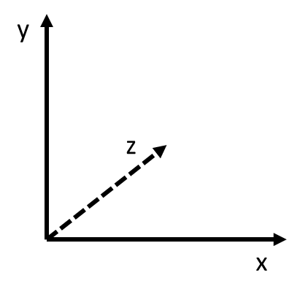
In this unit, students will start measuring in three dimensions. The words and grammar for dimensions words in English are challenging, so this unit provides practice with the vocabulary and grammar to talk about height, width, length, (and depth). In most cases, there are no hard and fast rules about which dimension word goes with each measurement, but there are some guidelines about general usage:
- For two dimensional objects, the longer measurement is often called the length and the shorter measurement the width.
- For three dimensional objects that don’t have a specific orientation, the longest measurement is often called the length.
- For three dimensional objects that do have a specific orientation, the measurement up and down from the ground is the height. The names of the others can vary.
- For furniture, the vertical (up and down) measurement is the height, the horizontal (side to side) measurement is the width, and the measurement out from the wall is often called the depth. This last word is introduced in the furniture activity.

Activities and Practice

Introducing the Unit
In-Person/Remote Activity
Uses Student Packet p. 43
Have students read the text on p. 43. The prompt (A time when you had to decide if something would fit in your home.) can be used for a Think, Pair, Share—students get a minute to think, then to share with a partner, then a few groups share with the whole class.
Point out any details of the shared stories that are relevant to the idea of measuring or estimating space and considering the dimensions of an object to decide if it will fit. What tools (formal or informal) did they use? What units? Why? Which dimensions of the object did they mention? Did they use any proxy measurements (such as measuring with a string and bringing the string to the store)? Did they run into problems? Did they think about how accurate the measurement needed to be? All of these real-life experiences are relevant to the math students will be learning in this unit.

Warmup Routines
In-Person/Remote Activity
Uses downloadable files About the Same Length PowerPoint and Estimate the Length PowerPoint
Continue alternating Routine 2 (Number of the Day) and 3 (Two Truths and a Lie) as warmups, as needed. In this unit, you will introduce a new routine, called What Am I?

Introduce Routine: What Am I?
In-Person/Remote Activity
Uses downloadable file What Am I? Template PowerPoint
Choose a large object or two in the classroom. Measure the length and width of the object. On each slide, write 3–4 clues to help students figure out what the object is. Your clues should include the measurements (see example in the What Am I? Template PowerPoint).
Leave measuring tools out and allow students to choose the tools they want to use. Students will have to measure objects around the room to solve the riddle, and they will also need to convince others if they think they have the answer.
Once students understand the routine, creating a riddle or two for the start of each class is a fun opener and good practice using the measuring tools.

Dimensions
In-Person/Remote Activity
Uses Student Packet, pp. 46–47

- Teach the definition of the word dimensions: Measurements of an object in different directions. Usually includes length, width, and height.
Discuss the difference between an object with two dimensions (like a shape, a rectangle) and an object with three dimensions (a solid, like a box).
- Students often want to know how to tell which measurement is length, which is width, and so on. Explain that there are no hard and fast rules, but there are guidelines (see Math Background, pp. 33–34 of this Teacher’s Guide).
- On p. 46, the names of the measurements are nouns. They use articles (often “the”) and act as the subject in a sentence. Have students read the examples.
- On p. 47, the adjective forms of each dimension are given. All of these are pretty irregular, so practice pronunciation and spelling of the noun and adjective forms as needed. Point out that the adjective forms are describing words, and they often come after the measurement itself (30 feet high).
- Have students complete grammar practice on p. 48.

Measure Dimensions
In-Person Activity
Uses Student Packet pp. 49–50
- Indicate a chair and table in the room for students to measure and make measuring tools available.
- As students measure, ask:
Does it matter if I measure the table height from top to bottom or from bottom to top?
Does it matter if I measure this side of the chair or this side (the opposite parallel side)?
Which measurements are more useful, the measurements to the closest foot or the measurements to the closest inch? Why do you think that?

Final Project

Financial Literacy: Buying Furniture

TSTM Skills: Processing and Analyzing Information, Problem-Solving
In-Person Activity
Uses Student Packet pp. 52–56
Need computers available for students to use

Setup
Check ahead of time that computers available to students can access Wayfair.com or find a similar online furniture retailer.
Mark a large rectangle on the floor with painters’ tape. This will be the space available for an area rug.
Extension: Mark an area on the wall of the classroom as the space for a bookshelf or choose a bookshelf in the classroom that will be “replaced.” This is what students will measure to determine the space available for a bookshelf.
Optional extension to the project (bookshelf, which involves measuring in 3 dimensions, pp. 55–56). You can have student pairs choose one or the other as a way to differentiate, assign one or the other, or complete both.
- Read the opening p. 52 with students and answer questions.
- Have student pairs work together and provide support as needed.
- When students find a rug or bookshelf, ask them how the dimensions compare to the space they measured. Which dimensions are longer? Which are shorter? By how much? Make sure they consider how the differences will work in the space. They may want to mark out the dimensions of the actual object on the floor or wall to see if they are acceptable.
- Have students complete the written exercise at the end of the project to practice the grammar of comparison.
Corrections adaptation: Print out several product descriptions ahead of time and have partners discuss which would best fit the space.

Unit 3 Vocabulary Quiz (Summative Assessment)
In-Person/Remote Activity
Uses Reproducible pp. 46–47 in Teacher’s Guide

Answer Key:
Part 1
- 5 ft
- 8 ft
- 335 in
- 15 in
- 17 in
Part 2
- high
- width
- deep
- length
- high

Vocabulary
dimensions: Measurements of an object in different directions. Usually includes length, width, and height.
length/long: Often, the longer of two dimensions.
width/wide: Often, the shorter of two dimensions.
height/high: The measurement up and down.
depth/deep: In furniture, the measurement out from the wall.

Things to Watch For

Measuring in Different Directions
Dimensions are measurements in different directions, perpendicular to each other. Sometimes students will measure the same direction twice, such as measuring the width of a bookshelf at the top and bottom of the shelf, without recognizing that this is only a single dimension (width). Use visuals and real-life modeling to reinforce the different directions, and when possible, refer to the students’ frame of reference (i.e., height is up and down, width is side to side, depth is away from you).
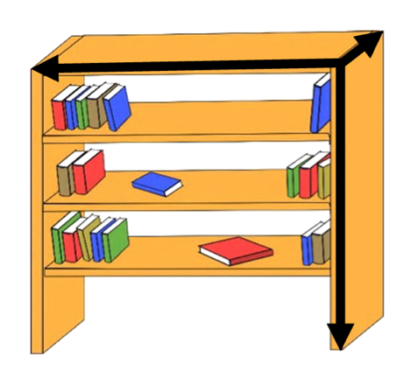

Reading and Comparing Dimensions Correctly
Let’s say students are looking for a rug to fill a space that is 5’ x 7’. They find a rug that is 7’ x 10’. Students may not compare lengths to lengths and widths to widths and may conclude that this rug is a good fit because one of the numbers matches. While rugs can be turned, it is even more important that students compare dimensions correctly (heights to heights widths to widths and depths to depths) with bookshelves, which need to be positioned a certain way. Websites that show furniture dimensions usually include a labelled diagram of the piece of furniture, so this can be a good reference as students are trying to make sense of the measurements.

Real Life Considerations
The goal is to replicate real-life decision making with this project, so push students to think about things like walkways, barriers, and gaps between the piece and other furniture.

Name:___________________________ Date:__________________

Measurement and Data: Unit 1, Steps and Directions
Objective | Student Self-Evaluation  (Struggling, Learning, Mastery) | Teacher  Evaluation
- I can measure the same distance using large and small steps.
- I can make a dot plot of measurement data.
- I can write directions to get from one place to another.
- I can find the median and range of a group of measurements.

Name:___________________________ Date:__________________
Measurement and Data: Unit 2, Measuring Length
Objective | Student Self-Evaluation  (Struggling, Learning, Mastery) | Teacher Evaluation
- I can use a ruler, yardstick, or measuring tape to measure length.
- I can measure length to the nearest foot or inch.
- I can use correct grammar to compare the lengths of two objects.
- I can measure length to the nearest centimeter.
I can use familiar benchmarks to estimate length in different units.
Name:___________________________ Date:__________________
Measurement and Data: Unit 3, Using Dimensions
Objective | Student Self-Evaluation  (Struggling, Learning, Mastery) | Teacher Evaluation
- I can use correct vocabulary and grammar to describe the dimensions of an object.
- I can measure and compare dimensions to find a piece of furniture that would fit in a certain space.

Name:___________________________ Date:__________________

Unit 1: Vocabulary Quiz
Part 1
Word Bank
data dot plot units length
Fill in the blank with the correct vocabulary word. Each word is used once.
- How long does it take people in our class to get to school? If I want to answer this question, I need to collect ____________.
- Some common ___________ used to measure length are feet, inches, and centimeters.
- When my son was born, his weight was 8 pounds, 7 ounces and his ____________ was 20 inches.
- The graph below is a ___________.

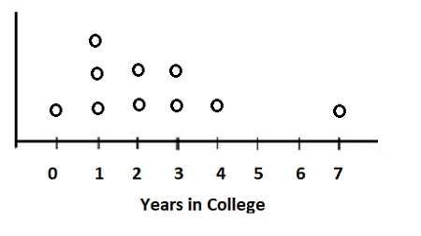

Part 2
Find the median (middle value) of the data below.

Find the range of the data below.

Name | Age (years)
Peter | 5
Khalil | 3
Maritza | 6
Destiny | 8
Laura | 2

Name:___________________________ Date:__________________
Unit 2: Vocabulary Quiz

Part 1
For each object, circle the best tool to measure the length.

Tools
- Cell phone ruler yardstick tape measure


- Door ruler yardstick tape measure

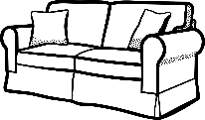
- Couch ruler yardstick tape measure


- Shell ruler yardstick tape measure

Part 2
For each blank, write feet or inches.

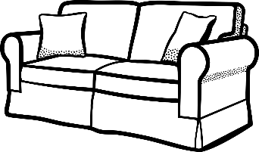
- A couch is about 8 _________ long.

- A cell phone is about 6 _________ long.


- A door is about 6 _________ high.

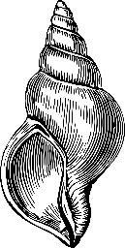
- A shell is about 5 _________ long.

Name:___________________________ Date:__________________
Unit 3: Vocabulary Quiz

Part 1
Fill in the blank with the correct measurement from the picture.
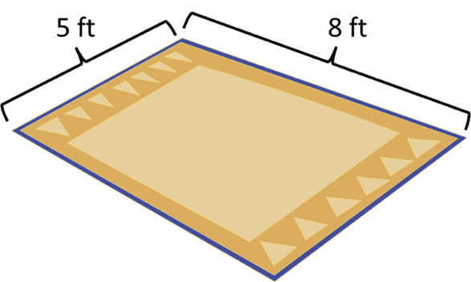
- The rug is _________ ft wide.
- The rug is _________ ft long.

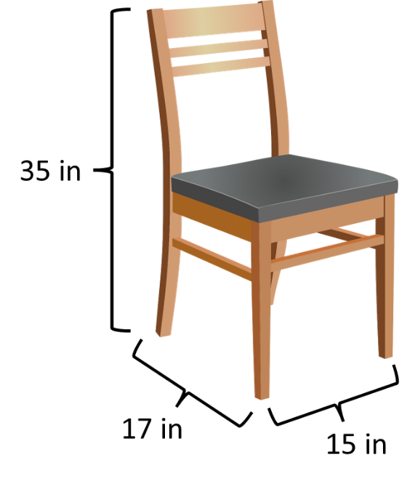
- The height of the chair is _________ in.
- The width of the chair is _________ in.
- The depth of the chair is _________ in.

Part 2
Circle the correct word to complete the sentence.
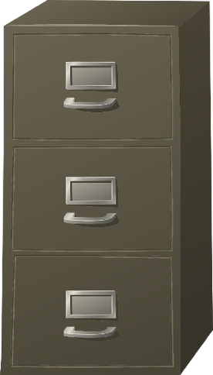
- How (high/height) is the filing cabinet?
- The filing cabinet has a (wide/width) of 38 cm.
- The filing cabinet is 45 cm (deep/depth).

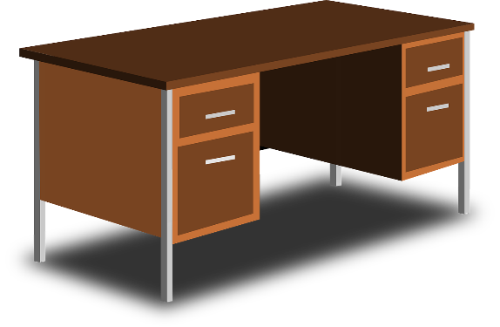
- What is the (long/length) of the desk?

- The desk is 30 inches (high/height).

INCHSTICK
An inchstick is a ruler, 12 inches long, with inch lengths marked off in alternating dark and light squares. Because there are no numbers on an inchstick, students must actually count the units as they make measurements of length, rather than reading off a number that they may not understand.
When printing, be sure to select “actual size” to prevent auto-resizing.

Adapted from Investigations Grade 3: Curriculum Unit: "FROM PACES TO FEET" © 1993 by Savvas Learning Company LLC, or its affiliates. Used by permission. All Rights Reserved.
[NOTE: The presented content is for example only and may not appear in the same format (or order) as the original publication.]

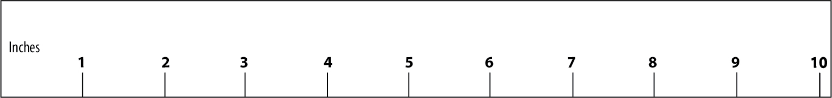
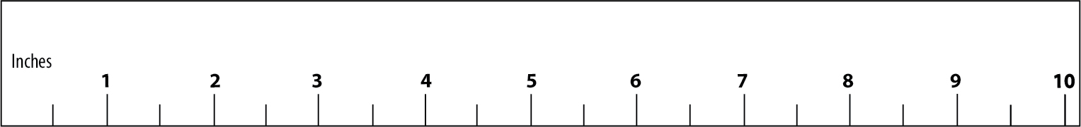
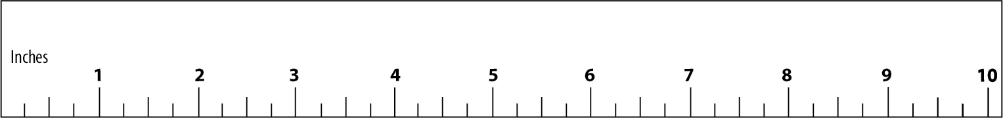
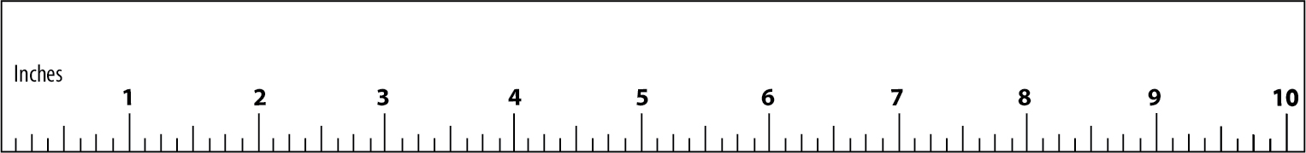
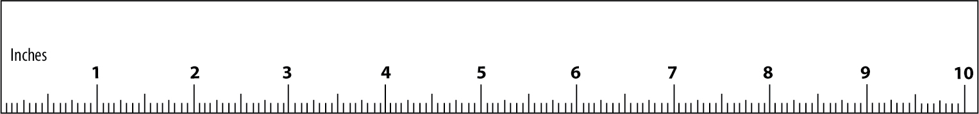

Centimeter rulers

Centimeter grid (20 cm x 20 cm)

