
Measurement and Data
Beginning Curriculum for Adults Learning Math

STUDENT PACKET


Acknowledgements

The titles in the BeCALM series were developed and piloted in the classroom by Melissa Braaten for the SABES Mathematics and Adult Numeracy Curriculum & Instruction PD Team, with contributions from Yvonne Readdy, Emily Rudd, and Sherry Soares.

The BeCALM series includes four sequential packets:
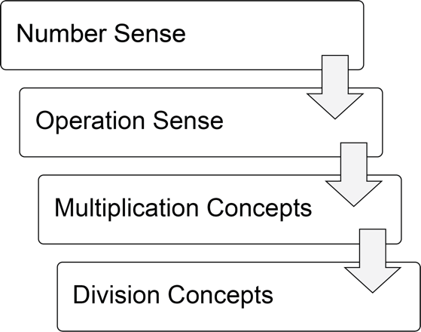

And three non-sequential packets:
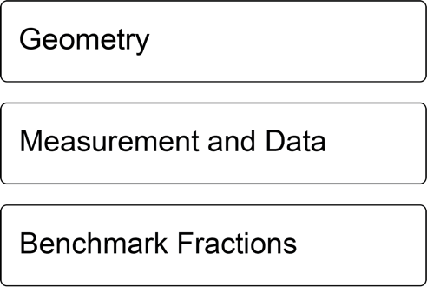

The following activities are adapted from Investigations Grade 3: Curriculum Unit: "FROM PACES TO FEET" © 1993 by Savvas Learning Company LLC, or its affiliates. Used by permission. All Rights Reserved.
Pages 34 & 35 “Measure and Compare”
Page 37 “Background on the Metric System” adapted from Investigations
Page 38 “Metric Scavenger Hunt”
Page 39 “My Sizes in Metric”
[NOTE: The presented content is for example only, and may not appear in the same format (or order) as the original publication.]
UNIT 1: Steps and Directions


In this unit, you will learn about some basic ideas in measurement and data.

Think and share:
A time when you got lost trying to get somewhere.

Vocabulary List for This Unit
Word | Definition | Example
unit  (of length) | What you ________ when you are measuring  Must be the same ________ to be useful | 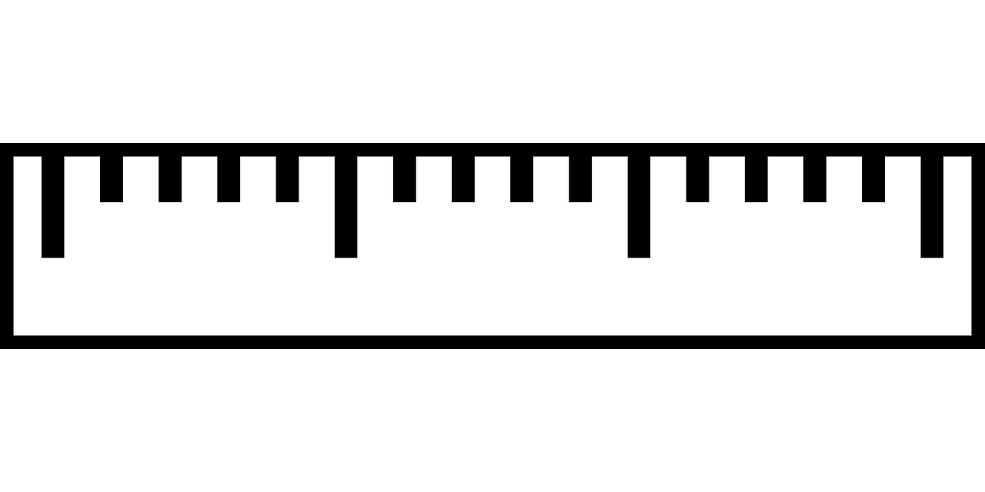
length | How ________ something is in one direction | 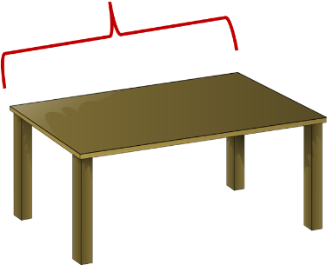
dot plot | A dot plot has numbers along the bottom, and one ________ for each time that number appears in the data | 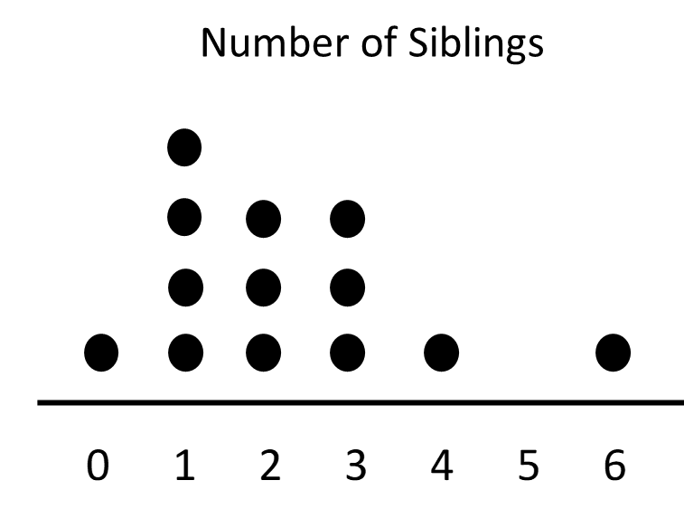
data | Measurements or counts of things in the real world

Word | Definition | Example
median | When you put all of the ________ in order, the median is the number in the ________.
range | The difference between the ________ data point and the ________ data point

Talking about Quantity

Quantity means “how many of something”

Name | Number of steps to walk across the room
Anhad | 12
Carmen | 14
Rose | 15
Patrick | 17

These examples compare the quantity of steps:
- Anhad took the least steps.
- Carmen took more steps than Anhad.
- Rose took fewer steps than Patrick.
- Patrick took the most steps.

Talking about Length
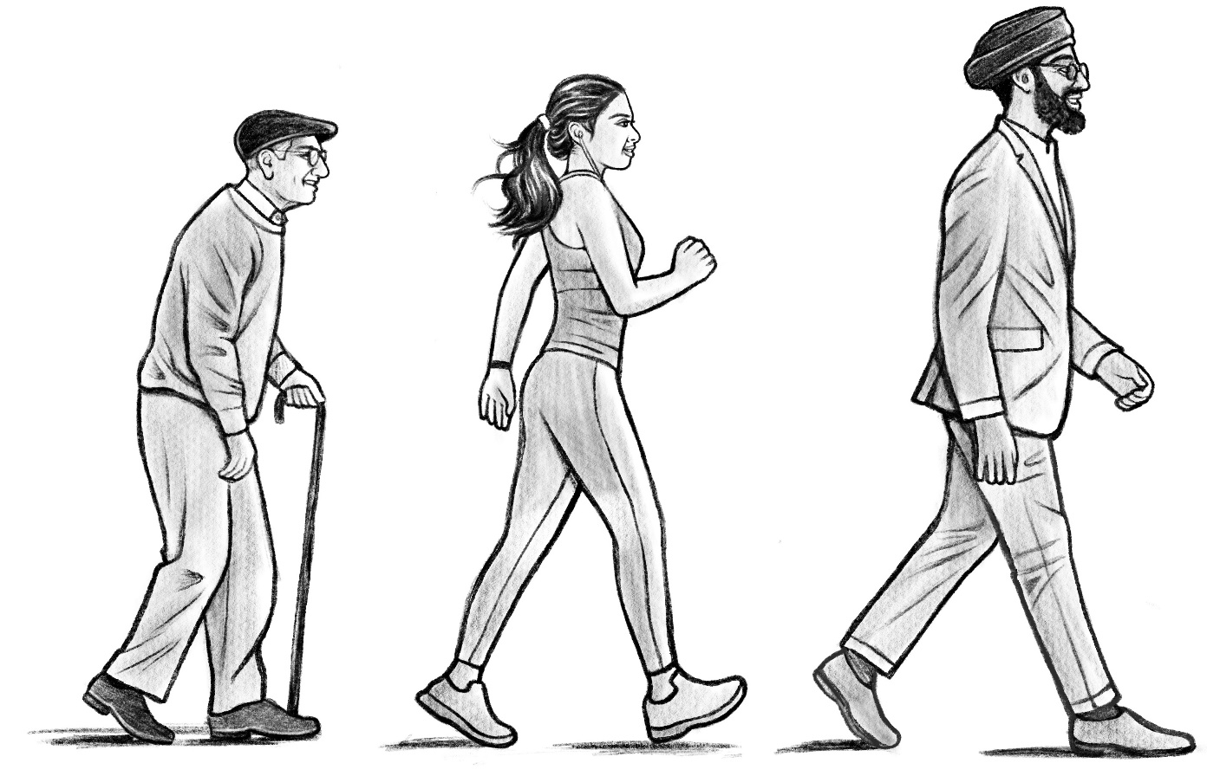
Patrick Carmen Anhad
shortest step longest step

These examples compare the size or length of the steps:
- Patrick's steps are shorter than Carmen's.
- Anhad's steps are longer than Patrick's.
- Patrick's steps are the shortest.
- Anhad's steps are the longest.

Large Steps
Name | Number of steps

Who took the most steps?

Who took the least steps?

Who took the longest steps? How do you know?

Small Steps
Name | Number of steps

Who took the most steps?

Who took the least steps?

Who took the shortest steps? How do you know?

Vocabulary Review 1

Word Bank:
unit length dot plot data

Fill in the blank with the correct vocabulary word.
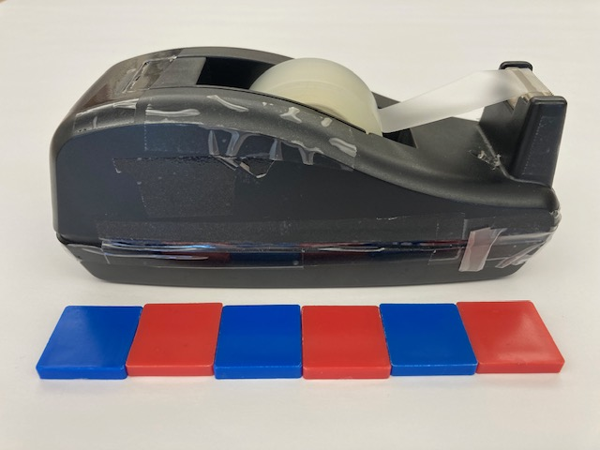
- The example above is using square tiles as a ___________.
- The ____________ of the tape dispenser is 6 tiles.
- If you want to know how tall each student in the class is, you will have to collect _____________.

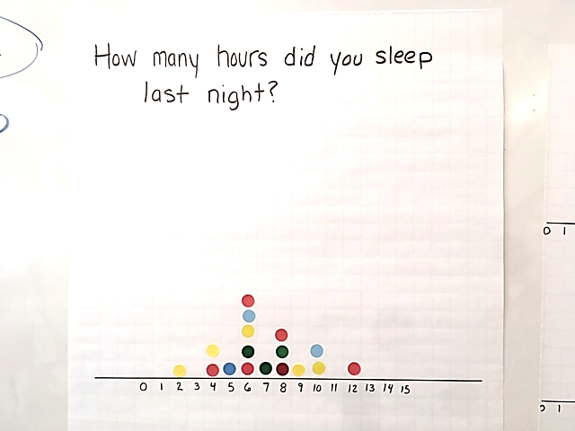
How many hours did you sleep last night?

- This is an example of a ______________. Each dot represents one person. Each dot is placed over the number of hours that person slept.

Siblings Dot Plot
How many siblings (brothers and sisters) do you have?

Name | Number of siblings



Robot Directions
Write directions from your starting point to your target.
Write one direction on each line. Each line should tell the robot a number of steps to take or to turn.

___________________________________________________________
___________________________________________________________
___________________________________________________________
___________________________________________________________
___________________________________________________________
___________________________________________________________
___________________________________________________________
___________________________________________________________
___________________________________________________________


Vocabulary Review 2

Word Bank:
dot plot data median range

Fill in the blank with the correct vocabulary word.
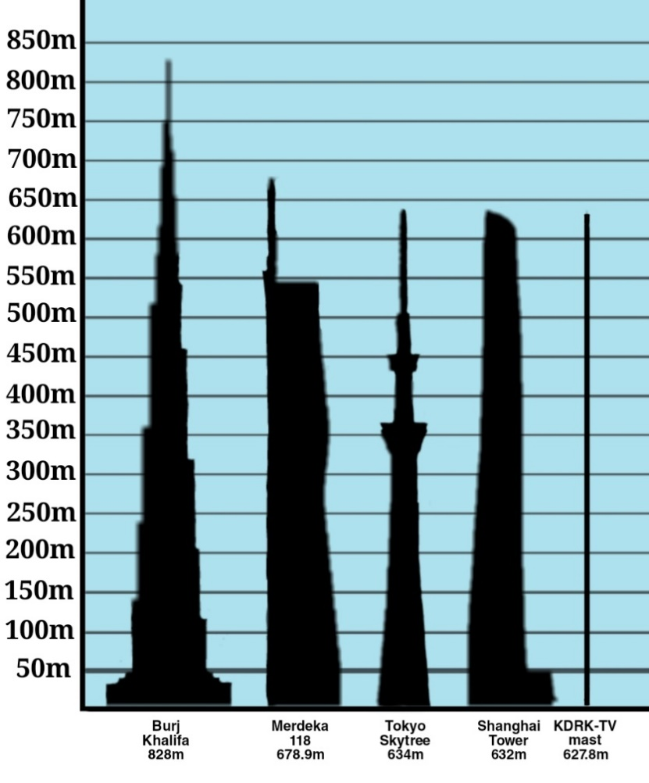
Image credit: Wofwhineoffire, CC BY-SA 4.0 via Wikimedia Commons

- The picture above shows the five tallest buildings in the world (in 2023). The height of the Tokyo Skytree is the ____________ for this group.

- This is a _____________ showing the number of siblings each person in a class has.

- The ______________ for this set of data is 6.

- A dot plot is a way of looking at ___________ to help us understand it better.

Health Literacy: Children’s Growth Charts
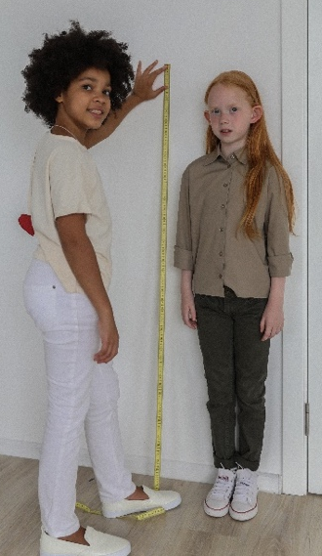
When children are young, doctors keep track of their height and growth. Sometimes, a doctor will say that a child is in a certain “percentile” for height.
The 50th percentile is another name for the median. This means that it is a middle value. If a child is in the 50th percentile for height, that means that half of the children their age are taller than they are, and half of the children are shorter.
If the percentile is higher than 50, the child is in the taller half of children their age.
If the percentile is lower than 50, the child is in the shorter half of children their age.

Median Height of Girls by Age (Data from CDC)
Age (years) | Median Height  (50th percentile) in inches
2 | 33
3 | 37
4 | 40
5 | 42
6 | 45
7 | 48

Exit Ticket/Homework
The class counted how many steps it took each person to walk down the hall.
Name | Number of steps
Maria | 25
Jose | 21
Fatima | 29
Jamal | 19

Who had the longest steps? How do you know?

UNIT 2: Measuring Length
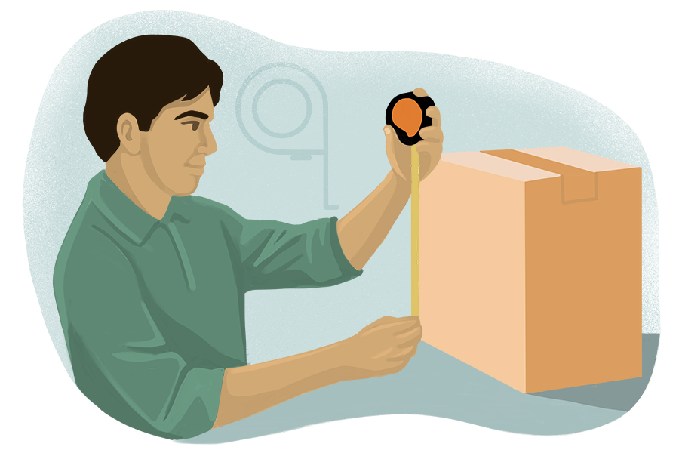

In this unit, you will learn how to measure length using different measurement tools, including rulers, yardsticks, and tape measures. You will learn to use and estimate with different units, including feet, inches, and centimeters.

Think and share:
A time when you had to measure or estimate the length of something.

Vocabulary List for This Unit
Word | Definition | Example
ruler | A measuring tool  Used to measure the ________ of small objects
yardstick | A measuring tool  Used to measure the ________ of medium objects | 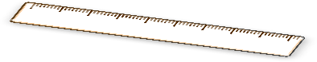
measuring tape | a measuring tool  used to measure the ________ of longer objects or spaces | 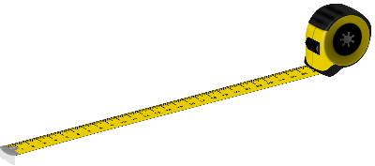
foot (feet) | A measurement unit  Contains ________ inches | 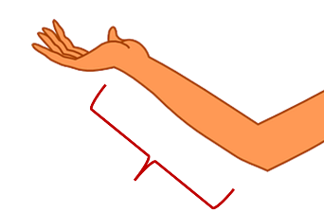
Word | Definition | Example
inch | A measurement unit  ________ of them make one foot | 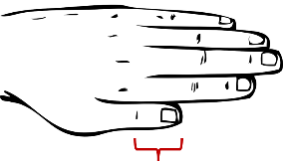
metric system | A system of measurements that uses __________ and __________ to measure length

Who Is Right?

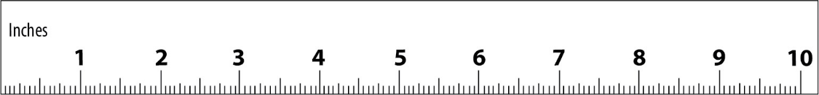

Marcel said, “The glasses are about 6 inches long.”
Diana said, “No, they are about 7 inches long.”
Who is right? Why?

Notes on Using a Ruler

Point the ruler in the same direction as the length that you want to measure.
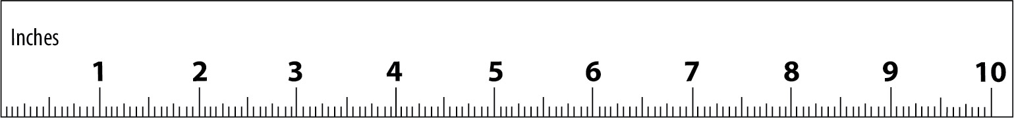
Start measuring at the 0 on the ruler. It might not be labeled.
0
Choose the inch (the labeled number) closest to the end of the length.
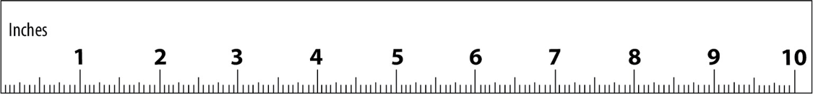

Classroom Measurements – Small Objects
Object | Length (inches)

Classroom Measurements – Small Objects (Remote)
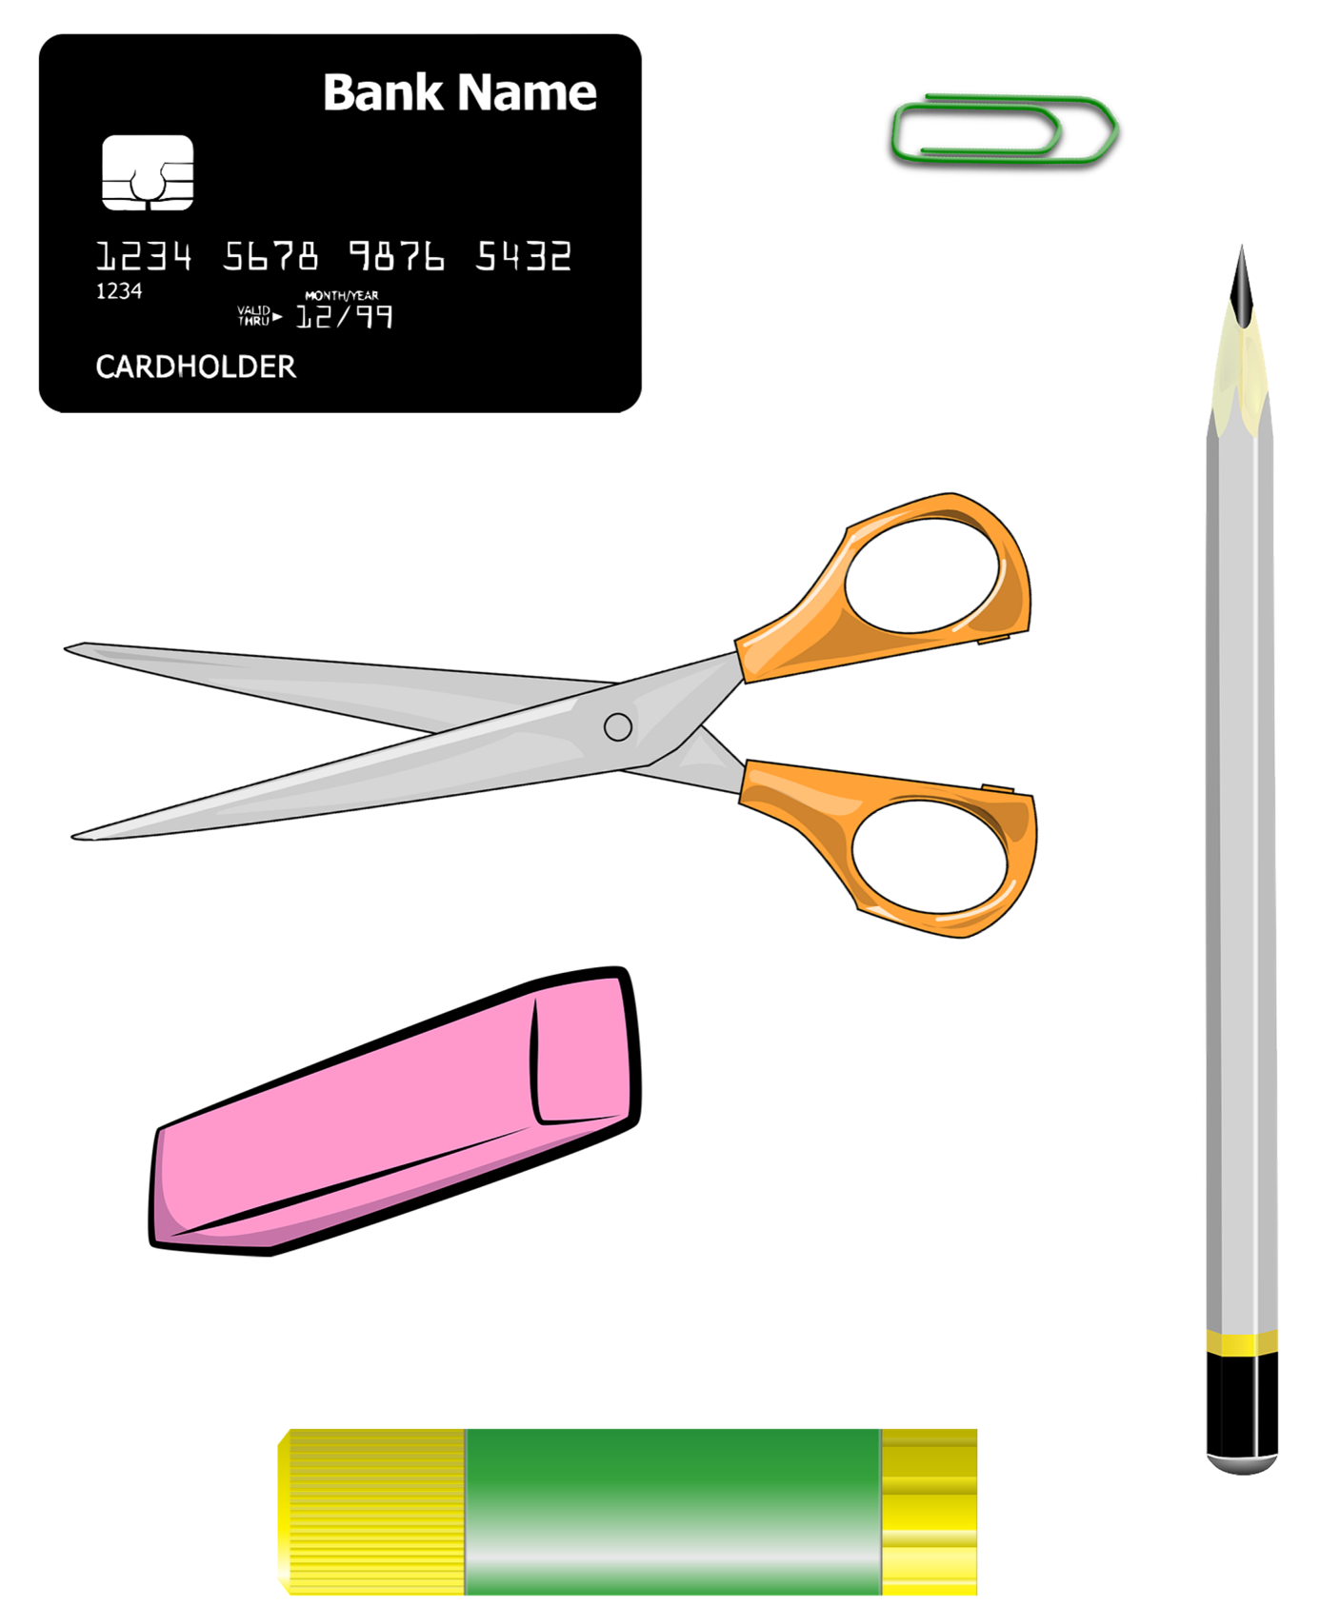

Classroom Measurements – Large Objects

Object | Length (inches)

Vocabulary Review 3
Word Bank:
ruler yardstick measuring tape
feet inches
Fill in the blank with the correct vocabulary word.

- Phil wants to buy a new couch. First, he needs to use a __________________ to measure how much space he has in his living room.
- Phil needs a couch that is no more than 9 ____________ long.
- Ellen is buying a new cell phone. She wants it to be the same size as her old cell phone. She measures her cell phone with a __________________.

- Ellen’s cell phone is 6 _______________ long.

- Melissa uses a ___________________ to measure the height of her dog.

Who Is Right?

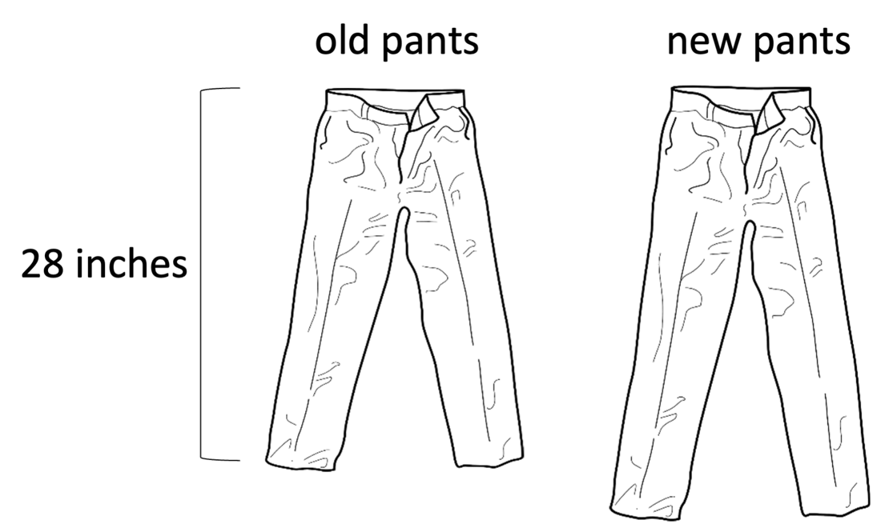

Linh: The legs on these new pants are 4 inches longer than the legs on my old pants.
Ariam: Your old pants were 28 inches long. There is no way that the new pants are only 4 inches long.

Comparing Lengths: Difference

Sometimes we want to compare the length of two things. We want to talk about how much longer or shorter one of them is than the other. This is called the difference.

Shorter length
Longer length
Difference

1 inch
Difference
3 inches

The length of the shorter rectangle is 1 inch.
The length of the longer rectangle is 3 inches.
The difference between the rectangles is 2 inches.

Asking for the Difference
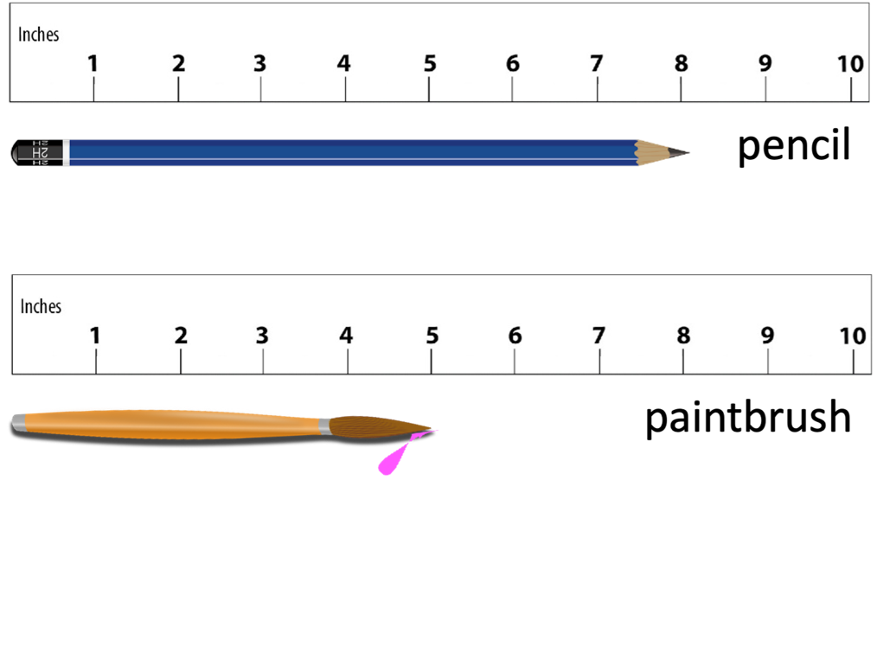
What is the difference between the two objects? ____ inches

How much | longer  shorter | is | … | than | …?

How much longer is the pencil than the paintbrush?
How much shorter is the paintbrush than the pencil?

Comparing Lengths: Examples
How much longer is the pencil? _______________
(difference)

… | is | [difference] | longer  shorter | than | …

The pencil is 3 inches longer than the paintbrush.

The paintbrush is 3 inches shorter than the pencil.

Comparing Lengths: Practice 1
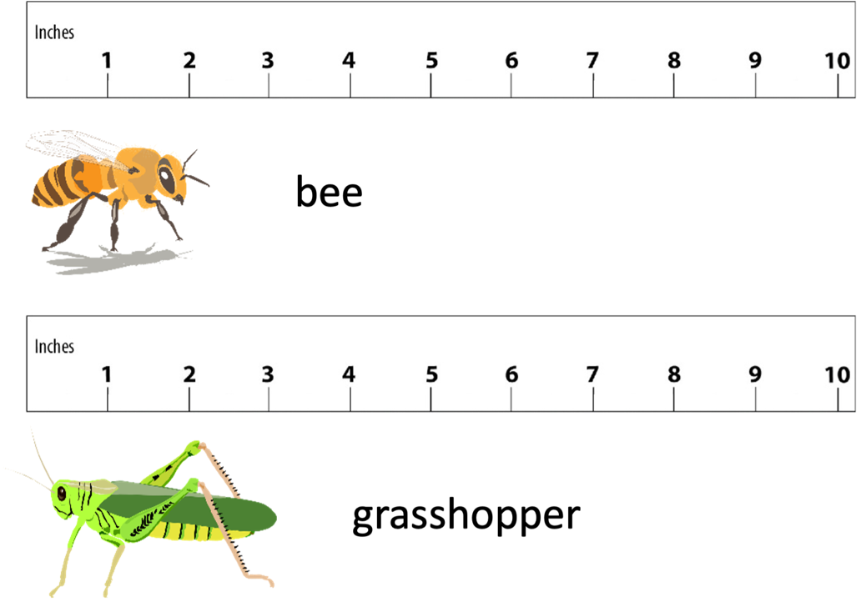

How much shorter is the bee than the grasshopper?________
(difference)

Fill in the blanks.
… | is | [difference] | longer  shorter | than | …

The __________ is __________ shorter than the ____________.

The __________ is __________ longer than the ____________.

Comparing Lengths: Practice 2
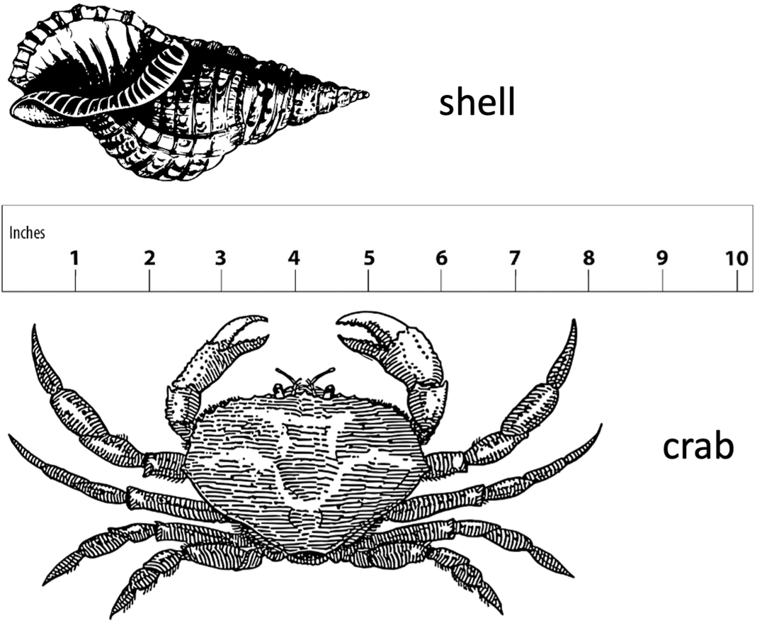

How much shorter is the shell than the crab? __________
(difference)

Fill in the blanks.
… | is | [difference] | longer  shorter | than | …

The __________ is __________ shorter than the ____________.

The __________ is __________ longer than the ____________.

Two Truths and a Lie

Which statement is the lie?
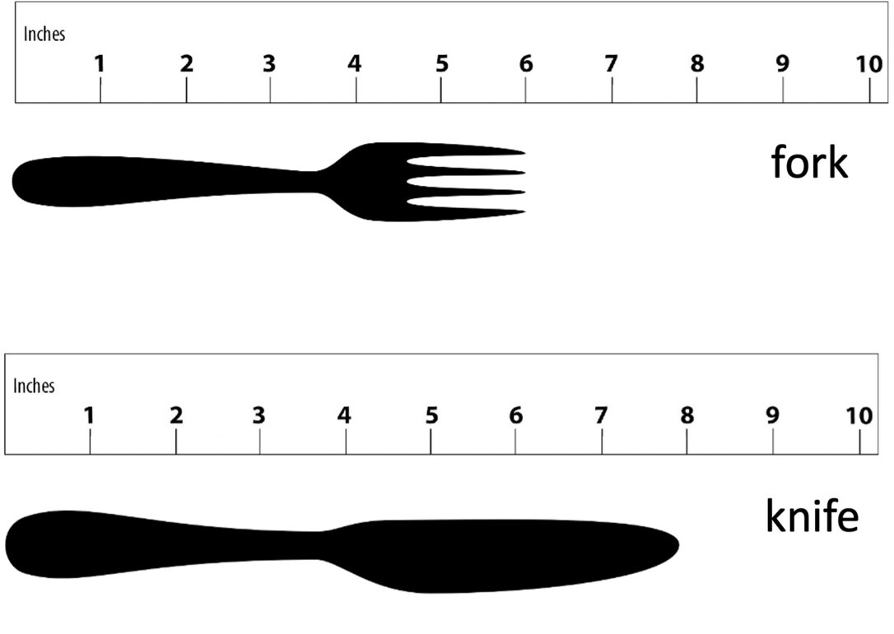

- The fork is 6 inches shorter than the knife.
- The knife is 2 inches longer than the fork.
- The fork is 2 inches shorter than the knife.

More Practice Comparing Lengths
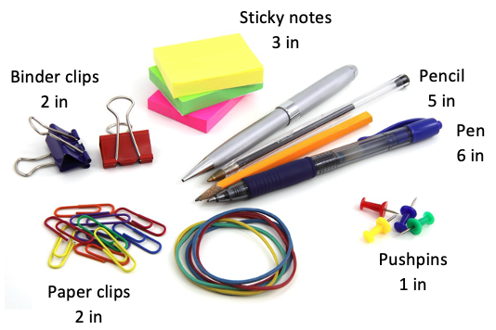
Write 3 sentences to compare the lengths of different objects.
Example:
The paper clips are 1 inch longer than the pushpins.
(difference)
1.
2.
3.

Measure and Compare
- Measure each of these things. Write down your measurements.
- Write a sentence saying how much bigger one thing is than the other. Show or tell how you figured it out.
  ID card |   marker
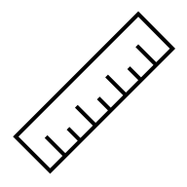  ruler |   pencil
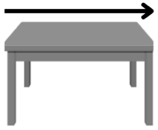  length  of table | 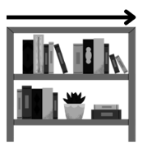  length of  bookshelf

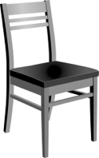  height of  a chair | 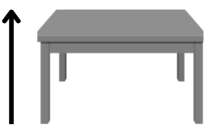  height of  a table
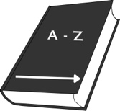  width of  a dictionary  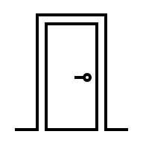 |   length of your  reading book
width of the door | 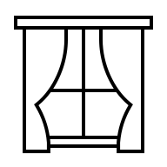  width of a window

Introduction to Metric Measurements
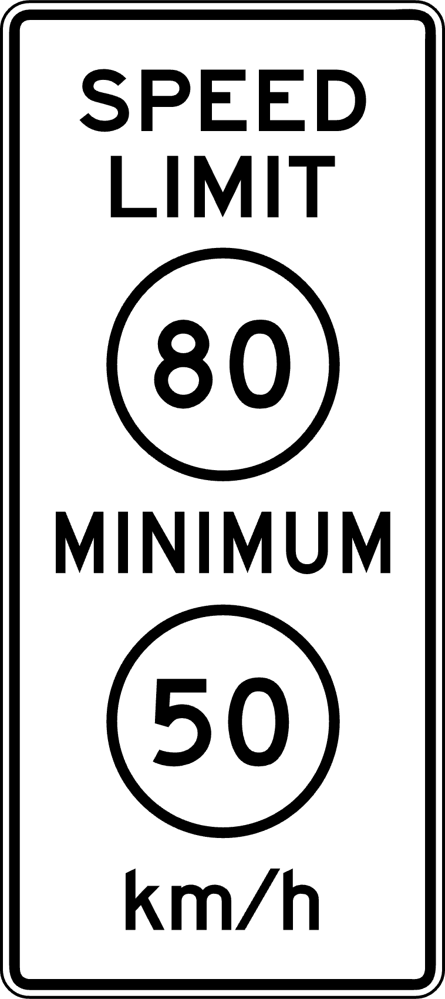
Most countries in the world use the metric system. Scientists all use the metric system so that they can easily compare results. Because of this, scientists in the U.S. know the metric system, but many other U.S. citizens do not.
Liberia is another country that uses the U.S. Standard System of measurement. Freed slaves from the United States helped to found the country of Liberia in the early 1800s. They brought the US measurement system with them. It is still used in Liberia today.
Source: Federal Highway Administration - MUTCD, Public domain, via Wikimedia Commons
The United States has tried to change to the metric system. Americans did not want to change because it is difficult to learn a new system, and it can be expensive. In the 1980s, there was a major effort to change to the metric system. For a short time, speed limit signs had both kilometers and miles per hour. This attempt by the U.S. government failed. The U.S. still uses U.S. Standard measurements today.

Metric Scavenger Hunt

Things that are 1 meter long and 1 centimeter long

Things I found that are about 1 meter long:

Things I found that are about 1 centimeter long:

My Sizes in Metric

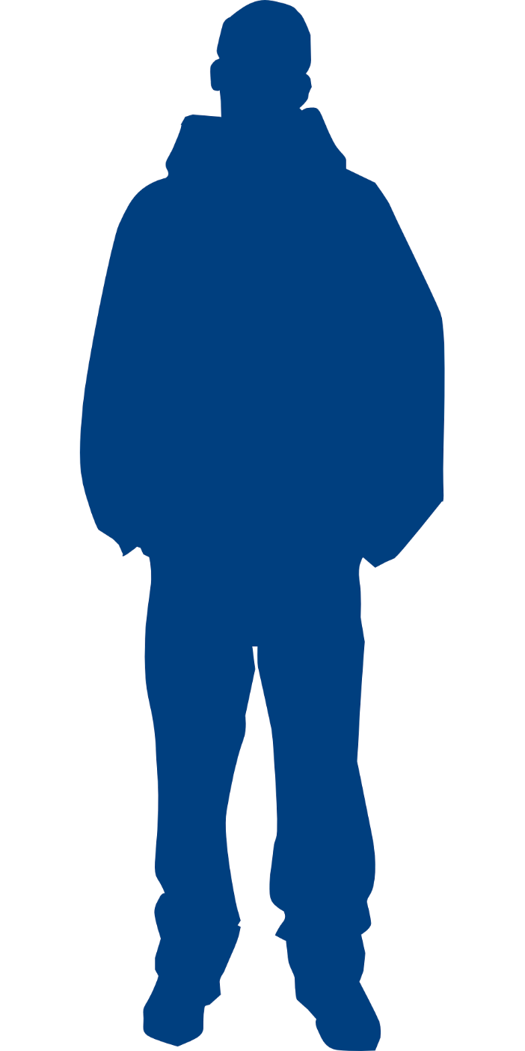
distance around your head =
_____ cm
height =
_____ cm
(Fasten your “head string” to this sheet of paper with tape.)

sleeve length = _____ cm

pants length = _____ cm

foot length = _____ cm

Image by Clker-Free-Vector-Images from Pixabay

Health Literacy: Talking About Height

In the US, an adult’s height is usually given in feet and inches. Sometimes a child’s height is given in inches only.
Unit | Plural | Abbreviation | Symbol
foot | feet | ft | ’
inch | inches | in | ”

Roberta is 5’ 2”.
Roberta is five feet, two [inches].

Practice:
Take turns reading each sentence out loud to a partner.
Read the symbols and abbreviations as regular words.

- My husband is 6’ 3”. He is the tallest person in my family.
- I am 5’ 2”.
- My son is 42” tall.
- My father is 5’10”. He is taller than me.
- My daughter is 36” tall. She is the shortest.

Problem Solving: Ordering Uniforms
Mariana needs to order school uniforms for her children. She is looking at the size chart below.
Children’s Uniform Shirts
 | Size | Age | Height | Weight
XS (4/5) | 4 | 3-4 yr | 39”-41” | 33-37
XS (4/5) | 5 | 4-5 yr | 42” - 44” | 38-42
S (6/7) | 6 | 5-6 yr | 45” - 46.5” | 43-48
S (6/7) | 7 | 6-7 yr | 47 - 49.5” | 49-57
M (8) | 8 | 7-8 yr | 50” - 52” | 50-67
L (10/12) | 10 | 9-10 yr | 53” - 55.5” | 68-77
L (10/12) | 12 | 11-12 yr | 56” - 58.5” | 78-87
XL (14/16) | 14 | 12-13 yr | 59” - 61” | 88-97
XL (14/16) | 16 | 14 yr and up | 62” - 64” | 98 and up
XXL (18/20) | 18 | 14 yr and up | 65” - 66.5” | 98 and up
XXL (18/20) | 20 | 14 yr and up | 67” - 69” | 98 and up

Her children have the following ages and measurements:
Milo (age 4) Height: 41” Weight: 40 lbs
Lacey (age 7) Height: 50” Weight: 49 lbs
Persephone (age 8) Height: 51” Weight: 53 lbs

What size should she order for each child? How did you decide?

Exit Ticket/Homework
Measure the pictures in inches. Then fill in the blanks.

The flower is _____ inches long.
The stick is _____ inches long.

The __________ is ____ inches longer than the ____________.


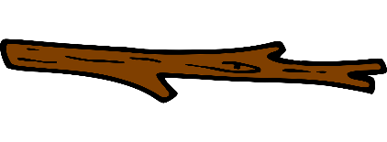

UNIT 3: Using Dimensions
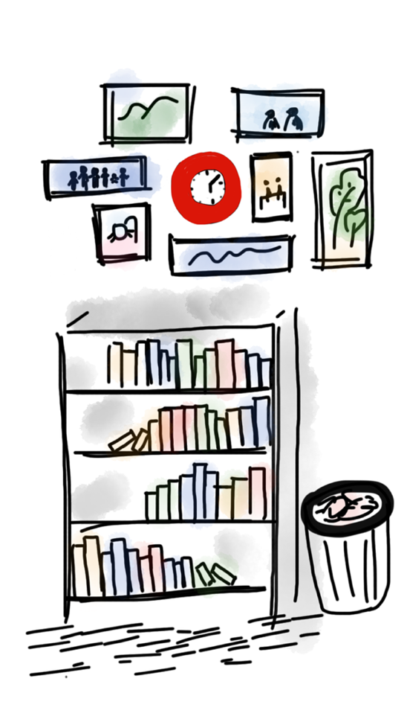
Image by MJ Jin from Pixabay
In this unit, you will learn how talk about the dimensions (length, width, and height) of an object.
You will complete a project where you will measure the dimensions of part of your classroom and search online for a piece of furniture to fit in that space.

Think and share:
A time when you had to decide if something would fit in your home.

Vocabulary List for This Unit
Word | Definition | Example
dimensions | Measurements of an object in different directions. Usually includes ________, __________, and __________. | 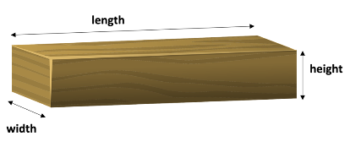
length  long | Often, the __________ of two dimensions. | 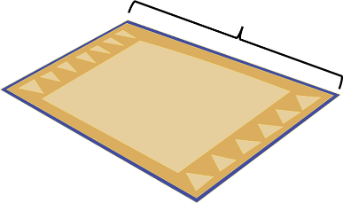
width  wide | Often, the __________ of two dimensions. | 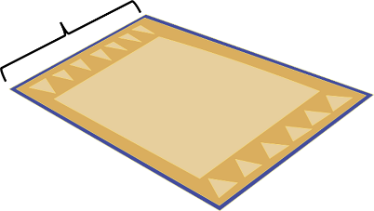
height  high | The measurement __________ | 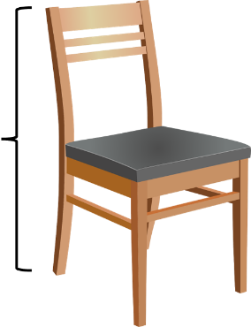

Word | Definition | Example
depth  deep | In furniture, the measurement out from the __________. | 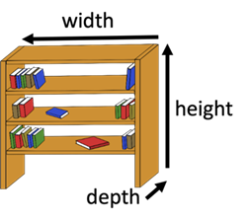

Dimensions
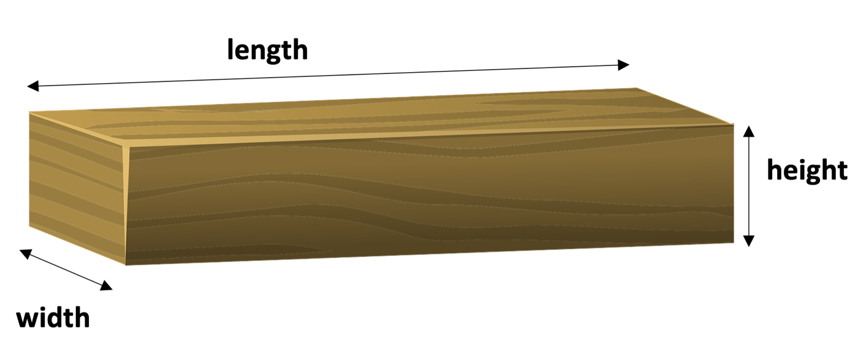

The words above are nouns. They use “the”.

The height of the tree is 30 feet.

The width of the classroom is 15 feet.

The length of the table is 8 feet.

How wide?

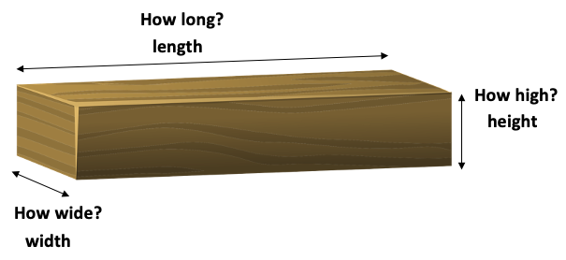
Here are the adjective forms.

- How high is the tree? The tree is 30 feet high.

- How wide is the classroom? The classroom is 15 feet wide.

- How long is the table? The table is 8 feet long.

Dimensions Grammar Practice
Circle the correct word in each sentence.

- The laptop is 15 inches (width/wide).
- The table is 2 feet (height/high).
- The (width/wide) of the table is 2 feet.
- My cell phone is 6 inches (length/long).
- The (height/high) of the building is 45 feet.
- The (length/long) of her hair is 12 inches.

Measure Dimensions
Measure the dimensions of classroom tables and chairs to the closest foot.
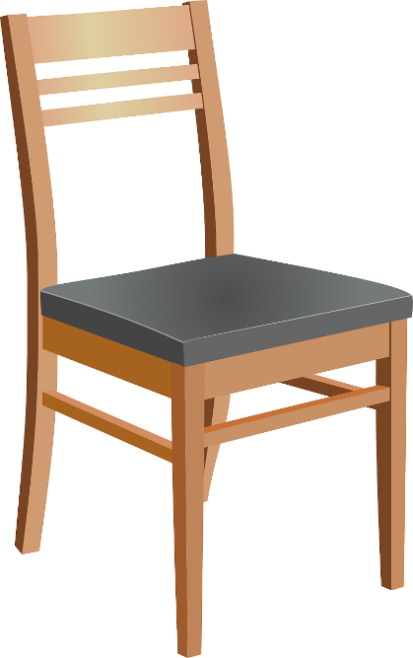
The chair is ______ ft _________.
The chair is ______ ft _________.
The chair is ______ ft _________.

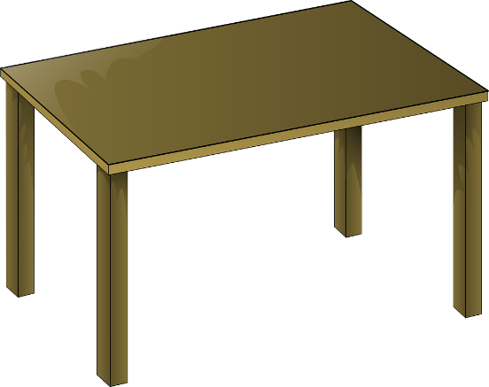
The table is ______ ft _________.
The table is ______ ft _________.
The table is ______ ft _________.

Now, measure the dimensions of classroom tables and chairs to the closest inch.
The chair is ______ in _________.
The chair is ______ in _________.
The chair is ______in _________.

The table is ______ in _________.
The table is ______ in _________.
The table is ______ in _________.

Review of Dimensions

Circle the correct word in parentheses to complete the sentence.
- The table is 5 ft (length/long).
- The (width/wide) of the bookshelf is 28 in.
- The (height/high) of the chair is 3 ft.
- The hallway is 100 ft (length/long).
- How (length/long) is the classroom?
- What is the (height/high) of the bookshelf?
- What is the (width/wide) of the refrigerator?
- How (width/wide) is the river?

Final Project: Buying Furniture

When you buy a piece of furniture for your home, you need to make sure that it will be the right size for your space. You need to measure the space you have in your room and compare this to the dimensions of the furniture you are going to buy.

For this project, you will measure part of the classroom and use a website to find a piece of furniture that will fit the space.

Part 1: Area Rug (uses length and width, uses feet)

Part 2: Bookshelf (uses width, depth, and height, uses inches)

Part 1: Area Rug
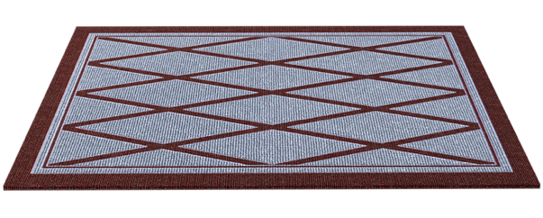

- Your teacher will show you which part of the classroom to use. Measure the length and width of the floor that you want an area rug to cover. Measure to the nearest foot.
Write the dimensions here.
Width: ________
Length: ________

- Go to Wayfair.com. Search for “Area rugs”.
- Find a rug that you like that would fit the space well.
Note: Many of the rugs come in different sizes. It is ok for a rug to be a little smaller or a little larger than the floor markings.
- Write the dimensions of the rug you chose here:
Width: ________
Length: ________
- Write a sentence comparing the length of your rug and the length of the floor space. For example: “Our rug is 1 foot shorter than the floor space.”

Part 2: Bookshelf
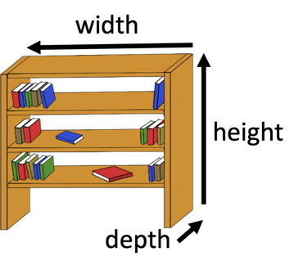
- Your teacher will show you which part of the classroom to use. Measure the width, depth, and height of the space available for the bookshelf. Measure to the nearest inch.
Write the dimensions here.
Height:_________
Width:_________
Depth:_________

- Go to Wayfair.com. Search for “bookshelf.”
- On the left side, you will see an option to search by “Size.” Click that option. Make choices that will help you find bookshelves that are the right size.
- When you look at individual bookshelves, you will have to find the information about “Dimensions.” Note: It is ok for a bookshelf to be a little smaller than the available space, but not larger.

- Write the dimensions of the bookshelf you chose here:
Height:_________
Width:_________
Depth:_________

- Write a sentence comparing the width of your bookshelf and the width of the available space. For example: “Our bookshelf is 2 inches shorter than the available space.”

