

Division Concepts
Beginning Curriculum for Adults Learning Math
Curriculum for GLE 2–4

TEACHER’S GUIDE

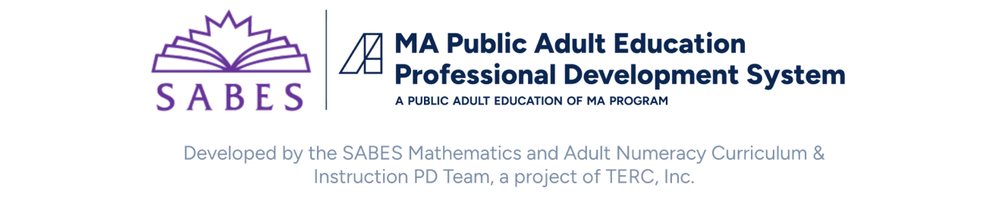

Acknowledgements

The titles in the BeCALM series were developed and piloted in the classroom by Melissa Braaten for the SABES Mathematics and Adult Numeracy Curriculum & Instruction PD Team, with contributions from Yvonne Readdy, Emily Rudd, and Sherry Soares.

The BeCALM series includes four sequential packets:
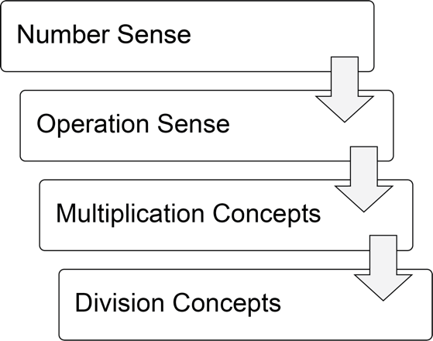
And three non-sequential packets:
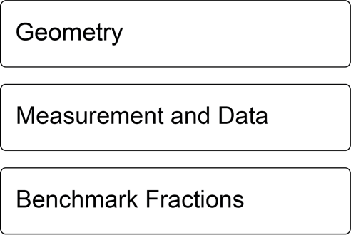
Activities from the EMPower™ and EMPower Plus™ series title Everyday Number Sense: Mental Math and Visual Models Student Book are used and/or adapted with permission from the author, TERC, Inc.

Learner Level
The math content is aimed at ABE level math students (approximately GLE 2–4). While adult students at this math level may have any level of reading, the student materials were designed to be used by adults with a reading level GLE 2 or above. To keep things accessible, the text in the Student Packet is kept to a minimum so that this can be used with students at an ABE reading level or students who are beginning to intermediate English Language Learners.
Note: This curriculum is designed to follow BeCALM Multiplication Concepts and builds on the concepts and tools introduced in that curriculum.

Use in Different Settings (In-Person, Remote, Corrections)
This curriculum was designed for use in-person, hybrid, or in a remote classroom. In some cases, the same activity could be used in either format. Other times, a virtual game or interactive is substituted for an in-person activity that can’t be facilitated in a remote classroom. Each activity is labeled based on its format.
Note: Virtual resources often work better on computers, laptops, tablets, or Chromebooks rather than on Smartphones, especially due to small screen size. There are notes on the specific websites used in each unit. These virtual activities could also be used in an in-person class or assigned for homework.
Throughout this guide you will see the following icons that denote the delivery format(s) of the activity or resource:
In-person |  | Remote |  | Not recommended for smartphones | 
Suggestions for adapting in-person activities for use in correctional facilities are provided when necessary.
Students at the suggested level (GLE 2–4) are often building the skills covered in this unit, not simply reviewing them. The pilot-testing of these materials took about 12–16 hours of synchronous class time for each unit. This time included all of the synchronous elements listed below.

Teaching Skills that Matter (TSTM)
Teaching Skills that Matter (TSTM) in Adult Education is a project of the Office of Career, Technical, and Adult Education (OCTAE). See https://lincs.ed.gov/state-resources/federal-initiatives/teaching-skills-matter-adult-education for more information about the program and toolkit.
Information on the Massachusetts Teaching Skills That Matter Academies can be found at https://www.doe.mass.edu/acls/frameworks/tstm.html?section=fy2025.
Part of TSTM is integrating and contextualizing basic skill development in content areas relevant to adult learners. The five content areas highlighted by TSTM are Workforce Preparation, Financial Literacy, Health Literacy, Digital Literacy, and Civics Education. In this curriculum, each unit contains an activity in the context of financial literacy.
In addition, these activities are designed to build skills designated by TSTM as the “skills that matter,” which include:
- Adaptability and Willingness to Learn
- Communication
- Critical Thinking
- Interpersonal Skills
- Navigating Systems
- Problem-Solving
- Processing and Analyzing Information
- Respecting Differences and Diversity
- Self-Awareness
Financial Literacy activities are indicated with this icon:


Components of Synchronous Instruction

Routines
Classroom routines can be powerful tools in the math classroom. Routines provide a familiar structure to an activity that helps students feel safe because the directions and expectations are predictable. However, a good math routine still provides a cognitive challenge and requires some type of problem-solving every time. There are several routines included in this unit: Number of the Day, Two Truths and a Lie, and Fact Families with Arrays can be used as warmups, and some problem solving Open Middle tasks appear in Units 1–3. Instructions, materials, and notes for these routines appear in the Teachers Guide for each unit.

Introduction of New Concepts and Practice
Each unit includes one or two activities to introduce the new concepts for that unit. Instructions for facilitating are included in the unit details. The goal is to lay the foundation for conceptual understanding of the concepts, rather than simply explaining procedures.
Each unit also includes several activities for practice and extension, including in-person or online games. These can be done in class or assigned as homework, as appropriate.

Vocabulary and Things to Watch For
Each unit includes some suggestions on valuable vocabulary words and common misconceptions or interesting student ideas that came up in the pilot class.

Student Interaction and Interpersonal Skills
When possible, it is helpful to allow students to interact and work together without the teacher constantly present. In a remote setting, this can often be done using breakout rooms in video conferencing software. As long as the students all have the student materials available to them, they can work together on some of the activities or routines, but remote group work usually requires more scaffolding than in a face-to-face class. It can help to explicitly discuss expectations, etiquette, and goals before breaking into groups, and to debrief afterwards to troubleshoot any problems with the process. Since remote interactions usually offer less in terms of non-verbal communication, students will need to learn ways to be more explicit and verbal in their communication with their classmates.

Tech Support
Synchronous technology instruction and support is often necessary for students to be successful in a remote environment. This includes instruction on how to navigate and use the features of video conferencing software (like Zoom or Google Meet), and how to use any features of any other apps or software used for school communication, assignments, or other asynchronous instruction. Most students will benefit from at least some synchronous instruction with demonstrations when they start a class, with frequent review and support as needed. Students who struggle with technology usually do better with synchronous help rather than videos or documents, so incorporate this into your class time if they are not getting this help somewhere else.

Materials Overview
- Unit 1: Division as Equal Sharing
- Unit 2: Connecting Multiplication and Division
- Unit 3: How Many ___ in ___?
- Unit 4: Application Project: Converting Measurement Units
Each unit in the Student Packet includes materials for:
- Financial Literacy Instruction
- Activities and Practice
- Optional Language Support
- Self-Evaluation (reproducible from Teacher’s Guide pp. 49–52)
Additional PowerPoint documents also accompany this unit (separate downloads):
- Number of the Day Template
- Two Truths and a Lie Division
- Arrays for Fact Families
- Measurement Stations Remote

Math Background: Division Concepts
Note: The Math Background content below reproduced and adapted from the EMPower Plus: Everyday Number Sense Teacher and Student books, with permission from the author (the Adult Numeracy Center at TERC).
BeCALM strives to make the most of strategies adults bring to the table and makes explicit the understandings adults hold about numbers so that new ideas can be built on this foundation. Highly numerate adults use flexible, accurate, and efficient strategies for manipulating numbers and quantities in real-world problem-solving.

The importance of students bringing their understanding into the classroom
Many students have invented or collected a set of strategies that circumvent the procedures (the methods or algorithms) historically taught in school yet may think those are not the school-approved or “real” ways. Observations of adults at work and in consumer situations uncover a surprising assortment of methods. It is important that students be encouraged to bring their own good math sense to bear in various situations for managing the mathematical demands of school and everyday life. Strategies and methods may include a mix of finger counting, mental math, estimation, calculator use, and paper-and-pencil methods. Such strategies can support insight into higher mathematics.

A Focus on Meaning Making and Conceptual Understanding
Students who learn operations only by memorizing the steps of procedures may not be able to find meaning in what they are doing. When meaning is lost, it is difficult for students to leverage their intuition or to apply common sense to problem solving, recognizing patterns, generalizing, and making connections.
The National Research Council summarizes the research on the development of children’s mathematical proficiency. Their conclusion about teaching rational numbers is that instructional programs that use “approaches that build on students’ intuitive understanding and use of objects or contexts that help students make sense of the operations offer more promise than rule-based approaches” (NRC, 2002).
Students’ work in math class should involve connecting “symbolic representations and operations with physical or pictorial representations, as well as translating between various symbolic representations” (NRC, 2002).

Operation Sense
Many people confront math problems and find themselves uncertain which operation to use: addition, subtraction, multiplication, or division. Operation sense includes understanding the relationships among the operations, and the effect an operation will have on a pair of numbers (Huinker, 2002).
Operation sense also includes understanding the meanings and models of operations, the real-world situations they connect with, and the symbols that represent them. Limited understanding of operations with whole numbers often leads to confusion about which operation to use.

Different Models for Operations
The same operation can model, or represent, different types of real-world scenarios.
Recognizing problem types and testing or matching them to different models ultimately gives a person a wider range of ways to approach any problem. It strengthens strategic competence. Consider, for example, this problem: “How much do 2½ pounds of meat cost at $3.00/lb.?” Some people see it in terms of addition ($3.00 + $3.00 + $1.50). Some see it in terms of multiplication (2.5 × $3.00). The relationship between multiplication and repeated addition is why both approaches work.
In this curriculum, students will explore two approaches to division: division as equal sharing (called partitive division), and how many ____ in ____? (called quotitive or measurement division). While any division can be solved either way, understanding these two approaches to division can help students recognize the different ways division appears in real world scenarios. This curriculum also aims to create a deep conceptual understanding of the connections between division and multiplication.
Researchers argue that a focus on the behavior of operations allows students to start in familiar territory of number and computation and to progress to true engagement in the discipline of mathematics (Russell, Bastable, & Schifter, 2011).

Fluency with Multiplication Facts
In most classes, teachers will detect a wide range of fluency with one-digit addition, subtraction, and multiplication facts. Some students have never learned to recite their tables automatically. But adults who have never memorized 6 × 7 = 42, or even 6 + 7 = 13, buy things, earn money, and pay bills, and in doing so, do a lot of math. You do not have to know your multiplication tables to do some interesting math, although it certainly helps. Memorization (automatic retrieval of facts from memory) is one strategy; however, for learners who struggle with automatic retrieval, there are other strategies that can be effective to help them increase their fluency, such as noticing patterns and using known facts to find unknown facts.
BeCALM uses several methods to help students improve their fluency with multiplication facts:
- Embedded practice: problem-solving games and activities that involve a lot of calculation
- Visual models: fact practice that pairs with visual models, such as area models
- Patterns: observing patterns in multiplication facts makes them easier to retain
- Improving backup strategies: students learn ways they can find unknown facts from known facts, taking advantage of properties of operations
Fluency with multiplication facts is closely connected with fluency with division, and this curriculum will help students learn to leverage their understanding of multiplication to improve their fluency with division.

Note about mathematical learning disabilities: Some students in adult education classes may have specific mathematical learning disabilities which could interfere with their ability to benefit from the discovery of patterns or embedded practice to improve their fluency with single-digit multiplication facts. These students may also not have enough known facts to use as a basis for building to new facts. These students may require specific, tailored interventions that are outside the scope of this curriculum. If you think you have students who might need a more intensive intervention to improve their fluency with basic facts, reach out to the SABES Mathematics and Adult Numeracy Curriculum and Instruction Center director at heidi_schuler@terc.edu. We are currently investigating strategies that could be used with these adult learners and you may be able to help us in this effort.

Unit 1: Division as Equal Sharing
Learning Objectives | CCRSAE
I can divide an amount by sharing or passing out the amount into equal groups. | MP.4, 3.OA.2–3, 4.NBT.6 (up to three-digit divisors, extension up to four-digit divisors)
I can read and write division equations correctly. | 3.OA.2–4
I can write expressions equal to a target number (Number of the Day). | 5.OA.1–2, starting with simple expressions
I can write true equations with operations on both sides. (Two Truths and a Lie, Writing Equations) | 1.OA.7, extended to division
I can keep working on a challenging problem even if I don’t understand it right away.  (Open Middle) | MP.1

Note: EMPower Plus materials featured in Unit 1 can be found in Lesson 12 (Deal Me In) of the Everyday Number Sense: Mental Math and Visual Models books.

Standards for Mathematical Practice
MP.1 Make sense of problems and persevere in solving them
Students will engage in a challenging open middle problem where they put digits into an expression to get close to a target number.
MP.4 Model with mathematics
Students learn how division can be used to model situations in which a total must be passed out or shared into equal groups, and they use this to find equal monthly payments.

Extra Resources for this Unit
- Downloadable file: Number of the Day Template PowerPoint
- Downloadable file: Two Truths and a Lie Division PowerPoint
- Reproducible: Evaluation Unit 1, Teacher’s Guide p. 49
- Web link: Dare to Share Fairly
https://www.mathplayground.com/dare-to-share-fairly.html
- Play money (not included)
- Web link: Play Money (United States)
https://toytheater.com/play-money-united-states/

Math Background
The text below is adapted with permission from A Deep Dive into Teaching Division by Melissa Braaten, © 2023, Adult Numeracy Center at TERC. Full article at https://www.terc.edu/publications/a-deep-dive-into-teaching-division/

Why is division difficult?
When it comes to the four basic operations, division is often the one that students find the most difficult. Many adult education students, especially at beginning levels of math, have gaps in their understanding of both when and how to divide. Why does this operation seem to cause more problems than the rest? A lack of fluency in basic multiplication facts can sometimes be a factor, but there is more about division that can cause difficulties.
Addition and multiplication have an important property that makes them easier and more intuitive for many people than subtraction and division. When we add,
5 + 6 + 7 + 8 = 26
all of the numbers being added (5, 6, 7, and 8) are called addends. They are all performing the same “role” in the calculation. Because of this, we have a lot of flexibility in how we add them. We can rearrange the order (Commutative Property).
8 + 5 + 7 + 6 = 26
or regroup them (Associative Property)
5 + (6 + 7) + 8 = 26
without changing the result.
Multiplication has this same characteristic. The numbers we multiply (2, 3, and 4 in the example below) are all called factors
2 × 3 × 4 = 24
and are interchangeable when it comes to calculations.
4 × 2 × 3 = 24 (Commutative Property)
2 × (3 × 4) = 24 (Associative Property)
Subtraction and division are different. The numbers used in division, for example, are called the dividend and the divisor. They have different names because they are performing different “roles” in the calculation.
Dividend Divisor Quotient
20 ÷ 5 = 4
If we consider division’s relationship to multiplication, 5 and 4 can also be seen as factors, with a product (result) of 20.
5 × 4 = 20
Because factors are interchangeable, there is flexibility in division
20 ÷ 5 = 4 and 20 ÷ 4 = 5
but the flexibility is between the divisor and the quotient, not the dividend (20). The dividend has a unique role in division and cannot be exchanged without changing the meaning of the calculation. For example,
20 ÷ 5 = 4 could model a situation where $20 is shared equally among 5 people, whereas
5 ÷ 20 = .25 would mean that $5 is being shared among 20 people, a very different situation with a different result.

Partitive Division (Division as Equal Sharing)
One situation that can be modeled with division is “equal sharing”, which is known as partitive division (a word for teachers, not students). In situations where an amount is being shared equally into a certain number of groups, the dividend can be seen as the amount being shared, and the divisor represents the number of groups. For example,
$20 ÷ 5 = $4
could model a situation in which $20 was shared equally between 5 people. The quotient (result) tells us how much ends up in each group (in this case, $4).
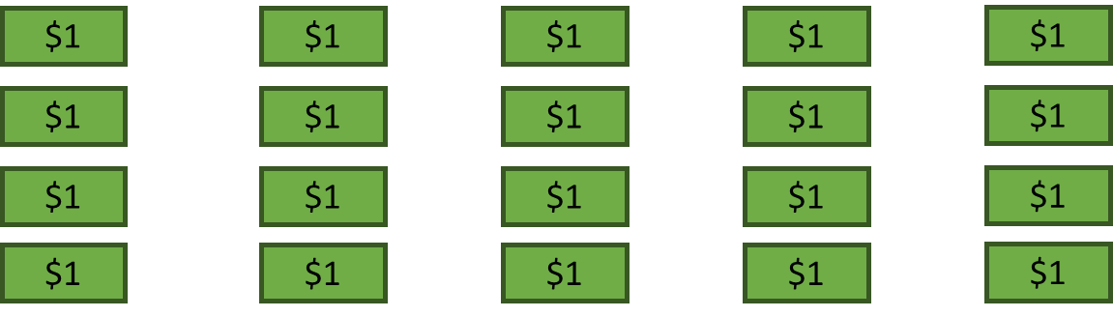

Dividing by “Passing Out”
Partitive division can be physically or visually modeled with a “passing out” situation, such as dealing cards, or passing out a pile of money to students equally until it is gone. By distributing the same amount to each group as the dividend is passed out, we can ensure that the distribution is “fair” or equal, and this continues until the dividend is gone. Students should also discover that it is possible to “pass out” value in equal “chunks.” For example, I could deal out 3 cards at a time to each player instead of 1.
As students deepen their understanding of creating equal groups, they can start to apply a “passing out” method more representationally. For example, if I wanted to pass out 120 into 3 equal groups, I might give each group 20, then 20 again, until all the value has been distributed.
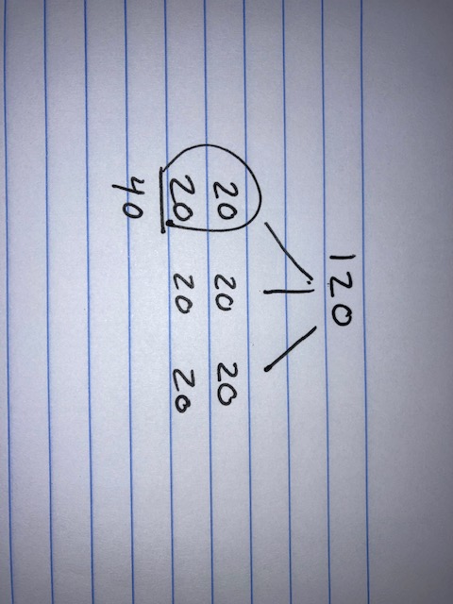
Finances provide a relevant context for exploring and modeling partitive division with adult learners. Splitting a bill, creating a savings plan, figuring out a monthly budget, or determining the monthly payments on a loan all involve partitive (equal sharing) division. Use small dividends for students who still need practice with physical manipulatives, such as money or chips, and larger amounts for folks who can pass out larger chunks by representing the amounts on paper.
More accessible example: A student uses play money to split a $60 bill among four people.

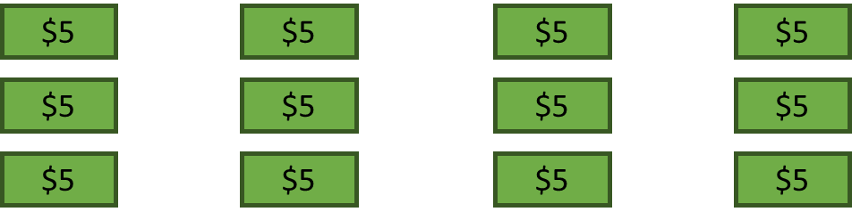
More advanced example: Students use paper and pencil to split a $1,260 loan into four monthly payments.
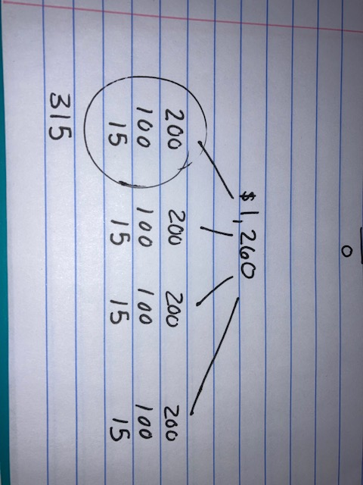
Because of the passing out nature of partitive division, this is most efficient when there are a small number of groups (in other words, when the divisor is small). It might be a good mental math strategy for a division problem like 270 ÷ 2 because we could break up 270 and pass it out into two groups.
However, thinking of 270 ÷ 12 as passing out into 12 groups would be inefficient to do mentally or on paper.

Division Notation
Students should explicitly be taught and practice common notation involved with communicating division, including:
20 ÷ 2
$$\frac{20}{12}$$
20 / 2
However, the notation used for long division is meant for paper and pencil calculations, not for communication. The setup of long division varies from country to country and students should use whatever format they are comfortable with. If they understand what they are doing, it is not necessary for them to use the U.S. format, as there is no setting outside of a U.S. primary school in which they would be asked to communicate with long division notation.
For more information about long division algorithms in other countries, check out this resource from the SABES website:
The Answer is Still the Same—It Doesn’t Matter How You Got It! by Mary Jane Schmitt
https://sabes.org/content/answer-still-same-it-doesnt-matter-how-you-got-it

Activities and Practice



Financial Literacy: Loans and Debt
TSTM Skills: Self-Awareness, Respecting Differences and Diversity, Navigating Systems


In-Person/Remote Activity
Uses Student Packet pp. 3–5
- Explain that different cultures, families, and individuals have different attitudes and habits when it comes to borrowing money. Have students fill out the three questions about their own habits on p. 3 and then allow students the opportunity to share if they want to. Emphasize that there isn’t a “right” or “best” answer, but the goal of financial literacy is for people to be aware of their own beliefs, values, and options so they can make financial decisions that help them achieve their goals and are in line with their values.
- Go over the different types of loans and debt on pp. 4–5. This is also an opportunity to see what students already know about these different types of loans. If they have some background knowledge, ask them to reflect on what they see as the advantages and disadvantages of these different types of debts. Students can also optionally share of they have had experiences with any of these types of loans.
Note: Make sure students have a basic understanding of the concept of an interest rate, in the sense that the higher the interest rate, the higher the fee you pay to borrow money. Interest is revisited in the financial literacy activity in Unit 3.

Introducing Routine 1: Number of the Day
In-Person/Remote Activity
Uses downloadable file Number of the Day Template PowerPoint

Note: This routine was also introduced in BeCALM Multiplication Concepts.
- This is a classic math routine that works great at all levels. Choose a number of the day (for this unit, consider numbers that have multiple sets of factors, such as 12 or 24.) Write the number on the board or screen. (There is a template slide included in the routine materials). Offer three of your own examples. Students should create at least three of their own expressions equal to the number of the day.
- When you first start this routine, allow students to use any operations and accept any expressions that are equal to the number, no matter how simple. As time goes on, start to push for expressions that use more than one operation, and encourage students to include multiplication and division. In a remote classroom, students can share responses in the chat box. In person, you can use small white boards or collect examples from students and put them on the board.
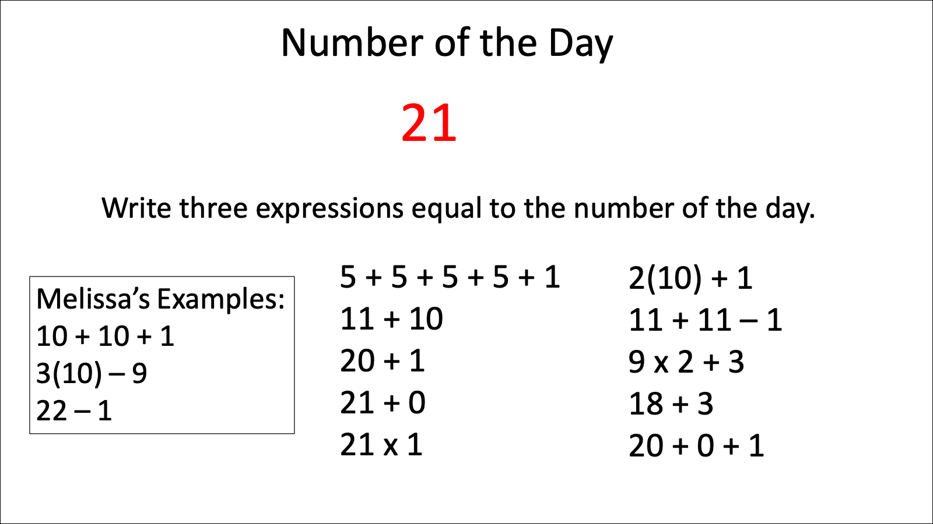
- Make sure students have the opportunity to see and ask questions about expressions written by other students. (You could include a deliberate “wrong” expression that you wrote to make sure they are looking carefully.) In the debrief, discuss one or two student questions, or highlight one or two features, such as different ways of using notation, properties of operations that come up, or strategies for creating expressions. Keep it short. The power of this routine comes from revisiting it frequently.

Introducing Routine 2: Two Truths and a Lie
In-Person/Remote Activity
Uses downloadable file: Two Truths and a Lie Division PowerPoint
- For this routine, students are presented with three equations. Two of those equations are true (the expressions on both sides have equal value), and one is false. Give students a decent amount of wait time before any thoughts are shared (encourage them not to call out which one is the lie until the wait time is over).
- Then have volunteers explain how they know each equation is true or false. Emphasize the meaning of the equals sign (left and right side have equal value) by circling and evaluating the expressions on each side.
The first four slides in the Two Truths and a Lie PowerPoint involve only equations. In Unit 2, you will introduce inequalities and inequality notation. After that, use the slides 6–14 that incorporate inequalities. This is a good warmup routine to alternate with Number of the Day.

Division as Equal Sharing: Opening Discussion
In-Person/Remote Activity

The following text is adapted with permission from EMPower Plus Everyday Number Sense © Adult Numeracy Center at TERC.
- In Person: Give partners a set of small manipulatives (or a deck of cards, jokers removed). Ask students to take 52 of these and make four equal piles. Observe the ways students split up the total and then ask for different strategies for dealing out the 52 objects.
Students might say:
“We dealt them out one by one.”
“We dealt them out 10 to a pile and then had 12 left, so we put three more in each pile.”
“We dealt them out by two’s until they were all gone.”
“We knew 4 × 10 = 40 and 4 × 3= 12, so 4 × 13 = 52.”
Remote: Hold up a deck of cards. Ask students how you could split the cards equally into four piles (equal sharing). If students only suggest dealing them one by one, ask if there are other ways they could be dealt equally (two by two, five by five, etc.)
- Summarize by asking:
What total number did you have at the start? And how many piles did you make?
How many are in each pile?
Connect the concrete model to symbolic notation and verbal language. Elicit students’ wording for this division by asking:
In your own words, what is another way to say, “Take 52 of something and make four equal piles”?
Listen and record expressions such as these:
“Fifty-two split up equally equals 13.”
“Fifty-two divided by four equals 13.”
“Four divided into 52 is 13.” (Note: This is incorrect, as “divided into” usually follows the order dividend “divided into” divisor, which in this case would read “52 divided into 4 is 13.”)
“Fifty-two shared among four people is 13.”
“Fifty-two broken into four equal parts is 13.”
- Continue by asking, How could you write this problem in math notation? What could an equation look like that would describe what you just did?
Some may see this as multiplication, others as division. Students should generate different forms for writing division, e.g., the division sign, ÷; ; or the fraction bar. List the problem in every format:
- Fifty-two divided by 4 equals 13
- 52 ÷ 4 = 13
- 4 x 13 = 52
- 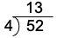
- $\frac{52}{4}$ = 13
If students have gone to school in other countries, they may have learned to write and do long division with the dividend preceding the divisor and will write the quotient below, rather than above, the box.

52
52
4
52
13
52
Check to see whether students’ ways of writing equations and verbal expressions are all correct. Some students may not realize that the order of the numbers in division problems is important. Say and post:
Is 52 ÷ 4 the same as 4 ÷ 52? Why or why not?
Check to be sure that students can give a visual example demonstrating that the two expressions have different meanings. If students insist they are the same or are unsure, explore the problem using money: $52 divided among four people as opposed to $4 divided among 52 people. Acknowledge that in multiplication the order of the numbers makes no difference (4 × 13 or 13 × 4), but in division the order influences the meaning and the answer.
Connect this concept to using the calculator. Ask students to verify that 52 ÷ 4 is different from 4 ÷ 52.
equal sharing: a situation in which a total needs to be shared into equal groups
notation: how symbols are used in math

Out to Dinner
In-Person/Remote Activity
Uses Student Packet p. 8
Uses play money
Remote: Online Play Money https://toytheater.com/play-money-united-states/

- This is a good place to model different strategies for passing out value. To start, give groups of students play money for the amount to be shared between the four friends. Encourage them to pass out the money into four groups, making change as needed so that they can pass it out equally.
- Encourage students who are ready to start to pass the value out representationally, by writing equal amounts underneath each person.
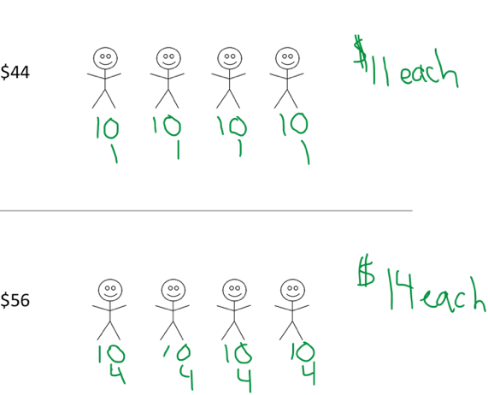

Students who need more practice with concrete manipulatives should keep using the play money as needed.
- Encourage students to write each division equation and debrief as a class to make sure they are written correctly.

Easy Payments (and extension)
In-Person/Remote Activity
Uses Student Packet pp. 9–10

- Given an amount ($360), the task is to calculate monthly payments for four different time frames: 3, 4, 6, and 12 months. The graphic organizer is to encourage passing out the amount on paper, although groups who need to use the play money can do that as well.
- Ask students to share the methods they used. Make sure to highlight a variety of ways the amount can be passed out. For example, (show image from Easy Payments student sheet) and ask:
What happened to the monthly payment as the number of months increased? Why?
- There is an extension page with a four-digit dividend that can be used for students who need the extra challenge.

Four Ways to Write Division
In-Person/Remote Activity
Uses Student Packet pp. 11–12
Start by reviewing the roles that the dividend and the divisor play in the division situations they are exploring (dividend is the total to be shared, divisor is the number of equal groups). This might be a good place to introduce dividend, divisor, and quotient.
Students often struggle with putting each number in the correct place, especially with notation they are less familiar with. Color coding the dividend and divisor across the different notations can help, especially with the examples that use letter variables.
Long division notation is different in different countries. If students are not familiar with the US long division notation, it is not that relevant for them to learn. Instead, all students need to know where to place the dividend and divisor in whichever form of long division notation they are comfortable with, so they can relate it to other forms of notation.
dividend: the total amount that will be divided
divisor: the number of groups or the size of one group
quotient: the result of dividing

Which is Not the Same
In-Person/Remote Activity
Uses Student Packet p.13
For more practice identifying equivalent expressions across notations.
Note: This activity includes expressions that use the American long division notation. This is useful for students who already use this form of notation for their long division, but not necessary for others. For students who are familiar with different long division notation, ask them to write the expression the way they would in the system they are comfortable with. The important thing is that students understand the role each number is playing (dividend or divisor) and where it appears in the notation.

Language Support: Monthly Payments Dialogue
In-Person/Remote Activity
Uses Student Packet p. 14
Have students read and fill in the appropriate monthly payments. Then they can practice the dialogue with a partner. Define the terms financing, zero interest, and per as needed.

Open Middle: Multiplying Multiples of Ten
In-Person/Remote Activity
Uses Student Packet p. 15
- This open middle task asks students to put digits into the boxes to make a product as close to 500 as possible. There are no restrictions on digits, and the same digit can be used more than once. Make sure students are familiar with the word multiple and can explain why a number with a zero in the ones place is a multiple of ten.

- If this is your students first exposure to an Open Middle problem, make sure they are familiar with the idea of a digit (a symbol, 0–9, whose value depends on its place value), and model an example so they understand that they have to place one digit in each box. In this case, they will be creating an equation that is a one-digit number times a multiple of ten, with a product that is a three-digit number (for example, 5 × 40 = 200.)
- Make sure students have time to make many attempts and to share and see other student’s examples as well. The goal of this activity is for them to see patterns: multiples of ten multiplied by a whole number will always have a product that is also a multiple of ten (and therefore has a zero in the one’s place). (This pattern will be of greater use to the student if they notice and understand the pattern on their own, rather than simply being told to add a zero when multiplying by ten.) Knowing their single digit multiplication facts will help with this task, since the product will be the product of the two non-zero digits, times ten.
4 × 60 = 4 × 6 × 10 = 24 × 10 = 240
3 × 90 = 3 × 9 × 10 = 27 × 10 = 270
They may also notice that reversing the non-zero digits does not change the product:
6 × 80 = 6 × 8 × 10 = 8 × 6 × 10 = 8 × 60 = 480
- The closest product to 500 is 7 × 70 = 490.

Online Games
Remote Activity
Supplemental activities

Dare to Share Fairly

https://www.mathplayground.com/dare-to-share-fairly.html
Note: Not recommended on a phone due to small screen size.

This game allows students to model passing out an amount to divide. It breaks the number into groups by place value and has a method where students can “make change” (for example, breaking a ten into ones). For students who are struggling to pass out with strategic groups, this could be a nice virtual manipulative, especially in a remote classroom where you can’t use physical manipulatives like play money.

Test Practice
In-Person/Remote Activity
Uses Student Packet p. 16

Answer Key:
- b
- d

Exit Ticket/Homework (Formative Assessment)
In-Person/Remote Activity
Uses Student Packet p. 17
Students choose from the options below. Choice 2 is an extension.
- Choice 1: Create a payment plan to pay back $120.
- Choice 2: Create a payment plan to pay back $450. The monthly payment cannot be higher than $100.

Vocabulary
equal sharing: a situation in which a total needs to be shared into equal groups
notation: how symbols are used in math
dividend: the total amount that will be divided
divisor: the number of groups or the size of one group
quotient: the result of dividing

Things to Watch For

Passing out in groups
Look to see how students pass value out into groups. Do they need physical manipulatives, like play money, or are they ready to start representing value with numbers on paper? Do they pass out by ones, or can they use larger, friendly groups like 5’s or 10’s or 100’s? Allow students whatever level of scaffolding they need to be successful, then challenge them to move a little beyond where they are comfortable. For example, if a student is passing out play money by ones, model for them how they could use tens and ones and break a two-digit number down by place value. For more challenge, give students larger dividends and encourage them to use larger groups like 50’s or 100’s.

Using notation correctly
Check to see that students are using notation correctly and identifying which number is the dividend (total to be shared) and the divisor (number of groups) in each situation. Make sure students are aware that reversing the numbers changes the situation and the result (10 ÷ 2 ≠ 2 ÷ 10). If students are using long division notation (of any type), make sure they can correctly identify which number is being shared and which is the number of groups.

Unit 2: Connecting Multiplication and Division
Learning Objectives | CCRSAE
I can use multiplication to help me solve and check division problems. | 3.OA.1–6
I can write fact families for factors and products. | 3.OA.5–6
I can use the symbols < and > to show which amount is greater or less. | 2.MBT.4, extended to inequalities involving numerical expressions
I can write expressions equal to a target number.  (Number of the Day) | 5.OA.1–2, starting with simple expressions
I can decide if a math sentence is true or false.  (Two Truths and a Lie) | 1.OA.7, extended to multiplication and division. 2.MBT.4, extended to inequalities involving numerical expressions
I can keep working on a challenging problem even if I don’t understand it right away. (Open Middle) | MP.1
Note: EMPower Plus materials featured in Unit 2 can be found in Lesson 12 (Deal Me In) of the Everyday Number Sense: Mental Math and Visual Models books.

Standards for Mathematical Practice
MP.1 Make sense of problems and persevere in solving them
Students will engage in another challenging open middle problem involving multiplication and division.
MP.7 Look for and make use of structure
Students will explore the relationship between multiplication and division and will see how a single array can represent all four facts in a fact family.

Extra Resources for this Unit
- Downloadable file: Number of the Day Template PowerPoint
- Downloadable file: Two Truths and a Lie Division PowerPoint
- Downloadable file: Arrays for Fact Families PowerPoint
- Reproducible: Array Cards, Teacher’s Guide pp. 61-66
- Reproducible: Evaluation Unit 2, Teacher’s Guide p. 50
- Link: Phet Area Builder
https://phet.colorado.edu/sims/html/area-builder/latest/area-builder_en.html

Math Background

Inverse Operations and Fact Families
Multiplication and division are inverse operations. In math, inverse operations “undo” each other, or show the same relationship in opposite directions.
Just as arrays were used in BeCALM Multiplication Concepts to show the commutative property of multiplication (a × b = b × a), they can also show related division facts. For example, a 5 × 3 array can show
5 groups of 3 OR 15 shared in 5 groups 3 groups of 5 OR 15 shared in 3 groups
5 × 3 = 15 15 ÷ 5 = 3 3 × 5 = 15 15 ÷ 3 = 5
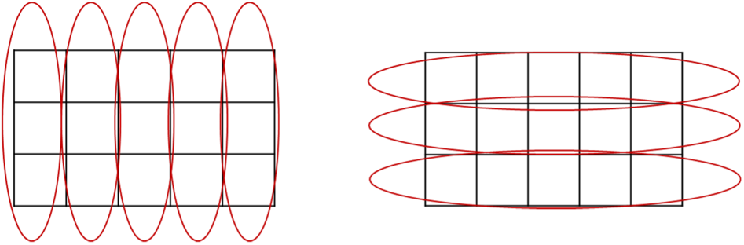
These four equations (two multiplication, two division) all describe the same relationship between the numbers 3, 5, and 15, which is shown in one array. A set of these related equations is called a fact family.
Learning fact families and inverse operations gives students more flexibility when solving problems (they can, for example, multiply up to solve a division problem) and also means that if they know one multiplication fact, they can figure out the other three members of the fact family as well.

Inequalities
A mathematical sentence can say that two amounts are not equal; these sentences are called inequalities. This unit introduces students to the greater than > and less than < symbols, which are used to create inequalities that tell which side has a larger value.
Just like with equations, students may be used to inequalities with numbers on one or both sides, such as
34 < 52
20 + 1 < 25
But may be less familiar with inequalities with expressions on both sides, such as
2 × 3 < 20 ÷ 2
Emphasize that what is being compared is the value of the expression on each side. Usually, they will need to evaluate each side in order to see that the comparison is true.

Activities and Practice

Financial Literacy: Problem Solving and Saving
TSTM Skills: Problem Solving, Self-Awareness, Respecting Differences and Diversity
In-Person/Remote Activity
Uses Student Packet pp. 18–19
- Students are given the following scenario:
Sten is having a very difficult month. He got laid off from his job, and his unemployment checks have not come yet. Last week, his car broke down, and it will cost $500 to fix it. He has $600 in the bank, but he also has rent to pay next week and buy groceries. Sten is not sure what to do.
- Start by having students brainstorm (could be done as a think-pair-share) what options Sten has. Come up with a list of options as a class.
- Have each pair or group of students choose one of the options and fill out a pro and cons list for that option. Make sure students are familiar with how a pro/cons list works.
- Bring the groups back together and have them share the pros and cons of each option.
- Finally, have the class vote on what they think Sten should do.
- Have students fill out the reflection questions about their saving habits on p. 20. Allow students to share if they want to.

Warmup Routines
In-Person/Remote Activity
Uses downloadable files Number of the Day Template PowerPoint, Two Truths and a Lie Division PowerPoint, and Arrays for Fact Families PowerPoint
Continue alternating Routines 1 (Number of the Day) and 2 (Two Truths and a Lie) as warmups. After inequalities have been introduced, use the Number of the Day slides that include inequalities (slides 6–14). Posting an array and having students write the fact family can be used as an alternate warm up as well once the fact families have been introduced.

Multiplication and Division with Arrays
In-Person/Remote Activity
Uses Student Packet p. 22
Use this page to introduce the idea of a fact family and to show how the same array can model all four equations. (See example in the Math Background for Unit 2 on page 24.)

Fact Families
In-Person/Remote Activity
Uses Student Packet pp. 23–24
Uses downloadable PowerPoint Arrays for Fact Families or Array Cards (reproducible pages at end of Teacher’s Guide, pp. 63–68)
- Display an array. Ask students to write the multiplication and division equations they see in the array. Go over the example together, asking students to notice patterns in where the numbers appear (for example the total/area/product is the answer to the multiplication equations and the first number/dividend in the division equations).
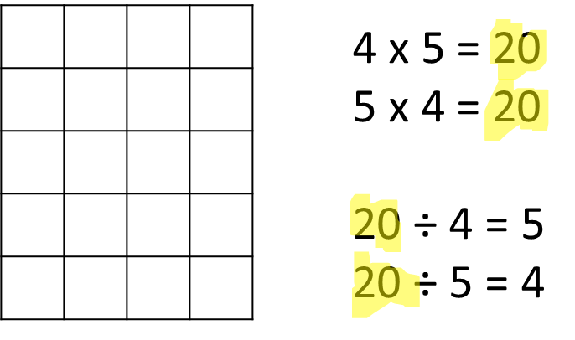
- Have students fill out more fact families for different arrays. In person, you can have students pick array cards to work from, or you can post slides from the Arrays for Fact Families PowerPoint (in person or remote)
fact family: a collection of math facts that show the relationship between the same set of numbers
- This is a good activity to revisit and review in future classes. It makes a good warm up or homework task as well.

Inequalities and Inequalities Practice
In-Person/Remote Activity
Uses Student Packet pp. 25–26
- Use the page Inequalities p. 25 to explain how the inequality symbols show which side is larger. Explain that just like equations, inequalities can have a single number or an expression on either or both sides. Ask if students already have any tricks for remembering which way the symbol points (there are many mnemonics out there, like an alligator eating the bigger amount, and arrow pointing at the smaller amount, etc.).
- Have students complete Inequalities Practice on p. 26, then go over. Make sure students are looking at the right and left side of the inequalities as whole sides to be evaluated.
inequality: a math sentence that says the left side and the right side are NOT equal

Language Support: Talking About Inequalities
In-Person/Remote Activity
Uses Student Packet p. 27
Use this page to introduce how inequalities are read: from left to right, with a word that describes the first number/amount: greater than if the first amount is larger, less than if it is smaller. Then use the examples from p. 27 to practice.
greater than: uses the symbol >, means that the left side is larger than the right side
less than: uses the symbol <, means that the left side is smaller than the right side

Two Truths and a Lie with Inequalities
In-Person/Remote Activity
Uses Student Packet p. 28
- This page introduces the routine Two Truths and a Lie using inequalities. By now, students should already be familiar with the routine, so explain that for an inequality to be true, the symbol has to correctly identify which side is larger. After students have identified he lie, have them change something to make the inequality true.
- After this has been done in class, start incorporating Two Truths and a Lie with inequalities as warmups (Two Truths and a Lie Division PowerPoint, Slides 6–14)

How Do You See It — Multiplication or Division?
In-Person/Remote Activity
Uses Student Packet pp. 29–30
- This inspection is designed to emphasize the relationship between multiplication and division. Some problem-solvers think through a division problem by re-framing it as multiplication, multiplying up vs. dividing down. This approach is similar to the idea of counting up, for example, to give change on a purchase of $3.25 paid with $5.00 a cashier might count up from $3.25 until they got to $5.00, handing back the amount they counted up by. Even though subtraction works, many find adding up easier. When adults re-frame division problems, figuring what needs to be multiplied to get to the original amount, they are using the fact that division and multiplication are inverse operations.
In this math inspection, reinforce the relationship between multiplication and division. Be sure that students realize that the two are closely connected, that they are inverses of each other, so each has the power to undo the effect of the other and finding a missing factor in a multiplication problem gives the same result as dividing.
- Ask students to first work independently so that they can really concentrate on their own thinking as they work on a solution to the problem.
- Point out a key difference between multiplication and division—that the commutative property holds for multiplication but not division (3 × 12 =12 × 3 but 3 ÷ 12 ≠ 12 ÷ 3).
- During whole class discussion you can introduce the term inverse operations. Take the opportunity to ask students to name other inverse operations they have been using (addition and subtraction, squares, and square roots). You might leave an open question: wonder aloud if there is any action in mathematics that does not have an inverse operation, a way to undo what was done.
inverse operations: pairs of operations that undo or are the opposite of each other

More Word Problem Practice, Making the Trip, and Gas Mileage
In-Person/Remote Activity
Uses Student Packet pp. 31–33
These are more word problems that make use of partitive division and multiplication. Encourage students to draw pictures or diagrams as needed and to write equations.

Savings Plans
In-Person/Remote Activity
Uses Student Packet pp. 34–35
- This is similar to the payment plans activity in Unit 1. Start by asking students if they have ever made a savings plan to reach a certain goal. Have students choose their own goal, then calculate the amount they would have to save each month if they wanted to reach their goal in three, four, or five months.
- Ask: If you want to reach your savings goal faster, how does that affect the amount you have to save each month?
Note: since students are choosing their own savings goals, the amount may not divide evenly by 3, 4, and 5. Plan to discuss this when it comes up, explaining that it is common for division to give results that are not whole numbers. How do they want to deal with this in their savings plan? (Round to nearest dollar or ten dollars, etc.)

Those Monthly Payments
In-Person/Remote Activity
Uses Student Packet p. 36
Students must calculate the monthly payment on each side, then use the correct inequality symbol to compare them.

Cell Phone Plans
In-Person/Remote Activity
Uses Student Packet pp. 37–38
- Explain that the cell phone plans each charge a regular monthly rate. Have students use the information given to complete each chart. Watch to see how they are finding the missing information: do they first find the monthly rate using division (for example, $120 for 10 months divided by 10) or do they repeat ratios (2 months for $24, if I do that three times, I would get 6 months for $72).
- Debrief and collect a variety of strategies. Highlight how multiplication and division are used in the different strategies.

Open Middle: Multiplication and Division within 100
In-Person/Remote Activity
Uses Student Packet p. 39
This open middle is very open ended and involves having a product on the left equal to a quotient on the right.

Some questions to ask as students explore:
- How did you start—with the multiplication or the division?
- What numbers are easier to use as a divisor? Which are harder?
- Did you have any attempts that did not divide to give you a whole number? Why does that happen?
- Are there any digits in your equation that you could switch around and still have the equation be true?
For more challenge, restrict students to using only digits 2–9 and only one time each.
There are many possible answers. Here are some examples:
Without restrictions:
2 × 3 = 24 ÷ 4
9 × 9 = 81 ÷ 1
4 × 7 = 84 ÷ 3
With challenge restrictions:
2 × 4 = 56 ÷ 7
6 × 7 = 84 ÷ 2
6 × 4 = 72 ÷ 3

Online Games
Remote Activity
Supplemental activities

Phet Area Builder
https://phet.colorado.edu/sims/html/area-builder/latest/area-builder_en.html
Note: Not recommended on a phone due to small screen size.

Using the “Explore” mode, you can ask students to build a rectangular array using a certain number of tiles. Have them see how many different rectangles they can make with a certain total. Discuss how multiplication and division can be seen in the rectangles they create.

Test Practice
In-Person/Remote Activity
Uses Student Packet p. 40

Answer Key
- c
- b

Exit Ticket/Homework
In-Person/Remote Activity
Uses Student Packet p. 41
- Students are given the following task:
Write three true inequalities.
Include multiplication and division somewhere in your inequalities.
- Look to see that students are using correct notation and whether they incorporate operations into both sides of the inequality.

Vocabulary
fact family: a collection of math facts that show the relationship between the same set of numbers
inequality: a math sentence that says the left side and the right side are NOT equal
greater than: uses the symbol >, means that the left side is larger than the right side
less than: uses the symbol <, means that the left side is smaller than the right side
inverse operations: pairs of operations that undo or are the opposite of each other

Things to Watch For

Mixing up factors and products in fact families
Sometimes students will use the product in a fact family as a factor and create new equations that don’t fit the fact family. Let students know that they have created a correct equation, but it does not fit with the array or the other equations in the fact family. They need to come up with equations that only use the three numbers in the family (two factors and a product).
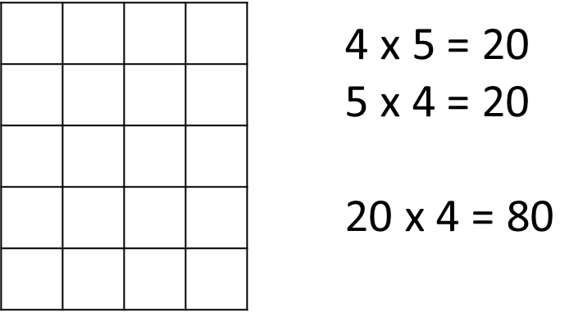

Thinking that a remainder is a mistake
There may be occasions in this unit when students will divide numbers and get a remainder. You may see them checking on a calculator and puzzling at an answer with decimal places. Some students automatically think that they made a mistake when this happens. Division is the only one of the basic operations that can give a mixed decimal result from two whole numbers. Something like 10 ÷ 3 looks so simple and familiar, and 10 and 3 don’t cause any problems when we add, subtract, or multiply them, so it can be surprising when students suddenly find themselves faced with strange repeating decimals that they weren’t expecting. Model the idea of a remainder with concrete objects or visuals as it comes up and explain that when a calculator produces an answer with a remainder, the remainder becomes part of the answer as a decimal. Remainders will become an area of more focus in Units 3 and 4, but this curriculum will focus on expressing them as whole number remainders, (10 ÷ 3 = 3 R 1) rather than as a decimal or fraction.

Inequalities with expressions on one or both sides
Similar to the way students sometimes struggle with the equal sign, some students see the inequality sign as comparing to an “answer” and don’t always consider the entire expression on each side. For example, if asked to place an inequality symbol between
2 × 4 10 ÷ 2
They may consider that 8 < 10 and then try to divide one or both sides by two as if it was an additional command to be carried out after the inequality has been taken care of. If this happens, continue to emphasize that each expression makes up one value. Circling each side can help to illustrate why the value on the right is 5.
2 × 4 10 ÷ 2
Therefore,
2 × 4 > 10 ÷ 2
In this case, the inequality is comparing the values 8 and 5, but neither of those numbers “appears” in the inequality!

Unit 3: How Many ____ in ____?
Learning Objectives | CCRSAE
I can solve division problems using repeated subtraction (how many ___ in ___?) | MP.4, 3.OA.2–4
I can show division on a number line. | 3.OA.3
I can find factors of a number. | 4.OA.4
I can estimate the answer to a division problem. | 3.OA.8 (focus on rounding)
I can write expressions equal to a target number.  (Number of the Day) | 5.OA.1–2, starting with simple expressions
I can decide if a math sentence is true or false.  (Two Truths and a Lie) | 1.OA.7, extended to multiplication and division. 2.MBT.4, extended to inequalities involving numerical expressions)
I can keep working on a challenging problem even if I don’t understand it right away. (Open Middle) | MP.1
Note: EMPower Plus materials featured in Unit 3 can be found in Lesson 13 (String it Along) of the Everyday Number Sense: Mental Math and Visual Models books.

Standards for Mathematical Practice
MP.4 Model with mathematics
Students will learn to use division to model quotitive (how many ___ in a ___) situations, and will practice in various contexts.
MP.6 Attend to precision
Students will learn to carefully read and use correct grammar to distinguish and describe partitive and quotitive division situations (Does the class get into two groups or groups of two?)

Extra Resources for this Unit
- Downloadable file: Number of the Day Template PowerPoint
- Downloadable file: Two Truths and a Lie Division PowerPoint
- Downloadable file: Arrays for Fact Families PowerPoint
- Reproducible: Array Cards, Teacher’s Guide pp. 61–66
- Reproducible: Evaluation Unit 3, Teacher’s Guide p. 51
- Link: Factorize
https://www.nctm.org/Classroom-Resources/Illuminations/Interactives/Factorize/
- Empty quart container (and half gallon and gallon, if available)
- Empty cups of different sizes, especially 8 ounce (standard), 16 ounce (large party cup) and 4 ounce (small water cup)
- Large bowl

Math Background
The text below is adapted with permission from A Deep Dive into Teaching Division by Melissa Braaten © 2023, Adult Numeracy Center at TERC. Full article at https://www.terc.edu/publications/a-deep-dive-into-teaching-division/

Quotitive Division (How many ____ in ____?)
I am 62 inches tall. When I want to figure out that height in feet, I am not thinking about passing out my inches into 12 equal groups. Instead, I am wondering how many groups of 12 inches I can make out of 62 inches. This type of situation can be modeled with quotitive division, which can be thought of as asking, How many ____ in ____? (For example, “How many inches in a foot?”)
62 ÷ 12 asks How many 12’s in 62?
In this case, the dividend is still the total amount, but the divisor (12) represents the size of the group we are interested in. The quotient (5, with a remainder of 2 inches!) tells us how many groups we can make of that size.

Teaching suggestions for quotitive division:
Quotitive division lends itself to physical/visual models of scooping and grouping. For example, we could figure out how many 8-ounce cups are in 32 ounces by scooping out 8-ounce cups until there is nothing left. The quotient tells us that we can do this four times. (How many 8’s in 32? Answer: 4)
32 ÷ 8 = 4
Mathematically, quotitive division can also be modeled with repeated subtraction of the same amount:
32 – 8 – 8 – 8 – 8 = 0
Number lines also work well as a visual model for quotitive division.

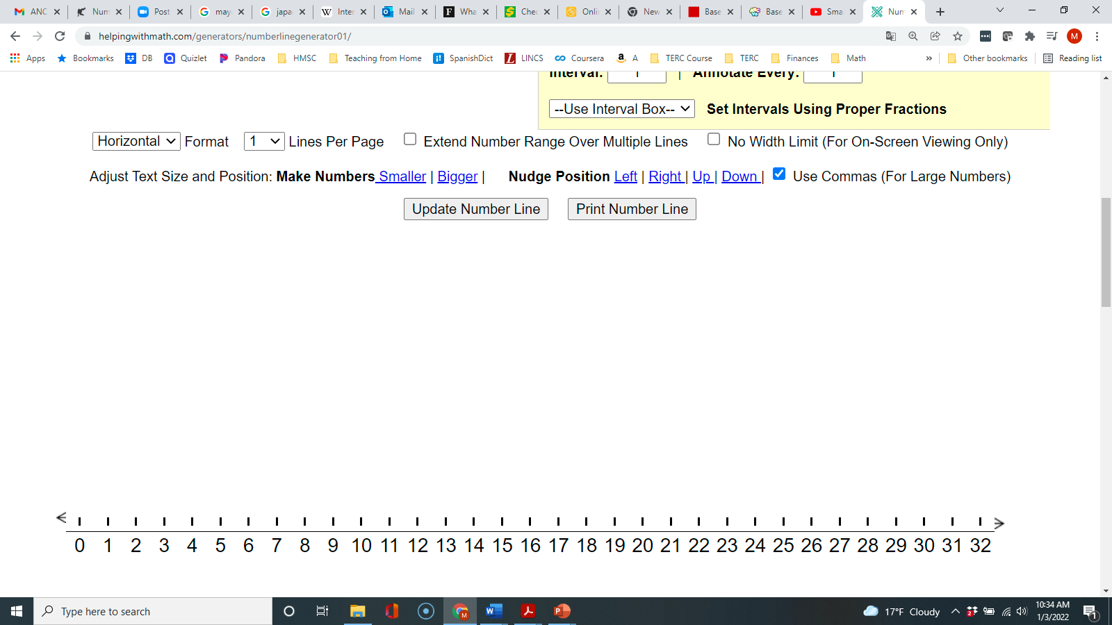
Number lines can also help demonstrate flexible ways of solving quotitive division. We can arrive at the quotient of 4 by
- knowing that 4 × 8 = 32
- repeatedly subtracting 8’s from 32
- adding 8’s from 0 until we get up to 32
Measurements are an important relevant context for adult learners to apply quotitive division. When we are converting from smaller units, such as inches, into larger units, such as feet, we are asking how many groups of a certain size we can make (How many groups of 12 inches can I make out of my 62 inches?) This also applies to other common measurements, such as seconds/minutes/hours, months/years, ounces/pounds, etc. Another advantage of using measurements as an application for quotitive division is that they easily make sense of remainders (62 inches ÷ 12 = 5 feet, 2 inches)
When calculating mentally or on paper, quotitive division is an efficient way to work with large divisors and forms the basis for how most people were taught long division. For example, it is easier to think of 275 ÷ 25 as how many 25’s are in 250, rather than envisioning passing out into 25 equal groups. Long division is simply a method that allows us to subtract out groups of 25 and to keep track of how many we have removed.
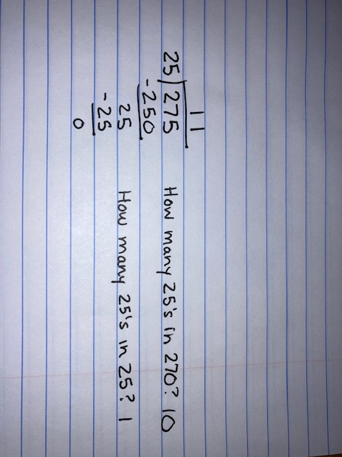

Activities and Practice

Financial Literacy: Savings and Loans in the American Financial System
TSTM Skill: Navigating Systems
In-Person/Remote Activity
Uses Student Packet pp. 42–43
- This activity includes two short readings about the role of interest and credit in the American financial system. After reading and answering questions the students have, ask them to think about the pros and cons of these aspects of the financial system. For example, interest is an incentive for people or institutions to lend money, but it can also get borrowers trapped in debt. Credit allows institutions to lend money to people they don’t know, but it can also make it hard for people with bad credit to get access to financial services.
- If you have students from other countries, you could also ask how the American system is similar or different from the system in their home country.

Warmup Routines
In-Person/Remote Activity
Uses downloadable files Number of the Day Template PowerPoint, Two Truths and a Lie Division PowerPoint, and Arrays for Fact Families PowerPoint
Continue alternating Routines 1 (Number of the Day), 2 (Two Truths and a Lie) and 3 (Writing Fact Families from Arrays) as warmups.

How Many Cups in a Quart?
In-Person/Remote Activity
Uses Student Packet pp. 46–49
Other materials:
- Empty quart container
- Empty cups of different sizes, especially 8 ounce (standard), 16 ounce (large party cup) and 4 ounce (small water cup)
- Large bowl
- Water
Note: Mention to students that the word “cup” has both an everyday meaning (like the different sized cups you are using in this activity to scoop water) and a specific measurement meaning (one cup as 8 oz in US Customary Units). In this activity, you will be using the word cup in the more everyday sense, since you will be using cups that are different sizes and contain different amounts of water.
- This works best as a live demo, whether done in person or as a demo on video conferencing software. Fill the quart container with water. Show to class and explain that this is a quart of water.
- Hold up the empty 8 oz cup. Ask students to guess how many of this size cup they think are in a quart of water.
- After you collect the guesses, pour the water into the cup, then pour the cup into the bowl. Count how many times you can fill the cup until the quart is empty (4).
- Tell students that the quart holds 32 ounces of liquid, and the cup holds 8 ounces. Ask students how they would represent the pouring out mathematically. After sharing some ideas, have them turn to Student Packet p. 46. Explain that the question, how many cups in a quart, can be thought of as a division question. Division can be used to ask how many 8’s in a 32? Sometimes we think of this type of division as “scooping” or repeated subtraction. We want to know how many 8’s we can “scoop” out of 32.
- Have students turn to p. 47 in the student packet to connect this type of division to the notation for division. This is different from the previous way they approached division. Before, the divisor represented the number of groups. Here, the divisor represents the size of a group, and we are trying to figure out how many groups fit.
- If you have the correct size cups available, repeat the demonstration with the 16 oz cup and the 4 oz cup. After the demo, have students fill out the repeated subtraction and division equations for the situation on Student Packet pp. 51–52. If cups are not available, use the images on the page and ask students to complete.

Operations on a Number Line
In-Person/Remote Activity
Uses Student Packet pp. 50–52
- Explain that this type of division, how many ___ in ___, can be shown on a number line. Show them the number line on p. 50 in the Student Packet, which matches the first cups in a quart situation. Explain that this number line represents how many 8’s in a 32? From the number line, ask them to write a repeated subtraction, multiplication, and division equation that they see in the number line.
Repeated subtraction: 32 – 8 – 8 – 8 – 8 = 0 (Seeing this as addition, 8 + 8 + 8 + 8 = 32, is also valid).
Multiplication: 8 × 4 = 32 (four groups of 8 makes 32)
Division: 32 ÷ 8 = 4 (how many 8’s in a 32? 4)
- Continue to pp. 51–52, which have more number line examples. Have students use the number line and write the corresponding division equations.
number line: a line on which numbers are marked at equal intervals (spaces)

Language Support: Talking about Groups
In-Person/Remote Activity
Uses Student Packet pp. 53–54
The grammar used to talk about groups (“3 groups of 5”) is important to understand and describe situations precisely. This page provides some review. In the next activity, the language of groups is the basis for understanding which type of division is described in a word problem (and for fully understanding and visualizing the scenario.)

Language Support: Which Type of Division?
In-Person/Remote Activity
Uses Student Packet pp. 55–56
- This activity has students compare two similar sounding word problems to focus on the difference that grammar and prepositions makes when describing groups. Have students read the two-word problems and ask them to think about how they are similar and how they are different.
- The class has 24 students. They need to get into 8 teams. How many students are on each team? (equal sharing)
- The class has 24 students. They need to get into teams of 8. How many teams can they make? (how many 8’s in a 24?)
- Encourage students to draw pictures of the two situations. Check to see if their pictures match a correct understanding of the problem.
- The next page highlights the relevant phrases in the text and has a sample drawing for each. As students work on word problems in the rest of the unit, encourage them to pay careful attention to the language of groups so they can correctly sketch and understand the problems.

Word Problem Practice
In-Person/Remote Activity
Uses Student Packet p. 57
For more practice reading, drawing, and solving quotitive situations.

How Many ____ in ____?
In-Person/Remote Activity
Uses Student Packet p. 58–59
For practice finding how many of one measure are in another.

Rental Vehicles
In-Person/Remote Activity
Uses Student Packet pp. 60–61
This quotitive division situation lends itself to drawing pictures. In several of the situations, there will be a remainder. Discuss the concept of a remainder with students and have them think about what they would do in this situation: hire another vehicle so as not to leave people behind?
remainder: the remaining value after performing division

The Commutative Property and the Four Operations
In-Person/Remote Activity
Uses Student Packet pp. 62–63
This inspection brings several of the ideas from the unit together. The statements focus on generalizations related to the commutative property (for which operations does it apply?) and to the conceptual understanding of the operations and their relationship to one another. Allow time for students to discuss, disagree, and try to argue their point (with mathematical examples!)
Some big ideas that might come up and could be highlighted:
- The commutative property holds for multiplication and addition but not for division and subtraction.
- Subtraction not only means take away but also can be used to compare two amounts (How much older is Joe than Tom?) and to find the missing part (Sarah had $20 but now has $4.32 in her pocket. How much did she spend?).
- Division can be considered repeated subtraction although the two are not inverse operations, just as multiplication can be considered repeated addition although the two are not inverse operations.

Factors
In-Person/Remote Activity
Uses Student Packet pp. 64–65
- Students have been introduced to the word factor in earlier units, but here it is being used to mean the factors of a specific number: that is, all the whole numbers that can be multiplied by other whole numbers to produce a given product (or conversely, all the numbers that can divide a number without remainder).
- Draw students’ attention to the way factors come in pairs and have them think about ways they can check to make sure they have found all the factors (listing them in order can help with this).
factors: the factors of a number are numbers that can divide that number without a remainder

Open Middle: Number with the Most Factors
In-Person/Remote Activity
Uses Student Packet p. 66
This is a good class activity, because students can share their numbers, then everyone can try to find a number with even more factors. Some students may simply go about this randomly, but others may be more strategic, using a multiplication chart to look for common products, or multiplying small factors together.
Some numbers less than 100 with many factors are:
Eight factors:
24 → 1, 2, 3, 4, 6, 8, 12, 24
30 → 1, 2, 3, 5, 6, 10, 15, 30
40 → 1, 2, 4, 5, 8, 10, 20, 40
42 → 1, 2, 3, 6, 7, 14, 21, 42
54 → 1, 2, 3, 6, 9, 18, 27, 54
56 → 1, 2, 3, 6, 11, 22, 33, 66
66 → 1, 2, 3, 6, 11, 22, 33, 66
70 → 1, 2, 5, 7, 10, 14, 35, 70
78 → 1, 2, 3, 6, 13, 26, 39, 78
Nine factors:
36 → 1, 2, 3, 4, 6, 9, 12, 18, 36
Ten factors:
48 → 1, 2, 3, 4, 6, 8, 12, 16, 24, 48
80 → 1, 2, 4, 5, 8, 10, 16, 20, 40, 80
Twelve factors:
60 → 1, 2, 3, 4, 5, 6, 10, 12, 15, 20, 30, 60
72 → 1, 2, 3, 4, 6, 8, 9, 12, 18, 24, 36, 72
84 → 1, 2, 3, 4, 6, 7, 12, 14, 21, 28, 42, 84
90 → 1, 2, 3, 5, 6, 9, 10, 15, 18, 30, 45, 90
96 → 1, 2, 3, 4, 6, 8, 12, 16, 24, 32, 48, 96

About How Many Times as Large?
In-Person/Remote Activity
Uses Student Packet p. 67
- For practice finding out about how many times larger one amount is than another. Point out the word “about” in the task and explain that they will be estimating. Ask students what strategies they might use to estimate. (Rounding to friendly numbers would be a good strategy for these). Review rounding to the nearest ten as needed.
- Because they are estimating, they are not expected to find an exact answer with a remainder.
- The last problem is a quotitive situation, (about how many 2’s in 200) but it would be very inefficient to solve with repeated subtraction. Ask students how they solved this. It could be solved efficiently with equal sharing, (200 shared into 2 groups) even though the problem structure doesn’t match that interpretation: the answer will come out the same in either case. Over time, push students to recognize that they can choose a division method strategically, whether or not it matches what is happening in the problem.
Marcel weighs 197 pounds. His kitten weighs only 2 pounds. About how many times heavier than his kitten is Marcel?

Serving Size
In-Person/Remote Activity
Uses Student Packet pp. 68–69
This is also an activity about estimating the answer to a division problem. Review rounding as needed. If students are not familiar, go over what is meant by serving size and where this information can be found on a food label. Make sure they pay attention to units, which in this case uses grams (g), a metric unit of weight.
If students are struggling with how to estimate, model using repeated addition of the serving size, and see how many it takes to get close to the weight in the box.
56 + 56 + 56 + 56 + 56 + 56 + 56 = 392
56 × 8 = 448
Between 7 and 8 servings

Online Games
Remote Activity
Supplemental activities

Factorize

https://www.nctm.org/Classroom-Resources/Illuminations/Interactives/Factorize/
Note: Not recommended on a phone due to small screen size.

This game asks students to create rectangles with certain areas, and they have to find all the rectangles that match the factors of the number. As they drag their finger or mouse over the grid, it will highlight and area and count it. When the area is correct, they can let go and the rectangle will stay highlighted (if the area is incorrect, it will disappear). They then must type the factors into the box on the right (such as 4 × 5). Different orientations (like 4 x 5 and 5 x 4) are treated as the same rectangle.
This is a nice game for exploring how some numbers have many pairs of factors, while some have only one (prime). It is faster than the Phet game since they do not have to move tiles one at a time.

Test Practice
In-Person/Remote Activity
Uses Student Packet pp. 70–71

Answer Key:
- b
- b
- c
Note: The pricing information given at the beginning is not needed to actually solve the problems; none of them ask about price. Discuss this with students: not all information is relevant to a particular problem.

Exit Ticket/Homework
In-Person/Remote Activity
Uses Student Packet p. 72
Students choose one to solve. Choice 2 is an extension.
Look to see how students show their work (Multiplication? Repeated subtraction or addition? Number line?) and whether they are correctly writing a division equation.

Vocabulary
number line: a line on which numbers are marked at equal intervals (spaces)
remainder: the remaining value after performing division
factors: the factors of a number are numbers that can divide that number without a remainder

Things to Watch For

Flexibility in problem solving
There are opportunities for students to use any of the four basic operations to solve the problems in this unit. For example, students could solve how many 12’s are in a 36 by
Repeated addition: 12 + 12 + 12 = 36
Repeated subtraction: 36 – 12 – 12 – 12 = 0
Multiplication (missing factor): 12 × ? = 36
Division: 36 ÷ 12 = 3
Students with good operation and number sense will choose a strategy that is efficient for the number they are working with. However, they perform their calculations, make sure they connect what they are doing to the problem How many ___ in ___? and to the idea of division. When students share different strategies with the class, ask them which strategies look the easiest for the particular problem. There isn’t always a correct answer but try to get them thinking about making strategic choices.
Generally, if students have weaker number and operation sense, or lack a base of basic facts to work from, they may show less flexibility or may rely too heavily on a calculator. Make sure these students get plenty of exposure to pictures and diagrams and help them connect what is happening to the different operations. They may find and stick with one strategy for now that makes sense to them. If they don’t have a strong grasp of the connection between multiplication and division, or if their conceptual understanding of multiplication is weak, they probably need some additional instruction in multiplication before they will master division concepts.
If you have students that you suspect might have specific mathematical learning disabilities interfering with their ability to build a repertoire of basic facts, they may need more specific, tailored interventions. Reach out to the SABES Mathematics and Adult Numeracy Curriculum and Instruction Team director at heidi_schuler@terc.edu. We are currently investigating strategies that could be used with these adult learners and you may be able to help us in this effort.

Unit 4: Application Project
Learning Objectives | CCRSAE
I can make sense of remainders in context. | MP.2, 4.OA.3
I can use division to convert common measurement units. | 4.OA.3
I can write expressions equal to a target number.  (Number of the Day) | 5.OA.1–2, starting with simple expressions
I can decide if a math sentence is true or false.  (Two Truths and a Lie) | 1.OA.7, extended to multiplication and division. 2.MBT.4, extended to inequalities involving numerical expressions)
I can keep working on a challenging problem even if I don’t understand it right away. (Open Middle) | MP.1
Note: EMPower Plus materials featured in Unit 4 can be found in Lesson 14 (Making Do) of the Everyday Number Sense: Mental Math and Visual Models books.

Standards for Mathematical Practice
MP.2 Reason abstractly and qualitatively
Students will need to attend carefully to the units in the context as they interpret remainders in unit conversion situations.
MP.4 Model with mathematics
Students will use mathematical operations to convert common measurement units.

Extra Resources for this Unit
- Downloadable file: Measurement Stations PowerPoint (Remote)
- Reproducible: Measurement Stations 1–4, Teacher’s Guide (In-Person) pp. 53–60
- Reproducible: Evaluation Unit 4, Teacher’s Guide p. 52

Math Background

Dealing with Remainders
Division is the only one of the basic operations that can produce fractional results and remainders from whole number inputs. Physical/visual representations and considering context are important to help students make sense of the idea of a remainder. For beginning level students, keep remainders as whole numbers with labels (62 ÷ 12 = 5 remainder 2) and leave decimal or fraction representations until later.
This unit uses examples of common measurement units to help students make sense of remainders. In the application project, students convert small measurement units (inches, minutes, ounces, cups) into mixed units (feet and inches, hours and minutes, pounds and ounces, quarts, and cups). Unit conversion is an example of measurement or quotitive division because we are asking how many ___ in a ___?
For example, how many feet (groups of 12 inches) in 62 inches?
All of the examples in the measurement stations involve numbers that produce a remainder. In this case, the remainder will remain in small units:
62 inches ÷ 12 = 5 feet, 2 inches
The quotient, 5, is the number of feet (groups of 12 inches), while the remainder of 2 simply stays in inches.
There are different ways students could approach the calculations for these problems.
Repeated subtraction: 62 – 12 – 12 – 12 – 12 – 12 = 2
This involves subtracting groups of 12 until less than 12 remains.
Repeated addition: 12 + 12 + 12 + 12 + 12 = 60
60 inches is 5 feet, and then 2 more inches are needed to make 62 inches.
Missing factor:
What multiplied by 12 gets close to 62? 5 × 12 = 60. Then, 62 – 60 = 2, which is the remainder.
Long division:
This is a missing factor approach broken into several steps.
Calculator:
Some students will figure out that when they divide using the calculator, they can use the whole number part to find the missing factor.
62 ÷ 12 = 5.166666667
So, five groups of 12 go into 62, with some remainder. (5 × 12 = 60, then 62 – 60 gives a remainder of 2.)

Activities and Practice

Financial Literacy: Self-Reflection

Teaching Skills That Matter (TSTM) Skill: Self-Awareness
In-Person/Remote Activity
Uses Student Packet p. 73
This short financial literacy activity has students self-reflect on different areas of their own financial lives, and to set short and medium-term financial goals. It is easy to focus on long-term financial goals without zooming in to plan the steps it will take to get there. Setting smaller, short-term goals can encourage people to plan steps that are more immediately actionable and achievable and can get them moving towards those longer-term goals.

Weeks and Days
In-Person/Remote Activity
Uses Student Packet p. 76
This introduces the idea of converting measurement units in a familiar context. In the first problem, 28 days becomes 4 weeks without a remainder. In the second, students have to grapple with how to describe the number of weeks in 31 days. This is a good place to introduce the word remainder if it hasn’t already come up. In this case, the remainder (the leftover days) can simply be left in its original unit: 4 weeks and 3 days.

Application Project: Measurement Stations
In-Person/Remote Activity
Uses Student Packet pp. 77–84
Remote: Use downloadable file Measurement Stations PowerPoint
In this application project, students have to use measurement division (how many ___ in ___) and remainders to convert common units.
unit: what you count when you are measuring. Small units can often be grouped to make larger units. Example: 12 inches makes 1 foot.

Station 1: Feet and Inches
Setup:
- Page showing 12 inches = 1 foot (reproducible at end of Teachers Guide, p. 47)
- Tape measures
Students may already know their height in feet and inches. Encourage them to measure each other and to start with a number of inches. If they measure and convert correctly, they should know if they are correct! You may have to explain that an arm span is fingertip to fingertip, with the arms stretched wide.
Remote: Use Marta’s measurements in downloadable file Measurement Stations PowerPoint.

Station 2: Hours and Minutes
Setup:
- Page showing 60 minutes = 1 hour (reproducible at end of Teacher’s Guide, p. 48)
- A variety of movie covers showing title and running time in minutes (find your own, or use the reproducible at end of Teachers Guide, pp. 49–50)
Remote: Use movie posters on slide in downloadable file Measurement Stations PowerPoint.

Station 3: Pounds and Ounces
Setup:
- Page showing 16 ounces = 1 pound (reproducible at end of Teacher’s Guide, p. 51)
- Photos of babies with birth weights in ounces (collect some from your staff or students, or use the reproducible at end of Teachers Guide, p. 52)
Remote: Use baby weights on slide in downloadable file Measurement Stations PowerPoint.

Station 4: Quarts and Cups
Setup:
- Page showing 4 cups = 1 quart (reproducible at end of Teacher’s Guide, p. 53)
- Recipes involving many cups of chicken broth (find your own or use the reproducible at end of Teachers Guide, p. 54)
This station requires students to think about the context: if chicken broth is only sold in quarts, they may decide to buy enough quarts to have more than they need, rather than to be short a few cups of broth.
Remote: Use recipe in downloadable file Measurement Stations PowerPoint.

Medicine Math
In-Person/Remote Activity
Uses Student Packet, p. 85
For another context in which to think carefully about remainders.

Interpreting Remainders
In-Person/Remote Activity
Uses Student Packet, p. 86
For practice with remainders in different forms.

Meaningful Remainders
In-Person/Remote Activity
Uses Student Packet, p. 87
For practice matching reasonable ways to express the quotient.

Language Support: Talking About Common Measurements
In-Person/Remote Activity
Uses Student Packet, pp. 88–89
This page introduces vocabulary, abbreviations, and symbols for American units of length, weight, and time duration.

Extension: How Many Beans?
In-Person/Remote Activity
Uses Student Packet, p. 90
This optional extension has students exploring divisibility and remainders with numbers up to 20. Students can use the number chart to cross out numbers that won’t work, or they can experiment with beans or counters and see what happens when they put them in different sized groups. Ask students to share their strategies and any patterns they see. For example, do they think about odd and even numbers when putting the beans into groups of 2? How do they find numbers that will make groups of 5 with none left over?

Vocabulary
unit: what you count when you are measuring. Small units can often be grouped to make larger units. Example: 12 inches makes 1 foot.

Things to Watch For

Making Sense of Units
See if students are making sense of the units used in the measurement stations. Do they correctly identify which units are larger (for example, that pounds are larger than ounces) and understand that the same measurement will use fewer of a larger unit (5 feet vs. 60 inches)? Do they understand the larger unit as a group of smaller units (1 foot is a group of 12 inches) and connect with the idea of division?

Decimals and Measurement Units
Many of our common measurements do not translate well into decimals. The decimal number system is based on tens: tenths, hundredths, thousandths, etc. However, many common units are not based on tens. A minute is 1/60 of an hour, not 1/100. An inch is 1/12 of a foot, not 1/10. This is why a mixed decimal answer for the division problem does not always translate nicely into larger and smaller units. For example, someone who is 66 inches tall is 5’6” but doing the division on a calculator (which usually converts the remainder into a decimal) will give 66 ÷ 12 = 5.5. Many students will incorrectly interpret this as 5 feet 5 inches. 5/10 of foot is half of a foot, or six inches (6/12). If students have background knowledge of 1/2 as a fraction, you can use this as an example. (Another common example is half of a year, which is also 6/12 months, rather than 5).

Name:___________________________ Date:__________________
Division Concepts: Unit 1, Division as Equal Sharing
Objective | Student Self-Evaluation  (Struggling, Learning, Mastery) | Teacher  Evaluation
- I can divide an amount by sharing or passing out the amount into equal groups.
- I can read and write division equations correctly.
I can write expressions equal to a target number.
(Number of the Day)
- I can write true equations with operations on both sides.
- I can keep working on a challenging problem even if I don’t understand it right away
Name:___________________________ Date:__________________
Division Concepts: Unit 2, Connecting Multiplication and Division
Objective | Student Self-Evaluation  (Struggling, Learning, Mastery) | Teacher  Evaluation
- I can use multiplication to help me solve and check division problems.
- I can write fact families for factors and products.
- I can use the symbols < and > to show which amount is greater or less.
- I can write expressions equal to a target number.
(Number of the Day)
I can decide if a math sentence is true or false.
- (Two Truths and a Lie)
- I can keep working on a challenging problem even if I don’t understand it right away.
Name:___________________________ Date:__________________
Division Concepts: Unit 3, How Many _____ in _____?
Objective | Student Self-Evaluation  (Struggling, Learning, Mastery) | Teacher  Evaluation
- I can solve division problems using repeated subtraction (how many __ in __?)
- I can show division on a number line.
- I can find factors of a number.
- I can estimate the answer to a division problem.
I can write expressions equal to a target number.
- (Number of the Day)
I can decide if a math sentence is true or false.
- (Two Truths and a Lie)
- I can keep working on a challenging problem even if I don’t understand it right away.
Name:___________________________ Date:__________________
Division Concepts: Unit 4, Application Project
Objective | Student Self-Evaluation  (Struggling, Learning, Mastery) | Teacher  Evaluation
- I can make sense of remainders in context.
- I can use division to convert common measurement units.
- I can write expressions equal to a target number.
(Number of the Day)
- I can decide if a math sentence is true or false.
(Two Truths and a Lie)
- I can keep working on a challenging problem even if I don’t understand it right away.

Station 1: Feet and Inches

12 in. = 1 ft.
(12 inches = 1 foot)

Station 2: Hours and Minutes

60 min. = 1 h.
(60 minutes = 1 hour)

Station 2 Movie Covers
Boston Invasion — Run time: 133 mins

The Ruins — Run Time: 185 min

The Mermaid Age — Run time: 102 mins

Run from Everything — Run time: 150 mins


Station 3: Pounds and Ounces

16 oz. = 1 lb.
(16 ounces = 1 pound)

Station 3: Baby Photos
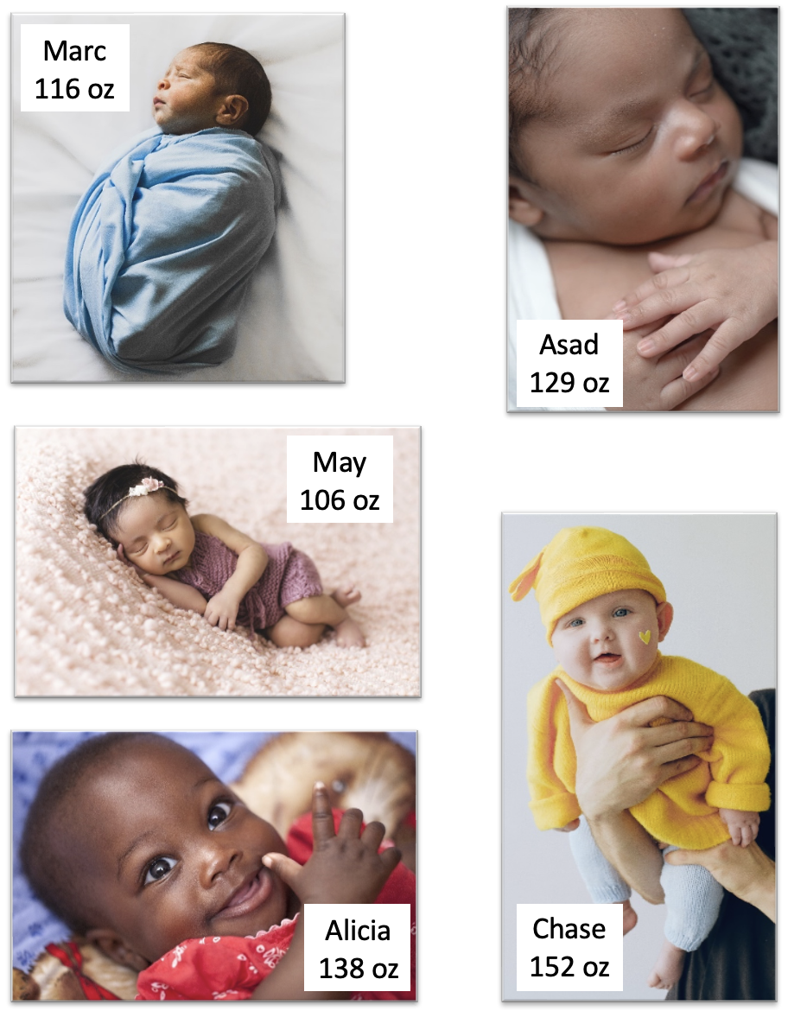

Station 4: Quarts and Cups

4 C = 1 qt
(4 cups = 1 quart)

Station 4 Recipes

Tia Amaya’s Spicy Chicken Soup
Ingredients:
- 14 C chicken broth
- 1 lb. carrots
- 2 large onions
- 6 celery stalks
- 1 C broccoli, chopped
- ½ C butter
- 3 lbs. chicken thighs
- Adobo


Braised Cabbage and Onions
Ingredients:
- 7 C chicken broth
- 2 large green cabbages
- 2 large carrots
- 1 sweet onion
- 1 large, cured sausage
- 1 C canned chickpeas

Array Cards (1 of 6)

Array Cards (2 of 6)

Array Cards (3 of 6)

Array Cards (4 of 6)

Array Cards (5 of 6)

Array Cards (6 of 6)

