

Division Concepts
Beginning Curriculum for Adults Learning Math

STUDENT PACKET


Acknowledgements

The titles in the BeCALM series were developed and piloted in the classroom by Melissa Braaten for the SABES Mathematics and Adult Numeracy Curriculum & Instruction PD Team, with contributions from Yvonne Readdy, Emily Rudd, and Sherry Soares.

The BeCALM series includes four sequential packets:

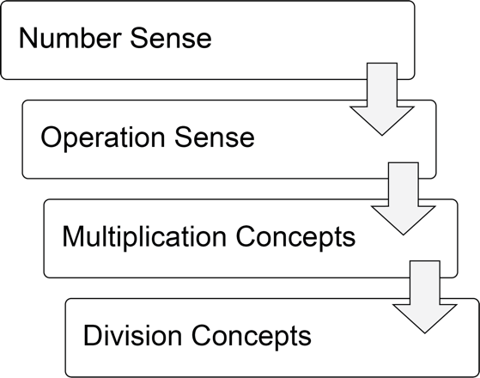

And three non-sequential packets:

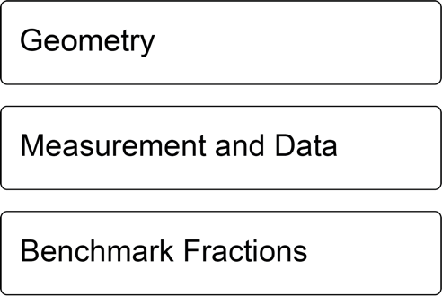

Activities from the EMPower™ and EMPower Plus™ series title Everyday Number Sense: Mental Math and Visual Models Student Book are used and/or adapted with permission from the author, TERC, Inc.

The activities on pages 15 and 39 are from OpenMiddle.com

UNIT 1: Division as Equal Sharing

Financial Literacy: Loans and Debt

- I try to avoid having any debt or borrowing any money.

- Not true about me
- A little true about me
- Very true about me

- I am willing to borrow money for certain things: for example, to buy a car, or to pay for college.

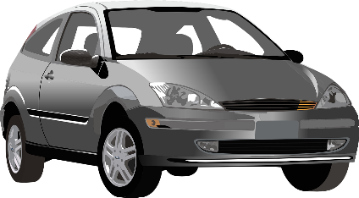
- Not true about me
- A little true about me
- Very true about me

- If I have to borrow money, I prefer to borrow from a:

- Person I know
- Credit card
- Payday loan provider
- Bank
- The government

Common Types of Loans/Debt

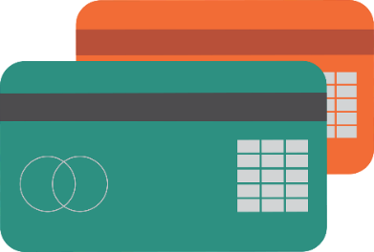
Credit Cards: Credit cards allow you to borrow money and pay it back with monthly payments. If you pay back the whole amount each month, you don’t pay any interest. If you don’t, the interest rates can be pretty high.

Payday Loans: These are short-term loans that are meant to be paid back within a week or two. They come from payday loan and check cashing businesses. They often have very high fees and very high interest rates.

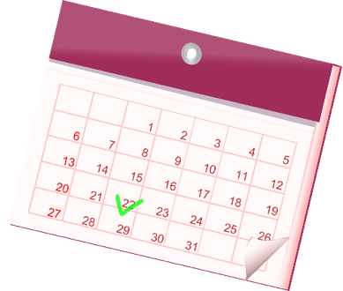
Auto loan: This is a loan to buy a car. The dealership will usually offer a loan when you buy the car, which allows you to pay back the price of the car in monthly payments, plus interest.

Mortgages: This is a loan to buy a house. Mortgages usually come through a bank. You usually must apply and have the mortgage approved before you can close on the house (“to close” means to complete the sale of a house).



Student Loans: These are loans for college or other higher education. The federal government offers student loans with fairly low interest rates and a variety of borrower protections. There are also private student loans offered through banks, although the interest rates are usually higher.



Vocabulary List for This Unit
Word | Definition | Example
equal sharing | a situation in which a total needs to be shared into _________ groups | 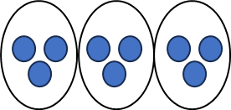  9 shared in 3 groups
notation | how _________ are used in math | 20 ÷ 2  $$\frac{20}{12}$$  20 / 2  Notation for division
dividend | the __________ amount that will be divided | 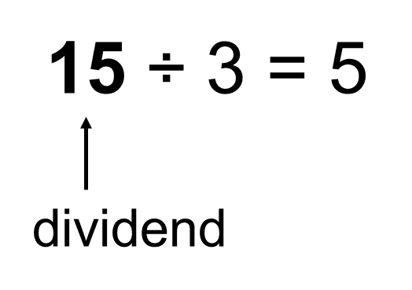
divisor | the ________ of groups or the _________ of one group | 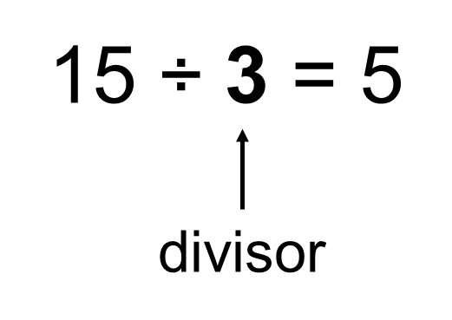
Word | Definition | Example
quotient | the ____________ of dividing | 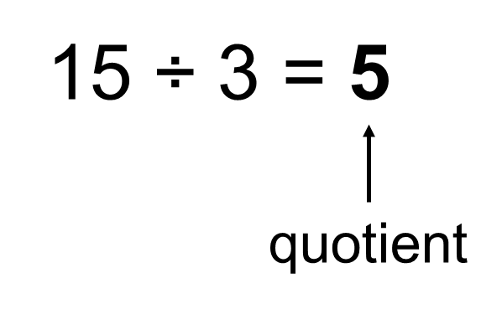

Out to Dinner
Four friends go out to dinner. They decide to share the bill evenly. For each bill, figure out how much each friend should pay. Then write an equation.

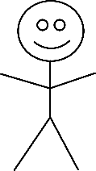
$44

$56

$72

$104

Easy Payments
Expensive items are often paid off over several months.
Figure how much you would pay each month if you spread out the payments.
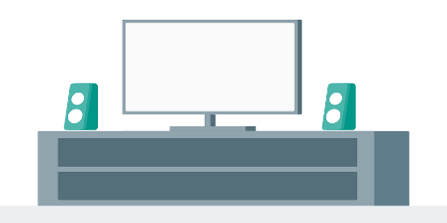

$360 over 3 months

$360 over 4 months

$360 over 6 months

$360 over 12 months

Extension: Easy Payments
Expensive items are often paid off over several months.
Figure how much you would pay each month if you spread out the payments.


$9,600 over 3 months

$9,600 over 4 months

$9,600 over 6 months

$9,600 over 12 months

Source: EMPower™ book Everyday Number Sense: Mental Math and Visual Models

Four Ways to Write Division
Division can be written in several ways.
If this is a picture of one candy bar…



This would mean 10 candy bars divided between two people.
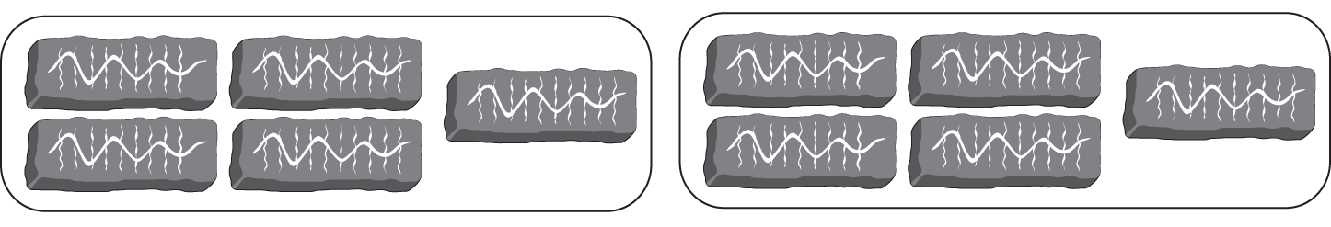

 | 10 ÷ 2 |  | 10 divided by 2

Be careful! The order of the numbers makes a difference in division.

But the representations below mean 2 candy bars divided among 10 people.

 | 2 ÷ 10 |  | 2 divided  by 10

Complete each row by writing the division three other ways.

 | 56 ÷ 8 |  | 56 divided by 8
 | 30 ÷ 5
 | 40 ÷ 1
2 divided
by 7
 |  |  | m divided by 10

Source: EMPower™ book Everyday Number Sense: Mental Math and Visual Models

Which Is Not the Same?
Order makes a difference in division:
10 ÷ 5 is not the same as 5 ÷ 10!

Choose the one expression that is NOT the same as the others.
Set 1  - 28 ÷ 7  - 28 divided by 7  7  - 28  - $\frac{28}{7}$ | Set 2  - $\frac{3}{60}$  - 60 ÷ 3  60  - 3  - $\frac{60}{3}$
Set 3  - 10 divided by 60  - (64 – 4) ÷ 10  60  - 10  - $\frac{60}{10}$ | Set 4  - (100 + 80) ÷ 4  - (100 + 80) ÷ 4  - 100 +(80 ÷ 4)  - (100 ÷ 4) + 20  - 25 + 20

Monthly Payments Dialogue

Sales representative:
The total for the washing machine is $600.

Customer:
Do you offer financing?

Sales rep:
Yes, we can offer you financing with zero interest for 3, 6, or 12 months.

Customer:
Let’s see. If I pay the total in 3 months, my monthly payments would be ________. That’s a little high for me.

Sales rep:
If you choose the 12-month financing, you would only have to pay ________ each month.

Customer:
That’s true, but I would like to pay it off sooner. I’ll pay it back in 6 months. Then I will pay ________ per month, which I can afford.

Open Middle: Multiplying Multiples of Ten

Put digits in the boxes to make the product as close to 500 as possible.



Source: https://www.openmiddle.com/multiplying-multiples-of-ten-2 by Robert Kaplinsky
Open Middle© problems are licensed under a Creative Commons Attribution-NonCommerical-ShareAlike 4.0 International License

Test Practice Problems
- Thirty people were waiting to check out at the store. If the three check-out lines were equal, how many people were in each line? Which of the following expressions matches the story?

- 3 divided by 30
- 30 divided by 3
- $\frac{3}{30}$
- 3 × 30
- $\frac{10}{30}$
- The car insurance payment is $789.50 a year. If Jo pays it quarterly (4 times per year), that means she pays about how much each time?

- Less than $10
- Less than $100
- About $150
- About $200
- About $400

Source: EMPower™ book Everyday Number Sense: Mental Math and Visual Models

Exit Ticket/Homework
Choose one of the options below.

Choice 1: Create a payment plan to pay back $120.

Choice 2: Create a payment plan to pay back $450. The monthly payment cannot be higher than $100.

UNIT 2: Connecting Multiplication and Division

Financial Literacy: Problem Solving

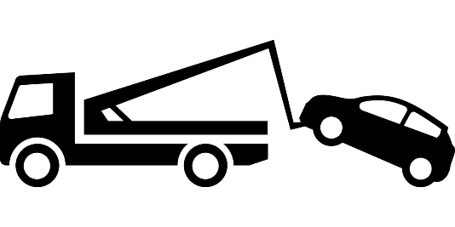
Sten is having a very difficult month. He got laid off from his job, and his unemployment checks have not come yet. Last week, his car broke down, and it will cost $500 to fix it. He has $600 in the bank, but he also has to pay rent next week, and he needs to buy groceries. Sten is not sure what to do.

- What are some options?

- Choose one and list the pros and cons of that option.
Pros | Cons

- After hearing about the pros and cons of different options, what do you think Sten should do and why?

Financial Literacy: Saving

- I save money every month, even if I can only save a small amount.

- Not true about me
- A little true about me
- Very true about me

- If I have extra money, I usually end up spending it.

- Not true about me
- A little true about me
- Very true about me

- When I save money, I:

- Keep it as cash
- Give it to someone else to hold on to
- Put it in a savings or checking account
- Use financial products like a CD or a savings bond
- Invest it
- Other:_____________________

Vocabulary List for This Unit
Word | Definition | Example
fact family | a collection of math facts that show the __________ between the same set of numbers | 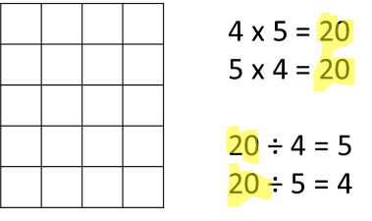  20 is the total in all facts.
inequality | a math __________ that says the left side and the right side are _________ equal | 12 < 20  4 + 5 > 4 + 3  4 x 5 > 20 ÷ 2
greater than | uses the symbol >, means that the left side is __________ than the right side | 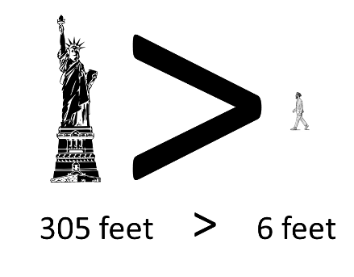  305 is greater than 6
less than | uses the symbol <, means that the left side is __________ than the right side | 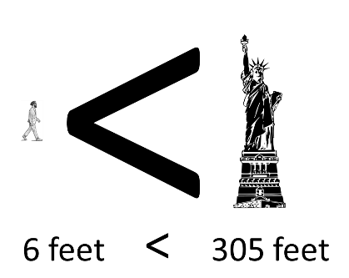  6 is less than 305

Word | Definition | Example
inverse operations | pairs of operations that __________ or are the opposite of each other | 2 x 5 = 10 10 ÷ 5 = 2  Multiplication and division are inverse operations.  7 + 5 = 12 12 – 5 = 7  Addition and subtraction are inverse operations.

Multiplication and Division (with Arrays)

Arrays can show both multiplication and division.

For example, this 5 by 3 array has 15 squares.

How can you see each of these multiplication and division equations in the array above?

3 × 5 = 15 15 ÷ 5 = 3
5 × 3 = 15 15 ÷ 3 = 5

The related multiplication and division equations for an array are called a fact family.

Fact Families
Write the fact family for each array.

____ × ____ = _____ ____ ÷ ____ = _____

____ × ____ = _____ ____ ÷ ____ = _____

____ × ____ = _____ ____ ÷ ____ = _____

____ × ____ = _____ ____ ÷ ____ = _____

____ × ____ = _____ ____ ÷ ____ = _____

____ × ____ = _____ ____ ÷ ____ = _____

____ × ____ = _____ ____ ÷ ____ = _____

____ × ____ = _____ ____ ÷ ____ = _____

____ × ____ = _____ ____ ÷ ____ = _____

____ × ____ = _____ ____ ÷ ____ = _____

____ × ____ = _____ ____ ÷ ____ = _____

____ × ____ = _____ ____ ÷ ____ = _____

Inequalities

Inequalities are math sentences where the two sides are NOT equal.

We use symbols to show which side is larger.

smaller < larger

2 < 5

larger > smaller

5 > 2

The symbol opens towards the larger amount.

Inequalities Practice

Practice writing the correct symbol to make each inequality true ( < or > ).

3 8
12 9
10 + 1 13
20 6 × 3
3 × 2 18 ÷ 2
20 ÷ 5 36 ÷ 3
40 ÷ 2 60 ÷ 4
42 ÷ 3 50 ÷ 5

Talking About Inequalities

When we read inequalities, we read from left to right.

The word describes the first number (or expression).

2 < 5
“Two is less than five.”
(less describes the 2)

5 > 2
“Five is more than two.”
(more describes the 5)

Note: It is also common to use the word “greater”.
5 > 2
“Five is greater than two.”

Practice reading the inequalities on the previous page.

Two Truths and a Lie
Two of these statements are true, and one is false.
Can you find the lie?

- 4 × 2 > 7
- 5 + 5 < 4 + 4 + 4
- 6 × 3 > 10 × 2

Two of these statements are true, and one is false.
Can you find the lie?

- 10 ÷ 2 > 5 × 2
- 2 × 3 + 2 < 12
- 6 ÷ 3 < 24 ÷ 6

How Do You See It—Multiplication or Division?

John just got a new car that gets 50 miles per gallon. If he is planning to drive 500 miles, how many gallons will he use?

- How did you solve the problem above? Did you think of it as a division problem or a multiplication problem?

- Now solve the problem using the inverse operation and write the expression or equation used.

Source: EMPower™ book Everyday Number Sense: Mental Math and Visual Models
For each word problem, explain if you solved it using multiplication or division.
Then write both a multiplication and division equation for each problem.
- Phill has to pay for rental insurance 4 times a year. The annual premium (cost for the entire year) is $60. How much are his payments?

- Neusa and two friends go out to dinner and decide to split the bill evenly. They owe $18. How much should they each contribute?

- Christine bought 4 pounds of beef and paid a total of $20. How much did she pay per pound?

More Word Problem Practice
- Saul wants to save $20 per month for the next 4 months. How much will he save in total?

- Melissa bought 5 loaves of bread and paid a total of $10. How much did each loaf cost?

- Avery paid for three movie tickets, for a total of $24. How much did they pay for each ticket?

Making the Trip
- Jean Louis is planning a 300 mile trip. If he is hoping to make the drive in 5 days, how far will he drive each day?

- Michelle wants to drive from New Orleans to Lafayette. The trip is 150 miles, and she wants to complete it in 3 days. How far does she have to drive each day?

- Marc wants to bike 75 miles in 3 days. How far does he have to bike each day?



Gas Mileage


- Marina drove 132 miles on 6 gallons of gas. How far can she drive on 1 gallon?

- Jeanette drove 320 miles and used 10 gallons of gas. How far can she drive on 1 gallon?

- Renee drove a total of 240 miles. They used 8 gallons of gas. How far can they drive on 1 gallon?

Savings Plans

Savings Goals

Three Months:

Four Months:

Five Months:

Savings Goals

Three Months:

Four Months:

Five Months:

Those Monthly Payments
In the following problems, is the monthly payment for the first payment given greater than (>), less than (<), or equal to (=) the monthly payment for the second amount?
Example:
$1,800 over 3 months > $2,000 over 4 months

- $1,500 over 5 months $1,200 over 3 months

- $1,000 over 4 months $600 over 3 months

- $2,000 over 5 months $1,800 over 4 months

- $500 over 3 months $700 over 4 months

Source: EMPower™ book Everyday Number Sense: Mental Math and Visual Models

Cell Phone Plans
Each of the following charts below represents the cost of a different cell phone plan. Fill in the blanks and show how you found your answers.

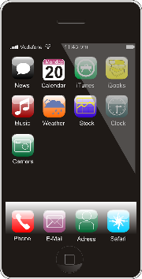
Shira’s Cells
Months | Total Cost
12 months
10 months | $120
6 months
2 months | $24
Monthly

Alejandro’s Data
Months | Total Cost
12 months
10 months | $230
6 months
2 months | $46
Monthly

Ellen’s Direct Line
Months | Total Cost
24 months
12 months
6 months
3 months | $54
Monthly

Daniel’s Continuous Coverage
Months | Total Cost
24 months
12 months
10 months | $240
2 months
Monthly

Which cell plan is the cheapest?
Which is the most expensive?

Open Middle: Multiplication and Division within 100
Put any digits 1–9 (no zeros) in the boxes to make a true equation. See how many equations you can make.



Source: https://www.openmiddle.com/multiply-and-divide-within-a-hundred-1 by Robert Kaplinsky
Open Middle© problems are licensed under a Creative Commons Attribution-NonCommerical-ShareAlike 4.0 International License

Test Practice
- George works 5 days a week, and his total weekly salary is $650 per week. How much does George earn per day?

- $65
- $105
- $130
- $200
- $210

- Use the information in Problem 1 (above) to decide how much George’s total monthly salary should be. (Assume that a month has four weeks.)

- Less than $2,000
- Between $2,000 and $2,800
- Between $2,800 and $3,500
- Between $3,500 and $4,000
- More than $4,000

Source: EMPower™ book Everyday Number Sense: Mental Math and Visual Models

Exit Ticket/Homework
Write three true inequalities.
Include multiplication and division somewhere in your inequalities.

UNIT 3: How Many _____ in _____?

Financial Literacy:

Savings and Loans in the American Financial System

Interest
When you borrow money, you pay back the money you borrowed, plus extra. The extra money is called interest. This is how lenders make a profit from lending the money to you.
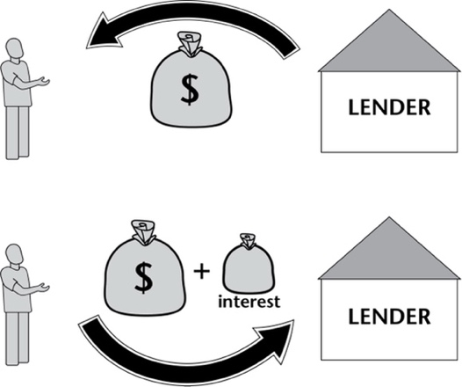
When you put your money in a savings account, the bank will usually pay YOU interest. In this case, they are using your money while it is in your account, and they pay you for allowing them to use it.
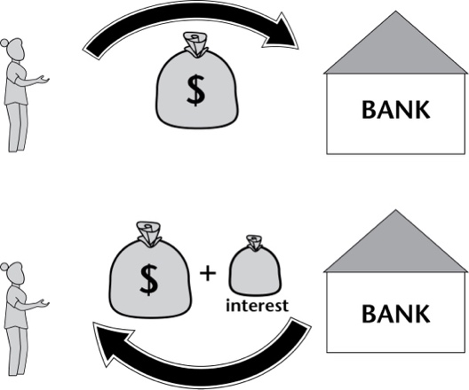
Interest plays an important role in the American banking and financial system.
What are some pros and cons of interest?

Credit
In America, there are companies that keep track of all the money you borrow and pay back. They give you a score, called a credit score, based on how well you pay back the money that you borrow.
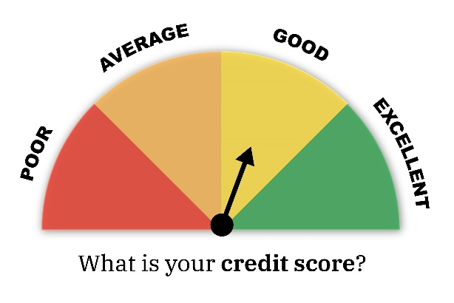
If you have a good credit score, it will be easier and cheaper for you to borrow money in the future. Companies and banks will trust you to pay it back.
If you have a bad credit score, it will be harder and more expensive for you to borrow money in the future. Companies and banks will consider you a risk.
If you do not borrow any money (no credit cards, loan payments, etc.), you will have no credit score at all. This can make it difficult to get a loan if you need one, for example, if you want to buy a car or a house.
Credit scores play an important role in the American banking and financial system.
What are some pros and cons of credit?

Vocabulary List for This Unit
Word | Definition | Example
number line | a line on which numbers are marked at __________ intervals (spaces) | 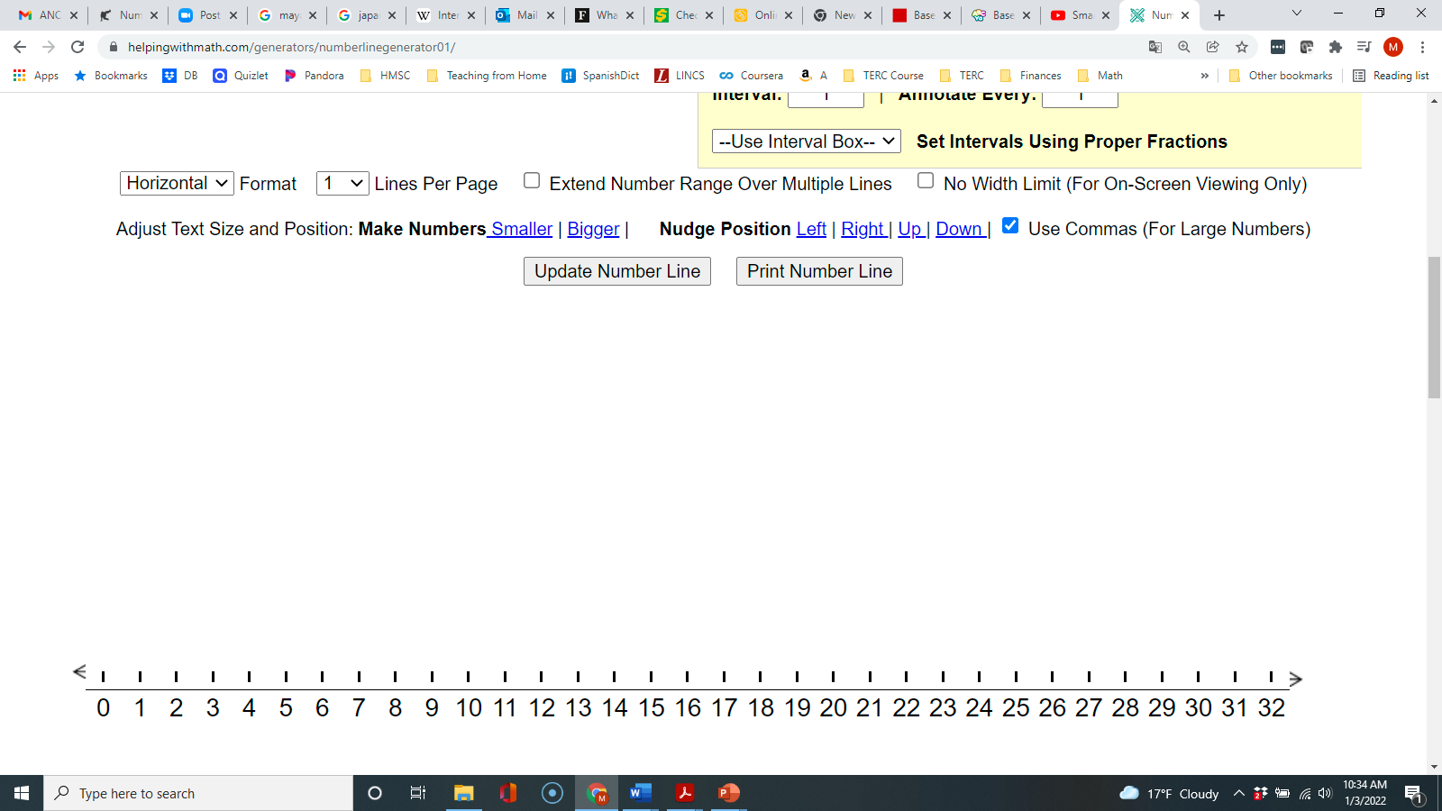
remainder | the remaining value after performing __________ | 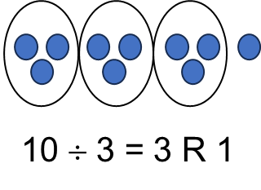
factors | the factors of a number are numbers that can __________ that number without a __________ | The factors of 10 are 1, 2, 5, and 10.

Word | Definition | Example

How Many Cups in a Quart?

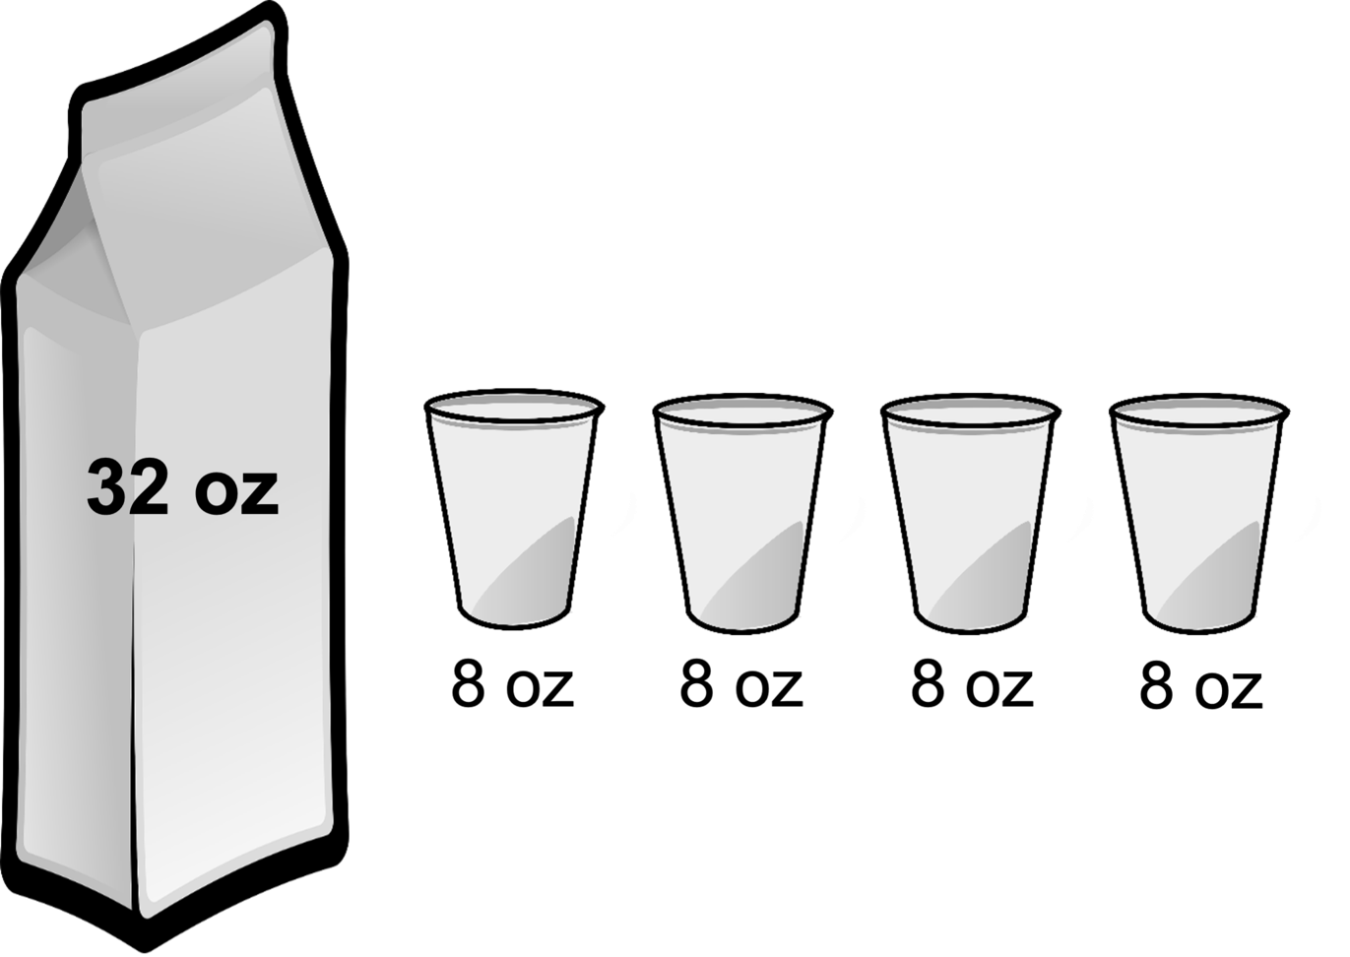

How many 8’s in a 32?

32 – 8 – 8 – 8 – 8 = 0
We can scoop out (subtract) four 8’s from 32.

32 ÷ 8 = 4

Another Way to Think about Division

How many ____ in ____?

Size of Group Total

How many 8 oz. cups in a 32 oz. quart?

32 ÷ 8 = 4

Total Size of Group How many groups?

How Many Cups in a Quart?

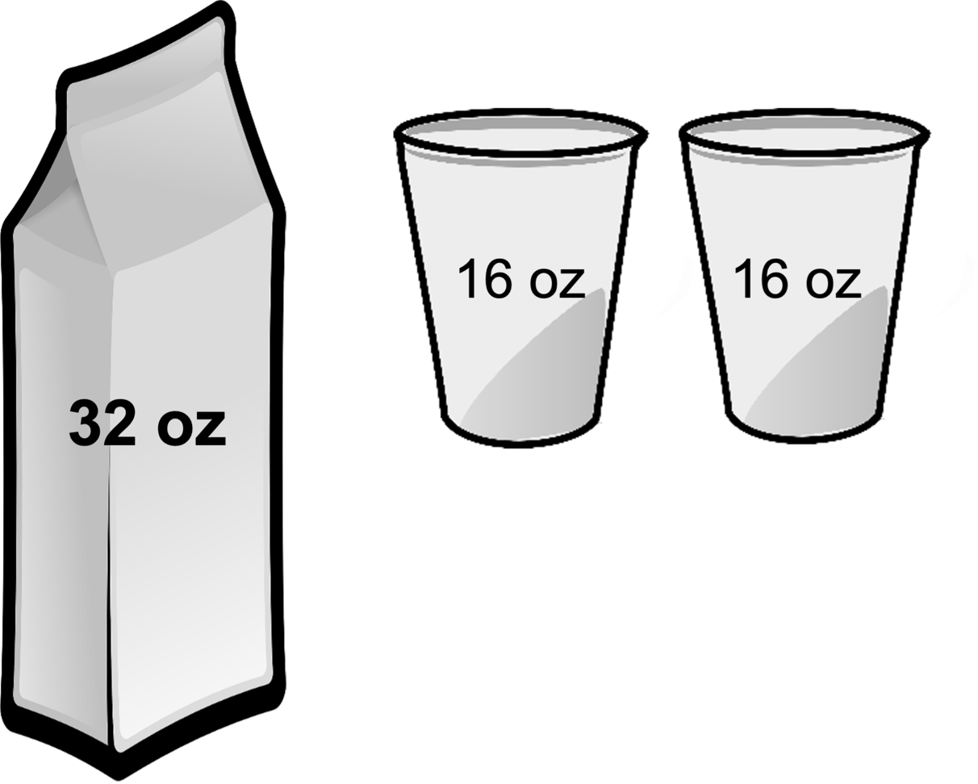

How many 16’s in a 32?

Write the repeated subtraction.

Write the division problem.

How Many Cups in a Quart?

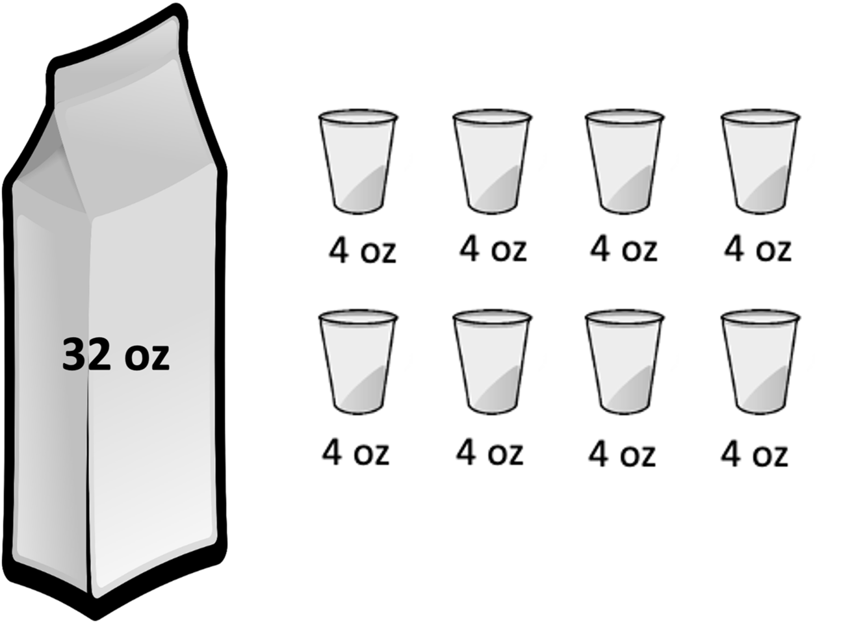

How many 4’s in a 32?

Write the repeated subtraction.

Write the division problem.

Operations on a Number Line

How many 8’s in a 32?
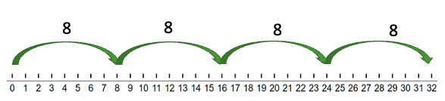
Write a repeated addition equation.

Write a repeated subtraction equation.

Write a multiplication equation.

Write a division equation.

Use the number line to solve, then write the division equation.

How many 8’s in a 24?

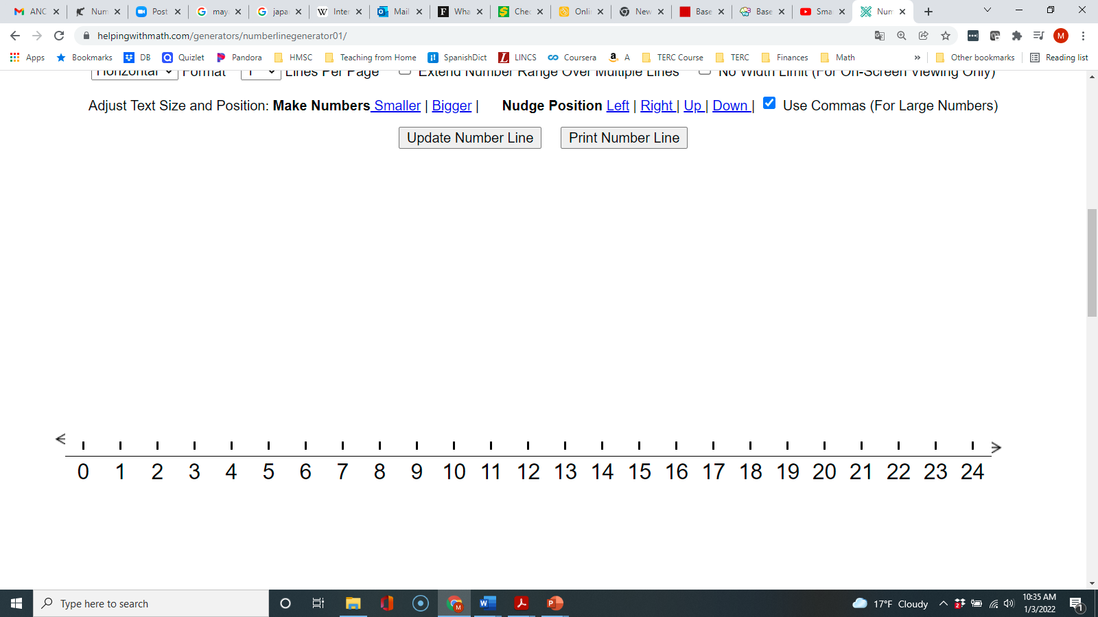
How many 6’s in a 24?

How many 12’s in a 24?

How many 6’s in an 18?

How many 9’s in an 18?

How many 3’s in an 18?


Talking About Groups
5 groups of 3

number of groups size of the group

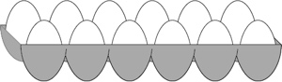
______ groups of ______
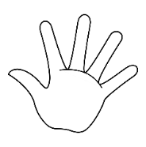
______groups of ______

Draw “3 groups of 2” | Draw “2 groups of 4”
Which phrase describes this situation:
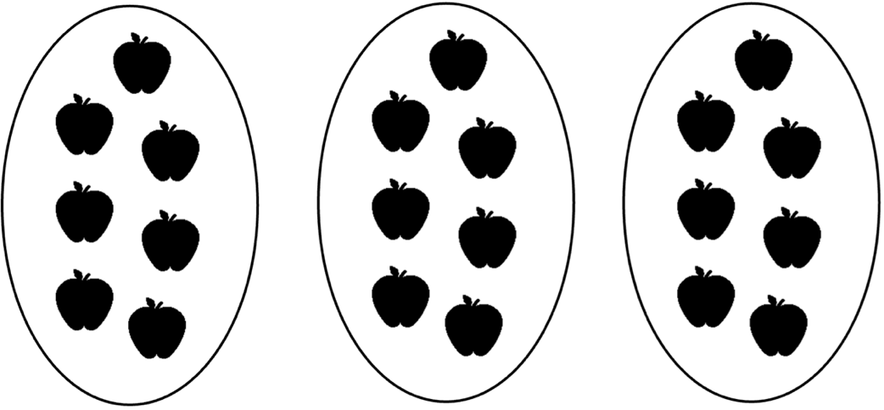
- 3 groups of 7
- 7 groups of 3

Which phrase describes this situation:
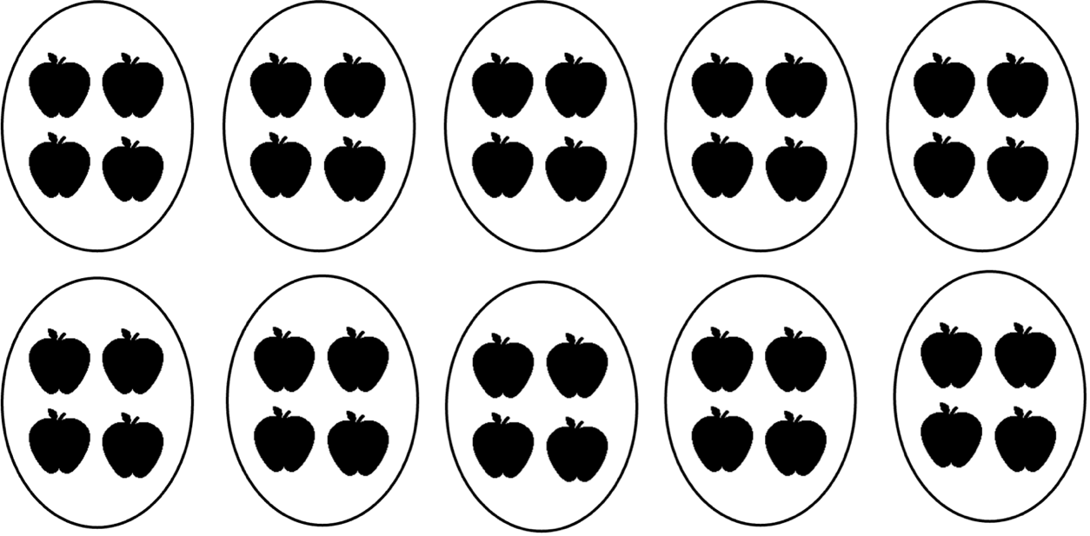

- 4 groups of 10
- 10 groups of 4

Which Type of Division?

How are these two problems the same?
How are they different?

- The class has 24 students. They need to get into 8 teams. How many students are on each team?
- The class has 24 students. They need to get into teams of 8. How many teams can they make?

Draw a picture of each situation.

- The class has 24 students. They need to get into 8 teams. How many students are on each team?
- The class has 24 students. They need to get into teams of 8. How many teams can they make?

In Example A, 8 is the number of teams. The 24 students are shared equally among the 8 teams. (equal sharing)
In Example B, 8 is the size of a team. We need to know how many teams of 8 students we can get out of 24. (How many ___ in ___?)

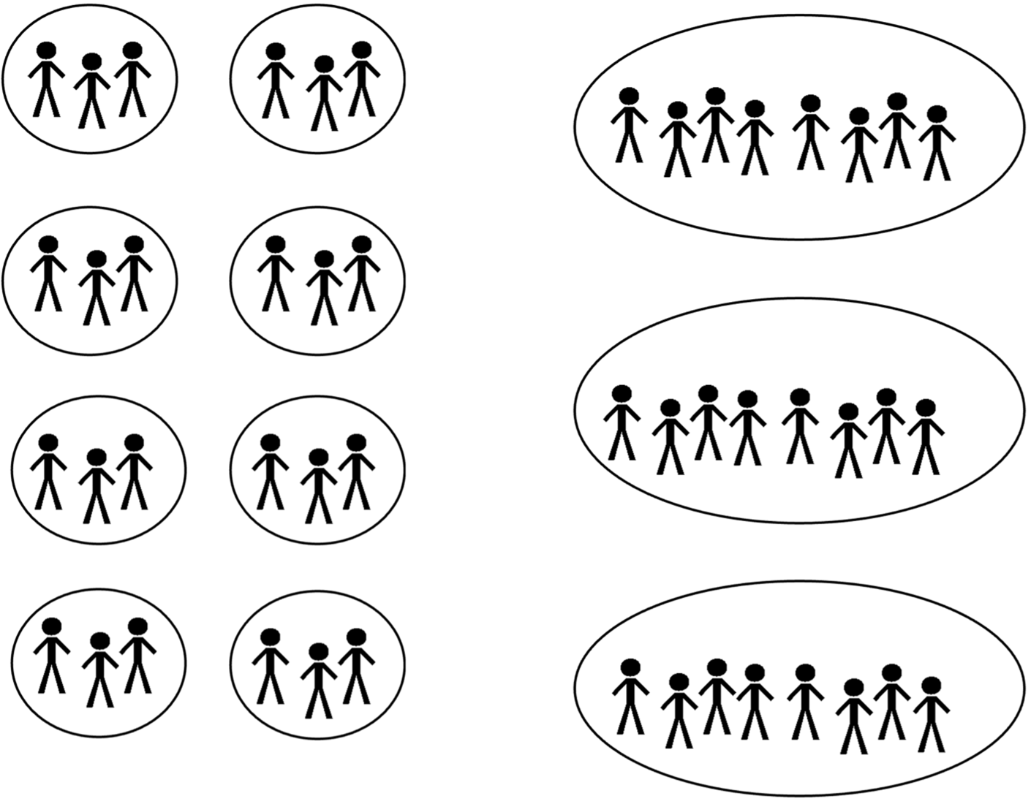

Word Problem Practice
Draw a picture and write an equation to help you solve each word problem.

- The class needs to get into groups of 4. There are 20 students in the class. How many groups will there be?

- Melissa needs to buy 36 notebooks to give to her students. The notebooks come in packs of 6. How many packs does she need to buy?

- The medicine must be taken for 21 days. How many weeks is that?

Source: EMPower™ book Everyday Number Sense: Mental Math and Visual Models

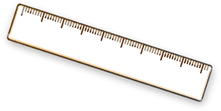
How Many _____ in _____?
- a) Write an equation:
How many 12" rulers fit in a 36" yardstick?

b) Draw a picture or number line to show the situation.

c) Solution:

- a) Write an equation:
How many 15-minute periods are in a 60-minute game?

b) Draw a picture or number line to show the situation.

c) Solution:

- a) Write an equation:
How many 16-oz. glasses of milk are in a 128-oz. (gallon) jug?
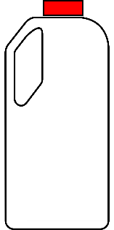

b) Draw a picture or number line to show the situation.

c) Solution:

Source: EMPower™ book Everyday Number Sense: Mental Math and Visual Models

Rental Vehicles
Adelaide Adult Education wants to rent vehicles to take 50 students to a job fair in the city. For each type of vehicle, how many would the school need to rent? Show how you know.

- Rental car, midsize  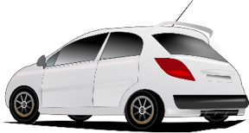  Can fit 5 people each | How many would they need to take everyone?
- Rental van, extra large  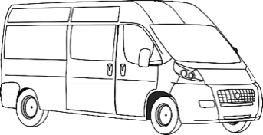  Can fit 10 people each | How many would they need to take everyone?
- Rental bus  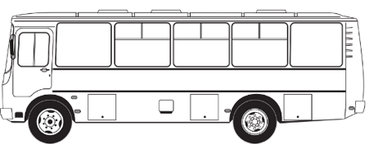  Can fit 20 people each | How many would they need to take everyone?
- Rental minivan  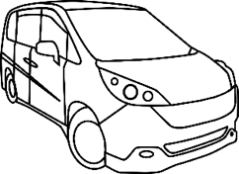  Can fit 6 people each | How many would they need to take everyone?
- Rental bus, small  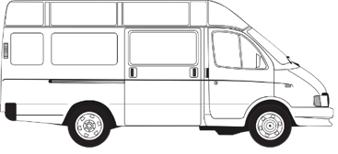  Can fit 15 people each | How many would they need to take everyone?
Look back at your answers. Are there cases where some of the vehicles are not full? Why does that happen?

The Commutative Property and

the Four Operations
Decide whether each statement below is true or false. Then explain your reasoning.

- You can add up when you have a subtraction problem.

- It does not matter in what order you add numbers together.

- One way to multiply two numbers is to do repeated addition.

- It does not matter in what order you subtract two numbers.

- It does not matter in what order you multiply two numbers.

- Division can be solved with repeated subtraction.

- It does not matter in what order you divide two numbers.

- Division is the inverse of subtraction.

Source: EMPower™ book Everyday Number Sense: Mental Math and Visual Models

Factors
Thinking about all the factors of a number can help you do multiplication and division.
Remember the factors of any whole number are the whole numbers that can be divided into the number evenly.
Some numbers have many factors. Others have only two.
- 12 has six factors: 1, 2, 3, 4, 6, and 12.
- 13 has only two factors: 1 and 13.

- List all the factors of the following numbers:

- 20

- 23

- 24

- 25

Fill in the blanks, using the numbers 20, 23, 24, and 25, to make each sentence a true statement. (Some numbers will be used more than once.)

- Five is a factor of ______ and _______.

- Twelve is a factor of _______.

- Ten is a factor of _______.

- The number with only two factors is _______.

- The number with the most factors is _______.

Source: EMPower™ book Everyday Number Sense: Mental Math and Visual Models

Open Middle: Number with the Most Factors
Find a number less than 100 with as many factors as possible.
Remember, a factor of a number can divide the number with no remainder.

About How Many Times as Large?
Answer each of the following problems and show how you found an approximate (close) answer.
- Luzita is seven years old. Her grandmother, Abuela Lupe, is 72. About how many times older is Abuela Lupe than Luzita?

- Sergio weighs 140 pounds. His daughter, Marissa, weighs 68 pounds. About how many times heavier than Marissa is Sergio?

- Marcel weighs 197 pounds. His kitten weighs only 2 pounds. About how many times heavier than his kitten is Marcel?

Source: EMPower™ book Everyday Number Sense: Mental Math and Visual Models

Serving Size
When you buy a food product, the box or label will tell you the weight of the food, usually in grams (g).
The nutritional information will tell you the serving size (how much they expect you to eat at one time).
For food products below, determine about how many servings you get in the box. (You can round both the weight of the food and the serving size to friendly numbers. Then think about how many servings you could get out of the box.)

Serving Size: 56 g
About how many servings are in the box?
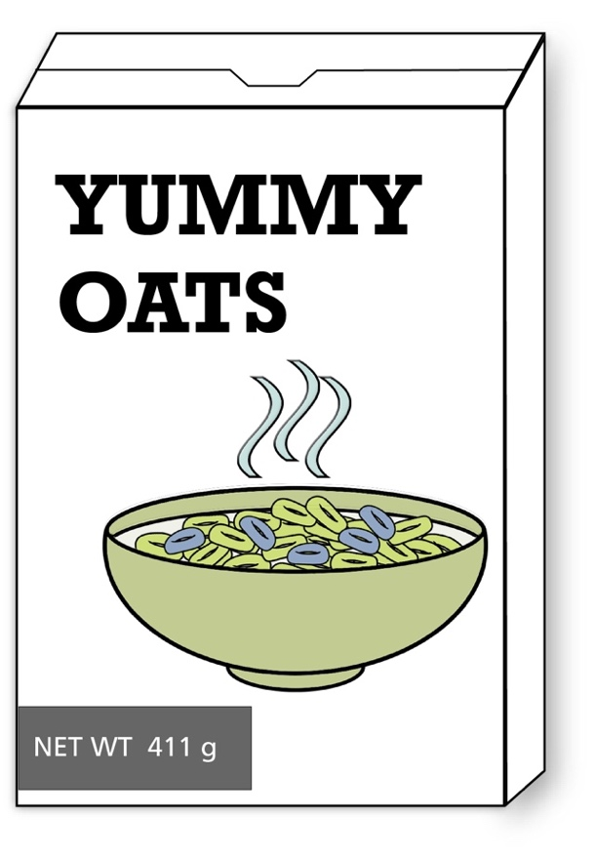
Serving Size: 31 g
About how many servings are in the box?


Serving Size: 28 g
About how many servings are in the box?
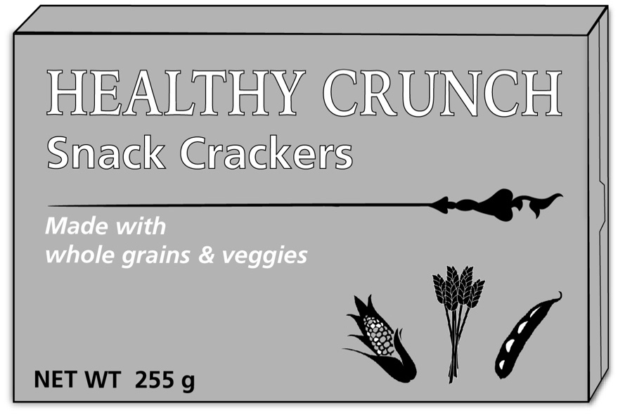

Test Practice Problems
You can buy envelopes from the Acme Envelope Company individually or in packages. Here is the Acme price list:

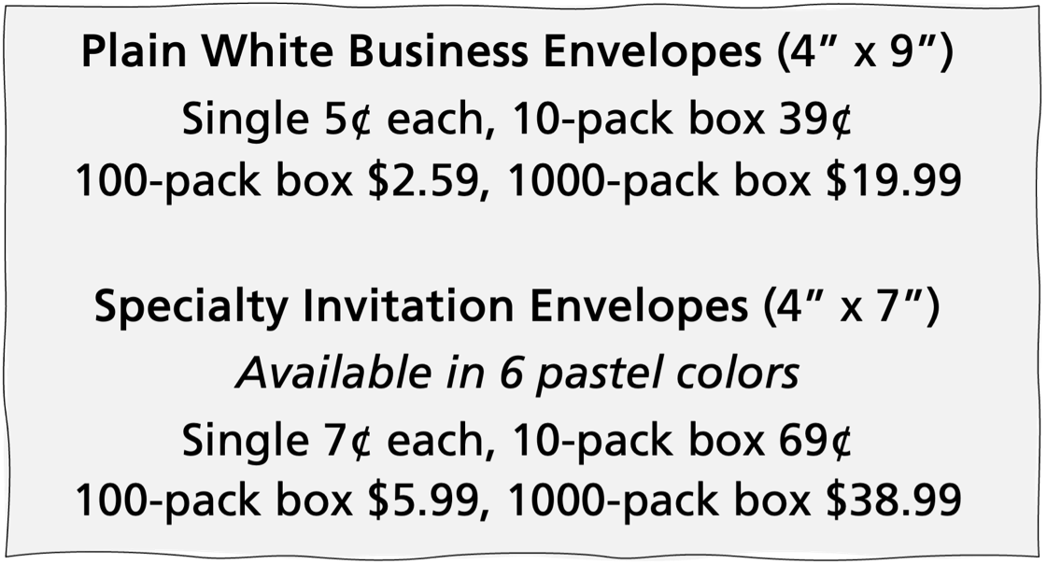

Use the information above to answer the questions 1–3.
- The office manager estimates that the staff uses 480 envelopes a year. Which expression could you use to find the number of envelopes used in a month?

- 480 × 12
- $\frac{480}{12}$
- 12 ÷ 480
- $\frac{12}{480}$
- 12 × 480
- The purchasing officer of a small corporation decides to order 20,000 white envelopes for the coming year. She wants to order them in 1,000-pack boxes. How many boxes should she order?

- 10
- 20
- 1,000
- 2,000
- 20,000

- Tasha wants to buy 1,500 specialty envelopes for invitations for various community center functions in equal amounts of three pastel colors: yellow, green, and blue. How many 10-pack boxes should she buy of each color?

- 15
- 25
- 50
- 150
- 500

Source: EMPower™ book Everyday Number Sense: Mental Math and Visual Models

Exit Ticket/Homework:

Choose one to solve.

Choice 1:
How many 8-hour days in a 32-hour work week?
Show how you know, and write a division equation.

Choice 2:
How many dozens of eggs (12) in a gross of eggs (144)?
Show how you know, and write a division equation.

UNIT 4: Application Project

Financial Literacy: Self-Reflection

 | This is an area I want to improve. | This is fine the way it is. | This is a strength for me.
Income
Spending
Budgeting
Borrowing Money
Saving
Avoiding Scams

A short-term financial goal (6 months or less):

A medium-term financial goal (1–3 years):

Something I would like to learn more about:

Vocabulary List for This Unit
Word | Definition | Example
unit | what you __________ when you are measuring. Small units can often be __________ to make larger units. | 12 inches makes  1 foot.  60 minutes makes 1 hour.

Word | Definition | Example


Weeks and Days

- February has 28 days. How many weeks is that? Show how you solved it.

- March has 31 days. How many weeks is that?
Show how you solved it.

How is problem 2 different from problem 1? How do we make sense of problems like problem 2?

Activity: Measurement Stations

Station 1: Feet and Inches
Measure your height in inches.
Record your height in inches here: ____________________
Convert your height into feet and inches. Show all your work below.

Measure your arm span in inches.
Record your arm span in inches here: _________________
Convert your arm span into feet and inches. Show all your work below.

Station 2: Hours and Minutes
Choose 3 movies.

Title:_______________________________________________
Running time in minutes:_____________________________
Convert the running time into hours and minutes. Show all your work below.

Title:_______________________________________________
Running time in minutes: _____________________________
Convert the running time into hours and minutes. Show all your work below.

Title:_______________________________________________
Running time in minutes: _____________________________
Convert the running time into hours and minutes. Show all your work below.

Station 3: Pounds and Ounces
Most baby weights at birth are given in pounds (lbs) and ounces (oz). Choose 3 babies.

Name:___________________ Weight in ounces:_________
Convert the weight into pounds and ounces. Show all your work below.

Name:___________________ Weight in ounces:_________
Convert the weight into pounds and ounces. Show all your work below.

Name:___________________ Weight in ounces:_________
Convert the weight into pounds and ounces. Show all your work below.

Station 4: Quarts and Cups
For each recipe, explain how many quarts of chicken broth you would buy and how you made your decision.

Recipe:________________________________________
Cups of chicken broth:____________________________
I would buy ________ quarts because…

Recipe:________________________________________
Cups of chicken broth:____________________________
I would buy ________ quarts because…

Activity: Measurement Stations

(Remote Version)

Station 1: Feet and Inches
Record Marta’s height in inches here: __________________
Convert her height into feet and inches. Show all your work below.

Record Marta’s arm span in inches here: _______________
Convert her arm span into feet and inches. Show all your work below.

Station 2: Hours and Minutes

Title:_______________________________________________
Running time in minutes:_____________________________
Convert the running time into hours and minutes. Show all your work below.

Title:_______________________________________________
Running time in minutes:_____________________________
Convert the running time into hours and minutes. Show all your work below.

Station 3: Pounds and Ounces
Most baby weights at birth are given in pounds (lbs) and ounces (oz). Choose 3 babies.

Name:___________________ Weight in ounces:_________
Convert the weight into pounds and ounces. Show all your work below.

Name:___________________ Weight in ounces:_________
Convert the weight into pounds and ounces. Show all your work below.

Station 4: Quarts and Cups
For this recipe, explain how many quarts of chicken broth you would buy and how you made your decision.

Cups of chicken broth: _______________________________
I would buy ______ quarts because…

Medicine Math
- Ahmik tests his blood sugar three times a day using one strip each time. If he has 50 strips, how many days will they last?

- Tracy takes two pills every four hours for three days. Then she takes two pills every six hours until they are used up. The pills come in bottles of 100. Will her pills last one month? Explain.

Source: EMPower™ book Everyday Number Sense: Mental Math and Visual Models

Interpreting Remainders
Each situation has a matching answer. Label the situations with the letter from the answer column that is the best fit. One is done for you.

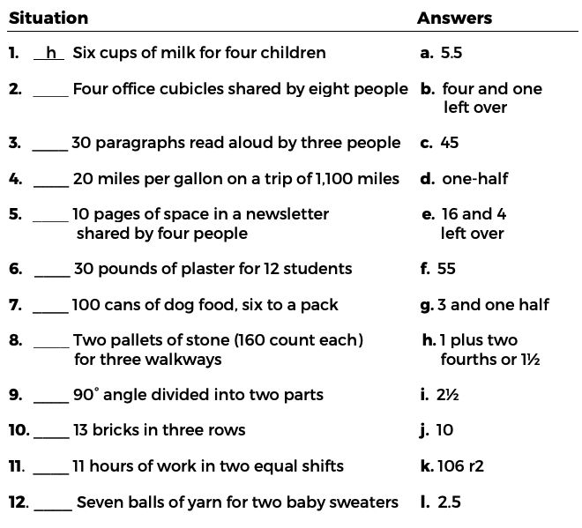

Source: EMPower™ book Everyday Number Sense: Mental Math and Visual Models

Meaningful Remainders
Read and solve the problems. Think about what the remainder means in each situation. Note the remaining amount if anything is left over.
- Jody has $100 to spend on presents for her daughter’s birthday. How many gift cards costing $15 each can she purchase?

- A ferry can hold 30 cars. How many trips will it make to carry 175 cars across the river?

- A rope is 75 feet long. How many nine-foot jump ropes can be made?

Source: EMPower™ book Everyday Number Sense: Mental Math and Visual Models

Talking about Common Measurements

Length/Height
Unit | Plural | Abbreviation | Symbol
foot | feet | ft | ’
inch | inches | in | ”

Roberta is 5’ 2”.
Roberta is five feet, two [inches].

Weight
Unit | Plural | Abbreviation
pound | pounds | lb.
ounce | ounces | oz

The baby weighs 8 lb. 6 oz.
The baby weighs eight pounds, six ounces.

Duration (length of time)
Unit | Plural | Abbreviation | Symbol
hour | hours | h | h:min
minute | minutes | min or m | h:min

The movie is 2:12.
The movie is 2h 12min.
The movie is two hours and twelve minutes.

Practice:
Take turns reading each sentence out loud to a partner. Read the symbols and abbreviations as regular words.

- My husband is 6’ 3”.
- I am 5’ 2”.
- The baby weighs 9 lb. 2 oz.
- When I was born, I weighed 7 lb. 8 oz.
- The movie’s running time is 3:08.
- The movie is 1h 46 min long.


Extension: How Many Beans?
Use the number chart or some beans or counters to help you find the number of beans.

- There are between 0 and 20 beans.
If you put the beans in groups of 2, you will have 1 left over.
If you put the beans in groups of 3, you will have none left over.
If you put the beans in groups of 4, you will have 3 left over.
If you put the beans in groups of 5, you will have none left over.
How many beans are there?

1 | 2 | 3 | 4 | 5 | 6 | 7 | 8 | 9 | 10
11 | 12 | 13 | 14 | 15 | 16 | 17 | 18 | 19 | 20

- There are between 0 and 20 beans.
If you put the beans in groups of 2, you will have none left over.
If you put the beans in groups of 3, you will have 2 left over.
If you put the beans in groups of 4, you will have none left over.
If you put the beans in groups of 5, you will have 3 left over.
How many beans are there?

1 | 2 | 3 | 4 | 5 | 6 | 7 | 8 | 9 | 10
11 | 12 | 13 | 14 | 15 | 16 | 17 | 18 | 19 | 20

Multiplication Table (grid)
x | 1 | 2 | 3 | 4 | 5 | 6 | 7 | 8 | 9 | 10
1 | 1 | 2 | 3 | 4 | 5 | 6 | 7 | 8 | 9 | 10
2 | 2 | 4 | 6 | 8 | 10 | 12 | 14 | 16 | 18 | 20
3 | 3 | 6 | 9 | 12 | 15 | 18 | 21 | 24 | 27 | 30
4 | 4 | 8 | 12 | 16 | 20 | 24 | 28 | 32 | 36 | 40
5 | 5 | 10 | 15 | 20 | 25 | 30 | 35 | 40 | 45 | 50
6 | 6 | 12 | 18 | 24 | 30 | 36 | 42 | 48 | 54 | 60
7 | 7 | 14 | 21 | 28 | 35 | 42 | 49 | 56 | 63 | 70
8 | 8 | 16 | 24 | 32 | 40 | 48 | 56 | 64 | 72 | 80
9 | 9 | 18 | 27 | 36 | 45 | 54 | 63 | 72 | 81 | 90
10 | 10 | 20 | 30 | 40 | 50 | 60 | 70 | 80 | 90 | 100

