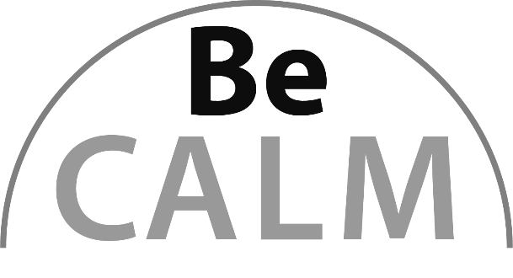

Benchmark Fractions
Beginning Curriculum for Adults Learning Math
Curriculum for GLE 2–4

TEACHER’S GUIDE

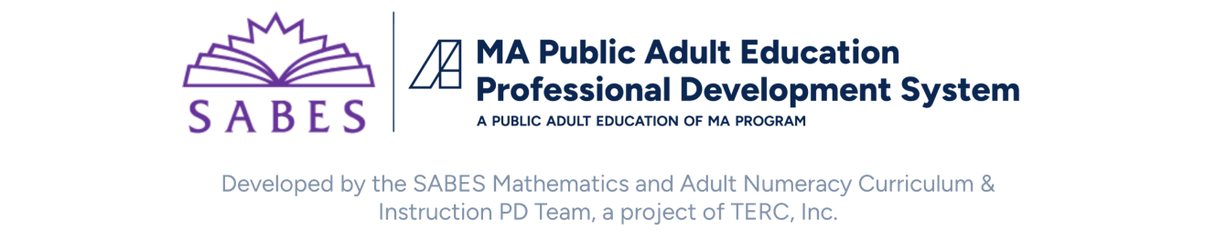

Acknowledgements

The titles in the BeCALM series were developed and piloted in the classroom by Melissa Braaten for the SABES Mathematics and Adult Numeracy Curriculum & Instruction PD Team, with contributions from Yvonne Readdy, Emily Rudd, and Sherry Soares.

The BeCALM series includes four sequential packets:
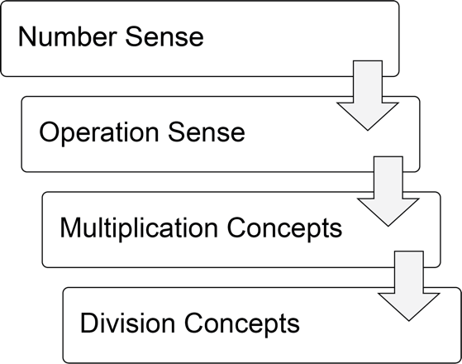
and three non-sequential packets:
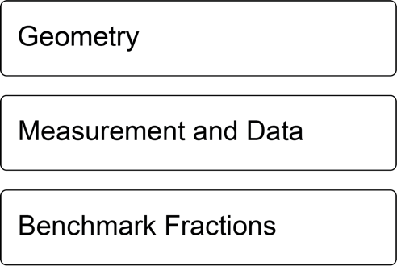

Activities from the EMPower™ series title Using Benchmarks: Fractions and Operations are used and/or adapted with permission from the author, TERC, Inc.

Learner Level
The math content is aimed at ABE level math students (approximately GLE 2–4). While adult students at this math level may have any level of reading, the student materials were designed to be used by adults with a reading level GLE 2 or above. To keep things accessible, the text in the Student Packet is kept to a minimum so that this can be used with students at an ABE reading level or students who are beginning to intermediate English Language Learners.

Use in Different Settings (In-Person, Remote, Corrections)
This curriculum was designed for use in-person, hybrid, or in a remote classroom. In some cases, the same activity could be used in either format. Other times, suggestions are made for altering the activity in a remote classroom. Each activity is labeled based on its format.
Note: Virtual resources often work better on computers, laptops, tablets, or Chromebooks rather than on Smartphones, especially due to small screen size. There are notes on the specific websites used in each unit. These virtual activities could also be used in an in-person class or assigned for homework.
Throughout this guide you will see the following icons that denote the delivery format(s) of the activity or resource:

Suggestions for adapting in-person activities for use in correctional facilities are provided when necessary.
Students at the suggested level (GLE 2–4) are often building the skills covered in this unit, not simply reviewing them. The pilot-testing of these materials took about 12 hours of class time for each unit (not including the final survey project).

Teaching Skills that Matter (TSTM)
Teaching Skills that Matter (TSTM) in Adult Education is a project of the Office of Career, Technical, and Adult Education (OCTAE). See https://lincs.ed.gov/state-resources/federal-initiatives/teaching-skills-matter-adult-education for more information about the program and toolkit.
Information on the Massachusetts Teaching Skills That Matter Academies can be found at https://www.doe.mass.edu/acls/frameworks/tstm.html?section=fy2025.
Part of TSTM is integrating and contextualizing basic skill development in content areas relevant to adult learners. The five content areas highlighted by TSTM are Workforce Preparation, Financial Literacy, Health Literacy, Digital Literacy, and Civics Education. In this curriculum, each unit contains an activity in the context of financial literacy.
In addition, these activities are designed to build skills designated by TSTM as the “skills that matter,” which include:
- Adaptability and Willingness to Learn
- Communication
- Critical Thinking
- Interpersonal Skills
- Navigating Systems
- Problem-Solving
- Processing and Analyzing Information
- Respecting Differences and Diversity
- Self-Awareness
Financial Literacy activities are indicated with this icon:


Components of Instruction

Routines
Classroom routines can be powerful tools in the math classroom. Routines provide a familiar structure to an activity that helps students feel safe because the directions and expectations are predictable. However, a good math routine still provides a cognitive challenge and requires some type of problem-solving every time. There are several routines included in this unit, with notes and descriptions of how to facilitate these routines in the unit details. PowerPoint files for these routines can be downloaded from https://www.dropbox.com/scl/fo/sboxrdrxe8ih9kf0z0tqw/AAuJqEvknO22Ia4jL3ya3Rc?rlkey=pvsgdssupejow9qa7q4utd5tw&st=sp1jseca&dl=0

Introduction of New Concepts
Each unit includes one or two activities to introduce the new concepts for that unit. Instructions for facilitating are included in the unit details. The goal is to lay the foundation for conceptual understanding of the concepts, rather than simply explaining procedures.

Vocabulary and Things to Watch For
Each unit includes some suggestions on valuable vocabulary words and common misconceptions or interesting student ideas that came up in the pilot class.

Materials Overview
- Unit 1: One-half
- Unit 2: More or Less than One-half?
- Unit 3: One-fourth
- Unit 4: Application Project: Survey
Each unit includes materials for:
- Financial Literacy or Application Project
- Activities and Practice
- Language Support
- Self-Evaluation (reproducible from Teacher’s Guide pp. 48, 51, 54, 55)
Additional PowerPoint documents also accompany this unit (separate downloads):
- Is It Half?
- Two Truths and a Lie
- Data Says…

Suggested Virtual Tools for Visualizing Fractions
These web resources are great tools for creating visuals of fractions, decimals, and percents. They can be used by the teacher during instruction or by students as a way of investigating or showing their thinking.
Fraction Wall
https://www.visnos.com/demos/fraction-wall
Allows you to create equivalent fraction strips.

Circles and Rectangles
https://www.visnos.com/demos/percentage-fraction-decimals-grid
Allows you to create fraction visuals using circles and rectangles. Can show percent and decimal equivalents.

Build a Fraction: Lab
https://phet.colorado.edu/sims/html/build-a-fraction/latest/build-a-fraction_en.html
The lab mode allows you to build fractions and mixed numbers using circles.

Visualizing Fractions
https://www.geogebra.org/m/DV6Ehjnx
This is a collection of Geogebra applets that create fraction visuals, using bars, number lines, circles, and more.

Math Background: Benchmark Fractions
Text below adapted from EMPower Plus Using Benchmarks Teacher Book, pp. xix–xx. Used with permission.
Scope of this Curriculum
This unit builds students’ understanding and ability to work with benchmark fractions in a way that makes sense to them. Many beginning math learners have had fraction instruction in the past, but it didn’t “stick,” because they may have memorized rules that they didn’t understand. In our professional development work with adult education teachers in Massachusetts, fractions is the math topic that teacher claim they have to “reteach” the most. By taking the time to establish the concepts of part-whole, a portion of an amount, and some basic benchmark fractions, students develop a solid foundation for understanding rational numbers that will serve them well as they reason about data, work with percents, and continue to make sense of numbers in their everyday lives.
The first two parts develop foundational concepts about fractions and part-whole relationships by focusing on the benchmark fraction one-half (and its decimal and percent equivalents). In part 3, students build on one-half to use fourths as benchmarks. By the end of this unit, students will be able to use 0, ¼, ½, ¾, and 1 as benchmarks to estimate, draw, and make sense of other fractions.
The last part is an application project in which students create survey questions and circle graphs of the results. Depending on the class level and the amount of time available, a teacher might choose to teach parts 1 and 2 and have the class complete the project using only one half as a benchmark.

Using friendly fractions, decimals, and percents as benchmarks
Encouraging students to consider … benchmarks or referents is a way of helping them develop better conceptual understanding of fractions, decimals, and percentages. This intuitive understanding is a priority and should precede the study of operating with fractions, decimals, and percentages (Developing Number Sense in the Middle Grades, The Addenda Series, Grades 5–8, 1991.)
Although this statement was written about developing number sense in school-age children, it makes sense for all fraction learners. In everyday life, numerate adults gravitate to friendly numbers: $7.99 is about eight dollars; 2.254 is a little more than 2¼; 1,744,542 is nearly 1¾ million. We call such friendly numbers “benchmarks” because they serve as points of reference by which to judge less-familiar numbers. Benchmarks not only allow us to arrive at reasonable estimates, they also anchor working with other fractions, decimals, and percents. In this unit, lessons begin with the familiar fraction one-half and build on what people know intuitively about halving. Students start by showing half of something and move on to discuss how they know it is one-half. Once they establish that a part is half of the whole (by dividing the whole by two or by separating items into two groups), they use this knowledge to determine whether other fractions are larger or smaller than 1/2. Students then move on to the benchmark 1/4. Again, they start by showing what they know. They then consider the fraction 3/4 and how other fractions compare to it.

Understanding a fraction as the relationship between a part and a whole
Students are first asked to focus on fractions as the relationship between two quantities, a part and a whole. They visualize part-whole relationships in a variety of ways—by drawing pictures and using number line segments, area models, sets of discrete objects, and arrays to increase their repertoires. Understanding a fraction as a part-whole relationship also requires an understanding of the whole as the sum of its parts. To that end, the unit includes activities and practices that focus on the need for fraction complements that total one whole, such as 1/2 and 1/2 or 1/4 and 3/4.

Understanding a fraction as a signal to find a portion of something
“I keep only one-half of my monthly earnings of $800.” “I heard the budget for education might be slashed by 25%. What does that mean in dollars?” Helping adults address these useful applications of fractions, decimals, and percents is essential. Students are asked to solve problems in which they find portions of amounts by exploring everyday situations. As part of this exploration, students not only find the fractional part when they know the whole but also, given the fractional part, are asked to find the whole. The lessons go further than simply mirroring the problems adults see in their daily lives. The activities presented in the lessons work to bring to the surface and develop methods for visualizing and explaining rational numbers that result in students moving beyond memorization of rules.

Unit 1: One-Half
Learning Objectives | CCRSAE
I can find half of a whole shape or amount. | 3.NF.1–3, 3.G.2
I can write a fraction equal to one-half. | 3.NF.3
I can find the whole when I know one-half. | 3.NF.1-3
I can use correct grammar to talk about parts and wholes.

Standards for Mathematical Practice
MP.2 Reason abstractly and quantitatively
Students will represent different situations as fractions and interpret the fraction one-half in different contexts.

Extra Resources for this Unit
- Downloadable file: Is It Half? PowerPoint
- Downloadable file: Two Truths and a Lie PowerPoint
- Reproducible: Part/Whole Graphic Organizer for One-Half, Teacher’s Guide p. 56
- Reproducible: Evaluation Unit 1, Teacher’s Guide p. 46
- Reproducible: Unit 1 Quiz, Teacher’s Guide pp. 50–51
Other materials
play money, a ruler, a book, a small cup of beans, a price tag, a piece of string, other classroom objects that can be used to represent a whole amount

Math Background

One-half of different wholes
This unit attempts to provide a broad foundation of understanding part-whole relationships in a variety of contexts, all through the benchmark fraction one-half. One-half is probably the most accessible benchmark fraction, since it is usually easy to visualize and calculate, so it is a good jumping off point to explore a number of basic fraction concepts.
The opening activity starts by exploring half of shapes, which means students are finding half of the area of a given shape. This is the most accessible when the shapes can easily be cut into two identical parts, or if the shape is symmetrical:

However, we also want to push students beyond symmetrical pieces to think about equivalent fractions, such as 2/4 or 3/6. In this case, they start to see one half as two equal portions, not just two identical or mirrored shapes.
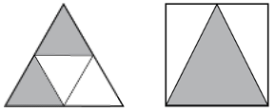
Portions can also be equal even if the pieces are not all the same size, as seen on this wall, shaded half gray and half white:
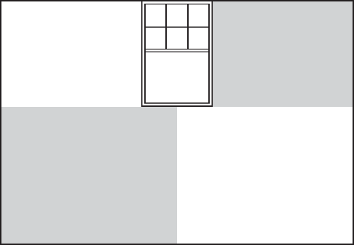
After the opening activity, students move to finding half of discrete quantities (like half of a group of beans), half of continuous lengths (like a piece of string or a ruler or number line), and half of larger, represented quantities (such as money with bills in different denominations), or simply numbers (like the number of pages in a book.)

Methods for Finding Half
Depending on the whole (symmetrical shape, area, line, quantity, etc.), a number of methods can be used to determine half of a whole.

Find the middle
Symmetrical shapes and lines lend themselves to finding the middle or folding a shape (or a string) in half.

Passing out
Some wholes lend themselves to a “passing out” method, in which equal areas or quantities are assigned to each half.
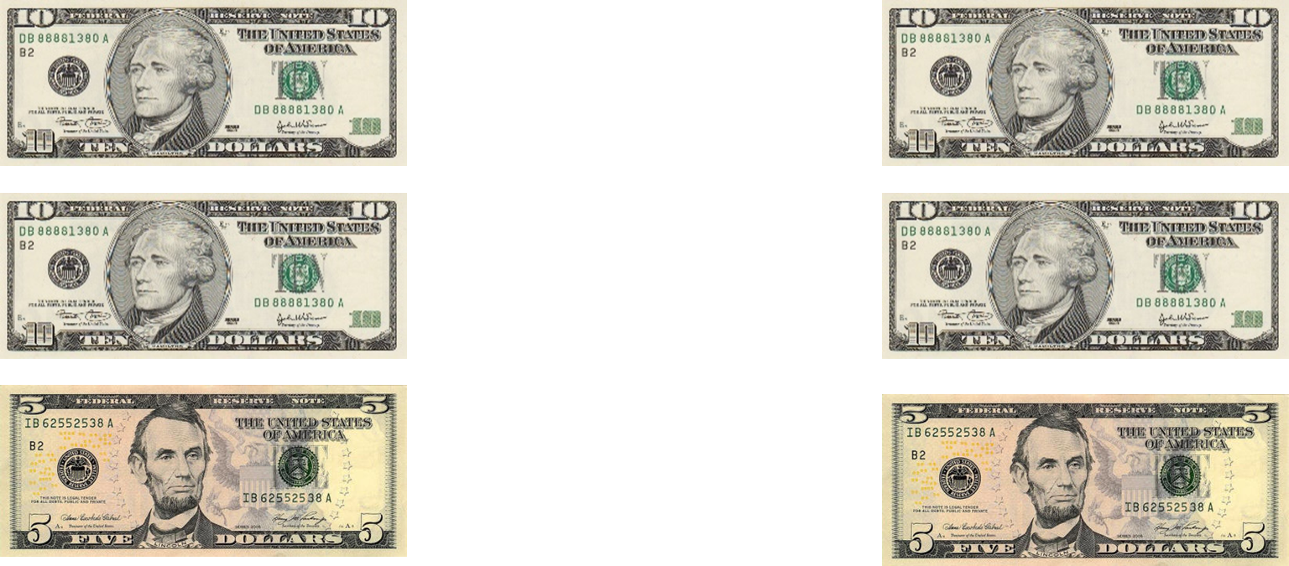

Divide by 2
Students familiar with division will recognize that whole quantities can be divided by 2. (The teacher should consciously use even or odd whole numbers or decimals depending on the level of the student).
Students who are ready can be pushed to develop number sense strategies to help them divide. For example, a student could be asked to find half of 352 using mental math. Some students will attempt to perform the long division algorithm in their head, carrying the difference for each step over into the next place value.
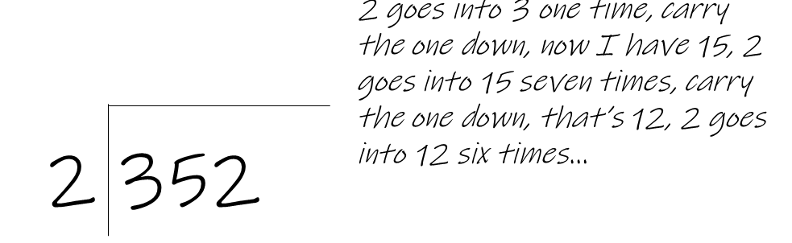
While this may work for some students, especially with smaller numbers, this often uses more working memory than a decomposition approach.

Decomposition
With decomposition, the number 352 can be broken up, or “decomposed” into 300 + 50 + 2. Finding half of each part is usually simpler (since the pieces are generally friendly numbers), and then these can be combined to find the half).

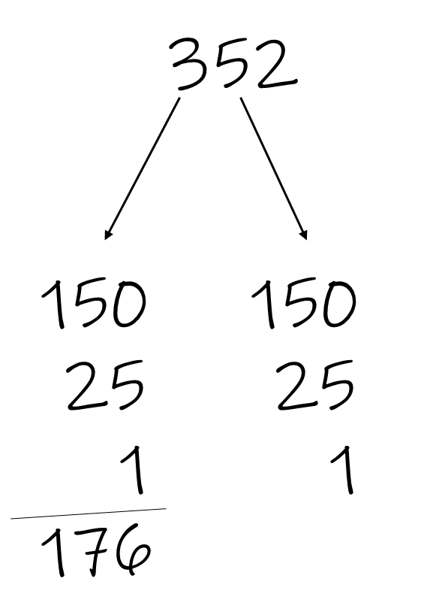

Equivalent Fractions
Another big idea in this unit is that other fractions can be equivalent to one-half. This can start as early as the first activity, in which the shapes can be cut into many equal parts and half of the parts shaded. Students need to practice writing these fractions in part/whole fraction form, identifying the part as the numerator and the whole as the denominator. There is a graphic organizer provided (see Teacher’s Guide p. 57) that can be helpful for students who are learning to set up and write fractions this way.
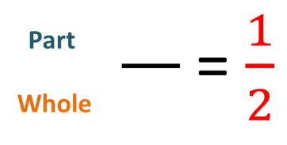

Talking About Parts and Wholes
As students are learning the concept of parts and wholes and identifying them, they are also introduced to the grammar used to talk about part-whole relationships in English. This is valuable for both English language learners and native speakers, since the grammar we use when we talk about mathematical relationships is very precise and depends on the position of quantities and certain prepositions in the phrase.
In this case, the phrase is “portion of whole.” The part can appear in different places in the sentence, but “portion of whole” remains intact.
Example:
10 is ½ of 20 ½ of 20 is 10
What is ½ of 20? 10 is ½ of what?

The materials use the following steps to teach this grammatical phrase:
- Create cognitive dissonance. (Two truths and a lie)
- Provide anchor chart with visuals. (Both on paper; should be provided as a visual in the classroom, when possible).
- Varied practice, higher scaffolding lower scaffolding.
- Frequent short, cyclical review (warmups, homework, review questions on quiz) which should continue into the following units.

Activities and Practice


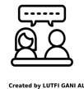
INTRODUCING THE UNIT
In-Person/Remote Activity
Uses Student Packet p. 3
Have students read the text on p. 3 and complete the think and share.

OPENING DISCUSSION
In-Person/Remote Activity
Uses Student Packet p. 6
- Invite the students to find three ways to shade one-half of each shape on page 6. If they are not sure what is meant by one-half, explain that they need to share the cake equally between two people.
- Collect a bunch of different examples to discuss, including ones that use equivalent fractions such as 2/4. (If no students draw this, introduce it yourself.)
- Ask: Is it one-half? How do you know?
- Continue to page 7. Debrief some examples, again asking how students know they have shaded one-half.
The goal of this introduction is to introduce the idea of one-half as one out of two equal portions and to informally assess what students already know about one-half and fractions, and their ability to think spatially when breaking up and comparing parts of shapes.
This is also a good place to introduce fraction notation, where the “whole” is on the bottom and the “part” is on the top. See the reproducible graphic organizer on page 57 in the Teacher’s Guide.

Vocabulary for this Unit
In-Person/Remote Activity
Uses Student Packet p. 4

Fill-in-the-blank definitions and examples have been provided for the major terms in this unit. Teach/review words along with activities where they arise, rather than teaching them all at once.
- part-whole: A portion of something. The part is included in the whole.
- one-half: One of two equal parts or groups.
- numerator: the top number in a fraction, representing the part.
- denominator: the bottom number in a fraction, representing the whole.
Other words to consider teaching: double, twice

Introducing Routine 1: Is it half?
In-Person/Remote Activity
Uses downloadable file Is It Half? PowerPoint
This is a simple warm up to get students to think about the concept of one half in different situations: shapes, number lines, quantities, and equivalent fractions. For each image, ask students, Is it half? How do you know? Give them time to think, then have volunteers explain their thinking. You can start with one or two slides at the beginning of each class, then alternate with other routines once they are introduced.
Note: Teacher explanations for each slide are included in the PPT notes.

Show Me One-Half
In-Person/Remote Activity
Uses Student Packet p. 8
This has even more examples of geometric, measurement, and quantity situations that involve finding half. For each problem, emphasize identifying the whole and ask students, how do we find half of that?
- Start to record informal methods for finding half, such as “cut it in the middle” or “divide by 2” or “shade every other candle.”
- Debrief examples of student solutions so they can see that there are different ways to show half that are equivalent, and different methods.

Find half of it
In-Person/Remote Activity
Uses Student Packet pp. 10–11
- This provides practice finding half of numerical wholes. Encourage students to use number sense to decompose larger numbers to find half. For example, thinking of 88 years as 80 and 8, finding half of 80 (40) and half of 8 (4) and putting them together.
- Discuss what happens when we have to find half of an odd number, such as #5, $25. Discuss different ways of writing the result, such as 12.50 or 12½. Emphasize that it is ok for a fraction to include a decimal or another fraction in the numerator or denominator.
For students who need more support, give them two-digit whole numbers on cards or pieces of paper, and make manipulatives available. Make sure all students can explain their methods for finding half an amount and can write the equivalent fraction correctly. Use the graphic organizer (reproducible in Teacher’s Guide page 57) to provide support as long as needed.

More practice with finding half
In-Person/Remote Activity
Materials needed (in-person): trays, string, books, rulers, index cards, other classroom objects
In person: Use small trays. On each tray, put a variety of objects that could represent a whole: a ruler, a book, a small cup of beans, a price tag, a piece of string, etc. Ask students to find half of each amount, and if possible, to write the equivalent fraction. Provide the graphic organizer (reproducible in Teacher’s Guide page 57) as needed.
This provides practice with finding half of different types of wholes, such as discrete quantities (beans), lengths (string), amounts (price tag), etc. The objects on the tray can be modified to match the level of the student. Continuous wholes, like the string or the piece of paper, could be folded or measured to find half.
Remote alterative: Have students collect a few objects from their environment (a book, a cord, a handful of dried beans, etc.). Ask them to find half of each and to write an equivalent fraction. For remote students, include several copies of the graphic organizer page (reproducible in Teacher’s Guide page 57) in their packets so they have them available at home.

doubling
In-Person/Remote Activity
Uses Student Packet pp. 12–13
- Ask: How can you double a number? Make sure students mention both adding a number to itself and multiplying by 2.
This activity is meant to provide practice doubling whole numbers. Ask students to look for and describe any patterns they see when doubling the numbers. (Some students may notice that doubled numbers are always even, or that doubling the multiples of ten follows the same pattern as doubling single digit numbers.)
- Ask: Which numbers were easier to double? Which were harder?
The last set of numbers is probably the most difficult for most students, since they have numbers greater than 5 in the ones place and require regrouping.

What is the whole?
In-Person/Remote Activity
Uses Student Packet p. 14
- First, ask students to identify the part and the whole in each picture/diagram. Then ask, which one do we know?
- Have students find the whole and explain their method for finding the whole. Collect a few methods, such as “adding the half to itself” or “doubling.”
- Have students write an equivalent fraction for each part-whole.
Note: This contains three common visuals to show one-half: A circle graph, a bar diagram, and a number line. All three will be used in this curriculum. Ask students which diagram they prefer and encourage them to draw their own diagrams as needed when they are finding halves and wholes.

Practice: what is the whole?
In-Person/Remote Activity
Uses Student Packet p.15
- Go over how the table works, and have students identify what information is given (the half, the part) and what they have to find (the whole). Ask them what methods they used to find the whole in the previous activity.
- Explain how to write a fraction that represents the whole, or “all of it.” Ask: Why do these fractions have the same number on the top and bottom of the fraction?

Language support: talking about parts and wholes
In-Person/Remote Activity
Uses Student Packet pp. 16–24
- Start by presenting students with the true or false statements on page 16. Ask them, what is different between the two? Does it matter? Does it change the meaning when we change the place of the numbers in the phrase?
- Go over the anchor chart on page 17. (It is helpful to have a poster copy available in the classroom as well.) Explain that each number goes in a certain place in the phrase.
- Have students complete the examples where one number is missing. Ask: Which number is missing, the part or the whole? How can you find the half/whole?
- Have students complete the open-ended statements on page 18 and have them share how they created their own examples.
- Have students complete the open-ended phrases on page 19 and to write the equivalent fractions.
- On page 20, the students are introduced to the fact that the word order can change, but the phrase always remains “portion of whole”. Emphasize that in this grammar structure, the word “of” comes before the number or amount that is the whole.
- Have students practice this on pages 21–24. You may not want to do this all in one lesson but start and then return over the course of a few lessons. Students will also continue to practice this grammar structure with Routine 2: Two Truths and a Lie.

Introducing Routine 2: Two Truths and A Lie?
In-Person/Remote Activity
Uses downloadable file Two Truths and a Lie PowerPoint
In this routine, students are presented with three statements, two of which are true, and one is false. They need to find the “lie.” Make sure there is enough quiet wait time for all students before you allow students to share.
All of the slides in this PPT provide practice with the grammar of talking about parts and wholes. The first slides only use 1/2, while later slides use .5 and 50% as well. Continue to revisit this routine throughout the curriculum so students get lot of practice. There are also some slides with open-ended grammar sentences as well, so that students can practice the grammar in different ways.

Word Problem Practice
In-Person/Remote Activity
Uses Student Packet pp. 25–26
Encourage students to read carefully and to decide if each number is a part or a whole. They should be on the lookout for the phrase “portion of whole” to help them decide.

Exit Ticket/Homework (Formative Assessment)
In-Person/Remote Activity
Uses Student Packet p. 27
Encourage students to write a fraction for half of the bill and explain how they know that it is half. Look and listen for correct grammar when talking about halves and wholes, correct use of fraction notation, and the use of appropriate methods for finding half of a whole.

Unit 1 Quiz (Summative Assessment)
In-Person/Remote Activity
Reproducible in Teacher’s Guide pp. 50–51

Answer Key:
- $\frac{14}{28}$ students
- $\frac{36}{72}$ pages
- $\frac{\$6.50}{\$13.00}$
- $64
- a) True b) False c) True

Vocabulary
part-whole: a portion of something. The part is included in the whole.
one-half: one of two equal parts or groups.
numerator: the top number in a fraction, representing the part.
denominator: the bottom number in a fraction, representing the whole.

Things to Watch For

Challenging language
In addition to the challenging grammar that is explicitly addressed in this unit, some of the vocabulary words can be difficult for students as well.
- “Half” and “whole” can be challenging for non-native speakers because they both have silent letters and can be easily confused with “have” and “hole.”
- The phrase “out of”, which is commonly used to describe part-whole relationships, such as “4 out of 6,” is often confused with subtraction or removal. A student may think you are asking them to “take 4 out of 6” and respond with “2.”
- 1/2 “One-half” and 1½ “One and one-half” are frequently conflated by native and non-native speakers alike. It is helpful to point out the difference explicitly, with pictures and a number line. Also, it is common for English speakers to refer to “one-half” simply as “a half.”

Unit 2: More or Less than One-Half?
Learning Objectives | CCRSAE
I can write one-half as a fraction, decimal, or percentage. | 4.NF.6
I can use a number line and a circle graph/pie chart to show one-half. | 3.NF.2
I can decide if a fraction, decimal, or percent is more than, less than, or equal to one-half. | 3.NF.3, 4.NF.2
I can measure length with a ruler to the nearest ½ inch. | 2.MD.2–4

Standards for Mathematical Practice
MP.3 Construct viable arguments and critique the reasoning of others.
Students will explain how they know if an amount is more or less than half using calculations, number lines, circle graphs, etc., and consider the explanations of others.
MP.4 Model with Mathematics
Students will use fractions, decimals, percents, number lines and circles graphs to make sense of real-world problems.

Extra Resources for this Unit
- Downloadable file: Two Truths and a Lie PowerPoint
- Downloadable file: Data Says… PowerPoint
- Downloadable file: Compare Half Stations Remote PowerPoint
- Reproducible: Bill and Check for Comparing Fractions to 1/2, Teacher’s Guide p. 60
- Reproducible: Evaluation Unit 2, Teacher’s Guide, p. 47
- Reproducible: Unit 2 Quiz, Teacher’s Guide, pp. 49–50
- Reproducible: Half Inch Rulers, Teacher’s Guide, p. 59
- Web link: Compare Fractions to Benchmarks on Geogebra.org
https://www.geogebra.org/m/fmap6quz

Other Materials
Circle graph makers
These are made from two paper plates in contrasting colors. Make one cut into the center on each plate, and slide together, as shown below.

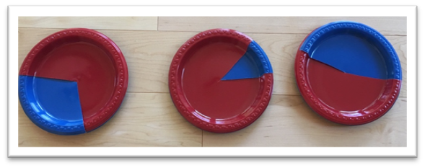
Materials for stations:
- Page from a calendar (choose a month with 30 days)
- Box of 100 paper clips
- Book and bookmark
- Yardstick (or ruler, if yardstick is not available)
- Reproducible: Bill and Check for Comparing Fractions to 1/2, Teacher’s Guide p. 60

Math Background

Using Benchmarks
In this unit, students begin to use the benchmark one-half (and it’s decimal and fraction equivalents) to think about the size of other fractions, decimals and percents. By comparing to one-half, students can reason that, for example, 56/100 is a little more than half, or that 35% attendance is less than half. Having a way to make sense of the size of non-benchmark fractions is crucial for students to be able to tell, for example, whether they are close to finishing a trip or whether a tax percentage is high or low. Students also use 0 and 1 (or 0% and 100%) as benchmarks in this unit, so they can decide and describe whether a portion is very small or almost a whole.
Two visual tools are used to help students with these comparisons. Number lines are introduced in the context of traveling distances, since distance lends itself to a number line interpretation. Percents are explored using circle graphs/pie charts, since this is a common way that students will encounter percents, especially for data and statistics. Circle graph makers (see materials) are a great way to give students interactive practice with identifying these benchmarks and estimating other percents.

Percent and Decimal Equivalents for One-half
This unit introduces percents and decimals in a simple way, by explaining the percent and decimal equivalents for one half. By introducing all three representations of these benchmarks together, students can apply what they know about one-half to make sense of irregular percents and decimals as well.
Percents are mostly addressed in the context of data and discounts, and represented with a circle graph, since the benchmarks 0%, 50%, and 100% are easy to visualize and compare to on a circle. Decimals are introduced in the context of money, especially $0.50 as half of one dollar. The goal is not to address percents and decimals in their entirety in this unit, but to connect these forms of representation to one-half as intuitively as possible, and to lay a foundation that can be built upon later.

Thinking about Data
The activity Women in the Workforce and the routine Data Says… both give students exposure to the use of percents to describe data. The data used in the materials is based on real data from cited sources. Data is often intrinsically interesting to students because it tells them something about the world and invites interpretation and questions. Statistics are also a great way to get students thinking about parts and wholes. There are suggested questions in the Data Says… routine to get students thinking about what or who is the whole in the circle graph/statistic (the whole US population or just children, for example), and who or what is represented by the percent not included in the statistic (if 89% of the world population is right handed, what does that mean about the other 11%). If it comes up, give students some time to wonder about how people might collect this data (Do you think they checked every person on Earth? Why or why not? How else might they come up with this percent?)

Using Mixed Numbers
Mixed numbers come into this unit in the context of measuring to the nearest half inch with a ruler, but they are an important foundational number idea as well. Prior to this, students will have used a ruler and/or yardstick previously to find fractions equivalent to one-half, such as 6 out of 12 inches. In that case, the entire length of the ruler is used as the whole. When using the ruler to measure to the nearest half inch, one inch is the whole.
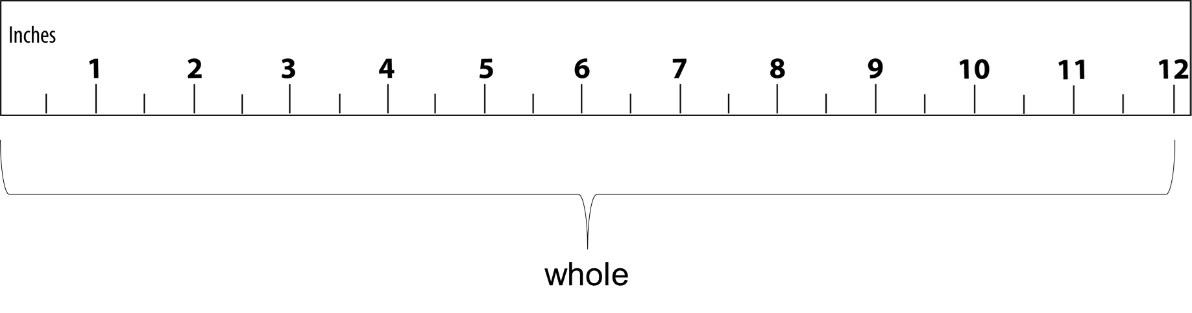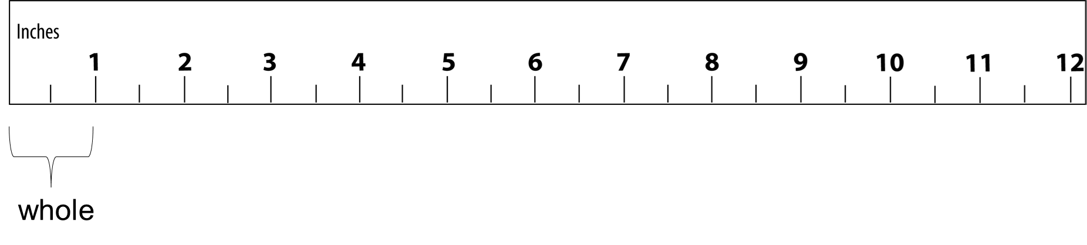
This is a bit different from their previous thinking about half of a discrete quantity (such as 100 out of 200 pages of a book). Instead, the discrete (countable) items are multiple wholes, and a single continuous item (like an inch, or an egg) is the whole. Drawing students’ attention to what counts as a whole is important here. Use additional concrete examples as needed, such as food items that can be cut in half.
2 $\frac{1}{2}$ avocados
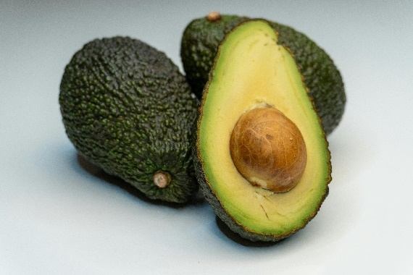

Activities and Practice

Introducing the Unit
In-Person/Remote Activity
Uses Student Packet p. 28
Have students read the text on p. 28 and complete the think and share.

Opening Discussion
In-Person/Remote Activity
Downloadable PPT: Data Says…
Materials: Circle graph makers (two paper plates in contrasting colors for each one)
- Start by showing a circle graph/pie chart with a recent statistic. The graph should have just two colors/categories. You can sketch the graph yourself, or make one with software like Excel or Google Sheets, or you can use one of the examples from the PPT, Data Says...
- Ask: Is that a lot or a little? How do we make sense of this portion?
- Explain the term benchmark fraction, and that one-half is a very common and useful benchmark. Explain that in this unit, they will be using one-half to decide if other fractions are more than, less than, or equal to one-half.
- Start with a pie chart/circle graph maker. (These are made using two paper plates in contrasting colors. Make one cut into the center on each plate, then slide them together.) If you are in person, it is helpful to have a circle graph maker for each student to use.
- First, ask students to show one-half on the circle graph maker. Ask for volunteers to explain how they know that it is one half.
- Then ask students to show you a fraction that is greater than one-half (specify the color). Ask how they know that it is greater than one-half.
- What about the other color? More or less than one half? Ask how they know.
- Ask them to show a portion close to 0. Ask them to show a portion close to one whole.
- Explain that 0 and 1 (whole) are also benchmarks that will help them to make sense of other fractions.
Remote alternative: You can use a circle graph maker as a visual on camera, and have students identify in the chat whether a certain color is more than, less than, or equal to one half, and also if it is close to 0 or 1 (whole).

Vocabulary for this Unit
In-Person/Remote Activity
Uses Student Packet pp. 29–30

Fill-in-the-blank definitions and examples have been provided for the major terms in this unit. Teach/review words along with activities where they arise, rather than teaching them all at once.
- benchmark fraction: A fraction that is easy to understand and calculate. We can use benchmarks to understand other fractions.
- decimal: the place values that come after the decimal point. These represent fractions or parts of the whole.
- percentage (percent): a percentage is part of 100 (the whole is 100)
- circle graph/pie chart: a graph that shows percentages by breaking up a circle into parts. The whole circle represents 100%.
- data: measurements or counts of things in the real world
- to the nearest 1/2 inch: when measuring, this means you choose the closest whole or half inch on the ruler.
Other words to consider teaching: greater than

Why is 50% a Half?
In-Person/Remote Activity
Uses Student Packet p. 31
- First ask students how many small squares are in the grid, and how they know. (Hopefully students will notice and use groups of ten, rather than counting one by one.)
- Explain that percent means “per hundred” or “for every hundred.” The root “cent” might be familiar to some students from other languages:
Spanish: cien, ciento
Portuguese: cem, cento
French: cent
- Ask them to use the grid to show why 50% (or 50/100) is one half. Share examples. Emphasize the idea that there are two 50’s in 100, so 50% is one out of two equal portions.
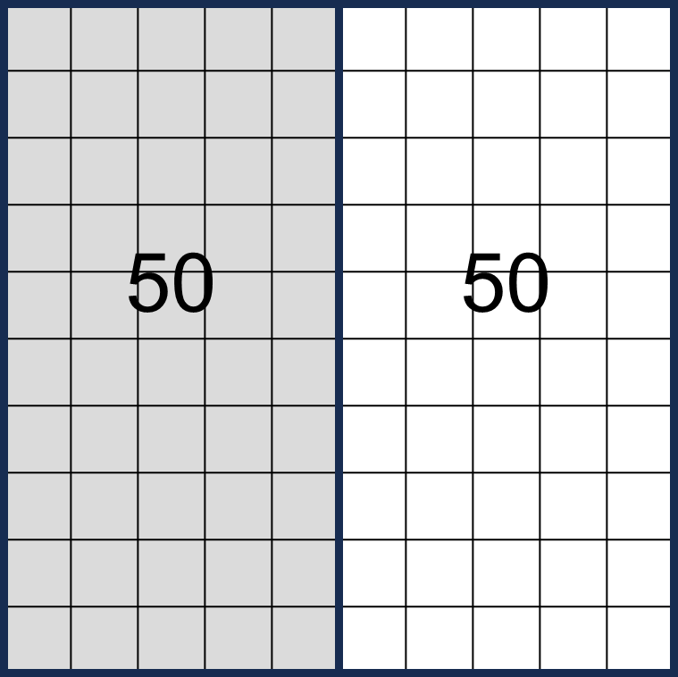
- Ask: Is it still 1/2 if we shade it differently (like, for example, every other row)? Is it still 50%? Make sure students can identify that it is the amount/portion, not the arrangement or shape, that makes it 1/2.
- Revisit the circle graph maker. Explain that circle graphs are often used to show percentages. Repeat the activity in the introduction, but ask students to show you 50%, more than 50%, less than 50%, etc. Also demonstrate what 0% and 100% look like on the circle graph maker and ask students to show you percents close to those.

Half of a Dollar
In-Person/Remote Activity
Uses Student Packet p. 32
Optional: play money
This activity is meant to help students connect the benchmark one-half to its decimal equivalents, 0.5 and 0.50, using the context of American money.
- First ask, What is half of a dollar? Most students will know that this is $0.50. Spend some time making sure students know how to write and read different ways of writing “fifty cents.” Go over
50¢ $0.50
and make sure they are using the symbols correctly (common mistakes include .50¢ and ¢50 and 0.50$)
- Ask them to explain why 50 cents is half of a dollar. Listen for or prompt explanations such as “two $0.50 is one dollar” or “two 50’s is 100,” or even something using coins, such as “two quarters is 50 cents and 4 quarters is a dollar.”
Optional: Ask students to show you different ways they could make 50 cents with different coins. Ask them to use all of one type of coin, such as all dimes or all nickels.
- Ask: How many (nickels) to make 50 cents? How many (nickels) to make one dollar? Have them write this as a part/whole fraction and to show how they know it is equal to one half. For example:
$$\frac{10}{20} \text{nickels}= \frac{1}{2}$$
- Explain that decimals are a way of writing certain fractions. The first decimal place is for writing tenths. The second decimal place is a way of writing hundredths. Connect tenths to dimes and hundredths to pennies. Ask students to prove why 5 out of 10 dimes and 50 out of 100 pennies are both half of a dollar.

Women in the Workforce
In-Person/Remote Activity
Uses Student Packet, p. 33
Materials: Circle graph makers
- On the first page, ask students to identify whether each percentage is more or less than half (50%).
- Using the circle graph makers, review the benchmarks 0%, 50% and 100%. Ask students to estimate other percentages with the circle graph makers, such as 5%, 45%, or 98%. You can also create a circle graph and have students estimate the percent and explain their estimate.
- See if students use other benchmarks (i.e., 25%, 75%) to help their reasoning. If not, that’s ok at this point. Those benchmarks will be introduced in Unit 3.

Introducing Routine 3: Data says…
In-Person/Remote Activity
Uses downloadable file Data Says… PowerPoint
In this routine, students use pie chart makers and the benchmarks 0%, 50%, and 100% to estimate other percentages.
- Have students make a guess with a pie chart maker about the percent in the statistic.
- Go to the next slide to show the actual percent. Have students adjust their pie chart makers. Ask:
Were you too low? Too high?
What does the whole circle represent in this situation?
What does the other part/portion represent in this situation?

Are We There Yet?
In-Person/Remote Activity
Uses Student Packet pp. 34–35
This activity introduces the use of number lines to show parts of a whole, and specifically to decide if a portion is more or less than half. Since it is in the context of travelling distances, the use of the number line to show quantity as distance should be easier for students to understand.
- Show students how to label the benchmarks on each number line. The leftmost tick mark should be 0, and can also be written in fraction form, as 0/whole (use whatever the whole number of miles is for each trip. Since the trip starts in Boston, Boston is located at the 0. The destination is at the rightmost tick mark, and this fraction represents the whole, for example, Worcester, 50/50.
- Ask students to label the halfway point of the trip on the number line in fraction form.
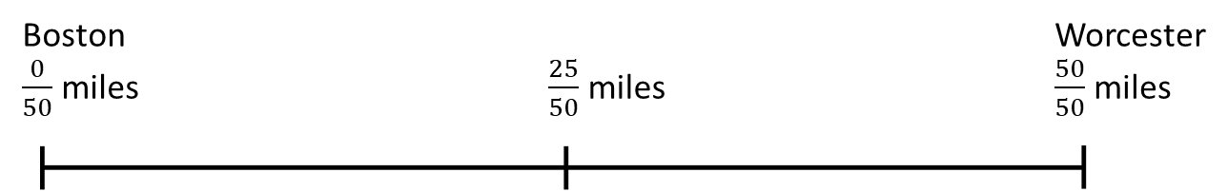

- Once students have labeled a number line, ask them about other portions of the trip. For example, say “I am driving from Boston to Worcester. I have gone 32 miles. Am I more or less than halfway there?” Explain how knowing the halfway point (25/50 miles) can allow us to describe other fractions (such as 32/50) as more or less than half.
- Continue with other number lines. Ask them about portions that are close to 0 and close to the whole as well or ask students to give you a number of miles that is more or less than half.

Stations: Comparing Fractions to 1/2
In-Person/Remote Activity
Uses Student Packet, p. 36
Copies of More or Less than One Half Number Lines, Teacher’s Guide p. 60
In-Person Materials and Set Up:
- Set up five Fraction Stations. Each needs to communicate the idea of a total and some part of it. Here are some ideas:
Station 1: Place on a table or post a page from a monthly calendar with 16 days crossed out.
Station 2: Place a box of paper clips on a table (these usually have 100 clips) with some in a pile outside the box.
Station 3: Position a bookmark at the halfway point in a novel or reference book.
Station 4: Mark a yardstick at 20 inches.
Station 5: Post a bill along with a check for less than half the amount due. (See Teacher’s Guide p. 61 for reproducible)
- Complete the first example as a class (calendar). Ask students: Where do I find the number for the part? For the whole? What fraction of this month is crossed out? Is that fraction more than, less than, or equal to 1/2? How do you know?
- Listen to students’ explanations, and relate them to the methods described earlier, especially the use of operations and the number line.
- Complete the table for the calendar. Ask: What fraction of this month is not crossed out? How did you determine that? Is that fraction more than, less than, or equal to 1/2? How do you know?
- Tell student pairs to visit each station to complete their tables. Listen to how students reach conclusions so you can summarize later and address any questions that arose. Post a copy of the table on the board. Invite pairs to complete the table and explain how they determined answers. Have copies of the More or Less than One-Half Number Lines available for students to use to show their thinking, if they choose. Have students show their reasoning on a number line segment with 0 at one end (e.g., 0/30); the whole amount at the other (e.g., 30/30); the halfway point (e.g., 15/30); and the actual fraction represented (e.g., 16/30).
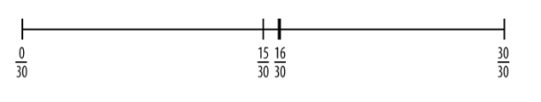
- Once everyone has agreed on the answers, return to the idea of writing a fraction to represent the whole. For each station, how would you write a fraction that represents the whole?
Remote Alternative: Use the PPT Compare Half Stations Remote. Do the first example together, then give students time to work through and discuss each slide.

Choose an amount
In-Person/Remote Activity
Uses Student Packet, p. 37
There are many correct answers for each question. Remind students to find one-half as a benchmark to help them compare other fractions and encourage them to use pictures or diagrams like number lines if that is helpful.

Is it Half?
In-Person/Remote Activity
Uses Student Packet, pp. 38–39
- First, model how to fill in the table. For example: the whole class is 20 students, 18 are present.
Fraction for the whole (total) | Fraction for half of the whole | Fraction of students who are present
$$\frac{20}{20}$$ | $$\frac{10}{20}$$ | $$\frac{18}{20}$$
As students work on the problems, listen for or highlight the following:
- The denominator of the fraction is the number of equal parts that make up the whole.
- The numerator in the fraction is the number of equal parts being considered.
- The numerator and denominator together make a single number that is fraction.
- The whole in this case is different from a whole number.
- Encourage students to use visual representations, counters, or paper clips for each of their methods so they can share their thinking. As needed, ask:
What is the whole? What are the parts?
How did pictures help you think about this problem? What different pictures did others use?
Who thought about it in a different way?

Practice: More "Is it Half?" Problems
In-Person/Remote Activity
Uses Student Packet, p. 40
Encourage students to work together and to draw pictures or number lines to support their thinking. The language in these problems is slightly more challenging than the previous activity.

Compare Fractions to Benchmarks
Remote/Virtual Activity
Supplemental activity
Uses Compare Fractions to Benchmarks on Geogebra.org
https://www.geogebra.org/m/fmap6quz

Note: Not recommended on a phone due to small screen size.
Students have a deck of fraction cards which they reveal one at a time and sort into categories of closer to 0, closer to 1/2, or closer to 1. They cannot check their work until all cards have been sorted. Upon checking, the applet tells the students how many in each bin are wrong and gives circle visuals to help with figuring out which ones they are. Students can then try again, this time with the circle visuals visible. They can continue to click “check my work” to evaluate their progress. There are three decks available.

Measuring to the Nearest 1/2 inch
In-Person/Remote Activity
Uses Student Packet, pp. 41–42
Materials: Half inch rulers, reproducible from Teacher’s Guide p. 60
- See what students already know about using a ruler. Ask students to measure something small, like their cell phone or pencil. Walk around and see if they align the ruler properly, and if they know to start the measurement at the 0 or beginning point of the ruler. If needed, review information about using a ruler (Student Packet p. 41).
- Ask students to look at the half inch ruler and to tell you what they notice. They should notice that the whole inches are labeled, and that there are lines in between each of the whole inches that are not labeled. Point to 2½ and see if students can tell you what this measurement is. If needed, review how to read/say “two and one half.”
- Have students label all of the half inches on the ruler, then go through as a class and read all the labels, including the whole numbers. (Note: students often are especially confused about the distinction between one-half (½) and one and one-half (1½) Make sure to emphasize this and check that students have written it correctly and understand the difference.)
- Explain that when we measure to the nearest half inch, we are choosing the measurement that is the nearest whole or half inch on the ruler. Ask students why they think a measurement of 2 inches could be to the nearest half inch. Look for an understanding that when we count by halves, whole numbers are included.
- Have students measure the pictures on page 42, then check to see if they agree on the measurements.

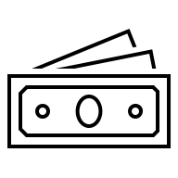

Financial Literacy: Comparing Sales
TSTM Skill: Critical Thinking
In-Person/Remote Activity
Uses Student Packet p. 43
- Have students read the text at the top of the page. Ask students if they have seen these types of sales before: 50% off, Buy One Get One, Buy One Get One 50% off.
- With a partner, they should consider the three sales and decide which one they think is the best choice. They should be prepared to explain their choice to the class. Explanations should include price/cost but can also include things like expiration date, etc.

Exit Ticket
In-Person/Remote Activity
Uses Student Packet p. 44
In addition to using 50% as a benchmark, this exit ticket checks to see if students are distinguishing between the units in the problem (the person saved $50) and the concept of a percent (in this case, $50 is less than half, or less than 50%).

Unit 2 Quiz (Summative Assessment)
In-Person/Remote Activity
Reproducible in Teacher’s Guide pp. 52–53

Answer Key:
- more than half
- more than half
- less than half
- $42
- Answers will vary. Some examples: 13/24, 53%, .51
- 5.5 inches (or 5½ inches)

Vocabulary
benchmark fraction: A fraction that is easy to understand and calculate. We can use benchmarks to understand other fractions.
decimal: the place values that come after the decimal point. These represent fractions or parts of the whole.
percentage (percent): a percentage is part of 100 (the whole is 100)
circle graph/pie chart: a graph that shows percentages by breaking up a circle into parts. The whole circle represents 100%.
data: measurements or counts of things in the real world
to the nearest ½ inch: when measuring, this means you choose the closest whole or half inch on the ruler.

Things to Watch For

Mixing up the target fraction and the benchmark
When comparing a target fraction to a benchmark, students can mix up the two and forget which fraction they want to describe. For example, if students are considering 16/30, and then they find the fraction for half (15/30), sometimes they will say “less” because 15/30 is less than 16/30. It is important to teach students the entire phrase “less than half” or “more/greater than half” and point out that they are describing a fraction by comparing it to half. Avoid letting them just say “more” or “less.” Understanding and practicing the full phrase will also be important when they start using other benchmarks for comparison (more or less than one-fourth, for example).

More and less getting mixed up on the number line
Students who are unfamiliar with number lines will need some practice setting them up and labeling them. Most people find it fairly intuitive that numbers conventionally increase from left to right, but some students may find it helpful to draw a line or a bar along the number line to represent the quantity, so it is easier to see if it is more or less than half.
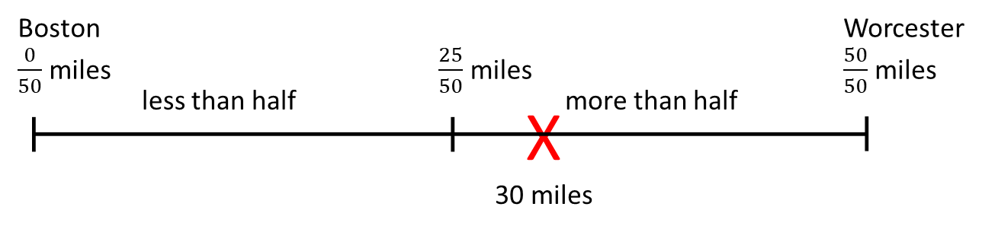

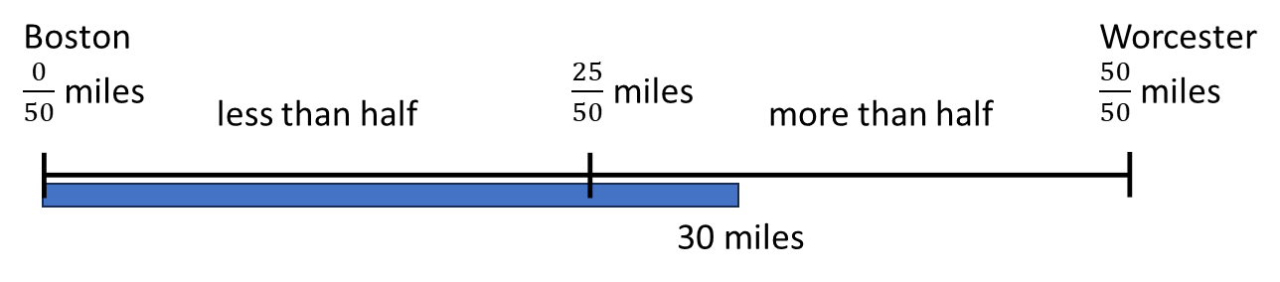

Confusion with mixed numbers when measuring
Measuring to the nearest half inch is the first formal appearance of mixed numbers in this curriculum. Take some time to label the half inch rulers with the appropriate mixed numbers and explain the notation and how it is read, for example, 4 and a half inches or 4 and one-half inches. The use of the word and helps to separate the whole and fractional parts of the mixed number when speaking and listening. A few common points of confusion:
- As mentioned in Unit 1, ½ “One-half” and 1½ “One and one-half” are frequently conflated by native and non-native speakers alike. It is helpful to point out the difference explicitly, with pictures and a number line. Also, it is common for English speakers to refer to “one-half” simply as “a half,” which can also make listening comprehension confusing for students listening for the phrase “one-half.”
- When measuring to the nearest half-inch, many students will question why they can choose a whole number of inches. Make sure to spend time with the ruler as a number line, demonstrating how counting by half inches will hit both the whole number of inches and the mixed numbers in between.

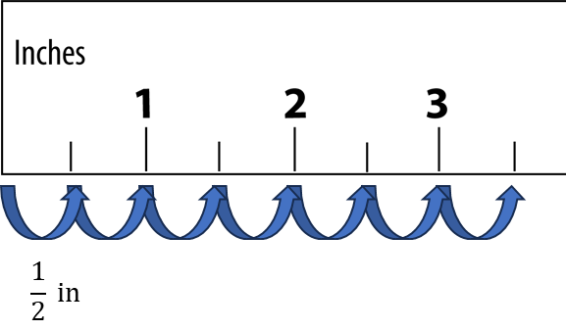
- As mentioned above, students will have used a ruler and/or yardstick previously to find fractions equivalent to one-half, such as 6 out of 12 inches. In that case, the entire length of the ruler is used as the whole. When using the ruler to measure to the nearest half inch, one inch is the whole. Spend some time addressing this explicitly, referring back to identifying the whole in Part 1. Identifying the correct whole is an important foundational understanding in this curriculum, and this use of the ruler can be a good example for students to consider.

Unit 3: One-Fourth
Learning Objectives | CCRSAE
I can find one-fourth of an amount using multiple strategies, including finding half of a half or dividing by 4. | 3.NF.1–3
I can write one-fourth as a fraction, decimal, or percentage. | 4.NF.6
I can find the whole when I know one-fourth. | 3.NF.1-3
I can use a number line and a circle/pie chart to show one fourth. | 3.NF.2
I can use benchmark percentages to make sense of discounts. | 4.NF.2

Standards for Mathematical Practice
MP.3 Construct viable arguments and critique the reasoning of others.
Students will explain how they know if an amount is one-fourth using calculations, drawings, number lines, etc.
MP.4 Model with Mathematics
Students will use fractions, decimals, percents, number lines and circles graphs to make sense of real-world problems.

Extra Resources for this Unit
- Downloadable file: Two Truths and a Lie PowerPoint
- Downloadable file: Data Says… PowerPoint
- Reproducible: Evaluation Unit 3, Teacher’s Guide p. 48
- Reproducible: Unit 3 Quiz, Teacher’s Guide pp. 54–55
- Web link: Locating Fractions on a Number Line
https://www.geogebra.org/m/kw4gfghp
- Web link: Build a Fraction
https://phet.colorado.edu/sims/html/build-a-fraction/latest/build-a-fraction_en.html

Other Materials
play money, a ruler, a book, a small cup of beans, a price tag, a piece of string, other classroom objects that can be used to represent a whole amount (can reuse materials from Unit 1)
sample paystubs (can be found online)

Math Background

Half of a Half
How do students explain finding fourths? If “half of a half” does not make sense to them, help them articulate the idea of four parts using their own words. Dividing by four is one way, and this will work well for students comfortable with division or with using a calculator. However, in some situations the answer will contain a decimal.
Check whether students use what they know about half to find one-fourth visually or with objects. Assist students in making a visual representation for half and then dividing by two. If they are starting with a new drawing or a new set of objects, for example, encourage them to think about how the two parts could become four.
A shape similar to this one
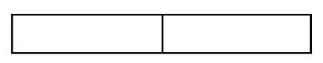
becomes
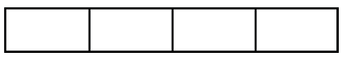
Folding a strip of paper in half and then into fourths is helpful. Objects can be divided among the sections to connect the area model of fractions with fractions of discrete numbers. Dividing by two and by two again will help some students keep the meaning of the parts intact.
Encourage students to try multiple strategies so they have ways to check their work, new ways to approach a problem if they get stuck, and some conceptual connections as they encounter more complex fractions.

Three-Fourths
In this lesson, students identify three-fourths only as the “leftover” amount after one-fourth is wasted or used. Determining the amount left over when one-fourth is taken away is a two-step process. The use of objects (such as snap cubes or counters) or drawings of shapes partitioned into fourths can help students see that when one-fourth is used up, removed, or subtracted, the remaining amount is three-quarters of the total original amount. Accompany demonstrations with notation to outline computational steps taken to find the amount left over.
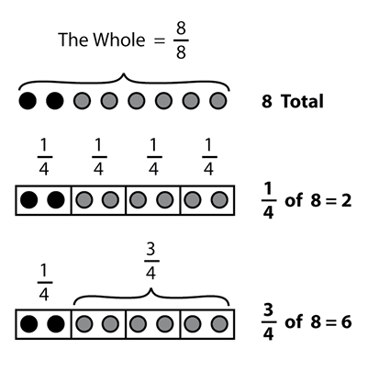
When finding the whole from one-fourth, the use of a partitioned rectangle can be helpful. Start with several objects in the first one-fourth of the rectangle. Ask how many would be needed to fill the remaining fourths.
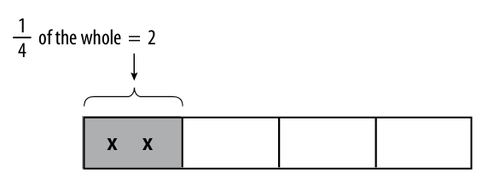
Continue by adding notation to the diagram until students understand that if they know one-fourth, they can add that amount four times or multiply that amount by four to find the whole.
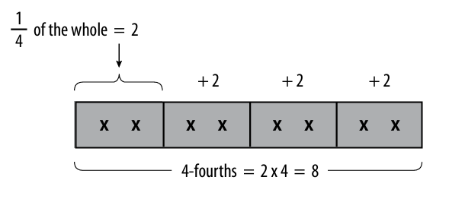

Refining Estimates
Teach students what the new benchmarks of 25% and 75% look like on the pie chart maker. Having more benchmarks means that they will be able to refine their estimates, for example when using the pie chart makers in the warmup routine, Data Says... Before, a percent like 30% was simply “less than half”; now they can additionally consider that it is a little more than one-fourth and make their estimates more accurate.

Activities and Practice

Introducing the Unit
In-Person/Remote Activity
Uses Student Packet p. 45
Have students read the text on p. 45 and complete the think and share.

Opening Discussion
In-Person/Remote Activity
Uses Student Packet p. 46
You want to know whether students have ways to find a fourth of a quantity and the remainder of that quantity and whether they have knowledge of different terms for one-fourth.
- Ask: Yesterday I was waiting in line at the post office, where one-fourth of the people had packages to mail. There were eight people in line. How many had packages?
- Have students share solution strategies. Invite the use of snap cubes, counters, or colored markers to show others their thinking until reasoning and visual strategies are shared for the following:
- Halving a half
- Dividing by four
- Diagramming
- Using a number line
- Summarize for students by connecting visual representations to part-whole language.
Say: One-half indicates one out of two equal groups. One-fourth signifies one out of four equal groups. How do you get four equal groups? You can divide by four, or you can find half and then divide each half into halves. Focus on the whole.
- Ask: How do you write the fraction to show the whole for four groups? (4/4) How do you know? What fraction represents the whole group of people in line at the post office? (8/8)
- Explain that this lesson involves finding one-fourth of different quantities and also the part that remains out of the whole after one-fourth is accounted for. For instance, in the post-office line there were eight people, and one-fourth of the people, or two out of eight, were mailing packages. How many were not mailing packages? Connect this concept to previous visual and reasoning strategies.
Then write on the board the following sentence: One-fourth of the people had packages.
- Ask: What is another way to say “one-fourth”?
Add the term “one-fourth” with its synonyms (a quarter, 1/4, 0.25, and 25%) to the class vocabulary list. Reinforce the relationship between one-fourth and one-quarter by introducing a set of words, such as “quart, quadruplets, quarter-pounder, quartet,” etc., and asking what all these words have in common. (All relate to the number four.)
Make the connection between finding 50% of a number and finding 25% of the same number. We have said one-fourth is half of half. Fifty percent is half of 100%, or the whole; 25% is half of the half, or half of 50%.

Vocabulary for this Unit
In-Person/Remote Activity
Uses Student Packet p. 46
Fill-in-the-blank definitions and examples have been provided for the major terms in this unit. Teach/review words along with activities where they arise, rather than teaching them all at once.
- one-fourth/one quarter: One out of four equal parts or portions. “Half of a half.” As a decimal: .25 As a percent: 25%
- discount: when a price has been lowered
Other words to consider teaching: markdown, bargain, sale, clearance, good deal

Warmup Routines
In-Person/Remote Activity
Uses downloadable files Two Truths and a Lie PowerPoint and Data Says PowerPoint
Continue alternating Routine 2 (Two Truths and a Lie) and 3 (Data Says…) as warmups, as needed. Two Truths and A Lie slides 17–24 involve one-fourth and three-fourth benchmarks introduced in this Unit. As students learn these new benchmarks, encourage them to use them to further refine their estimates of the circle graphs for Data Says...

Language Support: What a Bargain!
In-Person/Remote Activity
Uses Student Packet p. 48
This is a good place to teach the word discount and other synonyms/near synonyms (markdown, bargain, sale, clearance, good deal). This page also highlights some potentially confusing phrases related to bargains: on sale vs for sale, 25% of vs 25% off.

Thinking About Discounts
In-Person/Remote Activity
Uses Student Packet p. 49
Two challenging word problems to get students thinking about discounts and percents. These make good class discussion questions. Problem 1 highlights that taking a percent off of each item is equivalent to taking the same percent off of the total. Problem 2 involves recognizing that after 50% is taken off of the original price, the next 50% is taken off of the sale price, not the original, so the item is not free (it will end up being 75% off).

One-Fourth of a Shape
In-Person/Remote Activity
Uses Student Packet p. 50
Ask students to shade one-fourth of each shape and ask them how they know it is one-fourth (or equivalent to one-fourth). Many shapes have more than one solution, so have students share their drawings.
Note: the final trapezoid can be cut in half but can’t be easily broken into four equal pieces. The triangle can be cut into fourths, as shown:
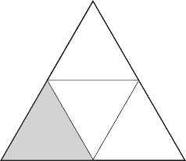

Find One-Fourth
In-Person/Remote Activity
Materials needed (in-person): trays, string, books, rulers, index cards, other classroom objects
In person: Use small trays. On each tray, put a variety of objects that could represent a whole: a ruler, a book, a small cup of beans, a price tag, a piece of string, etc. Ask students to find one-fourth of each amount, and to write the equivalent fraction. Provide the graphic organizer (reproducible in Teacher’s Guide p. 59) as needed.
Remote alterative: Have students collect a few objects from their environment (a book, a cord, a handful of dried beans, etc.). Ask them to find one-fourth of each and to write an equivalent fraction. For remote students, include several copies of the graphic organizer page (reproducible in Teacher’s Guide p. 59) in their packets so they have them available at home.

One-Fourth Spent
In-Person/Remote Activity
Uses Student Packet, pp. 51–52
Do an example together using the bar diagram, drawing students attention to the different parts, 1/4 and 3/4, and the whole, 4/4. Have students put their strategies for finding 1/4 and 3/4 of an amount into words.

Supermarket Power Lost
In-Person/Remote Activity
Uses Student Packet, pp. 53–54
This has more examples of finding 1/4, 3/4, and the whole using a bar diagram. The last few examples ask students to find the whole from 1/4 and 3/4. Again, encourage students to put their strategies into words. Help students to see that 3/4 of an amount is both 1/4 less than the whole and three times 1/4.

What Makes it a Quarter?
In-Person/Remote Activity
Uses Student Packet p. 55
A 100-square grid marked as pennies prompts students to consider why the shaded fourth is a quarter, or 25%.

Show Me 1/4
In-Person/Remote Activity
Uses Student Packet pp. 56–57
For practice finding one-fourth with visual examples. Prompt students to think about equivalent fractions as well, such as cutting the square into 8 pieces and shading 2. Finding one-fourth of the number line with a total of 6 can be challenging. Encourage students to try finding “half of a half.”

One-Fourth Measurements
In-Person/Remote Activity
Uses Student Packet pp. 58–59
For practice finding one-fourth of various measurements.

How Many, How Far
In-Person/Remote Activity
Uses Student Packet pp. 60–62
For practice solving problems and creating diagrams.

Discounts
In-Person/Remote Activity
Uses Student Packet pp. 63–64
- The first page offers an example with some visuals to help students understand how a 25% discount works. Make sure to draw their attention to both parts of the whole: the part that is saved, and the part that they have to pay.
- Ask students to share methods of calculation. Do they add the three 6’s together to find the sale price, or do they subtract 6 from the original price? Both are reasonable methods for finding 3/4 or 75% of an amount.
The following page has practice problems for finding discounts of 50%, 25% and 75% off. Provide more examples for homework or review as needed.

Comparing Fractions to 1/4
In-Person/Remote Activity
Uses Student Packet p. 65
For practice stating parts, wholes, fractions, and comparing fractions to one-fourth. Remind students of the activity they completed in Unit 2 where they compared fractions to one-half and encourage them to use number lines as needed.

Extension: Missing Quantities – Parts and Wholes
In-Person/Remote Activity
Uses Student Packet p. 66
For practice finding 1/4, 3/4, or 4/4 when one of those quantities is known. This is an extension as it has students working from 3/4 as a starting point for several exercises. Have students use drawings and visuals to make sense of how they calculate from one fraction to another.

Open Sentences with 1/4
In-Person/Remote Activity
Uses Student Packet p. 67
Review the grammar of parts and wholes from Unit 1 as necessary, emphasizing that the whole comes after the word "of" in these phrases.

Test Practice Problems
In-Person/Remote Activity
Uses Student Packet pp. 68–69
Multiple choice word problems involving one-fourth. Question 3 involves finding the whole by reading numbers off a bar graph: this might require a class discussion if students are unfamiliar with bar graphs and how to find the total amount. Many students will incorrectly choose the top number on the y-axis as the total instead of adding up the different bars.

Locating Fractions on a Number Line
Remote/Virtual Activity
Supplemental activity
Uses Locating Fractions on a Number Line on Geogebra.org
https://www.geogebra.org/m/kw4gfghp
Note: Not recommended on a phone due to small screen size.
Students drag fractions onto a number line with some helpful tick marks. Students can get a hint which labels another point on the line and sometimes can get a second hint. Problems 1–4 are appropriate for this level, Problems 5–6 could be an extension, because the number line is not based on 1.

Extension: Build a Fraction
Remote/Virtual Activity
Supplemental activity
Uses Build a Fraction on Phet
https://phet.colorado.edu/sims/html/build-a-fraction/latest/build-a-fraction_en.html
Note: Not recommended on a phone due to small screen size.
There are two ways of playing and ten levels for each of them. In one, three fractions are given and students create models from shapes to match them and then drag them to the right places. In the other, three pictures are given and students find the numbers to name the fraction. Each level has three problems on one screen and when you complete those, you go to the next level. The denominators get larger and you may need to use equivalent fractions. The first few levels could be used as an extension activity for students who are ready for extra challenge, since it goes beyond the benchmarks of halves and fourths.

Financial Literacy: Getting Paid

TSTM Skills: Processing and Analyzing Information, Navigating Systems
In-Person/Remote Activity
Uses Student Packet pp. 70–73
Sample paystubs (these are easy to find online)
- This activity begins with a discussion to see what experience and knowledge students have about payroll deductions. There are a few vocabulary words on page 70:
Gross pay: the total amount of money a person earns in each paycheck
Net pay/Take-home pay: the amount of money the person is paid, after deductions.
Deductions: to deduct means to subtract. Deductions are amounts subtracted from the gross pay (money that you don’t get to take home!)
- Pass out or display some sample paystubs. Ask students to identify the gross pay, net pay, and deductions. What else do they notice/wonder about?
- Page 71 provides some background information about common deductions. Provide reading support as necessary.
- There are a few practice problems that use the benchmark 25% on pages 72–73. Marie’s Pay involves working in both directions (gross pay to net pay, and net pay to gross pay). Ming’s Paystub involves using 25% as a benchmark and drawing a circle graph.

Exit Ticket
In-Person/Remote Activity
Uses Student Packet p. 74
To solve this problem, students must find and identify a part and whole (she missed 7 out of 28 classes), decide on the appropriate benchmark fraction (she missed 25%) AND be attentive to which part is indicated (percent attendance, 75%).

Unit 3 Quiz (Summative Assessment)
In-Person/Remote Activity
Uses Reproducible pp. 55–56 in Teacher’s Guide

Answer Key:
- a) $\frac{7}{28}$ students
b) $\frac{45}{180}$ days
c) $\frac{\$1.50}{\$6.00}$
- Answers will vary.
- Answers will vary.
- 1,000 miles
- He saved $120. He paid $360.

Vocabulary
one-fourth/one quarter: One out of four equal parts or portions.
“Half of a half.”
As a decimal: .25
As a percent: 25%
discount: when a price has been lowered

Things to Watch For

Confusion with decimals
Decimals will occur whenever the whole amount is not divisible by 4. Often students at this level are not very comfortable with decimals, and sometimes assume that a decimal answer means they made a mistake. Keep numbers friendly and appropriate for the level of the student. Help students understand decimals that come up in the context of money, which is often the place where they have the most exposure to them: “one-fourth of $10 is $2.50” is easier to understand than “one fourth of 10 is 2.5.”

Which part?
When working with one-half, both parts of the whole were the same size. Now students are working with a fraction in which the fraction one-fourth and the remaining part, three-fourths, are not the same. Ask students to clearly find and identify both parts in context. For example, when working with 25% discounts, they should identify both the amount saved (25%) and the amount paid (75%). This will also help students to see the relationship between the two fractions that add up to a whole, and how knowing one of them can help them find the other (an important idea that lays the foundation for other complementary fractions, like finding 9/10 when 1/10 is known, for example).

Unit 4: Survey Project
Learning Objectives | CCRSAE
I can use a survey to collect data to answer a statistical question. | 6.SP.1 [only questions with two, mutually exclusive responses]
I can use benchmark percents to sketch a circle graph. | 4.NF.2

Standards for Mathematical Practice
MP.4 Model with Mathematics
Students will use fractions, decimals, percents, number lines and circles graphs to make sense of real-world problems.
MP.6 Attend to precision
Students will consider accuracy in data collection by discussing how survey questions are posed and how data is collected.

Extra Resources for this Unit
- Reproducible: Survey Rubric, Teacher’s Guide, p. 61
- Reproducible: Evaluation Unit 4, Teacher’s Guide, p. 49

Math Background

Collecting Data
In this project, students write yes or no survey questions and collect and report on their data. Although students are not explicitly taught a statistical process, they go through the various stages in their investigation:
- Formulate a statistical question (one that anticipates variability).
- Collect data.
- Analyze the data. Students graph the data with a circle graph and use benchmarks to describe the portion.
- Interpret the results: The teacher can push students to think further about their results by asking questions like “Do you think you would get similar results if you asked (different group of people)? Why or why not?”

Activities and Practice

Introducing the Project
In-Person/Remote Activity
Uses Student Packet p. 75
Explain the project, and have students complete the think and share on page 75. Define survey and ask students to share their different experiences taking surveys. Discuss why someone might want to gather that information.

Writing Yes or No Survey Questions
In-Person/Remote Activity
Uses Student Packet p. 78
Read through the examples on page 78. Discuss how to make questions as clear as possible, so it is easy for someone to answer yes or no. Have students write their own yes or no questions and collect them on the board. Keep the list.

Survey Question Report
In-Person/Remote Activity
Uses Student Packet p. 79
Start by modeling this project with class data. Choose one of the yes-or-no questions generated in the previous activity and use it as an example. Demonstrate collecting the data from the class, filling out a table with the data, and making a pie chart.
For their own project, put the students in pairs, and have each pair choose a question from the list that the class generated. Ask them to think about why the answer to that question might be useful.
As a class, decide on the best way to collect a larger sample of data. Some possibilities:
- Create a paper survey with all the questions and give them out to other classes.
- Poll other students at the school face-to-face.
- Go into another class and have the students raise their hands, yes or no, for each question.
- Create a Google form and have students/staff complete it electronically.
Whatever you decide, it is important to get students thinking about the practical aspects of collecting data, so give them time to think and consider the options. Also set a number of responses you would like them to collect at a minimum.
Go over the rubric for grading the projects (a suggested rubric is included on page 61 of the Teachers Guide). Be clear about which benchmarks you want them to use. If you skipped Unit 3, you could have the students complete the project using only one-half as a benchmark. Otherwise, you can have them use quarters as well.

Vocabulary
survey: A tool used to collect data. A survey asks people to answer questions. Can be done face-to-face, on paper, or electronically.

Things to Watch For

Unclear Responses
No matter how clear a question is, students will probably get some ambiguous answers. Someone might circle both yes and no or perhaps write in another response. Discuss as a class what to do with these responses. Emphasize that it’s not ok to decide what the person meant if it is unclear and if they can’t ask the person themselves for clarification. Instead they might choose not to use those surveys, or to count them as “other.”
Name:___________________________ Date:__________________

Benchmark Fractions: Unit 1, What is one-half?
Objective | Student Self-Evaluation  (Struggling, Learning, Mastery) | Teacher Evaluation
I can find half of a whole shape or amount.
I can write a fraction equal to one-half.
I can find the whole when I know one-half.
I can use correct grammar to talk about parts and wholes.

Name:___________________________ Date:__________________

Benchmark Fractions: Unit 2, More or Less than Half?
Objective | Student Self-Evaluation  (Struggling, Learning, Mastery) | Teacher Evaluation
I can write one half as a fraction, decimal, or percentage.
I can use a number line and a circle/pie chart to show one-half.
I can decide if a fraction, decimal, or percent is more, less, or equal to one-half.
I can measure length with a ruler to the nearest 1/2 inch.

Name:___________________________ Date:__________________

Benchmark Fractions: Unit 3, One-fourth
Objective | Student Self-Evaluation  (Struggling, Learning, Mastery) | Teacher  Evaluation
I can find one-fourth of an amount using multiple strategies, including finding half of a half or dividing by 4.
I can write one-fourth as a fraction, decimal, or percentage.
I can find the whole when I know one-fourth.
I can use a number line and a circle/pie chart to show one-fourth.
I can use benchmark percentages to make sense of discounts.

Name:___________________________ Date:__________________

Benchmark Fractions: Unit 4, Surveys
Objective | Student Self-Evaluation  (Struggling, Learning, Mastery) | Teacher  Evaluation
I can use a survey to collect data to answer a statistical question.
I can use benchmark percents to sketch a circle graph.

Name:___________________________ Date:__________________
Unit 1 Quiz: One-Half
For each whole, write a fraction that represents $\frac{1}{2}.$
- 28 students in the class

- 72 pages in the book

- $13

- Joanne gave me half of the money we got from selling the bike. She gave me $32. How much money did we get from selling the bike?

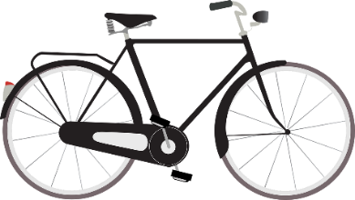

- Decide if each statement is true or false, and show how you know.

- 14 is 1/2 of 28.

- 1/2 of 2 is 4.

- 3.5 is 1/2 of 7.

Name:___________________________ Date:__________________
Unit 2 Quiz: More or Less than One-Half?
For each fraction, decide if it is more or less than one-half. Show how you know.
- 200 out of 300 miles
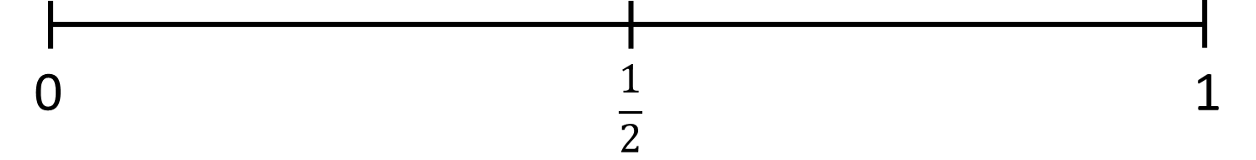

- 13 out of 24 students

- $\frac{6}{16}$

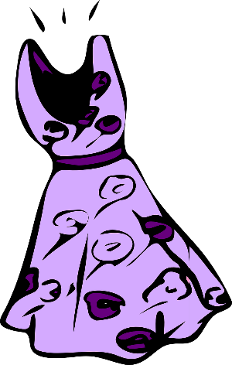
- I want to buy a dress that usually costs $84, but it is on sale for 50% off! How much does it cost now?

- Write three fractions, decimals, or percents that are close to one-half, but are not equal to one-half.

- How long are the scissors, to the nearest half inch? Use the ruler on the paper.

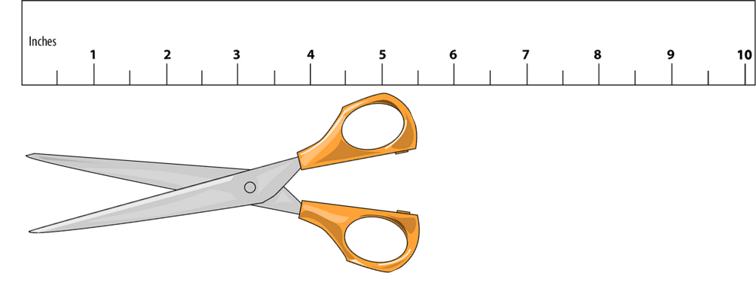
Name:___________________________ Date:__________________
Unit 3 Quiz: One-Fourth
- For each whole, write a fraction that represents $\frac{1}{4}.$
Show how you found one-fourth.

- 28 students

- 180 days

- $6

- Write a decimal that is equal to one-fourth.

- Write a percent that is more than one-fourth, but less than one-half.

- Virginia is driving from Boston to Chicago. She has driven $\frac{1}{4}$ of the distance so far. She has driven 250 miles. How many miles is her whole trip?

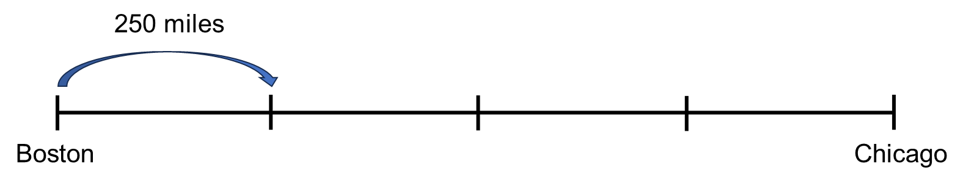

- Mahmoud bought a computer that was on sale for 25% off.

The original price was $480.
a) How much did he save?

b) How much did he pay?

c) Show how you know.

Part / Whole Graphic Organizer for One-Half

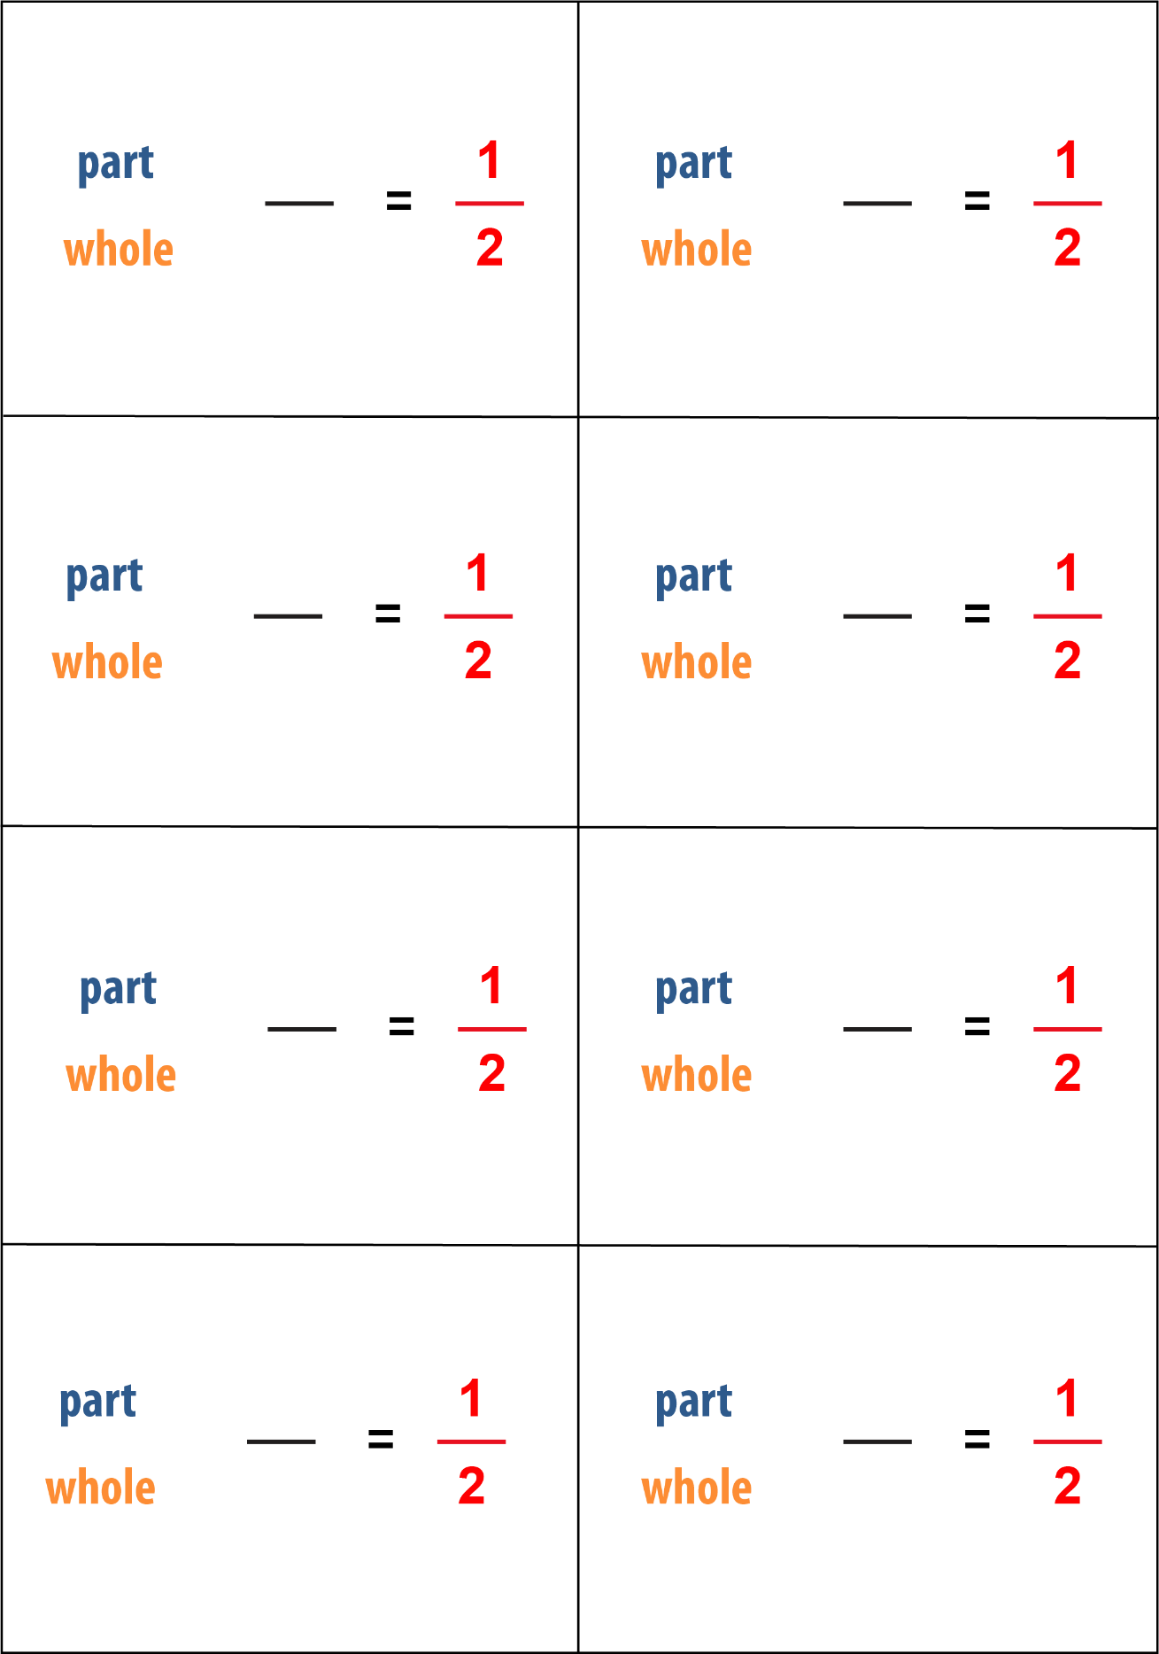

More or Less than One-Half Number Lines

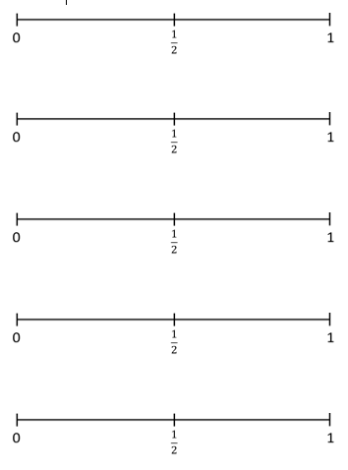

Part / Whole Graphic Organizer for One-Fourth

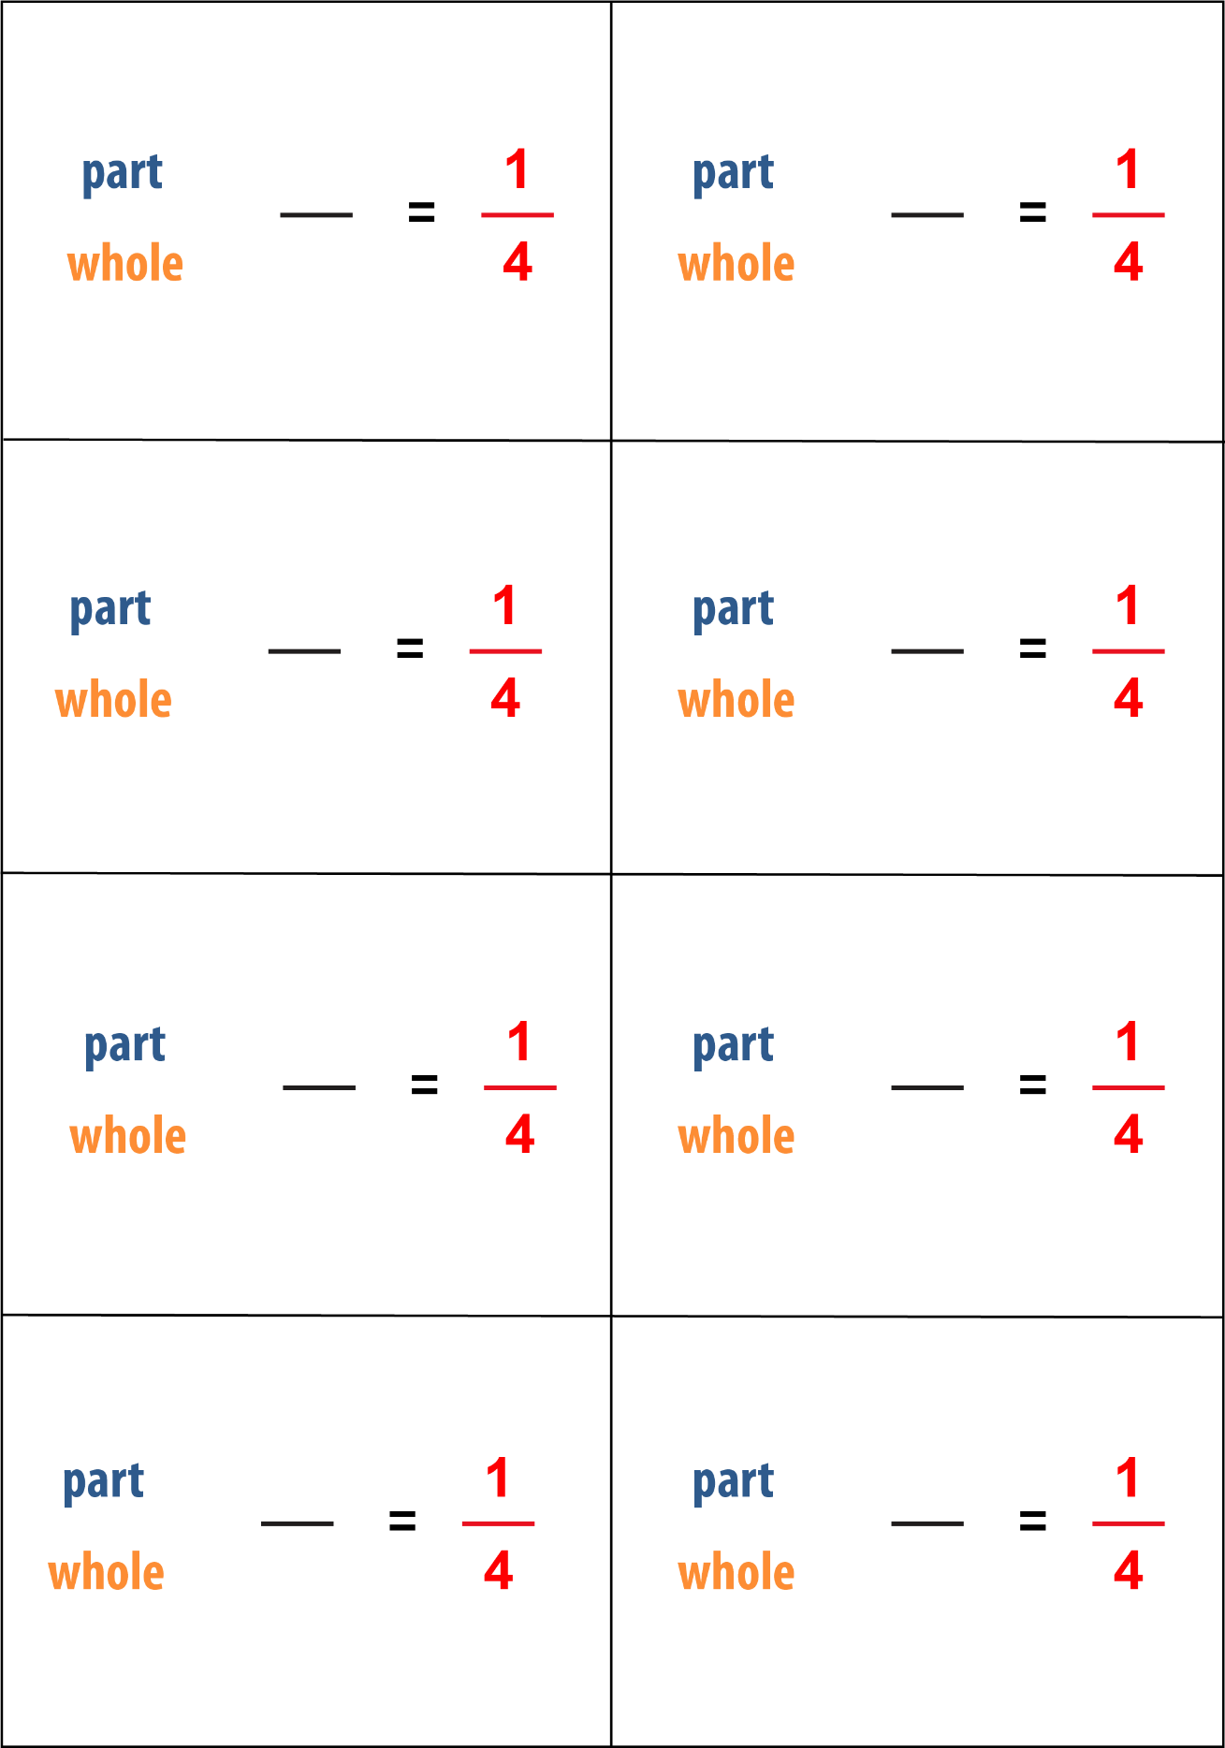

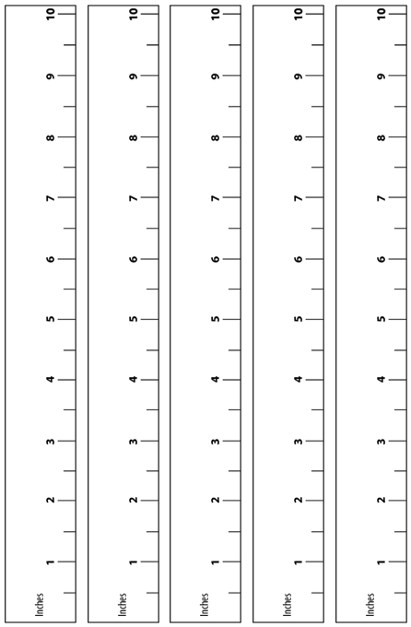

Bill and Check for Comparing Fractions to 1/2

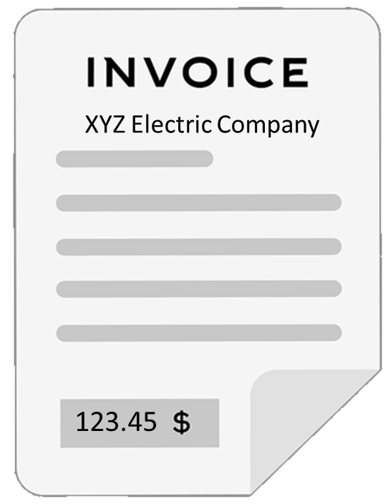

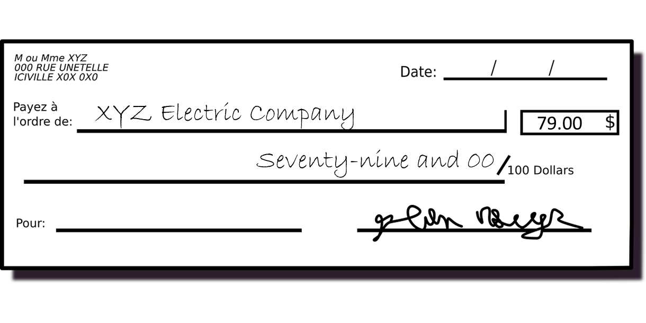

Name(s):___________________________ Date:________________

Rubric for Survey Project

Criteria | Outstanding | Good | Needs Support
Question | The question is clear, well worded and relevant. | The question is interesting and attempts to present two options. | The question is unclear or not a statistical question.
Data collection | Data was collected using a reasonable technique, is clearly reported, and has at least ten responses. | Data is reported, but there are less than ten responses. | Data is not reported or is made up.
Graph | The circle graph accurately makes use of benchmarks to estimate the size of each section. The graph is neat and clearly and correctly labeled and titled. | The circle graph uses benchmarks to estimate each section, but is less accurate, unclear, or only partially labeled. | No graph or incorrect graph.
Conclusion | The conclusion uses benchmarks to explain the results and answer the question. | The conclusion answers the question but doesn't use benchmarks accurately. | No conclusion or incorrect conclusion.

