Integrating Math into

ESOL Units
A Math Packet for ESOL Teachers

SHOPPING


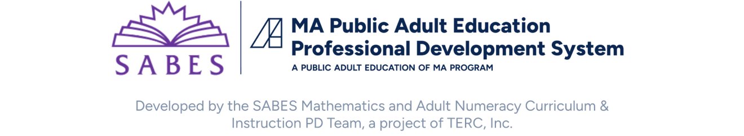

TABLE OF CONTENTS
Introduction 1
Lesson 1: U.S. Currency 3
Lesson Plan 4
Lesson 2: Place Value 7
Lesson Plan 9
Handout: Template Place Value Puzzle 14
Handout: Roll, Show, Write 15
Handout: A Place Value Game 16
Handout: Math in Line 17
Lesson 3: Number Sense: Connecting the Operations 21
Lesson Plan 23
Handout: Shopping Scenario 26
Handout: The Four Operations 27
Handout: The Four Operations Answer Key 28
Handout: Number Line Templates 30
Lesson 4: Benchmark Fractions, Decimals, and Percents 33
Lesson Plan 34
Teacher Resource: Consumer Awareness and Financial Literacy 39
Handout: Store A—Sample Reasoning 40
Handout: Store B—Sample Reasoning 41
Handout: Practice Reasoning with Benchmarks 42
Handout: Fraction Strip Word Problems 43
Lesson 5: Proportional Reasoning 45
Lesson Plan 46
Teacher Resource: Double the Donuts 50
Handout: 2 for $3 51
Handout: Brownie Recipe 52
Lesson 6: Measurement 53
Lesson Plan 54
Vocabulary Cards–Containers 58
Teacher Resource: Metric Word Web 59
Lesson 7: Data 61
Lesson Plan 62
Handout: Ice Cream Flavors 65
Handout: Survey Template 66
Teacher Resource: Constructing a Circle Graph from a Bar Graph 67

Integrating Math into ESOL Units:

A Math Packet for ESOL Teachers (Shopping)

Math and language are part of our daily activities. When we make a purchase, cook, exercise, and take public transportation, we are using math. In many ESOL course books, math topics are included in thematic units such as shopping, banking, and food. Some books might ask students to tally a bill, write a check, or create a budget, but ESOL course books generally don’t deconstruct the math concepts needed for those tasks.
Understanding math is so much more than memorizing math rules. Think about how you mentally total a bill or calculate sales tax. It is likely that you use different strategies depending on the situation. The math we encounter involves understanding math concepts and how they are related, selecting strategies for problem solving and making sense of math procedures and when to apply them.
In response to ESOL teachers who would like to integrate math in their language classrooms, the SABES Mathematics and Adult Numeracy Curriculum & Instruction PD Team at TERC developed a set of Math Packets for ESOL Teachers. Each packet includes a series of language lessons that integrate math. The math activities are designed to dig deeper into math topics and provide the building blocks that teach the skills and knowledge our learners need to understand the underlying math concepts.
Each ESOL Math Packet includes:
- Background knowledge for the teacher
- Prior knowledge needed by learners
- Language tasks
- Activities that allow learners to explore math concepts
- List of materials needed
- Instructional strategies including ideas for differentiating for math abilities
- Assessments

This ESOL Math Packet was created with funding from Public Adult Education of MA by the SABES Mathematics and Adult Numeracy Curriculum & Instruction PD Team, which is managed by TERC, Inc. This document was authored by Sherry Lehane, an adult ESOL instructor, and Melissa Braaten, an adult basic education teacher, with contributions from Sherry Soares, Donna Curry, and Aren Lew.

LESSON 1: U.S. CURRENCY

Rationale
Identifying U.S. currency and writing its numerical representation is a task found in many ESOL course books. However, the ability to speak and write vocabulary is only one step in being able to use money for life skills such as completing purchasing transactions. In this lesson, you will have the resources to move your students beyond this first step by combining language and math to explore the underlying math concepts that each of us employs when using money. These concepts are:
- number sense: place value, estimation strategies, and operations
- decimal fractions
- proportional reasoning
- data and graphs
- measurement

Background
In many cultures, the use of commas and decimal points is the opposite of standard U.S. math notation. In other words, we use a decimal point to separate dollars and cents ($300.21) while many other countries use a comma to separate these numbers ($300,21).
Along the same idea, we use a comma to separate digits in larger numbers to make them easier to read (432,000.00) while other countries use a decimal point to separate larger numbers (430.000,00).
Here is another example. For the amount “thirty-one thousand, four hundred dollars, fifty-seven cents”, people in U.S. would write: $31,400.57 but in some other countries, people would write: $31.400,57.
(For more information on how math notation differs in other countries, we suggest the free resource The Answer is Still the Same… It Doesn’t Matter How You Got It!: A Comparison of U.S. and Other Computation Methods for Math Teachers and Students of Various Backgrounds.)
In this lesson, as your students write math sentences, note who uses a comma rather than a decimal point to separate dollars and cents. This is an opportunity for students to share what they know about math notation in their culture and how it is the same or different from standard U.S. notation. Allowing students to use language to talk about math provides an authentic communication context and gets students used to sharing what they know about math and numeracy.

LESSON 1: U.S. CURRENCY LESSON PLAN

ESOL Tasks
- Recognize and label U.S. currency
- Aural comprehension and verbal production of currency amounts
- Read and write math sentences

Math Concepts Addressed
- Number sense
- Place Value
- Operations

Materials
- Piles of play money – enough for each student to have at least one of each coin (pennies, nickels, dimes, etc.) and a few bills of various denominations.
- Optional: Sets of picture cards with objects for purchase

Math Vocabulary

penny
one cent
dime
nickel
one-dollar bill, five-dollar bill, etc.
add, subtract, plus, minus
equal to

INTRODUCTION / WARM UP

Collect class data
As students enter the class, they complete sentences. For example:
With $1.00, I can buy ____________.
With $5.00, I can buy ____________.
With $20.00, I can buy ___________.
With $100.00, I can buy __________.

4 Strategies for Differentiation

More accessible:
- Provide picture cards for objects that can be purchased.

More challenging:
- Students can create sentences with different currency amounts.
- More advanced students can use mixed numbers, for example: $20.75

ACTIVITIES
- Option 1: Write a few math sentences on the board and elicit how to say them.
Review symbols for operations as needed: (+), ( – ), (=), etc. and elicit the math operation they represent (addition, subtraction, multiplication, division) and how we say the operations in a math sentence or equation, for example:
We write: 1 + 1 = 2
We say: 1 plus 1 equals 2, or 1 plus 1 is 2.
Option 2: Students write their own math sentences and give them to a partner to read aloud.
- Using the same pile of coins and bills in the middle of the table, write an amount on the board (for example, $1.25) and ask students to select coins to equal that amount. Model with several different amounts.
Note: Show how cents are sometimes written without a decimal point: 5₵, 10₵
- Pair students. Each student takes turns saying or writing an amount of money on a piece of paper and the partner selects coins/bills to equal that amount. Students describe their partner’s combination.

4 Strategies for Differentiation

More accessible:
- Provide cards with dollar amounts. Students can state the combinations in simple terms, for example: Five cents plus five cents is / equals ten cents.

More challenging:
- Students can create sentences with past tense verbs, for example: She added five cents and five cents to equal ten cents. Then she added...

Extending the activity:
- Select amounts and ask: What is the fewest number of coins you could use to get this amount?

ASSESSMENT

Show me the money
- Put a pile of play money in the middle of the table and say to students:
Show me $2.50
Show me $1.27.
Note: Use three and four digit numbers (such as $435.78 or $1,289.00) for more advanced students.
- Dictate currency amounts and students write the amount on a piece of paper or small white board.

ADDITIONAL RESOURCES
- The Answer is Still the Same… It Doesn’t Matter How You Got it!: A Comparison of US and Other Computation Methods for Math Teachers and Students from Various Backgrounds
- New World Encyclopedia: Decimal

LESSON 2: PLACE VALUE

Rationale
Do you ever stand in line at the cash register and mentally estimate the total amount of your purchase? If so, pause to think about the strategies you use. Do you round up to the nearest dollar or ten dollars and mentally keep a running total? Or maybe you add all the items that are about one dollar and then those that are closest to five dollars, etc. and keep a running total?
There is no correct way to estimate in this scenario. At school, most of us learned rules like rounding up (five or more) and rounding down (four or less), but in real life, we don’t normally apply those rules. We use the strategy that best fits the situation. In the case of shopping, we round up because we want an idea of the total and either want to make sure we have enough cash or simply want to know the most our purchase should be. (Although if we stepped on a scale to weigh ourselves, we might choose to round down!)
The math concepts we are employing are number sense, place value, operations, and estimation strategies. Wow! That’s seems like a lot of math. Let’s look at how we can make these math concepts transparent to our students so they have the confidence to use these skills when they need them.

Background
Our number system is a decimal system. The prefix deci- in the metric system is of Latin origin and means one-tenth of a measurement unit. In our U.S. number system, decimal refers to our base ten number system. That means that each new place value is created with ten groups of the previous place value. For example, ten groups of 100 gives us 1,000; ten groups of 1,000 gives us 10,000, and so on.
What this means is that every time we move one place value to the left, the next place value is ten times larger. Let’s look at the number 111 as an example:

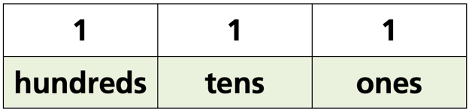

If we move to the right of the decimal point, to numbers less than 1, we encounter the opposite. Each time we move one place to the right, the next place value is ten times smaller. Note the place value of ten cents (.10) and one cent (.01). One cent is one-tenth of ten cents.
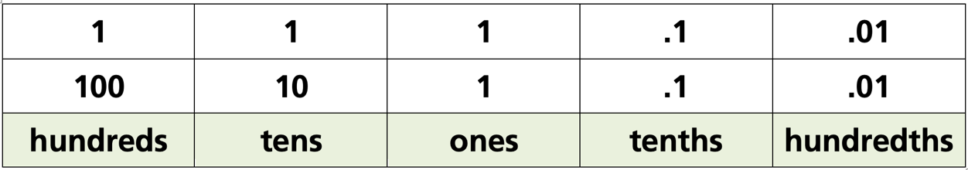

Our ESOL students need to recognize the difference between the whole number ten (10) and the fraction, one-tenth (1/10). The challenges our learners often have are:
aural discrimination between ten and tenth, four and fourth, etc.
visual discrimination between 1.0, .10, and .01.

In this lesson, we will focus on the role of place value in estimating currency amounts.

LESSON 2: PLACE VALUE LESSON PLAN

Prior Knowledge
- Students are able to recognize most U.S. currency (coins and bills) and state the amount each represents. Example: A nickel is worth five cents.
- Students are able to add and subtract 2-digit numbers.
- Students understand U.S. math notation (see Lesson 1: U.S. Currency).

ESOL Tasks
- Tally a bill using mental math
- Complete a purchasing transaction

Math Concepts Addressed
- Place value
- Connections between addition and subtraction

Materials
- Play money (at least one ten- or twenty-dollar bill for each student)
- Handout: Template Place Value Puzzle
- Handout: Roll, Show, Write
- Handout: Place Value Game
- Handout: Math in Line
- Ten-sided dice, three for each pair/small group (You can also draw numbers out of a bag if dice are not available.)
- Store flyers with pictures and prices

Math Vocabulary

- place value
- ones
- tens / tenths
- hundreds / hundredths
- thousands / thousandths
- ten thousands
- digit

INTRODUCTION / WARM UP
Ask students:
Which is bigger: $5.00, .50, or .05? How do you know?

ACTIVITIES

I. Introduce place value
Using pictures from flyers, introduce the concept of place value (the value of a number, or digit, changes depending on its place).
Elicit the value of the number “3” in each of these prices:
$325.00 and $3,500.00.
Chances are students know the value of a number changes according to its place within a number. If they struggle to find the words to describe this, write their explanation on the board exactly as they say it and then go back and fill in the sentence with the math terms such as ones and hundreds and then give them the math term: place value.

II. Place value rotation stations
Students rotate to each station to practice the concept of place value. Here are some examples of activities you can use or create.

STATION 1: Place Value Puzzles
Handout: Template Place Value Puzzle
- Using the template provided, students write a number in standard notation, expanded notation and in words.

More accessible:
Write the standard form for students.

More challenging:
Students create their own four- to six-digit numbers.

STATION 2: Roll it, show it, write it
Handout: Roll, Show, Write
- Using dice, students roll two or three die and assemble them to form a number. Next, they complete each column in the handout with a sketch and numerical representation of the number rolled.

STATION 3: Build a number
Mathwire’s Build a Number Activity
- Create challenge statements for students. Differentiate the activity by changing the complexity of the task as noted in the activity.

III. A place value game
Distribute the Place Value Game handout to each student and give one ten-sided die to each pair of students. Taking turns, the students roll the die eight times and after each roll, place the number that comes up in one of the eight blanks in the top line. After rolling eight times, they should have completely filled in the blanks representing the amount of money they started with and the amount of money they spent. Students then write down something that they could buy equivalent to the amount of money they "spent" in the appropriate blank on the bottom line and calculate the amount of change they would get. The player with the greatest amount of change wins the game.

4 Strategies for Differentiation

More accessible:
- Allow students to roll the die and collect all eight numbers before deciding which blanks to put them in.

More challenging:
- Mix up which blanks get filled in. For example, have students fill in the amount spent and the change and then figure out how much they started with or have them fill in what they started with and the change and figure out how much they spent.

Alternative way of playing:
- Make the game cooperative and have student pairs decide together how to place the numbers in the blanks.

IV. Applying place value in estimation
Using pictures of items in flyers, students round to the nearest dollar, ten dollars, and hundred dollars.

4Technology Integration (optional)

Using smartphone calculators
This is an opportunity for students to explore the calculator on their phones (or you can give them regular calculators to use). Most calculators have a setting to adjust the number of decimal place to the right of the decimal point. Based on the setting, the calculator will automatically round to the nearest tenth, hundredth, etc. (Consult the manual of the calculator you are using or do an Internet search to find out how to change the setting before beginning this activity. The setting will differ from calculator to calculator.)
- Before changing any calculator settings, give students some two-, three- and four-digit whole numbers to add, subtract and multiply. Let them compare the answers on their calculators with a partner.
- Next, show them how to change the decimal point setting so that only two decimal places are displayed.
- Give students numbers with several decimal places such as 9.345, 7.555, 4.989, etc. Ask them to first predict what the calculator will round each number to if it will only show two decimal places to the right of the decimal point.
Students enter the numbers and compare their calculator’s number with a partner.

4Strategies for Differentiation

More accessible:
- Use smaller number up to 10 or 100.
- Use whole numbers only.
- Students use concrete objects such as small and large blocks (such as base ten blocks) to show place value.
- Extend the writing and listening with dictation of two-digit prices.

More challenging:
- Use larger numbers.
- Use mixed numbers (dollars and cents).

Extending the Activity:
Handout: Math in Line

Assessment

Estimating prices
- Give students $200.00 in play money and a few advertisements from store flyers of products with prices. Select prices with one-, two-, and three-digit numbers.
- Ask students to decide if they have enough money by:
estimating each amount by rounding to nearest whole dollar, ten dollars and hundred dollars
adjusting by adding or subtracting to find the exact amount
showing how they figured out the answer

Additional Resources
- Math is Fun: Decimals
- Place Value video
- Place Value Puzzle

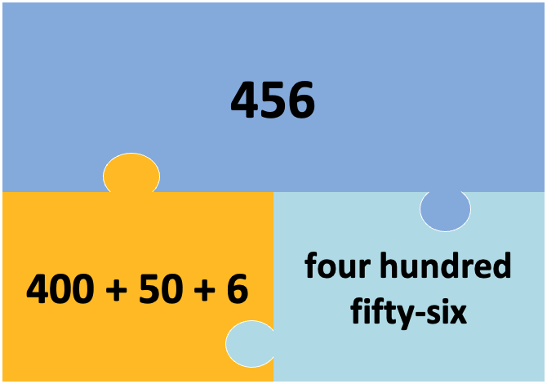
EXAMPLE


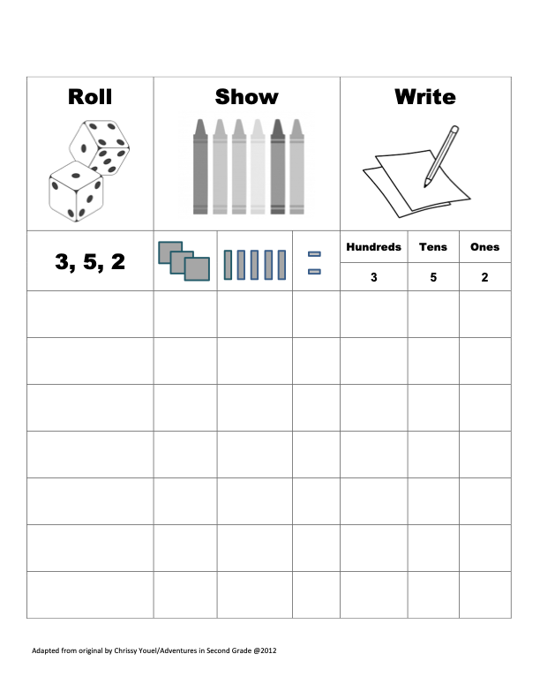

Play with a partner. Take turns rolling the die.
- Put each number that comes up in one of the blanks on the first line. You decide where to put it!
- Write what you bought in the blank on the second line.
- Calculate how much money you have left. The player with the most money left wins the round. (If you spent more than you had, you lose!)

ROUND 1

I had $___ ___.___ ___ and I spent $___ ___.___ ___ on (a/an/some) ___________. Now I have $___ ___. ___ ___ left.

ROUND 2

I had $___ ___.___ ___ and I spent $___ ___.___ ___ on (a/an/some) ___________. Now I have $___ ___. ___ ___ left.

ROUND 3

I had $___ ___.___ ___ and I spent $___ ___.___ ___ on (a/an/some) ___________. Now I have $___ ___. ___ ___ left.

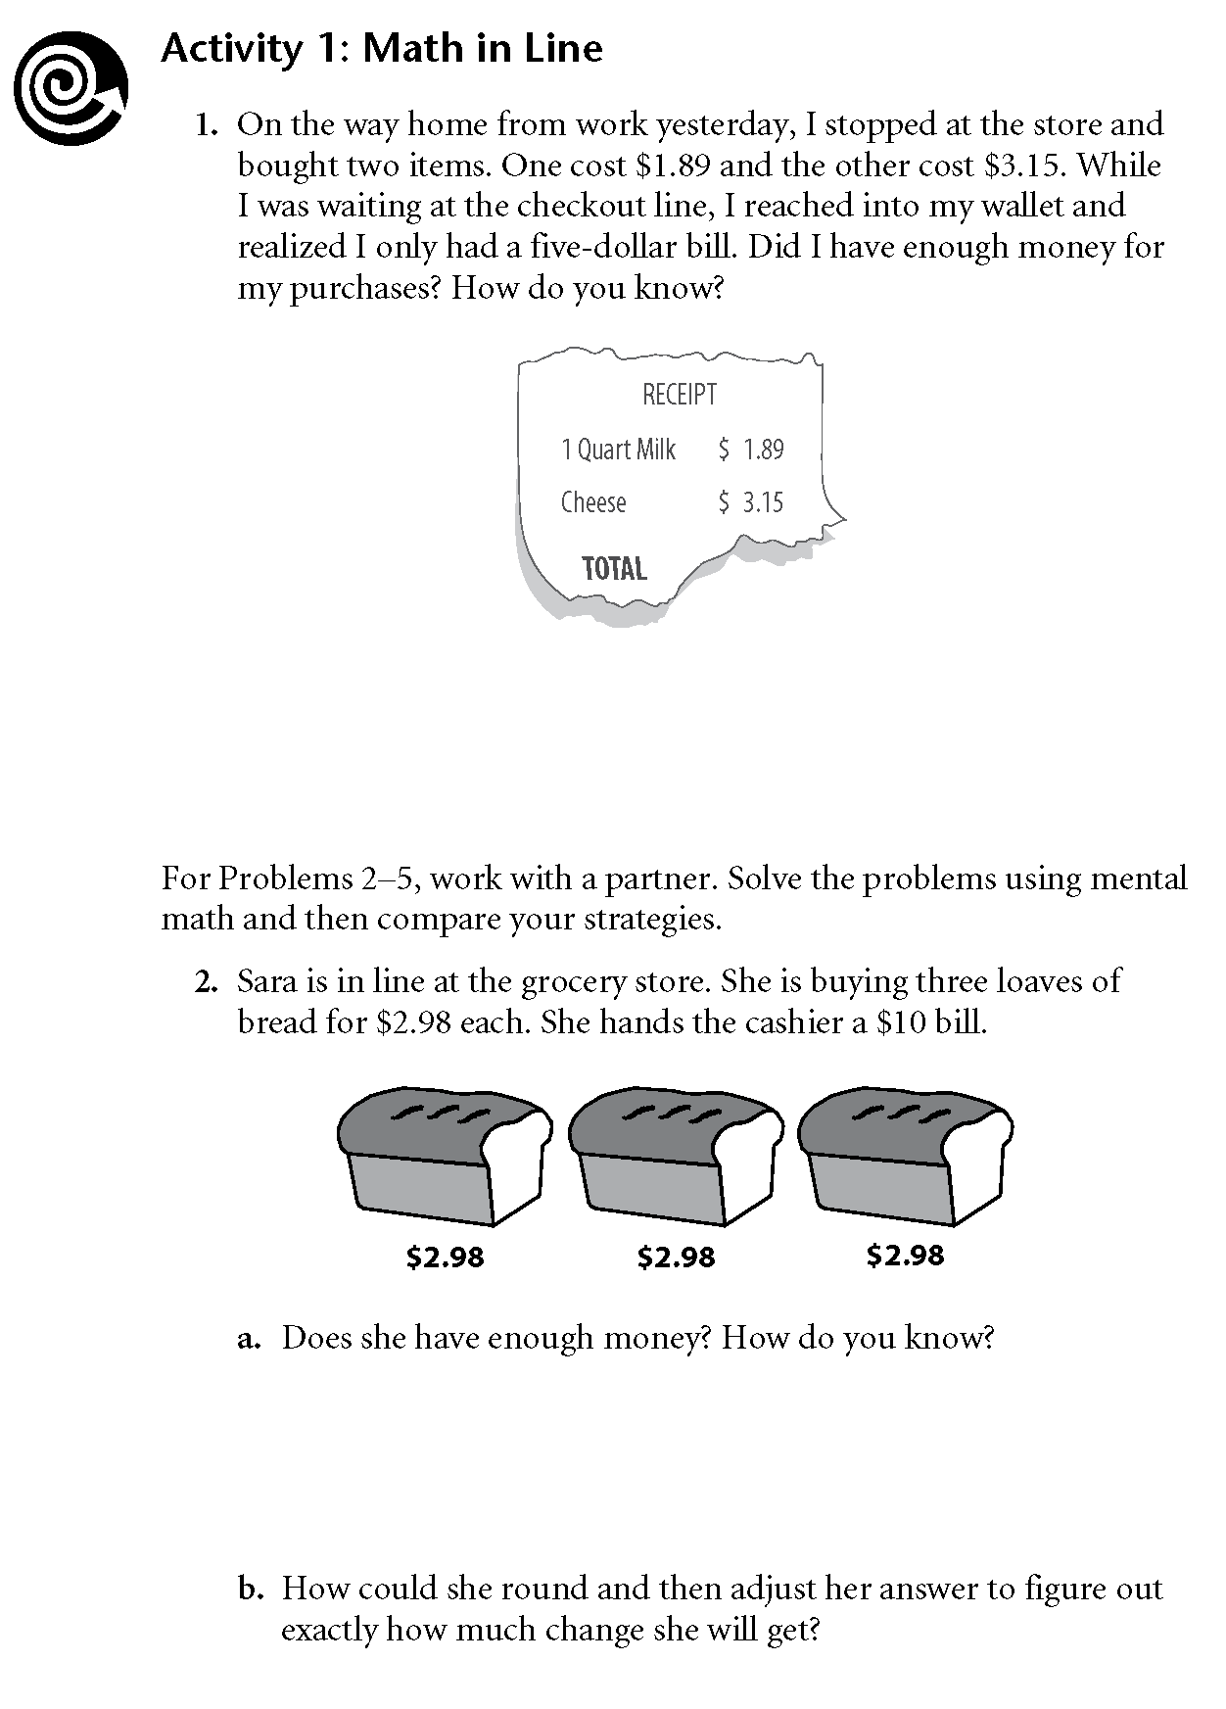

Copyright © 2016, TERC. All rights reserved. From EMPower book Everyday Number Sense, Lesson 2 (Student Book). Used with permission.
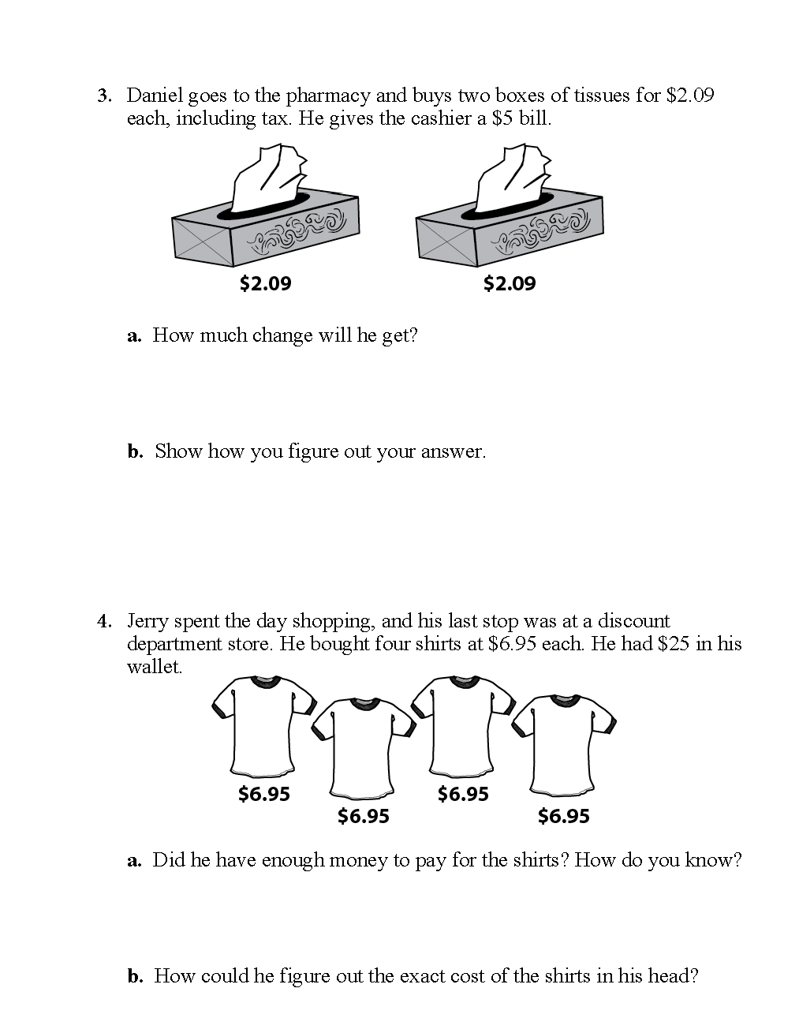

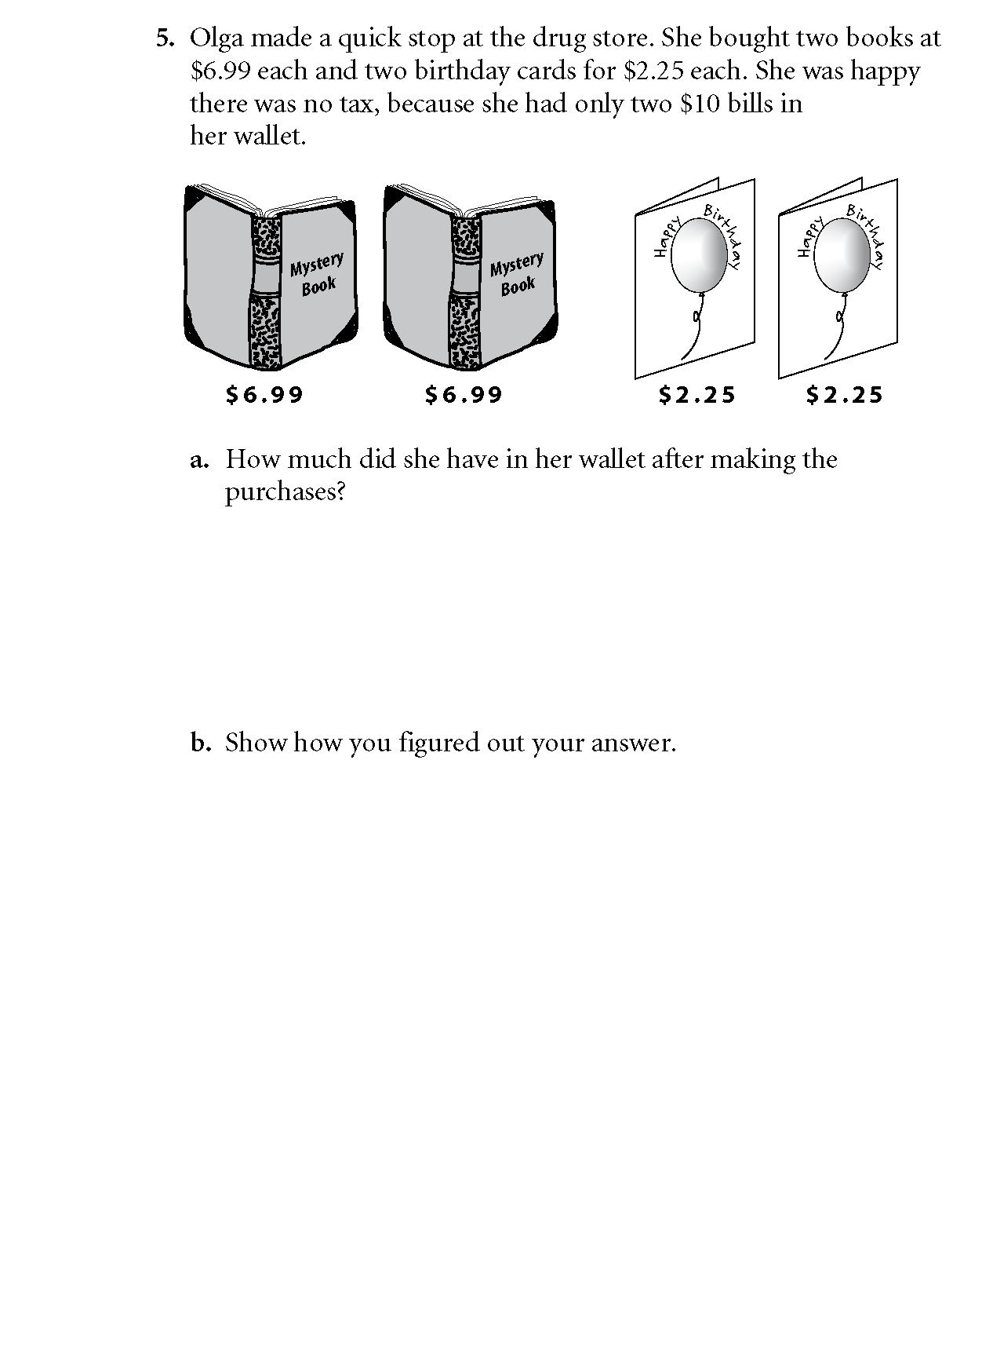

LESSON 3: NUMBER SENSE

(Connecting the Operations)

Rationale
Think back to the last time you made a cash purchase. When you received change back, did you count it or did the cashier count it as she handed it to you? Let’s take a look at a common cash purchase transaction:
Cashier: That will be $9.00.
(You hand the cashier a ten-dollar bill.)
Cashier: Out of ten… nine and one makes ten.
Today, cash registers do the work of calculating the amount the cashier needs to give the customer, but it is our job as wise consumers to count the change and confirm it is correct. Look back at the scenario above. What do you notice about the cashier’s thinking as she counts back the change?

Background
You may have noticed that instead of subtracting (10 – 9 = 1), she has added up (9 + 1 = 10). The four operations (addition, subtraction, multiplication, division) are so tightly related that we use these connections to our advantage without being cognizant of what we are doing and why.
In the scenario above, the cashier is mentally making a connection between addition and subtraction. A number line can provide a visual image of the inverse relationship of addition and subtraction. Regardless of the direction you go—up or down—you are simply finding the difference between two numbers.
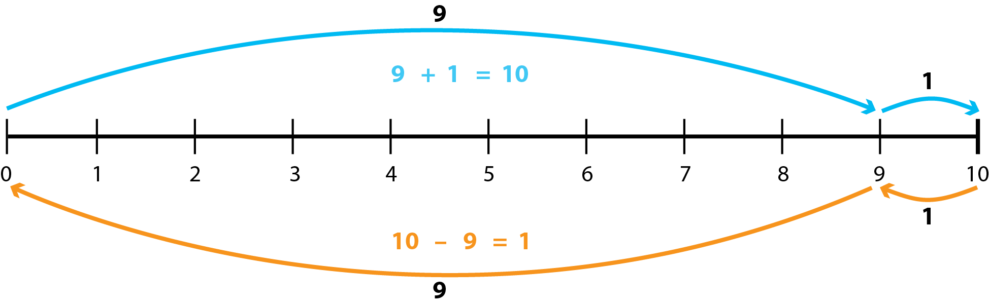
The notion of counting up includes an understanding of place value. (See Lesson Topic: Place Value). When we count up, we often count up to the nearest one or ten.
There are many ways we make connections among the four operations in our daily activities. Let’s take a look at another way this knowledge serves us using the following problem:
You want to save some money to buy a new TV. You think you can save $50.00 a month. The TV costs $250.00. How many months will it take you to save enough money to buy this TV?
You could solve this problem by looking at the inverse relationship between addition and subtraction: by adding up instead of subtracting. The same is true for division. You can multiply up instead of dividing. You can think about what you would have to multiply to get the original total. In the example above, you could either think about how many 50s would make 250, or you could divide 50 into 250.

LESSON 3: NUMBER SENSE LESSON PLAN

Prior Knowledge
- Students are able to recognize most U.S. currency (coins and bills) and state the amount each represents. Example: A nickel is worth five cents.
- Students are able to add and subtract two-digit numbers.
- Students understand U.S. math notation (see Lesson 1: U.S. Currency).

ESOL Tasks
- Using a shopping scenario, students create a role play

Math Concepts Addressed
Number sense: connections between the four operations

Materials
- Handout: Shopping Scenario
- Props for role play (play money, etc.)
- Handout: Math Inspection: The Four Operations
- Handout: Math Inspection: The Four Operations Answer Key
- Handout: Number Line Template

Math Vocabulary

- place value
- count up
- number line
- ones
- tens
- hundreds
- thousands
- ten thousands
- digit

INTRODUCTION / WARM UP
Give students this scenario:
You buy a coffee at Dunkin Donuts. The coffee costs $______.
You give the cashier $5.00. She gives you change.
How do you know if you have received the correct change?
There’s no one correct answer to this question. Students may respond that they don’t count the change they receive. That’s OK. It is likely that some students will report counting up from the cost of the coffee to $5.00 and others will subtract by counting down.

ACTIVITIES

I. Role play: Shopping transaction
Students will discuss a shopping scenario, then write a dialogue between a cashier and a customer.
- Use the Shopping Scenario handout provided (or create your own). This is an open word problem. Students will work together to decide the gift they are going to buy and the amount they want to spend.
- As students do the math, note what operations students use for calculations. You may notice some students use addition, and others use multiplication, division, or subtraction.

Key strategy:
Select students with different approaches and ask them to share with the rest of the class.
- Elicit why the different approaches work and start writing the connection on the Handout: Math Inspection: The Four Operations. You can create this as a poster and students can add to it throughout the year using numbers, equations, sketches, or words.
- Using their role play script, students perform the shopping transaction in pairs.

4 Technology Integration (optional):

Using Google Docs for collaboration and communication
Students can work collaboratively on the dialogue using Google docs. As they create shopping dialogues, you can see their work in real time, monitor their work online and send them feedback, ask questions, or give prompts directly in the document as a comment or suggestion. The timely feedback will help to improve their writing.

4 Strategies for Differentiation
When student create their own role play conversations, they will create the dialogue using language they know. Offer vocabulary as needed.

More accessible:
- Scaffold the role play with blanks for students to fill in.
- Use smaller numbers.

More challenging:
Have students write and role play their own shopping scenario.

ASSESSMENT
- Option A: Use the Number Line Template provided or create your own. The number line can be in increments of 1 (1 through 10), or 10s (10, 20, 30, etc.). Students fill it in with numbers and use arrows or equations to show two different ways to find the difference between two numbers on their number line (counting up and counting down). Refer to the example in the Background of this lesson. They can refer back to the shopping scenario or choose create their own scenario.
- Option B: Give students a copy of the Math Inspection: The Four Operations handout. Students write, draw or give examples of any of the connections among the four operations. Students explain their chart to a classmate.

ADDITIONAL RESOURCES
- Number Sense: the most important mathematical concept in 21st century K-12 education
- Jo Boaler video clip on number sense
- Number Sense
- More Connections with The Four Operations

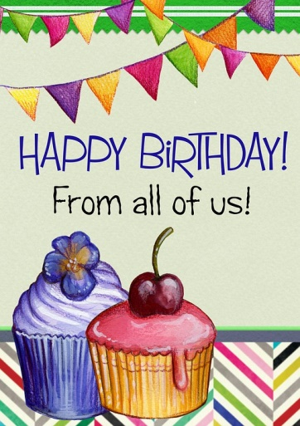
Your friend is having a birthday. You and 3 other friends are going to buy her a gift. You know she likes _______________________ and you want to spend approximately $ _________. If the gift costs $__________, each person will spend $ _____________.

Write a conversation between you and the cashier at the store. Here is an example:

Cashier: Hi, how are you today?
You: ________________________________
Cashier: Will that be cash or credit?
You: Cash, please.
Cashier: Ok. That will be $ ______________________
You: Here’s $ _____________________
Cashier: Out of $_______________________. (She counts the change back to you).
You: Oh, you made a mistake. The price is $____________________ and you gave me $ ___________ (count the change back to the cashier).
Cashier: Oh, you’re right. Sorry about that. Here you go. That’s $ ________________.
You: Thank you. Have a nice day.
Cashier: You too.

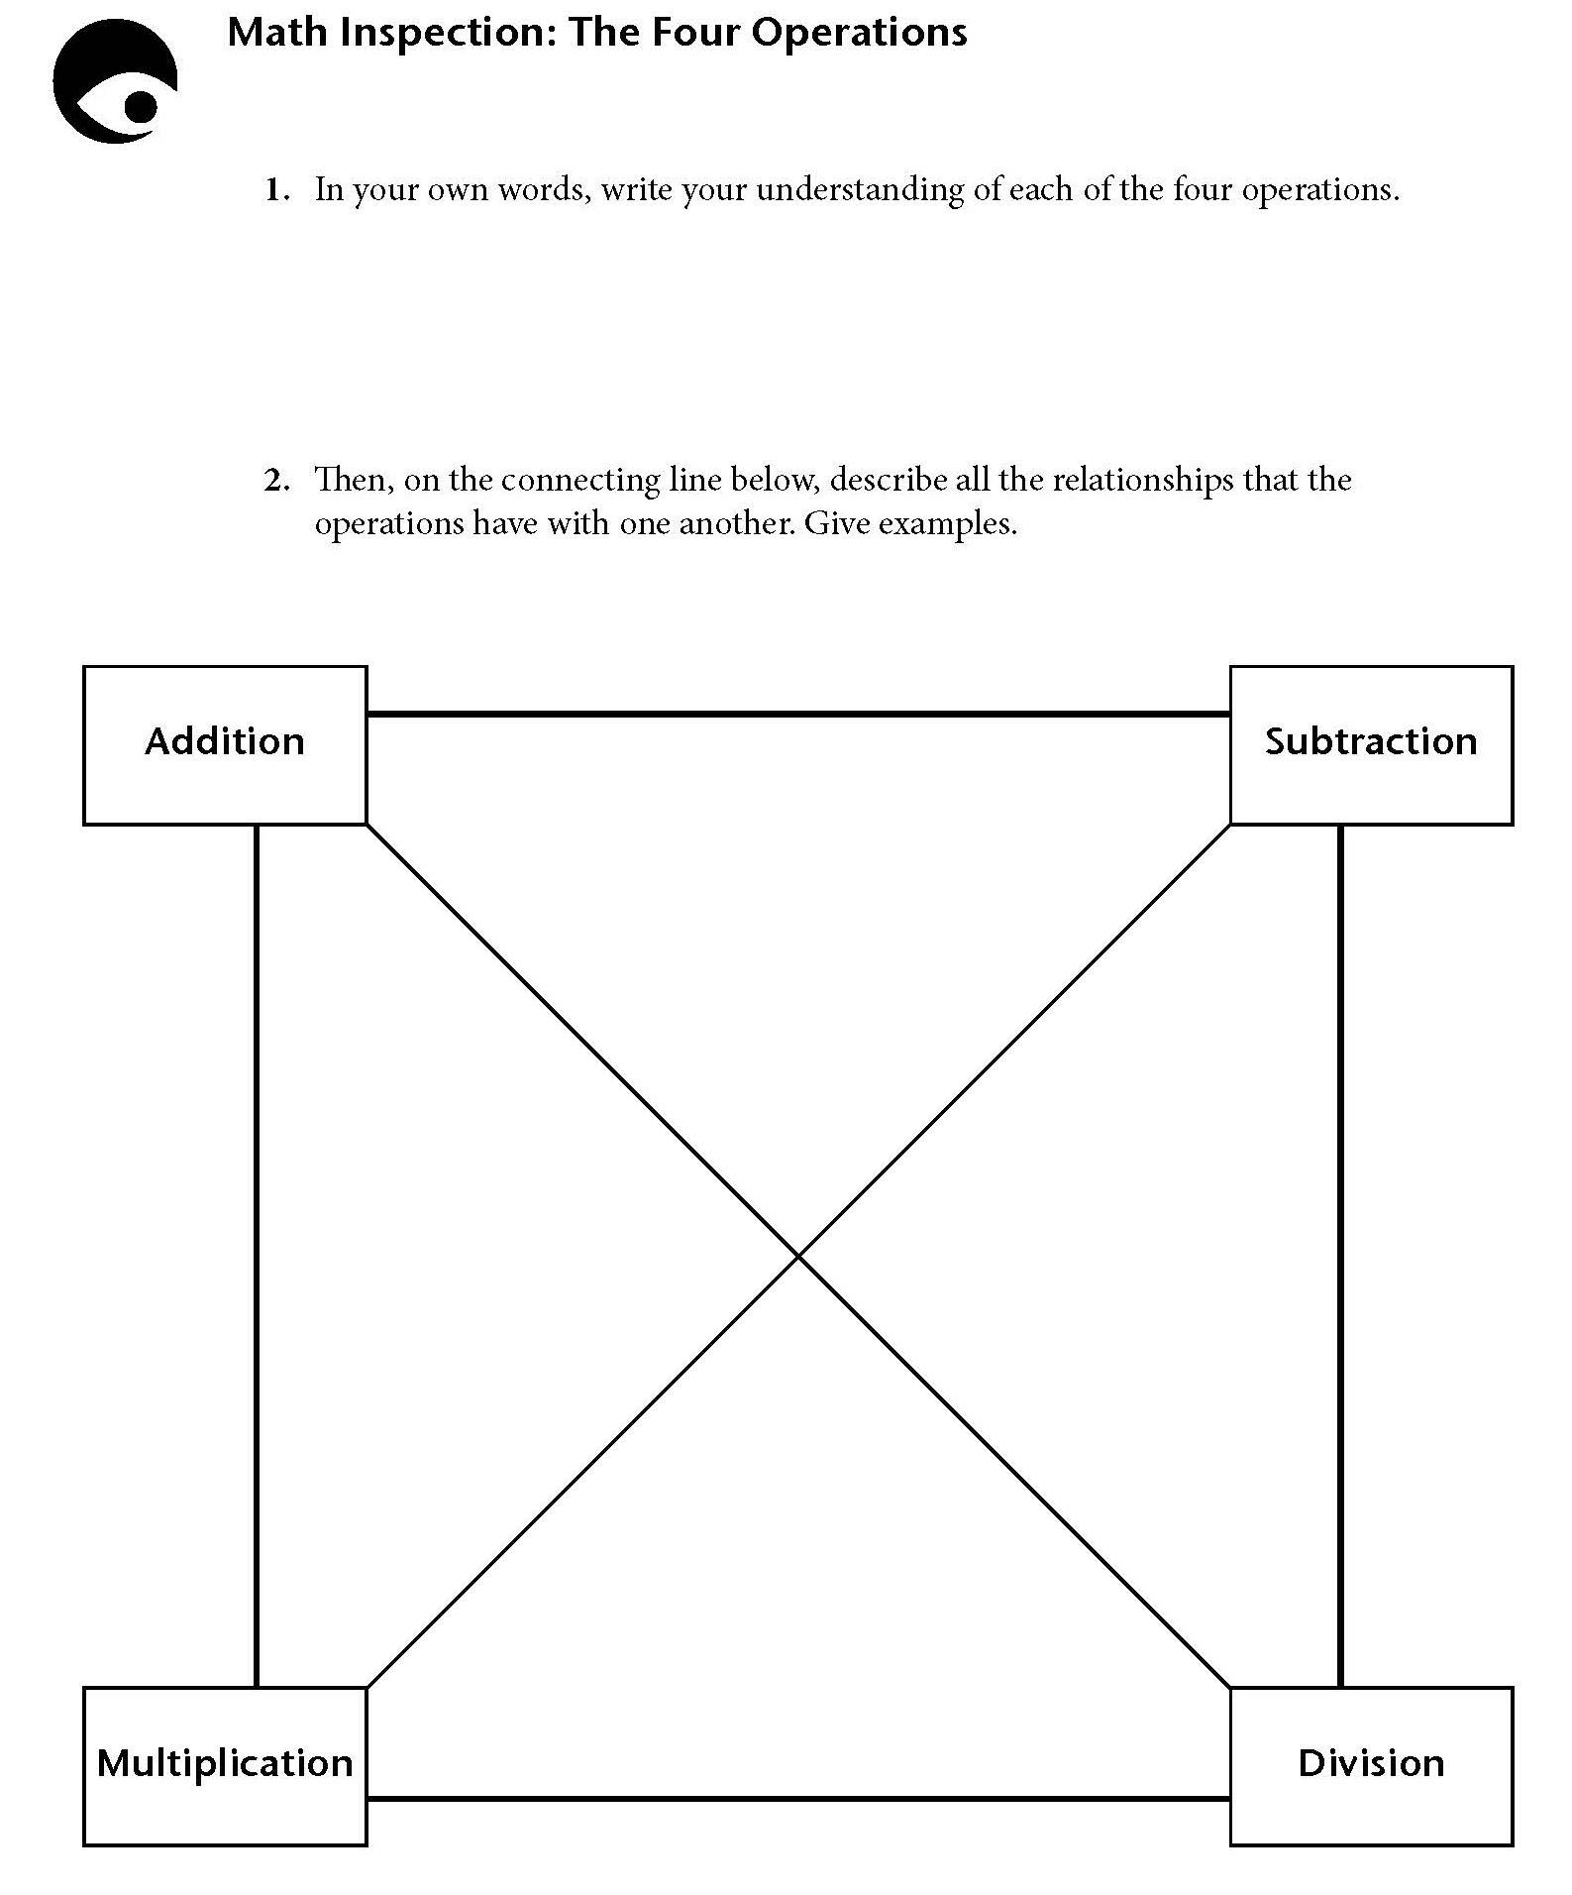
Copyright © 2016, TERC. All rights reserved. From EMPower book Everyday Number Sense, Lesson 14 (Student Book). Used with permission.

Math Inspection: The Four Operations

This inspection serves as a way to assess students’ understanding of the four operations, including their relationships to each other.

- Ask students to begin working independently and then to work with another student. They can compare and discuss relationships one found and the other did not list or does not recognize. Encourage students who struggle writing their ideas to use concrete examples to help clarify their thinking. As you circulate, you might prompt with examples of short-cuts or tricks that rely on these relationships. For example, you can calculate the multiplication facts for 9 by multiplying by 10 and subtracting.
- Once students have done what they can, discuss their ideas. Create a large version of the four operations and record all of the interrelationships students’ listed.
Listen for the following key points. If students do not say them, add them to the mix.
- Addition means to find the sum, to combine amounts. It is the inverse of subtraction. Repeated addition can be used for whole number multiplication situations: 4 = 3 = 4 + 4 + 4). It is commutative.
- Subtraction has several different meanings: taking an amount away, finding the difference between two amounts, or comparing two amounts. It is the inverse of addition. Repeated subtraction can be used for whole number division situations (10 ÷ 2 can be found by subtracting 2 from 10 until you run out of groups of 2). It is not commutative.
- Multiplication means to find the product. Multiplication is about equal groups. It can also be repeated addition. Exponents can be used to show repeated multiplication of the same base: (4² = 4 = 4). Multiplication is the inverse of division. It is commutative.
- Division means to find the quotient. Division has two meanings: finding how many of an amount in a total (12 ÷ 3 can mean to find how many groups of 3 there are in 12), and splitting up an amount into parts (12 ÷ 3 can also mean to find how many are in each group if 12 is evenly divided into 3 groups). Division is the inverse of multiplication. It is not commutative.

LESSON 4: BENCHMARK FRACTIONS, DECIMALS, AND PERCENTS

Rationale
As consumers, we are inundated with media advertisements for sales and best buys. Think about a sales promotion in a flyer: 1/2 off the original price or get an additional 50% off when buying the larger size! We encounter these situations daily and need strategies to be able to quickly compute what the sales price will be, how much money we will save, or how much more product we are buying if something is 50% more.
Our learners face the same challenge. In addition to interpreting language, they want to understand the math so they can make informed decisions.

Background
Benchmark numbers such as 1/2, 1/4, and 3/4 are numbers that are easy to visualize and calculate and can be used as reference points against which to estimate the size of less familiar numbers. The advantage of using benchmarks is that they are accessible to ESOL teachers and learners at varying levels of math competence, and mirror what numerate adults do with fractions, percentages, and decimals in their everyday life.
Before students are taught operations with fractions, percentages, and decimals they should:

have a strong conceptual understanding of what these numbers mean (part/whole) and understand how they connect to one another
be able to visualize what they look like (visual models)
use benchmarks to understand less familiar numbers
know the three different ways to represent benchmark numbers: fraction, decimal, and percentage

In many math textbooks fractions, decimals, and percentages are each treated separately as if they were completely unrelated concepts. However, all three are actually different ways of representing the same amount. Just as languages have synonyms, the language of math has different forms of representation, which may be more or less useful depending on the situation.
Students usually know what 1/2 and 1/4 look like. They probably know one or more of the representations, but often they don’t make the connection between the fraction, decimal, and percentage forms. For example, they may know that 1/2 is equivalent to 50%, but they may not make the connection to .50, or they know 1/4, but don’t realize this is also 25%. This is one reason why we hear so often from adult learners that fractions, decimals, and percentages confuse them.

LESSON 4: BENCHMARK FRACTIONS, DECIMALS, AND PERCENTS LESSON PLAN

Prior Knowledge
- Students are able to recognize most U.S. currency (coins and bills) and state the amount each represents. Example: A nickel is worth five cents.
- Students are able to add and subtract two-digit numbers.
- Students recognize U.S. math notation (see Lesson 1: U.S. Currency).

ESOL Tasks
- Read and interpret store advertisements to determine the best value

Math Concepts Addressed
- Recognize benchmarks fractions, decimals, and percents
- Use benchmarks fractions, decimals, and percents to reason about less common numbers

Materials
- Play money
- 7” diameter paper plates (2 different colors)
- Colored construction paper cut into 1” x 11” strips (4 strips per student)
- Plastic document protector sheets (1 per student)
- Teacher Resource: Consumer Awareness and Financial Literacy
- Handout: Store A – Sample Reasoning
- Handout: Practice Reasoning with Benchmarks
- Handout: Fraction Strip Word Problems

Math Vocabulary

- part
- whole
- decimal
- fraction
- decimal fraction
- percentage

INTRODUCTION / WARM UP

Which is the better deal?
- Use the Consumer Awareness and Financial Literacy advertisements or create your own set of advertisements that use different wording or representations with discounts of 1/2 off the regular price. For example, use one ad with 1/2 off and another that says: Buy 1, get 1 free for the same product.
- Ask students to think about which is the better deal and do some math if they wish, but they should not yell out the answer. As students work, walk around and monitor their work. Look for different approaches to solving the problem.
- When all students have had enough time to think about the problem, elicit the response which should be: They are the same deal. Then ask: How do you know?
- Throughout this activity, note students who have different strategies. Don’t skip this step! Later in this lesson, you will want to highlight different approaches to finding one-half.

ACTIVITIES

I. Looking at equal parts
Start with 1/2. Students need to understand that half, or 1/2 means two equal parts. In the first activity, students use currency to create one-half by creating two equal parts.
- Using play money, ask students to show you half of a dollar. They might use 2 quarters, 5 dimes, etc. Then ask them, How do you know? Next ask them to write the amount on a piece of paper or a small white board. Look for different representations: .50, 1/2, 50%. 50₵. If not, ask if there are different ways to write the number.
- Change the amount to eighty cents (.80) or any amount that divides evenly and again, ask them to show you half of that amount. Each time asking: How do you know?

Extending the Activity
Give students concrete objects to show one-half as two equal parts.
Option 1: Using a loaf of bread, a cake, or a cookie ask students to divide the item into halves.
Option 2: Using two paper plates of different colors, cut each paper plate halfway to the center and fit together (see following photo). Students manipulate the plates to show one-half.
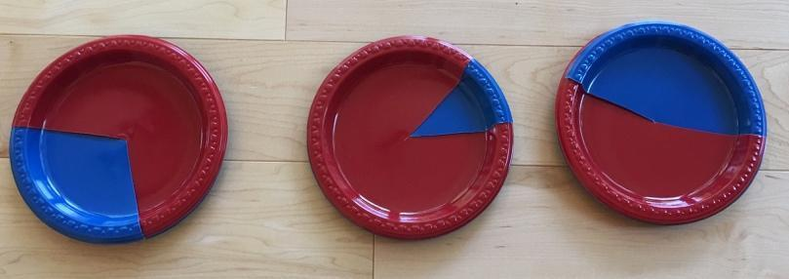
Key strategy: As students illustrate halves with one or more of the activities above, listen for reasoning about equal parts. If they don’t come up with it ask: What do you notice about the 2 parts? How are they the same?
Be explicit that 1/2 means one of two equal parts.

II. Finding one-quarter from one-half
- Repeat above for 1/4. (Listen for reasoning of four equal parts.) You can start with one dollar or choose a different amount such as eighty cents. Use numbers that divide evenly.
You can use the paper plates or bread, etc. to show 1/4 or create a drawing. Remember to point out the different representations: 1/4, 25%, .25 and 25₵.

III. Visualizing one-quarter with a pie chart

Building a conceptual understanding of the relationships between 1/2, 1/4, and 1/8.
In this activity, students will create fraction strips as visual aids for the relative size of fractions, equivalent fractions and the relationship between 1/2, 1/4, and 1/8. The value of this activity is having students create their own fraction strips.
- Refer to Equal Measures (Lesson 6, pp. 67-74) in the EMPower Plus: Using Benchmarks: Fractions and Operations teacher book for this activity (Or, you can go to https://vimeo.com/showcase/6708687?share=copy&fl=sm&fe=fe to learn how to create and use fraction strips.) You will cut the strips of paper ahead of time, but be sure to let the students do the folding and labeling of the strips. In folding the strips, students discover that half of 1/2 is one-quarter and half of one-quarter is one-eighth. So, each time they double the paper strip, the fraction is half the size of the previous one.

Extending the activity
- The fraction strips are visual aids to calculate parts (discounted amount), percentages and the original price. Using the sample advertisement provided in the handout Consumer Awareness and Financial Literacy, ask students to use the play money together with the fraction strips to show which is the lower prices and explain their reasoning. See example provided on the handout Store A – Sample Reasoning.
Note: This activity similar to a strategy known as bar modeling, tape diagrams, or Singapore strips. Refer to the Additional Resources section for more information and practice.

IV. Using fraction strips to calculate discounts
Using an ad for 1/4 or 25% off, students use fractions strips to show:
- The original or regular price
- The amount of the discount (how much money is 25%)
- The sale price

V. Using benchmarks to make sense of less common numbers
- Using the handout Reasoning with Benchmarks Practice, students will use their knowledge of 50% and 25% to estimate the amount of a 40% discount.

Additional Practice: Reasoning with benchmarks
- EMPower Plus: Using Benchmarks, Fractions and Operations (student book), pp. 9, 17, 37, 55

4 Strategies for Differentiation

More accessible:
- Use two-digit numbers.
- Stick to 1/2 and 1/4.

More challenging:
- Extend to 1/10.
- Extend to 1/3, 1/6, 1/12 by preparing new fraction strips for students.
- Use three- and four-digit numbers (hundreds or thousands).
- Use mixed numbers.
- Extend to adding and subtracting fractions using handout Fraction Strip Word Problems.

ASSESSMENT
Students create their own shopping discount advertisement using colored pencils, paper, drawings, magazine images, etc. Underneath the ad, students use bar modeling to show:
- the original price
- the fractional parts of the whole
- the part that represents the discount
- the amount of the discount

ADDITIONAL RESOURCES
- Thinking Blocks Fractions (interactive website)
- Decimals, Fractions, and Percentages (interactive website)
- Singapore Math Bar Model Strategy video (practice bar modeling)
- Fractions Are Parts video
- EMPower Plus: Using Benchmarks: Fractions and Operations (teacher and student books).



You have $100.00 to buy shoes for your family.
Look at the advertisements below. Which store offers a better deal for your family? How did you decide?

Store A
YEAR END SALE!!!
Buy one and get 50% off second pair!
(All shoes $40.00 first pair)

Store B
YEAR END SALE!!!
25% off all items!
(Originally $28.00 / pair)

Advertisement #1

Sneakers: Originally $28.00

25% off



$28.00

$7.00 | $7.00 | $7.00 | $7.00
25% | 25% | 25% | 25%

Reasoning:
25% or ¼ of 28 is 7.
$28.00 - $7.00 = $21.00
Final price is $21.00

Advertisement #2

SALE

Buy 1 pair, Get 2nd pair 50% off



$30

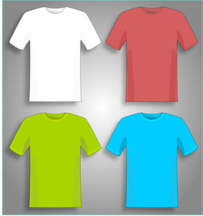
Today only!
All T-shirts are 50% off regular price of $5.00 each.

1. The amount of the discount is
- more than $2.00
- less than $2.00
- exactly $2.00
Show your reasoning with a number line or drawing.

2. A discount of $1.00 off a loaf of bread that costs $3.49 is
- more than 25% of the regular price of the bread
- less than 25% of the regular price of the bread
- exactly 25% of the regular price of the bread
Show your reasoning with a number line or drawing.

3. Fill in the missing amounts in the gray boxes.
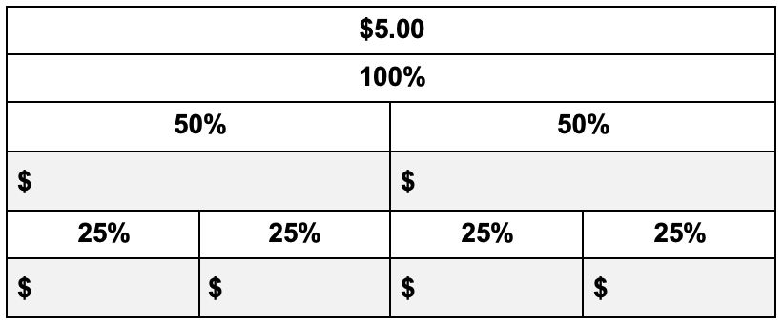
- You just made a recipe of lemon cookies. The recipe called for 3/4 cup of sugar. You decide you want them to be a bit sweeter next time you make them so you make a note to add an extra 1/8 of a cup of sugar next time. How much total sugar will you need for next time?

- Derek has 5/8 of a cup of water and pours out 1/4 of a cup. How much does he have left?

- Your son has a school project. He needs to create a diagram of blocks using 3 blocks – 1/2 “, 3/8” and 1/4” wide. What is the total width of these blocks if they are laid side by side?

- There is a whole cake left after a party. You give 1/4 to your brother and 3/8 to your sister. How much is left? How much did you give away?

LESSON 5: PROPORTIONAL REASONING

Rationale
Consumer literacy is a topic that we commonly teach in our ESOL classes. Our students need to know how to read labels and advertisements, engage in purchasing transactions, and navigate systems regarding buying and selling products in the United States. All consumers want the best value for the lowest price, but sometimes figuring out the better deal is not obvious. What do we need to know as consumers, and how can we teach these skills to our learners?

Background
A ratio represents the relationship between two numbers. For example, 2 donuts for $1.00 is a ratio. In math notation, a ratio can be written several ways: 2:1, 2/1, or even 2 to 1. Note that order matters! The order of the numbers corresponds to the ratio we are describing.
When two ratios are equal, they are proportional. The opportunity for students to use proportional reasoning will be much greater when it builds on their intuitive understanding of familiar contexts, such as how quantity and cost are usually related when shopping. For this reason, we advocate keeping numbers in context as much as possible, especially at first.
Contextualize language and math at the level of your students. Numbers that divide evenly and whole numbers are generally easier to work with. Talk about food items your students typically purchase and use ads from the stores where they tend to shop. Later, students can use the concepts they have gained to make sense of more abstract numbers.

LESSON 5: PROPORTIONAL REASONING LESSON PLAN

Prior Knowledge
- Students are able to recognize most U.S. currency (coins and bills) and state the amount each represents. Example: A nickel is worth five cents.
- Students are able to add and subtract two-digit numbers.
- Students recognize U.S. math notation (see Lesson 1: U.S. Currency).
- Students have conceptual understanding of fractions as equal parts.
- Students are familiar with the notation of fractions.

ESOL Tasks
- Compare prices
- Determine best buy
- Use correct English phrases and notation for ratios and proportions.

Math Concepts Addressed
- Find equivalent ratios.
- Use drawings to prove that two ratios are equivalent.
- Predict an amount needed

Materials
- Store advertisements with ratios
- Paper
- Colored pencils
- Small whiteboards (1 per student), or paper
- Teacher Resource: Double the Donuts
- Teacher Resource: 2 for $3.00
- Handout: Brownie Recipe

Math Vocabulary
- ratios
- proportions
- colon
- fraction
- equal

INTRODUCTION / WARM UP
Using the teacher resource Double the Donuts, say to the students:
I want to double the amount of donuts. Complete the picture to show me how much I will pay for double the amount.

ACTIVITIES

I. Using visuals to show proportional relationships
- Use the teacher resource 2 for $3 advertisement provided, or create your own.
- Elicit how they would describe the sale: Two for three dollars.
- As they speak, write the numbers as a ratio: 2:3. Elicit how they might describe the relationship between the two numbers. Then write “ratio” on the board. When writing with a colon, be explicit the punctuation and be explicit that the colon, in this context, represents the relationship between the two numbers and we call that a ratio. Recall that they know a colon from its use in telling time. Elicit uses of the colon in their culture. A colon is used for division in some countries.
- Using white boards or paper, ask students if they know other ways to write a ratio without a colon. It can be written as a fraction. $\frac{2}{3}$.
- Ask students to draw the ratio as they saw in the warm up activity. Then show an equal ratio by drawing it. Ask them to write the proportion in math terms: Ex: $\frac{2}{3}$ = $\frac{4}{6}$ or 2:3 = 4:6.
- Give students store ads with ratios and for each ad, they should:
Write the ratio in numbers.
Draw the ratio.
Draw an equal ratio.
Write the two ratios as a proportion.
- Do a language lesson for talking about ratios with words such as: per, for, a and ask students to write sentences. For example: The store has 2 avocadoes for 3 dollars. As you move through the other activities in this lesson, have students write out sentences as we would normally describe the ratio: 2 for a dollar; $1.00 per mango, a dollar a mango, etc.

Extending the Activity:
Use the Brownie Recipe handout provided or create your own and ask students to double or triple the recipe, keeping all the ingredients in proportion.

II. Using ratios for currency conversion
Note: You may want to research the rate of exchange for the currencies of your students’ native countries.
- Ask students to write down the name of the currency in their native country.
- If they don’t know the rate of exchange, research it on the Internet and write it as a ratio. For example, the ratio between the U.S. dollar to the Chinese yuan is $1.00 USD : 6.65 Chinese CNŸ.
- Create a table, commonly referred to as an In/Out Table. Students will build a currency conversion chart such as shown below. Start by doubling the numbers and then build out the table for the U.S. currency amounts: $5, $10, $20, $100.
US Dollars | Yuan
1 | 6.65
2 | 13.30
4 | 26.60
5

III. Using a table to make predictions
Using an In/Out Table, students will fill in numbers to make a prediction.
- Give students the case scenario:
You are having a party for 30 people. You are buying avocadoes for a salad. You normally use 2 avocadoes to make a salad for 4 people. How many avocadoes do you think you’ll need?
- Create an In/Out Table, and build the first few proportions together and then allow students to complete the table.

4 Strategies for Differentiation

More accessible:
- Use ratios that divide evenly such as: 1:2 or 5:10.
- Simplify the party scenario in Activity III by using a smaller number of people and numbers that divide evenly, such as 5 avocadoes to make salad for 10 people.

More challenging:
- Ask students to create their own scenario involving proportional relationships such as miles : gallon or price : pound.

ASSESSMENT
Students create their own food shopping advertisements with ratios. They can draw the products or use store flyers. For each ad, they will:
- Write in words the product and sale ratio. For example: There are 2 boxes of cereal for $5.00.
- Draw the ratio as a picture representation:
- Write the ratio using math notation: 2:5
- Double or triple the ratio.
- Create a drawing to show the two ratios are equal.
- Write the equivalent ratios as a proportion: $\frac{2}{5}$ = $\frac{6}{15}$

4 Technology Integration (optional)

Teaching digital citizenship
Students can create their flyers using Microsoft Word, Google Docs or a free web-based application like www.smore.com. However, students should be aware of copyright laws and creative commons licenses. This is an opportunity to teach students how to search for images with proper usage rights. Here is a resource that explains how to filter images by usage rights: https://support.google.com/websearch/answer/29508?hl=en

ADDITIONAL RESOURCES
- EMPower: Keeping Things in Proportion: Reasoning with Ratios (teacher and student books).
- Proportional Reasoning (ratios and proportions activities)

DONUTS



3 for $4.000

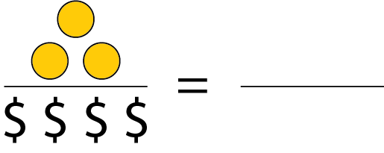

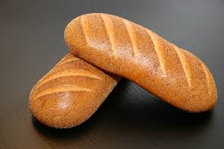
Two loaves of bread for $3.00
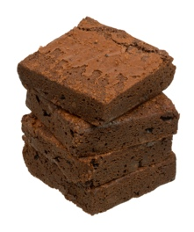
Ginger wants to bake brownies. Her recipe calls for eight eggs. She has two eggs. She decides to bake a smaller amount and reduces the recipe.

- What fraction of the recipe is she making? How do you know?

b. Show the amounts in her recipe change:

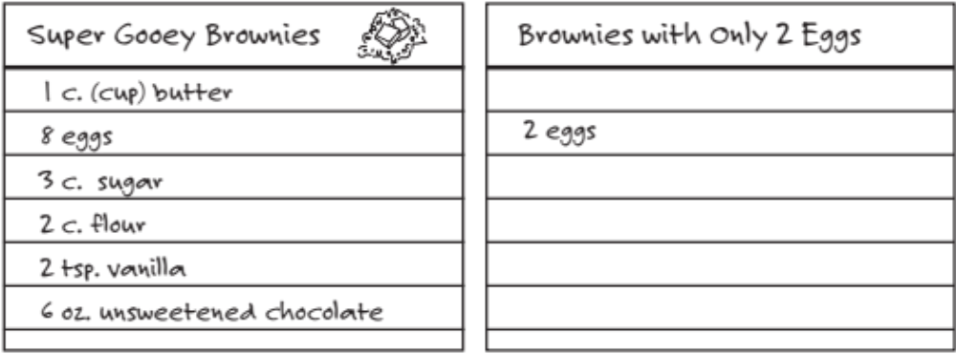

c. Which ingredients were easy to adjust? Why?

d. Which ingredients were hard to adjust? Show how you solved these problems.

Copyright © 2016, TERC. All rights reserved. From EMPower Plus book Using Benchmarks: Fractions and Operations, Lesson 2 (Student Book). Used and adapted with permission.

LESSON 6: MEASUREMENT

Rationale
The United States standard or customary system of measurement (also called the English, Imperial or American) is the most commonly used system of measurement in the United States. Although most ESOL students are better acquainted with the metric system of measurement, many items for sale in the U.S. (especially food) fortunately have both the English and metric equivalents listed on the packaging. This provides a base to build understanding of the relationship between the two measurement systems.

Background
According to the National Council of Teachers of Mathematics (2015), “Students need to develop an understanding of customary units and their relationships… Because some non-metric units of measure are common in particular contexts, students need to develop familiarity with multiple systems of measure, including metric and customary systems and their relationships.” Because most ESOL teachers may be more comfortable with the customary system of measurement, it is important for teachers to familiarize and understand the metric prefixes which are combined with increments of length (meter), volume (liter) and weight (gram).
Each metric prefix increases or decreases by a factor of ten (see the table below).
Base units: meter, liter, gram
kilo hecto deca deci centi milli
For example, it takes 10 milligrams to make 1 centigram and 1 deciliter is 1/10 of a liter. The chart can be a useful reference as well as realizing our monetary system is based on factors of 10 as well (10 dimes to make 1 dollar, 100 cents to make 1 dollar). Refer back to Lesson 2: Place Value for a discussion of factors of ten.

LESSON 6: MEASUREMENT LESSON PLAN

Prior Knowledge
- Students are able to recognize most U.S. currency (coins and bills) and state the amount each represents. Example: A nickel is worth five cents.
- Students are able to add and subtract two-digit numbers.
- Students recognize U.S. math notation (see Lesson 1: U.S. Currency).
- Students have conceptual understanding of fractions as equal parts.
- Students are familiar with the notation of fractions.

ESOL Tasks
- Read and interpret food labels
- Write standard U.S. measurements using common abbreviations.
- Role play a customer service scenario to solve a problem.

Math Concepts Addressed
- Ratios and proportional reasoning
- Measure in standard units

Materials
- Measuring cups and spoons
- Food scale
- Rulers and yardsticks
- Containers filled with a product (box, jar, bag, can, bottle, package, bar of chocolate)
- Set of Handout: Vocabulary Cards – Containers (1 per group of 4)
- Teacher Resource: Metric Word Web
- Teacher Resource: Food Labels and Serving Size Activity from http://sph.unc.edu/files/2014/07/Food-Labels-and-Serving-Sizes.pdf

Math Vocabulary

- gram
- milligram
- kilogram
- liter
- ounce
- cup
- pint
- quart
- gallon
- pound

INTRODUCTION / WARM UP
Place the various containers around the room. Group students and give each group a set of Vocabulary Cards – Containers to match with each object.

ACTIVITIES

I. Metric system
- Create a word web with “metric system” in the center (see sample Teacher Resource: Metric Word Web) and elicit metric measurements.
- Using the example provided, students work together to build out the metric system.
- Elicit the pattern they see (based on tenths).
Note: See Additional Resources section for useful websites on metric system information and practice.

4 Technology Integration (optional)

Blended learning
Create a blended lesson by sharing online resources with students and give them an opportunity to first practice in class so they will know how to access them outside of class. Check to see if they are accessible on mobile devices.
Tip: Create a document or website that you can store digital resources for easy access. Hyperlink them so students do not have to remember long URLs. You can shorten the URLs using the free services at https://bitly.com/ or https://tinyurl.com/.

II. Estimating measurements with sensory perception
- Students close their eyes. Give each student an item to hold such as a chocolate bar, a package of cookies, a box of rice, etc. and ask them to estimate the weight in metric measurement. Students will make statements such as: A chocolate bar weighs about 100 grams. Record their estimates.
- Ask students to open their eyes and read the labels to check the accuracy of their estimates.
- Ask students if they can estimate the weight in the Imperial system by feeling the weight of the object in their hands. Students write sentences with their estimates.
- Using measuring cups and spoons and food scale, students complete the table with equivalent Imperial measurements.
- Place portions of food items such as cereal, rice, dried beans, bread, etc. in bowls and plates.
- Ask students to estimate the weight by visually inspecting the objects, then write sentences. For example: There is 1 cup or 8 ounces of cereal.
- In groups, have students use the measuring tools to check the accuracy of their estimates. They can put the cereal in the measuring cups, the bread on the food scale, etc.
- Students write down the correct measurements next to the estimates.

III. Build conversion tables
Build conversion tables for metric : imperial conversion using standard measurements such as: kilogram : pound; deciliter : ounces. You may want to limit conversions to principal units of measurement. See Lesson 5 on Proportional Reasoning.

IV. Reading food labels
Follow the instructions for the Food Labels and Serving Size Activity available from https://sph.unc.edu/wp-content/uploads/sites/112/2014/07/Food-Labels-and-Serving-Sizes.pdf

4 Strategies for Differentiation

More accessible:
- Limit measurements to the most common units: e.g., cup, ounce, tablespoon.

More challenging:
Give students food labels to compare for nutritional values: sugar, carbohydrates, protein, fat, etc. See Additional Resources: Food Label Activities.

ASSESSMENT
- Give students a food label. Using the serving size and measuring tools, students measure out the quantity of one serving.
- Using food products and measuring tools, students measure out one cup, one tablespoon, one pint and one quart. Arrange them in order from smallest to largest.

ADDITIONAL RESOURCES
- The Metric System
- Center for Nutrition in Schools (UC Davis) Nutrition to Grow On curriculum, Lesson 5: Food Labels
- EMPower: Over, Around, and Within: Geometry (teacher and student books)

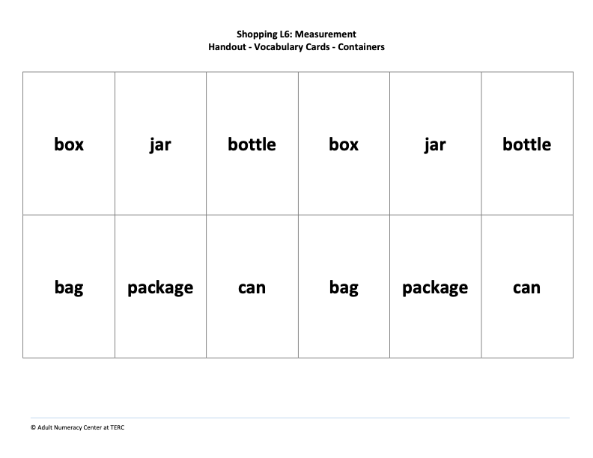

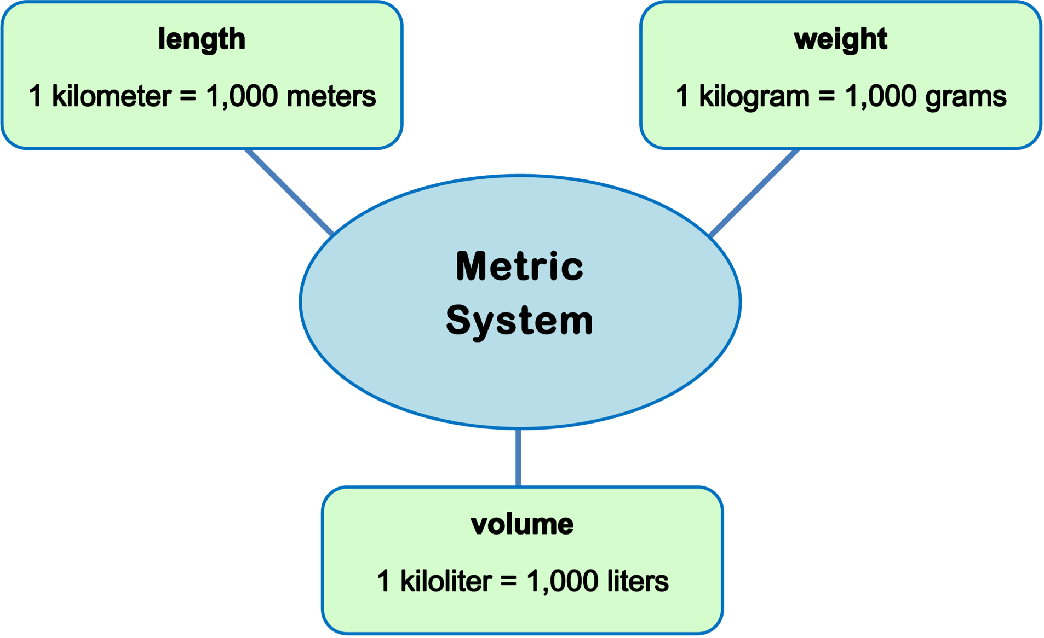

LESSON 7: DATA

Rationale
ESOL students are confronted with data displayed in many forms daily. They need to be able to interpret and analyze data using a variety of strategies. Students need to understand that data can be made to tell different stories, depending on the way they are categorized and displayed.

Background
The four types of graphs commonly used are bar, circle, line, and frequency graphs. Although they are sometimes used interchangeably, at times one graph is more useful than another. There is often more than one correct way to display a set of data. However, each type of graph has particular strengths and sometimes one type of graph is useless for a particular purpose. For example, a bar graph might be used to compare prices of items from various stores or a frequency graph might be utilized to present shopping trends.

LESSON 7: DATA LESSON PLAN

Prior Knowledge
- Students are able to recognize most U.S. currency (coins and bills) and state the amount each represents. Example: A nickel is worth five cents.
- Students are able to add and subtract two-digit numbers.
- Students understand U.S. math notation (see Lesson 1: U.S. Currency).
- Students have a conceptual understanding of fractions as equal parts.
- Students are familiar with the notation of fractions.

ESOL Tasks
- Create a survey.

Math Concepts Addressed
- Represent and interpret data

Materials
- Handout: Ice Cream Flavors
- Handout: Survey Template
- Paper plates (in one or more colors depending on how you run the activity)
- Sticky notes (large)
- Teacher Resource: Constructing a Circle Graph from a Bar Graph

Math Vocabulary
- graph
- whole
- circle
- pie chart / circle graph
- survey

INTRODUCTION / WARM UP
- Use the graph provided in the Ice Cream Flavors handout or create your own, and ask students to talk about what information they understand from the graph.
- Talk about the circle as the whole, or 100%. Elicit responses to the following questions:
What must be the total percentage of the 2 parts/slices of the pie chart?
How many categories do you see?

I. Class survey
Students will create a survey by asking classmates and/or family members and friends.
- Using the Survey Template handout, students will think of a question with two categories. This should be a yes or no question or any question that limits the response to one of two options. For example: Do you prefer chocolate or vanilla ice cream?
- Students ask classmates or family and friends the question and record the responses. They can survey any number of people.
- Give each student a white paper plate and using benchmark numbers, students estimate the percentage and color in the plate to represent their data. For example: If 4 of out 10 students prefer chocolate ice cream, the color representing chocolate should cover almost 1/2 of the plate. [An alternative to this is to give each student two different-colored pie plates that can be put together to make a pie chart that can be shifted around, creating various sized slices, or percentages. See Lesson 4, Activity I: Extending the Activity for instructions and an illustration.]

Extending the activity: Favorite Colors activity
Note: before beginning this activity, review the teacher resource Constructing a Circle Graph from a Bar Graph in preparation for Steps 5-7.
- Ask students to jot down their favorite color on a large sticky note and post it to a common wall area for all to see.
- Ask for a couple of volunteers to come up and categorize the data.
- Then model the creation of first a frequency graph (with an “x” for each item in each category so students can clearly count each item) and then a bar graph (which covers up all the individual “x” marks which requires students to now use the y-axis to determine how tall each bar is). Post this on chart paper for all to see.
- Now ask for a couple of other volunteers to collapse some of the categories (this will work well if there are lots of colors in the data set.) For example, if the colors chosen included orange, red, yellow, blue, green, students could be asked to create fewer groupings, which they could choose themselves. They could choose to reorganize the colors into warm and cool colors, or colors they like vs. don’t like, or even primary colors vs. secondary colors.
- Once the categories have been collapsed, create another bar graph and ask students to do likewise using different colors for each bar. Be sure to ask students to consider the two different bar graphs based on the same data so that they can see what happens when data gets collapsed into fewer categories. (This is an important big idea in understanding what happens when data are represented in graph form.)
- Then cut out each bar of your graph and combine them for a pie chart as students do the same with their own graphs.
- Debrief by asking about any aha moments that they had as they did the activity.

4 Technology Integration (optional)

Data to Graphs
If you are comfortable with Microsoft Excel or Google sheets, you could show more advanced students how to enter class data into a spreadsheet and then how to convert the data into a pie chart or bar graph. Learners can practice by creating their own survey with family members, entering the data on a spreadsheet and converting it to a graph. Students can create a presentation for the class using the visuals they have created.
Another option is for students to practice using Google Forms to create an online version of their survey to collect data.

ASSESSMENT
- Option A: Give students a graph and ask them to write sentences about the data.
- Option B: Give students a set of data. Ask them to create a bar and a circle graph, and then reorganize the data to illustrate how organizing data can change the story.

ADDITIONAL RESOURCES
- Statistics for Action: Drawing Your Own Conclusions
- Statistics for Action: Memorable Graphs
- EMPower: Many Points Make a Point: Data and Graphs (teacher and student books)

FAVORITE FLAVOR ICE CREAM

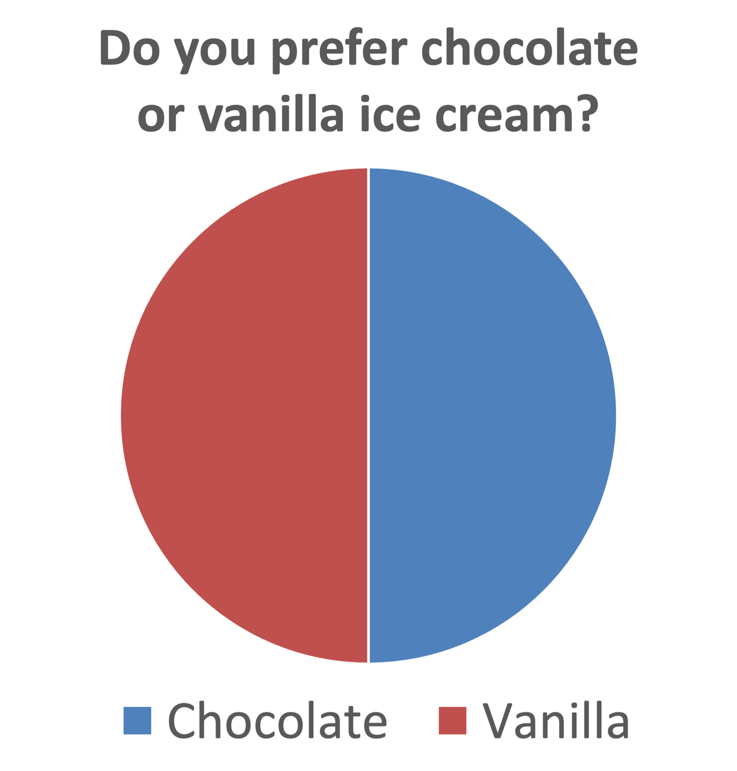

What do you prefer:

________________________ or ________________________?

Put an X for each person under the option they choose.

OPTION 1
OPTION 2

Demonstrate how a bar graph can be changed into a circle graph. Talk through this process as you do it. Draw students into decision-making where appropriate.

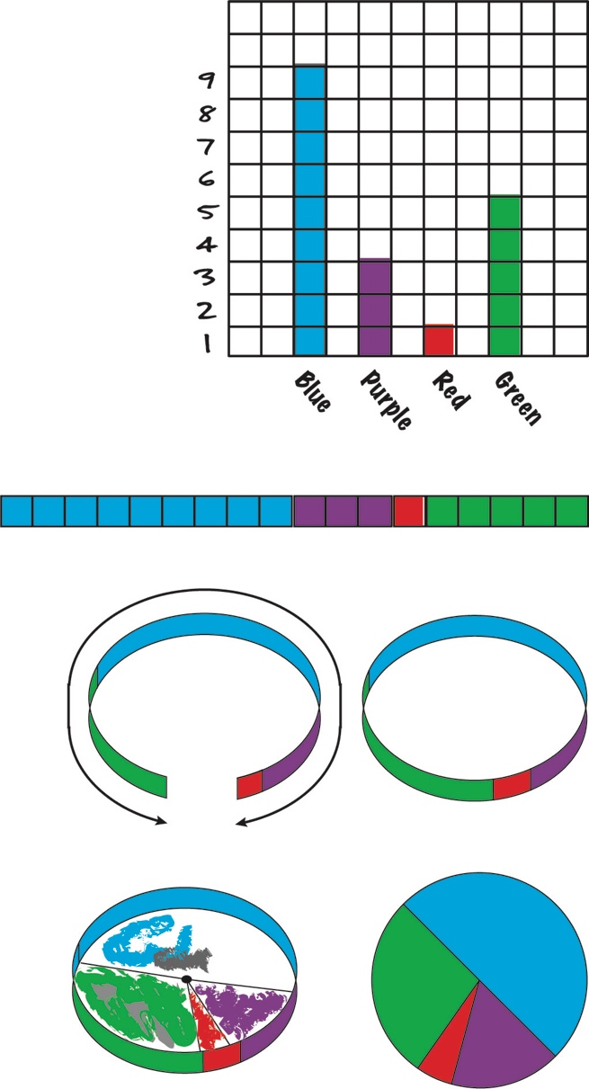
- Start with a bar graph drawn on graph or chart paper, where each bar is a different color.

- Cut out the bars.

- Tape the bars together, end-to-end, creating one long strip.

- Create a circle from the strip by connecting the two ends.

- Trace the circle onto a new piece of paper.

- Mark off where each category begins and ends.

- Draw a line from the center of the circle to the marks on the edge of the circle, creating pie slices for each different section.

- To keep track of the data, establish a legend or key, using one color for each bar. Record the legend next to the circle.

- Write a title for your circle graph.

Copyright © 2011, TERC. All rights reserved. From EMPower book Many Points Make a Point: Data and Graphs, Lesson 3 (Student Book). Used and adapted with permission.

