Integrating Math into
ESOL Units
A Math Packet for ESOL Teachers

EMPLOYMENT




TABLE OF CONTENTS
Introduction 1
Lesson 1: Data Collection 2
Lesson Plan 4
Lesson 2: Place Value 11
Lesson Plan 17
Handout: Job Ads at Home DIY 25
Handout: Job Ad Abbreviations 26
Handout: Job Ad Definitions 27
Handout: Time Card for Susanne 28
Handout: Time Card for Susanne Answer Key 29
Handout: Number Line Template 30
Lesson 3: Number Sense 31
Lesson Plan 34
Handout: Number Line Templates 40
Lesson 4: Benchmark Fractions, Decimals, and Percents 43
Lesson Plan 46
Handout: America's Education 54
Handout: Women in the Workforce 55
Handout: Analyzing Pay Stubs 57
Handout: Sam's Monthly Budget 59
Handout: Sam's Pay Stub 60
Lesson 5: Proportional Reasoning 61
Lesson Plan 63
Teacher Resource: Rose Order 70
Handout: Mixing Paint 71
Handout: Time on Task 72
Lesson 6: Measurement 73
Lesson Plan 76
Handout: Divide the Shapes 83
Handout: Matching Cards: Measurement Units 84
Handout: Room Area 86
Handout: How Much Paint? 87
Handout: How Much Paint? Answer Key 89
Handout: How Does Your Garden Grow? 91
Lesson 7: Data 95
Lesson Plan 97
Handout: Farm, Farmer, Farmstand 101
Handout: Reporting Data 2 102

Integrating Math into ESOL Units:

A Math Packet for ESOL Teachers (Employment)

Math and language are part of our daily activities. When we make a purchase, cook, exercise, and take public transportation, we are using math. In many ESOL course books, math topics are included in thematic units such as shopping, banking, and food. Some books might ask students to tally a bill, write a check, or create a budget, but ESOL course books generally don’t deconstruct the math concepts needed for those tasks.
Understanding math is so much more than memorizing math rules. Think about how you mentally total a bill or calculate sales tax. It is likely that you use different strategies depending on the situation. The math we encounter involves understanding math concepts and how they are related, selecting strategies for problem solving and making sense of math procedures and when to apply them.
In response to ESOL teachers who would like to integrate math in their language classrooms, the SABES Mathematics and Adult Numeracy Curriculum & Instruction PD Team at TERC developed a set of Math Packets for ESOL Teachers. Each packet includes a series of language lessons that integrate math. The math activities are designed to dig deeper into math topics and provide the building blocks that teach the skills and knowledge our learners need to understand the underlying math concepts.
Each ESOL Math Packet includes:
- Background knowledge for the teacher
- Prior knowledge needed by learners
- Language tasks
- Activities that allow learners to explore math concepts
- List of materials needed
- Instructional strategies including ideas for differentiating for math abilities
- Assessments

This ESOL Math Packet was created with funding from Public Adult Education of MA by the SABES Mathematics and Adult Numeracy Curriculum & Instruction PD Team, which is managed by TERC, Inc. This document was authored by Sherry Lehane, an adult ESOL instructor, and Melissa Braaten, an adult basic education teacher, with contributions from Sherry Soares, Donna Curry, and Aren Lew.

LESSON 1: DATA COLLECTION

Rationale
Data and data analysis drive business. Companies promote their products and services using marketing strategies that present data in ways that are often confusing or simply don’t make sense. Some examples are radio and television ads that introduce surveys with statements such as, "Nine out of 10 people surveyed prefer...". While this may sound impressive, we don't know exactly how many people were surveyed, who the people were, or how the data were collected.
Data analysis requires critical thinking skills and careful inspection of the sources of information and the methods used in obtaining data. We can help our students develop analytical skills by showing them how data are collected, represented, and used for persuasion. In this lesson, students will collect data and make statements about their data. In Lesson 7 of this Employment unit (Data Analysis), students will engage in higher-level thinking skills by analyzing data and presenting their conclusions.

Background
In this first lesson, students will be working with data collected from a census of their class. A census is a form of data collection in which all the individuals in the group are surveyed. This is a good place to start when working with data, because you can collect real-world data easily and quickly, and you don’t have to worry about sampling.
Writing good survey questions takes some practice. The most basic questions have two, mutually exclusive answers (like yes/no). For example:
Are you currently working? Yes / No
Questions that have more than two categories can be tricky. For example, if students ask:
Are you working…
Full time / Part time / Looking for work / Not looking for work
it is quite possible that someone could be working part time and be looking for work, or be working and not looking for work, etc. The choices are not mutually exclusive, which can make the data difficult to interpret.
Sometimes questions are not exhaustive, so people are unsure how to answer.
For example:
Are you interested in …
Health careers / Customer service / IT careers
This is clearly not an exhaustive list, so questions of this type will often need an “other” category.
For this lesson, it may be best to start with simple yes/no questions (also referred to as closed questions), and then encourage students who are comfortable to experiment with more categories.
Data can be collected into frequency tables, which simply show the number of responses in each category. Here’s an example for the question, Are you currently working?
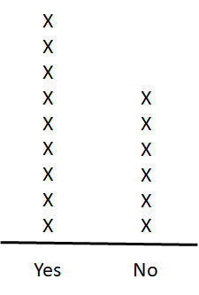

These graphs can later be built into bar graphs (which use a vertical scale, rather than symbols) and circle graphs (which require proportional reasoning). (For more on bar and circle graphs, see Lesson 7 in the Shopping unit.)
Once data have been collected, students can practice making statements about them. Describing data involves both math and language skills. Start with simple comparative statements, such as, “There are more people working than not working,” or “There are fewer people not working than working.” If appropriate, you can connect this language and concept to these mathematical symbols:
> (greater than)
< (less than)
= (equal to).
The next step mathematically is to make the comparisons more specific by describing the difference between the counts in two categories. For example, “There are three more people working than not working.”
NOTE: At this stage of exploring data, do not focus on changing data results into percents that are not easy to understand. When using percentages and fractions, stick with common benchmarks, like one half or one quarter, when describing the data. For example, a statement like "The 'yes' responses represent more than half of the total number of responses" is appropriate at this point. Describing the data using benchmark fractions, decimals, and percents will be explored later in the unit.

LESSON 1: DATA COLLECTION LESSON PLAN

Prior Knowledge
- Students are able to read and write numbers up to 5 digits (e.g., 30,000).
- Students are able to add and subtract three-digit numbers.
- Students recognize U.S. math notation (see Shopping Unit, Lesson 1: U.S. Currency).

ESOL Tasks
- Create a class employment survey.
- Comprehend survey data presented aurally and produce verbal summary/simple analysis of data.
- Read and write math sentences.

Math Concepts Addressed
- Write a simple survey question with at least two categories.
- Describe the data collected from a census using comparative vocabulary like more, fewer, same amount.
- (Optional) Connect these comparisons with symbolic notation (>, <, =).
- Represent census data in a frequency table and simple frequency graph.

Materials
- Board, chart paper or computer with projection
- Paper
- Computer, projector and Internet connection (for video)
- Video: Real English - Dream Job (4:31 min)

Math Vocabulary

numbers 1 through 30
count
data
survey
graph
table
frequency

INTRODUCTION / WARM UP

Collect class data
In this activity, students will create a class survey to find out the employment goals of classmates. The question about looking for a job is intended to capture anyone who is under-employed, or who simply wants to change jobs.
- Offer two questions that are appropriate for the level of your students. Each should be a closed question, and it is usually best to start with only two answer choices. For example, beginner levels might work on questions using the simple present verb tense, for example: Do you work? [Yes / No]. Higher levels can ask questions using the present continuous tense, such as: Are you looking for a job? [Yes, I am. / No, I’m not].
- Model this activity by asking students the questions and creating a frequency table and a frequency graph based on their responses (as shown in the Background section). If the words table and graph are unfamiliar to your students, you may want to show some examples of other types of tables and graphs so they can see the difference (a table usually uses rows and columns to organize data, while a graph has some sort of visual component.)
Tip: For lower ESOL levels, reduce metalanguage by giving them a handout with a blank table to fill in or use printable 1-centimeter graph paper. You can find free printable graph paper at: https://www.printablepaper.net/category/graph
- Give students an opportunity to generate a few questions they could ask, and have them share. As a class, decide on two or three to use.
- Students mingle, asking each classmate the questions and recording their responses. They should create a frequency table and a frequency graph with the results.
Note: Verify students have the same data before asking them to create statements about their data in the next step. Get a group consensus of the numbers from their surveys and write them on the board.
- Using class data, students create statements from their frequency graph. For example: Four students work. Eight students do not work.
More challenging:
Students write sentences from their class data, using comparison phrases such as:
Fewer than five students are looking for work.
Most of the students work.
More students are looking for work than not.
Note: You might be tempted to introduce ratios here. Ratios are introduced in greater depth in Lesson 5: Proportional Reasoning. If students express the data in ratios (for example, “There are nine students who work to six students who don’t work”, or “Nine out of 15 students work”) that’s fine, and you can correct their language as needed, but save the explicit instruction on how to create ratios for the lesson that targets that math concept.

4 Strategies for Differentiation

More accessible:
- Create a survey with only one closed question, such as: Are you working? [Yes, I am. / No, I am not]. The survey would have two columns: one for “yes” and one for “no”.

More challenging:
- Encourage students to write questions with more than two categories. Challenge them to test whether their categories are mutually exclusive and/or exhaustive.
- Push students to describe orally or in writing the difference between the amounts they are comparing (for example, "Three more students work than don’t work").

Make the language more challenging:
- Students can work in groups and ask follow-up questions about their jobs, such as:
What is your job?
What are your job responsibilities?
What do you like about it?
What hours do you work?

4Technology Integration (optional)

Create a bar graph with spreadsheet software
Create the survey using Excel or Google Sheets. Students create a bar graph from their survey data.

ACTIVITIES

Aural practice
In this activity, students will watch a video where people respond to the question: Is this your dream job?
- Warm up by asking students some questions about a dream job, like:
Do you have a dream job now?
What would be a dream job for you?
- Students watch the video Real English: Dream Job (4:31 min.) This video is subtitled and works well for beginning to intermediate learners. Ask students to listen for four or five dream jobs that people would like to have and three to four jobs that people currently have and are happy with.
- Students report back.

4 Strategies for Differentiation

More challenging:
- For more advanced students, Real English has several videos with more extensive dialogues where people talk about their jobs. You can also search for videos that are job specific and relevant to the kinds of jobs your students have, or you could work with a text instead of a video.

Extending the activity:
- Students can write about their current job, a job they have had in the past, or a job they would like to have. They can describe things like job responsibilities, hours worked, and what they like/don’t like about their jobs. For beginners, you can create a cloze paragraph. More advanced learners can free-write.

4Technology Integration (optional)

Slideshows and Google Docs
- Students create a slide presentation of a job they have or have had and share with the rest of the class or in small groups.
- Students write about their current job, a job they had in the past or a job they would like in the future using Google docs and share with other students who can provide feedback, add comments, or ask questions using the comment feature.

ASSESSMENT
- In pairs, students create another survey by asking classmates closed-ended questions. This will give students further practice in collecting data, creating a graph, and using this information to tell a story. It will also prepare them for the next activity. Possible questions might include:
What is more important to you—the location of the job or the work schedule?
What do you prefer: to work in a big company or a small company?
- Students mingle, asking questions and noting responses.
- Students give an oral and /or written report of their survey results, using statements such as:
Three students prefer to work in a big company, but most of my classmates prefer to work in a small company.

ADDITIONAL RESOURCES
- The Answer is Still the Same… It Doesn’t Matter How You Got it!: A Comparison of US and Other Computation Methods for Math Teachers and Students from Various Backgrounds (PDF)
- Description of Level A Data Collection Skills: Choosing the Band for the End of the Year Party (see pages 24–26)

LESSON 2: PLACE VALUE

Rationale
What factors do you consider when applying for a job? Wages, benefits, schedules, and job location are among the factors that people often consider when comparing jobs to determine which is the best fit, and each of these considerations involves math.
Now, take a moment to pause and think about the last time you used math to figure out work hours, pay, vacation time, or anything else related to your job. Did you need an exact number or was an estimate good enough? If you estimated using mental math, what strategies did you use? You might have rounded up to the nearest whole number, hour, or mile and mentally kept a running total. Or maybe you added numbers that totaled tens or hundreds (10, 20, 30, 100, 200, etc.). There is no one correct way to estimate in most scenarios.
In school, most of us learned rules like rounding up (five or more) and rounding down (four or less), but in real life, we don’t always apply those rules. Instead, we use the strategy that best fits the situation. For example, in the case of work hours, we often round to the nearest quarter of an hour because we can get a reasonable level of specificity using benchmarks that we use every day. Quarters of an hour are an example of a benchmark we use often and with ease.
In our lives, we employ math concepts like number sense, place value, operations, and estimation strategies. Wow! That’s seems like a lot of math. Let’s look at how we can make these math concepts transparent to our students so they have the confidence to use these skills when they need them.
In this lesson, we will focus on place value and rounding to estimate employment salaries. If you’d like to give your students more practice with place value, see Lesson 2: Place Value in the Shopping Unit.

Background

Estimation
Adults estimate all the time, and in all kinds of situation. We might glance at our classroom and quickly sense that about 10 students are present, without taking the time to count. I might notice that the height of a ceiling seems to be about twice my height, and estimate it at 10 feet.
Think about the calculations you had to perform today. How many of them did you use a calculator for? How many did you do on paper? How many did you estimate (mentally or otherwise) because an exact answer wasn’t necessary?
Most adults use estimation as often as (or more often than) other ways of calculating in their daily lives. In addition, it is an important math skill for making sense of problems and helps develop number and operation sense. Adults can use estimation not only when they are out in the world, but also whenever they are performing exact calculations, so they will know whether their results make sense. For example,
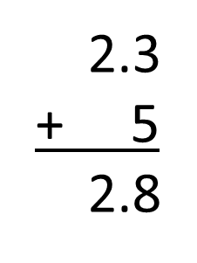
This would be an easy calculation mistake to make on paper, especially for students who have a weak grasp on adding decimals (they might be thinking, I need to line up the number and add). Yet a quick look at the size of the numbers shows us that the answer should be about 7, so 2.8 is obviously way off. Students who only focus on following procedures for calculation and don’t use estimation to make sense of the numbers they are working with can easily make mistakes like this without noticing.

Estimation Strategies
Students are often taught rounding as a strategy for estimation, but it is important to realize that there are many types of estimation situations, and many ways to estimate when calculating. Rounding is only one method, and sometimes it is not the most strategic. For example, if we wanted to estimate 40 ÷ 13, we could instead estimate using 39 ÷ 13 = 3. In this case, 39 is a more convenient number than 40, since it can be divided evenly by 13.
We can also use rounding in conjunction with other strategies, such as in the example of adding $6.49 + $2.75 + $3.22. We might start by adding all the whole dollars ($6 + $2 + $3 = $11) to give us a ballpark estimate. Then, we might notice that the $0.75 and $0.22 are very close to a dollar when combined, so we could add another dollar to the total ($12), and then add the remaining (rounded) $0.50, for a fairly accurate estimate of $12.50. Although this might look messier to write down on paper, it is easier to solve mentally. We didn't follow any specific set of rules or procedures to come to the estimate, but instead used a number of strategic moves based on what made it easier to make sense of the total.
Rounding is a strategy for estimation that involves finding benchmark numbers (numbers that are easier to visualize or calculate with) that are close to the number we are using. The benchmarks we use are chosen strategically, based on the level of accuracy or ease of computation that we want. Because rounding often deepens an understanding of place value, we will focus on rounding strategies in this lesson.

Rounding
The typical rule for rounding taught in school (look at place value to the right, and if the number is 5 or higher, round up) is often considered a fairly elementary math skill, but it requires an understanding of place value and how different numbers are related to one another. As we will see below, in real life there are many acceptable ways to "round" depending on the purpose and the estimate needed. We will start with a look at the traditional way of rounding since it involves an understanding of place value, which is an important concept for students to understand. A number line can be a powerful visual tool to help develop this conceptual understanding. For example, what if we are told:
Round $13.65 to the nearest dollar.
We can imagine a number line with each interval of $1 acting as a benchmark (nearest dollar). Then we look at which benchmark is closest to our number.

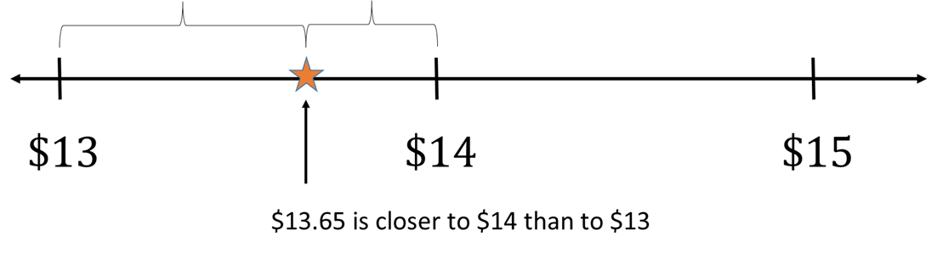

Most adults have a variety of sound ways of rounding in their everyday lives that do not always rely on place values as the “benchmarks”. For example, let's say a person is buying three grocery items that cost $2.23, $6.65, and $10.99. He might round each to the nearest dollar in his head. Or, he might decide to round the first two amounts ($2.23 and $6.65) to $2.25 and $6.75, which will simplify addition by making a dollar out of the change. He may also simply decide to round every amount up, no matter what, to make sure he doesn’t go over his budget.
Most math tasks can be done in two directions, and asking students to think backwards is valuable for deepening conceptual understanding. One of the activities in this lesson asks students to think backwards from a rounded or estimated number to the possible exact value an amount might have been. Again, number lines can be a valuable tool for helping students find a range of possibilities. For example, what if a problem reads:
A number has been rounded to the nearest ten. The rounded number is 450. What might the exact number have been?

(Note that since the number was rounded to the nearest 10, we are using benchmarks of multiples of 10.)

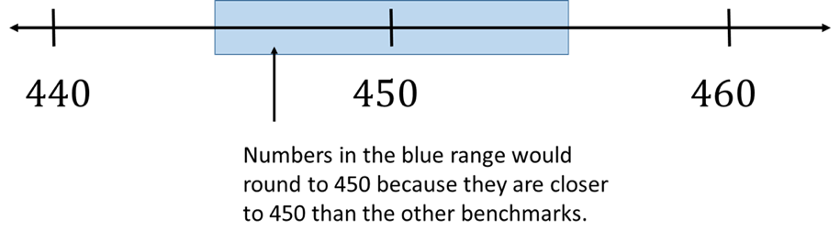
We can also ask students to think about more open-ended questions, like:
If there are about 450 students in a school, what might the exact number of students be?
In this case (as we often do in real life), we encounter an approximate number, but we are not told what benchmarks or strategies were used to estimate. Instead, we have to consider the different possibilities. In real life, the context will help determine which types of estimation make the most sense (and how accurate our estimate needs to be).

Our Place Value System
Our number system is a decimal system. The prefix deci- in the metric system is of Latin origin and means one-tenth of a measurement unit. In our U.S. number system, decimal refers to our base ten number system. That means that each new place value is created with ten groups of the previous place value. For example, ten groups of 100 gives us 1,000; ten groups of 1,000 gives us 10,000, and so on.
What this means is that every time we move one place value to the left, the next place value is ten times larger. Let’s look at the number 111 as an example:

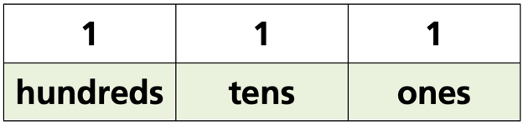

If we move to the right of the decimal point (to numbers less than 1), we encounter the opposite. Each time we move one place to the right, the next place value is ten times smaller. Using the previous example of 111, let’s imagine that amount as money. Now, let’s add some cents and make the number $111.11. Note the place value of ten cents (.10) and one cent (.01). One cent is one-tenth of ten cents.
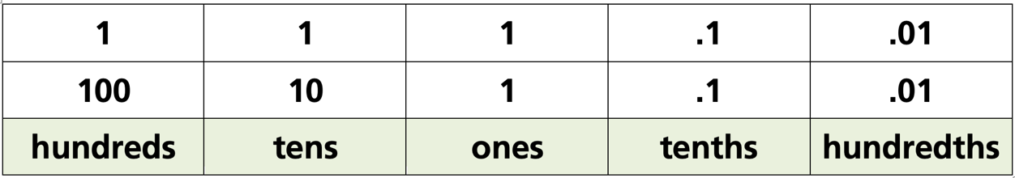
Our ESOL students need to recognize the difference between the whole number ten (10) and the fraction, one-tenth (1/10). The challenges our learners often have are:
- aural discrimination between ten and tenth, four and fourth, etc.
- visual discrimination between 1.0, .10, and .01.

LESSON 2: PLACE VALUE LESSON PLAN

Prior Knowledge
- Students are able to recognize most U.S. currency (coins and bills) and state the amount each represents. Example: A nickel is worth five cents.
- Students are able to read and write numbers up to 5 digits (e.g., 30,000).
- Students are able to add and subtract three-digit numbers.
- Students recognize U.S. math notation (see Shopping Unit, Lesson 1: U.S. Currency).
- Students are able to read and tell time.

ESOL Tasks
- Read and interpret job ads.
- Estimate wages for different jobs.
- Determine considerations for choosing a job and explain opinion.
- Read numerical entries on an employment timesheet.

Math Concepts Addressed
- Understand and name ones, tens, hundreds, and thousands place values (and if appropriate, decimal tenths and hundredths place values).
- Understand that rounding is a way of estimating a number by its closest benchmark.
- Use rounding and adjusting as a mental math strategy.

Materials
- Reading for Life: Job Ads, or select job advertisements from a newspaper
- Handout: Job Ads at Home DIY
- Handout: Job Ad Abbreviations and Job Ad Definitions matching cards (cut out) or create your own
- Handout: Time Card for Susanne
- Handout: Number Line Template
- (Optional) computer, projector, and Internet connection

Math Vocabulary

- place value
- ones
- tens / tenths
- hundreds / hundredths
- thousands / thousandths
- ten thousands
- digit
- hourly wages
- weekly
- annual
- salary
- mental math
- round up / down
- estimate
- number line
- benchmark numbers

INTRODUCTION / WARM UP
- Elicit from students words that are related to a job search. To narrow the focus, ask students what considerations are important to them when choosing jobs. Create a mind map (also known as a concept map) on a white board, chart paper, or a computer connected to a projector or interactive whiteboard.
- In small groups, students share the three most important considerations in choosing a job. Is it job duties and responsibilities, salary, hours, location, or something else? (You may have some of this information from the introductory lesson of this unit.)

Optional: Extend the activity with practice of ordinal numbers.
- Students use ordinal numbers to rank the importance of each factor such as: salary, location, schedule, job duties and responsibilities, vacation, sick time, and health insurance.
- Students can orally share their priorities using superlatives and ordinal numbers by making statements such as:
The most/least important for me is…
The second most important is…

ACTIVITIES

I. Read and interpret job ads
In this activity, students will talk about different ways to search for jobs before focusing on vocabulary commonly found in help wanted ads.
- In pairs or trios, students brainstorm different ways to look for a job. How is this similar or different from doing a job search in their native country? How did they (or a friend, partner, or family member) find their current job? As groups report back, record their responses.
Optional: create a resource document that you can share with them digitally or as a hard copy.
- Give students a copy of pages 19–23 of the Reading for Life packet, or create your own.
- Using the Job Ad Abbreviations and vocabulary provided on pages 20–21, students work with a partner to identify abbreviations in the ads and match them to a definition. Students can work individually or in pairs to answer additional questions about the job ads. See resource pages 23–23 for a list of questions.
- Give students a list of prompts or questions and ask them to use the prompts to describe each job. Students can work in pairs and verbally describe one or more of the jobs to their partner. Possible prompts are:
What is the [ job title / name of company / hourly wage ]?
Is the job full-time or part-time?
Do you need to have experience?
How do you apply?
Which job would you like and why?

4 Strategies for Differentiation

More challenging:
- Provide the abbreviations. Students write the word under the corresponding abbreviation.
- Use authentic job ads from an online job site such as Indeed.com or a local newspaper. Students identify abbreviations in job ads. Then make a list of the abbreviations and provide a definition.

II. Introduce place value: Students estimate weekly wages using job ads
In this activity, students are first rounding hourly wages to the nearest dollar and then the nearest 50 cents.
- Give students a copy of the handout, Job Ads at Home DIY, and ask them about how much each job pays per hour.
- Ask students what strategies they used and why. Give them vocabulary as needed such as: I rounded up/down, or I rounded to the nearest…
- Pre-teach the term benchmark number (a familiar or commonly used number that we can use as a reference to understand less-familiar numbers). Show a number line with dollar benchmarks labeled. Talk about how rounding is about finding which benchmark number is the closest. You can point out benchmark numbers on the number line as the one dollar marks. Plot one of the hourly wages on the number line, and show how it is closer to one dollar than another.
- Repeat with an example where the benchmarks are every $.50. You can round to any type of benchmark you want, but the idea is the same: which is closest to my number?
Note: For more information on benchmark numbers, refer to the Learnzillion online resource in the Additional Resources at the end of this lesson plan.
- While you are working with the number line, ask students what they think about a midpoint (for example, should $1.50 round to $1.00 or $2.00?). While the math class “rule” says to round up, elicit the fact that the distance is actually the same. Can they think of situations in which they might want to round up or down, even if it is not technically the closest benchmark?
- Students will practice rounding using larger numbers. Elicit how many hours are considered full-time. Give students the yearly salary for each of the jobs and ask them to round each salary to the nearest ten dollars and then to the nearest one hundred dollars. Ask students to draw a number line for at least one of the examples. Then ask them why and when they would want to round a number to the nearest ten or the nearest hundred? What are the advantages of each?
- Offer a choice of the two problems below for students to think once more about the concepts of rounding.
Choice A (more accessible): Maria earns about $16 per hour. What are some possible values (numbers) for Maria’s exact wage? What is the highest it could be? What is the lowest it could be? (See Note below.)
Choice B: Maria earns about $450 a week. What are some possible values (numbers) for Maria’s exact weekly pay? What is the highest it could be? What is the lowest it could be?
Note: Encourage students to draw a number line to think about their problem. Both choices are open questions; we do not say how Maria’s hourly wage was estimated. For example, some students may be comfortable going as low as $15.50 and as high as $16.50 for Choice A, but others may think the values need to be closer to $16. That is fine. Encourage the discussion.
Choice B is also open, and simply uses an estimated amount with a higher place value. See how high or low students feel the exact number could go, and ask them why. If students have different ranges, ask them what the advantage of a smaller range (rounding the nearest ten, for example, the exact amount might be between $445 and $455) versus a larger range (if it was rounded to the nearest $50, the range might be $425-$475), and when you might choose one over the other. The big idea is that any time we estimate, we choose our methods and benchmarks strategically. In the real world, we are rarely instructed to round to a specific place value to estimate—instead, we make that choice ourselves.
No matter which of the choices students work on, make sure they are considering values both above and below the rounded value. Also, make sure that they understand that we use different estimates depending on how close we need to be. It is okay to round $78 to $80 or $100, or even to $75 in some cases. It all depends on the purpose and how close to the exact amount the estimate needs to be.

III. Use an estimate to calculate daily pay
In this activity, students are weighing the job options from the Job Ads at Home DIY handout (or other job ads you have provided). They start by calculating the daily pay by using estimation strategies and then reflect on whether their estimate is higher or lower than the exact amount.
- Using the hourly wage of one of the jobs, ask students how they could estimate how much money they would make in an eight-hour day. Mental math and/or visuals are encouraged, but emphasize that you don’t want an exact answer (using a calculator to find an exact answer then rounding defeats the point).
- When students are done, ask them to share the strategies they used. Also ask: Do you think your estimate is higher or lower than the exact amount? Why?
- Select students with different strategies to share their approaches with the rest of the group. They can show their work on the board or explain it to and you can put their work on the board. It can be helpful to name each strategy after the student has shared it, so the class has a quick way to reference different strategies.

4 Strategies for Differentiation

More accessible:
- Use hourly wages that are close to a whole number and/or easier to multiply, such as $10.05 or $14.95.
- Use smaller numbers by having students round weekly salaries, rather than the annual salaries, to the nearest one dollar or ten dollars.

More challenging:
- Ask students to round the same salary to the nearest $100 and then the nearest $1,000. How is the result different? When would one be more useful than the other? Will they ever come out the same?
Note: When we talk about weekly and annual salaries, we are working with larger numbers, and we normally round to the nearest hundred or thousand. For example: If an annual salary is $33,700, we would say the annual salary is about $34,000. Why is this? This is a good question to ask students to get them thinking about why we often use less precise estimation with larger numbers (although this is context dependent). For example, a person may be fine with rounding to the nearest hundred if she's told a car will cost about $16,000, when the actual price is $16,150, while she would not be ok if given a repair estimate of about $152 only to find out the actual cost would be $200.

Extending the activity: Estimate time worked
- Use the handout Time Card for Susanne, or create your own.
- Students round each time to the nearest quarter of an hour and complete the total number of hours worked per day. Ask them to plot at least one day’s schedule on a number line with five-minute intervals or a clock with movable hands.
- Ask students to share the strategies they used. As students share their reasoning, refer back to the list of strategies you made earlier to reinforce language acquisition.

4Technology Integration (optional)

Using smartphone calculators
This is an opportunity for students to explore the calculator on their phones (or you can give them regular calculators to use). Most calculators have a setting to adjust the number of decimal place to the right of the decimal point. Based on the setting, the calculator will automatically round to the nearest tenth, hundredth, etc. (Consult the manual of the calculator you are using or do an Internet search to find out how to change the setting before beginning this activity. The setting will differ from calculator to calculator.)
- Before changing any calculator settings, give students some two-, three- and four-digit whole numbers to add, subtract and multiply. Let them compare the answers on their calculators with a partner.
- Next, show them how to change the decimal point setting so that only two decimal places are displayed.
- Give students numbers with several decimal places such as 9.345, 7.555, 4.989, etc. Ask them to first predict what the calculator will round each number to if it will only show two decimal places to the right of the decimal point.
Students enter the numbers and compare their calculator’s number with a partner.

Assessment

Mental math and place value
Give students three pictures of different jobs and ask them to use mental math to determine how much each job pays per day and (optionally) per week. You can provide an hourly wage for each job or let students decide. Look for whether students can:
- Estimate the daily or weekly amounts using a reasonable estimation strategy.
- Explain why they chose the estimation or rounding strategy that they used.

Additional Resources
- Reading for Life: Job Ads in Reading for Life Volume 1
- Ordinal Number Definition and Examples: Glossary of Grammatical and Rhetorical Terms
- Math is Fun: Decimals
- Place Value video
- Place Value Puzzle

HOME DIY
is hiring customer service representatives! Apply online.

Painting Department



Assist customers in selecting paint and painting tools
$16.79/hr., den., med., vac.
37.5 hours per week; days, nights and weekends

Garden Center

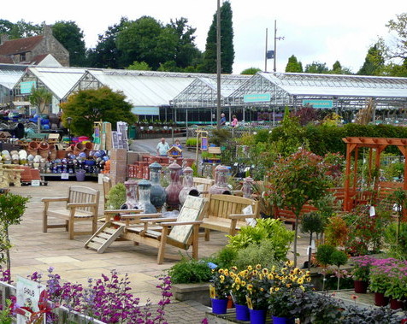

Assist customers with gardening and landscaping needs
$16.17/hr., den., med., vac.
40 hrs./wk.; days and weekends

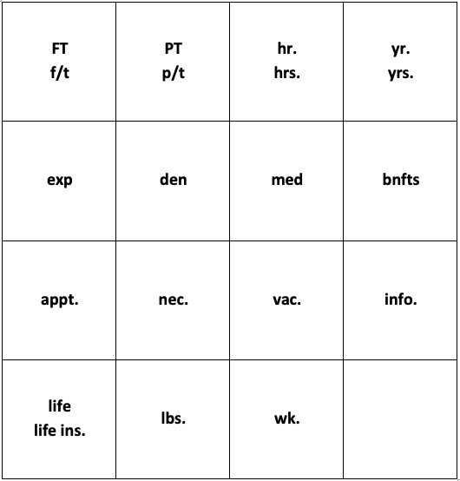

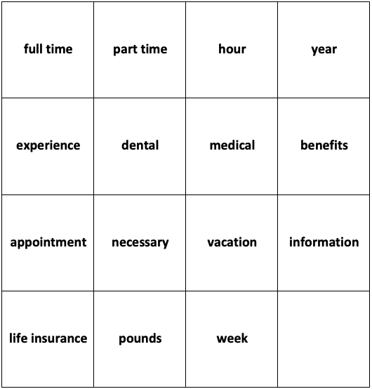

Day | Time In | Nearest  15 min. | Time Out | Nearest 15 min. | Total Hours
Monday | 6:53 |  | 2:59
Tuesday | 6:47 |  | 11:10
Wednesday | 7:01 |  | 3:01
Thursday | 6:59 |  | 3:10
Friday | 7:00 |  | 2:49
Saturday | 8:13 |  | 11:59

Weekly Total: ___________

Day | Time In | Nearest  15 min. | Time Out | Nearest 15 min. | Total Hours
Monday | 6:53 | 7:00 | 2:59 | 3:00 | 8
Tuesday | 6:47 | 6:45 | 11:10 | 11:00 | 4.25
Wednesday | 7:01 | 7:00 | 3:01 | 3:00 | 8
Thursday | 6:59 | 7:00 | 3:10 | 3:15 | 8.25
Friday | 7:00 | 7:00 | 2:49 | 2:45 | 7.75
Saturday | 8:13 | 8:15 | 11:59 | 12:00 | 3.75

Weekly Total: 40

LESSON 3: NUMBER SENSE

Rationale
Think about the last time you had to find the difference between two numbers. For example, let's imagine that you work 37.5 hours per week and this week you've worked 24 hours so far. Using mental math, would you count up from 24 to 37.5 to find the difference, or would you subtract 24 from 37.5? Both would be correct, but why is it possible to use addition or subtraction to find the difference between two numbers?
We can increase the math fluency skills of our adult learners by allowing them to explore the connections among the four operations. In the example of the work hours, we make the connection between subtraction and addition without a conscious effort. The operation we choose might depend on the context, the number, or a personal preference. In this lesson, students build on their knowledge of place value by exploring the connections among operations using visual tools such as number lines.

Background
In the visual below, you may have noticed it’s possible to both subtract (37.5 – 24 = 13.5), or to add up (24 + 13.5 = 37.5) to get the answer. The four operations (addition, subtraction, multiplication, division) are so tightly related that we use these connections to our advantage without being cognizant of what we are doing and why.
In the scenario above, you are mentally making a connection between addition and subtraction. A number line can provide a visual image of the inverse relationship of addition and subtraction. Regardless of the direction you go—up or down—you are simply finding the difference between two numbers.
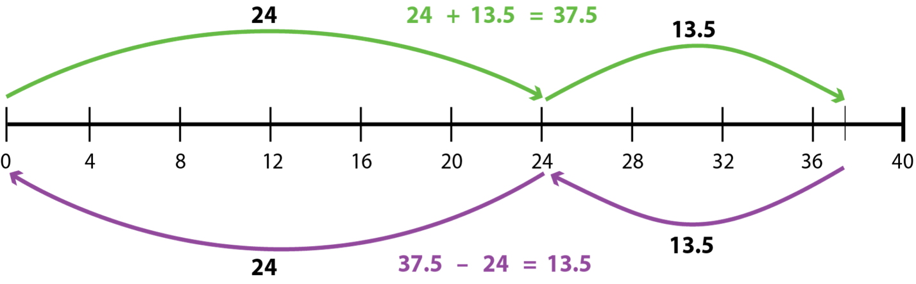
The notion of counting up includes an understanding of place value (See Lesson 2: Place Value in this Employment unit). When we count up, we often count up to the nearest one or ten.
There are many ways we make connections among the four operations in our daily activities. Let’s take a look at another way this knowledge serves us using the following problem:
You want to save some money to buy a new TV. You think you can save $50.00 a month. The TV costs $250.00. How many months will it take you to save enough money to buy this TV?
You could solve this problem by looking at the inverse relationship between addition and subtraction: by adding up instead of subtracting. The same is true for division. You can multiply up instead of dividing. You can think about what you would have to multiply to get the original total. In the example above, you could either think about how many 50s would make 250, or you could divide 50 into 250.

Multiplication as Repeated Addition
Many students may be familiar with thinking about multiplication as repeated addition of the same number, but it can be helpful to make this connection explicit. In the first part of the lesson activities, students are given this problem that can be solved in a variety of ways:
If you get the job at HOME DIY, you will take public transportation to work. The subway costs about $3.75 per day. How much is your weekly transportation cost if you work 6 days per week?

While many folks might immediately turn to multiplication to solve this problem (3.75 $×$ 6), others who are uncomfortable with multiplying decimals or who want to use mental math can make use of addition, or a combination of operations. Students should see that:
3.75 + 3.75 + 3.75 + 3.75 + 3.75 + 3.75
is equivalent to
3.75 $×$ 6
or
six groups of 3.75.

Other possible solutions include:
(3.75 + 3.75) $×$ 3 (somewhat easier to calculate mentally)
(3.75 x 2) $×$ 3 (same as above, but using multiplication to double)
(4 $×$ 6) – (.25 $×$ 6) (rounding and adjusting)
(3 $×$ 6) + (.75 $×$ 6) (another way of breaking up the numbers for rounding and adjusting)
...and so on. It is not necessary for students to come up with every possible combination, but rather to start to appreciate that there are many ways to use the operations to arrive at a solution. This is what number and operation sense is all about! Encourage students to try to solve the problem more than one way and push them to put their strategies into words (even if they don’t know the precise math vocabulary). It is helpful for the teacher to provide a symbolic representation (like the math expressions above) of the strategy whenever possible, so that students can see the connection between symbolic math notation and meaningful strategies that make sense to them.

Division as repeated subtraction
Certain situations lend themselves to an understanding of division as repeated subtraction, such as the problem given in the second part of the lesson activity:
You have been hired by HOME DIY. You have a subway card with a $9.00 credit. If a subway ride costs $2.25 one way, how many rides can you take before you need a new card?

This problem could be solved very efficiently by division (9 ÷ 2.25), although division, especially with a mixed number divisor like 2.25, can be hard for some to visualize. Because the context lends itself to repeated subtraction (as each subway ride is debited from the card), some students may use a method like this:
9 – 2.25 – 2.25 – 2.25 – 2.25
to subtract the card down to zero. In this case, the number of times we can subtract 2.25 from 9 to get to zero is a way to understand the quotient 9 ÷ 2.25. In other words, we can think of division in this situation as, “How many units of $2.25 are there in $9?”
A number line also works well to illustrate this:
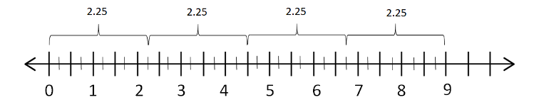
If the student is thinking in terms of jumping backwards from 9 to 0 in jumps of 2.25, then they may be thinking in terms of subtraction. If they are asking themselves how many jumps of 2.25 they can fit in 9, then they are thinking in terms of division. They may also add up from 0 in groups of 2.25 to reach 9, or even test what can be multiplied by 2.25 to give a product of 9. The ability to see these connections and options and to use them flexibly and strategically is what is meant by number sense, and has a huge impact on a student’s overall comfort and achievement in mathematics at all levels.

LESSON 3: NUMBER SENSE LESSON PLAN

Prior Knowledge
- Students are able to recognize most U.S. currency (coins and bills) and state the amount each represents. Example: A nickel is worth five cents.
- Students are able to add and subtract two-digit numbers.
- Students recognize U.S. math notation (see Shopping Unit, Lesson 1: U.S. Currency).

ESOL Tasks
- Compare job salaries.
- Complete timesheets.
- Debate options for transportation.
- Use math terminology to talk about math operations.

Math Concepts Addressed
Number sense: connections between the four operations
- Recognize addition and subtraction as inverse operations.
- Recognize that multiplication can be seen as repeated addition of the same number.
- Recognize that division can be seen as repeated subtraction of the same number.

Materials
- Handout: Jobs Ads for Home DIY (from Lesson 2: Place Value)
- Handout: Number Line Templates

Math Vocabulary

- place value
- count up
- number line
- ones
- tens
- hundreds
- thousands
- ten thousands
- digit
- credit
- add / addition
- subtract / subtraction
- multiply / multiplication
- divide / division
- plus
- minus
- equals

INTRODUCTION / WARM UP
In Lesson 2 of this unit, students explored the concept of place value by using strategies to estimate job salaries. In this lesson, we build on the concept of place value.
- Using the number line template and the Job Ads for DIY (or other job ads), place one weekly salary on the number line. Ask students to add the salary for the second job. (Ads are in hourly wages. You can convert the wages to weekly salary, or for lower math levels, use the weekly salaries.)
- Using the number line, students find the difference between the salaries.
- Referring to the number line, elicit from students the strategies they used to find the difference between the salaries. Who counted up? Who subtracted? Did anyone first round to the nearest ten cents, or did they jump count by tens? Who used a different strategy?
Note: There’s no one correct answer to this question. Students may have a response without using the number line or using mental math for calculations. Select students to share their strategies using the number line.

Key strategy:
Highlight the different approaches students use and be explicit about what makes these approaches valid: the connection between addition and subtraction. Elicit how they might articulate this connection.

Practice the language of math
You can present the language we use to talk about operations by writing a calculation out in words using basic math terminology.
- Model this by writing a couple of simple equations in numbers and symbols, and putting their counterparts using the target math vocabulary below them. For example, write:
2 + 2 = 4 9 – 6 = 3
2 plus 2 equals 4 9 minus 6 is 3

Ask the students to read the examples out loud. Then add a few more in short form only and ask volunteers to read them. Switch roles and have the students dictate a few equations for you to write.
Note: Be sure students understand that the "=" symbol can be read as "equals" or "is". Some students may know that "x" can be read as "times".
- Students work in pairs. Student A creates a math sentence and Student B reads it aloud using math terminology.

Extended practice: Work on prepositions
As a language practice option, you can focus on prepositions using such phrases as:
add ... to ... (Add 3 to 17.)
subtract ... from ... (Subtract 3 from 20.)
multiply ... by ... (Multiply 2 by 5.)
divide ... by ... (Divide 10 by 2.)

4 Strategies for Differentiation

More accessible:
- For lower level language learners, practice one operation until they are ready to focus on a second operation. For example, in pairs or small groups, students only work on addition equations.

More challenging:
- For students with more advanced language skills, challenge them to create math equations using all four operations and larger numbers or mixed numbers. For added language challenge, students can incorporate equations into more complex or contextualized full sentences, like: I can calculate my paycheck by multiplying $[hourly rate] by 40 hours.
- For more advanced math levels, students can create math equations with a mix of operations in the same math sentence. For example: (27 $×$ 18) $÷$ 2 = 243.

ACTIVITIES

I. Exploring connections among the four operations
In this activity, students use the context of transportation costs to examine the connections among the four operations, beginning with the connection between addition and multiplication.
- Give students this word problem. They can work on the problem using pencil and paper, a calculator, or mental math:
If you get the job at HOME DIY, you will take public transportation to work. The bus costs $3.75 per day. How much is your weekly transportation cost if you work 6 days per week?
- Students share their strategies in small groups. As students share, listen to their strategies. Who multiplied the daily rate by 6? Did anyone add the numbers?
- Groups report back on different strategies used by members in their group. If no one reports using addition instead of multiplication, ask students to think of other ways to solve.

Key strategy:
As students offer suggestions, write them on the board. Alternative methods include:
repeated addition: 3.75 + 3.75 + 3.75 + 3.75 + 3.75
grouping numbers: (3.75 + 3.75) $×$ 3
distributing numbers: (3 $×$ 6) + (.75 $×$ 6)
Elicit when one method might be preferred over another.

II. Calculating transportation expenses
Students will continue to explore the connections among the four operations by looking at the connection between division and subtraction. Review the connections students have made so far: addition and subtraction are inverse operations; multiplication is repeated addition.
- Compare types of transportation. Ask students the forms of transportation they use, eliciting the prepositions: by car, by train, on foot. What are the advantages and disadvantages of each? Which do they prefer and why? Which is cheaper? Which is more convenient? Give students the following word problem:
You have been hired by HOME DIY. You have a subway card with a $9.00 credit. If a subway ride costs $2.25 one way, how many rides can you take before you need a new card?

Key Strategy:
Walk around and observe students’ work. You are likely to see different approaches. Some may use subtraction and some may use division. While discussing their approaches, write the notation for each strategy on the board. This is especially important for subtraction and division, as the order matters.
- Using the handout Number Line Template, ask students to show you how they could subtract groups of 2.25 from 9 (as illustrated in Background of this lesson).

Optional: Extended practice
- In this activity, students will start with a mathematical expression and work backwards to create a context. You can choose one to do as a group and then let students create their own, working individually or in small groups.
Here are some ideas:
a) 3.50 $×$ 16
b) 4 + 4 + 4 + 4 + 4
c) 15 / 2.50
d) 6 – 1.50 – 1.50 – 1.50 – 1.50
Note: Division can be written with the ÷ or / symbols, or a horizontal division bar (like in a fraction). It is good to be familiar with different symbols and to explicitly make students aware of them. Some countries may use one more than the other, but all are valid.

4 Technology Integration (optional):

Using the internet to look up local transportation costs and schedules
- Have students open a web browser and then a search engine such as Google.
- Elicit the keyword they can use for their town, city, or state. For example: MBTA or Boston Transportation. Elicit what words they need (schedule, fares) to find the information.
- What options do they have in their community and how do the prices differ? What is cheaper? What is more expensive?
- Small group discussion: What transportation do they use? Why? Is it the most convenient or the cheapest?
- Are there options available that they had not considered (e.g., biking, ride-sharing, on-demand transport like taxis, Uber, etc.)?

4 Strategies for Differentiation

More accessible:
- Offer options that use whole numbers only. Offer options for division in which the dividend is small and can be easily modeled on a 0 to 20 number line.
- For the final activity, ask students to match scenarios to expressions instead of writing their own.

More challenging:
- Use monetary amounts with decimals other than .50 and .25.
- Offer division amounts in which the dividend and divisor are mixed decimals, such as 17.50 /2.50.

ASSESSMENT
Give students this word problem:
The gas tank on Alexa's car holds 18 gallons. Each day, her one-way commute to work takes 1.5 gallons. How many days can she commute on a full tank of gas?
Ask students to show two different ways the answer to this question can be determined, and to explain why both methods work.

Answer Key
Possible strategies might include:
- Using repeated subtraction to subtract groups of 3 gallons (the round-trip gas quantity) from 18. This would be 6 groups of 3. The answer is 6 days.
- 18 divided by 3 is 6.

ADDITIONAL RESOURCES
- Number sense (Printing resources on this site requires you to create an account.)
- Jo Boaler video clip on number sense

LESSON 4: BENCHMARK FRACTIONS, DECIMALS, AND PERCENTS

Rationale
Employers, employees, and customers deal with fractions, decimals, and percentages on a daily basis. In the workplace, our wages are taxed as a percentage of earnings, employees might be asked to help a customer figure out a dollar amount of a savings promotion, tools are labeled with fractions, and our U.S. currency system uses decimal fractions for amounts less than one dollar. We encounter situations regularly that require us to use strategies to be able to conceptualize less common numbers such as 40% or 2/5. Our learners face the same challenge. In addition to interpreting language, they need to understand the math so they can make informed decisions.

Background
Benchmark numbers such as 1/2, 1/4, and 3/4 are numbers that are easy to visualize and calculate and can be used as reference points against which to estimate the size of less familiar numbers. The advantage of using benchmarks is that they are accessible to ESOL teachers and learners at varying levels of math competence, and mirror what numerate adults do with fractions, percentages, and decimals in their everyday life.
In many math textbooks fractions, decimals, and percentages are each treated separately, as if they were completely unrelated concepts. However, all three are actually different ways of representing the same amounts. Just as languages have synonyms, the language of math has different forms of representation, which may be more or less useful depending on the situation.

Visual and Intuitive Methods of Working with Benchmarks
In this lesson, we will focus on helping students develop visual models and intuitive strategies for working with the benchmarks 0, 1/4, 1/2, 3/4, and 1 (0%, 25%, 50%, 75%, and 100%). Some students may already have procedural knowledge of how to find these amounts by multiplying the whole by the decimal fraction (for example, finding 75% of 500 by multiplying 500 x .75). While this is efficient, many adults find it difficult to explain why this method works and may lack the deeper number sense of what 75% really is and how it relates to other fractional amounts. [As a side note, in our pilot of ESOL assessments, we found that some students who were able to work with the benchmark fractions 1/2, 1/4, and 3/4 were not able to extend their reasoning to other fractions like 1/3 or 1/5, indicating that they had some procedures for specific values but did not have conceptual understanding at a foundational level. It is important that students develop this conceptual understanding so that they can reason about other fractions that they encounter in the real world.]
In order to teach these benchmarks visually and intuitively, we use 1/2 (one half or 50%) as our starting point. Most adults can visualize 1/2 and many already know how to calculate it by dividing the whole into two equal parts. We then start to use 1/2 or 50% as a benchmark by asking students to compare other fractional amounts to it. For example, is 7/16 more or less than 1/2? How can you use 50% to make sense of 54%? Starting here means that students can have an intuitive and visual sense of the approximate size of any fraction, which is critical for sense making with fractions, decimals, and percents.
Next, 1/2 is used to make sense of 1/4 (one quarter or 25%). 1/4 follows the same logic as 1/2 (one out of four equal parts), but it can also be calculated by finding half, then breaking the half in half. If you give students a sheet of paper and ask them to fold it into four, most students will do this “half of a half” method automatically (fold the paper in half, then in half again). After students can find 1/4 or 25% of a number, this can be used as an additional benchmark to which less-common numbers can be compared. For example, how does 4/25 compare to 1/4?
The next step in this learning progression is to use 1/4 and 1/2 to make sense of 3/4 (three quarters or 75%). 3/4 of an amount can be built from the other benchmarks in any of the following ways:
Finding 1/4 and multiplying that amount by 3
Finding 1/2 and 1/4 and adding them together
Finding 1/4 and subtracting it from the whole
Some students may be comfortable enough with 1/2 and 1/4 to make these connections, while others may need more time to get used to the earlier benchmarks.
Since your students will probably have a wide range of math backgrounds and exposure, the goal is not to get everyone to the same point, but to provide the opportunity for students to explore these ideas using visual models and to give them language practice discussing mathematical ideas and concepts.

Helping Students Who Struggle with Calculations
You may find that you have a few students who struggle with basic calculations. For example, some adults do not have a good conceptual understanding of division and may struggle to divide a larger number into two equal parts. They may rely on calculators to perform calculations that should be accessible mentally (such as 30 divided by 2). One visual strategy that often works well with such students is a “sharing” model:
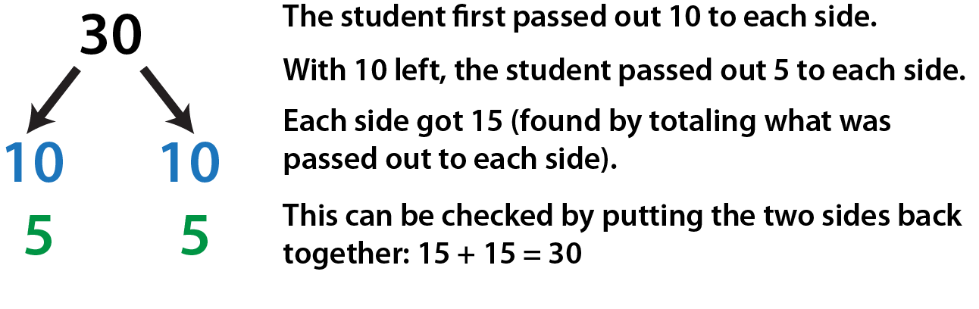
This is essentially a paper and pencil model of what many adults do mentally when they are breaking a number in half. It can be used for larger, less friendly numbers as well:
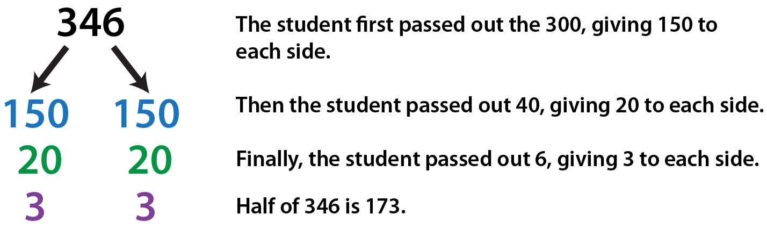
The advantage of showing struggling students a method like this is that it reinforces an understanding of division (breaking into equal parts), is accessible to most students with limited math ability, and reinforces number sense (such as the fact that numbers can be broken up in convenient ways, such as by place value). If you have students who don’t know how to divide, trying to teach them a method like long division requires other, prerequisite concepts and won’t fit into the scope of everything else you are trying to accomplish in this lesson.

LESSON 4: BENCHMARK FRACTIONS, DECIMALS, AND PERCENTS LESSON PLAN

Prior Knowledge
- Students are able to recognize most U.S. currency (coins and bills) and state the amount each represents. Example: A nickel is worth five cents.
- Students are able to add and subtract two-digit numbers.
- Students recognize U.S. math notation (see Shopping Unit, Lesson 1: U.S. Currency).

ESOL Tasks
- Read and interpret a paycheck.
- Create a monthly household budget.

Math Concepts Addressed
- Recognize 0 as "none" and recognize common benchmark numbers as fractions (1/4, 1/2, 3/4, 1), decimals (.25, .50., .75, 1.00), and percentages (25%, 50%, 75%, 100%).
- Understand the concept of part versus whole (100%).
- Use benchmarks fractions, decimals, and percents to reason about less common numbers.

Materials
- A piece of string
- A cup with 12 black beans (or other small uniform objects)
- A book
- A ruler
- Play money worth an even number of dollars
- A calendar with 30 days
- 7” diameter paper plates (2 different colors)
- Handout: America's Education
- Handout: Women in the Workforce
- Reading a Paystub (online activity) or one of the following handouts:
- Handout: Sample Lesson “Know Your Take-Home Pay”
- Handout: How to Read a Pay Stub (PDF)
- Handout: Sam’s Monthly Budget
- Handout: Sam’s Pay Stub
- (Optional) It’s Your Paycheck!: Know Your Dough (PDF)

Math Vocabulary

- one-half / half
- one-quarter / one-fourth
- three-quarters / three-fourths
- part
- whole
- decimal
- fraction
- decimal fraction
- benchmark numbers
- percentage
- expenses
- deductions
- gross pay
- net pay
- budget
- discretionary spending

INTRODUCTION / WARM UP

What does one-half look like?
- Draw several shapes on the board. Ask students to shade one half of the shape in as many different ways as they can. Suggested shapes and some possible answers are below.

Possible solutions:
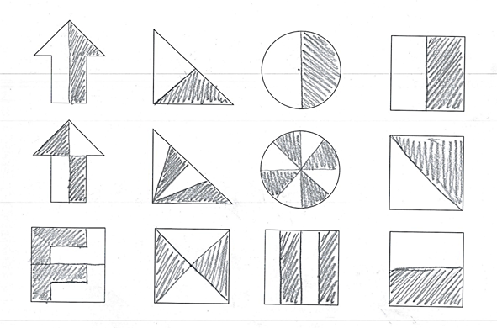
Encourage students to find new ways to shade one half, especially with the square, which has many possibilities.
- Ask students to share different ways of shading on the board. Push each student to justify why he knows he has shaded half. Come to a consensus that in order to be half, we have to have shaded one out of two equal portions (even if the portions are broken into several pieces).
- Introduce one-half (half) with a statistic that involves a number close to one-half. You can use class data, program data or any data that is relevant to your learners. Below are a couple of examples:
Option 1: Say: What if I told you about half of adults said they could not live without their smartphone? Let’s see if our class is the same. How many of you can’t live without your phone? Is this more than or less than half? How do you know?
Option 2: Say: Do you think you spend more than or less than half of your monthly income on rent/mortgage? How do you know?
- Say to the class: Let’s take a look at how one-half can help us estimate numbers that are more difficult to mentally calculate or visualize (see).

ACTIVITIES

I. Looking at equal parts
- Give each pair or trio of students a tray with the following objects:
a piece of string
a cup with 12 black beans (or other small uniform objects)
a book
a ruler
play money worth an even number of dollars
a calendar with 30 days
- Ask the students to show you one-half of each item, and to be able to explain how they know they found one-half.
- Ask, How many ways do you know to write one-half? Collect responses on the board. If no one mentions it, ask if they know what fraction means one-half (1/2), what percent means one-half (50%), and what one-half looks like as a decimal (0.5, .5, or .50).
Note: Pay attention to different notation that students use. For example, many countries use the comma and decimal point in exactly the opposite way they are used in the U.S., so they might write 0,5. Point out that this is correct in many countries, but make sure all students are aware of the way we use the decimal point here.
- Change the amount to eighty cents (.80) or any amount that divides evenly and again, ask them to show you half of that amount. Each time, ask: How do you know?

II. Visualizing one-half with a pie chart
- Using two paper plates of different colors, cut each paper plate halfway to the center and fit together (see photo).
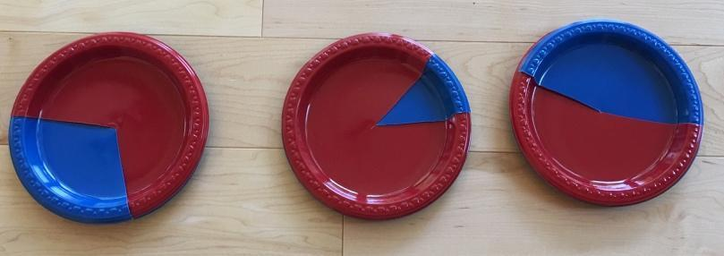
- Give each student or pair of students a set of plates. Using the plates, ask students to show you:
50% red [or other color]
0% red
100% red
Make sure all students understand that 0% means none or 0, and that 100% means the whole, or 1.
- Next, ask students to show you:
More than 1/2 red
Less than 1/2 red
Almost 100% red
A little more than 0% red
A little more than 50% red
Ask students to estimate what percent red they think their pie might be for each one.

III. Thinking critically about data with one-half
- Share the handout America’s Education with students. Spend a few minutes as a class making observations about the graph/data. Ask: What do you notice? What do you wonder? Make sure students are noticing that the numbers on the left and right are percentages, and that they understand what each of those percentages refers to.
- Ask students to write two statements about some part of the data. Their sentences should make use of one or more phrases from the list below:
A (little) more than 1/2 (50%)
A (little) less than 1/2 (50%)
Close to 0 (0%)
Almost all (Close to 100%)
- Ask students: How has education changed over time in the U.S.? How do you think these changes affect jobs in the U.S. today?

IV. Finding one-quarter from one-half
- Write the fraction 1/4 on the board, and ask students if they know how to read this number (one-fourth or one-quarter) and what it means. Ask them to draw you a picture of 1/4. Have students share a few pictures on the board. Work on articulating an understanding that 1/4 is one out of four equal portions.
- Return to the trays of objects, and ask students to show you 1/4 of each object. As they work, walk around and ask students to show you how they know they found 1/4 for one or more of the items.
- Ask students to share strategies for finding 1/4. Some students may talk about breaking into four equal groups. See if they can connect this with the operation of dividing by 4. Other students may mention finding half, then finding half of the half. (This is very easy to demonstrate with the string.) Make sure students know that both of these are valid strategies for finding 1/4. Sometimes one will be easier to use than another.
- Brainstorm what different representations we have for 1/4: 25%, .25, and if it comes up, equivalent fractions like 3/12 (this might be mentioned from working with the beans).

V. Visualizing one-quarter with a pie chart
- Working with the pie plates, ask students to show you:
1/4 red
25% red (Follow with, What percent would be blue?)
75% red (Ask those who show this correctly how they know.)
A little less than 25% red
More than 50% red but less than 75% red

4 Strategies for Differentiation

More challenging:
- Extend 1/4 to 1/8. Show how we can find 1/8 by finding half of 1/4.
- Extend to 1/10. Discuss 1/10 (10%) as one out of ten equal portions. Compare the size of 1/10 with other benchmarks.

VI. Looking at Data with Benchmarks
- Define a benchmark number as one that is easy to visualize and calculate, which is useful for comparing other numbers to. Tell students that 0%, 25%, 50%, 75%, and 100% can be considered benchmarks, and we will use them to make sense of less friendly fractions and percentages.
- Give the students the handout Women in the Workforce. For each statistic, they should identify and write down the closest benchmark percent. Then, on the second page of the handout, they will choose three of these examples to draw as a pie chart. (You may want to mention that it is important to draw their wedges from the center of the circle, just like the pie chart maker.)

VII. Create a budget
Students estimate monthly household expenses using benchmark fractions and percentages.
- Write the words: Monthly Expenses on the board and elicit some examples: rent, gas, etc. Students work in pairs or trios to make a list of categories of monthly expenses. They don’t have to add numbers, just a list of what the expenses are. Pairs compare the types of expenses they have with two other groups. Groups compare the types of expenses they have with two other groups.
- Give students a copy of the handout Sam’s Monthly Budget.
- Using benchmarks 25%, 50% and 75%, students determine if Sam meets the bank’s criteria to qualify for a loan. Encourage students to find the benchmarks of his total income first.
Note: This makes a good pair or group activity. Since we did not explicitly go over how to find 75% of an amount in the lesson, after students have worked for a few minutes, ask the class if anyone has a strategy for doing this. Possible strategies might include:
Finding 1/4 and multiplying that amount by 3
Finding 1/2 and 1/4 and adding them together
Finding 1/4 and subtracting it from the whole
If students mention multiplying Sam's monthly salary ($2,700) $×$ .75, acknowledge that this is a correct strategy, but ask if anyone else has a strategy that makes use of the benchmarks 1/4 and/or 1/2. The goal is to help students find more intuitive ways of working with these benchmarks before they get used to the “shortcut” method of multiplying by a decimal (which is harder for most students to understand conceptually, although it is easy to carry out.)

VIII. Interpreting Pay Stubs
- Students use benchmark fractions to describe standard payroll deductions. You may choose one or both options. (Note that Option 2 requires a computer and internet connection.)
Option 1: Distribute page 2 of the handout Analyzing Pay Stubs and elicit the categories of information: Employee information, hours, pay rate, deductions, etc. Ask students if they can think of other deductions; some might offer the example of union dues, etc.) Next, students can work on the page 1 comprehension questions.
Option 2: Students try the online activity (Reading a Pay Stub) to first complete a vocabulary match and comprehension questions.
- Give students a copy of the Sam's Pay Stub handout. Students use benchmark fractions or percents to estimate the amounts deducted from Sam’s pay.

4 Strategies for Differentiation

More accessible:
- Use whole numbers instead of decimals.
- Change Sam’s monthly pay to $2,000.

More challenging:
- Ask students to find 75% of different types of amounts (some that divide by four, some that don’t, larger numbers, money amounts).
- Give students a number that represents a part, and ask them to find the whole. (For example, $25 is 1/4 of what? instead of What is 1/4 of 100?)

Extending Learning:
- Using the online resource It’s Your Paycheck!: Know your Dough, discuss W-2, W-4 forms for employment. Students practice computing gross pay, net pay and completing W-2 and W-4 forms.

Additional Practice: Reasoning with benchmarks
- EMPower Plus Using Benchmarks: Fractions and Operations (student book), pages 9, 17, 37, 41, 55

ASSESSMENT
Students create their own budget and estimate some of their expenses using the same guidelines as Sam’s monthly budget. Students describe their expenses in terms of benchmark fractions or percentages, and can create pie charts to represent their budget.

ADDITIONAL RESOURCES
- Thinking Blocks Fractions (interactive website)
- Decimals, Fractions, and Percentages (interactive website)
- Singapore Math Bar Model Strategy video (practice bar modeling)
- Fractions Are Parts video
- EMPower Plus: Using Benchmarks: Fractions and Operations (teacher and student books).
- Reading a Paystub (interactive website)
- How to Read a Pay Stub (PDF)
- Optional Resource: It’s Your Paycheck!: Know Your Dough (PDF)

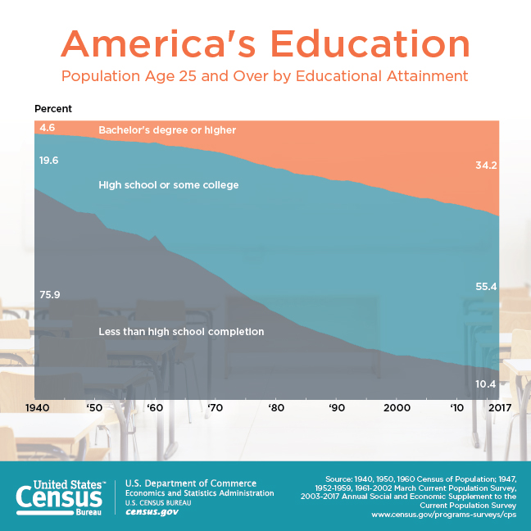



These data are from the U.S. Department of Labor about working women in the United States.

For each percentage, choose a close benchmark percentage (0%, 25%, 50%, 75%, 100%).

Percentage Information | This is close to…
Women who work: 57%
Women with children under 18 years old who work: 70%
Women who have given birth in the last year who work: 62%
26% of people who work in computer- or math- related jobs are women.
94% of childcare workers are women.
4% of firefighters are women.

Data taken or adapted from Department of Labor, Data and Statistics: Women in the Labor Force. Retrieved from https://www.dol.gov/wb/stats/stats_data.htm

Choose 3 of the statistics from the first page and draw a pie chart for each one. Make sure to label your chart. See the example below.

Example:
Women in the US who work: 57%

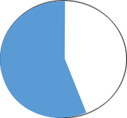
57%

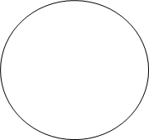

Part A
Sam has been hired at HOME DIY. His new monthly income will be about $1,300.00. He would like to buy a car soon, but he will need to get a loan from the bank. He knows the bank will look at his income and expenses to determine if he qualifies for a loan. Help Sam figure out if his situation will meet the bank’s guidelines.

The bank says that Sam should meet the following guidelines:

- Rent should be no more than 50% of his monthly income.
- Utilities and food should be less than 25% of his monthly income.
- Total expenses should be less than 75% of his monthly income.

Sam’s Current Monthly Expenses
Expenses | Amount
Rent | $620.00
Utilities (gas, electric, TV) | $160.00
Food | $150.00
Total | ?

Does Sam meet the bank’s guidelines to qualify for a loan? How do you know?
Show your work using fraction strips.

Part B
Sam would like to have some money left at the end of the month for recreation and leisure (also known as discretionary spending). If he pays $200.00 a month on a car loan, about what percentage of his income will be left for discretionary spending? Will it be more or less than 25%? How do you know?

Sam’s Future Monthly Expenses
Expenses | Amount
Rent | $620.00
Utilities (gas, electric, TV) | $160.00
Food | $150.00
Car loan | $200.00
Discretionary spending | ?

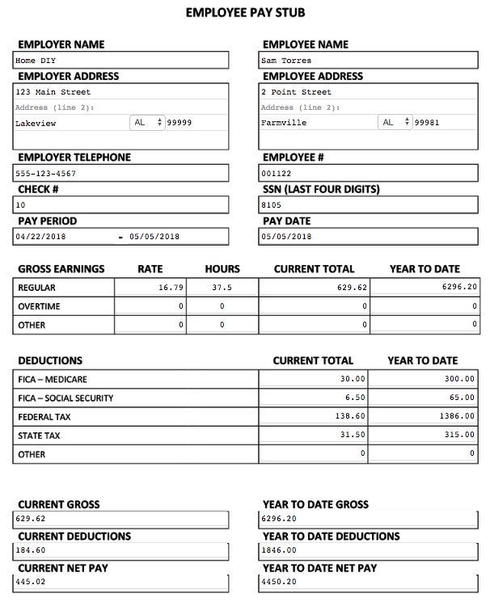

LESSON 5: PROPORTIONAL REASONING

Rationale
Have you ever adjusted a recipe to feed a larger crowd or tried to enlarge a picture on your computer and noticed it didn’t look quite right? These situations are proportional reasoning in action. Recipe measurements, photo enlargement, unit pricing on products, and tax rates are examples of contexts that use ratios and require us to examine the relationships among numbers.
Proportional reasoning can be intuitive. We can look at a picture and tell if it’s too wide or too long. We can taste lemonade and decide if it’s too sweet or too sour. In other situations, we need to work with numbers to get the information we need. In this lesson, we will employ strategies to determine whether or not a situation is proportional, and use ratios to make predictions and informed decisions.

Background
A ratio represents a relationship between two numbers. For example, 2 donuts for $1.00 is a ratio. When we are shopping, we usually don’t have to buy the amount listed in the deal. We could buy 6 donuts, or even just 1. However, if we change the quantity we are buying, the total cost will change as well. Buying 2 donuts for $1.00 and buying 6 donuts for $3.00 do have something in common: in both cases, we are getting the same deal. If an employee is paid $30 for 2 hours of work and $60 for 4 hours of work, he has a different schedule and paycheck in each situation, but he is still being paid the same wage. What remains the same in these scenarios is the ratio, or relationship, between the two amounts, even as the amounts themselves change. Situations in which we expect the relationship between two amounts to stay the same even as the amounts change are called proportional situations. Most adults already use proportional reasoning in many areas of their lives, even if they are not conscious that this is what they are doing. The activities modeled in this lesson help students consciously explore these proportional situations more deeply.

Look for Patterns
The math in this lesson focuses on creating equivalent ratios, reasoning about how we know they are equivalent, and looking for patterns within such ratios. Simple drawings are powerful visual tools for making sense of equivalent ratios. For example, if a recipe for mixing paint asks for 4 parts red and 2 parts blue, this could be sketched as:
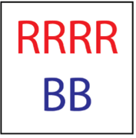
This allows us to see that the recipe involves 6 parts altogether. We can also repeat (iterate) the ratio if we want to make more paint:
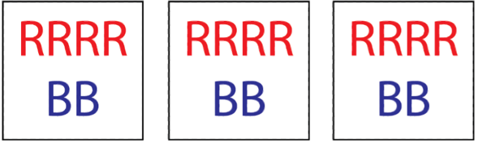
Now we have a recipe for 18 parts of paint, which involves mixing 12 parts red and 6 parts blue. The visual not only helps keep track of how the quantities are changing, but we can still see the original ratio in the new recipe. Eventually students may start to notice that all of the individual paint quantities were multiplied by 3.
A similar pattern can be seen in a table of ratios, like the one below (used in Activity IV of the lesson). This table represents a situation in which you can move 6 plants in 5 minutes. Because the ratio between the number of plants you can move and the time it takes remains constant (every 6 plants takes 5 minutes), this is a proportional situation. Students should discover, for example, that if they double the number of plants, they will also double the number of minutes (or if they triple one, they must triple both). They can also add plants and minutes as long as they are added in the proper ratio (add 6 plants, add 5 minutes). Or they could add an equivalent ratio from the table (add 24 plants, add 20 mins).
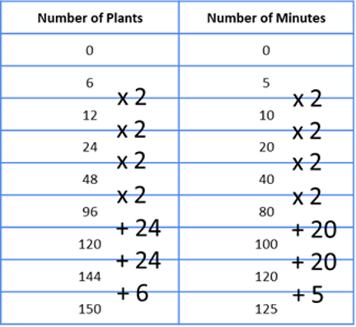
In math notation, a ratio can be written several ways, for example:

2:1
2/1
2 to 1
Order matters! The order of the numbers corresponds to the ratio we are describing.

LESSON 5: PROPORTIONAL REASONING LESSON PLAN

Prior Knowledge
- Students are able to recognize most U.S. currency (coins and bills) and state the amount each represents. Example: A nickel is worth five cents.
- Students are able to add and subtract two-digit numbers.
- Students recognize U.S. math notation (see Shopping Unit, Lesson 1: U.S. Currency).
- Students have conceptual understanding of fractions as equal parts.
- Students are familiar with the notation of fractions.

ESOL Tasks
- Order supplies.
- Apply problem solving skills to completing a task.
- Use correct English phrases and notation for ratios and proportions.

Math Concepts Addressed
- Find equivalent ratios.
- Use drawings to prove that two ratios are equivalent.
- Determine proportional amounts needed for a purchase.

Materials
- Teacher Resource: Rose Order
- Handout: Mixing Paint
- Handout: Time on Task
- (Optional) quart and gallon sized containers
- (Optional) paint chips from a store
- (Optional) white, yellow, and blue paint and brushes

Math Vocabulary

- ratios
- proportions
- colon
- fraction
- equal
- part
- whole
- per
- rate
- in-out table

INTRODUCTION / WARM UP

Introduce ratios in a work context
In this lesson, students imagine they work at HOME DIY. There are several lessons that target tasks they might perform in a garden center and several for the paint department.
- Introduce the topic by asking students what plants and flowers grow in their yard, grew in their native country or what kinds of plants and flowers they like.
- Give students the word problem below. (For an accompanying visual, use the teacher resource Rose Order.) You can give it as a reading, or for listening and writing practice, give it as a dictation, or create a cloze activity. You could also leave prepositions out and have students fill them in.
You need to order rose plants for your job at HOME DIY. The plants are sold 2 for $6.00. Does the customer have to buy 2 rose plants? If they buy more or less than 2, how do they figure out the cost?
- Do a language lesson for talking about ratios with words such as: per, for, a, and ask students to write sentences. For example: The store buys 1 plant for 3 dollars. As you move through the other activities in this lesson, have students write out sentences as we would normally describe the ratio: 1 for a dollar; a dollar a plant, $3.00 per plant, etc.
- Students work in pairs and brainstorm other situations in their own lives that involve ratios. Using their list, students write complete sentences, change partners and read their sentences aloud to their new partner. For example: I pay two dollars and twenty-five cents for a ride on the subway, or Gas is three dollars and fifty-nine cents per gallon.

ACTIVITIES

I. Explore proportional relationships
- Return to the rose example above. Tell students you want 6 rose plants. Complete the drawing to show how much 6 plants cost.
- Write on the board, 2 plants for $6 or 6 plants for $18. Ask: What is different about these two purchases? What is the same? Push for them to articulate that even though both the number of roses and the cost has changed, the deal remains the same. This deal can be called the ratio between the two numbers.
- Ask students if they know of different ways that these ratios could be written. Be sure to mention both the use of a colon or show the fraction notation if they don’t come up. (Remember, order matters!)

This example can be written as:
2:6 and 6:18 or $\frac{2}{6}$ and $\frac{6}{18}$
Note: When writing with a colon, be explicit about its use here. In this context, a colon represents the relationship between the two numbers and we call that a ratio. Recall that they know a colon from its use in telling time. Elicit uses of the colon in their culture. A colon is used for division in some countries.
- Have students come up with another quantity of rose plants and cost that would be the same deal as the ones above. Ask them to draw a picture to prove they are the same.
- Give the students the word problem below. You can give it as a text to read, or for listening and writing practice, create a cloze activity.
Rose plants at Home DIY are 2 for $6.00. Jean Louis just visited another garden store and told you that the plants at the other store are much more expensive. Give examples of prices that would be more expensive than 2 for $6.00. How much would each rose plant cost at a more expensive price?
Note: This is an open question, which means there are many possible answers. Ask students to justify how they know that their deal is “more expensive” than the ones above.
Students might write the ratios as fractions and cross-multiply. Using this algorithm can be helpful once students have developed a conceptual understanding of what proportional reasoning means and use strategies to test whether or not a situation is proportional. Using visual models and concrete manipulatives allows students to explore the concept of equal ratios. Encourage them to create a sketch that shows the equivalent proportions. Push on their conceptual understanding by asking them: What is the relationship among the numbers? They should be looking for patterns.

II. Extend the Activity: Paint Recipes
In this activity, students investigate part-part relationships. Think of a recipe with more than one ingredient, such as a cake. If you double the recipe, you need to double the amount of flour, sugar, and butter. Students will apply their understanding of relationships among numbers to mix paint for their new job at HOME DIY.
- Introduce the topic by asking students some questions about colors and painting rooms. Start by asking students: What is your favorite color? Have you ever painted a room? What color walls do you have in your bedroom, kitchen, living room, etc.? Have you ever mixed different colors together to get a new color? You can show them paint chips from a hardware store and talk about the extensive variety of shades of color. If possible, bring in a quart and a gallon of paint or another product to give students a visual sense of the quantities.
- Give students a copy of the handout, Mixing Paint. Review the scenario with them, clarifying vocabulary as needed.
Note: For additional practice with units of measurement, refer to Lesson 5, Proportional Reasoning, in the Shopping Unit.
- Ask students to apply what they have learned using sketches to determine the amount of paint needed.
- Students share their work in small groups. Encourage them to describe their work. It’s good language practice!
- Once students have determined the paint ratios, they can role play the scenario. For lower levels, create a cloze dialogue. Higher levels can create their own dialogues.

Extending practice:
Ask students to work on this final challenge in pairs.
- First, tell students:
Create a recipe for a shade of green using a certain amount of yellow and blue paint. Write it down like this:
_______ part(s) yellow _______ part(s) blue

- Next, give students this word problem:
You need a total of 15 gallons of paint to complete your project. How much yellow and blue will you need to buy so that you can paint the room your shade of green?
Once again, ask students to share their strategies.
Optional: If you have access to paint, you could allow students to experiment with different ratios of yellow and blue to create their “green recipe” before they complete the task above. (Alternatively, you could use water or milk and food coloring.)

4 Strategies for Differentiation

More accessible:
- Use 2 colors only.
- Use whole numbers.
- Keep all parts of the ratio in the same units: gallons and gallons.
- Make the language more accessible by using "parts" instead of specific quantity names like gallons and quarts: 1 part yellow to 2 parts red.

More challenging:
- Use a three part ratio: For every gallon of red paint, she needs __ quarts of yellow paint and __ quarts of white paint.
- Use mixed numbers (i.e., 1.5 quarts white paint)
- Challenge students to come up with a way to rewrite the “orange” recipe from Mixing Paint so that it uses all the same units (could be all gallons, all quarts, or the more generic “parts”). This requires some unit conversions, which also makes use of proportional reasoning.

III. Use ratios to make predictions
In this activity, students will use their understanding of proportional relationships to predict how much time is needed to perform a task.
- Ask students if they have ever needed to estimate how much time it would take them to complete a repetitive task such as baking several cakes or making many phone calls. Maybe they have seen car washes where students wash cars to raise money for a sporting event. How did they or how could they predict the total amount of time needed?
- Use the handout Time on Task. Tell students they want to know how much time they will need because the plants need to be unloaded before lunch time.
- Create a table, commonly referred to as an in-out table. Students will build a chart such as the one shown below. Let student grapple with the numbers a bit. They might start by doubling the numbers and then build out the table in amounts of 5: 5, 10, 15, etc. as shown in the table on the following page.
Once they have a few rows correctly filled in, ask students: What patterns do you see? Give them vocabulary words as needed (you can write the word they need on a sticky note and post it on the board or give it to the student who needs the word to accurately articulate an idea). They should see that the number of plants increases in multiples of 6 and the minutes in multiples of 5.

Number of Plants | Number of Minutes
6 | 5
12
24
150

- Give students this final dialogue to discuss and role play:
Marie: I just moved all those plants at a rate of 50 plants per hour!
Cara: That’s impossible. You only worked for 30 minutes!
Ask students: Is it possible for Marie to move plants at a rate of 50 plants per hour if she only worked for 30 minutes? Why or why not?

4 Strategies for Differentiation

More accessible:
- Use ratios that divide evenly such as: 1:2 or 5:10.
- Simplify the Time on Task scenario in Activity III by using a smaller number of boxes and a small number of total plants, such as 30.

More challenging:
- Use all mixed numbers.
- Increase the quantities.

ASSESSMENT
Students choose one of the following contexts that involve ratios:
- Sales tax is 6 cents per dollar.
- A human can walk 50 miles in 2 days.
- Gas costs $4 per gallon.
- 2 inches is about equal to 5 centimeters.

For their scenario they should:
- Find an equivalent ratio.
- Create a drawing that shows the two ratios are equal.
Optional: Write a short dialogue that includes both the original and equivalent ratio.

ADDITIONAL RESOURCES
- EMPower: Keeping Things in Proportion: Reasoning with Ratios (teacher and student books).
- Proportional Reasoning (ratios and proportions activities)

2 rose plants for $6.00



$1 $1 $1 $1 $1 $1

A customer comes to the painting department at HOME DIY. She wants a very specific color of orange paint. She mixed red with yellow to make the color she wants. Now she needs to buy more paint and mix exactly the same shade of orange.



Her original mix was:

For every gallon of red paint, add 3 quarts of yellow paint.
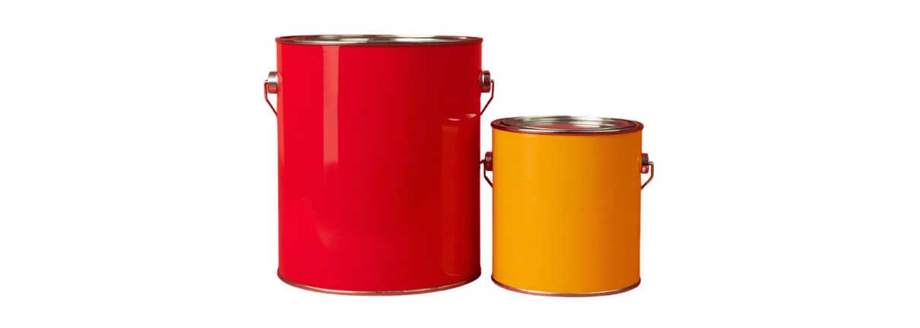

The customer has 7 gallons of red paint. Help the customer figure out how much yellow paint she should buy.

Role play the conversation between the customer and the store representative. Change roles.

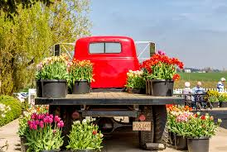
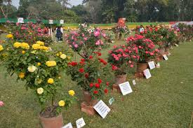

You work in the garden center and you need to put out new inventory of rose plants.

You have 150 plants to take out of a truck and put on display. You want to estimate how much time you will need.

You take 6 plants from the truck and put them out for display. It takes you 5 minutes.

6 plants in 5 minutes



1 min 1 min 1 min 1 min 1 min

LESSON 6: MEASUREMENT

Rationale
Take a moment to think about things you measure. What math did you use? Was it linear measurement or did you measure the area of a surface? Our students may be used to working with metric or standard U.S. measurements, but the math they need to measure the perimeter, area, and volume does not change. Our learners also need math language to talk about units of measurement, measuring tools, and to describe situations that require measurement. In this lesson, we will revisit proportional reasoning and some of the connections we made among the four operations as we explore ways to conceptually teach topics of measurement and provide students opportunities to apply their understanding in an employment context.
For lessons on metric conversion and standard U.S. measurement, see Lesson 6 of the Shopping Unit.

Background
The United States is one of only three countries in the world that use the standard system of measurement (inches, pounds, miles, etc.) rather than the metric system. There is a good chance that most of your students will be familiar with metric measurements from their home country, and may not be as familiar with the units used in the U.S. In addition, while the metric system is based on multiples of ten and uses a regular system of prefixes, the standard system used in the U.S. is irregular both in its mathematical ratios (12 inches : 1 foot, 16 ounces: 1 lb., etc.) as well as its language and abbreviations. Who would guess that pound is abbreviated lb. and ounce abbreviated oz., or that the plural of foot is feet? Integrating standard units of measurement and the language and math associated with it is of great relevance to your learners.

Body Benchmarks
Using the body as a benchmark for estimating in standard measurements is a very important tool. When we grow up with a system of measurement, we have mental “benchmarks” that we use to make sense of other measurements. For example, if I am five feet tall, I have a very concrete and familiar way to make sense of a length of 5 feet, or 6 feet (a little taller than me), or 10 feet (twice as tall as me). Other body benchmarks can be useful as well: most people have a forearm about 1 foot long (elbow to wrist), and a final thumb joint about 1 inch long. Have your students estimate lengths with these convenient benchmarks to start to internalize them, so they can more readily imagine the other measurements they are presented with.

Perimeter
An important aspect of perimeter is that it is a linear measurement, which means that it is essentially a line. This can be demonstrated visually by laying a piece of string around the perimeter of a shape. After students understand that the perimeter goes around all sides, remove the string and show how it is really just a line that has wrapped around a shape.
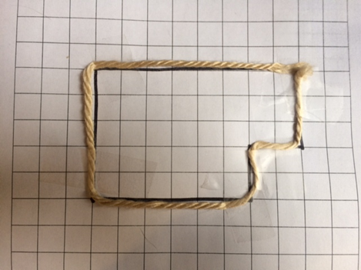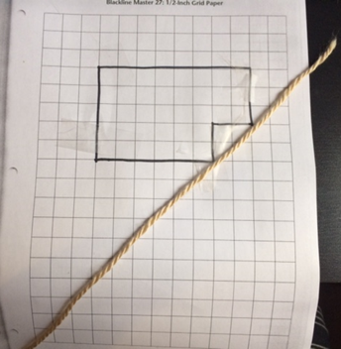
Many students confuse the perimeter with the shape itself, which makes distinguishing between area and perimeter difficult. The same piece of string can be used to make another shape. Perimeter itself does not contain information about shape: as a line, it is only a length.

Area

Shifting from perimeter to area involves a shift from thinking in one dimension (length of a line) to thinking in two dimensions (surface). We cannot cover a surface in lines, which is why we shift to square units when talking about area.
Just like with the linear measurements, make sure students have a visual/tactile representation of the square units you are using so they can have a concrete experience with it. This can be square foot or square inch tiles, or just square inches or feet cut out of paper. Students can start playing with these units by using them to “cover” different surfaces, such as a notebook or a table. A classroom floor with square foot tiles also works for this.
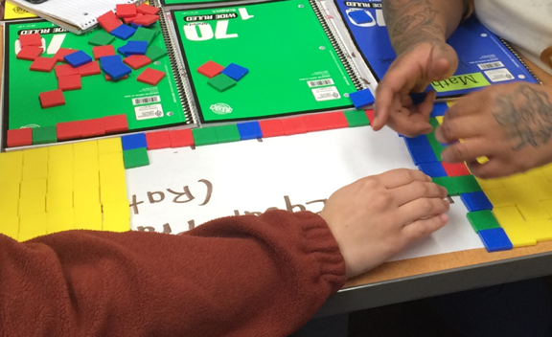
Use these experiences and the visual of the grid to help students see why multiplication is involved in area. For example, a 4 x 5 grid can be seen as 4 rows of 5, or as 5 columns of 4.
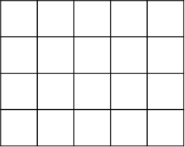

Making these discoveries on their own will help tremendously when they later have to remember whether to add or multiply the dimensions (a common confusion with students who are only taught formulas for area and perimeter, rather than constructing their own understanding with visuals). Even students who have a solid grasp of the measurement concepts in the metric system will benefit from the practice with the language and ratios of unfamiliar standard units

LESSON 6: MEASUREMENT LESSON PLAN

Prior Knowledge
- Students are able to add and subtract two-digit numbers.
- Students recognize U.S. math notation (see Shopping Unit, Lesson 1: U.S. Currency).

ESOL Tasks
- Read symbols on standard measuring tools.
- Write standard U.S. measurements using common abbreviations.
- Role play a customer service scenario to solve a problem.

Math Concepts Addressed
- Use linear measurement tools to find length, width, and height.
- Generate strategies for estimating large linear measurements.
- Identify perimeter as a linear measurement around a shape, and generate methods for calculating.
- Understand why area is measured in square units, and use various methods to find area.

Materials
- Board, chart paper or computer with projector
- Rulers, yardsticks, measuring cup
- 1-centimeter grid paper
- Measuring tape
- Square foot tiles (easily found at a hardware store) or a few square feet cut out of paper
- (Optional) 1-inch square tiles (a math teacher in your program may have some you can borrow)
- Handout: Matching Cards: Measurement Units
- (Optional) Handout: Room Area
- Handout: Divide the Shapes
- Handout: How Much Paint?
- Handout: How Much Paint? (Answer Key)
- (Optional) Handout: How Does Your Garden Grow?

Math Vocabulary

- measure
- ruler
- inches
- foot/feet
- yard
- estimate
- perimeter
- area
- dimensions
- length
- width
- height
- square feet, square footage
- volume
- pound
- meter
- centimeter
- tape measure

INTRODUCTION / WARM UP

Introduce topic; assess background knowledge
- Have a variety of measuring tools available (or pictures of measuring tools) as students enter the room such as rulers, yardsticks, measuring cups and spoons.
- Write the words measuring tools on the board.
- Elicit what kinds of things we measure with these tools. As students offer ideas, create a list or a mind map on the board.
- Ask students if they can put the words into categories of area/surface, volume, and linear measurement. Start by giving an example of each such as area is the surface of the wall, floor, or soccer field; volume is how much is in a cup or swimming pool, and linear is how tall you are or how many miles it is to walk to school.
- Tell them to think about the jobs they have been discussing in this unit (gardening, painting and other). Ask: What kinds of measurement might be needed for gardening and painting? Write their ideas on the board. (Paint walls, put up a garden fence, plant a garden).

ACTIVITIES

I. Looking Closely at Measurement Tools
- Introduce or elicit vocabulary used to talk about measurement. Especially highlight any similar forms that are different parts of speech (for example, height and width are nouns but high and wide are adjectives). Mention that the irregular plural of foot (feet).
- Ask each student how tall he/she is. They might know their height in meters and centimeters or feet and inches.
- Give each student a ruler and elicit the size and the name of the units. Write on the board: 1 foot = 12 inches. If the rulers have centimeters on one side, be explicit about standard U.S. measurement on one side and metric on the other. You can ask them to give you the ratio of inches to centimeter (1 inch: approximately 2.5 centimeters).
- Next, give students the yardstick. Ask them to look closely at the yardstick and ask them How many feet are in a yard? How many inches? (A meter is 3.3 feet, or approximately 1 yard.)

II. Practice Using Measuring Tools
- Pair students, ask them to choose a measuring tool (ruler, yardstick or tape measure) to measure each other’s height. Later, you can ask them why those chose a particular tool. It might be easier to read, manipulate or they might choose a tool they are most familiar with.
- Give them your height with the abbreviations for feet and inches, e.g., 5 ft., 2 in. Next, present the notation: 5’ 2”. Be explicit that the apostrophe and quotes are uses after the number and are often used to note feet and inches.
Note: Students probably know their height in meters or centimeters. Elicit the situations where they need to know their height or where someone measures their height (doctor’s office, driver’s license, amusement parks, tailoring for clothes).
- If it didn’t come up earlier, elicit if height is linear, surface, or volume measurement. Height is an example of linear measurement. It measures the length of something.

III. Abbreviations in Measurement
- Using the handout Matching Cards: Measurement Units (cut up the cards ahead of time to make sets) students match words with their abbreviations and a few standard equivalences such as 12 inches = 1 foot, 3 feet = 1 yard. You can add the math symbol for feet (’) and inches (”). Encourage students to use letter abbreviations ft. and in. and math notation ’ and ” in place of feet and inches for the activities in the rest of this unit.
Note: The abbreviations for ounce and pound appear on this handout. Although these units of measurement are not part of the lesson, they are common on many items, especially in home improvement (i.e., soil sold in 40 lb. bags, paint sold in quarts).

IV. Explore Perimeter
We often use body parts to estimate. We might judge the height of a ceiling against our own height or the length of a room by walking the room and counting our footsteps to determine the number of feet. In this activity, students will explore perimeter through kinesthetic activities.
- Ask students to look around the room, and ask: Where is there linear measurement here? Why might we need to measure it in this room? Elicit words for objects in the room such as baseboard, heater, molding, window, window frame, carpet, door, door frame, board, etc.
- Pre-teach the word estimate. (You may want to note this word can be a verb or a noun.) Ask students: How could you estimate the length or width of the room if they need to buy new baseboard or molding? (Possible answer: Walk it (heel to toe) and count 1 foot for each step.)
- Ask students to walk the length of the room and write their estimate, in feet, on the board. Ask students what they think accounts for the differences in numbers.
- Give students yardsticks or a tape measure and ask them to measure the length of the room to confirm the actual dimensions.
Extend the learning: Applying what they learned about proportional reasoning, students will convert their answers in feet to yards. Use words, pictures, or symbols to show the ratio, for example:
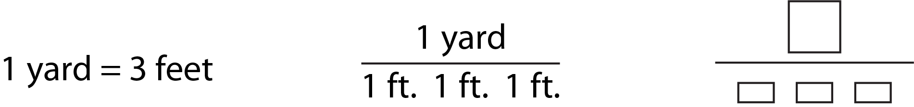
- Next tell students they are going to renovate the classroom and they are going to put a new baseboard around the room. What do they need to measure? (linear measurement of each wall)
- Introduce the word perimeter. In Latin, the prefix peri- means around, and meter means measure.
- Students work in pairs to measure the perimeter using yardsticks or a tape measure. Talk about the tape measure and elicit how it differs from a yard stick.
Note: It will be easier if all students use the same measuring tool. Ask students to record the measurement in feet.
Note: If your room is not a perfect rectangle, tape off a portion of the room to simplify measurements. If your room is too small or too crowded, use grid paper to present the scenario.
- Ask students if the order in which they measured and added the lengths matters or not.
Note: With multiplication and addition, the order of the numbers does not matter. 4 $×$ 3 = 3 $×$ 4 and 4 + 3 = 3 + 4. This is called the commutative property of multiplication and addition. When calculating perimeter, the sides can be added in any order. When measuring area, the length and width can be reversed and the areas of square unit will be the same. While it’s not important for students to know the name of this property, the concept is an important foundation of algebra.

V. Explore Area
- Tell students they now want to paint the floor of the room. How would they measure it? Rulers only measure lines!
- Give them the word area. When we talk about area, we speak in square units.
- If the floor in the room has square tiles, encourage students to use the tiles as a guide to think about methods of measuring. (If not, a few square foot tiles from the hardware store, or some square feet cut out of paper, can be a nice visual way to map out squares.) Tell the students: Each square is 1 foot long and 1 foot wide. These are the dimensions of the square. We say 1 foot by 1 foot.
- Tape off an area of the floor in your classroom (or use one of the alternatives below) and ask students:
How many square unit (feet) are inside the taped area?
Is there another way you could measure it?
What if we changed the direction of the marked area? Is the area still the same?
Alternative: If your classroom is too small or does not have tile flooring, you can do one of the following:
Option A: Distribute 1-centimeter graph paper and tell students that the paper represents a floor surface. Tell students each centimeter will represent 1 foot by 1 foot. Then, have students draw their own rectangles which they can then use to calculate area. Let students choose which rectangle they want to work with and calculate the area.
Option B: Use the handout Room Area (the grid is divided into 1" blocks).

Extending learning: Working with Irregular Shapes
- Have students work on the handout Divide the Shapes.
- Ask students to create their own irregular shapes made out of rectangles, and ask them to explain/show how they would find the area and/or perimeter.

V. Painting an Area
In this activity, student take on the roles of customers and customer service associates to complete a transaction that involves purchasing paint. Students will first work together on the math measurement, and then role-play the transaction.
- Tell students that at most stores that sell paint, customers rely on the store employees to help them determine how much paint they need. Ask what information customers would need to provide for the store employees to figure out how much paint is needed (size of room and the paint to area ratio).
- Pair students and designate one student as the Customer and the other as the Customer Service Representative.
- Give students this scenario:
You work in the painting department at HOME DIY. Your job is to help customers select paint and painting supplies, use the paint mixing machines to mix paint for them, and answer questions they have about painting. A customer comes in with this sketch. He is painting some areas in his house.
- Give students a copy of the handout, How Much Paint? After students discuss their responses in question 3 on the handout, elicit some possible dimensions. Show the dimensions on the board or large grid paper as students describe them. Ask them: What did you learn about area from this activity?
- Students role-play the scenario, then change roles and repeat.

4 Strategies for Differentiation

More accessible:
- Create a cloze activity for the role play dialogue for buying paint or flowers or use a context relative to students’ work.

More challenging:
- Using the handout How much paint? as a model, students create their own dialogue for a role-play.

Extend the Learning:
How Does Your Garden Grow? optional handout

ASSESSMENT
- Students measure the perimeter of a wall(s) in one room of their house and sketch it on grid paper. If they don’t have access to a measuring tape, they can use a body benchmark like a foot or forearm length to take measurements.
- Based on their measurements, students calculate the area of the wall(s).
- Next, students calculate how much paint they would need for the wall(s). A gallon of interior paint covers about 400 square feet with one coat of paint.

ADDITIONAL RESOURCES
- Customizable, printable graph paper
- EMPower: Over, Around, and Within: Geometry (teacher and student books)

Copyright © 2011, TERC. All rights reserved. From EMPower book Over, Around, and Within: Geometry and Measurement, Lesson 6 (Student Book). Used with permission.

foot | yard | inch | centimeter
height | weight | pound | quart
volume | meter | gallon | ft.
yd. | in. | cm. | ht.

wt. | lb. | qt. | vol.
gal. | 12 inches | 3 feet | ,
” | m.

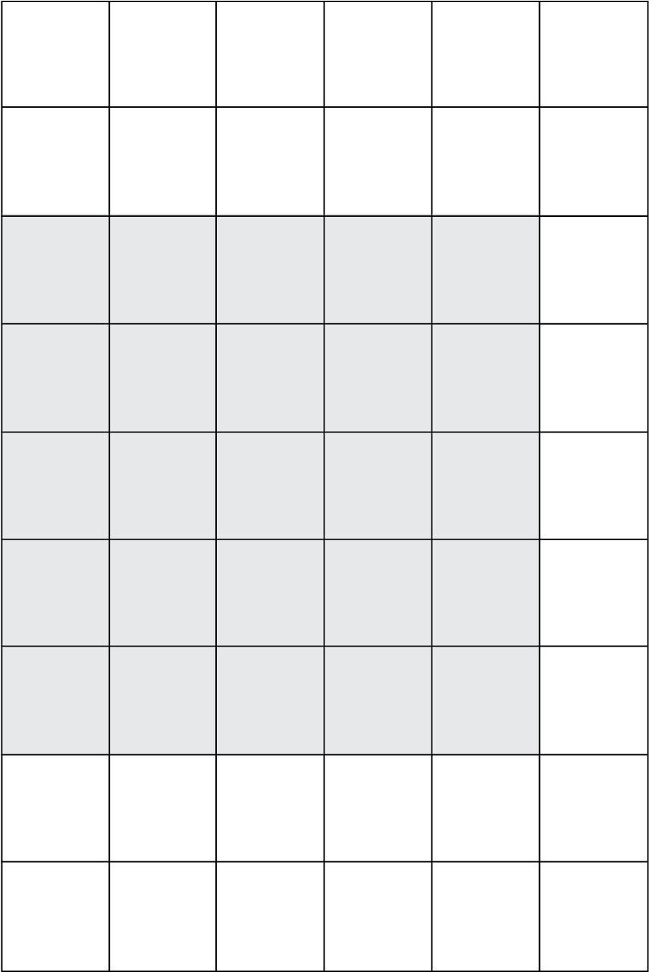
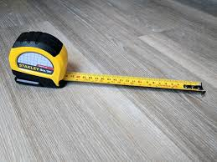
A customer comes into the paint department of HOME DIY and says he wants to paint the ceiling of a hallway in his house.

He tells you the ceiling is 24 square feet.

- What dimensions did he measure?

2. Using grid paper, show two or more possible dimensions of the ceiling.

3. Discuss with your partner:
- What are the possible dimensions?

- How do you know each of the possible options is 24 square feet?

- Which option has the smallest perimeter?

- Which option has the largest perimeter?

Extend the Activity

A week later, the customer returns and tells you he has decided to paint the back side of his house. He tells you the dimensions are 30' x 55'.

1. What is the area?

2. For outdoor paint, one gallon covers about 300 square feet. Write this as a ratio.

3. How much paint does he need? Can you explain two different ways to calculate the answer?

4. Share your answers to Question 3 with a partner.

A customer comes into the paint department of HOME DIY and says he wants to paint the ceiling of a hallway in his house.

He tells you the ceiling is 24 square feet.

- What dimensions did he measure?
He measured width/length and height.

2. Using grid paper, show two or more possible dimensions of the ceiling.

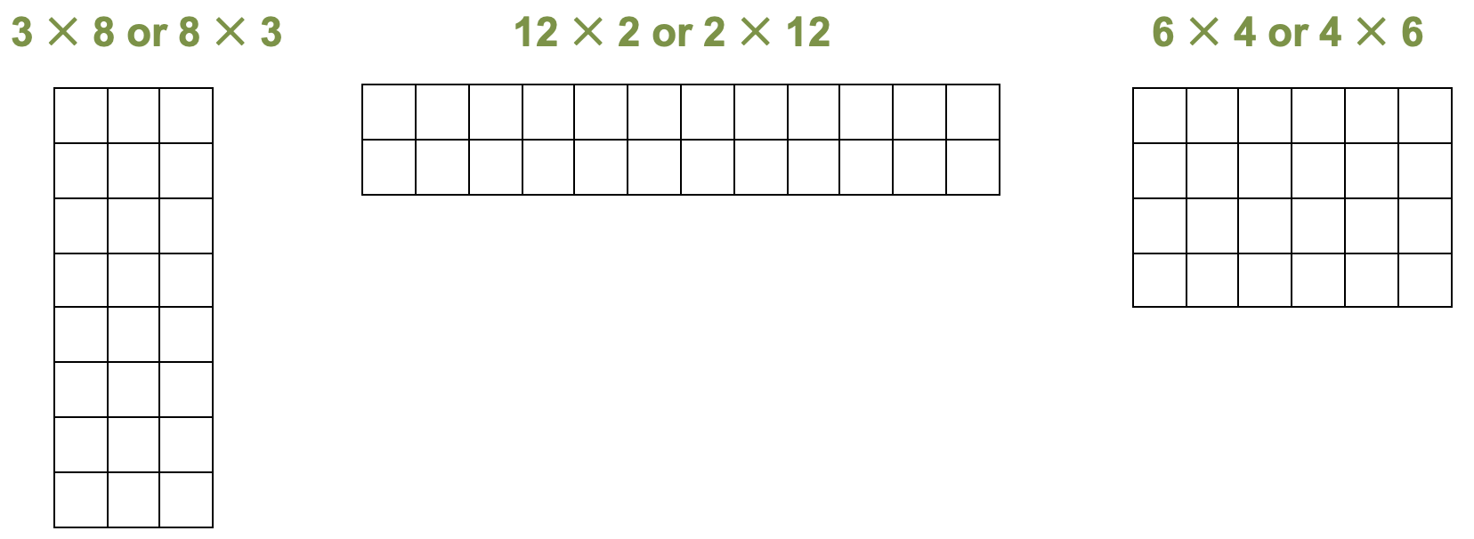

3. Discuss with your partner:
- What are the possible dimensions?
Possible dimensions are: 8 $×$ 3, 12 $×$ 2, or 6 $×$ 4.

- How do you know each of the possible options is 24 square feet?
I have outlined 24 units on my grid paper.

- Which option has the smallest perimeter?
6 $×$ 4 is the smallest perimeter.

- Which option has the largest perimeter?
12 $×$ 2 is the largest perimeter.
Extend the Activity

A week later, the customer returns and tells you he has decided to paint the back side of his house. He tells you the dimensions are 30' x 55'.

1. What is the area?
1,650 square feet

2. For outdoor paint, one gallon covers about 300 square feet. Write this as a ratio.
1 : 300

3. How much paint does he need? Can you explain two different ways to calculate the answer?
5.5 gallons. Answers will vary on how to arrive at this result.

4. Share your answers to Question 3 with a partner.

Use the garden shapes to design a garden. Cut out and tape your shapes on the grid below. Create a scale based on what you would like your actual garden size to be. Don’t forget to add pathways to walk between areas and rows. Then complete the questions on the next page.

Scale: ½” =
1” =
1. Based on your scale and garden shape, what is the total area, including pathways?

- Show how you figured out the area in Step 1.

- Now think of another way to calculate the area from Step 1.

- If you put a fence around the entire outside of the garden, how much fencing would you need (based on your scale)?

- What if you decided to separate each garden area (according to the different shapes you used) with edging so that the design is clearly seen. How much edging would you need (based on your scale)?

- Is the amount of edging more or less than the fencing? Explain your answer.

Challenge: Is there a way you could redesign your garden, using the same shapes, to save on fencing?

GARDEN SHAPES

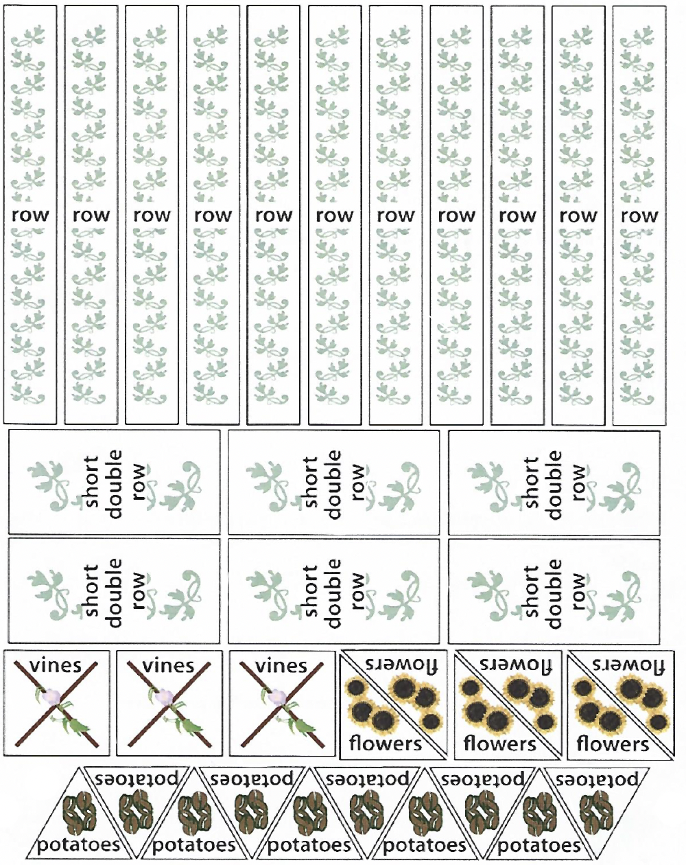

LESSON 7: DATA

Rationale
Data is becoming increasingly important to business. Businesses want to use data to make decisions, and many jobs may call upon employees to collect, analyze, or use data in some way. In Lesson 1, Data Collection, students performed a simple census to collect data and analyzed it with visual tools, such as a frequency graph. In this lesson, we will return to the topic of data and look at how we can collect, sort, and analyze more open-ended data. This will require the creation of categories to sort data into meaningful groups. Categorization is a valuable critical thinking skill in its own right, and when it comes to data analysis, can affect the way the data is perceived or even the conclusions that are drawn.
How can data be manipulated to tell a compelling story? Can we tell a different story with the same data? In this lesson, students will think critically about data and the messages it can convey.

Background
Categorizing data can be trickier than it first appears, because real world data isn’t made to fit into pre-established categories. For example, a survey of what vegetables people like to eat could yield:
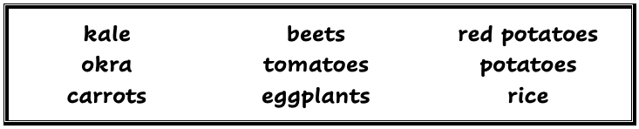
Hmm, what to do with this? First of all, we may get responses that don’t clearly fit the question we were asking (tomatoes, eggplants, and even rice could all be considered fruits!) What do we do with those? Secondly, we may get responses with different levels of specificity: red potatoes is more specific than potatoes. Do we make a potato category? Or do we group the two of them together with carrots and beets as “root vegetables”? Partially, these decisions will depend on our judgements of which groupings will best help us to answer the question we are interested in.
A few considerations when creating categories:
- Categories should be mutually exclusive. If I decide to create a category for “Root Vegetables” and one for “Red Vegetables”, where do I put beets? Even if "beets" was not one of the responses I had to deal with, categories like this could cause problems down the road if we collected more data.
- Every piece of data we consider legitimate should fit into a category. (We may sometimes make a judgement to exclude a piece of data, such as if someone wrote “Pop tarts” or "Mickey Mouse” or something else nonsensical.) Instead of naming a category “Rice” because that was the one we couldn’t fit, it’s far more useful to have a category for “Other” or “Miscellaneous” which can then accommodate other data points that don’t fit anywhere else.

LESSON 7: DATA LESSON PLAN

Prior Knowledge
- Students are able to add and subtract two-digit numbers.
- Students recognize U.S. math notation (see Shopping Unit, Lesson 1: U.S. Currency).
- Students have a conceptual understanding of fractions as equal parts.
- Students are familiar with the notation of fractions.

ESOL Tasks
- Collect and sort data.
- Analyze data.
- Solve problems.
- Think critically.

Math Concepts Addressed
- Consider different ways of sorting data from an open-ended question into categories and how this affects the message of the data.
- Use simple comparative statements and/or benchmark fractions to analyze data.
- Use data to support a recommendation or conclusion.

Materials
- Sticky notes (large)
- (Optional) Pictures and names of vegetables and fruit. One online resource is ESOL Help Online Picture Dictionary.
- Large chart paper
- Markers
- (Optional) Handout: Farm, Farmer, Farm stand
- Handout: Reporting Data 2

Math Vocabulary
- data
- graph
- survey
- category

INTRODUCTION / WARM UP

Introduce the topic
Note: Pre-teach vocabulary as needed for specific vegetables and fruit using picture cards, picture dictionaries, or an online, interactive dictionary such as:
http://www.esolhelp.com/picture-dictionary-vegetables.html
http://www.esolhelp.com/picture-dictionary-fruits.html
Optional: Use Farm, Farmer, Farmstand handout.
- Ask students to come up with some questions about vegetables, fruit, and gardening such as:
Who here has a garden? Do any of you grow your own vegetables/fruit?
What vegetables/fruit are easiest to grow?
What vegetables/fruit from your native country are difficult to find in the United States?
Are farm stands popular in your community?
Do you ever go to a farm and pick your own fruit or vegetables?
If you owned a farm stand or another kind of business, what type of information would you want to know before deciding what products to sell?
Note: Although this example is about farming and produce, the activities in this lesson would work for many different contexts. Any question that will generate a few pieces of categorical data (not numbers) from each student, and which would allow for a variety of responses, would work. For example, if the farm stand context doesn’t match the unit you're teaching, you could ask a more general employment question such as:
Name three jobs you are interested in, now or in the future (this could produce a lot of interesting data for categorizing, as jobs can be categorized in different ways).
Name one to three places where you have worked.

I. Class Data
In Lesson 1, students worked with a finite data set using a closed question with only two responses possible (like yes/no). In this lesson, students will work with a larger data set by asking an open-ended question and categorizing the data.
- Give students this scenario:
A nearby farm is doing a survey to find out what produce (fruits and vegetables) will sell the most at their farm stand in the city. You were hired to do a survey to find out what produce people in your community usually buy.
- Give students sticky notes and ask them to write down the names of three or four fruits and vegetables they like to eat. They must write only one vegetable or fruit per sticky note.
Note: If you have over 15 students, have students work in 2 groups.
- When students are ready, they can put their sticky note answers on a sheet of large chart paper posted in the classroom.
- Ask one student to read off the names of the vegetables and fruit on the sticky notes to the rest of the class.
- As a group, students decide how they want to categorize the fruits and vegetables. They might choose group themes by color, texture, shape, or seasonal vegetables. They should categorize them into at least three categories but no more than five or six categories.
- Once the categories are agreed upon, ask for volunteers to write the names of the categories on a new sheet of chart paper in columns and move each sticky note under the corresponding category column. Tally each column.
Note: Keep this visual posted or ask a student to take a picture or write on a piece of paper the names of the categories and the number of items in each category. Students will need this information for Activity II: Recategorizing the Data.
- Using the data, students write sentences and share them with a partner.

4 Strategies for Differentiation

More accessible:
Students write sentences using whole numbers and/or comparatives and superlatives. For example:
- The most popular vegetables are root vegetables.
- 15 (or fifteen) people prefer leafy vegetables.
- Four more people prefer leafy vegetables than root vegetables.

More challenging:
Students write sentences using benchmark fraction or percentages. For example:
- More than half of the suggestions are leafy vegetables.
- Less than 25% of the group likes green vegetables.

- Put students into small groups to discuss these questions:
Would the data be the same if they asked children?
Would the data be the same if they asked people from certain parts of the United States or from different cultures?
Would the data be the same if they asked 1,000 people instead of just the number of students in the class?
What is the recommendation to the farmer about what produce will sell the most?

II. Recategorizing the Data
In this activity students will think critically about data by changing the categories of their data.
- Ask students to go back to the original sticky notes with the names of fruits and vegetables and to re-categorize the data into only two or three categories. The group should agree on what the categories will be.
- Once the new categories are decided, students will repeat the steps of writing the names of the categories, putting the sticky notes under the appropriate categories and tallying the data.
- Using their new data set, students again write sentences about the data.
- Group students to discuss:
Did the re-categorization change the story of what produce items are most popular?
Would they make the same recommendation to the farmer about what produce will sell the most?
What did they learn from this activity?
What other types of businesses would want to collect data about their customer preferences? What types of questions might they ask?

Extending the Activity
Students to create a graph (frequency, bar, or circle) to report the results of the data collection to the farm stand owner. For more on creating these kinds of graphs, see the Shopping Unit, Lesson 7: Data.

ASSESSMENT
Handout: Reporting Data 2

ADDITIONAL RESOURCES
- ESOL Help Online Picture Dictionary: Food
- Statistics for Action: Drawing Your Own Conclusions
- Statistics for Action: Memorable Graphs
- EMPower: Many Points Make a Point: Data and Graphs (teacher and student books)
This place is a fruit and vegetable farm.
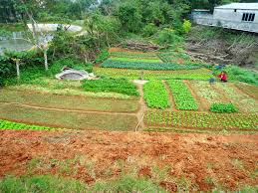

A farmer is the person who works on a farm.
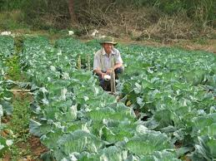

A farm stand is a place where farmers can sell their produce. It can be indoor or outdoor.
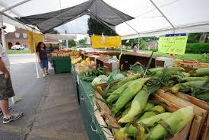
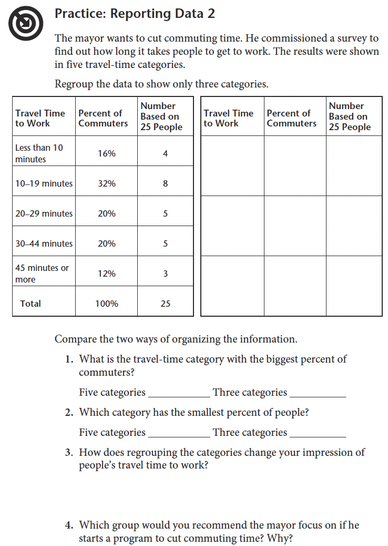

Copyright © 2011, TERC. All rights reserved. From EMPower book Many Points Make a Point: Data and Graphs, Lesson 1 (Student Book). Used with permission.

