Integrating Math into
ESOL Units
A Math Packet for ESOL Teachers

HEALTH




TABLE OF CONTENTS
Introduction 1
Lesson 1: Illness and Symptoms (Units of Measurement) 3
Lesson Plan 6
Handout: Aches and Pains: Name the Body Part 16
Handout: Images of Injury and Illness 19
Handout: What’s the Matter? 20
Teacher Resource: Audio Transcript: Identifying Symptoms 21
Handout: Identifying Symptoms 23
Handout: Body Weight Discussion Cards 24
Handout: Fahrenheit/Celsius Thermometer 25
Handout: Cyril’s Temperature 26
Handout: Lesson 1 Assessment 27
Lesson 2: A Visit to the Doctor (Proportional Reasoning) 28
Lesson Plan 32
Teacher Resource: Medical Facilities 41
Handout: Making a Doctor’s Appointment by Phone 43
Handout: Speaking Practice: Doctor’s Appointment Phone Calls 48
Handout: Rita’s Family Health History 50
Handout: Family Health History 52
Handout: Heart Rates at Rest 58
Handout: Personal Heart Rate 59
Handout: Lesson 2 Assessment 60
Lesson 3: Medications (Units of Measurement) 61
Lesson Plan 63
Teacher Resource: Units of Volume 76
Handout: Medication or Drug? 77
Handout: OTC Drug Labels 78
Handout: Pictogram Flash Cards/Answer Key 81
Handout: Interpreting Warnings and Directions 87
Handout: Prescription Labels 88
Handout: Prescription Label Questions 89
Handout: Listening Comprehension: Prescription Medication 90
Handout: Generic Drug Facts 91
Handout: Questions to Ask Your Doctor about Your Medicine 92
Handout: Medication Syringe 93
Handout: Spoonfuls 94
Handout: Fluid Ounces and Milliliters 95
Handout: Weight or Volume? 96
Handout: Information about your medicine 98
Handout: Taking Medicine / Reading Medical Labels 99
Lesson 4: Nutrition (Proportional Reasoning) 101
Lesson Plan 104
Handout: Nutrition Labels 116
Handout: Reading Food Labels 117
Handout: Serving Size 125
Handout: How Many Calories A 127
Handout: How Many Calories B 128
Handout: Fewer Calories 129
Lesson 5: Healthy Living (Proportional Reasoning) 133
Lesson Plan 135
Handout: How Many Calories Am I Burning? 145
Handout: Exercise Plans 148
Handout: Health Graphs 150
Handout: Graphs of Calories Burned 151
Teacher Resource: Activities and Calories Burned Class Graph 152
Handout: Action Plan for a Healthy Lifestyle 154

Integrating Math into ESOL Units:

A Math Packet for ESOL Teachers (Health)

Math and language are part of our daily activities. When we make a purchase, cook, exercise, and take public transportation, we are using math. In many ESOL course books, math topics are included in thematic units such as shopping, banking, and food. Some books might ask students to tally a bill, write a check, or create a budget, but ESOL course books generally don’t deconstruct the math concepts needed for those tasks.
Understanding math is so much more than memorizing math rules. Think about how you mentally total a bill or calculate sales tax. It is likely that you use different strategies depending on the situation. The math we encounter involves understanding math concepts and how they are related, selecting strategies for problem solving and making sense of math procedures and when to apply them.
In response to ESOL teachers who would like to integrate math in their language classrooms, the SABES Mathematics and Adult Numeracy Curriculum & Instruction PD Team at TERC developed a set of Math Packets for ESOL Teachers. Each packet includes a series of language lessons that integrate math. The math activities are designed to dig deeper into math topics and provide the building blocks that teach the skills and knowledge our learners need to understand the underlying math concepts.
Each ESOL Math Packet includes:
- Background knowledge for the teacher
- Prior knowledge needed by learners
- Language tasks
- Activities that allow learners to explore math concepts
- List of materials needed
- Instructional strategies including ideas for differentiating for math abilities
- Assessments

This ESOL Math Packet was created with funding from Public Adult Education of MA by the SABES Mathematics and Adult Numeracy Curriculum & Instruction PD Team, which is managed by TERC, Inc. This document was authored by Sherry Lehane, an adult ESOL instructor, and Melissa Braaten, an adult basic education teacher, with contributions from Sherry Soares, Donna Curry, and Aren Lew.

Acknowledgments

The goal of this packet is to provide quality mathematics activities and materials that are appropriate for use in adult ESOL classrooms, whether or not the instructor has a strong math background. To that end, we enlisted the help of several ESOL instructors to review the packet contents and pilot-teach some of the math activities with their classes. Our pilot group included teachers from Massachusetts (Immigrant Learning Center and the Ludlow Area Adult Learning Center/Holyoke Community College), Rhode Island (Genesis Center), and Georgia (Chattahoochee Technical College).
We would like to extend our gratitude to those folks for their feedback on content, level, and instructor accessibility. Look for some of their post-teaching reflections, called Lessons in Action, throughout the packet!

LESSON 1: ILLNESS AND SYMPTOMS

(Units of Measurement)

Rationale
Wellness and illness is a common topic of conversation. The discussions often include describing symptoms such as fevers, aches and pains, or seasonal illnesses like allergies and the flu. Wellness visits to the doctor will undoubtedly include routine measurement of height, weight, and body temperature as well as discussions about general health and illness-related symptoms. In this lesson, we have combined language activities that include describing illnesses and symptoms with an exploration of units of measurement as they relate to height, weight, and body temperature. The strategies presented in this unit mirror how numerate adults instinctively use measurement in daily encounters.

Background

Measurements and Unit Conversions
The United States is one of only three countries in the world that does not primarily use the metric system for measurements. Because of this, it is likely that many (if not all) of your students will be more familiar with metric units for different measurements (meters/centimeters, kilograms/grams, liters/milliliters, Celsius degrees, etc.) rather than standard U.S. units (feet/inches, pounds/ounces, fluid ounces/cups/gallons, Fahrenheit degrees). To become comfortable with U.S. measurements, students need to know more than just a procedure for converting between the systems; they need to develop a “sense” for the size of these measurements through repeated sensory exposure. The activities in this lesson focus on encouraging students to find common objects or parts of their body that correspond to different U.S. standard measurements so that over time, they can develop a feel for these units, just as they may already have for the metric units with which they grew up.
When converting, the focus is again on developing a general intuition, so approximate conversions that are easier to calculate mentally are used. There is no need to spend time on memorizing or calculating long decimal conversion factors. In real life, when this is needed, online and smartphone technologies can easily provide exact conversions. Mental calculations are much more useful for allowing students to develop the “feel” for standard measurements, as they attention is focused on the relative size of the units (5 pounds for every 2 kilograms, for example).

Estimation and Mental Math
When should you encourage students to estimate? Always! Estimation is powerful because it develops the flexibility with numbers that math teachers call “number sense” (solving things differently in one's head than on paper). It also more closely replicates what numerate adults do in their daily life; often, an approximate calculation will do. Because estimation is strategic and varied, students will use different methods. This gives them something to share as they practice putting their thinking into words.

Notice/Wonder
Notice/wonder is a powerful teaching strategy that encourages careful observation, curiosity, and increased language use. The teacher gives students a prompt (several are provided throughout this packet, including the thermometer image in this lesson), in which students are asked to carefully observe and then share (out loud or in writing) several things that they notice about the prompt. The teacher records all observations on the board. Next, students are given time to come up with several questions about the prompt, things they wonder about. These are also shared and recorded on the board.
Generally, students will generate the mathematically relevant questions themselves, which they then have more ownership of and are more motivated to investigate. For the thermometer activity in this lesson, students are asked to notice and wonder about a thermometer with scales written in Fahrenheit and Celsius. The class is likely to wonder about things such as “How are Celsius and Fahrenheit related?” or “Are they ever the same?” or “Which is colder, 0° in F or in C?” All of these are rich mathematical questions that students can benefit from wondering about, and then exploring with their peers.

Number Lines
Students from other countries may be more familiar with Celsius temperatures, where a normal body temperature is around 37 degrees. Since they will usually encounter Fahrenheit temperatures in the U.S., it is helpful for them to develop some benchmarks for understanding temperature in Fahrenheit. Important benchmark temperatures include the freezing point of water (32°F or 0°C), normal body temperature (98.6°F or 37°C), and room temperature (around 70°F or 21°C).
When comparing other types of units — for example pounds and kilograms — "0" means the same thing in both measurements: no weight. However, temperature units are a bit different from other types of unit conversions, as they are not proportional. Consider a day when the temperature rises from 20°F to 40°F. It appears that the temperature has “doubled.” However, the same change in Celsius degrees would go from about -7°C to 4°C which is nothing like doubling. The type of proportional reasoning that can be used to reason with other units does not work here. The reason for this is that "0" does not represent a quantity, but rather a reference point for comparison: when we say it is 40° Fahrenheit, we mean it is 40 degrees warmer than 0. With temperature, we don’t even have the same reference point on both scales: the freezing point of water is 0° Celsius and 32° Fahrenheit.
Because temperatures are not proportional, the activity in this lesson uses a number line (a thermometer labeled with both scales). Students are given a chance to make observations. They should notice a few important features: first, where "0" occurs on both scales; second, the point at which both scales give the same number (visually, -40 is about the same level on a thermometer in both temperature scales); and lastly, the size of the increments. The Fahrenheit scale appears to get large “faster,” because Fahrenheit degrees represent a smaller change in temperature than Celsius degrees.

LESSON 1: ILLNESSES AND SYMPTOMS LESSON PLAN

Prior Knowledge
- Doubling and halving two- and three-digit whole numbers (calculators OK)
- Ability to read a gauge

ESOL Tasks
- Label body parts, organs, and other anatomy
- Use comparisons to talk about height
- Name common illnesses and related symptoms
- Brainstorm remedies for minor health symptoms

Math Concepts Addressed
- Find benchmarks for 1 foot and 1 inch
- Estimate body height in feet
- Measure body height in feet and inches with a tape measure
- Physically compare pounds and kilograms
- Find benchmarks for weights in pounds
- Use estimation to convert between pounds and kilograms
- Make observations of a thermometer with Fahrenheit and Celsius
- Compare benchmark temperatures (room temperature, body temperature) in Fahrenheit and Celsius

Materials

Introduction/Warm Up
- (Optional) Parts of the Body interactive quiz
- (Optional) Body Parts Online Picture Dictionary with oral/aural practice
- (Optional) Parts of the Body in English (PDFs and video)

Activity I: Practice speaking about body parts
- Handout: Aches and Pains: Name the Body Part

Activity II: Making sense of height
- rulers (1 foot)
- tape measure

Activity IV: Assess background knowledge of illnesses and symptoms
- Handout: Images of Injury and Illness
- Handout: What’s the matter?
- (Optional) Doctor’s Flash Cards

Activity VI: Aural skills: Strategies for listening comprehension
- Audio files for Identifying Symptoms or use Teacher Resource: Audio Transcript: Identifying symptoms
- Handout: Identifying symptoms
- (Optional) General listening quiz: Drugs and medication
- Device with external speaker (computer, smartphone, etc.) to play audio files (MP3)

Activity VII: Making sense of body weight
- 1 liter bottle of water
- 1 lb. can of soup
- Bathroom scale
- Handout: Body Weight Discussion Cards
- Calculators (or students can use their phones as calculators)

Activity VIII: Making sense of body temperature
- Thermometers (or Handout: Fahrenheit/Celsius Thermometer) with scales in both Fahrenheit and Celsius
- Room thermostat or an image of one
- Handout: Cyril’s Temperature

Assessment
- Handout: Lesson 1 Assessment
- (Optional) Online health vocabulary quizzes for ESOL

Math Vocabulary

height
foot / feet
inches
benchmark
ruler
tape measure
weight
pounds
kilograms
twice as much / half as much
estimate

Fahrenheit
Celsius
degree

INTRODUCTION / WARM UP
- Introduce the theme of this unit with visuals such as pictures of common illnesses or injuries that necessitate a visit to a doctor. You can use the handout Images of Injury and Illness, or create your own.
- Warm up with a quick show of hands for a health related question such as: Raise your hand if you have ever broken a bone. Pantomime as needed or use an image to clarify the question.
- Pair students to sketch a body and label it with the names of all the body parts they know. You can also gamify this activity by telling students the pair with the most correct body vocabulary wins.
- Optional: Parts of the Body interactive quiz –This is an online drag-and-drop activity for students to learn or practice body part vocabulary.

4 Strategies for Differentiation

More accessible:
- Students use a picture dictionary or an online ESOL dictionary such as Body Parts Online Picture Dictionary.
- The web page Body Parts: Parts of the Body in English with Pictures features PDFs and a video. The video moves slow enough for students to repeat after the speaker for pronunciation practice. You might want to direct students to one specific part of the video to avoid cognitive overload.

More challenging:
- More advanced language learners can label organs and other anatomical features such as blood, veins, muscles, joints, etc.

ACTIVITIES

I. Practice speaking about body parts
- Pre-teach hurt, ache, and pain by pantomiming or giving examples. Give some examples of usage as well:
As a verb: My body aches. My feet ache.
As a general noun: I have aches and pains all over my body.
As a compound noun (combined with a body part): I have a headache; I have a backache; I have a stomachache.
Note: Point out that the word ache has an irregular pronunciation, in that the “ch” is pronounced as a /k/ sound. It is also unique in that it can be used as both a verb and a noun (while hurt and pain are not as flexible).

- Using the handout Aches and Pains: Name the Body Part, students complete the dialogues with vocabulary from the Word Bank on page 1 of the handout.

II. Making sense of height
Height and weight are part of the routine measurements taken at a doctor’s visit during a basic health screening routine. The next activity integrates math by introducing units of measurement as they relate to height. We have contextualized the math to replicate the way we estimate a person’s height.
- Introduce adjectives we commonly use to describe weight and height such as: tall, short, average height, slim, heavy, average [weight/height] for his/her age. Point out that while we could refer to someone as simply tall or short, we often describe a person with a numerical estimation of their height, e.g., He’s around 6 feet tall.
- Get a sense for which system of measurement students are familiar with. Most countries outside of the U.S. use meters and centimeters. Explain that in the U.S., it is most common for height to be measured in feet and inches.
- Pass out rulers for students to hold and examine. Explain that this ruler is one foot, or 12 inches. (You may want to pause and go over the plural form, feet, since it is irregular).
- Ask students to name a body part that is about 1 foot long, and a body part that is about 1 inch long. (For most folks, the forearm is about 1 foot, and the last thumb joint is about 1 inch, but anything that works for them will do.)
These are body benchmarks. Elicit how or when they might use this information. (We often use body benchmarks for estimating. For example, a person might estimate the length of a room by walking the room if her feet are about 1 foot long.)
Ask students to write down and then share a few statements about the length of objects in relation to the body benchmarks they determined in the last step. It may be helpful to pre-teach that one-half = a half = ½. The key is to estimate, not to measure.
Example statement: My hand is about one-half (or a half) of a foot, or 6 inches long.
- Ask students if they know their height in feet (without checking their IDs!). If students don’t know their height in feet, ask them to estimate with the ruler or with their body benchmarks.
- Give your own height in feet and inches by saying, “I am __ feet, __inches tall.” Ask students if they want to change their estimate based on this information.
- Pass around a tape measure. Explain how to read the feet and inch measurements.
Note: For beginning students, the ruler marks for inches may be as deep as you go for now. Other students, especially those that have experience using rulers at work, may be comfortable working with half-, quarter-, and even eighth-inch increments.
- Pair students to help one another measure their heights. Discuss the best way to get an accurate measurement to the nearest inch. (For example, they may want to decide whether to measure their heights with or without shoes.) They can go to the board and write their exact height.
- When all students have measured their height, have them write down their height in words. Write down the different ways we can talk about our height:
I am 5 feet, 2 inches tall.
I’m 5 foot 2.
I’m five-two.
- Have students practice asking and responding to questions about height:
How tall are you? (I am...)
How tall is [classmate's name]? (He/she is…)
Activity II in Action
"The students had so much fun using the rulers to find different standard dimensions on their body (foot, inch, etc.) during the body benchmarks activity. Since everyone’s body size and shape are different, they had a lot of fun comparing thumbs to each other and showing how one’s thumb length was an inch, but another’s would be the width of their thumb. Quite a few students did not know how to use a tape measure. The students that did help the ones who did not, therefore not just confirming their knowledge of it, but also being able to explain it to someone else at a different knowledge level."
ESOL (SPL 3-4) Instructor– Chattahoochee Technical College, Acworth, GA

III. Using comparatives and superlatives with height
- Ask students to work together to create a chart on the board of all their heights. When the chart is complete, students make sentences verbally and then in writing using comparatives and superlatives. Provide some examples and be sure to give the converse for each example:
I am shorter than Marie. Marie is taller than me.
I am 3 inches taller than Jose. Jose is 3 inches shorter than me.
- Students can practice writing and responding to open questions. For example: Who is taller than Jose? Who is taller than 5 feet, 2 inches?
- Introduce superlatives. Explain how they are different from comparatives (comparatives compare something to one or more other things using "than", but superlatives indicate something is at the upper or lower limit of a group). For example:
Marie, Jose, and Clara are all shorter than me, but Clara is the shortest person in the class.
- Students practice using superlatives in conversation. If needed, provide prompts, such as: Who is the tallest in the class? Who is the shortest?

Follow up activities:
(Based on an activity from TERC’s Mixing in Math materials.) Find world records or interesting facts involving measurement or use one of the ones below. Write the fact on the board. For example:
Smallest dog: 6 inches
Tallest Dog: 42.25 inches
Shortest Man: 22 inches
Tallest Man: 8 ft. 11 in.
- Say: The world record for the tallest dog is 42 inches. How tall is 42 inches? Is it taller than the table? Ask students to estimate the height or make a comparison to something in the room, then measure to find out.
- As homework, have students go home and measure the height of something in feet and or inches (choose something pretty much everyone has access to, like a kitchen table, or a couch, or a child). In the next class, collect the data on the board. Have students discuss the heights and which are taller/ longer/ shorter and tallest/ longest/ shortest. You can also discuss the data as a whole (e.g., About how tall do our kitchen tables tend to be? Are the heights close together or spread out?)

IV. Assess background knowledge of illnesses and symptoms
In this activity, students will first work with vocabulary related to illnesses and symptoms before using the modal verb should to give advice for remedies.
- Discuss the difference between an injury and an illness and elicit examples of each. You can use the handout Images of Injury and Illness to illustrate examples.
- Give students the handout What’s the matter? or display the page on a computer projector and elicit the illness or injury in the image. Students match the image with the word(s) that describe the problem.

4 Strategies for Differentiation

More challenging:
- Advanced learners work in pairs. Student A gives a verbal definition. Student B guesses the word. Students change roles after 7 to 10 words. You can create your own cards or pick and choose words from the online resource Doctors (flash cards).

V. Group discussion: Giving advice with should
- Pre-teach the modal verb should and give a few examples in the context of offering health-related advice such as: If you have a toothache, you should go to the dentist. or If you have a cold, you should rest. (Present or review the grammatical rules for modal verbs as needed.)
- Pre-teach the word remedy as something you can do to help or treat the problem. Remedies can be medicinal or natural. For example, the advice "You should rest" is suggesting a natural remedy, while “You should take cough medicine" is suggesting a medicinal remedy.
- Put students into small groups. Using the handout What’s the matter?, students discuss the advice they would give for each scenario and complete the dialogue.

4Technology Integration (optional)

Pronunciation using mobile phone recordings
- Pair students to write a role play. Student A will describe symptoms or the health problem, while Student B offers advice.
- Students can use their cell phones to record their conversation. You can listen to their recordings and offer feedback on pronunciation.

VI. Aural skills: Strategies for listening comprehension
Using the Identifying Symptoms audio recordings, students listen to four different dialogues. The first part of the listening activity focuses on listening for the gist of the conversation. The second part of the activity focuses on listening for details. Students can use the handout Identifying Symptoms to record their answers.
- Play each dialogue once and ask students to listen, but not write. Play the dialogue a second time and ask students to listen for the gist of the conversation and answer the question, What is the problem?
- Students write the problem the person is describing as well as the remedy or advice.
- Repeat steps 1-2 for each of the dialogues.

4 Strategies for Differentiation

More challenging:
- For more advanced learners, try this listening activity called General listening quiz: Drugs and medication. A transcript is available.

VII. Making sense of body weight
Earlier in this unit, we introduced height measurement. A visit to the doctor will undoubtedly include a weight measurement as part of the routine screening as well, since changes in weight are sometimes health indicators.
Ask students if they use kilograms or pounds to measure weight in their home country. Most will probably use kilograms. Explain that kilograms are an example of a metric measurement. See what other metric measurements students are familiar with.
- Pounds are the standard system unit for weight in the U.S. Write the word pound and its abbreviation (lb.).
- Pass around a liter of water (1 kg) and a can of soup (1 lb.). Ask, How do they compare? Which is heavier? How much heavier? Collect estimates.
- Explain that a kilogram is a little more than 2 lbs. A kilogram weighs about twice as much as a pound. A pound is a little more than half a kilogram. It weighs about half as much.
- Give students some time to look around the room to find something they think weighs about 1 lb., something that they think weighs about 3 lbs., and something they think weighs about 10 lbs. Share findings and methods. If a scale is available, weigh the items to see how close the estimates were!
- Give out the Body Weight Discussion Cards, one or two to each pair. After pairs have discussed their thinking with each other, have a few groups share out.

Follow Up Activities:
- Bring a common household object to class that can be passed around (book, container of milk, shampoo, etc.). Have students feel the object and estimate the weight in pounds. Then weigh the object (or weigh it at home) and reveal the weight.
- Ask students how heavy they think their purse or backpack is in pounds. Weigh one student’s purse or backpack and pass it around for comparison. Allow students to weigh their purse or backpack to see how close they were.
- How much paper does our class recycle in a week (or month)? Have students estimate, and record their estimate. Collect all the paper to be recycled in a box for that period of time. At the end of the week (or month), have students feel the box and estimate the weight, then weigh on a scale.

VIII. Making sense of body temperatures
Body temperature is another indication of a potential health issue.
- Ask students if they know what a normal body temperature is supposed to be. This can also help you assess whether students are more familiar with Fahrenheit (98.6 degrees) or Celsius (37 degrees).
- Give students a thermometer (or a laminated picture of one, if they are not available). Ask, What do you notice? What do you wonder? Collect observations and wonderings on board. Look for some of the following observations:
-40 is about the same on both scales.
0 is higher (warmer) on the Celsius scale. It is about the same as 32° F.
Both scales have positive and negative numbers.
The Fahrenheit scale reaches a higher number. (What does that tell us?)
Note: Fahrenheit degrees are “smaller” than Celsius degrees. In other words, a change of 1 degree Celsius is a larger change than a change in 1 degree Fahrenheit.
- Explain that Fahrenheit and Celsius are different scales for measuring temperature. The U.S. tends to use Fahrenheit, while most other countries use Celsius. Scientists in the U.S. also tend to use Celsius.
- What is the temperature in this room in degrees Fahrenheit and degrees Celsius? Ask for an estimate, then check. (If you don’t have real thermometers, use the thermostat in the classroom.)
- Discuss body temperature. What are some ways to “take a temperature”?
- Distribute the handout Cyril’s Temperature. Have students discuss the questions with a partner, then share out.

Follow Up Activities:
Post the temperature on the board in Fahrenheit and Celsius for a few days. Remind students that these are two ways of recording the same temperature. If it is winter, ask students each day if it is cold enough to snow (based on the temperature).
- Post the temperature forecasts on the board for the upcoming week. Ask students what clothing would be appropriate to wear each day, based on the temperature.
- Ask students about the warmest or coldest temperatures they have ever experienced. If they give the temperature in Celsius, have students look at the thermometer images to convert to Fahrenheit.

Activity VIII in Action
"My students were quite familiar with temperatures already, because every day that we start class we start with the weather and how it reflects temperature wise to the small thermometer we have up on the board. However, the structure of this activity helped them correlate temperatures and how they differ in the body. This activity was great from a practical perspective and also helped reflect the changes in body temperature."
ESOL (SPL 3-4) Instructor – Chattahoochee Technical College, Acworth, GA

ASSESSMENT
Give students the Lesson 1 Assessment. Listen as they discuss the questions in pairs. You could also have students write their answers to certain questions if you want to collect them.

ADDITIONAL RESOURCES
- Parts of the Body Interactive Quiz
- Body Parts Online Picture Dictionary
- Body Parts: Parts of the Body in English with Pictures (PDF and video)
- General listening quiz: Drugs and medication
- What’s the matter? Worksheet
- Doctors (flashcards)
- Identifying Symptoms audio files 1-4
- Learning Chocolate’s online Body/Health vocabulary quizzes for ESOL
- Human Body Vocabulary Quiz (online and printable version)

Directions
Use the words in the Word Bank below to complete the dialogues. There is more than one correct answer.

Word Bank

Upper Body
Mid Body
Low Body

head
arm
leg

face
hand
foot (feet)

neck
elbow
toe

ear
finger
ankle

eye
thumb
thigh

nose
wrist
knee

mouth
back
calf

lips chest

teeth buttocks
forehead

Dialogue 1

Student A: I can’t go running today.
Student B: Why? What’s wrong?
Student A: My __________________ hurt(s).

Dialogue 2

Student A: What’s the matter? You don’t look well.
Student B: My ________________ hurts and I don’t feel like eating anything.
Student B: Oh, sit down and rest. Do you feel like you are going to vomit?
Student A: _______________________________________________.

Dialogue 3

Student A: Ouch! I just stood up and hit my ________________ on this desk.
Student B: Do you want some ice for it?
Student A: ____________________________________________________.

Dialogue 4

Student A: My ______________ hurts when I bend my arm.
Student B: Oh, yeah. It looks red and swollen. Do you know what happened?
Student A: I think I ______________________________________________.

Directions
Your turn! Create a dialogue with words from the Word Bank or use your own.

Dialogue 5

Student A: ____________________________________________________.

Student B: ____________________________________________________.

Student B: ____________________________________________________.

Student A: ____________________________________________________.

An injury is damage to a body part. An illness is sickness or disease. Below are examples or illnesses and injuries. Write the word illness or injury under each picture.

Dialogue 1
A: Good morning, Adrianna. What’s the matter?
B: I don’t know. I don’t feel well. My stomach hurts.
A: Since when does it hurt?
B: Since yesterday when I woke up with a stomach ache.
A: Oh, do you want to eat something and see if that helps?
B: Ok. I’ll have some dry toast. I didn’t eat yesterday.
A: If you didn’t eat anything yesterday, you should try and eat something today. It might make you feel better. I’ll make you some toast.
B. Thanks, Mom.

Dialogue 2
A: Hey, are you feeling ok? You don’t look well.
B: No, I feel terrible.
A: What’s wrong?
B: My back is killing me.
A: Yeah, I can tell by the way you walk. What happened?
B: I don’t know. I think I hurt myself lifting a box yesterday.
A: Why don’t you put some ice on it? I’ll get you an ice pack.
B: Ok. Thanks.

Dialogue 3
A: Hey Leeann, how are you?
B: Not great. I think I have a fever.
A: Oh, you look pale. Did you take your temperature?
B: Yes, it’s 101 degrees and my whole body hurts.
A: You might have the flu. You should probably go to the doctor right away.
B: I’m going right now. Can you drive me?
A: Yeah, let me get my keys and let’s go.

Dialogue 4
A: Ouch! I stepped on something and hurt my foot!
B: What did you step on?
A: I don’t know. I think it might be a pin.
B: Oh, sorry. I think I dropped that.
A: Oh, I’m bleeding.
B: I’ll get you a band aid.
A: Thanks.

Dialogue 5
Now it’s your turn!
Write your own dialogue and give advice for a health problem.

_______________________________________________________________
_______________________________________________________________
_______________________________________________________________
_______________________________________________________________
_______________________________________________________________
_______________________________________________________________
_______________________________________________________________
_______________________________________________________________
_______________________________________________________________
_______________________________________________________________

Directions
- Listen to each conversation several times. The first time, listen but don’t write.
- The second time, listen for the gist of the conversation. That means don’t focus on every word. Instead, listen for the general topic of the conversation. What problem is the person talking about?
- The third time, listen for details. What advice is the person suggesting? You can write down any other detail you wish.
Conversation | What’s the problem? | What advice is suggested? | Other details
Conversation 1
Conversation 2
Conversation 3
Conversation 4

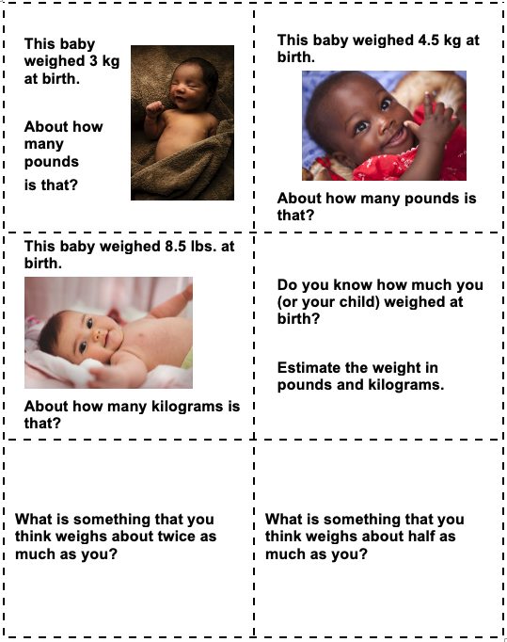

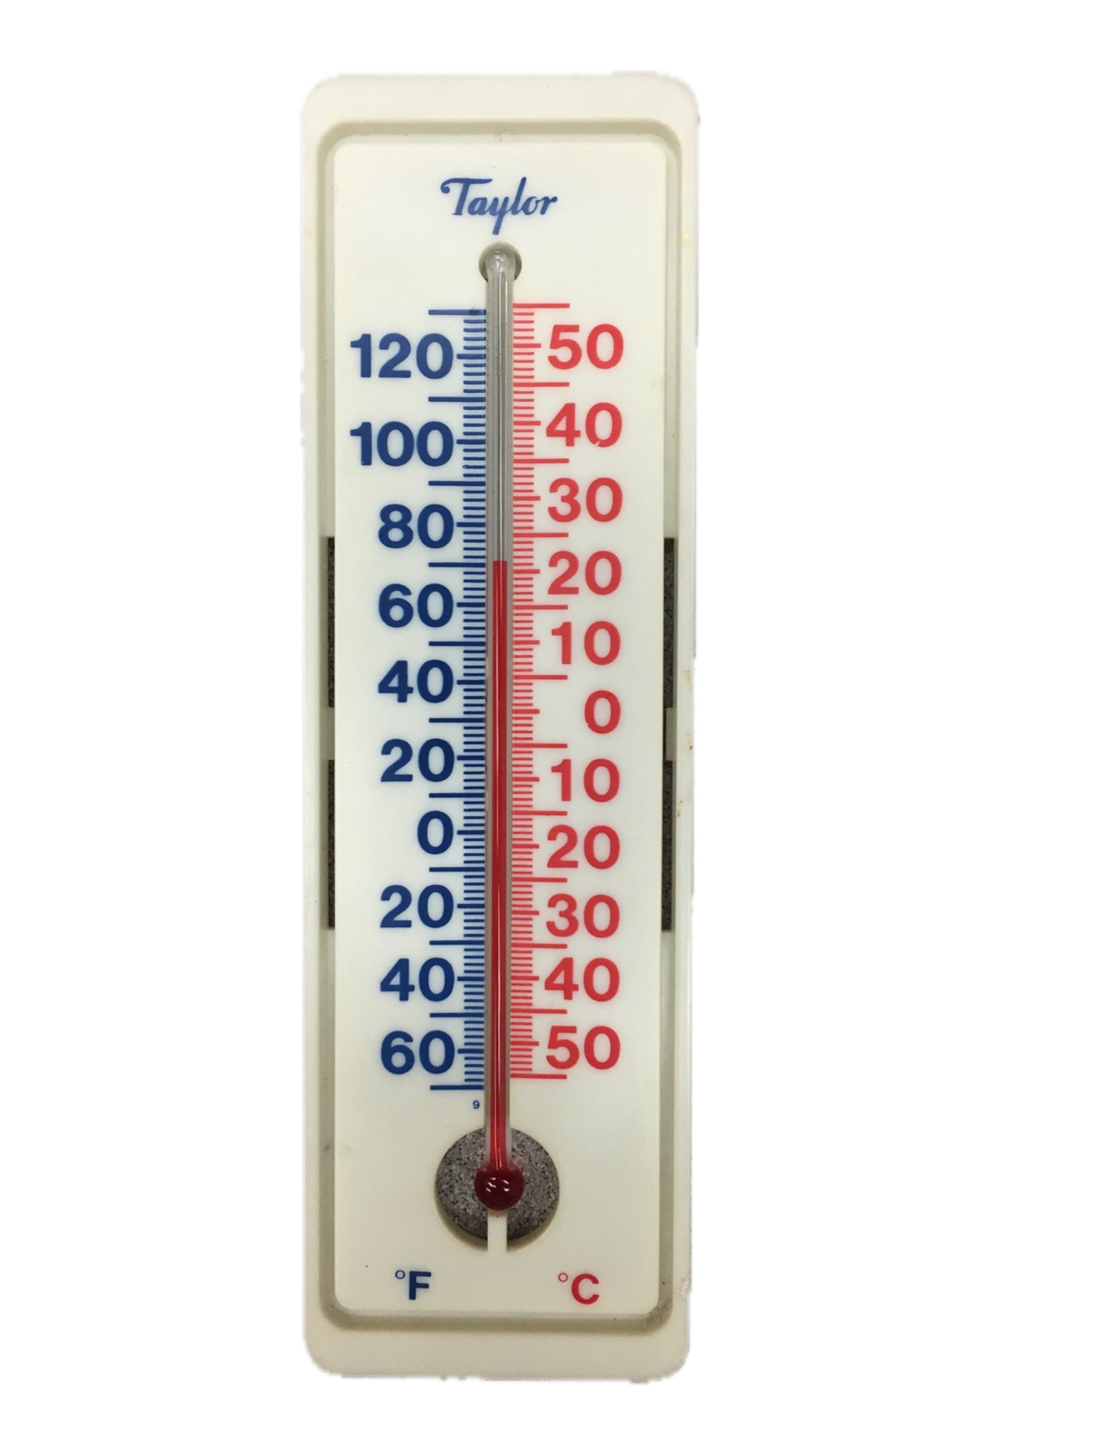

Adults (Oral body temperature)
Normal Body Temperature | Fever | High Fever  (call the doctor)*
98.6°F | 100.4°F or higher | 103°F or higher
37°C | 38°C or higher | 39.4°C or higher
* Based on information from webmd.com

Cyril is an adult. The two temperature readings below were taken from under his armpit. The instructions for this type of thermometer say that the temperature taken this way is about 1.0°F to 2.0°F lower than the temperature from an oral thermometer.
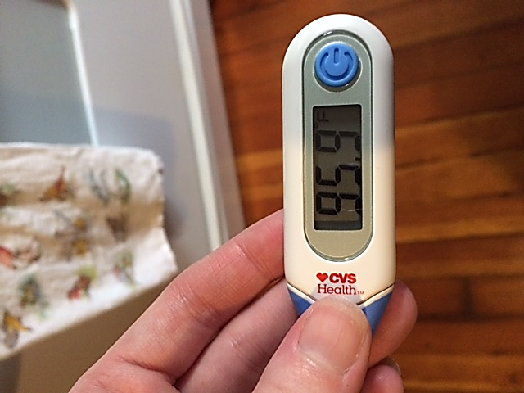

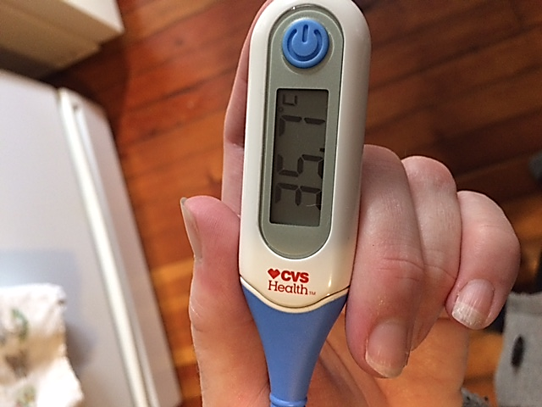

Discuss with your partner:
- Which temperature is in Celsius? Which is in Fahrenheit? How do you know?
- Does Cyril have a fever?
- Should he call the doctor?

Devon is 5 years old. He went to see the doctor twice this week.



MONDAY
Height 43 inches
Weight 39.5 lbs.
Temperature: 102°F

FRIDAY
Height 43 inches
Weight 39 lbs.
Temperature: 98.2°F

With a partner:

- Compare Devon’s measurements on Monday and Friday.
- Describe Devon’s symptoms, based on the measurements in the chart.
- What illnesses might cause these symptoms?
- Give advice to Devon’s parents. Use the word “should”.

LESSON 2: A VISIT TO THE DOCTOR

(Proportional Reasoning)

Rationale and Context
A heart rate is one of the basic vital signs that people can measure at home. Adults may need to monitor their own heart rate to note changes due to illness, stress, exercise, or medication, or they may need to take a child’s heart rate to have information to share with the doctor.
Normally, the human heart beats 60–80 beats per minute (bpm), although it can beat up to 200 bpm or more during intense exercise periods. Exercise is not the only stimulus that can raise a person’s heart rate, however. Drugs, such as caffeine and nicotine; hormones, like epinephrine and those produced by the thyroid; and mental conditions, like anxiety, can all raise a person’s heart rate. High body temperatures, like those experienced during a fever, can also increase the heart rate to make you feel like your heart is racing. Low body temperatures decrease the heart rate, as does being in good physical condition.
In addition to learning how to measure heart rate, students will look at the proportional reasoning involved in rates that can be applied to other contexts.

Background

Rates
Adults encounter rates everywhere. We talk of miles per gallon, miles per hour, interest rates, heart rates, etc. all the time. However, understanding the mathematical relationships involved in rates is often difficult. The most commonly used rates involve change over time or distance. The dependence of one variable on the other—of miles per gallon of gas or interest paid for a number of months or years—can be confusing to anyone whose sense of proportion is shaky. This is because rates involve two variables, either of which can influence the magnitude of the other. As proportional relationships, common rates can be represented as linear relationships (lines) on graphs, which will be dealt with in Lesson 4, Healthy Living.
From a language standpoint, it will be useful to explicitly discuss the ways we write about rates, such as 60 beats per minute, 60 beats/min., 60 beats in 1 minute.

Proportional Reasoning
In Lesson 1, students used proportional reasoning to estimate unit conversions (about 2.5 lbs. for every kilogram, which means about 5 lbs. for 2 kilograms, 10 lbs. for 4 kilograms, and so on). Rates also involve proportional situations, which means they can be extended while keeping the underlying relationship the same, i.e., 60 beats in 1 minute is the same rate as 600 beats in 10 minutes; 15 beats in 15 seconds is the same as 60 beats in 60 seconds.
All proportional situations involve ratios. A ratio is a relationship between two quantities. When we say that 5 lbs for 2 kgs is the same as 10 lbs for 4 kg, all of our quantities have changed, but the relationship between them hasn’t. What stays the same (the relationship) is what we call the ratio.
A proportion is a statement that two ratios are equal. When we say that 15 beats in 15 seconds is the same as 60 beats in 60 seconds, that is a proportion. Formally, we may be used to proportions that look like this:

$$\frac{15 beats}{15 seconds}= \frac{60 beats}{60 seconds}$$

What is equal in this case between the two situations is again the ratio or relationship between the quantities, not the quantities themselves.
Proportional reasoning is a mathematically rich topic. At its heart is reasoning with multiplication. The relationships between the numbers in a ratio (and a proportion) all involve multiplication (or its flip side, division). For example, if we were considering a situation in which there are 6 servings of granola in 2 cups, we would also know that there are 12 servings in 4 cups, and the following relationships would exist between the quantities in the proportion:
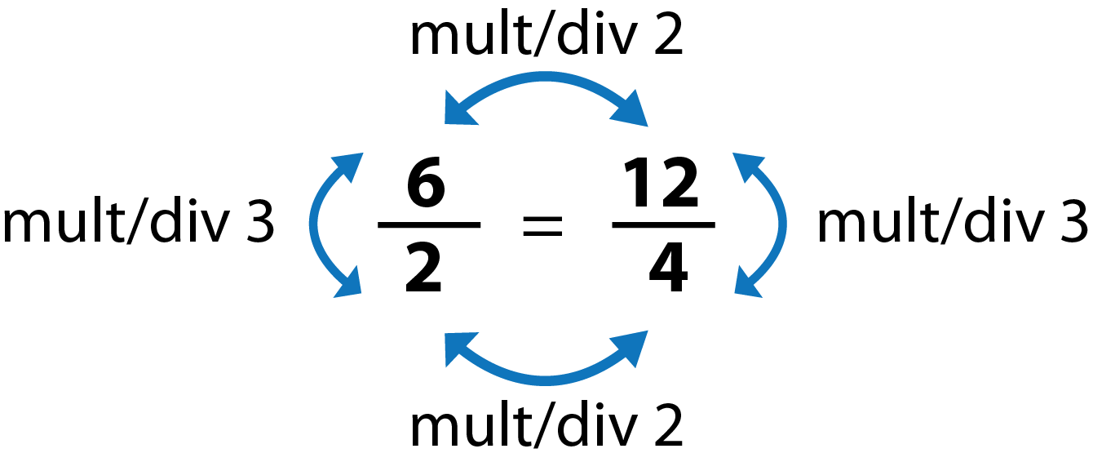
There are many ways to think about and solve problems dealing with proportion, and researchers who observe adults going about everyday activities have noticed that people use a variety of strategies. With this in mind, students are encouraged to develop and use a bank of appropriate strategies. In this packet, we offer students tables as a tool to help them see and work with these relationships.
Some students may be familiar with cross-multiplication when working with proportions. While this is a valid method, it is not emphasized here. Research has shown that cross multiplication, if taught too early, can shut down a student’s proportional reasoning in favor of “answer getting”.

Tables and Rules
Throughout the lessons in this packet, students will be introduced to the use of in-out tables to examine patterns and relationships between different quantities, such as time and number of heartbeats, time and calories burned, or the number of tablets and the amount of medication. In-out tables show relationships between two variables (two amounts that can change).
For example, one of the tables in this lesson looks at the relationship between time (the “in” variable) and number of heart beats (the “out” variable). The table for someone with a heart rate of 72 beats per minute might look something like this:
Time In Minutes (M) | My Total Number of Heartbeats (B)
1 | 72
2 | 144
3 | 216
5 | 360
10 | 720
30 | 2,160
60 (an hour) | 4,320
1,440 (a day) | 103,680

There are many patterns that students might notice in this table. For example, they might notice that for the first three rows, the number of heart beats goes up by 72 each time. They might notice that they can double the number of heartbeats in 5 minutes to find the number in 10 minutes. They could potentially add the heartbeats for 10 minutes and 5 minutes (720 + 360) to find the number of heartbeats in 15 minutes, if desired.
The most powerful pattern that students can notice is the function, or “rule” for the table. The function describes what happens to the number that comes in (in this case, the time in minutes) in order to calculate the number that comes out (the total number of heart beats). The function in this table might be described as:
Take the time in minutes, multiply by 72, and you will get the number of heartbeats.
The function is powerful because it allows us to calculate the “out” value (number of heartbeats) for ANY “in” value (amount of time). Recognizing this pattern is what allows students to make the leap to calculate the heart beats in one day (instead of having to go through the cumbersome process of repeatedly counting up by 72!).
Even native English speakers struggle to put mathematical functions into words precisely, so students will probably need some just-in-time language and grammar support to make sure their thoughts are clear. For example, a student might say that the rule is “times by 72”, and the teacher could prompt for more clarification, asking, “Which number do you want to multiply by 72?” Offering a template like the one below can be helpful as well:
Take [in variable], [do something to it], get [out variable].
If appropriate for the class, these activities can be extended to practice simple algebraic notation. Once students are able to describe the rule or function or the table in words, they can formalize it into math symbols. Variables (indicated with letters or symbols) are used to stand for the quantities that change (the “in” and “out” quantities in the table.) The rule above could be written as:
M $×$ 72 = B (Minutes $×$ 72 = number of Beats)
Algebra has its own set of grammar, punctuation, and syntax. While students can and should use intuitive reasoning and problem solving to discover patterns and relationships between quantities, conventions like notation and algebraic syntax have to be explicitly taught. How far you want to go into this in your language class will depend on your judgement of what is appropriate for your students.
Remember, this background knowledge is intended to deepen your understanding and increase your confidence to share integrate math. You can refer back to this information as you read through the lesson activities that follow.

LESSON 2: A VISIT TO THE DOCTOR LESSON PLAN

Prior Knowledge
- Addition and/or multiplication with whole number within 1,000 (calculators OK)

ESOL Tasks
- Select a medical facility: walk-in clinic, private practice, hospital
- Schedule and cancel an appointment
- Fill out a medical information form

Math Concepts Addressed
- Identify examples of rates
- Describe the pattern in a situation with a verbal rule
- (Optional) Connect the pattern in a table with a symbolic rule (algebraic equation)
- Use a table to extend a pattern

Materials

Introduction/Warm Up
- (Optional) Choosing a doctor: Quick tips

Activity I: Distinguish differences among hospitals, walk-in clinics, and private medical practices
- Teacher resource: Medical Facilities
- Handout: What’s the matter? (from Lesson 1)

Activity II: Vocabulary matching–Specialists
- (Optional) 15 Types of Doctors with Different Specialties

Activity III: Make, cancel, and reschedule a doctor’s appointment
- Audio File: Listening Comprehension: Making a Doctor’s Appointment
- Handout: Making a Doctor’s Appointment by Phone
- (Optional) Handout: Speaking Practice: Doctor’s Appointment Phone Calls

Activity V: Articulating family medical history
- Handout and audio file: Rita’s Family Health History
- Handout: Medical Family History

Activity VII: Heart rates at rest
- Handout: Heart Rates at Rest
- Clock with second hand or timer

Activity VIII: How many beats per day?
- Handout: Personal Heart Rate
- Calculators (or students can use their phones as calculators)

Assessment
- Handout: Lesson 2 Assessment

Math Vocabulary

- rate
- (optional) equation
- (optional) variable

INTRODUCTION / WARM UP
- Ask students: How do you choose a doctor? What kinds of things are important when deciding what doctor to go to?
- Generate a list or mind map on the board.
- When the list is complete, students work in groups and check the information against an online text or resource. Here is one option: tips. You can simplify this list for beginning ESOL or create your own.

ACTIVITIES

I. Distinguish differences among hospitals, walk-in clinics, and private medical practices
- Use the teacher resource, Medical Facilities, or project your own images of a hospital, walk-in clinic, and private medical practice and elicit the differences. Possible answers include:
Hospital emergency rooms are for severe emergencies that might require surgery or are life and death situations. You don’t normally schedule an appointment although you might for a doctor’s office located in a hospital.
Walk-in clinics are for less severe illnesses like colds or the flu that require medical attention but are not necessarily an emergency.
Private medical practices are good for medical needs that do not require care on the same day. You must make an appointment. You can have the same doctor follow-up with your care and treatment.
- Using the handout What’s the matter? from Lesson 1 of this unit, elicit for each image the ideal place to seek medical care given the three options: a hospital emergency room, a walk-in clinic or a private medical practice.

II. Vocabulary matching – Specialists
Using the online resource 15 Types of Doctors with Different Specialties students can study this list of medical specialists and then take the online quiz. Alternately, you can create your own hard copy version.

III. Make, cancel and reschedule a doctor’s appointment
This activity begins with a listening exercise to practice aural skills. It also serves to help learners generate their own dialogues for a role play in the next activity.
Aural Skills: Listening for specific information
Using the audio recordings, students listen to a conversation between a medical receptionist and a patient and answer the questions on the handout. You will need the following resources for this activity:
- Audio File: Listening Comprehension: Making an Appointment
- Handout: Conversation: Making a Doctor’s Appointment by Phone
- Students listen to the audio recording, Listening Comprehension: Making an Appointment.
- Give students page 3a-1 of the handout Conversation: Making a Doctor’s Appointment by Phone. Give students time to read through the questions and ask for clarification as needed.
- Students listen to the audio recording a few times and answer the questions on the handout.

Extended vocabulary and reading practice:
Students can work on the rest of the pages in Conversation: Making a Doctor’s Appointment by Phone.

IV. Speaking practice: Making a doctor’s appointment
- Choose a scenario for a doctor’s appointment such as a cold, an annual physical exam or an unusual ache or pain.
- Create several cloze activities as a role-play for learners. One can be to make a doctor’s appointment, another to reschedule the appointment, and a third to cancel the appointment. Alternately, you can use the handout Speaking Practice: Doctor’s Appointment Phone Calls.

4Strategies for Differentiation

More accessible:
- Learners fill in key information such as name, date, and symptom.

More challenging:
- Increase the number of missing words. You can choose to leave out all prepositions, verb tenses, etc. Advanced learners can also create their own dialogues in pairs.
- Pair students to role play making, cancelling, and rescheduling the appointment.

V. Articulating family medical history
- Medical information forms contain a lot of vocabulary. Start by asking students about the medical history in their family. You can give some examples such as: There is heart disease in my family. My brother had a heart attack. On my mother’s side, there is breast cancer.
Note: The following activities use two resources: the handout Medical Family History and the audio file, Rita’s Family Health History.
- As a pre-reading activity, students read the questions on page 5a of Medical Family History to prepare them for listening for specific information.
- Play the audio recording, Rita’s Family Health History (40 seconds). Students listen, but don’t write.
- Replay the recording one or two times depending on the level of your learners. Students complete the questions on page 5a of the handouts.
- Pair students to complete pages 5c and 5d of the Medical Family History handout. This activity will pre-teach vocabulary in preparation for completing their own personal family history form.
Page 5c is pair work. Students survey each other about their personal family health history.
Page 5d is a vocabulary list with space for translations.
- Assist learners as needed or pair learners to work together to complete a personal Medical History form on pages 5e1 through 5e3. Students can use this form and the vocabulary on page 5d as a reference at an actual doctor’s appointment.

VI. Heart Health
When you visit a doctor, one of the first things a medical assistant will do is check your vital signs. This includes taking your temperature, measuring your height and weight and checking your heart rate.
In this lesson, we will integrate the math concept of proportional reasoning by looking at heart rates. As an introduction to this concept, you can use a variety of resources about heart health. We have included two resources, one more accessible and one more challenging. Each resource provides vocabulary, and aural and written practice activities.
- Introduce the topic by asking learners some things people can do to maintain a healthy heart. Write their responses on the board and use this vocabulary to pre-teach words as needed before students use the following resources.

4Strategies for Differentiation

More accessible:
- One-minute audio text on heart health, heart rate and stress: English Listening Lesson on Heart Attacks. This is a one-minute audio file about factors that contribute to heart attacks. Below the audio file is the transcript for the audio, a cloze listening activity, and several vocabulary and writing activities that are related to the listening text. For beginning ESOL, you can simplify the activity by asking them to identify the factor that the speaker says increases a chance for heart attack (stress).

More challenging:
- Audio text: English Lesson on World Heart Day .This resource is a two-minute audio text about heart health. Below the audio file are several pages of activities including cloze listening activities that accompany the audio file, listening and correcting words, reconstructing the text and student generated question activity.

VII. Heart rates at rest
- See if students are familiar with the word rate. Explain that a rate is a relationship between two different types of amounts, for example, distance and time. Many rates tell how fast something is happening. Brainstorm some examples (international phone calls might charge per minute, cars drive in miles per hour, people type in words per minute, wages are paid in dollars per hour, computers download in bytes per second, etc.)
- Give out the Heart Rates at Rest handout, and have students read the text at the top. Go over the words heart rate, pulse, and conventions for talking about rate (e.g., beats per minute, beats per 15 seconds). Explain that when there is no number given in the rate (70 beats per minute), we assume that the number is 1 (70 beats per 1 minute).
- Ask students if they know how to take a pulse. Allow students to show others how to find a pulse. Have each student count their own pulse for 15 seconds. Record results on the board. Students can fill this data in on their handout.
- Ask students to think about how they could use this information to find the number of beats per minute. Encourage them to put their “rule” into words. First have them explain their rule to a partner, then share out. Provide language support as necessary to connect their explanation with academic math language (multiply by 4, or the number of beats in 15 seconds times 4, gives you, is equal to).

VIII. Language practice: describing heart rates: faster than, slower than
Students can practice their speaking and listening skills by describing heart rates during different activities.

4Strategies for Differentiation

More accessible:
- Pairs ask/answer questions using models on the board, or on a worksheet, such as:
Q: How does your heart beat when you [activity/verb]?
A: My heart beats [faster/slower].
You can give options of activities such as running, watching TV, shopping, swimming, walking, cooking, gardening, playing a video game or students can fill in the blanks with their own daily activities.
- Practice using “than” and other comparative constructions with cloze sentences that vary the missing parts of speech. For example:
When I run, my heart beats _[adjective]_ than when I _[verb]_.
When _[verb]_, my heart beats faster than when I_[verb]_.
The heart works harder when a person is _[gerund]_.
_[Gerund]_ will make your heart rate go down, but _[gerund]_ will make it go up.

4Technology integration (more challenging)
Using this information, students write sentences comparing those rates to humans as well as the other animals. For example:
A hummingbird’s heart beats faster than a human heart.
Advanced learners can practice using math and math terms by estimating the rate increase using language such as “double” or “three times as fast as”. For example: A cat’s heart beats twice as fast as a human’s heart.

Optional Extension:
- Ask students if they can write a math equation to show the rule for finding the beats in one minute when you know the beats in 15 seconds. An equation is a math statement that two amounts are equal. Some students will write numerical equations for specific examples, e.g., 15 $×$ 4 = 60. List these on the board so that they all follow the pattern: (beats per 15 secs) $×$ 4 = (beats per minute). For example, you might have a list like this:
15 $×$ 4 = 60
17 $×$ 4 = 68
22 $×$ 4 = 88
21 $×$ 4 = 84
16 $×$ 4 = 64
Note: Color coding the list as you write it can be useful for the discussion that follows. For example, make all the beats per 15 seconds one color, the x 4 in another, and the beats per minute in a third color.
- Run your finger down the list, and ask, What numbers change? Which numbers stay the same?
- Connect the first column of numbers with what they mean in the scenario (beats per 15 seconds). Connect the last column of numbers with what they mean in the scenario (beats per minute).
- Ask, How could we write a rule that describes all of these equations?
Note: In addition to following the color-coding scheme, using words in the rule can be helpful, as well: (beats per 15 secs) x 4 = (beats per minute)

- You can explain that often we use letters or other symbols to stand for the amounts that change. We call them variables, because these are the amounts that can change, or vary, even though the rule stays the same. We can use any letters or symbols we want as variables, although it is good to avoid ones (like l, o, or in this case x, since we are using the multiplication symbol) that could cause confusion.
Note: The algebraic convention is to write the coefficient (number being multiplied) before the variable without using the multiplication symbol $×$, for example, 4f=m. This notation can be very hard for students to get used to and may not be worth getting into here. Writing the rule using arithmetic notation (f $×$ 4 = m) is still mathematically correct and acceptable, and easier for students to understand when they are first learning to write equations.

Follow up activities:
- Repeat the activity with other, easily observable body rates, like breathing rate, or number of blinks per minute. Choose different amounts of time for the sample count (10 seconds, 30 seconds) and ask students to notice how that changes the rule.
- Have one or two student volunteers perform a physical activity (such as jumping jacks) for one minute, then take their pulse. How does this change their heart rate?

4Strategies for differentiation

More challenging:
- Ask students to change their heart rate in beats per minute into beats per second. Have them estimate first by asking, Do you think your heart beats more than once per second or less than once per second? Then you could also ask, Estimate how many seconds it takes per beat (more than one second or less than one second). How do you know?

VIII. How many beats per day?
- Remind students of their personal heart rate in beats per minute from the previous activity. Ask students to explain what it means if their heart rate is 75 beats per minute (every minute, another 75 beats).
- Give out the handout Personal Heart Rate and ask students to think about how they could find the total number of heartbeats for each amount of time. Give them some time to think on their own, then they should share their thinking with a partner. Remind students that each person’s table will have different numbers, since they are each using their own personal heart rate.
- Have students practice putting their rule into words and provide language support as needed.
- Students can also practice talking about rates. From the table they can determine their rate of beats per hour and beats per day.
Note: This activity can be extended to practice using variables to write algebraic rules using the same procedure described for the previous activity, Heart Rates at Rest.

Assessment
Give students Lesson 2 Assessment. Listen as they discuss the questions in pairs. You could also have students write their answers to certain questions if you want to collect them.

Additional Resources
- Choosing a Doctor: Quick Tips
- What’s the Matter?
- 15 Types of Doctors with Different Specialties
- English Listening Lesson on Heart Attacks
- English Lesson on World Health Heart Day
- Breaking News English Lesson on Heart Disease (audio and other files)
- Southwest ABE’s Reading Skills for Today’s Adults non-fiction reading texts by grade level.(There are many text with health-related topics. Texts can be read online or printed.)
- Health (Online interactive resource)

Hospital Emergency Room


Walk-In Clinic


Private Practice


Making an Appointment

Receptionist: Hello, Doctor Gray’s office.
You: Hi, My name is _________________. I would like to make an appointment with Dr. Gray.
Receptionist: Have you been here before?
You: _____________________________________________.
Receptionist: When would you like to come?
You: _____________________________________________.
Receptionist: Please bring your insurance card with you when you come. Call us 24 hours in advance. If you need to cancel or reschedule, you will be charged for the visit.
You: _____________________________________________.
Receptionist: Goodbye.
You: _____________________________________________.

Rescheduling an Appointment

Receptionist: Hello, Doctor Gray’s office.
You: Hi, My name is ____________. I would like to reschedule my appointment with Dr. Gray.
Receptionist: OK. When is your appointment?
You: On _________________ (day) at __________________ (time).
Receptionist: When are you available to come?
You: I can come on ____________________________(day(s) of week).
Receptionist: We have an appointment available on ________________ (day) at _________ (time).
You: Ok. That’s fine.
Receptionist: See you on ______________ (day) at___________(time).
You: ______________________________________________.

Cancelling a Doctor’s Appointment

Receptionist: Hello, Doctor Gray’s office.
You: Hi, My name is _____________________. I would like to cancel my appointment with Dr. Gray.
Receptionist: OK. When is your appointment?
You: On ____________________ (day) at __________________ (time).
Receptionist: Would you like to reschedule the appointment?
You: No, not at this time. Thank you.
Receptionist: Ok. Thank you for calling.
You: ______________________________________________________.

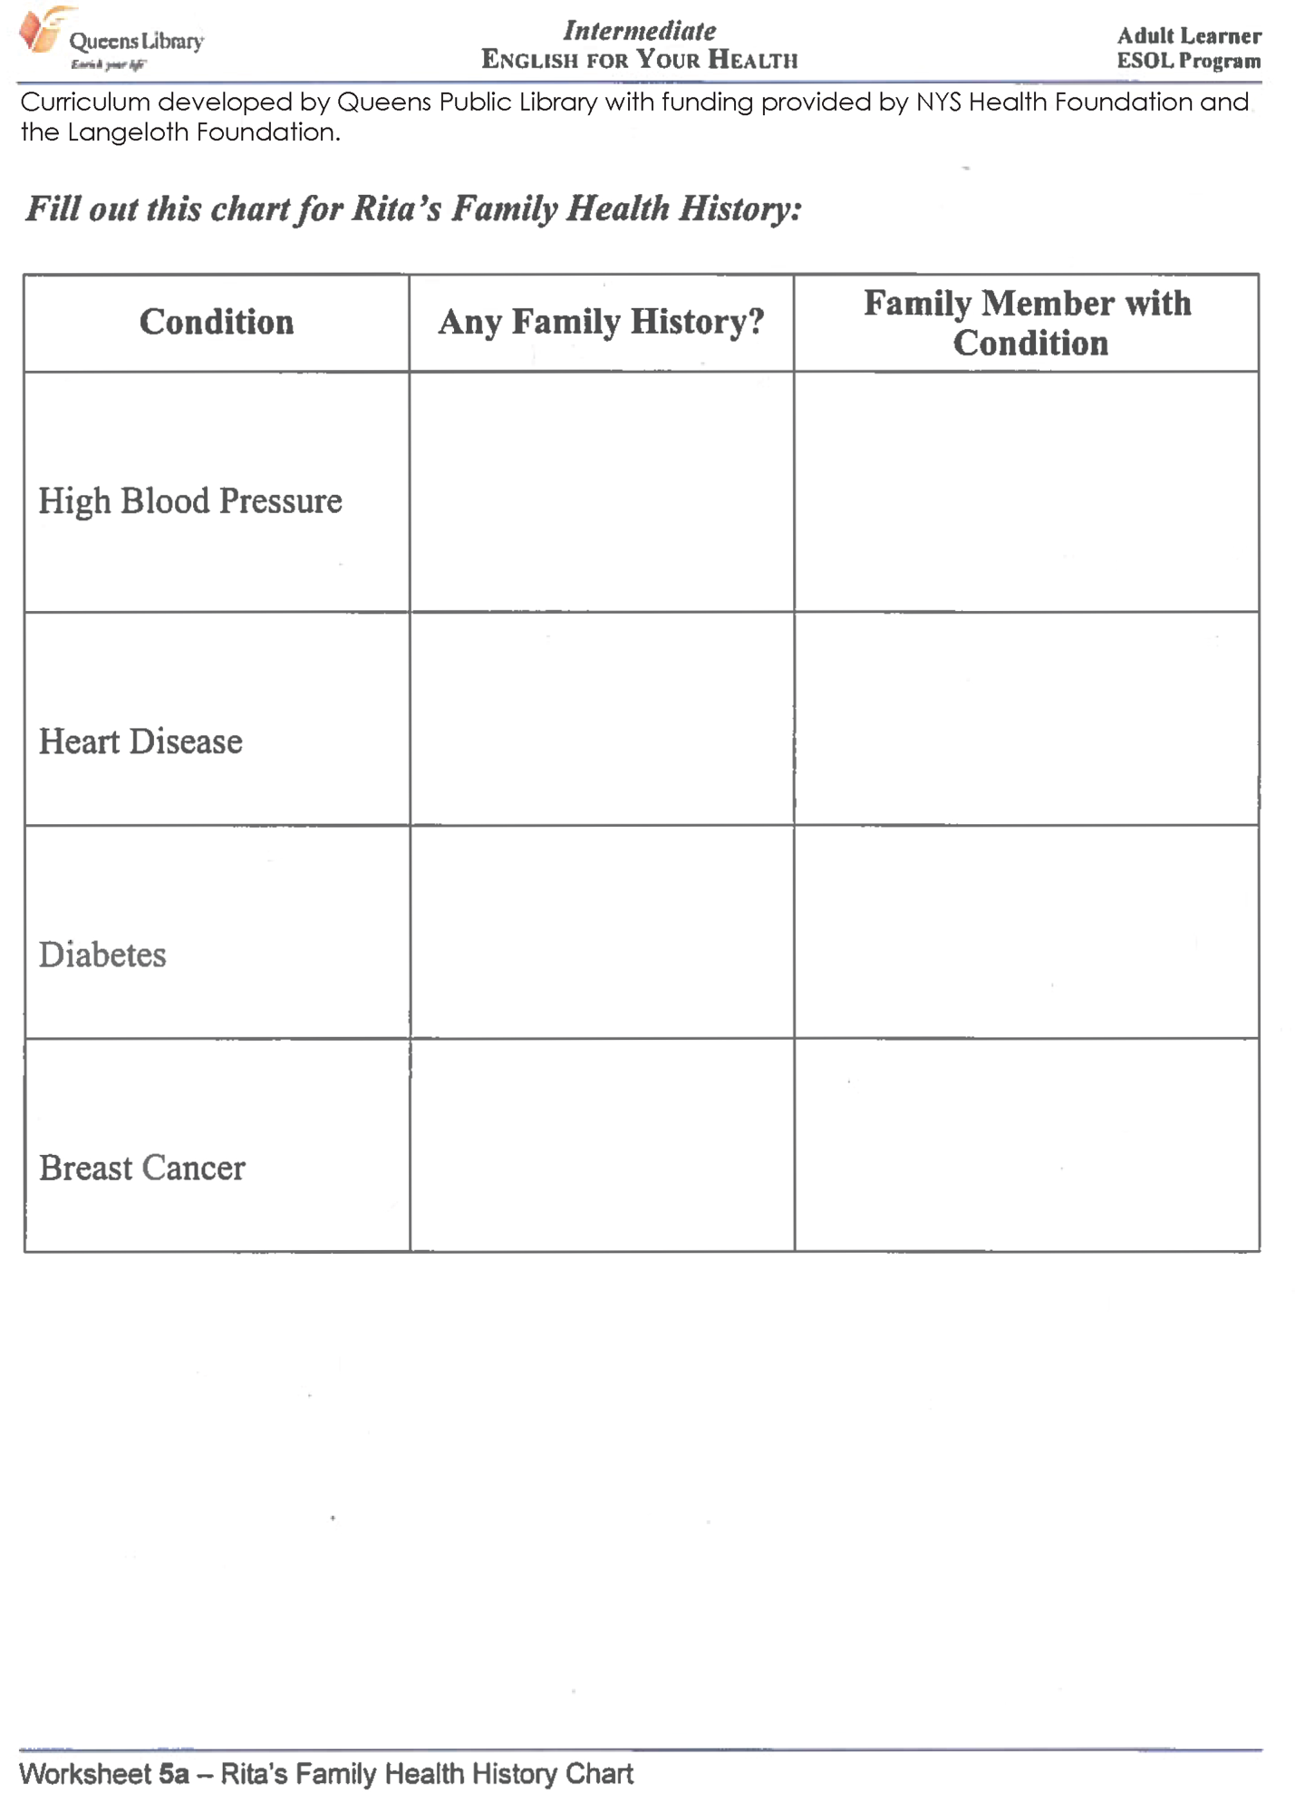
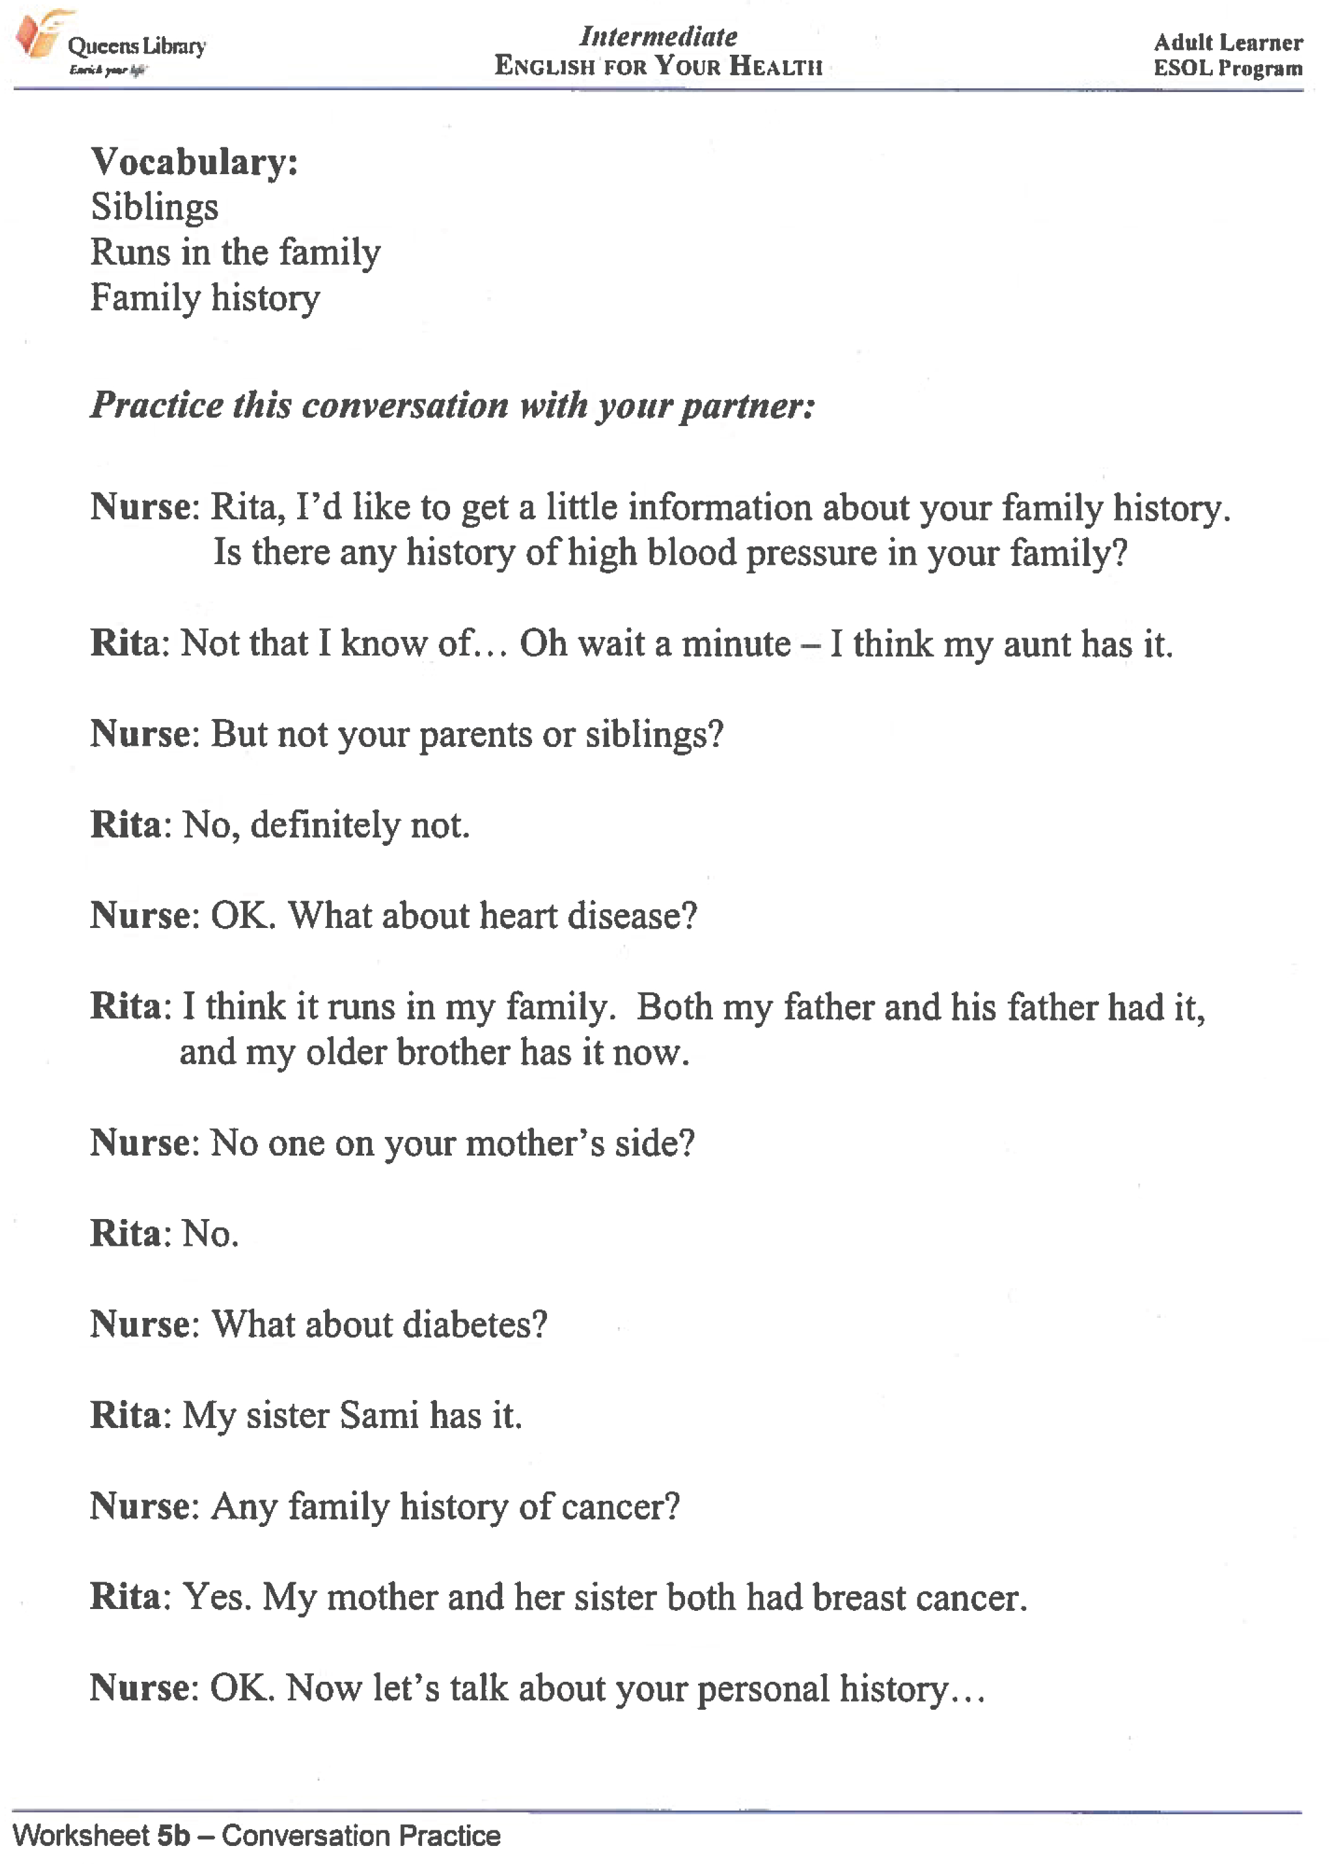
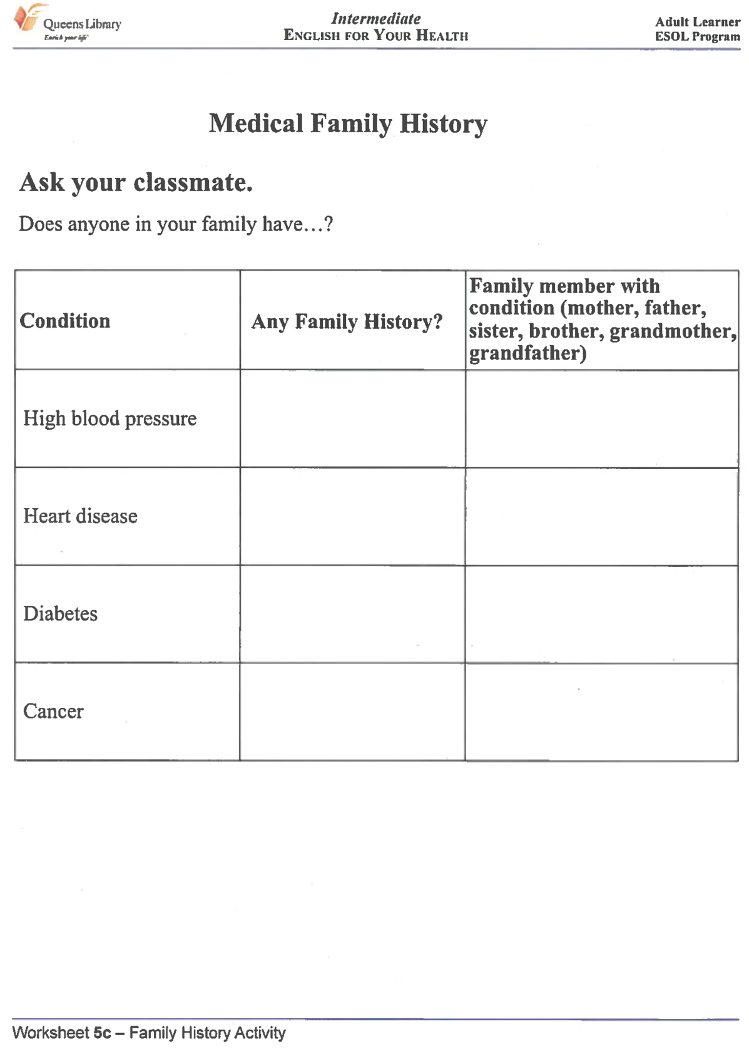
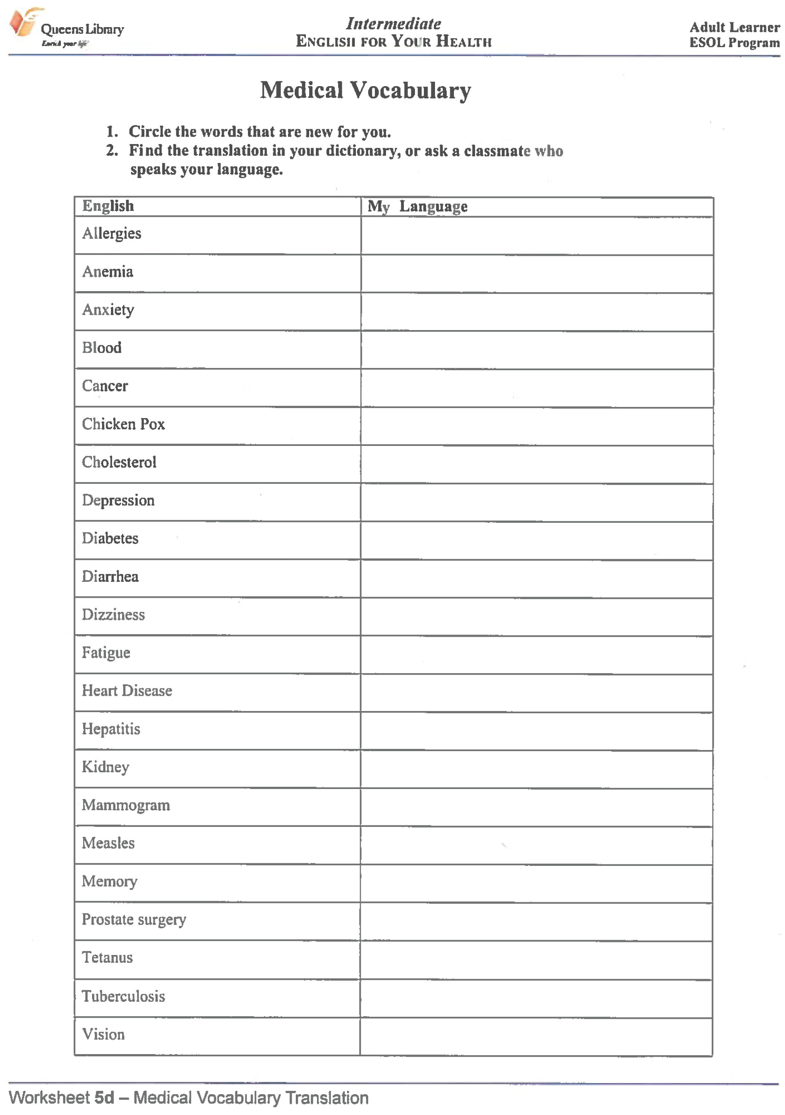
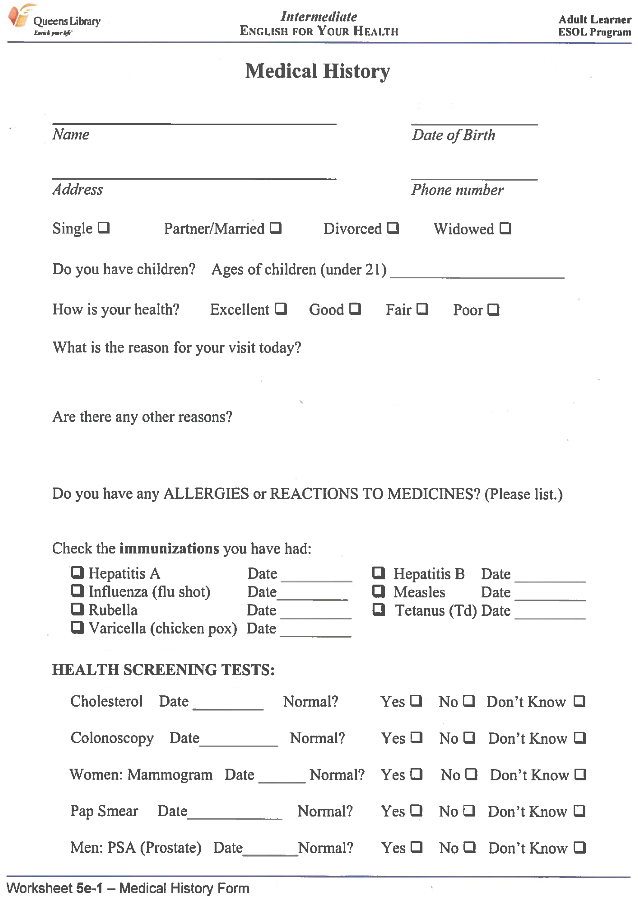
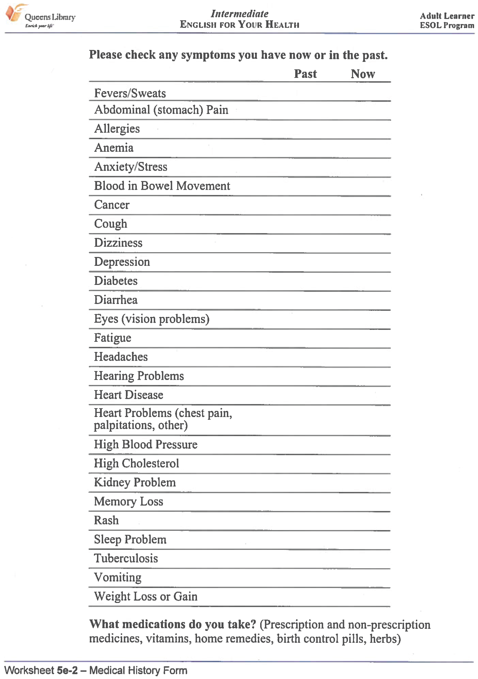
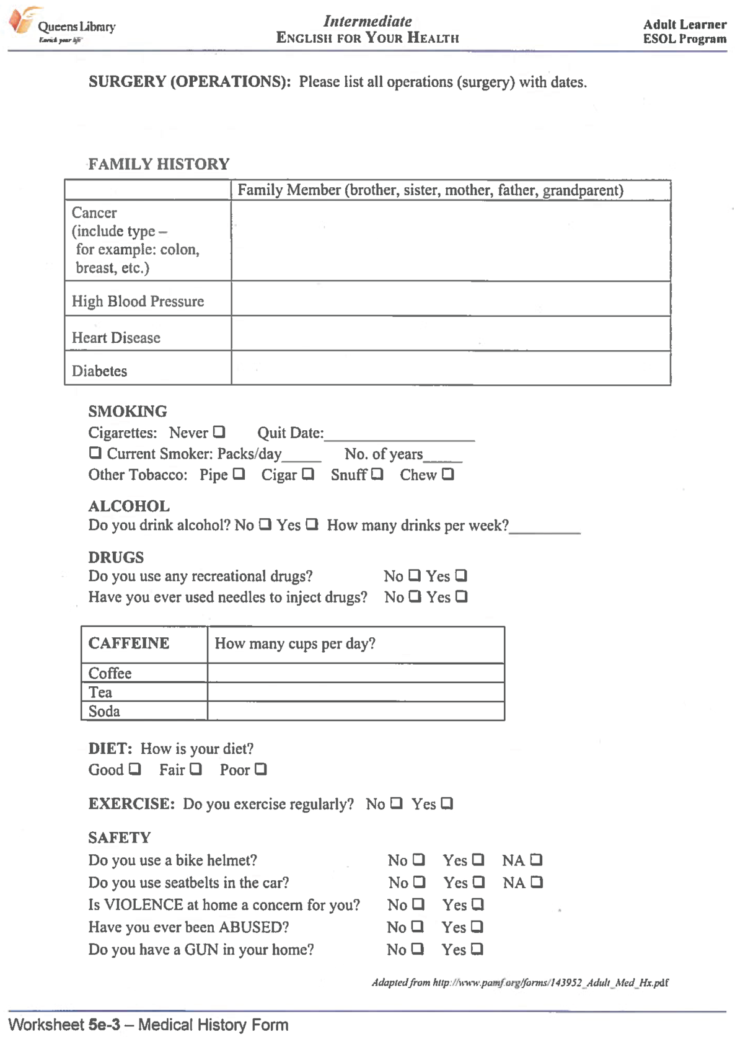
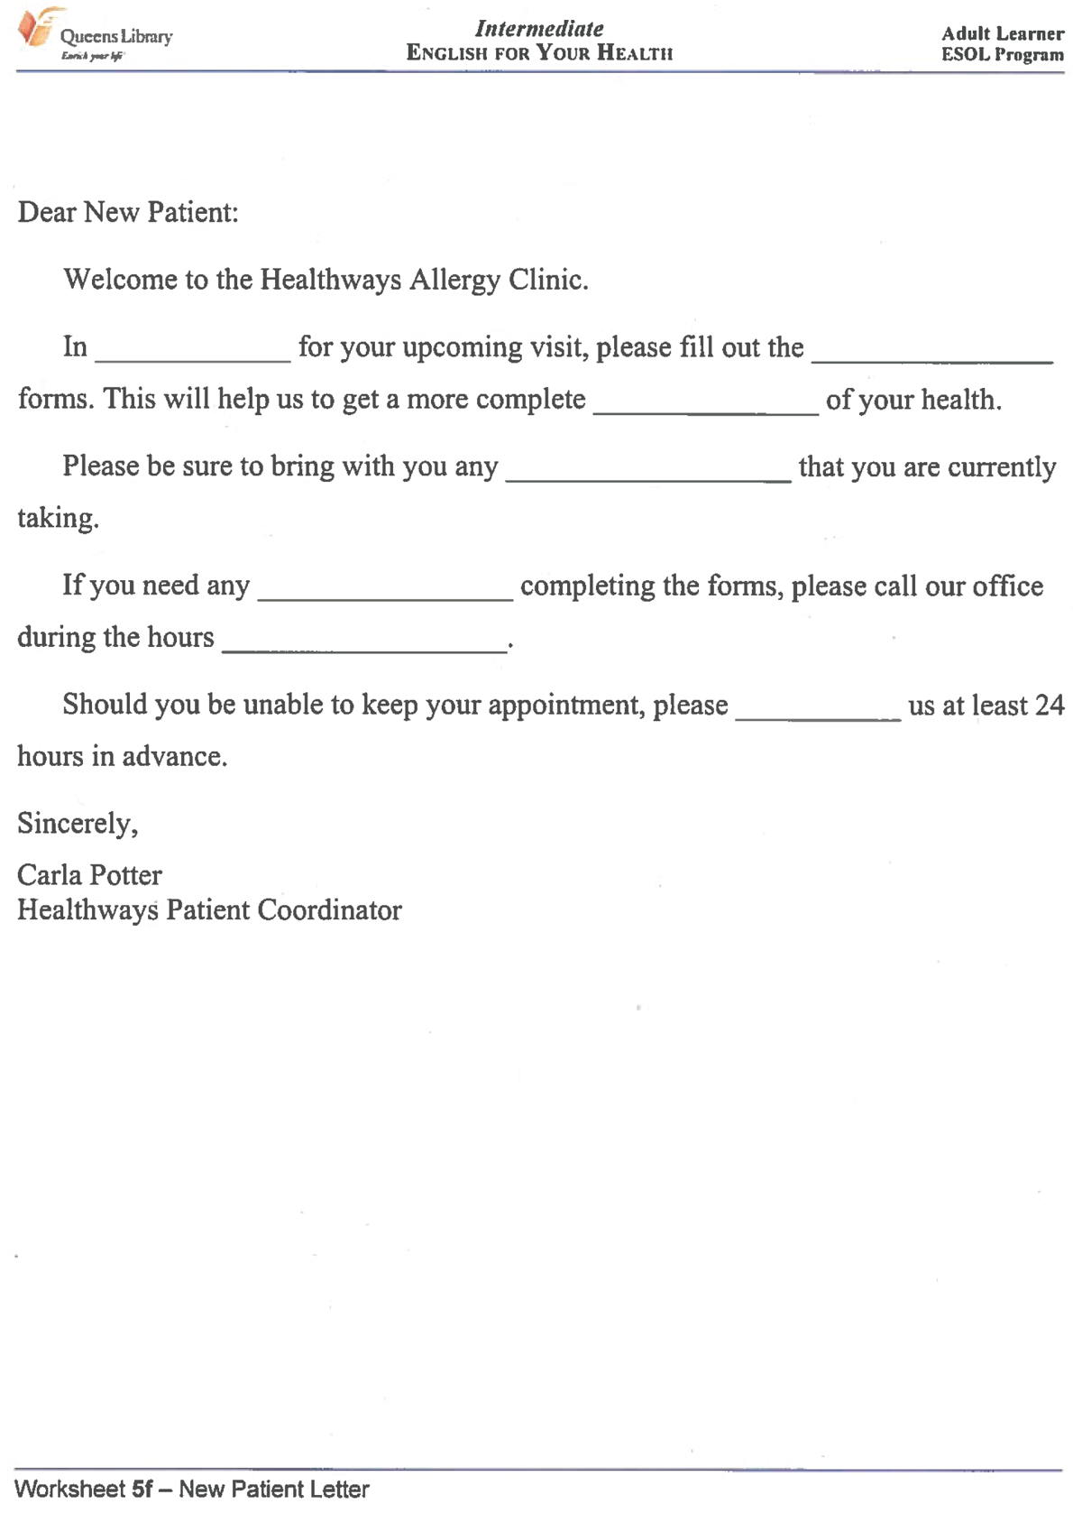

Your heart rate is how many times your heart beats in one minute. If your heart beats 70 times in one minute, you would say that your heart rate is 70 beats per minute.
Often, a nurse will find a heart rate by counting a person’s pulse for 15 seconds.

Class Data

Name | Beats per 15 seconds | Beats per minute
A baby | 30
An adult with a fever | 35

How did you use the number of beats in 15 seconds to find the beats per minute?

Personal Heart Rate

What is your heart rate (beats per minute)? _________

Personal Heart Rate Table

Time in Minutes (M) | My Total Number of Heartbeats (B)
1
2
3
5
10
30
60 (an hour)
1,440 (a day)

What is a rule for finding the total number of heartbeats when you know
the number of minutes?

Valeria is 63 years old. She is keeping track of her heart rate.

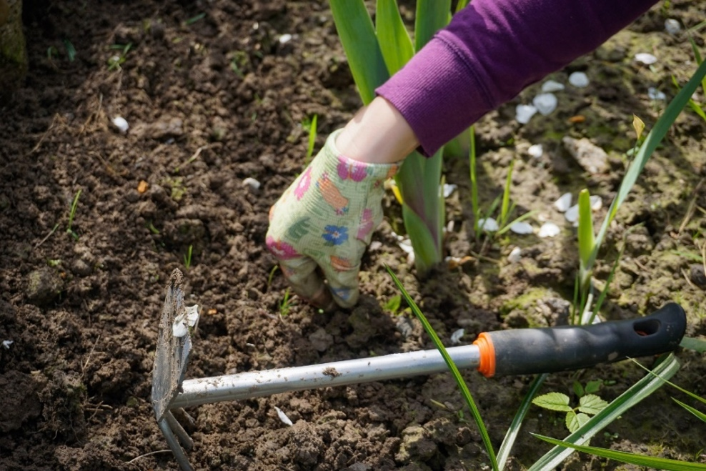

Activity Heart Rate

Sitting still watching TV 65 beats per minute
While walking 80 beats per minute
While working in the garden 100 beats per minute
After jogging on the treadmill for 10 mins 140 beats per minute

With a partner,

- Compare Valeria’s heart rate during different activities.
- Choose one or more of the activities. How many times would her heart beat in 5 minutes of that activity? How many times would her heart beat during 10 minutes of that activity? How do you know? (Hint: An in-out table could help you see patterns.)
- What activity do you like to do that would raise your heart rate?

LESSON 3: MEDICATIONS (Units of Measurement)

Rationale
Over-the-counter and prescription medications include two types of information, both of which are found in the packaging and are intended to inform consumers and reduce risks associated with taking any type of medication. One type of information helps consumers understand key information about a specific medication such as how to take it, how to store it, and safety measures. You see this on the packaging label as well as the paper handout found inside the medication package, known as the Medication Guide. The Medication Guide also offers detailed information about the drug including what it is, FDA approvals, and in-depth information on risks associated with the medication and what to do if you experience certain side effects. It can be a lot of information to process – but it’s critical that consumers understand this information to keep themselves and their families safe.
Lesson 3 focuses on consumer safety using the context of taking medications. The language activities target literacy skills that will help students navigate the information found on medication labels and instructions. In addition, students will practice speaking with a health professional, like a pharmacist, in order to ask questions that are specific to their health situation (for example, if certain medications can be taken together, or whether it’s safe to take a certain medication when pregnant). We have integrated math to provide learners with a deeper understanding of measurement and proportional reasoning which are essential for understanding safe consumption/dosing when using medications.

Background

Weight and Volume
Medication, food, and personal care items can be sold by volume or weight. If the product you are purchasing is measured in pounds, ounces, grams, or kilograms, it is measured by weight. Sometimes this information is pointed out on the package (“Sold by weight; Product may have settled”) to explain why the container may not be full when you open it up. The metric system uses handy prefixes that help us understand the ratios. For example, kilo means one thousand, so 1 kilogram is equal to 1,000 grams. Other standard units of weight, like pounds and ounces, don’t have such clear-cut relationships (16 ounces equals 1 pound), but are nevertheless commonly used in the U.S.
Other products (especially liquids) are often sold by volume instead of weight. When we buy something sold by volume, the product is measured by the amount of space it takes up. Volume can be confusing, not least of all because there are so many different units. Considering that many Americans are confused by standard measurements for volume, it’s no wonder that they can be especially confusing for folks who have never encountered them before coming to this country. (See included Teacher Resource: Volume Units for notes on different units of volume.)
Here are some teaching strategies to keep in mind when teaching and exposing students to standard units of volume:
- Bring in containers to demonstrate different sizes. Let students see, hold, fill, pour, and measure to develop physical and sensory connections to these different measurement units.
- Emphasize different units and conversions depending on the context. If you are talking about purchasing gas, discuss the relationship between liters and gallons. If you are discussing medication, look at milliliters, fluid ounces, or possibly tablespoons and teaspoons. Not all units are common in every context, and some conversions (like turning gallons into milliliters) have less real-world application.
- Explicitly point out names and abbreviations that can be confusing, such as ounces and fluid ounces (oz and fl. oz, which are completely different units) and tablespoon and teaspoon (t and T, or tsp and tbsp, which can be easily confused).
- In countries that use the metric system, recipes often measure ingredients by weight (grams), instead of volume (cups), as is common in the U.S. This can make conversions tricky, since the measurements are based on different physical properties.

Picturing Ratios
Ratios appear throughout this lesson and unit, both when thinking about measurement conversions and when using proportional reasoning to extend patterns. Simple pictures can help students understand a ratio as a “for every” relationship that can repeat. For example, when students are trying to understand the relationship between milliliters and fluid ounces in the Liquid Medications activity, simple drawings like this could help them see that for every fluid ounce, there are (about) 30 mL.
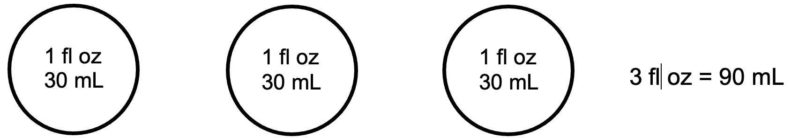

Tables – Looking for Rules
Sometimes the dosage of a medication can vary, depending on the person’s size, age, or weight. In this lesson, students are given a table (a dosing chart for Children’s Tylenol) and asked to look for and describe the patterns they find. In this case, there is a clear proportional relationship between the number of tablets and the amount of medication (or equivalent amount of liquid). However, the relationship between the tablets and the body weight of the child is less clear and not fully proportional. When students are developing proportional reasoning, it is also important for them to recognize when it is not appropriate to reason proportionally (doubling the weight of the child does not always mean we double the medicine).

LESSON 3: MEDICATION LESSON PLAN

Prior Knowledge
- Addition and/or multiplication of whole numbers within 1,000 (calculators OK)
- Division by small, whole numbers (calculators OK)
- Estimation and/or rounding

ESOL Tasks
- Distinguish between prescription and over-the-counter medication
- Interpret medicine label warnings and dosage
- Describe and compare generic and brand names
- Read and understand directions for children's medication
- Formulate questions for doctors and pharmacists

Math Concepts Addressed
- Understand the difference and the relationship between teaspoons and tablespoons
- Use proportional reasoning to discover the relationship between milliliters and fluid ounces
- Convert between milliliters and fluid ounces, using estimation
- Read a dosage chart
- Look for patterns in tables to decide if a relationship is proportional
- Distinguish between commonly confused units of weight and volume used for medication (ounces vs. fluid ounces)

Materials

Introduction/Warm Up
- Handout: Medication or Drug?
- Three to five packages of over-the-counter medications such as pain reliever, antacid, etc. or images of both over-the-counter and prescription medicine labels (at least three of each), including the Drug Facts labels

Activity II. Reading over-the-counter (OTC) medication labels
- Labels from OTC medication or use Handout: OTC Drug Labels
- Handout: Pictogram Flash Cards / Pictogram Flash Cards Answer Key
- Handout: Interpreting Warnings and Directions

Activity III. Compare over-the-counter and prescription labels
- Handout: Prescription Labels
- Handout: Prescription Label Questions

Activity IV. Listening practice: Prescription medication
- Audio files for Listening Comprehension: Prescription Medication
- Handout: Listening Comprehension: Prescription Medication

Activity V. Speaking practice: a conversation with the pharmacist
- Video: Meet Blue: Generic Medication PSA
- Handout: Generic Drug Facts
- Handout: Questions to ask your doctor about your medicine

Activity VI. Spoonfuls
- Teaspoons and tablespoons, both silverware and measuring spoons
- Measuring syringe (or Handout: Medication Syringe)
- Uncooked rice or sand
- Trays such as baking sheets or flat plastic lids from containers
- Optional Handout: Spoonfuls

Activity VII. Liquid medications
- Handout: Fluid Ounces and Milliliters
- Calculators (or students can use their phones as calculators)

Activity VIII. Medication dosage by weight
- Online Resource: Dosing for TYLENOL® Children’s & Infants’ Medicine
- Calculators (or students can use their phones as calculators)

Optional activity: Weight or volume?
- Examples of items by weight in ounces and by volume in fluid ounces (pharmacy type items work well)
- Handout: Weight or Volume?

Activity IX. Reading activity: Following Directions
- Handout: Information about your Medicine
- Handout: Taking Medicine and Reading Medical Labels

Math Vocabulary

- teaspoon (tsp)
- tablespoon (tbsp)
- accuracy / accurate
- liquid volume
- fluid ounces (fl oz)
- milliliters (mL)
- milligram
- weight, to weigh
- volume
- ounces
- equivalent

INTRODUCTION / WARM UP
- Bring in some examples of over-the-counter (OTC) medication such as a pain reliever, antacid medication, lotions for skin irritation, etc. or take photos of medication containers and print them out.
- Ask students how they would categorize the examples. For example, they might organize into categories such as lotions, creams, pills, or OTC versus prescription. If students do not know the terms over-the-counter and/or prescription, or other key vocabulary (tablet, pill, etc.), write them on the board. Ask how the medications are different and how they are alike.
Note: The words medicine and medication and sometimes drugs are often used interchangeably. However, there are differences. Here is an explanation of the differences among these three words:
Medication is the proper term for substances used for medical treatment, especially pharmaceuticals and include vitamins and other supplements people take for health reasons. They are intended to have a positive effect.
Medicine is the art or science of healing. There is holistic medicine, allopathic medicine, homeopathic medicine, etc. They are intended to have a positive medical effect.
Drugs can have both positive and negative effects. For example, heroin is a drug that has negative effects and no positive effects. Prescription pain medication is a drug that can have positive effects when taken as prescribed but negative effects when not.

- Using the handout Medication or Drug?, give students the definitions of medication and drugs and examples of each. Students assign each example to one part of the Venn diagram.

ACTIVITIES

I. Thinking critically
Ask students to think about the last time they bought over-the-counter (OTC) or prescription medication. Where did they purchase it? What questions did they have about the medication? If needed, you can prompt them with further questions such as:
- What information is important to think about before taking any medication?
- What options do you have for getting answers to your questions?
- What can you do if you don’t understand the answers to your questions? (We’ll come back to this last question later in this lesson.)

II. Reading over-the-counter (OTC) medication labels
Labels on most OTC and some prescription medications have important information, called “Drug Facts”, on or inside their packaging. This information is organized by categories and labeled with the same headings and in the same order on most, if not all, medications. They are:
Active Ingredients
Purpose
Uses
Warnings
Directions
Other information
Inactive ingredients
A starting point for interpreting medicine labels is understanding the labels and the organization of categories, which is usually in a table format with rows and possibly columns.
- Show students two or more medicine labels for OTC medication (or use the OTC Drug Labels handout) and ask them to look at how the information is organized, and how they know what words are important. Possible answers are: categories/groups of information, rows, columns, headings in dark print, warnings in red, etc.
- Ask students to write the names of the seven headings found on two different labels and explain, in their own words or with examples, what each heading means. Give your own examples as needed.
- Ask students to work together and list three general warnings found on most medications. Possible answers include: Do not take more than the maximum daily dosage listed or for prolonged periods of time; consult a doctor if pregnant; do not mix with other medications.
- Divide the cut-up Pictogram Flash Cards into two sets of ten cards. Pair students and give each pair one of the two sets of flash cards. Ask them to write the warning indicated on the card. Tip: If you color code the sets, it helps to keep them organized and facilitates the ‘pair share’ activity in the next step. Check student work for accuracy (refer to the Pictogram Answer Key handout) before the next step.
- When pairs complete the warning descriptions, ask them to ‘teach’ the warnings on their flash cards to a student pair who had the other set of flash cards. They can do this by showing the image on the card and explaining the warning using the imperative form of verbs such as take, use, shake, etc. and modals like should/shouldn’t, may/might, etc.
- Give students a copy of the Pictogram Answer Key to use as a reference at home.
- Next, refer students back to the OTC medications packaging or the OTC Drug Labels handout and ask them to read the warnings and directions and fill in the chart on the handout, Interpreting Warnings and Directions. Provide vocabulary as needed.
- Most medication has an expiration date. Ask students to locate the expiration dates on a few packages or containers. They are not always easy to read and are often stamped on the bottom of the package. You can also discuss safe disposal of medications. Here is one resource: Drug Disposal: Drug Take Back Locations.

III. Compare over-the-counter and prescription labels
Prescriptions medication has similar information regarding warnings and directions, and they have additional information that OTC drugs do not.
- Give students an OTC label and a sample prescription label from the handout Prescription Labels. Ask students to write five pieces of information that are found on prescription medications but not on OTC medication. (Answers: doctor’s name, patient’s name, Rx#, pharmacy phone numbers, number of pills in bottle, possible number of refills).
Note: Students may ask what “Rx” means. Here is a resource explaining why Rx is used as an abbreviation for prescriptions: https://www.merriam-webster.com/dictionary/Rx
- Using the handout Prescription Label Questions, students read the labels and answer questions about each one.

IV. Listening practice: Prescription medication
- Use the four audio files Listening Comprehension: Prescription Medication. These are short dialogues between a patient and a doctor about taking prescription medication. Students listen to the recording and place a check mark under the appropriate columns using the handout Listening Comprehension: Prescription Medication. Each audio file is under 25 seconds.

V. Speaking practice: A conversation with the pharmacist
- Pre-teach the word generic by showing students a store brand of a product and a name brand. Ask if anyone currently takes a generic medication and why. If it doesn’t come up, tell them one is less expensive. Ask which type of medication they believe is cheaper and why they think so.
- Use one or both of the resources below to validate or add ideas that students have presented:
A 30-second video about generic medication: Meet Blue: Generic Medication Public Service Announcement
The one-page U.S. Food and Drug Administration resource Generic Drug Facts (can be read in pairs)

- Based on the information they watched/read, ask students report back what they have learned about generic drugs, and if they would ask a doctor/pharmacist about the availability of a generic medication.
- Ask students to write a list of questions they might ask a pharmacist about any medication. When they are done, students compare their lists with three or four other students and create a master list. Here are a few questions you may want to prompt students to think about in case they are not mentioned:
Will this medication interact with ______(list other medications, vitamins, and supplements)?
Does this medication cause weight gain or loss of appetite?
Is it safe to take this medication if I am pregnant, trying to get pregnant, or breastfeeding?
- Groups can report out on their list. Using students’ questions, create a handout for future reference or ask for volunteers to create a handout that captures all the questions. Students can add questions to their list that are specific to their personal circumstances.
Note: See the teacher resource Questions to ask your doctor about your medicine.
- Role-play: Using labels from OTC or prescription medication and the questions they have created, students role-play a conversation with a pharmacist.
- Wrap up by asking students: Are there questions that are difficult to ask? Why? What other options do you have? (Ask to speak to them in private; ask over the phone; ask the doctor instead of the pharmacist; go to a health facility with a translator on staff or with family member).

VI. Spoonfuls
There is some important debate in the news about using standard versus metric measurement for medications. In this activity, students will first distinguish between and compare teaspoons and tablespoons and then discuss the levels of accuracy of different measuring tools, and appropriate uses for each tool. Finally, they will read an article about which system of measurement is recommended for consumers and why.
- Pass around silverware teaspoons and tablespoons. See if students know what they are called. Teach the name and abbreviation for each.
- Ask students if they have seen these abbreviations used as measurements, either in recipes, medications, or consumer products. Explain that in addition to being the name of a type of silverware, tablespoons and teaspoons are also measurements of volume. They might tell us how much cinnamon to add to a recipe or how much cough syrup to give a child.
- Pass around measuring spoons that are tablespoons and teaspoons. Ask students why they think the measuring spoons would be more accurate than the tableware. (For one thing, measuring spoons are designed to have a flat top, so you can tell when you have filled them properly, or so you can scrape off extra dry ingredients. Also, measuring spoons are made in 1/2 tablespoons, 1/4 tablespoons, etc., because it is very difficult to accurately measure half of a rounded spoonful by eyeballing it. In addition, the shape and volume of tableware can vary between styles and manufacturers and what looks like a teaspoon may actually hold a little more or less.)
- Ask students to estimate how many teaspoons fit inside a tablespoon, based on their observations of the spoons in front of them. How could we find out for sure?
- Allow students to measure a dry ingredient (like rice) to find the actual ratio, which is 3 teaspoons to 1 tablespoon. You may want to have them do this over trays for ease of clean up.
- Explain that teaspoons and tablespoons used to be very common for measuring liquid medication in the U.S., but have become less common.
- Depending on student level, have students read one or more of the resources mentioned in the Strategies for Differentiation (below).

4 Strategies for Differentiation

More accessible:
For beginning levels, give student pairs a copy of the article 2 simple ways to ensure you give your kids the right dose of medicine (lots of parents don’t) or Giving Your Child the Correct Medicine Dosage. (The latter article has a companion On Call for Kids video that we recommend.) An alternative article for more advanced students is the article Medicines: Using Them Safely.
- Ask the pairs to scan the article for unfamiliar vocabulary and mark those words. As a class, go over the vocabulary before the next step.
- Read the article aloud, pausing after main ideas, and using spoons, and milliliter droppers, illustrate the text by showing different shaped teaspoons.
- In the last paragraph, ask them to name a few reasons why many medical experts think it is not a good idea to use teaspoons and tablespoons to dispense liquid medication.
- Students read the article aloud together in pairs.

More challenging:
- Give each student a copy of the article and ask them to write the main ideas and three to five details that provide support for using metric (milliliters) vs. standard (teaspoons, tablespoons).
- Show an example of a medication syringe like the one mentioned in the article or use the handout Medication Syringe.
- Give out the handout Spoonfuls. Have students notice and wonder. Ask them what patterns they see, and what that tells them about how these different units are related.
Activity VI in Action
"Converting within units or even within different measurement systems is something that students generally want to avoid. They usually would just use Google to search for the answers they need whenever they are not acquainted with the terms or relationships between these systems/units. They realized that they encounter this type of math in a daily basis and that they needed to understand it in order to apply it.

We also went over its use in cooking and reading container labels for food… It really helped using props to demonstrate the relationships between the measuring units and tools. They enjoyed manipulating these tools and I really think that this strategy helped the learning become memorable as well as meaningful… I emphasized on the importance of reading medicine instructions very carefully and following them with accuracy. They found the reading "A spoonful of medicine may be too much" very interesting since most of them had been providing medicine to their kids using teaspoons or tablespoons. We had discussions on what to do and what procedures to follow in order to avoid risks associated with taking any type of medication.”

ESOL (low/high beginner) Instructor– Genesis Center, Providence, RI

VII. Liquid medications
In this activity, students will come up with an approximate ratio of fluid ounces to milliliters and then use this ratio to convert between fluid ounces and milliliters.
- Ask students what medications they have seen in a liquid form. Explain that in order to measure the right amount of medicine, we need to use units of liquid volume (the amount of space a liquid takes up). Dosages are often given using fluid ounces, milliliters, or both.
- Talk for a minute about fluid ounces. Fluid ounces has an irregular abbreviation (fl oz), and it’s also confusing because the standard measurement system also has a unit of weight called an ounce (oz). Fluid ounces measure volume, ounces measure weight. Sometimes people leave off the word “fluid” and call both forms ounces, but they are different units. You have to consider the situation to see if weight or volume is being measured.
- Give students the handout, Fluid Ounces and Milliliters. Ask them to look closely at the pictures. What do they notice? What do they wonder?
- Ask students to work with a partner or a small group to describe the relationship between fluid ounces and milliliters (about 30 mL in 1 Fl oz). Have a few groups share out how they determined the relationship.
Some possible guiding questions:
What are some amounts that are equal?
What is larger, a fluid ounce or a milliliter? How do you know?
If you double the number of fluid ounces, do you also double the number of milliliters? Why?
- Bring in a few examples of products measured in units of liquid volume (such as hand lotion, sunscreen, or nail polish remover). On some products, cover the measurement in fluid ounces, and on others cover the measurement in milliliters. Have students use the relationship they discovered to estimate the liquid volume in the missing unit.
Activity VII in Action
"At first, they had trouble understanding the difference between ounce and fluid ounce. Displaying containers for each measurement unit helped them realize that they can measure things by volume or by weight. They wanted more practice converting Fl oz to mL."

ESOL (low/high beginner) Instructor – Genesis Center, Providence, RI

"I passed out the realia and asked students what the items had in common. I wrote (milliliters) mL and fluid ounces (fl oz) on the board to see if students understood either and asked them to tell what they were used for measuring. Most students knew they were for liquids. Students also affirmed that mL is used in more native countries, but some understood fl oz too."

ESOL Level 2 (SPL 2-3) Instructor – Immigrant Learning Center, Malden, MA

VIII. Medication dosage by weight
In this activity, students will look for ratio patterns in a chart and then use ratio patterns to predict other amounts.
- Print out a few copies of the online resource Dosing for TYLENOL® Children’s & Infants’ Medicine, or project the web page in the classroom. Have students spend a few minutes looking at the chart. Ask them what they notice and what they wonder. Go over any unfamiliar vocabulary or abbreviations, such as:
dose/dosage
tablet
lb
mg / milligrams (used to measure the amount of medication in a tablet or liquid)
mL / milliliters (the amount of liquid used)
- Ask students what patterns they see in the table. Choose other questions below based on the level of your students (or offer choices).

4 Strategies for Differentiation

More accessible:
- What relationship do you notice between the amount of liquid and the number of tablets?
- How many tablets would be equivalent to 20 mL of liquid medicine? How do you know?

More challenging:
- There are 160 mg of acetaminophen (the medication in Tylenol) in each tablet. Find the amount of medication for each dose in the table. How do you know? What patterns do you see?
- There are 160 mg of acetaminophen in every 5mL of liquid. How many mg of acetaminophen per mL? How do you know?
- Do you see a relationship between the body weight and the dosage? Why or why not?

Optional: Weight or volume?
Students have looked at the warning signs and considered the danger of not giving correct dosages of medication. In this activity, students will learn the difference between weight and volume and identify the units used to measure them and then differentiate between fluid ounces (volume) and ounces (weight).
- Start by asking students, When do we measure weight? Brainstorm a list of contexts in which we often talk about or measure weight: body weight, new babies, buying deli food by the pound, weight limits on elevators and bridges, pay postage by weight (although the USPS now uses volume in the calculation as well), cooking (if students are used to using a kitchen scale to weigh out ingredients), etc.
- Check for understanding of volume: Ask students, If I blow up a balloon, what changes, the weight or the volume? (weight stays essentially the same, since air is so light, but volume increases).
- Ask students when we might want to know the volume of something instead of the weight. Some possible examples: volume of a box (to know if it will fit), volume of a liquid (how much water to fill the pool), volume of storage space.
- Ask students to name units used to measure volume, for example: cubic inch, cubic foot, cubic yard, tablespoon, teaspoon, fluid ounce, cup, pint, quart, gallon, cubic centimeter, cubic meter, milliliters, liters. (Students do not need to be familiar with all of these – focus on the units of liquid volume (fluid ounce, cup, pint, quart, gallon [standard] and milliliter, liter [metric]) for now.)
- Explain that one thing that can be very confusing in standard units is that there are two different types of ounces: ounces (oz) as a unit of weight (16 oz make 1 lb), and fluid ounces (fl oz) as a unit of volume (8 fl oz make 1 cup). To make things worse, sometimes people refer to fluid ounces (volume) as simply “ounces,” such as, A medium coffee is 12 oz. How can we tell the difference?
- Give out the handout, Weight or Volume? Have students look at the two columns of examples. What do they notice? What do they wonder? What are some clues that tell you whether something is sold by weight or volume?
- Based on what they observed, have them decide whether the measurements for the examples on the back of the page refer to weight or volume.

Follow up activities:
Ask students to bring in examples of packaging sold by weight or volume. Have students sort the examples and create a display in the classroom.
Ask students to keep track of how many fluid ounces of water they drink in a day. Collect data over time.
Have students create an in-out table for the relationship between ounces and pounds.
16 oz = 1 lb
32 oz = 2 lb
48 oz = 3 lb, etc.
You can follow up with questions like, How many ounces is a half-pound? Is 40 ounces closer to 2 lbs or 3 lbs? How do you know?

IX. Reading activity: Following directions
Here are two activities that can be used to emphasize the importance of understanding directions and taking medication safely. Choose the activity appropriate for the level of your learners.

More accessible:
- Use the handout Information about your Medicine, and circle the correct word.

More challenging:
- Using the handout Taking Medicine and Reading Medical Labels, students read the questions and answer ‘yes’ or ‘no’.

ASSESSMENT
Ask students to reflect on what they have learned in this lesson and write a guide for other students.
More accessible:
Students write a guide in list form that includes two to three examples of the following:
- Important Drug Facts for OTC medications: what they are, what information to look for
- Different ways a medication can be measured, and how to find the right dose
- Questions to ask a pharmacist for OTC or prescription medication

More challenging:
Students create a Safe Medication Cheat Sheet Guide on paper, as a poster, or as a slide presentation. Students can work in pairs or small groups and present their projects to students in other classes or other groups within their class.

ADDITIONAL RESOURCES
- Drug Disposal: Drug Take Back Locations (FDA web page)
- Meet Blue: Generic Medications PSA (video)
- Generic Drug Facts
- Buying and Using Medicine Safely (FDA web page)
- 2 Simple ways to ensure you give your kids the right does of medicine (lots of parents don’t)
- Giving Your Child the Correct Medicine Dosage
- On Call for Kids—Medicine Dosage in Children (video)
- Medicines: Using Them Safely (text with audio available)
- Dosing for TYLENOL® Children’s & Infants’ Medicine

Unit | System | Common Abbreviations | Notes
Cubic meters | Metric | m³ | Very large volume. Unlikely to be encountered in food or pharmacy items.
Cubic centimeters | Metric | cm³, cc’s | 1 cc is equal to 1 mL. Sometimes used for medications.
Liter | Metric | L | Unit of liquid volume. 1 liter is equal to 1,000 milliliters. Very close to 1 quart.
Milliliter | Metric | mL | Unit of liquid volume, equal to 1 cc. Often the preferred unit for liquid medications.
Teaspoon | Standard | t, tsp
Tablespoon | Standard | T, tbsp | 1 tbsp is equal to 3 tsp and .5 fluid ounce. No longer preferred for measuring medication.
Fluid ounce | Standard | fl oz, or sometimes just oz | Easily confused with ounce, which is a standard unit of weight. Often used for liquid products. 1 fluid ounce is equal to 2 tablespoons, and close to 30 milliliters.
Cup | Standard | C | 1 cup is equal to 8 fluid ounces. Commonly used for serving sizes and in recipes.
Pint | Standard | pt | 1 pint is equal to 2 cups.
Quart | Standard | qt | 1 quart is equal to 2 pints or 4 cups. Very close to 1 liter.
Gallon | Standard | gal | 1 gallon is equal to 4 quarts, 8 pints or 16 cups.

*Standard units of volume also include cubic inches, cubic feet, etc., but these are rarely encountered in food or pharmacy items.

- What is the difference between medication, medicine, and drug? Discuss what you know with your partner.
- Based on the definitions the teacher has given you, put the following words into the correct space in the Venn diagram below. The middle space is for items that can be either a drug or a medication, depending on how it is used.

Over-the-counter pain reliever
(Tylenol, Advil, Motrin)
Heroin
Antacids
(Tums, Zantac, Prilosec)
Cough syrup
Inhalers for asthma
Prescription pain reliever

Over-the-counter sleep aid
(Sominex, Unisom, Melatonin)
Cold tablets
Lactaid tablets
Marijuana
Calcium
Antibiotics
Cocaine

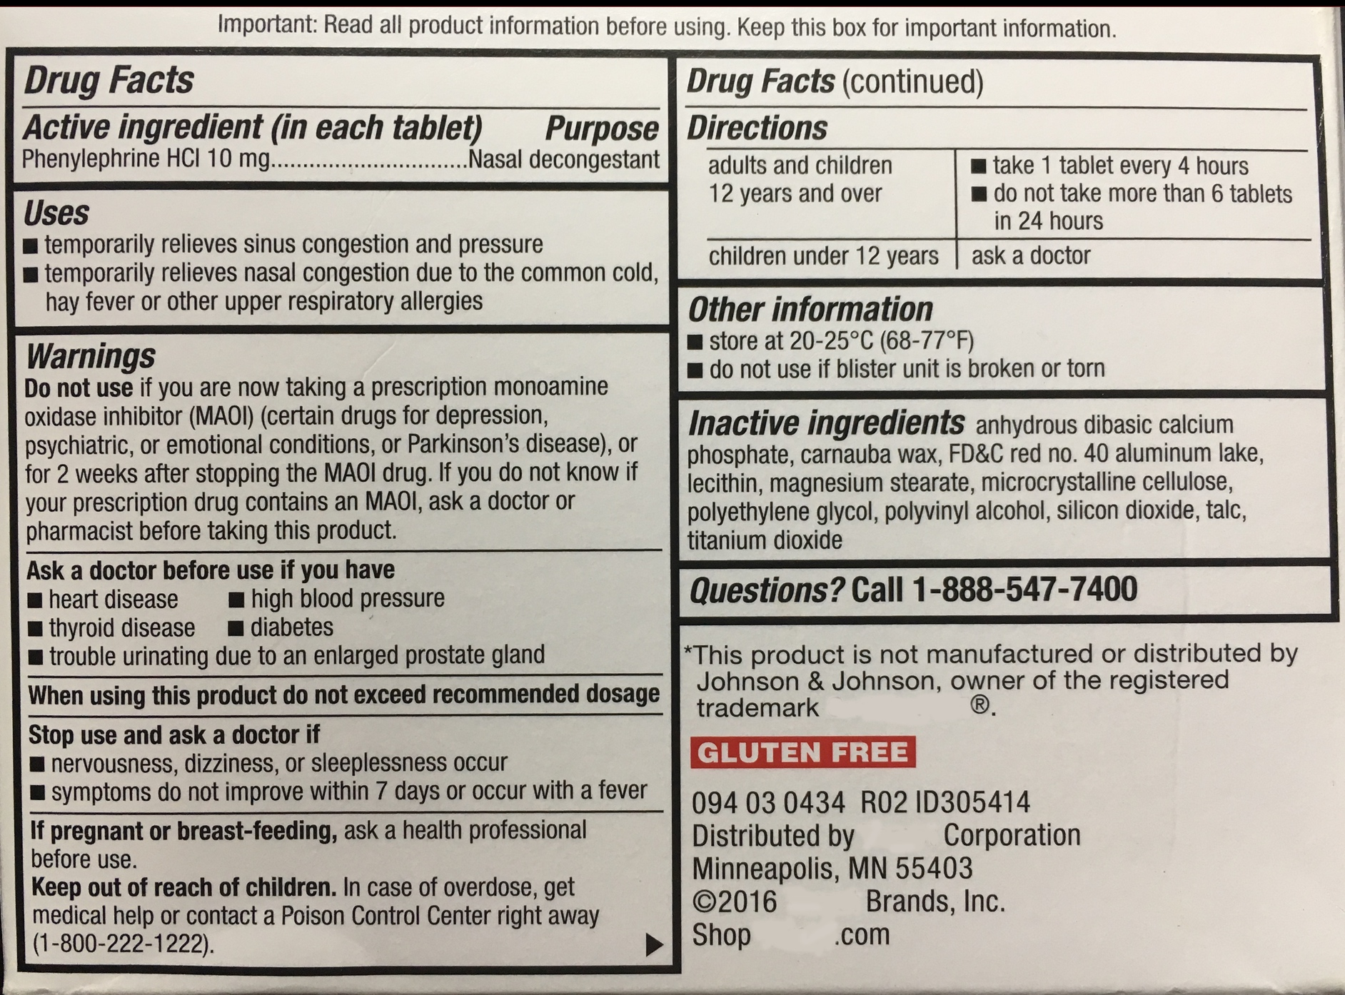
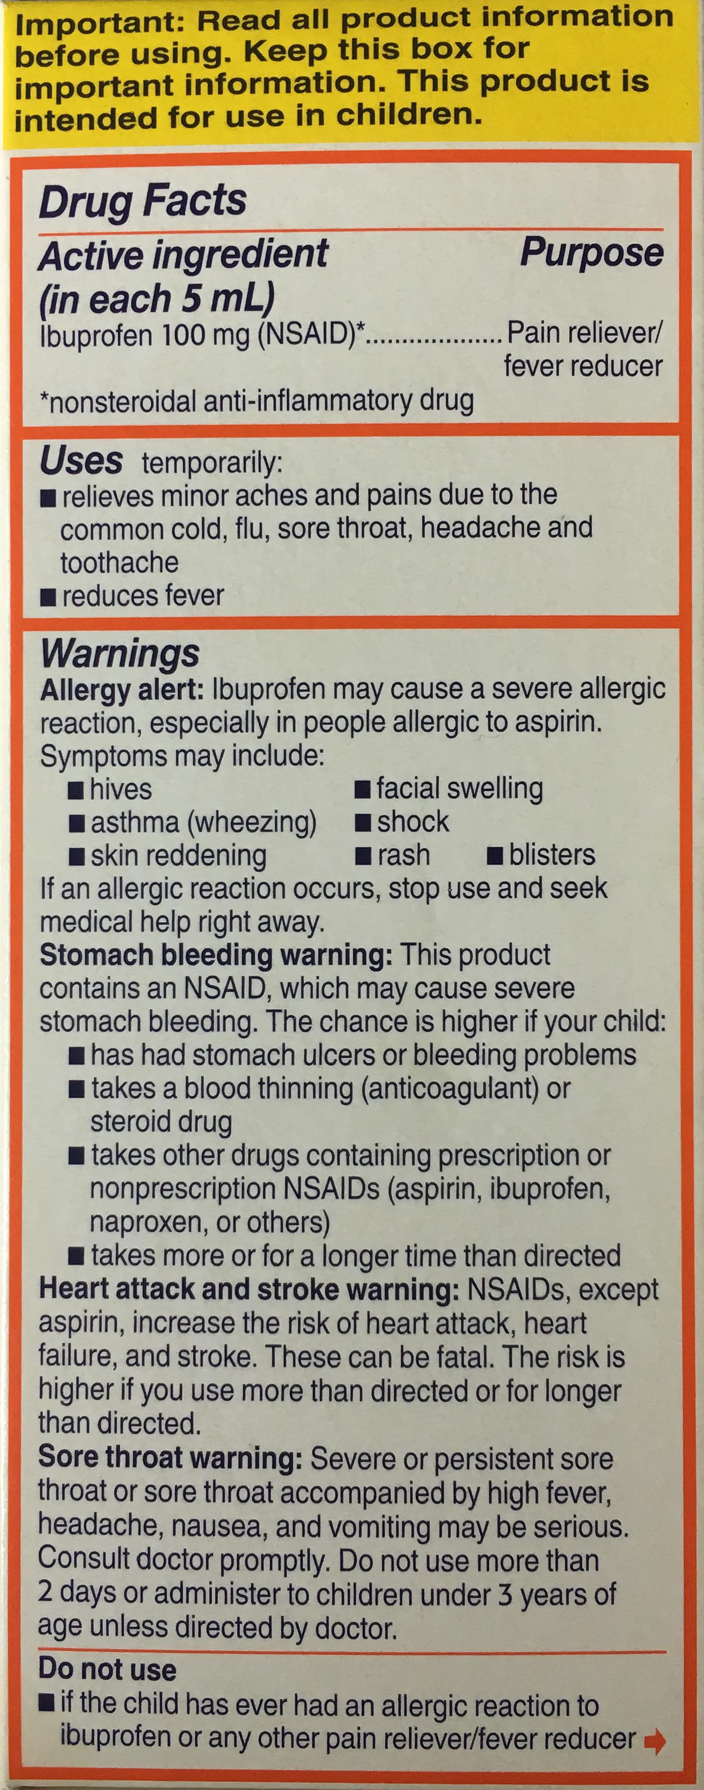

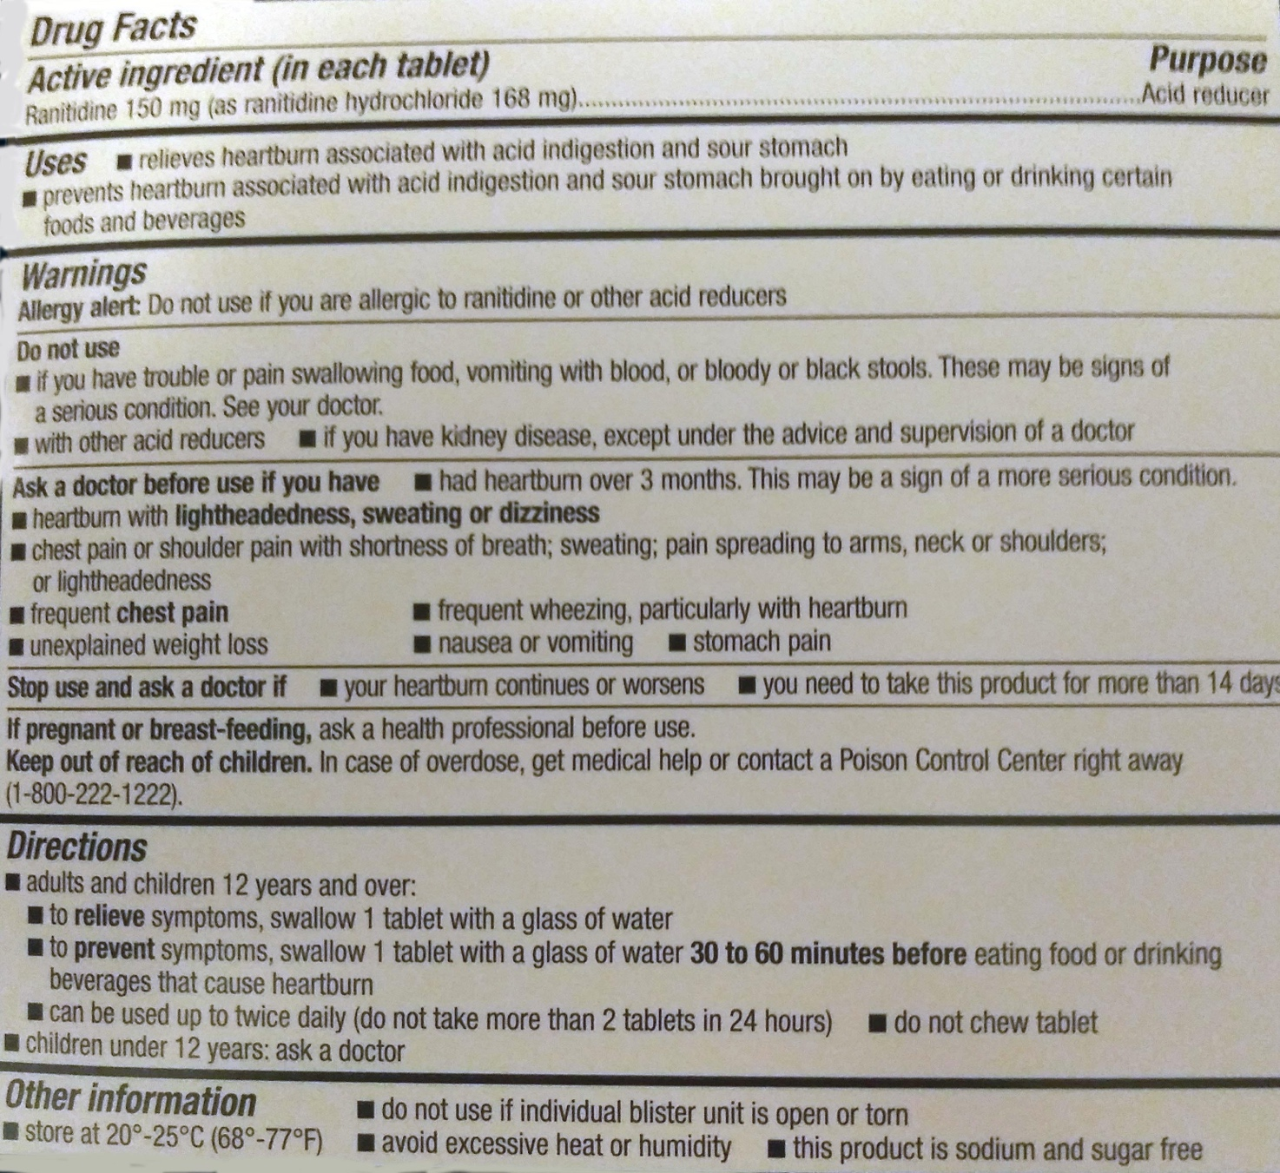

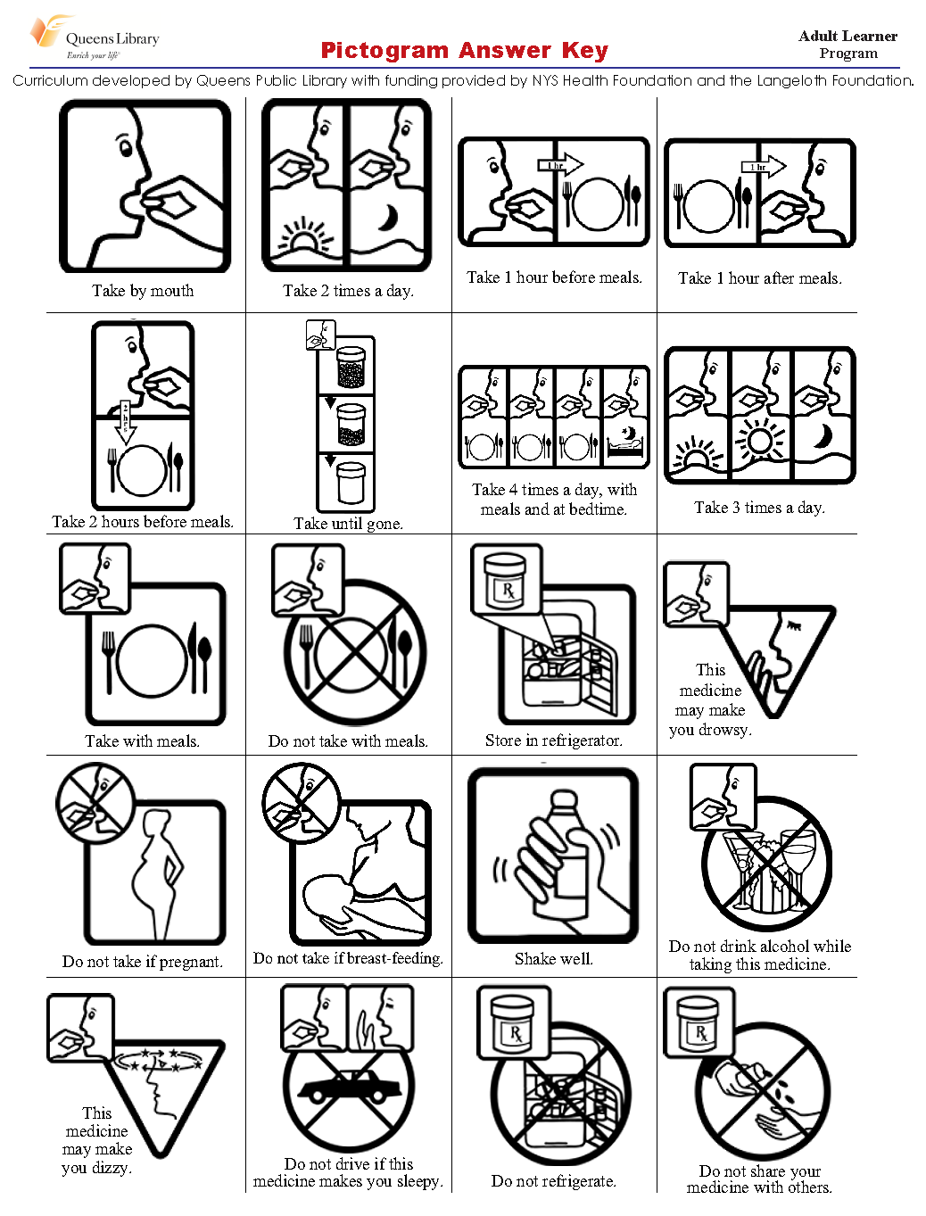

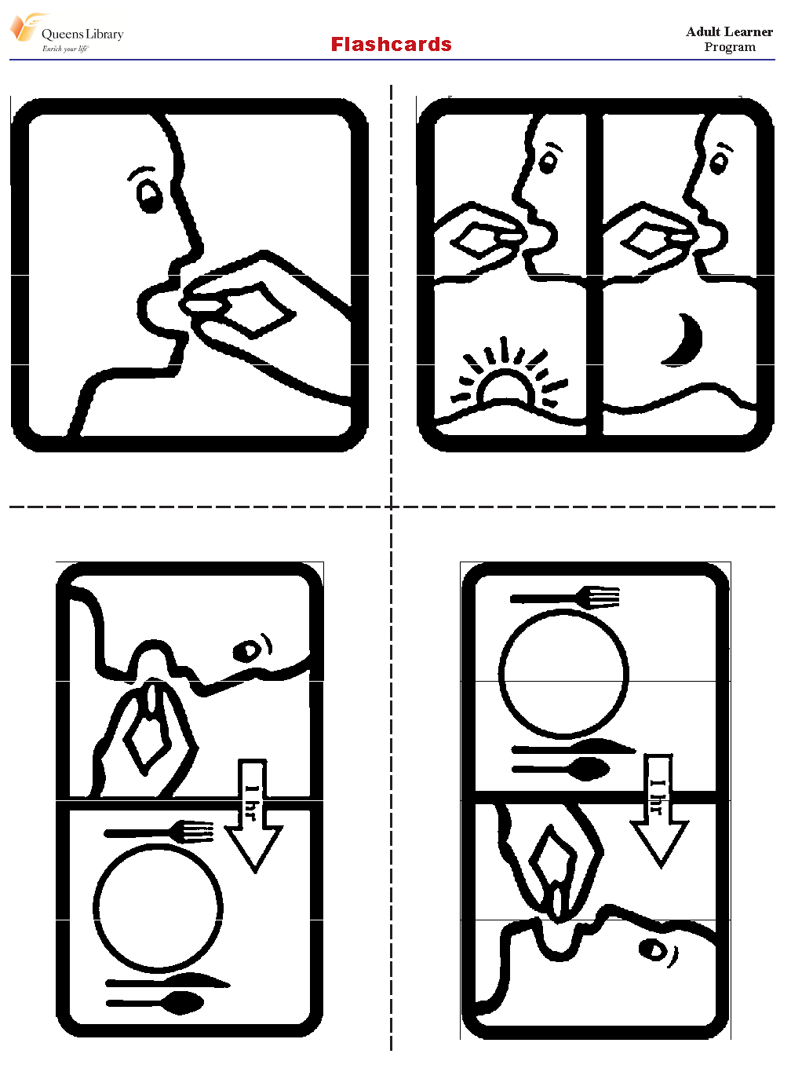

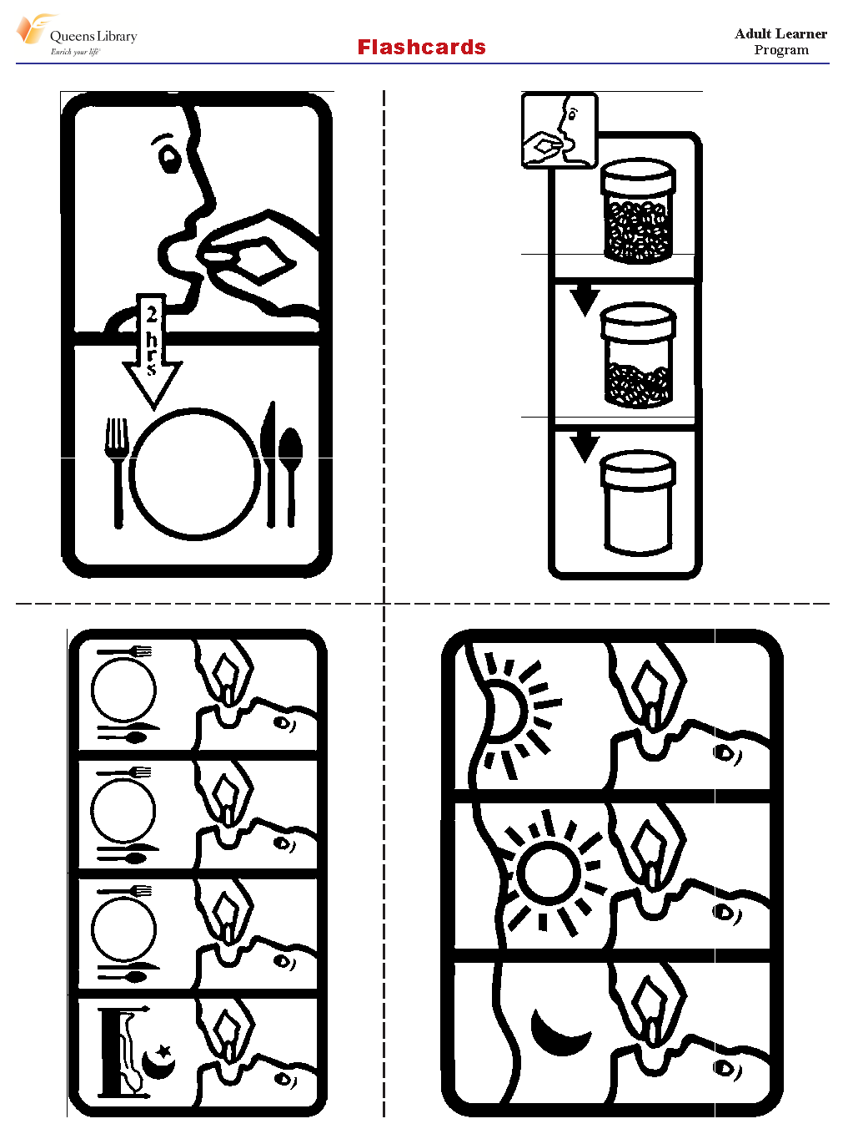

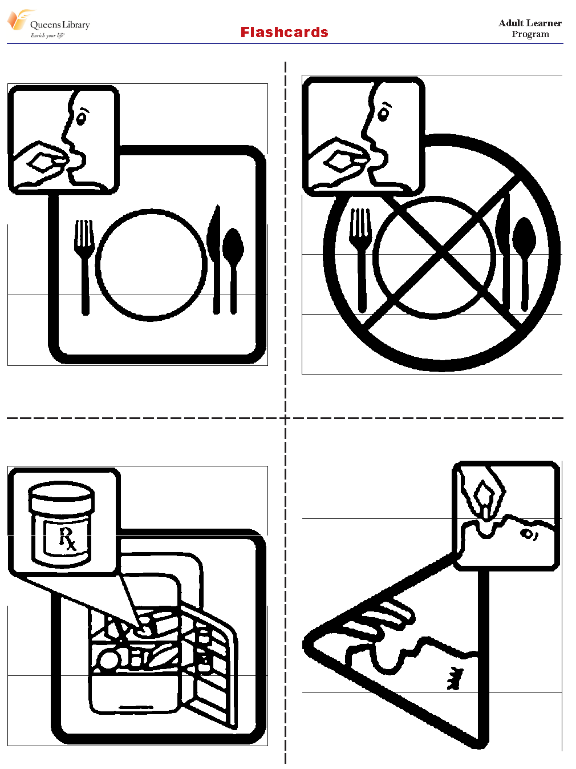

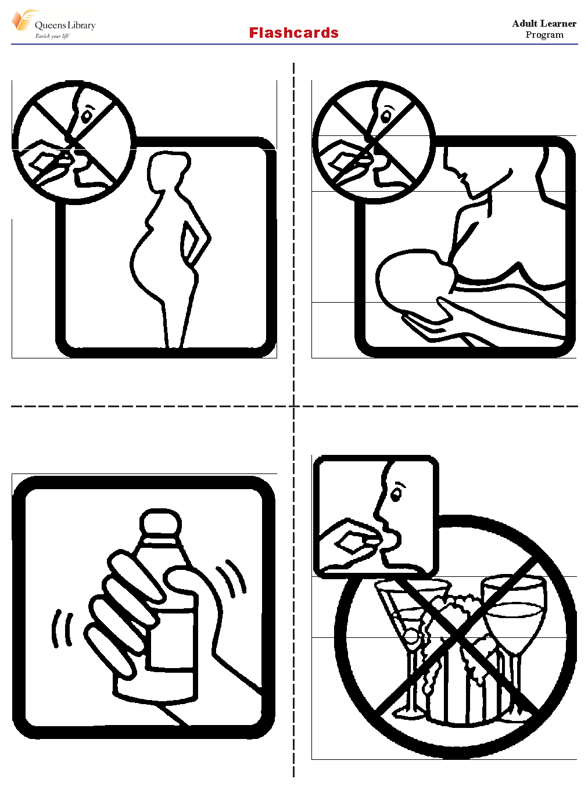

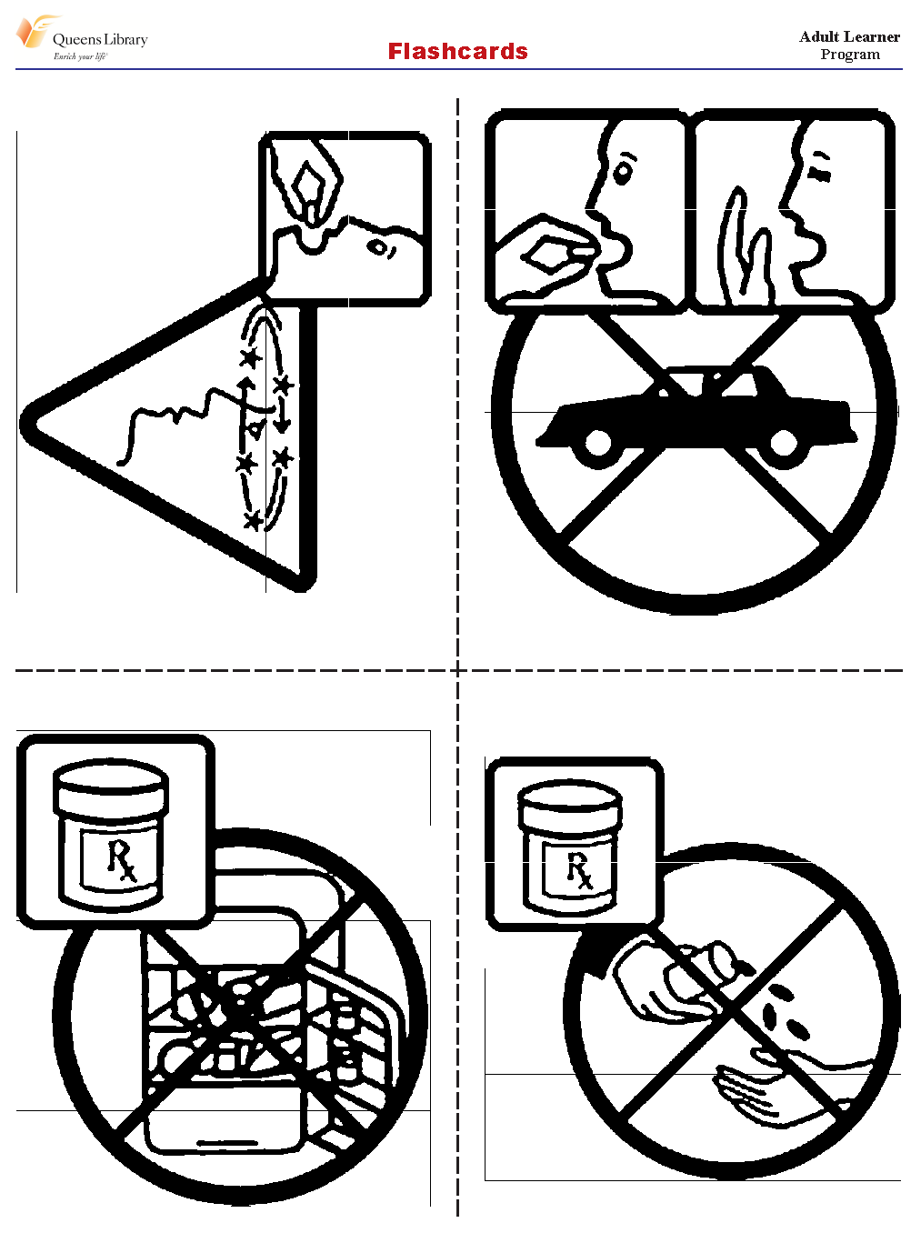

Name of Medication | Purpose  (What is it used for?) | Warnings | Directions for adults  and children over 12 years old | Directions for children under 12 years old

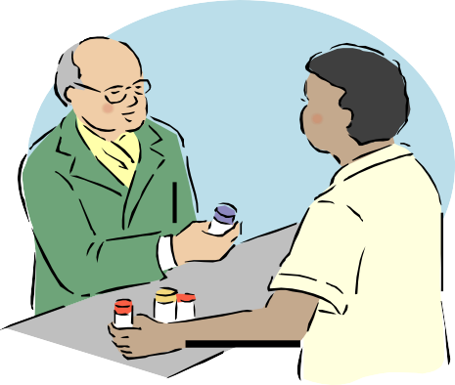
Listen to the dialogues. Check the instructions you hear.
Listen again and answer the questions below.

  - How many pills must this patient take every day?

  - What can he take for pain?

 | Take once a day | Take twice a day | Take  with food | Don’t drink alcohol | Don’t take antacids
1.
2.
3.
4.

  - When should she take this medicine?

  - Can she drive when she takes this medicine?

Adapted from Curriculum developed by Queens Public Library with funding provided by NYS Health Foundation and the Langeloth Foundation.

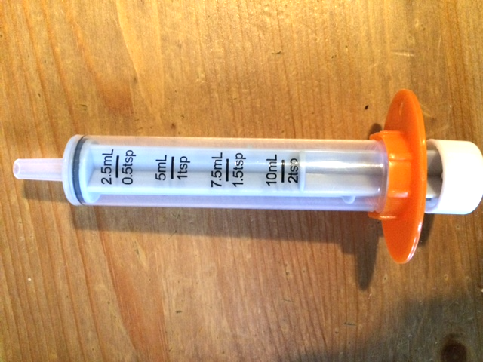

What do you notice? What do you wonder?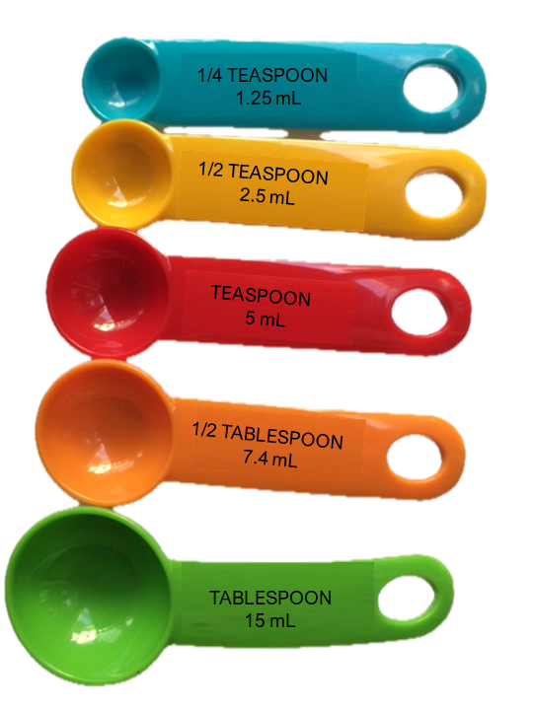

What is the relationship between fluid ounces (fl oz) and milliliters (mL)?
How do you know?

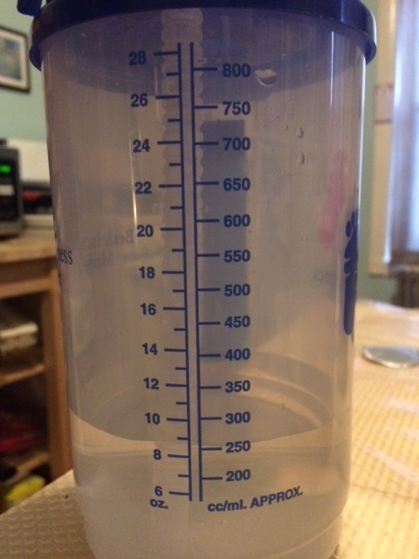

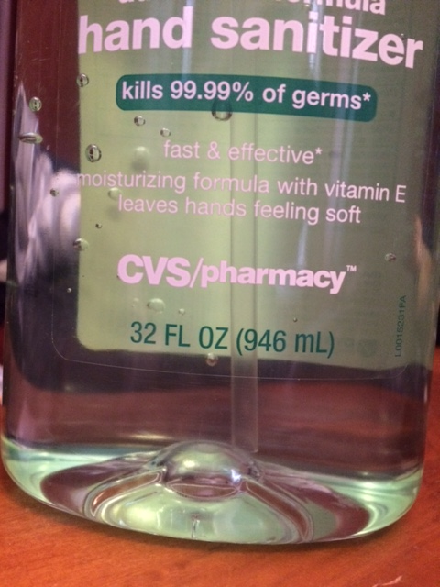
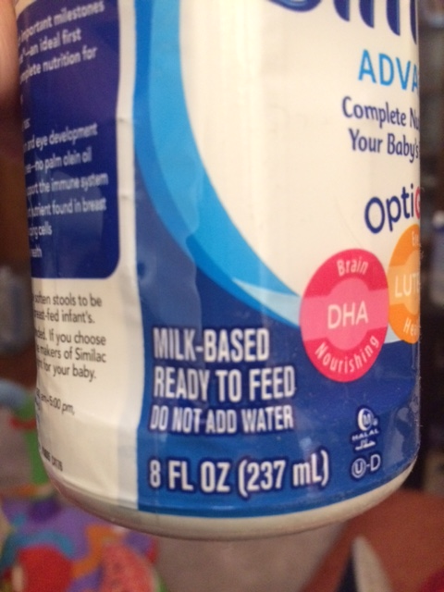
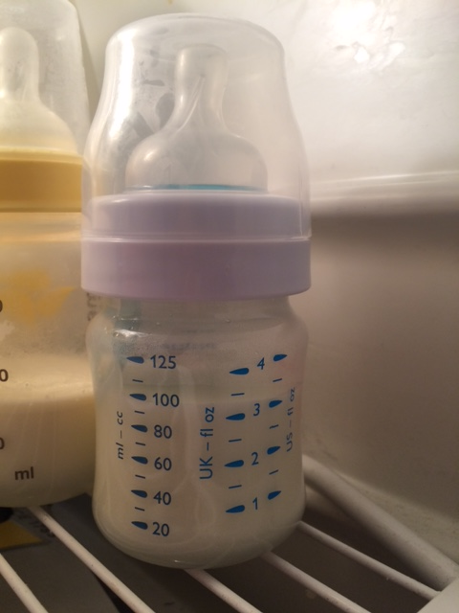
What do you notice?
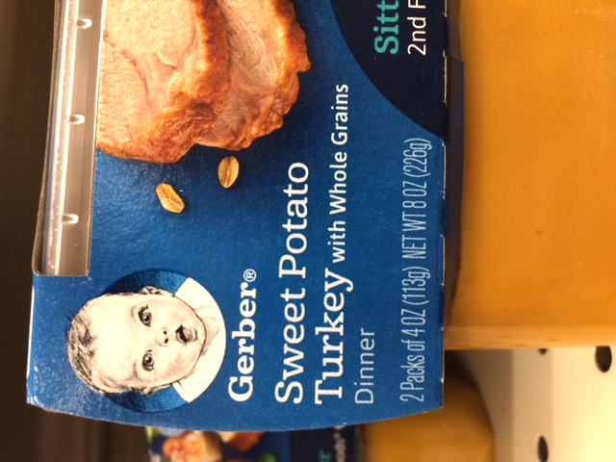
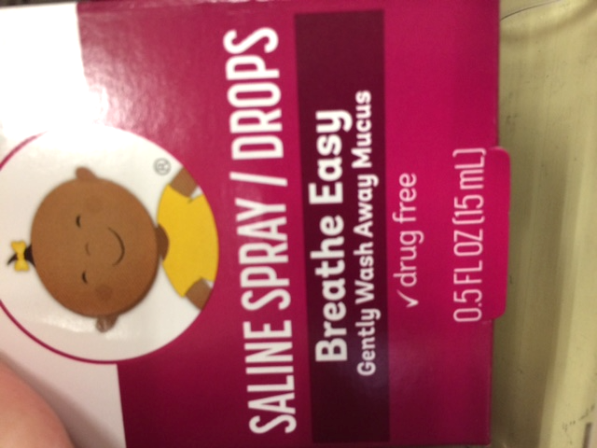
Products sold by weight Products sold by volume

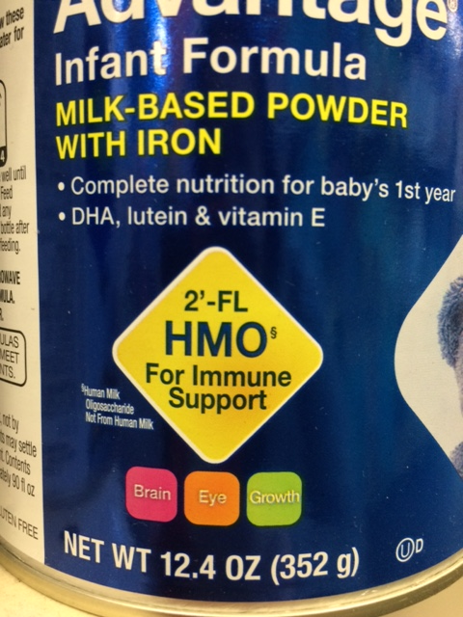
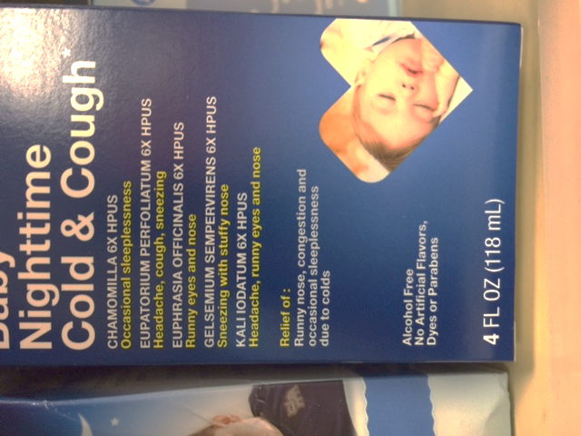
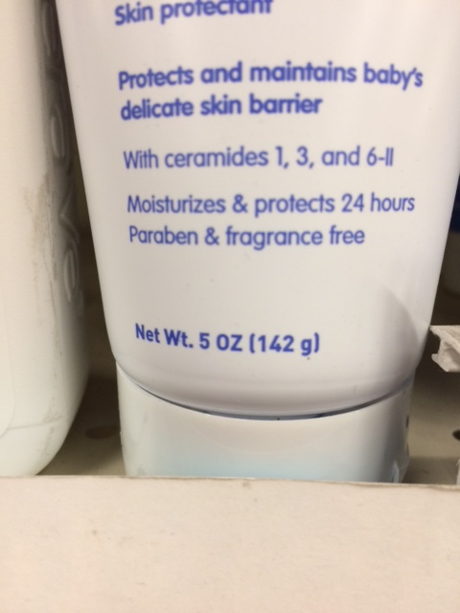
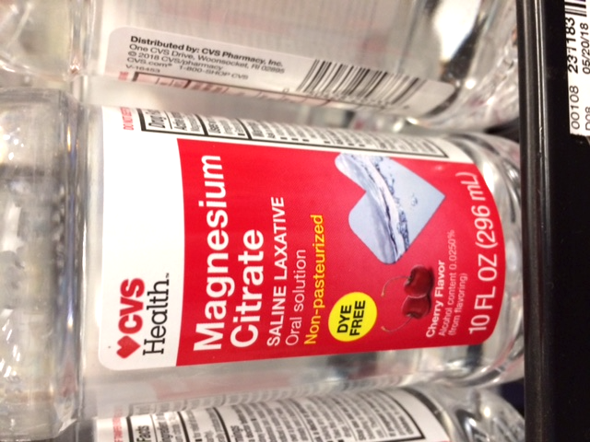
For each of the following products, decide if it is sold by weight or volume. How do you know?

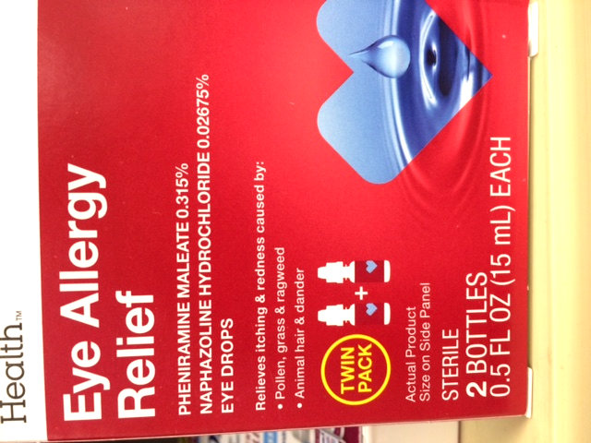
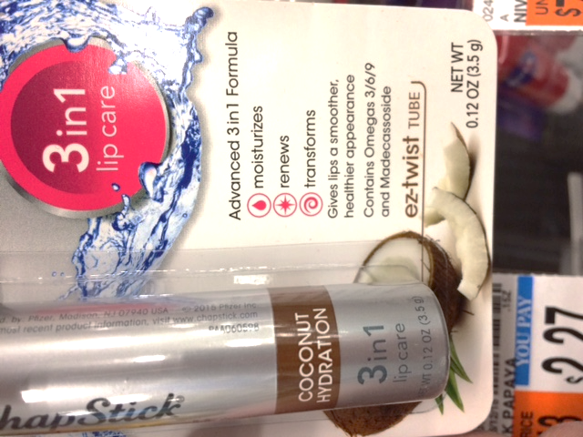
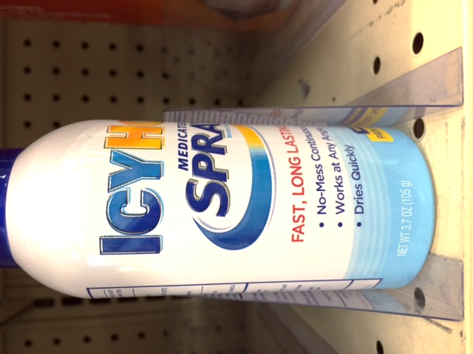
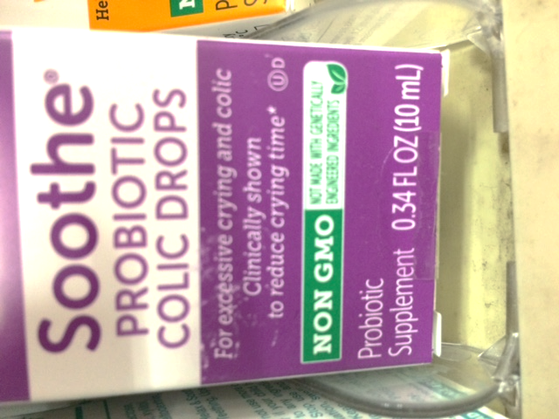

LESSON 4: NUTRITION (Proportional Reasoning)

Rationale
Healthy eating is a concept that everyone understands. What constitutes healthy eating varies in different cultures and for different people in the same culture. However, there are universal facts about nutrients that are good for our bodies. In this lesson, we focus on nutrients found in foods and ask students to research what those nutrients are and how they benefit the body. Next, we turn the learners’ attention to nutrition labels and use math to explore serving size and calorie intake.

Background
This lesson provides a new context for exploring volume units (in this case, cups) and the use of tables for proportional reasoning. See the Background section from Lesson 2: A Visit to the Doctor (Tables and Rules) and Lesson 3: Medications (Weight and Volume) for more discussion of these topics.

Comparing Ratios
There are many ways to compare ratios. The activity Fewer Calories? asks students to compare ratios, in this case the ratio of calories to volume (calorie density). When we want to consider which food item has fewer calories, it is not enough to simply look at the calories in a serving; we also have to consider the serving size.
For example, students may decide to find the number of calories in equal volumes of food (for example, How many calories of each in 1 cup?). Comparing equal volumes allows us to directly compare the number of calories. Likewise, we could instead start with a set amount of calories and figure out what quantity of different foods equal that amount of calories. For example, in Task 2 of the Fewer Calories? handout, a serving of cherries and cranberries are both 140 calories, but a serving size of cherries is smaller, and therefore more calorie-dense.
Sometimes students will consider the difference in both quantities. In Task 3, you could eat a half-cup more rice cereal (1 ¼ C rice cereal per serving versus ¾ C multigrain per serving) for only 30 more calories (150 versus 120). If we were going to eat a half-cup more of the multigrain cereal, it would have more than 30 calories. Students may also choose to simply divide to find the unit rate (calories per cup or calories per ounce).
All these methods are valuable, and students should be encouraged to share different strategies and learn from the strategies of others. Proportional reasoning takes many forms and having a variety of tools will help students be able to choose the one that makes the most sense for the situation at hand.

Helping Students Who Struggle
The math tasks in this packet are intended to provide relevant and intellectually challenging applications for the math concepts. Many of the tasks are fairly open-ended, and can be solved in a variety of ways. As math educators, we expect that most of these tasks will require some struggle for many students. Productive struggle allows for students to stretch and grow their understanding of mathematical concepts and is a normal and valuable part of doing mathematics. When we facilitate math tasks in the classroom, our job as a teacher is not to remove the struggle, but to help keep it productive. Here are some suggestions for responding to students as they are struggling with a task:
- Ask them to explain and/or show you how they are thinking about a task, even if you see that they have the wrong answer or seem to be on the wrong track. Listen carefully, even if you hear misunderstandings. This allows a student to clarify her thinking to herself, values her reasoning, and gives the teacher a better sense of what she is confused about.
- Encourage students to work with a partner. You can also pair up students who got different answers, and challenge them to try to convince the other why their thinking is right.
- If a student thinks he is right, but his answer is wrong or doesn’t make sense, try to show how his own thinking creates a contradiction. (See examples below.)
Here are some examples of mistakes students might make when using tables for proportional reasoning, and examples of how a teacher might respond. (The table below is from the activity in this lesson, How Many Calories?)

Example 1: Student keeps doubling, even when servings are not doubling.

Servings | Calories | Cups
1 | 100 | 1
2 | 200 | 2
3 | 400 | 4
5 | 800 | 8
Possible teacher responses:
How many calories would be in 4 servings?
(Directing attention to the fact that 4 cups is missing from their table, and trying to get them to reflect on whether their pattern makes sense.)
I notice that for the first two rows, the number of servings is the same as the number of cups, but after that, they are not the same. Should they be the same?
Why or why not?
(Pointing out something about their own work that doesn’t seem to make sense.)
Example 2: Student keeps adding 100, even when the servings jump by more than 1.
Servings | Calories | Cups
1 | 100 | 1
2 | 200 | 2
3 | 300 | 3
5 | 400 | 4
10 | 500 | 5
Possible teacher responses:
How many calories would be in 4 servings?
(Directing attention to the fact that 4 cups is missing from their table, in case they simply didn’t notice that the servings jumped).
What if I added 100 servings as the next row on the table?
(Including an extra-large number highlights the fact that the table doesn’t have to go up one serving at a time, and makes adding only 100 calories seem more unreasonable.)

LESSON 4: NUTRITION LESSON PLAN

Prior Knowledge
- Addition and/or multiplication of whole numbers within 1,000 (calculator use is fine)
- Understanding of basic fractions, including 1/2, 1/4, 3/4, and 1/3

ESOL Tasks
- Practice vocabulary related to food items and nutrition
- Read and understand information on nutrition labels
- Analyze nutritional values in foods

Math Concepts Addressed
- Measure serving size
- Compare weights and volume
- Interpret percentage of daily allowance

Materials

Activity I: Name the major food groups
- iSLCollective’s Visual Dictionary: Food

Activity II: Healthy eating
- Teacher resource: Nutrition Concepts
- Video: Essential Nutrients and Their Sources
- Video: Mayo Clinic Minute: 6 Tips to Eating Healthy on a Budget
- Online resource: Six essential nutrients and their functions
- (Optional) Online resource: The complete guide to evaluating online resources
- (Optional) Video: Foods that look like body parts give us clues to their benefits
- (Optional) Video: How the foods you eat affects your brain

Activity III. Reading nutrition labels
- Online resource: The Basics of the Nutrition Facts Label
- (Optional) Online resource Understanding food nutrition labels or companion PDF resource: Eat Smart with Food Nutrition Labels
- (Optional) Online resources: How to understand and use the nutrition facts label or The New Nutrition Facts Label
- Handout: Nutrition Labels
- Handout: Reading Food Labels

Activity IV. Seeing servings
- Food that can be poured (like popcorn or cereal), enough for class
- A few sets of measuring cups
- Napkins or plates
- Food boxes or labels from common food items like cereal that use cups to measure serving sizes
- Snack food containers with more than one serving
- Handout: Serving Size
- Bowl of cooked rice

Activity V. How many calories?
- Handouts: How Many Calories? A and How Many Calories? B
- Nutrition labels from various foods or use Handout: Nutrition Labels.
- Calculators (or students can use their phones as calculators)

Activity VI. Fewer calories
- Handout: Fewer Calories
- Calculators (or students can use their phones as calculators)

Math Vocabulary

- volume
- serving
- serving size
- cup (as a measurement)
- calories
- table
- ounces
- fluid ounces
- grams

INTRODUCTION / WARM UP
To begin a discussion about food groups, assess background knowledge of your learners through discussion about their favorite foods. Here are two suggestions:

Option 1:
Ask students to interview one another about their favorite foods. They can brainstorm questions to ask or you can provide questions such as:
- What are three of your favorite vegetables?
- What are three of your favorite fruits?
- What meat, if any, do you prefer? (e.g., pork, beef, chicken)
- If you like seafood, what kind do you eat? (e.g., fish, shrimp, clams)
- What snack food do you like? (e.g., chocolate, cookies, chips)
- What foods do you eat most often?

Option 2:
- Ask students to make a poster board of their favorite foods. They can do this individually, in pairs or in small groups and compare their preferences with other groups or individuals. They can draw, write words, or cut out images from magazines, flyers or cut and paste images form the internet in a Word document.
- Using their posters, students write a paragraph. For example:
I eat three meals a day. For breakfast, I like to eat toast and drink coffee. For lunch and dinner, I usually eat the same thing: noodles and meat, etc.
- In small groups, students present their posters and talk about their favorite foods and eating habits.

ACTIVITIES

I. Name the major food groups
- Using the information students collected from the warm up activity; ask them to categorize the food. There are different ways to categorize. They might categorize by food groups, texture, color, nutritional value, etc.
- If no students choose to organize by food groups, guide students in organizing by those categories.
Note: There are different ways to think about food groups. Two examples might be:
- Five food groups (fruits, vegetables and legumes, meat and poultry, grains, dairy)
- Six food groups: fruits, vegetables, protein, dairy, grains, oils

- Ask students to add more examples of food items to each of the food groups. Beginners can use a picture dictionary or an online dictionary such as iSLCollective’s Visual dictionary: Food.

II. Healthy eating
In this activity, students will first reflect on what our bodies need to be healthy. Next, they will connect some of these benefits to each food group.
- In pairs, ask students to briefly discuss the following: What do you know about nutrition? Share out and write key phrases and vocabulary on board.
- Ask student to make a list of some of the nutrients our bodies need to be healthy. This is intended to be an open question with many possible correct responses such as vitamins, carbohydrates, proteins, or students may provide specific nutrients such as: Vitamin C, Vitamin B, calcium, folic acid, etc.
This print resource offers teachers some ideas for explaining basic nutrition concepts: Nutrition Concepts. Another option is the video Essential Nutrients and Their Sources.

4 Strategies for Differentiation

More accessible:
- Students watch the video: Mayo Clinic Minute: 6 Tips to Healthy Eating on a Budget (1 min). Show the video once and ask students to listen, but not write.
- Show the video a few more times and ask students to write down the six things they can do to eat healthy and save money.
- Ask students: Do you agree or disagree? What ideas from the video are you most likely to do? Why or why not? Do you have other suggestions or things that you do to eat healthy that are economical?

More challenging: Essential nutrients (reading comprehension)
- More advanced learners can read the article, Six essential nutrients and their functions, and make notes to report back on. For example, they can record the names of the six nutrients, their primary function in the body and two examples of each. Students use their notes to create a visual presentation. This can be a graphic organizer, a drawing, or a slide presentation. Here is a resource for printable graphic organizers.

4 Technology Integration
- Ask students if everything they read on the internet is true. Remind them that anyone can post to the internet and it is their job to look critically at the information.
- Ask students what information they should look for in an online resources to evaluate the credibility and accuracy. Make a list on the board as they offer criteria for evaluation. Students compare their ideas against this online resource: The Complete Guide to Evaluating Online Resources. If needed, simplify the content by creating a simple list to share with students.
- Have students create a checklist to use when they evaluate the online resources. For example:
Who is the publisher or author of the resource?
Is the site a commercial (.com) or non-profit (.org)?
Is this an ad?
Does the resource have a date listed?
Is there a list of resources (like a bibliography) at the end that support this information?
Is the information well organized and easy to read?
- Students use the internet to find a resource they like about healthy eating. When they are done, they share their websites with the class by projecting the site and talking about what they like about it. Students will vote on their three favorite resources. Copy and paste the website addresses into an online class resource list that they can share with their friends and families outside of class.

Extend Learning: More on Essential Nutrients
In the Strategies for Differentiation below there are two resources, one of which is more accessible and one that is more challenging. Explain to students that different foods have different benefits. Select a video, depending on the level of your students, and ask them to listen for benefits of different foods.

4 Strategies for Differentiation

More accessible:
The two and a half minute video Foods that look like body parts give us clues to their benefits talks about five different foods (walnuts, carrots, tomatoes, olives, and Brazil nuts) and their health benefits.
- Pre-teach the names of these foods and ask students to predict what the health benefits might be.
- Show the video once and ask students to listen, but not write.
- Show the video again once or twice and ask students to listen for one benefit of each food.
- Students write sentences about the benefits of each food described in the video.

More challenging:
Students watch the video, How the food you eat affects your brain (4:53 min). To help students unpack the content in this video, you can divide students into groups and ask them to focus on one of the main ideas.
- Show the video once or twice and ask students to listen for main ideas. Write them on the board as students state them.
- Divide students into groups, giving each group one main idea of food group/nutrient to report back on. Play video again. Turn on closed-captioning if needed.
- Ask students to write a summary of what they have learned. Depending on their level, students may choose to make a list of things they learned, or write it up as a paragraph.

4 Technology Integration

Presentations (Optional)
Students work together to create a slide presentation or a shared Google Doc by contributing their notes from the video to create a collective summary of what they learned.

III. Reading nutrition labels
For this activity, you will need a variety of food labels. You can bring some in, ask students to bring in a couple of food items, or use the handout Nutrition Labels.
- Ask students if they look at nutrition labels. If so, what information do they look for when they read a label? What is important to them personally, and why? Based on what they learned about food nutrients, what information is most important for most people?
- Ask students to consider what information might be most important for someone with specific health conditions, like diabetes, heart disease, or food allergies. What about for pregnant women?
- Give students a copy of the online resource The basics of the nutrition facts label, or project it on a screen in the classroom. For lower levels, point out the seven steps on the handout and ask them to locate each category of information on the labels. More advanced learners can read the article.

4 Strategies for Differentiation
The two resources below will allow you to provide reading materials about nutrition labels that are slightly easier or more challenging.

More accessible:
- Project the online resource Understanding Food Nutrition Labels or Eat Smart with Food Nutrition Labels, both from the American Heart Association.

More challenging:
- Use How to understand and use the nutrition facts label or The New Nutrition Facts Label, both from the FDA’s website.
- For this step, you will need the handouts Nutrition Labels and the handout Reading Food Labels. Using the handout Nutrition Labels, students answer questions on the Reading Food Labels handout.
- Next, students complete the remaining pages of the Reading Food Labels handout.
Activity III in Action
"[T]he idea of reading nutrition labels is not new to students. Most of them already have the habit of looking at it while shopping, though only looking at sodium and not much else. After the instruction and practice, they feel more informed. Also, the comparison between two similar products was very interesting and mind-opening to most. I expanded that part by first letting them choose which one they would normally buy in a store and give reasons. After looking at the labels, a lot of them changed their mind… In general, students were very interested in learning about how to read nutrition labels."
ESOL Level 4 (SPL 5-6) Instructor, Immigrant Learning Center, Malden, MA

IV. Seeing Servings
(Based on an activity from TERC’s Mixing in Math materials.) In the next two activities, students will explore ratios and proportional reasoning through considering serving sizes and caloric intake.
In the first activity, students will examine U.S. measuring cups to visualize volume, use cups to measure out different volumes, and compare physical measurements with serving sizes on food labels.
- Decide ahead of time on a snack that students in your class like to eat, and check for food allergies. It needs to be something that can be measured with dry measuring cups (like popcorn or cereal). Make sure to keep the labels, but pour the snack into large bowls. Provide each table with a bowl of food, napkins, or plates, and a small scoop (without measurements on it). Don’t share the serving size or food label yet.
- Ask students to recall what they know about serving sizes, and how they are used on nutrition labels (all the nutritional information is based on one serving of a specific size, which varies depending on the food).
- Ask each student or pair of students to scoop out what they think is one serving of that type of snack and put it on a napkin in front of them. No eating yet!
- Pass around sets of measuring cups. Ask students what they notice and what they wonder about them. Also ask what they recall about weight and volume, and which types of units they use at home to measure out ingredients (probably cups(volume) or grams (weight)
Many countries measure dry ingredients by weight (grams) on a scale, rather than with volume (cups) like we do in the U.S.
- Have students measure the portion in front of them. Record measurements on the board.
- Pass around the food labels for the snack. How does the serving size compare to your estimate? Go around and have each student orally use comparatives to explain whether their estimate was larger, smaller, or the same as the actual serving size. You can also encourage modifiers (a little larger, a lot smaller, and so on).
- Pass around containers of different types of snack foods (or just the food labels from the containers) and ask students where to find the serving size on each label. Ask students to write three statements using comparatives. For example,
One serving of pretzels is smaller than a serving of popcorn.
A serving of cheese puffs is larger than a serving of cereal.
The serving size of cereal is the same as a serving of chips.
- Eat!

Follow Up Activities:
- Bring in some snack food containers (bags of chips, pretzels, etc.) where the container has more than one serving. Tell students the serving size and ask them to estimate how many are in the container.
- Give out the handout Serving Size. Discuss ways to estimate with the numbers so that students can use mental math.
- How much rice? Bring in bowl of cooked rice (not to be eaten – it’s going to be measured repeatedly!) and ask students to put on a plate how much they would normally eat in one meal. Next, tell them that one serving of white rice is 1/2 cup. Ask them to estimate how many servings are on their plate. Have them measure to check.
Activity IV in Action
"This activity was super fun... They loved the snacks. It is a night class, so they had a hard time holding off on eating the pretzels before we weighed them. I kept hearing crunching all around the room… Many were close on their serving sizes, some were way off and it was fun to watch them weigh and measure their food.”
ESOL Level 3 (high beginner/low intermediate) Instructor,
Ludlow Area Adult Learning Center, Ludlow, MA

V. How Many Calories?
In this activity, students will use a table to extend a pattern, and describe the pattern in a situation with a verbal rule. They will use the tables and patterns to solve problems.
- Looking at calories per serving is another way to explore proportional reasoning with tables. (Since the amount of fat, sugar, carbs, etc. is also proportional to the number of servings, you can use any of these with this activity in place of calories if you like.)
- Give the class the following example to discuss:
Multi-Grain Crackers
Serving Size: 4 crackers
Calories per serving: 60
Draw a table on the board with three columns. Fill in the first row.
Servings Calories Crackers
1 60 4
2
- Ask students to share ideas about how they could fill in the next few rows. What patterns do they see? Encourage students to look for multiple strategies or patterns in the table. Emphasize that there isn’t one prescribed method for filling in the table, but they should find a way that makes sense to them.
- Let students choose to work on either How Many Calories A (more accessible) or How Many Calories B (more challenging). Look at the nutrition label together and identify where it gives the serving size and number of calories per serving. Working with a partner, have them fill in the missing numbers of calories. After they have had a chance to work, ask pairs to share their strategies of how they came up with the missing numbers.
- What patterns do they see in the table? Help students with vocabulary, as needed, to describe what they see happening with the numbers. (For example, you multiply the number of servings times 190 to find the number of calories.)

4 Strategies for Differentiation

More accessible:
- Use the handout How Many Calories A, which has a serving size of 1 cup and 100 calories. For even more accessibility, remove the third column in the table and just work with numbers of servings and calories.

More challenging:
- How many calories in 50 servings? The idea here is to give them a number that cannot easily be solved by simply counting up with the table. Students will be pushed to use a multiplication relationship between the number of servings and the number of calories.
- How many calories in 40 tablespoons? This question can be asked to students working on How Many Calories B. Here students need to use a multiplication relationship between the volume measurement and the calories.

Follow up activities:
- Give students food labels to choose from, and have them create their own table of servings/calories/volume.
- Bring in (or ask students to bring in) snack food labels that have more than one serving (like a bag of chips or a soda). How many calories are in the entire container? Encourage students to create a table to show the relationship between servings and calories.
Activity V in Action
"[This activity] was pretty successful…I … tried to get students to explain to each other within their groups, to some success, and also to use multiple paths to get to an answer if they had different ideas. Students were also able to do an additional 1 or 2 tables after choosing a container from the front, and that was nice to see they could apply the concept to other foods and complete nutrition facts labels.”
ESOL Level 3 (SPL 3-5) Instructor, Immigrant Learning Center, Malden, MA

VI. Fewer Calories?
In this activity, students will use various strategies to compare ratios. Using the handout Fewer Calories, students are asked to reason about ratios of calories per volume (for example, calories per cup or calories per fl oz). This is an example of parallel tasks: there are three tasks to choose from, all of which ask students which item has the fewest calories per volume.
- Task 1 is the most accessible, because it uses only whole numbers.
- Task 2 uses unit fractions (1/4 and 1/3 of a cup).
- Task 3 is the most challenging, because it uses non-unit fractions and mixed numbers (3/4 cup and 1 ¼ cup).

Parallel tasks are a way to differentiate the level of the math activity. All tasks address the same concept (comparing ratios), but at different levels of complexity, based on the type of numbers used. You can give out different tasks to different students or groups, depending on math level, or allow students or groups to choose a task (self-differentiation).

- Discuss the following situation with the students:
You are trying to decide which type of crackers will have fewer calories.
As a class, discuss ways you could reason about this comparison.

Multi-Grain Crackers
Serving Size: 4 crackers
Calories per serving: 60
Herb-Flavored Crackers
Serving Size: 8 crackers
Calories per serving: 80

- Distribute the handout Fewer Calories? No matter which task students work on, they can all contribute to a class debrief addressing the question: How did you compare the calories when the serving sizes were different? Have students share strategies, using words, pictures, etc.

Follow up activities:
- Ask students to compare calories from different food labels you have collected (or that they bring in).
Activity VI in Action
"[This activity] was definitely not easy for most students, but it got them thinking and working… I gave just one copy of the worksheet out per small group (about 3 students) to necessitate their working together. A common issue that came up in this activity was students getting confused by their own numbers and what referred to what. I think that since they didn't label what their numbers referred to (e.g. calories per fluid ounce, calories per bottle, calories per fl in fruit soda vs. in the juice, etc.) sometimes they were able to figure out the right math to do, but then provided the wrong answer when asked. Altogether, I think students were really engaged by the topic and tasks, as they were quite relevant and intellectually challenging… I asked students if they thought they would use these skills in the future to fairly positive responses."
ESOL Level 3 (SPL 3-5) Instructor, Immigrant Learning Center, Malden, MA

VII. Wrap Up
Ask students to take 10-15 minutes and think about what they have learned in this lesson regarding the nutrients our bodies need, nutrition fact labels, serving sizes and calories, ratios and proportions. Ask them to look through their notes and any presentation they might have created and re-read them.
- Tell students: Imagine you are talking to a friend or family member about what you learned. What can you teach them? Write a few short sentences about what you have learned in this lesson and give 1-2 examples of each topic.
When they are done, ask them to share their learnings in pairs.

ASSESSMENT

Option 1:
Students can create an eating plan for three meals for one day. Each meal should be healthy and have a balance of different foods. Before planning the meals, it may be helpful to ask students to have a guiding goal such as staying within a certain amount of calories for the day, getting enough of a certain nutrient, or limiting their intake of something like sodium.

Option 2:
- Pose the following scenario: You want to limit the number of calories you eat when you are snacking, so that each snack has 100 calories or less.
- Ask students to think of some snack foods they like to eat, and have them find the serving size and calories per serving for each one. Ask, How much of that snack can you eat so that you don’t eat more than 100 calories? How do you know?
- (Optional) As a class, create a list of each snack and the portion size as a take-home reference.

ADDITIONAL RESOURCES
- iSLCollective’s Visual dictionary: Food
- Nutrition Concepts
- Essential Nutrients and Their Sources
- 6 Tips to Eating Healthy on a Budget
- Six Classes of Nutrients and their Functions
- Printable Graphic Organizers
- Foods That Look Like Body Parts Give Clues To Their Health Benefits
- How the food you eat affects your brain
- The Basics of the nutrition facts label
- Understanding food nutrition labels
- How to Understand and Use Nutrition Facts Label
- The New Nutrition Facts Label
- Teacher resource: Eat for health
- Teacher resource: Do you know how to choose healthy foods?

A. Macaroni and Cheese B. Oatmeal

- Pancakes D. Herb Crackers

When you buy a food product, the box or label will tell you the weight of the food, usually in grams (g).
The nutritional information will tell you the serving size (how much a person is expected to eat at one time).*

For food products below, determine about how many servings you get in the box. (You can round both the weight of the food and the serving size to friendly numbers. Then think about how many servings you could get out of the box.)
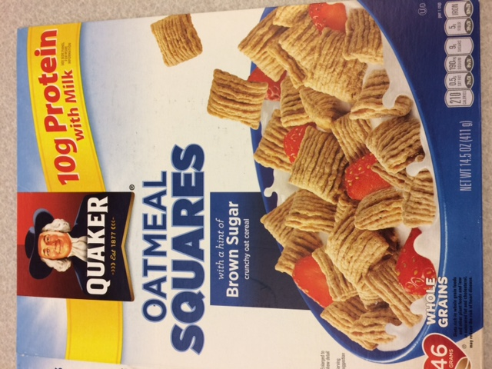

Serving Size: 56 g Net weight: 14.5 oz (411 g)

About how many servings are in the box?

* Serving sizes in the United States are determined by the U.S. Food and Drug Administration (FDA).
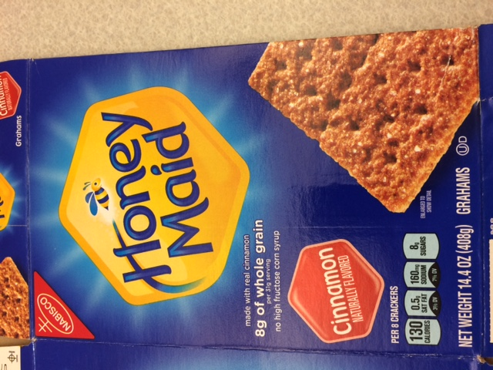

Serving Size: 31 g Net weight: 14.4 oz (408 g)
About how many servings are in the box?

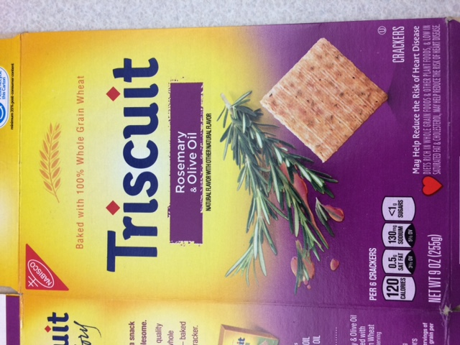
Serving Size: 28 g Net weight: 9 oz (255 g)
About how many servings are in the box

Breakfast Cereal

Fill in the table below.

Servings | Calories | Cups
1 | 100 | 1
2
3
5
10
0.5

Peanut Butter
Fill in the table below.

Servings | Calories | Tablespoons
1 | 190 | 2
2
3
5
10
0.5

Task 1
How can you compare the calories in these two drinks?

Fruit Soda

Fruit Juice
Task 2
Which type of dried fruit has the fewest calories per cup?
How do you know?

Dried cherries

Dried cranberries

Dried figs
Dried figs
Task 3
Which cereal has fewer calories per cup? How do you know?

Rice Cereal

Multigrain Cereal

LESSON 5: HEALTHY LIVING (Proportional Reasoning)

Rationale
We live in a culture that bombards us with advertisements for staying healthy. Television and other media target us with ads for food, medicine, and lifestyle products that claim to offer ways to a longer, better quality life. While advertisers may stretch the truth to sell products, the reality is that we all want to be in good health.
In this lesson, students will consider physical fitness as means of maintaining a healthy lifestyle. Burning calories while exercising is normally associated with losing weight, but there are many other benefits of exercise. Exercise can strengthen our muscles, bones, and brain as well as improve our stamina, balance, and mental well-being. This lesson targets proportional reasoning as it relates to exercise and how it can help us make sound health decisions based on math!

Background
This lesson contains intermediate level math content that may be more appropriate for intermediate- or advanced-level language students.

Graphs
There are many different types of graphs. Some of the graphs students encounter are visual displays of data. Others, like the graphs in this lesson, are visual representations of mathematical relationships. These graphs are called coordinate graphs, because the points are plotted based on a coordinate grid. The location of each point is determined by two amounts: one that tells us its location horizontally (the x-coordinate), and one that tells its location vertically (the y-coordinate). Coordinate graphing provides a new way to see the relationship between two amounts. Students may encounter coordinate graphs when studying science, economics, business, medicine, manufacturing, or any field where math is used to model something in the real world. In addition, coordinate plotting has other applications, such as reading maps and diagrams.
Similar to Lesson 2 (Going to the Doctor), this lesson has students working with in-out tables to investigate proportional relationships (see the Background section of Lesson 2 for a review). In this lesson, students will extend this activity to graph the relationships between time and calories burned when doing different activities.
These graphs allow us to see the mathematical relationships visually. With directly proportional relationships (the focus of this unit), the graph always forms a straight line. The line will slope up to the right and will start at the origin. This is because in a proportional situation, the ratio or relationship between the two amounts (such as minutes and calories burned) stays constant. For example, if we are jogging, every time the number of minutes increases by 1, the number of calories burned increases by 10. This will result in a slope that consistently goes to the right by 1, then up by 10, leading to a straight line.
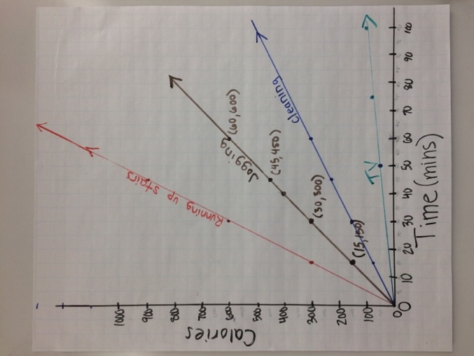
It is easiest for novice graph-makers to plot the points of the graph from table data. Each pair in the table (for example, 10 mins jogging burns 100 calories) is plotted as one point. The number of minutes and the number of calories determine the location of the point (10, 100).
A common graphing convention is that the independent variable (the one we know) is assigned to the horizontal x-axis, and the dependent variable (the one affected) to the vertical y-axis. The number of calories burned depends on the amount of time spent on an activity. In fact, many variables depend on time, so time is often assigned to the x-axis.
The slope of a line is introduced intuitively here. Students should notice that the activities with a higher rate will have a steeper slope, because the number of calories (y value) increases more quickly as time (x value) increases. Activities that burn calories slowly (like sitting) will be much flatter. They are still burning calories, but more slowly, so it will take much longer for the line to reach the same level.

LESSON 5: HEALTHY LIVING LESSON PLAN

Prior Knowledge
- Addition, multiplication, subtraction, division with whole numbers up to four digits (calculator use is fine)
- Ability to read labelled axes and plot points

ESOL Tasks
- Debate benefits of regular exercise
- Create surveys to collect data
- Describe visual representations of data verbally and in writing

Math Concepts Addressed
- Look for patterns to fill in missing information
- Describe the pattern verbally
- Use tables and rules to solve problems
- (Optional) Connect the pattern in a table with a symbolic rule (algebraic equation)
- Use tables and rules to solve problems
- Create simple line graphs from table data
- Connect the slope of the line to the rate at which calories are burned
- Use graphs to solve problems

Materials

Activity II: How many calories am I burning?
- Handout: How Many Calories Am I Burning?
- Handout: Exercise Plans
- Calculators (or students can use their phones as calculators)

Activity III: Graphs of Calories Burned
- Handout: Health Graphs
- Handout: Graphs of Calories Burned
- Teacher Resource: Activities and Calories Burned Class Graph
- Rulers
- Colored pencils
- Yardsticks (two)
- Easel paper with gridlines or a projector to project a grid onto a white board (to create a whole class graph)
- Markers

IV. Planning for healthy living
- Handout: Action Plan for a Healthy Lifestyle

Math Vocabulary

- graph
- Coordinates
- x-axis
- y-axis
- point
- origin
- increments
- slope (optional)

INTRODUCTION / WARM UP
The previous lessons in this unit have addressed sickness and nutritional health. In this lesson, we address the benefits of physical fitness.
- Start by asking students what the benefits of exercise are. They can work in small groups to brainstorm a list.
- Use a text, video, or other activity as a springboard to discussion about healthy living. Here are two resources:
Online Text: Exercise: 7 Benefits of Regular Physical Activity from the Mayo Clinic
Video: Physical, Mental and Overall Health Benefits of Regular Exercise: How Exercise Improves Health
- Ask the students how their list compared to what they learned in the text or video What was missing? Were there any surprises? Is one form of exercise better than others? Why or why not?

ACTIVITIES

I. Generating data from students
- Create a student-generated survey by asking students to think about ways people get physical exercise. They can make a list or mind map.
- Using this list, students generate questions to ask one another. The questions can be closed (for example: Do you walk a lot? (yes/no), or they can create multiple choice questions with checkboxes (for example: What 3 activities do you enjoy doing? followed by a list of options to choose from). See the Technology Integration note below for the option of creating an online survey.
- Students can complete the survey individually by recording their own responses or they can work in pairs, asking the questions and recording the responses of their partner for extra speaking and listening practice.
- Ask students to report out on what they learned about their classmates. What factors might play into the types of exercise they do or the reasons for exercising or not exercising?
- Ask students to reflect on their own goals for exercising by writing 2-3 specific health goals. For example:
My goal is to exercise regularly by walking for 15 minutes three times a week.
My goal is to eat less sugar. I will not eat dessert every day.

4 Technology Integration (optional)

Using Google Forms for surveys
One option for creating surveys is to use Google Forms. Google Forms can aggregate responses, enabling students to see a summary of the class results. It can also represent the data graphically and provide users with a download of the data in spreadsheet form. Tip: Create a survey with closed yes/no questions or multiple choice. Responses can be easily tallied.

II. How many calories am I burning?
- Remind students that many rates tell us how fast something is happening. When we exercise, we may want to know the rate at which we are burning calories.
- If students completed the heart rate activities from Lesson 2, ask them if they remember what types of patterns they found in the tables.
- Distribute the handout How Many Calories Am I Burning? Have students read the text at the top, and discuss any unfamiliar words/concepts. Ask, Why might someone want to know how many calories they are burning?
- Assign each pair or group one of the tables. Explain that they should look carefully at the table for patterns to help them determine the number of calories burned for different amounts of time.
- After groups fill in the tables, they should practice describing in words (orally first, then in writing) the rule that they see to find the number of calories burned based on the amount of time spent on the activity. Optional: If you want to push students to use variables to write an algebraic equation for the rule, you can follow the Extension activity from Lesson 2 (Heart Rate at Rest).
- After the class agrees on the numbers for the tables and the rules, ask, Which activity burns calories the fastest? The slowest? How do you know?
- Pose the following scenario and question to the class:
Maria jogged for 30 minutes. How long would you have to watch TV to burn the same number of calories as Maria? How do you know?
Most students will use the tables to help them solve the problem, and some may be able to use the algebraic equations. Have students share their methods and thinking. Why does it make sense that it would require a longer time to burn calories watching TV?

Extension: Exercise Plans
Note: Students must complete How Many Calories Am I Burning? first.
- Distribute the handout Exercise Plans. Read the text on the top. Make sure students understand how to read the table. This is a more challenging activity that requires students to use different rates for each activity.
- Have students share the exercise plans that they come up with, and how they created them. Record them on the board or in a chart.
- Ask: Which exercise plan takes the least amount of time? Why is that plan able to burn a pound of fat in less time? Which plan would you prefer to do? Why?
Activity II Extension in Action
"[This activity] was very fun for the class. Even though many were complaining about how much they dislike math — they were all very involved in the lesson. And lots and lots of English was being spoken. They had lots of questions and comments. They had a lot of fun making their exercise plans. Some of them were crazy — I will do housework for 5 hours. I had them write them on the board and discuss them with their classmates. Or, I will go up and down the stairs for 120 minutes. It was fun. It was great math practice and discussions about exercise and being active.”
ESOL Level 3 (high beginner/low intermediate) Instructor,
Ludlow Area Adult Learning Center, Ludlow, MA

III. Graphs of Calories Burned
Note: Students will need their completed tables from How Many Calories Am I Burning? for this activity. Prepare enlarged copies of the four activity tables to use for a class discussion.
- Ask students: When do you see graphs? What are graphs used for?
- Explain that one use of graphs is to allow us to see how two amounts are related. Pass out the handout Health Graphs. Have each pair of students choose a graph, and look at it carefully for a minute. Then ask them to share what their graphs are about with the class.
- Explain that you are going to create graphs that show how many calories are burned over time. Review the tables and rules discussed in the activity How Many Calories Am I Burning?
Note: In the following steps, be sure to cover the following math vocabulary:
x-axis: the horizontal line on a graph.
y-axis: the vertical line on a graph.
point: labeled with an x-value and a y-value. For example, the point (2, 5) indicates the x-value of 2 and the y-value of 5.
origin: the point where the x- and y-axes meet. It is labeled (0, 0).
- Guide the whole class in constructing a graph of the data on burning calories from the “Calories Burned Jogging” table. Have some easel chart paper with gridlines ready. Start off by asking volunteers to share what they know about making graphs, and the names for the different parts of a graph.
Discuss with the class how to set up and label the axes, and decide what scale make sense for each (increments of 5 minutes and 50 calories work well on easel paper with square-inch grids). Discuss how graph increments normally start at zero and increase, moving to the right on the x-axis and upward on the y-axis. The zero point is called the origin. Ask, What does the word “origin” make you think of? Connect the idea of “beginnings” with the origin of the axes.
- As you plot the first point, use two yardsticks to demonstrate the way the x value (minutes) meets the y value (calories) at a specific point. One yardstick is held vertically (showing the number of minutes) and the other horizontally (showing the number of calories). Where they meet is where we plot the point.
- (Optional) Ask if anyone knows the convention for labeling points, and ask volunteers to demonstrate by labeling several. If no one volunteers, write the ordered pair (1, 10) next to that point on the graph. Ask what the “1” and the “10” signify. Volunteers can label more points and explain where each value comes from.
Emphasize that points are always labeled in alphabetical order, with the x number first and the y number second.
- Have volunteers come up and plot the rest of the points from the “Calories Burned Jogging” table, then connect them with a line. When complete, the class’s graph will probably look something like this:
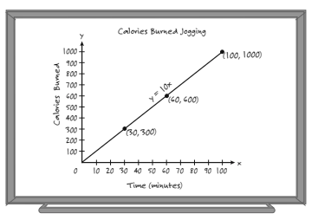

- Review vocabulary. Ask volunteers to locate and describe the terms x-axis, y-axis, increments, labeling points, and origin, so these can be posted on the class vocabulary list.
- When the graph is complete, say: Looking at the graph, what do you notice? Sharing observations about the graph shows you what features students are noticing. It is a good time to clarify misconceptions as well. When everyone seems comfortable with coordinate graphing conventions, give them the handout Graphs of Calories Burned.
- With partners, students proceed to copy the graph for Calories Burned Jogging onto their sheet, and to make graphs for the other three exercises. All four graphs will be on the same grid. While students are working, add the other three graphs to the large class graph (see Teacher Resource Activities and Calories Burned Class Graph).
- When most students have constructed all four graphs, refer to the large class graph and discuss:
What is different about these four graphs? What is the same?
Why do the graphs go upwards as we move to the right?
(Get students to connect the upwards slant of the graph with the idea that the longer we do an activity, the more calories we burn.)
Which activity burns calories the fastest? How do you see this in the graph? Which activity burns calories the slowest? How do you see this in the graph?
(You are looking for students to see that the rate at which the activity burns calories is reflected in how steeply or shallowly the line slopes up. You may want to mention the word “slope” here in an informal way. Don’t press for a formal definition of the term.)
Why do the graphs start at the origin?
(Press students to think about what 0, 0 means in context, i.e., if you do the activity for 0 minutes, you burn 0 calories. Many students have the misconception that all graphs must start at the origin. These graphs do, but many don’t. The (0,0) point is something that has meaning, depending on the context.)
- Offer several other hypothetical scenarios until students clearly see the connection between the rate and the relative steepness of the lines. For example:
Shoveling snow burns 8 calories per minute. If we made a graph for shoveling snow, what do you think the line would look like? Why?

4 Strategies for Differentiation

More Accessible:
- Have ready a copy of a line graph for students to examine and label with mathematical terms: x-axis, y-axis, and origin.

More Challenging:
- Push for precision in language. Ask more “What if… ” questions about changing the slope—e.g., What if the rate was ½ calorie per minute? What if it was 3.5 calories per minute?

Follow up activity:
Any of the tables created in these lessons can be graphed (heart beats vs. time, calories vs. servings, etc.). Since all the situations encountered in these lessons are proportional, they will all produce straight line graphs starting at the origin. The slope will be determined by the rate or ratio between the two variables.

IV. Planning for healthy living
Students reflect on goals they have for themselves and family members then create a plan for a healthy lifestyle.
- Ask students: What does a healthy lifestyle look like for you? (You may need to define “healthy lifestyle”—a way that a person lives that is good for their overall well-being.) Encourage them to think about mental health, physical health and social well-being. Students write down five or more things that they think are important for a healthy lifestyle.
- Students share their responses in pairs or small groups.
- Using the handout Action Plan for a Healthy Lifestyle, students create an action plan for each of their lifestyle goals.

4 Strategies for Differentiation

More accessible:
- Give students a list of possible categories such as food/eating, exercise, work, social activity, TV/screen time. Here is an online PDF resource that you can simplify: Parents Take Action: 5 Simple Steps to Success.
- Using the list from step 1 and the Action Plan for a Healthy Lifestyle handout, students create an action plan.

More challenging:
- Divide students in groups of five and give each students one ‘step’ of the Parents Take Action: 5 Simple Steps to Success to read. Students take turns sharing the big idea of their reading selection including one example with the other members of their group. You can then give each student a copy of the full article or the online link.
Using this information and other ideas they may have, students create a personal action plan for a healthy lifestyle. You can use the Action Plan for a Healthy Lifestyle handout, or students can write a paragraph describing their action plan.

ASSESSMENT

4 Strategies for Differentiation

More accessible:
Give students the Lesson 5 Assessment. Listen as they discuss the questions in pairs. You could also have students write their answers to certain questions if you want to collect them and give them feedback.

More challenging:
You can add this option to the Lesson 5 Assessment listed above.
- Give students this scenario:
You love to eat at McDonalds. You want to try to build this into your healthy lifestyle plan. Begin by choosing menu items for a typical breakfast, lunch, or dinner. Choose one meal only.
- You can project the McDonalds: Full Menu or students can write the names of food items on a piece of paper. Tell them to include something to eat and to drink.
- Students look up the calories for their menu items by using the McDonalds: About Our Food online nutrition calculator.
- Using the information from the Lesson 5 Assessment handout, students create an exercise plan that will burn off all the calories in the meal items they have chosen.

Extend the activity:
Students create graphs for each of the activities, then present their exercise plan to classmates using the graphs to support their reasoning. For example, one student may choose activities that burn the most calories in the least amount of time. Another student may choose one single activity that is done routinely in a given number of weeks. Another might choose to balance activities that work different muscle groups.

ADDITIONAL RESOURCES
- Exercise: 7 Benefits of Regular Physical Activity
- Physical, Mental and Overall Health Benefits of Regular Exercise: How Exercise Improves Health (video)
- Parents Take Action: 5 Simple Steps to Success
- McDonalds: Full Menu
- McDonalds: About Our Food
- Dietary Guidelines for Americans (PDF)

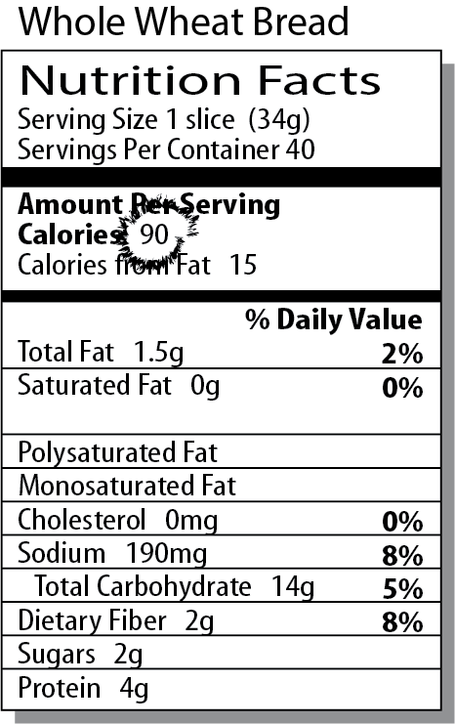
Some people pay close attention to the calories they eat. There are two ways to think about calories:
- We put calories into our bodies in the form of food.
- We burn calories at different rates, depending on what we do and how much time we spend doing it.
Look for patterns in the tables that follow, and fill in the missing information.

For the following tables, numbers are approximate, based upon an imaginary 5’8”, 190 lb. woman (source: http://www.caloriesperhour.com).

Jogging
Minutes Jogging | Calories Burned
1
15 | 150
30
45 | 450
60
100



Jogging burns _____ calories per minute.

Cleaning the House

Minutes  Cleaning | Calories Burned
1
15 | 75
30
45
60 | 300
100



Cleaning the house burns _____ calories per minute.

Running up stairs
Minutes Running up stairs | Calories Burned
1
15 | 300
30 | 600
45
60
100



Running up stairs burns _____ calories per minute.

Sitting (Reading or Watching TV)

Minutes  Sitting | Calories Burned
1
15
30 | 30
45
60 | 60
100

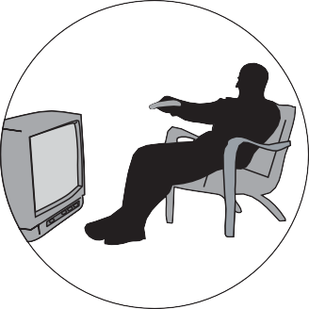

Sitting burns _____ calories per minute.

Copyright © 2011, TERC. All rights reserved. From EMPower book Seeking Patterns, Building Rules: Algebraic Thinking, Lesson 3 (Student Book). Adapted with permission.

Three Ways to Burn a Pound of Fat (3,500 calories)

You have to burn 3,500 calories to lose a pound of fat. Create three exercise plans for burning a pound of fat. Combine all three activities (Jogging, Cleaning House, Running Up Stairs) in each plan you create.

Plan 1 is started for you.

PLAN 1
Type of Activity  (Jogging, Cleaning, or Running Up Stairs) | Minutes | Calories
Jogging | 180
Cleaning the house | 100
Plan 1 Totals |  | 3,500

PLAN 2
Type of Activity  (Jogging, Cleaning, or Running Up Stairs) | Minutes | Calories
Plan 2 Totals |  | 3,500

PLAN 3
Type of Activity  (Jogging, Cleaning, or Running Up Stairs) | Minutes | Calories
Plan 3 Totals |  | 3,500

How did you create your plans?

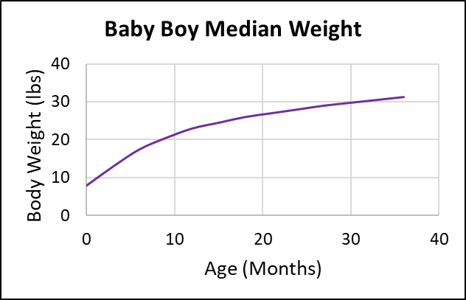
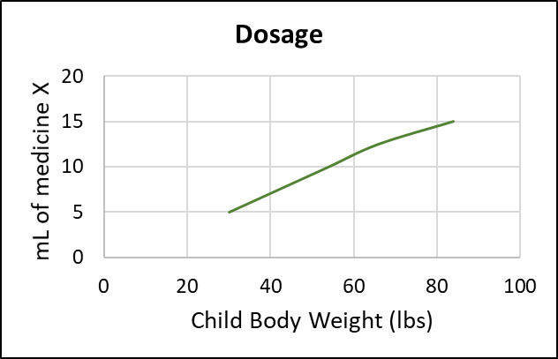
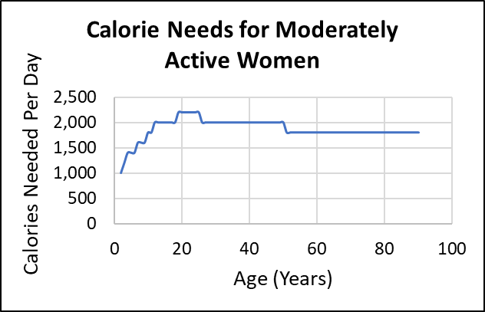
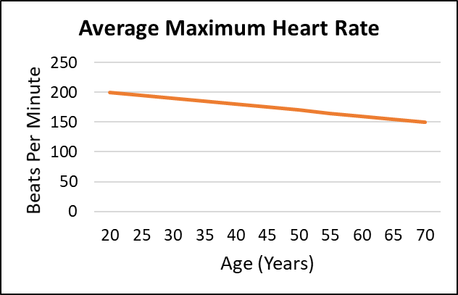
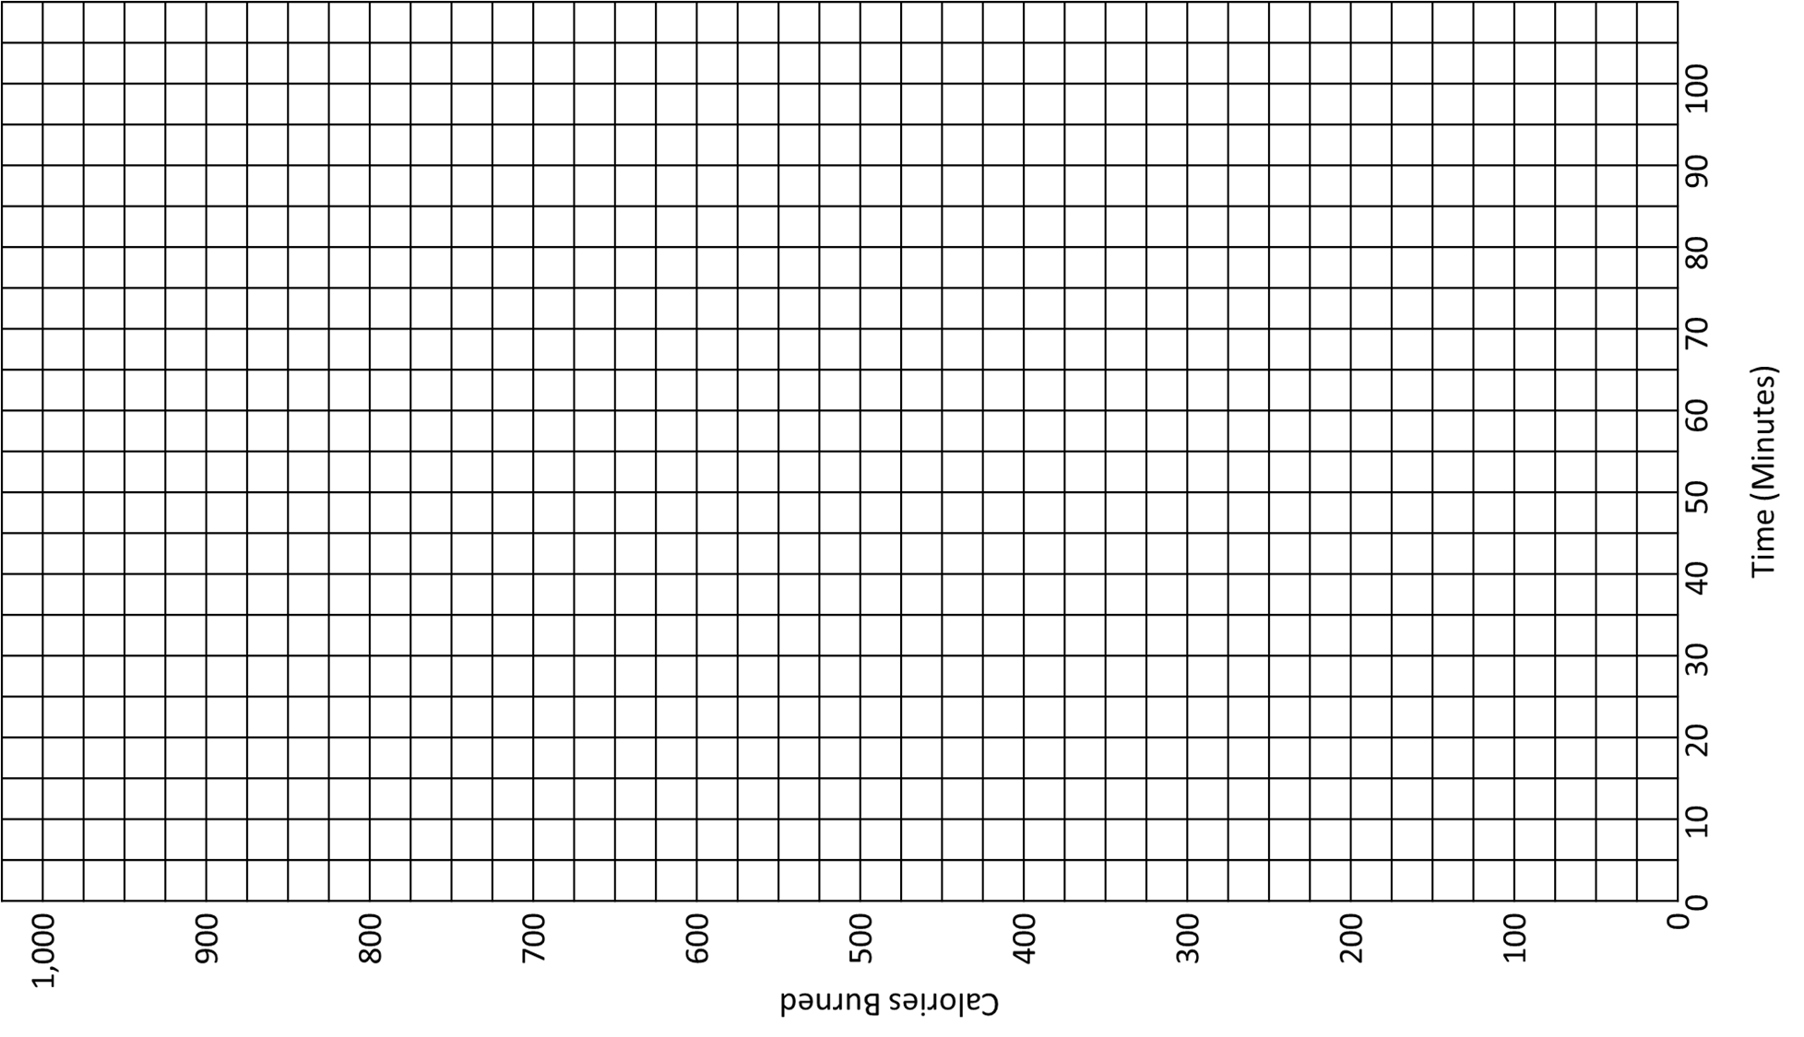
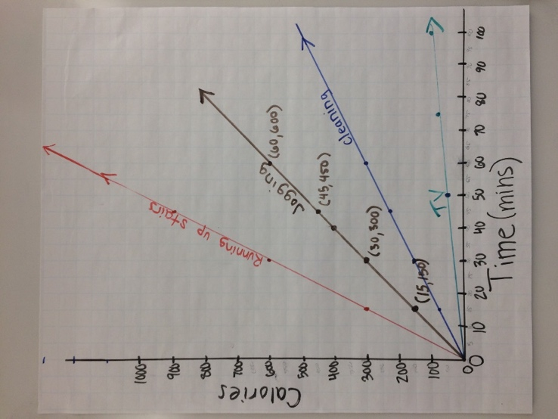

My personal action plan for healthy living:
Physical Well-Being

Three specific goals I have for myself are:

I will accomplish these goals by:

People who can support me are:

I will know I have achieved these goals when:

My personal action plan for healthy living:
Mental / Emotional/ Social Well-Being

Three specific goals I have for myself are:

I will accomplish these goals by:

People who can support me are:

I will know I have achieved these goals when:

