Here are some other fractions that are equal to 75%:

$\frac{6}{8}$ $\frac{12}{16}$ $\frac{15}{20}$ $\frac{60}{80}$

One thing you might notice about fractions that are equal to 75% is that the numerator is 3 times some number and the denominator is 4 times that same number. For example, the model shows you that $\frac{6}{8}$ is equal to $\frac{3}{4}$ , like this:

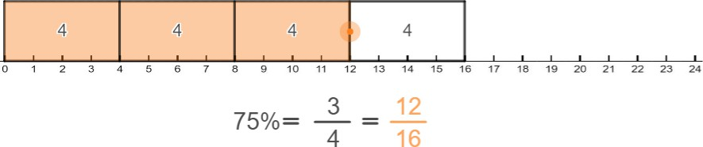
The three shaded boxes show you that 𝟏𝟐 = 𝟑 × 𝟒, and the four boxes that make up the whole rectangle show you that 𝟏𝟔 = 𝟒 × 𝟒. Another way of thinking about this is to write $\frac{12}{16}$ as $\frac{3×4}{4×4}$ . The numerator is 3 times 4 and the denominator is 4 times 4.

Another way to see whether a fraction is equal to 75% is to try drawing a picture of it like the model you’ve been playing with. For example, $\frac{6}{8}$ could look like this:

Divide the boxes into 4 equal groups like this:

If 3 of the 4 groups of boxes are shaded, then the fraction is equal to $\frac{6}{8}$ or 75%.

