by Donna Curry and Nicole McNeil

Dyscalculia is the term associated with specific learning disabilities in math. Some common indicators include:
- difficulty with counting, learning number facts, and doing math calculations,
- difficulty with measurement, telling time, counting money, and estimating number quantities, and
- trouble with mental math and problem-solving strategies. (https://www.ncld.org/wp-content/uploads/2014/11/2014-State-of-LD.pdf)
We suspect those characteristics describe the majority of students in our adult education programs. However, there is a good chance that they struggled with math NOT because of a specific learning issue such as dyscalculia, but because, for most of our adult learners, math was taught as a set of discrete skills to be memorized. If a student was adept at memorizing isolated facts and procedures, she could become "good" at math. So, while there may be some adult learners with specific learning disabilities related to math, we need to be cautious of labeling a student with a disability, especially if she has not previously been appropriately tested. Instead, we need to think of how to teach all our learners differently so that we can help them no matter how they've learned to approach math. We need to remember that all of our students CAN learn; it’s up to us as instructors to figure out how best to reach them.
Many of the definitions associated with learning disabilities in math, such as the one listed above, focus on procedures. These definitions do not take into account whether students know when to use specific strategies they have learned, what to do with the result of computations, or how to communicate ideas or process information that has a mathematical aspect to it. We know adults need to be able to apply math content in a variety of situations both at home and at work. However, according to the research by Lewis and Fisher (2016), many of the 164 research studies on mathematical learning disability between 1974 and 2013 focused only on elementary-aged students engaged in basic arithmetic calculation. In fact, the authors of the study suggest that more research is needed in addressing more complex mathematics encountered by adults, since math is much more than just computation.
In this paper, we intend to provide a few examples of powerful strategies that are appropriate for all learners – strategies that go well beyond calculations or the memorization of steps and procedures. We hope these examples spark your desire to learn more so you can better help your students.

Strategy 1: Alternative Representations with Operations
A researcher who compared low achievers to high achievers found that those performing at lower levels do so not because they know less, but because they don’t use numbers flexibly. From an early age they have been set on the path of trying to memorize methods instead of interacting with numbers flexibly. This incomplete instruction means that they are learning a harder mathematics and sadly, often face a lifetime of mathematics problems (Boaler, 2015). Below are some examples of how to help students use alternative ways to think more flexibly about numbers and operations rather than memorizing procedures.
Multiplication strategy. One strategy often suggested for students with learning differences is to use graph paper or turn lined paper sideways to align numbers to do long multiplication. However, this strategy focuses only on the procedure and not on conceptual understanding. Rather than expending this energy (and overloading working memory), help students learn number sense in order to estimate a reasonable answer, then check with a calculator. Using an area model helps students understand what is actually happening when they multiply two numbers together to get the product (which can be visualized as an area).
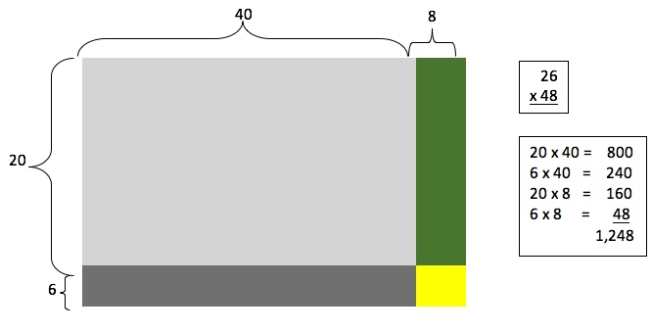

Area models can also be used to help students connect basic number facts – building on facts they already know, such as the 5 facts:
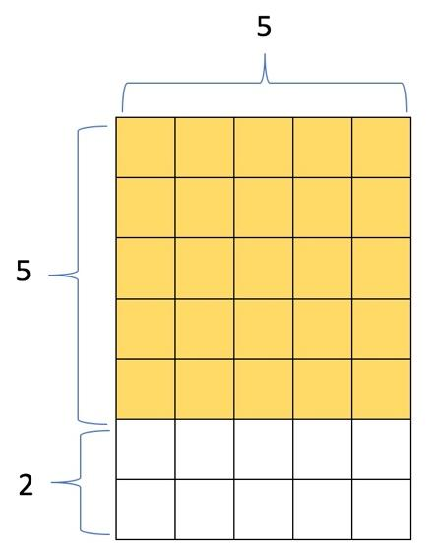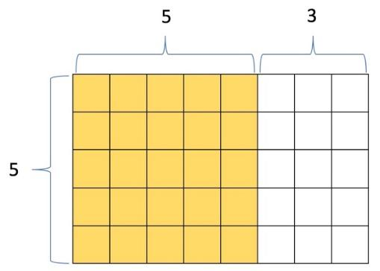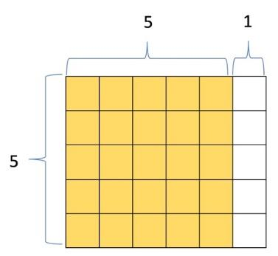

This also helps students see how the distributive property works.
Division strategy. Another strategy often suggested for use when working with students with learning differences is to use index cards to write out the steps for procedures, such as long division. This focuses only on memorizing a nonsensical procedure.
Consider what we do when we teach students how to divide:
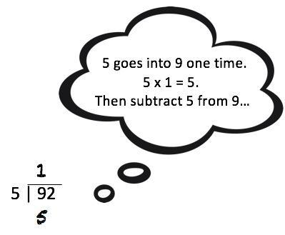
Instead, make sure that students understand that division is the act of seeing how many groups there are. It doesn’t matter whether we pull out the groups all at once, or several at a time (even one at a time). In thinking this through, there’s more than one way to get to the answer, and students don’t have to memorize the "right" procedure.
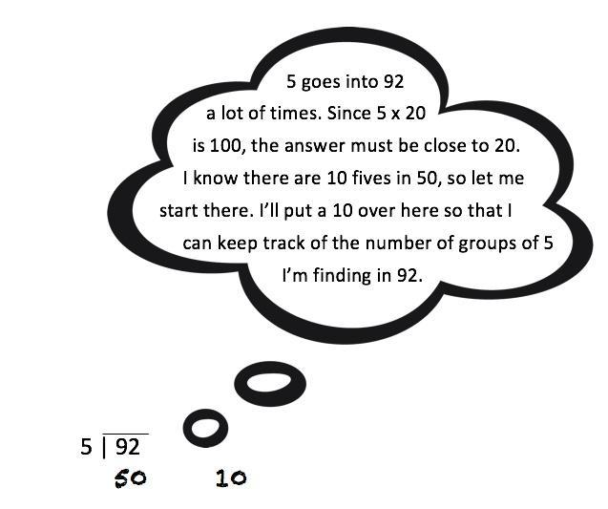

Subtraction strategy. If students know the relationship between addition and subtraction, rather than trying to figure out how to subtract (with or without borrowing), they can count up. So, instead of trying to figure out what 400 – 286 is, students can count up to 290, then add 10 to get to 300, then 100 more, etc. A number line is a perfect visual tool to show this.

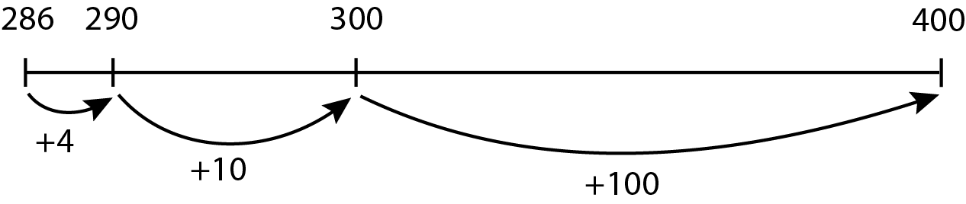

Key word strategy. Do not teach students simply to find “key” words without understanding a situation. Look at these examples:
- Rebecca gave $10 to Shamika. She has $40 left. How much did she have to begin with?
- Rebecca had $40 and gave $10 to Shamika. How much does she have left?
- Rebecca had several bills in her wallet. She gave Shamika $10 and noticed that she had $30 left in her wallet. How much did she have before sharing with Shamika?
Teaching students that the word left suggests subtraction could lead to trouble for students. It is more important that students can visualize the problem. Visual tools such as Singapore strips (also known as bar models or tape diagrams) can be much more valuable than teaching key words.
The visual representations of these three math problems that follow can help clarify the information given and what is being asked.



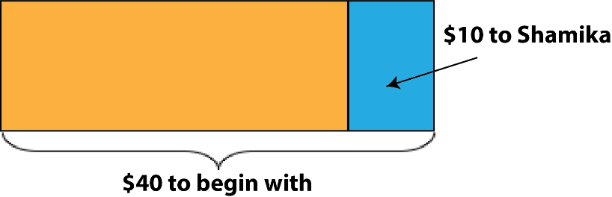



Strategy 2: Manipulatives
Manipulatives are a tangible visual that students both see and touch as they develop their own understanding. When learning new concepts, it is important to start with something concrete and then move to a representation (such as a drawing) before moving to an abstract representation. Consider the first manipulative most of us ever use – our own fingers! Some fascinating brain research on what happens when students use their fingers as they calculate has neuroscientists recommending that fingers be regarded as the link between numbers and their symbolic representation, and an external support for learning arithmetic problems (Boaler, 2017). From there, we move on to other manipulatives.
Manipulatives can be used for introducing many math concepts. For example, students should be able to use actual items, including play money, to see a pattern for proportional thinking. Later authentic items can be replaced with two different colors of square tiles. Much later, the idea of proportional reasoning can be explored through symbolic notation such as the cross-product procedure.
Research is clear: students need to have opportunities to use manipulatives. But, when? Consider keeping versatile manipulatives such as 1” square tiles and rulers available, and using them whenever you are talking about a concept with students. Students will begin to see the value of objects as tools to aid understanding.
Use manipulatives when teaching the relationship between addition and subtraction.
For example, students can readily see that 4 + 5 = 9, 5 + 4 = 9, 9 – 4 = 5, and 9 – 5 = 4. They can also see that 5 + 5 = 10, but 4 is one less than 5, so 4 + 5 = 9.
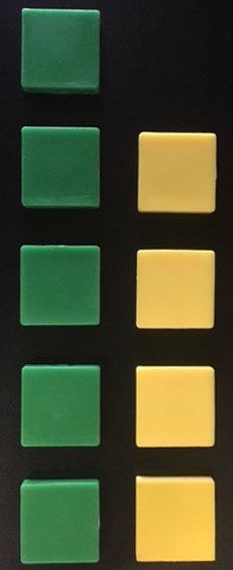
5
4

[The observed relationships are for students to discover and share! You listen.]

Use manipulatives to show how multiplication can be illustrated by repeated addition.
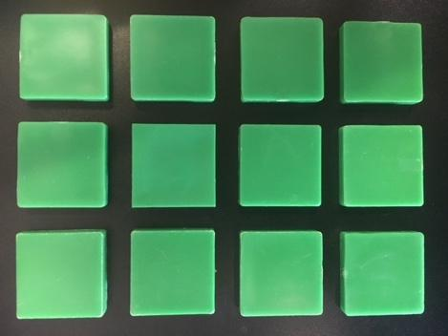
4
3

Use arrays to illustrate the commutative and the distributive property.
In the following example, we have 2(4) + 2(3) on the left and 2 (3 + 4) on the right.
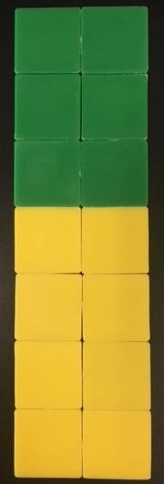
2
2
3
4
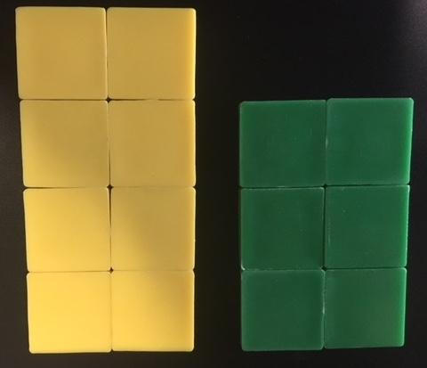
2
2
4
3

Use manipulatives to begin to help students develop proportional reasoning.
For example, 2/3 = 6/9 because there are three sets of 2/3 in 6/9 [not because the cross products are equal!].

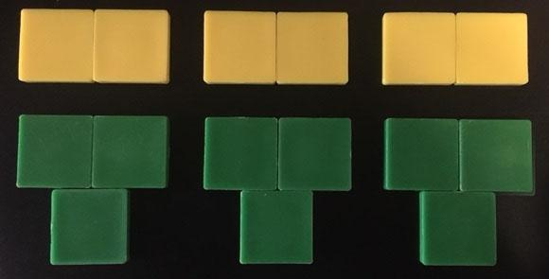

Use manipulatives to introduce the concept of operations with negative and positive integers.
Using manipulatives for negative numbers does not work for every operation, but students can use manipulatives to develop an understanding of what happens when you add and subtract integers.
Below is an example of a student using tile spacers to show 8 positive ones and using lines to show 2 negative ones. The pairing of 2 positives and 2 negatives are two “zero pairs,” leaving 6 positive ones.
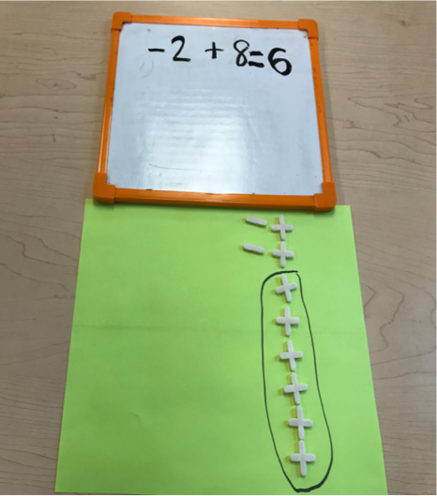

Strategy 3: Real Life Word Problems
Mathematics is about problem-solving – a life skill for adult learners. The dilemma with problem-solving is that it is difficult for students with learning disabilities (in fact, it’s often challenging for most learners). One strategy for problem-solving supported by research is to introduce new math concepts through everyday scenarios (Salend, 1994). Teachers should ask learners, “What math did you use this week?” Some answers might include filling up a tank of gas and calculating miles per gallon, budgeting childcare using percentage of income, or measuring the square footage of a room to paint a wall. These scenarios provide a perfect basis for creating authentic, real-world problems.
Another strategy to help learners with learning disabilities is break down a problem into smaller steps and provide prompts (Learning Disabilities Association of America, 2013). The following example shows a real-life problem broken down into steps. Eventually, using models such as the one on the following page, students will be able to develop their own prompts to break down problems into smaller steps.

Problem
José has two options for buying a washing machine. He could pay $500 cash or go to the local rental center and pay $50 a month for 2 years.
How much money does he save by paying cash?

Work Space
Guiding Questions
Option A (Cash)
How much does José pay if he pays cash?

Option B (Monthly Payments)
How many months is 2 years?

How much does José pay if he makes payments over the two years?

How much does he save?
Option B - Option A

Another useful tool is Dan Meyer’s Three Act Problems: (https://www.ted.com/talks/dan_meyer_math_curriculum_makeover).
Dan Meyer is the creator of the Three Act Math format, in which students are shown a video that stimulates their curiosity. The first act is the problem. The second act gives some information with prompting questions and the third act is when the answer is revealed. This combination of both real-life and prompting helps learners fully comprehend the situation.
The following "Sink Problem" on shows an example of student results of using a Three Act problem and proportioning reasoning.

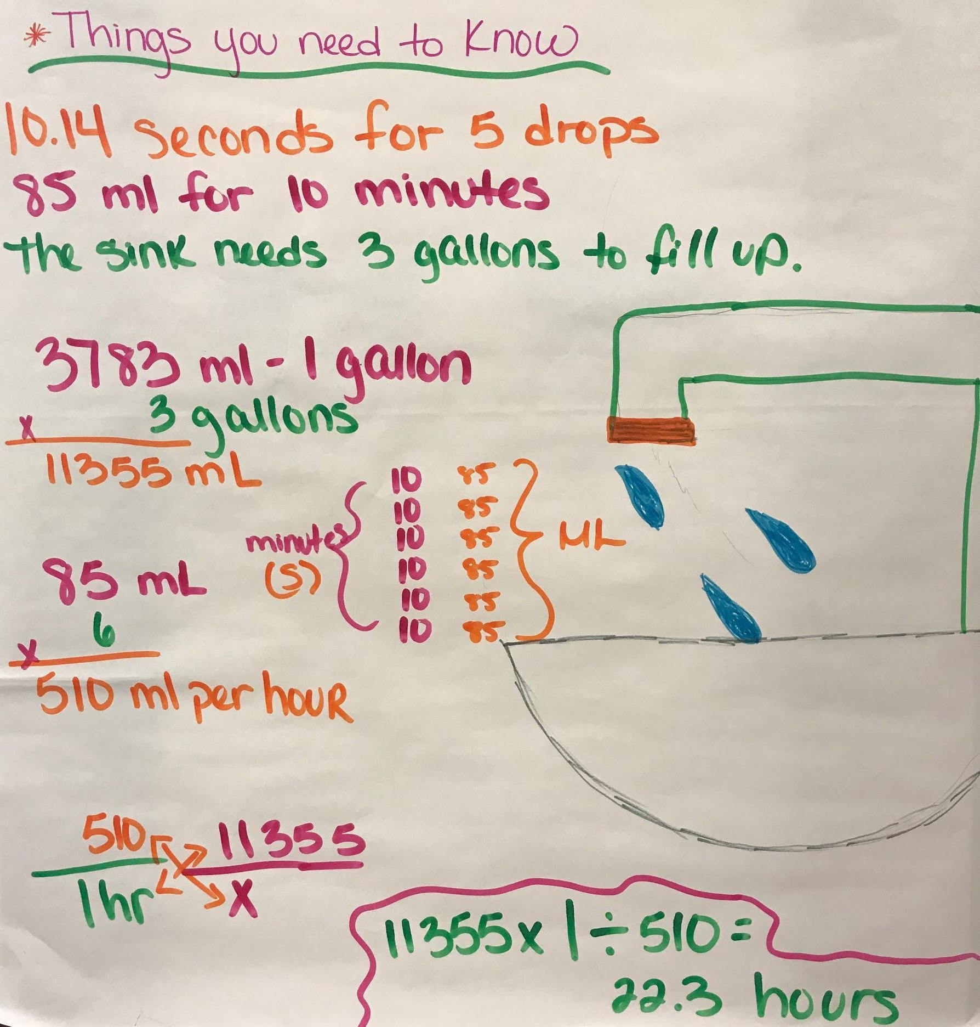

Strategy 4: Graphic Organizers
Graphic organizers are powerful visual tools for students with learning disabilities such as dyscalculia and dyslexia. They can be used to break down concepts and vocabulary. Examples of graphic organizers include KWL (Know, Want to Learn, Learned) charts, Venn diagrams, mind maps, T charts, flow charts, timelines, and compare and contrast charts. While many of these are encouraged in ELA classes, they are also valuable tools for math learners. The Frayer Model is another type of graphic organizer that is used mostly in ELA classes, but can be extremely helpful for understanding math topics. An example is below:
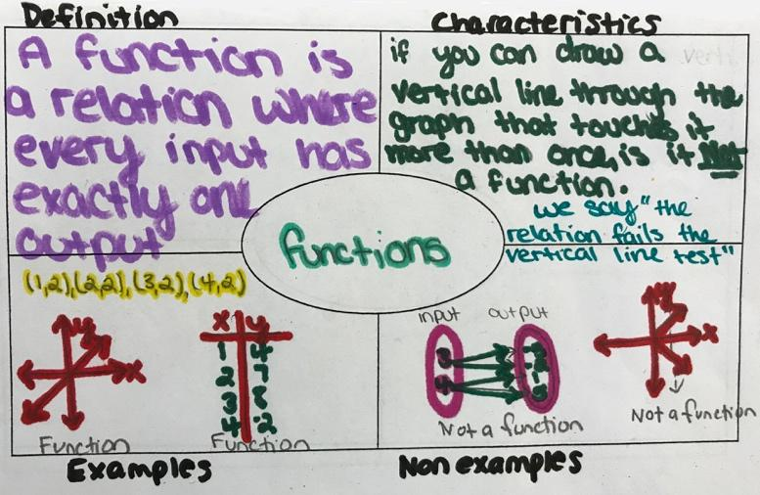

In Summary
Unfortunately, math is difficult for a lot of adult learners. The more that teachers provide different strategies to reach all students, the more successful students will be. In order to provide different strategies, teachers need to have a bag of ideas readily available to pull out when a student struggles.
Let the SABES Mathematics and Adult Numeracy Curriculum & Instruction PD Team help you fill that bag. We offer courses that specifically address strategies for students with Learning Differences, Difficulties, or Disabilities such as area models, number lines, and Singapore strips.

Strategies for Teaching More Than Just Computation
Below is a list of strategies for teachers to focus on conceptual understanding and application, as well as procedural fluency (which involves much more than simply memorizing or following a procedure).

Strategies That Support Math Students with Learning Disabilities

- Help students develop alternative strategies to develop operation sense
- Focus on operation sense, not just procedures
- Help students develop ways to connect basic number facts rather than simply memorize them
- Allow the use of calculators as appropriate
- Build number sense and stress estimation as a way to check for reasonableness
- Use visual tools (such as Singapore strips, area models, and number lines)
- Model with manipulatives
- Begin with real-life situations
- Use graphic organizers (such as Frayer model, KWL chart, Venn diagrams, and mind maps)
- Avoid problems with extra information when first teaching the concept
- Break down vocabulary and connect it to what a student already knows
- Break learning into smaller steps and provide prompts as needed

References and Resources

Boaler, J. (2015). Fluency without Fear. https://www.youcubed.org/evidence/fluency-without-fear/
Boaler, J. (2017). Seeing as Understanding: The Importance of Visual Mathematics for our Brain and Learning. https://www.hilarispublisher.com/open-access/seeing-as-understanding-the-importance-of-visual-mathematics-for-our-brain-and-learning-2168-9679-1000325.pdf
Braaten, M. (2018, June 6). Calculator Use in Adult Education. [Blog]. Retrieved from
https://adultnumeracyatterc.wordpress.com/2018/06/06/calculator-use-in-adult-education/
Center for Implementing Technology in Education. (2018). Beyond "Getting the Answer": Calculators Help Learning Disabled Students Get the Concepts. Retrieved from http://www.ldonline.org/article/19274/
Lewis, K., & Fisher, M. (2016). Taking Stock of 40 Years of Research on Mathematical Learning Disability: Methodological Issues and Future Directions. Journal for Research in Mathematics Education, 47(4), 338-371.
Salend, S J. (1994). Effective mainstreaming. Creating inclusive classrooms (2nd ed.). NY: MacMillian.
Learning Disabilities Association of America. Successful Strategies for Teaching Students with Learning Disabilities. (2013). Retrieved from https://ldaamerica.org/successful-strategies-for-teaching-students-with-learning-disabilities/
http://blog.mrmeyer.com/2011/the-three-acts-of-a-mathematical-story/
https://ldaamerica.org/
https://www.ted.com/talks/dan_meyer_math_curriculum_makeover
https://www.sabes.org/pd-center/math-and-numeracy
https://dpi.wi.gov/sites/default/files/imce/ela/bank/6-12_L.VAU_Frayer_Model.pdf (Frayer Model)

